CHEMICAL ENGINEERING TRANSACTIONS  VOL. 76, 2019 | A publication of
The Italian Association
of Chemical Engineering
Online at www.aidic.it/cet
Guest Editors: Andrea D’Anna, Paolo Ciambelli, Carmelo Sunseri
Copyright © 2019, AIDIC Servizi S.r.l.
ISBN 978-88-95608-71-6; ISSN 2283-9216

Evaluation of zeolite-based catalyst supports for the production of biokerosene by hydrotreating of oils
Manuel A. Mayorga* ^{a b}, Juan G. Cadavidª, José Martínezª, Luis I. Rodríguez-Varelaª, C. A. Trujilloª, Mauricio López^{c}, Javier Bonilla^{b}, Camilo López^{b}
ªChemical Engineering Department, Universidad Nacional, Bogotá, Colombia
^{b}Chemical Engineering Department, Universidad ECCI, Bogotá, Colombia
^{c}NCO School of the Colombian Air Force, Madrid, Colombia
mamayorgab@unal.edu.co
In order to optimize the conditions for the biofuels production by a hydrotreatment process, three platinum catalysts supported on different zeolites were evaluated. The three zeolites used for the hydrotreatment of soybean oil were USY (CBV-780), H-β and ZSM-5, impregnated with a 1 % platinum salt solution. The functional groups of the catalysts were analyzed by infrared transmission spectroscopy, the condition of the pores by scanning electron microscopy and, it was employed X-ray diffraction to determine the crystal structure. Subsequently, these catalysts were employed to hydrotreat some soybean oil samples of 80 mL, in a 300 mL reactor, operating at 525 K, 2500 kPa, and a H₂/N₂ molar ratio of 30 % for 6 h. Some gas chromatography analyses carried out over the synthesized biofuels evidenced that Zeolite H-β presents the best characteristics for the production of a biofuel with most similar properties to the currently employed fossil fuels.
  - Introduction
As a consequence of fossil resources deployment, geopolitical issues and, with the purpose to mitigate the global greenhouse emissions produced by the transport sector (Hill, Nelson, Tilman, Polasky, & Tiffany, 2006; Höök & Tang, 2013; Jacobson, Maheria, & Kumar Dalai, 2013), some researches have focused on the synthesis of biofuels which still has to overcome some issues as: fidelity to the physical-chemical properties with the fossil fuel, abundance of the feedstock for its production, compatibility with the currently employed technology for storage and transportation, favorable price and environmental sustainability (Makarfi Isa & Ganda, 2018).
An alternative to the transesterification processes used to achieve a fair physical-chemical fidelity with the fossil diesel is the hydrotreatment. This technology is currently in development and, some operational variables are still being studied (Demirbas & Dincer, 2008, Laverdura et al, 2018), such as: the type and origin of the vegetable oils, reactor type, temperature, pressure, operating time, concentration of reagents, solvents, promoters and inhibitors and, of course, the catalysts (Srifa, Faungnawakij, Itthibenchapong, & Assabumrungrat, 2015).
The hydrotreatment consists in the hydrogenation of the oils at high temperature and pressure conditions in order to deoxygenate the triglycerides. A good analysis over the reaction mechanism is a key factor to reduce the amount of spent hydrogen and, it depends on the specific conditions of the process, including the catalyst.
Hydrotreating can be produced by a pathway of hydrodeoxygenation (HDO), obtaining water of the reaction, or decarboxylation/decarbonylation (deCOx), which produces carbon oxides. Figure 1 depicts the two reaction mechanisms (Donnis, Egeberg, Blom, & Knudsen, 2009). Although the deCOx route is apparently more desired because it consumes less hydrogen in the process, the carbon dioxide produced by deCOx can react with the hydrogen to generate more monoxide and water. In addition, the monoxide can also be reduced to form methane and consume even more hydrogen than in the HDO route.
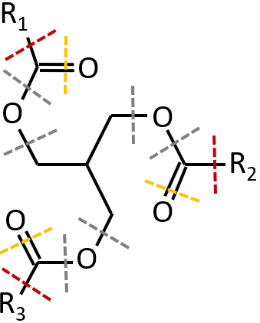
Figure 1: Pathway reaction for the hydrotreating of a glyceride. The dotted lines represent the bonds breaking: yellow line for the hydrodeoxygenation and red line for the decarboxylation/decarbonization.
For the active agent of the catalyst, metals are usually used in their reduced state, some metallic salts of carbon and phosphorus, or some bimetallic sulfur salts (Srifa et al., 2015). Santillan-Jimenez (2012) presents the list of metals in the activity order for a deoxygenation process, normalizing the results, in order not to consider the catalyst concentration or type of support: Pd > Pt > Ni > Rh > Ga > Ru > Os.
In the past, the most popular materials for hydrotreating (in the processes of desulfurization, denitrification and deoxygenation of crude oil) were those based on γ-alumina. However, these present an inconvenient because they form very strong bonds with the metal oxides, overcoming some disadvantages in the catalyst activation process (Jacobson et al., 2013). Thus, some research raised focused on the study of porous materials that offer great surface area, variety in shape and size of pores, mechanical and thermal stability and, resistance to carbon and nitrogen poisoning. Among the most studied materials with these properties are some aluminosilicates called zeolites.
The zeolites are popular supports because their synthesis process allows tailoring a wide range of sizes and shapes pores, as well as enabling the control of the concentration of acid functional groups onto their surface, by regulating the relationship between Al-Si (Weitkamp, 2000).
Regarding the oils hydrotreatment process, the zeolites performance has already been studied, especially in the processes of fossil oils desulfurization. Even more, there are already some industrial processes such as UOP/Eni (Kalnes, Marker, & Shonnard, 2007). Most recommended supports for this process are those with a small pore size (around 0.4 nm), which allow a fast hydrogenolysis. Likewise, it has been shown that the hydrogenation process is more affected by a high density of Brönsted active sites, than by the acid strength of the active sites (Huang, Long, Agrawal, & Jones, 2009). Inside the group of zeolites which afford these characteristics, are the ZSM-5, the USY and the H-β. Where the ZSM-5 is the most popular studied zeolite for hydrotreatment, and the others are zeolites with greater surfaces areas but less Al:Si molar ratio.
Consequently, this research aims to study three zeolite type supports, characterizing its BET area, surface functional groups, acidity and, the size and morphology of their pores. Then, these characteristics have been regarded as input parameters in order to analyze their influence in a deCOx process for a soybean oil.
  - Materials
The three zeolites employed as supports are solid white dusts. They are insoluble in water, with boiling points up to 1300 K, and specific properties which are reported in Table 1.
Table 1: Properties of the zeolites.
Property | USY | H-β | ZSM-5
Commercial reference | CVB-780 | Cp811c-300 | CBV-3024e
SiO₂/Al₂O₃ molar ratio | 80 | 300 | 30
Nominal form of the cation | Hydrogen | Hydrogen | Ammonium
Na₂O composition | 0.03% | 0.03% | 0.05%
BET Area | 780 m²/g | 620 m²/g | 405 m²/g

The salt employed to prepared the solution in the synthesis of the catalysts was Pt(NH₃)₄Cl₂.
A refined soybean oil was used, with an acidity index (ASTM D-664) of 0.22 mg KOH/g, and a moisture content (ASTM D-1744) of 0.04 %. Table 2 summarizes the fatty acids content profile in the soybean.
Table 2: Fatty acids content in the soybean oil.
Fatty acid | Length:unsaturations | Content
Palmitic | C16:0 | 24.66 %
Stearic | C18:0 | 3.76 %
Oleic | C18:1 | 33.30 %
Linoleic | C18:2 | 31.96 %
Linolenic | C18:3 | 3.86 %
Others | --- | 2.46 %

It was employed grade 5 nitrogen and hydrogen gases.
The standard references to chromatography analyses were n-heptane, n-octane, n-decane, n-dodecane, n-tridecane, n-tetradecane, n-pentadecane, n-hexadecane, tripalmitin, and tricaprin with a purity of 99 %.
  - Methods
    - Synthesis of the catalysts
1 %m/m platinum supported catalyst were prepared by wet impregnation using the three zeolites types (ZSM-5, USY and H-β). A solution of tetramine platinum dichloride salt (II) Pt(NH₃)₄Cl₂ was used as salt precursor.
These catalysts were activated at 470 K for 2 h in a reducing atmosphere of 30 % H₂/N₂. The heating was from room temperature with a rate of 2 K/min.
The crystal structures of the zeolites were characterized by X-ray diffraction (XRD), the surface functional groups were analyzed by X-ray spectrometry, and the morphology and particle size of the reduced catalysts were examined by scanning electron microscopy.
3.2 Oil hydrotreatment
The tests were carried out in a 300 mL batch reactor (Figure 2). 80 mL of oil and catalyst mixture in a 10:1 mass ratio was charged to a borosilicate vessel. The catalyst was a mixture between 1 % Pt/Zeolite and Zeolite (without metal) in a ratio of 1 to 13.5 by mass. The magnetic stirrer was located in the bottom of the vessel and then, it was introduced to the reactor. Subsequently, the system is purged 5 times with nitrogen reaching a pressure of 4000 kPa and slowly degassing up to 200 kPa. Finally, it is taken to room temperature and 1150 kPa with nitrogen and to 1500 kPa with hydrogen. Namely, the reactor had an atmosphere at 30 % of hydrogen. The system is heated up to 525 K with a rate of 7 K/min. Once the system reaches 525 K, magnetic agitation is activated and the reaction is allowed for 6 h.

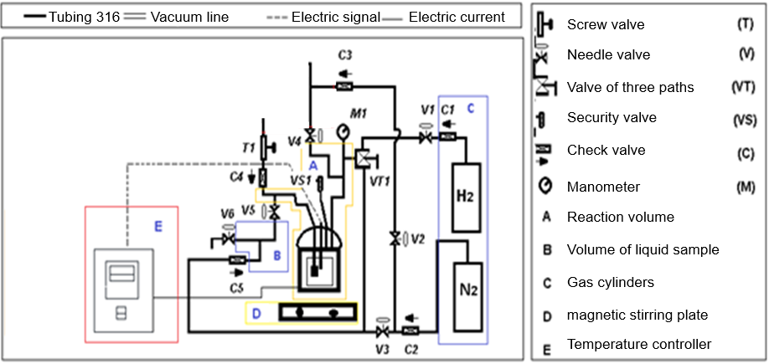
Figure 2: Reaction assembly for oil hydrotreating.
The products were separated by centrifugation (6000 rpm for 1 h) and decantation. The light phase was purified by filtration (0.42 μm filter) using n-hexane as solvent. The content of hydrocarbons was determined in a gas chromatograph (GC) Agilent 6820, using a cast silica pre-column (0.3 mx 0.53 mm) and a capillary fused silica column SUPELCO SGE HT- 5 (12 mx 0.53 mm x 0.15 mm). 20 mg of sample were placed in an Eppendorf tube, adding 5 mg tricaprin as internal standard and carrying up to 1.5 mL with n-hexane. Manual samples of 1 μL were injected manually to the chromatograph. After 1 min of stabilization at 413 K, the furnace temperature was programmed to increase from 253 K to 653 K at 20 K/min, remaining at 653 K for 10 min. The injector was at 623 K, and the detector was at 663 K. The carrier gas was nitrogen with a flow rate of 6 mL/min and a division ratio of 50:1. The hydrogen and dry air flows were 40 and 450 mL/min respectively.
  - Results and Discussion
    - Catalysts synthesis
The X-ray diffraction results for the three zeolites are presented in Figure 3. The Pt/ZSM-5 catalyst presents characteristic peaks of Tetrakis C₄₈H₁₁₆N₄O₁₉₆Si₉₆, which synthesizes carboxylic acids, its structure is monoclinic with an intense and narrow peak which indicates a growth in the particle size of the Tetrakis and a crystalline order, which is due to the presence of the ammonium ion. Zeolite H-β is a material which has Fe in its structure, which confers it magnetic and catalytic properties. The inclusion of Fe increases the spaces in its structure, presenting characteristic peaks in 22.58 and 21.76. There is also a peak of W₃₆P₄Cu₄N₂₄O₁₂₆C₉₂₈₈ at 7.9. Where as USY zeolite presented a size of the unit cell of 24.24 Å.

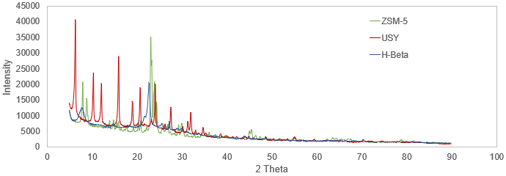
Figure 3: Diffractogram of the three catalysts.
The scanning electron microscopy showed a considerable grain size for the catalyst Pt/H-β, appreciating silicon. Meanwhile the Pt/USY presented some impurities, as can be observed in Figure 4. USY catalyst presented a greater surface area (780 m²/g compared to 620 m²/g), due to the smaller grain size. In addition, there are uniform zones and others with agglomerations seems due to the dispersion of platinum.

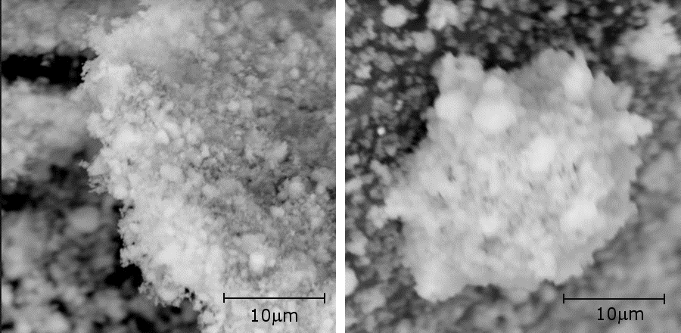
Figure 4: SEM for 1 % Pt/H-β (left) and 1 % Pt/USY (right).
Finally, the infrared absorptance and transmittance spectra, by the FTIR analysis, for the Pt/ZSM-5 and Pt/USY catalysts are shown in Figure 5.
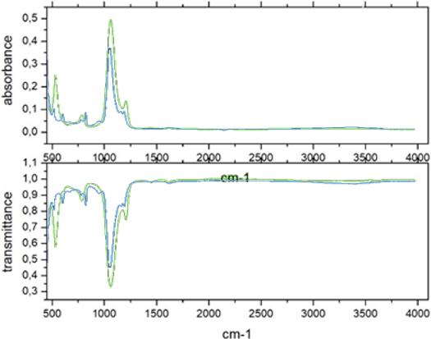
Figure 5: IR spectrum of 1 % Pt/ZSM-5 (green) y 1 % Pt/USY (blue).
Results are according with the zeolite description, since zeolite is a material that presents hydration in the ranges 3500 to 1640 cm⁻¹. Meanwhile the characteristic peaks of aluminosilicates (essential components of zeolites), are appreciated in the region of 560 to 630, due to the rings of vibration of SiO₄ and AlO₄.
    - Biofuel synthesis
It was appreciated a remarkable organoleptic difference between the fuels synthesized by the three catalysts, especially in the color (darker for the H-β zeolite), which may indicate a greater presence of long molecules chains. In the same way, it had a much higher viscosity and a more rancid odor than the others.
According to the comparative chromatogram of Figure 6, a high presence of fatty acids (mainly palmitic, stearic and oleic) is generated between 10.7 and 11.5 minutes, for the three cases, but mainly for the H-β zeolite support. A greater conversion also occurs when using this zeolite, in addition to the production of hydrocarbons with lengths between C-12 and C-13 (apparently an isomer of n-dodecane, therefore branched) in the minute 8.4, which represents around 0.6 % of the sample. This type of compounds are the essential components of biokerosene, since dodecane is the most representative of this oil fraction.

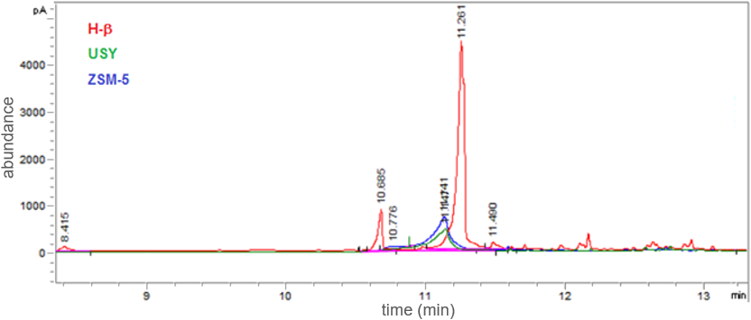
Figure 6: Comparative chromatogram of generated products.
H-β presented a better conversion to final products, avoiding intermediates as mono, di and triglycerides. This is conferred to the soy oil used, which are full saturated by hydrogenation of the double bonds; subsequently the gaseous hydrogen initiates a stage of hydrogenolysis to break the diglyceride and generate free fatty acids (which are evidenced in the chromatogram) and propane. Subsequently, the hydrogen generates a hydrogenation process to deoxygenate the fatty acids and transform them into linear alkanes, which subsequently the acid zeolite helps to fragment and isomerize. To make these last two conversions viable with the support of zeolite H-β it would be convenient to work at higher temperatures and in two steps, where after the linear alkanes are produced, they are treated with zeolite not impregnated with platinum to break and isomerize; in this way the proportion of dodecane can be more significant.
The presence of Fe in H-β zeolite structure could favors hydrogenation/dehydrogenation and hydrogenolysis reactions.
The smallest conversions occurred when the ZSM-5 zeolite was used as support, since the ammonium cation was present instead of hydrogen, so the process had to be heated in a vacuum at 770 K for at least 5 h before impregnation of platinum, that without commenting that it is the least acidic according to the Si:Al ratio.
Comparing the acidity in terms of the SiO₂:Al₂O₃ molar ratio of the zeolites used: H-β (300), USY (80) and ZSM-5 (30). However, an evaluation of the effective acidity of these zeolites should be made, which differentiates the Brönsted acid sites from the Lewis ones (Strong and weak).
  - Conclusions
The H-β zeolite, having a medium pore size (0.668 nm) and high acidity, is the zeolite that most converts hydrocarbons, presenting good selectivity towards medium products. USY zeolites of medium acidity with the largest pore cavity (0.74 nm) usually show good selectivity towards branched isomers; however, if its acidity is not controlled it can lead to excessive gas formation. ZSM-5 zeolites have the lowest acidity and specific area, due to no previous surface activation so it is the less convenient for these processes.
It is found that zeolites H-β (cp811c-300) are more promising to produce biodiesel from soybean oil than USY (CBV 780) and ZSM-5 (CBV-3024e). Then in order to improve the conversion, it is important to evaluate the USY zeolite with another operational conditions (temperature, pression and reaction times), and ZSM-5 in protonated phase.
Acknowledgments
This manuscript was supported by the Department of Science and Technology of Colombia (COLCIENCIAS) under the grant 995-2017. Furthermore, authors would like to express his gratitude to Colombian Air Force for its financial support.
References
Demirbas, A., & Dincer, K. (2008). Sustainable Green Diesel: A Futuristic View. Energy Sources, Part A: Recovery, Utilization, and Environmental Effects, 30(13), 1233–1241. doi:10.1080/15567030601082829
Donnis, B., Egeberg, R. G., Blom, P., & Knudsen, K. G. (2009). Hydroprocessing of Bio-Oils and Oxygenates to Hydrocarbons. Understanding the Reaction Routes. Topics in Catalysis, 52(3), 229–240. doi:10.1007/s11244-008-9159-z
Hill, J., Nelson, E., Tilman, D., Polasky, S., & Tiffany, D. (2006). Environmental, economic, and energetic costs and benefits of biodiesel and ethanol biofuels. Proceedings of the National Academy of Sciences, 103(30), 11206–11210. doi:10.1073/pnas.0604600103
Höök, M., & Tang, X. (2013). Depletion of fossil fuels and anthropogenic climate change-A review. Energy Policy, 52, 797–809. doi:10.1016/j.enpol.2012.10.046
Huang, J., Long, W., Agrawal, P. K., & Jones, C. W. (2009). Effects of acidity on the conversion of the model bio-oil ketone cyclopentanone on H-Y zeolites. Journal of Physical Chemistry C, 113(38), 16702–16710. doi:10.1021/jp905661w
Jacobson, K., Maheria, K. C., & Kumar Dalai, A. (2013). Bio-oil valorization: A review. Renewable and Sustainable Energy Reviews, 23, 91–106. doi:10.1016/j.rser.2013.02.036
Kalnes, T. M. T., Marker, T., & Shonnard, D. R. (2007). Green diesel: a second generation biofuel. International Journal of Chemical Reactor Engineering, 5, 10 pp. doi:10.2202/1542-6580.1554
Laverdura, U. P., Ferella, F., Creati, M., Giampaolo, M., Gallucci, K., Courson, C., … Rossi, L. (2018). Selective catalytic hydrogenation of triglycerides: Activity and selectivity towards C18:1. Chemical Engineering Transactions, 64(Schneider 2006), 115–120. doi:10.3303/CET1864020
Lindorff-Larsen, K., Piana, S., Dror, R. O., & Shaw, D. E. (2011). How Fast-Folding Proteins Fold. Science, 334(6055), 517–520. doi:10.1126/science.1208351
Makarfi Isa, Y., & Ganda, E. T. (2018). Bio-oil as a potential source of petroleum range fuels. Renewable and Sustainable Energy Reviews. doi:10.1016/j.rser.2017.07.036
Santillan-jimenez, E., & Crocker, M. (2012). Catalytic deoxygenation of fatty acids and their derivatives to hydrocarbon fuels via decarboxylation / decarbonylation. Journal of Chemical Technology and Biotechnology, (February), 1–10. doi:10.1002/jctb.3775
Srifa, A., Faungnawakij, K., Itthibenchapong, V., & Assabumrungrat, S. (2015). Roles of monometallic catalysts in hydrodeoxygenation of palm oil to green diesel. Chemical Engineering Journal, 278, 249–258. doi:10.1016/j.cej.2014.09.106
Weitkamp, J. (2000). Zeolites and catalysis. Solid State Ionics, 131(1–2), 175–188. doi:10.1016/S0167-2738(00)00632-9

