|  |  |
| --- | --- |
| cetlogo ***CHEMICAL ENGINEERING TRANSACTIONS***  ***VOL. 76, 2019*** | A publication of  aidiclogo_grande |
| The Italian Association  of Chemical Engineering  Online at www.aidic.it/cet |
| Guest Editors: Andrea D’Anna, Paolo Ciambelli, Carmelo Sunseri  Copyright © 2019, AIDIC Servizi S.r.l. **ISBN** 978-88-95608-71-6; **ISSN** 2283-9216 | |

Production of Renewable Diesel by Hydrotreating of Palm Oil with Noble Metallic Catalysts

Manuel A. Mayorga\* a b, Juan G. Cadavida, Oscar Yesid Suarez Palaciosa, Julio Vargasa, Jair Gonzáleza, Paulo C. Narváeza

aChemical and Evironmental Engineering Department, Universidad Nacional de Colombia sede Bogotá, Colombia

bChemical Engineering Department, GIATME Group, Universidad ECCI, Bogotá, Colombia

[mamayorgab@unal.edu.co](mailto:mamayorgab@unal.edu.co)

Biofuels have to be produced from biomass under sustainable conditions accomplishing appropriate characteristics and specification for their use as transportation fuels. Nowadays, renewable diesel appears as a more promising option than traditional biodiesel (methyl ester), because its properties are closer to diesel, facilitating its use in current diesel motors. Hydrotreating process for obtaining renewable diesel requires catalysts which are generally supported metals. In these catalysts, the active phase can be a reduced metal, sulphide, carbide or phosphide metallic or bimetallic; while the support can be active carbon, alumina or zeolite. The reduced metals are the simplest to prepare. They do not undergo leaching and have good selectivity. In this work, the behaviour of these catalysts in the production of renewable diesel from palm oil is evaluated. Tests in a STA (simultaneous TGA and DSC) are used to compare the catalytic activity of Pt, Pd, Rh and Ru catalysts, studying the effect on selectivity and conversion of the type and concentration of the active phase, as well as the support. The tests were carried out at 5 MPa of H2 from 20 °C to 290 °C with a temperature ramp of 10 °C/min. IR and GC-MS were also used for identifying the products obtained at the best operating conditions. High selectivity and conversion were found in the generation of hydrocarbons, mainly n-C15 alkanes up to n-C18. The appearance of fatty acids with the same number of carbons was detected.

**Keywords-** Renewable diesel; Hydrotreatment; Palm Oil; Noble Metallic Catalysts.

* 1. Introduction

Although FAME biodiesel implies a reduction in the generation of greenhouse gas emissions by using oil of biological origin instead of fossil crude, it has some disadvantages in terms of its sustainability. In the generation of FAME biodiesel from an alcohol, such as methanol, and a vegetable oil, one of the main disadvantages that arise is the presence of a carbonyl group in the product. The presence of that functional group as well as the degree of saturation in the carbon chain and the level of natural antioxidants present in the raw material, reduce the biodiesel oxidative stability (Lindfors, 2010). Throughout oxidation, a series of changes can arise in terms of properties, mainly increasing the acidity index and decreasing the content of methyl esters (Knothe, 2010). Consequently, different authors have presented hydrogen as an adequate substitute for methanol as raw material. Hydrogen produces the triacylglycerol deoxygenation, that is, the removal of oxygen in the esters groups, and the hydrogenation of the double-bonds present in the hydrocarbon chains. Both reaction can be carried out by a hydroprocess instead of a transesterification (Hanim et al., 2017). The result is a biofuel with a very similar chemical composition as fossil diesel (except for the aromatics fraction) and, therefore, with similar functional properties suitable for the total replacement of the latter (Aatola et al., 2008).

The success of hydroprocessing of biomass to obtain the product with the desired characteristics lies in the appropriate selection of the catalyst, because it affects not only the kinetics of the reaction, but also has a direct influence in the reaction mechanism determining a specific selectivity and conversion. In addition, the mechanisms of reaction and catalytic action were studied to develop a detailed understanding of the renewable diesel production process (also called green diesel) as a non-ester type biodiesel.

The active phase of the catalyst used in these processes is generally a supported metal, which can be a reduced noble metal, sulphided bimetallic, or phosphide or metal carbide. The most used supports are alumina or carbon (Ameen et al., 2017). Noble metals are the easiest to prepare (unlike phosphides and metal carbides), and they do not suffer leaching, unlike bimetallic sulphides (Srifa, Faungnawakij, Itthibenchapong, & Viriya-empikul, 2014).

Within the reduced metal catalysts, such as Co, Pd, Pt, Ni, Rh, Mo and Ru, deoxygenation during hydrotreating is favoured by decarboxylation and decarbonylation. Cobalt is the compound with the highest catalytic activity, whereas the use of Pd, Pt and Ni, strongly promotes the methanation reaction, increasing the consumption of hydrogen. The route of hydrodeoxygenation is favoured mainly by V, Fe and W that have a special affinity, reducing the temperature conditions, increasing the conversion and improving the selectivity towards saturated alkanes that constitute the final product. Comparative studies describing each metal as favouring one or another route are scarce (Srifa, Faungnawakij, Itthibenchapong, & Assabumrungrat, 2015).

This work aims to observe in more detail the transformations that occur in the reaction of palm oil with gaseous hydrogen at 5 MPa pressure, using different catalysts within the group of reduced noble metals as Pt, Pd, Rh and Ru, supported on activated carbon, γ-Al2O3 and ultra-stabilized type Y zeolites (USY). With a comparative perspective among these catalysts, the objective is to establish the step by step of the recorded reaction by means of a simultaneous term analyser (STA) and characterise the samples obtained by means of gas chromography (GC) and infrared (IR) spectroscopy. The equipment employed was adapted for the continuous analysis of both the energy and the mass change of the test sample throughout the reaction, managing to correlate them and to understand the chemical conversion associated to each peak of energy.

* 1. Experimental
     1. Materials
     2. Reagents

Hydrogen Prepurified 99.995% (Linde, Bogotá, D.C., Colombia) and refined palm oil (Integrasas S.A.S, Bogotá, D.C. Colombia) were used. The acid value of the oil was 0.19 mg KOH/g (ASTM D-664). Chromatographic grade standards such as n-hexane, n-pentadecane, n-hexadecane, n-heptadecane, n-octadecane and tripalmitin of were provided by Sigma Aldrich-Merck (St. Louis, United States). For chromatographic analysis tricaprin was used as internal standard (Fluka, Buchs, Switzerland).

* + 1. Catalysts

For this study, commercial catalysts from Sigma Aldrich – Merck of Pd, Pt, Rh, and Ru supported on activated carbon and γ-Al2O3 were used, namely: 5% Pd/C, 5% Pd/γ-Al2O3, 1% Pt/C, 3% Pt/C, 5% Pt/C, 10% Pt/C, 5% Pt/γ-Al2O3, 5% Rh/C, 5% Rh/γ-Al2O3, 5% Ru/C and 5% Ru/γ-Al2O3. A catalyst with 1%Pt/USY was prepared by wet impregnation. Platinum was supported on the zeolite, using tetrammineplatinum (II) chloride [Pt(NH3)]4Cl2, as precursor salt, synthesized in the laboratory from metallic Pt (Conard et al., 1946). The USY zeolite (CBV-780) was supplied by Zeolyst International and it has a moisture of 4.37%.

* + 1. Methods

2.2.1 Procedure

A Simultaneous Thermal Analyser of High Pressure (STA-HP) (LINSEIS, Germany) was used. It is showed schematically in Figure 1. This equipment is suitable to measure simultaneously heat flow (DSC) and mass changes (TGA), as a function of temperature and time in a controlled atmosphere and variation of pressure (Linseis, 2018).

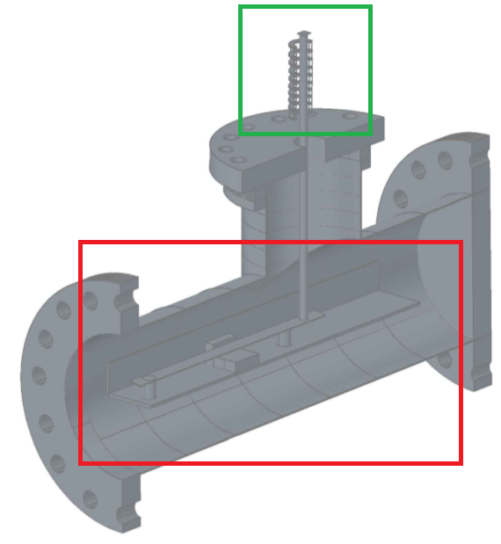

*Figure 1: Interior of the STA.*

For the catalyst activation, two 40 μl crucibles (R: Reference and S: Sample) were charged with 15 mg of catalyst and placed in a support.In Figure 1, the green box delimites the support for both crucibles and the red box indicates the interior balance. With a vacuum pump connected to the gas outlet, the system was brought to a pressure of 2.6 mbar. Once the desired pressure was reached, the equipment was heated with a ramp of 2 °C/min up to 300 °C. At the end of the heating ramp, the vacuum pump was turned off and the hydrogen exit valve in the system was opened. An input flowrate of 0.4 l/min was used until the system cools down to 30-40 °C.

For activation of the catalyst, the metal phase of the catalyst was carried out in the simultaneous thermal analyser before starting the reaction. The procedure was based on the work of Oudenhuijzen et al., who named as self-reduction methodology (Oudenhuijzen et al., 2002). The procedure consists of weighing 20 mg of catalyst in an aluminium crucible of 40 μl and bringing it to the STA-HP, where the sample was subjected to vacuum conditions, and heated with a rate of 2 °C/min up to 300 °C with the purpose of dislodging the water adsorbed in the support. Once the maximum temperature was reached, 1 l/min of hydrogen flowed through the system while it reaches room temperature.

The non-isothermal reaction is initiated once the catalyst is activated. 30 to 40 mg of palm oil were added, and the sample aluminium crucible (S) was capped without sealing. For the sample loading, both crucibles must be covered before placing them again in the equipment. The next step was to press the system up to 5 MPa by means of a hydrogen flow of 20 l/min. When the pressure was reached, a heating ramp of 10 °C/min was used to reach the desired temperature (in this case, 290 °C). At the same time, the hydrogen flow was changed to 0.4 l/min in order to drag any solid that can be retained in the balance.

**2.2.2 Analysis**

Once the test finished, the two crucibles are weighed to know the final mass in each of them. Then, the sample crucible is placed in a tube with 3 ml of n-hexane. To solubilize the sample in the solvent, it was brought to 40 °C with ultrasound for 20 min. Approximately 0.1 g of the sample was taken for analyse the presence of oxygenated compounds (as alcohols, aldehydes, ketones and carboxylic acids) using Fourier-transform infrared spectroscopy (FTIR) with ATR method from 4000 to 500 cm-1 in a *Bruker* Equipment.

10 mg of tricaprine are added to the rest of the sample to perform the respective GC analysis. If some turbidity is observed, centrifugation (6000 rpm for 10 min) and filtration (0.42 μm) were performed. Subsequently, 1 μL of this sample was manually injected into the *Agilent 6820* gas chromatograph (Agilent Technologies Co. Ltd., Shanghai, China). The purpose is to identify and quantify the hydrocarbons produced as linear n-C15 to n-C18 chains, as well as the amount of palm oil to determine conversion. The equipment has a flame ionization detector (FID), a fused silica precolumn (0.3 m x 0.53 mm) and a fused silica capillary column *Supelco* *SGE* HT-5 (12 m x 0.53 mm x 0.15 μm) (SGE International Pty. Ltd., Victoria, Australia). The method used is described as follows: after 1 min, the temperature is stabilized at 140 °C; then, the oven temperature increass from 140 °C with a ramp of 20 °C/min up to 380 °C, and stayed in the latter for 10 min. The temperature of the injector is 350 °C, and in the detector is 390 °C. Each test lasted 23 min. The carrier gas was nitrogen with a flow rate of 6 ml/min and a split of 50:1. The flows of H2 and dry air were 40 and 450 ml/min, respectively. The acquisition and processing of data was achieved with the *Cerity* program (Agilent Technologies Co. Ltd., Shanghai, China). To identify some species, as fatty acids, an MS (mass spectroscopy) detector coupled was used.

* 1. Results

In all the thermograms for heat flow, a first peak was found. It corresponds to the melting point of palm oil. It is endothermic from 35°C until 40°C approximately with a fusion heat near to 80 kJ/mol. Additionally, the second peak is exothermic. The difference lies in the height, area and position (in the evolution of the temperature), which vary according to each catalyst. This peak is attributed to hydrogenation of triglycerides for saturation of double-bonds. A third peak, which was exothermic too and more intense, showed a hydrogenolysis of the saturate triglycerides that generate fatty acids and propane, because the hydrogenation produces rupture. These three peaks were clearly definited in the case of Pd/C and Pt/USY (CBV 780), as shown in Figure 2. Other subsequent peaks, exothermic and relatively small, represented the deoxigenation of the fatty acids for obtaining hydrocarbons. It is unknown whether they correspond to hydrodeoxygenation, decarbonylation or decarboxylation. If subsequent peaks appear at temperatures above 300°C, they could mean the rupture and isomerization of the hydrocarbons generated as indicated by other works (Veriansyah et al., 2012).

*Figure 2:**Thermogram of Heat Flow (DSC) to 50 bar for Pd/C and Pt/USY.*

An increase in weight can be observed at the beginning of the thermograms, because the triglyceride is saturated with hydrogen atoms. After about 200°C, the weight starts to reduce quickly, probably due to propane generation by hydrogenolysis and gasses produced as carbon oxides during the deoxygenation. After 300°C, the sample weight diminishes notoriously (more than 90%) due to the rupture of hydrocarbon fractions into light gases as methane. All the foregoing can be observed in Figure 3 for two cases. However, the described behaviour was like the observed using other catalysts, although the main difference was the delay in each one of the stages of the hydrotreating mechanism.

*Figure 3: Thermogram of mass change (TGA) to 50 bar for Pd/C.*

The GC Analysis showed that the best selectivity (in the global hydrocarbons C-15 up to C-18 and fatty acids) and conversion were obtained with the Pt/USY catalyst (See Figure 4), due to the high acidity of the USY zeolite that favours the hydrogenation process. In contrast, the catalysts supported in alumina produced low conversion, unlike those supported on carbon that have a higher conversion, except for those of Ru (See Table 1). Also, the catalysts supported in alumina had low selectivity, except for the one of Pd that at the same time has the lowest conversion.

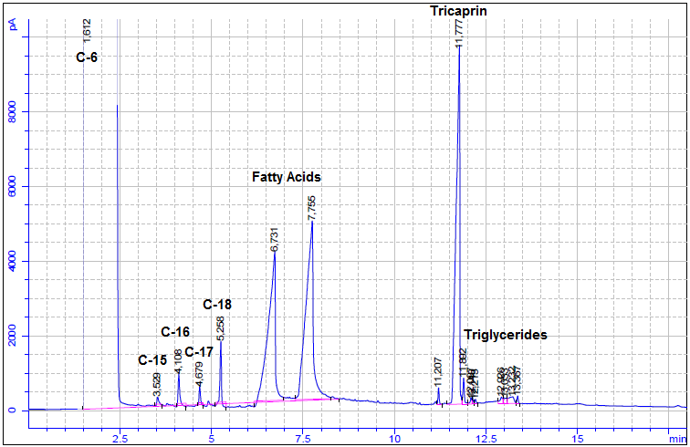

*Figure 4: Chromatogram of Hydrotreating of Palm Oil with 1% Pt/USY (CBV-780).*

The results of FTIR spectroscopy (See Figure 5) showed a region around 1400 to 600 cm-1 with a complex absorption pattern. More emphasis can be done on the region of 4000 to 1400 cm-1 where the hydroxyl, carbonyl and alkene groups can be identified. A noteworthy characteristic was the signal in the area from 1600 to 1300 cm-1, which is typical for the C = C bond, suggesting that the hydrogenation of the double bonds in the structure did not occur completely. As shown in Figure 5, there is a marked elongation in the section from 1600 to1800 cm-1, which is a representative value for the carbonyl group depending on whether it is aldehyde, acid or ester. As the curve presents two signals in this region, this behavior is characteristic of an acid or an ester. When the signal is present between 2400 and 3400 cm-1, it is characteristic for the OH of a carboxylic acid. Otherwise, the strong and sharp signal in the region from 1600-1800 cm-1 represents a C = O bond.

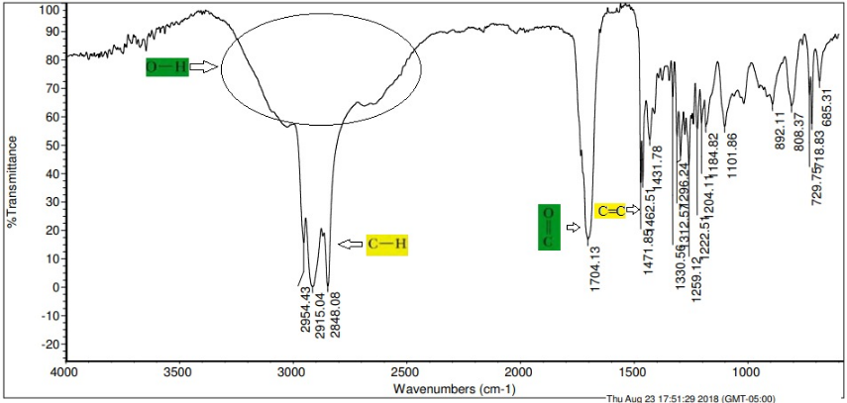

*Figure 5: Infrared spectrum of Hydrotreating of Palm Oil with 1% Pt/USY (CBV-780).*

The selectivity to hydrocarbons can be increased if the fatty acids, intermediate compounds of the process, are transformed to hydrocarbons, which is achieved by continuing the heating process keeping the ramp or by the isotherm for an additional time. In the case of the 5% Pd/C test, the low selectivity to hydrocarbons was probably due to the fact that they were cracked because of all the analysed samples. It was the only one that was carried in the STA up to 459.8 °C. For the sample of 1% Pt/USY two tests were carried out, in one it was also taken up to 459.8 °C but it was not analyzed and another up to 290 °C that was analysed chromatographically and whose result is shown in Table 1. In this table, it can be seen the results obtained for the analysis of all the tests up to 290 °C, except for the 5% Pd/C as mentioned above. The 1% Pt/USY system obtained the best values for conversion, selectivity to hydrocarbons and selectivity to fatty acids. The results obtained by the 5% Rh/C and 5% Pt/C catalysts are also highlighted.

Table 1: Process indicators of each catalyst in the hydrotreatment of Palm Oil

|  |  |  |  |
| --- | --- | --- | --- |
| **Catalyst** | **Conversión**  **(%)** | **Selectivity to (%)** | |
| **Hydrocarbons** | **Fatty Acids** |
| 5% Pd/γ-Al2O3 | 18.70 | 1.94 | 4.35 |
| 5% Pt/γ-Al2O3 | 80.84 | 0.21 | 0.57 |
| 5% Rh/γ-Al2O3 | 73.78 | 0.67 | 0.83 |
| 5% Ru/γ-Al2O3 | 79.67 | 0.71 | 0.54 |
| 5% Pd/C | 84.57 | 0.07 | 3.20 |
| 5% Pt/C | 70.52 | 1.75 | 14.81 |
| 5% Rh/C | 92.69 | 3.58 | 1.74 |
| 5% Ru/C | 29.36 | 3.68 | 17.08 |
| 1% Pt/C | 83.42 | 1.20 | 6.42 |
| 1% Pt/USY (CBV 780) | 98.38 | 3.95 | 32.07 |

* 1. Conclusions

The hydrotreatment of Palm Oil in a STA, at a temperature between 200 °C and 290 °C, showed that most of the changes in both, deoxygenation and hydrogenation, occurred without involving thermal breakage (cracking), achieving carbon chains from n-pentadecane to n-octadecane, and some intermediates as fatty acids. With respect to the catalyst, according to the characterization of the product and the thermograms observed, the most promissory noble catalyst that showed a high conversion and selectivity was 1%Pt/USY (CBV-780).

Acknowledgments

We thank to the Dirección de Investigación y Extensión de la Sede Bogotá and to Vicedecanatura de Investigación y Extensión de la Facultad de Ingeniería, Universidad Nacional de Colombia, for financing and management of the project: “*Producción de biodiésel no éster mediante desoxigenación catalítica de aceite de palma con generación de hidrógeno in situ*", código 37622. We also thank to Laboratorio de Catálisis Heterogenea (LCH), Departamento de Química de la Facultad de Ciencias, for the use of the STA-HP.

References

Aatola, H., Larmi, M., Sarjovaara, T., & Mikkonen, S. (2008). Hydrotreated Vegetable Oil (HVO) as a Renewable Diesel Fuel: Trade-off between NOx, Particulate Emission, and Fuel Consumption of a Heavy Duty Engine. SAE Technical Paper 2008-01-2500. *SAE Technical Papers*, (724). doi: 10.4271/2008-01-2500

Ameen, M., Tazli, M., Yusup, S., & Ramli, A. (2017). Hydroprocessing of Rubber Seed Oil over Ni-Mo/γAl2O3 for the Green Diesel Production, *Chemical Engineering Transactions*, *61*, 1843–1848. doi: 10.3303/CET1761305

Conard Fernelius, W., Audrieth, L. Bailar, J., Johnson, W., Kirk, R., Schumb, W. & Scott, J. (1946). Inorgaic Syntheses. Volume II. McGraw-Hill Book Company, Inc., 1a Edition, 3a Impression, New York. 250-253.

Hanim, N., Yunus, N. A., Hashim, H., & Abu, N. N. (2017). Resource Planning for Sustainable Production of Tailor-Made Green Diesel, *Chemical Engineering Transactions*, *56*, 727–732. doi: 10.3303/CET1756122

Knothe, G. (2010). Biodiesel and renewable diesel: A comparison. *Progress in Energy and Combustion Science*, *36*(3), 364–373. doi: 10.1016/j.pecs.2009.11.004

Lindfors, L. P. (2010). High Quality Transportation Fuels From Renewable Feedstock. In *XXIst World Energy Congress Montreal,* (pp. 1–12). Montreal, Canada. Retrieved from http://www.worldenergy.org/documents/congresspapers/178.pdf

Linseis. (2018). Simultaneous Thermal Analysis - STA (TGA/DSC). Retrieved from http://www.linseis.com/en/our-products/simultaneous-thermogravimetry/

Oudenhuijzen, M. K., Kooyman, P. J., Tappel, B., Van Bokhoven, J. A., & Koningsberger, D. C. (2002). Understanding the influence of the pretreatment procedure on platinum particle size and particle-size distribution for SiO2 impregnated with [Pt2+(NH3)4](NO3−)2: A combination of HRTEM, mass spectrometry, and quick EXAFS. *Journal of Catalysis*, *205*(1), 135–146. doi: 10.1006/jcat.2001.3433

Srifa, A., Faungnawakij, K., Itthibenchapong, V., & Assabumrungrat, S. (2015). Roles of monometallic catalysts in hydrodeoxygenation of palm oil to green diesel. *Chemical Engineering Journal*, *278*, 249-258. doi: 10.1016/j.cej.2014.09.106

Srifa, A., Faungnawakij, K., Itthibenchapong, V., & Viriya-empikul, N. (2014). Production of bio-hydrogenated diesel by catalytic hydrotreating of palm oil over NiMoS2/c-Al2O3 catalys. *BIORESOURCE TECHNOLOGY*, *158*, 81–90. doi: 10.1016/j.biortech.2014.01.100

Veriansyah, B., Young, J., Ki, S., Hong, S., Jun, Y., Sung, J., … Kim, J. (2012). Production of renewable diesel by hydroprocessing of soybean oil : Effect of catalysts. *Fuel*, 94, 578–585. doi: 10.1016/j.fuel.2011.10.057