|  |  |
| --- | --- |
| cetlogo ***CHEMICAL ENGINEERING TRANSACTIONS***  ***VOL. 76, 2019*** | A publication of  aidiclogo_grande |
| The Italian Association  of Chemical Engineering  Online at www.cetjournal.it |
| Guest Editors: Sauro Pierucci, Jiří Jaromír Klemeš, Laura Piazza  Copyright © 2019, AIDIC Servizi S.r.l. **ISBN** 978-88-95608-73-0; **ISSN** 2283-9216 | |

Waste cooking oil for wax esters synthesis using *Candida rugosa* lipase immobilized on Fe3O4@OA nanoparticles

Maria Sarnoa,b\*, Mariagrazia Iulianoa

aDepartment of Industrial Engineering, University of Salerno, via Giovanni Paolo II, 132 - 84084 Fisciano (SA), Italy

bNANO\_MATES Research Centre, University of Salerno, via Giovanni Paolo II, 132 - 84084 Fisciano (SA), Italy

[\*msarno@unisa.it](mailto:*msarno@unisa.it)

**Abstract**

Wax ester is an important skin conditioning agent derived from the esterification of fatty acids with alcohols. It is widely used in cosmetic as it has a composition similar to that of natural skin lipids. This study presents the synthesis of wax esters from hydrolyzed WCO in presence of cetyl alcohol and *Candida rugosa* lipase immobilized on Fe3O4@OA. The effects of the reaction time and cycles of reuse were investigated. The wax ester conversion has been monitored for 24 h. High conversion of ~ 89.3 % was observed already at 12 hours of synthesis. No significant reduction, during four cycles of use, of the lipase activity occurs.

* 1. Introduction

High-molecular weight esters from long-chain alcohols and long-chain acids are typically referred to as wax esters. The worldwide demand for waxes in 2010 was around 4.35 million of ton, including petroleum waxes (85%), synthetic waxes (11%) and animal or vegetable waxes (4%)(Anonymous 2010). Usually, these esters are composed of *n*-alkanoic acids and *n*-alkan-1-ols with a number of carbon atoms ranging from C12–C32 ([Misra et al., 1991](https://www.sciencedirect.com/science/article/pii/S0926669008000691" \l "bib10)). Saturated and unsaturated compounds, which determine the liquidity of the chemicals, constitute the wax esters. The novel characteristics of wax esters have maximized their usage in various industries ([Chen et al., 1997](https://www.sciencedirect.com/science/article/pii/S0926669008000691" \l "bib3); [Hallberg et al., 1999](https://www.sciencedirect.com/science/article/pii/S0926669008000691" \l "bib7)).

Wax esters are fine chemicals, which are produced in low volume but are highly priced with high profit margin, they are widely used as base materials in pharmaceuticals, cosmetics, lubricants, paints, wood coatings and perfumery products (Anonymous 2010; Doan et al., 2017; Petersson et al., 2005). Wax esters are biodegradable, non-toxic and can be prepared by renewable sources such as vegetable oils. In cosmetics, wax esters are formulated in numerous personal care products due to their excellent emollient behavior ([Peter et al., 2001](https://www.sciencedirect.com/science/article/pii/S0926669008000691" \l "bib14)). Jojoba oil and sperm whale oil are natural wax esters that fall within the fine chemicals group. The oil from the jojoba plant has been the main natural source of wax esters for commercial applications since the global ban on whale hunting. However, the main obstacles to large-scale use of jojoba oil are their cost and availability. To start initial seed production, commercial jojoba plantations require up to five years. On the other hand, the high-producing cultivars are only beginning to be available. Thus, attempts to synthesize wax esters with cheaper starting materials and shorter time have become very important ([Poisson et al., 1999](https://www.sciencedirect.com/science/article/pii/S0926669008000691" \l "bib15), [Salis et al., 2003](https://www.sciencedirect.com/science/article/pii/S0926669008000691" \l "bib17), [Radzi et al., 2005](https://www.sciencedirect.com/science/article/pii/S0926669008000691" \l "bib16)).

In this regard, WCOs (waste cooking oils) are inexhaustible renewable raw materials. In the world, indeed, every day large quantities of WCOs are generated by food processing industries, fast foods, restaurants and families. The elimination of WCOs is an environmental challenge, which can be overcome using them for energy (e.g. biodiesel, bio-lubricants production, etc..). In this way, industry can hold the promise of “zero waste” and “green chemistry”, and encourage waste and side-product recycle/utilization by eco-friendly procedures.

The production of wax esters via chemical synthesis has many disadvantages, such as the corrosive acids required, high energy consumption and degradation of synthesized esters. Enzyme based synthesis of wax esters provides a greener route alternative (Nishat et al., 2015; Alves et al., 2016;Lima et al., 2018). In particular, interest in lipase-catalyzed preparations of these long-chain esters has grown due to the possibility of obtaining a wide variety of high-quality products under mild reaction conditions utilizing the substrate selectivity of such biocatalysts. Furthermore, the growing demand for the production of ‘natural’ products using environmentally friendly processes has widened the use of enzymes as biocatalysts, particularly in the modification of lipids ([Steinke et al., 2000](https://www.sciencedirect.com/science/article/pii/S0926669008000691" \l "bib20)).

On other hand, free enzymes present poor stability towards pH, temperature and time and their cost encourage the use of immobilizations to facilitate separation, recovery and enhance activity.

The immobilization of enzymes onto nano-materials is a topic of great interest. Indeed the reduction of the enzyme support size can provide a larger surface area for the attachment, leading to higher loading (Sarno et al., 2018a). In the present study, enzymatic synthesis of wax ester (cetyl ester) from hydrolyzed WCO was carried out for the first time. The effects of the reaction time and stability were investigated.

* 1. Material & Method
     1. Material

WCOs were obtained from soybean oil after a simulated cooking (temperature of 240 °C for 2 h) (Brenes et al., 2002). Ethanol, hexane, benzyl ether (99%), oleic acid (OA), 1,2-hexadecanediol (97%), (90%), iron(III) acetylacetonate (Fe(acac)3) and Cetyl alcohol were purchased from Aldrich Chemical Co. All chemicals were analytical grade.

* + 1. Synthesis of Fe3O4 nanoparticles

Fe3O4 magnetic nanoparticles (Fe3O4@OA) synthesis was carried under nitrogen (Sarno et al., 2015; Sarno et al., 2016; Sarno et al., 2019). 20 mL of benzyl ether, 0.78 g of Fe(acac)3, 2.8 g of 1,2-hexadecanediol, 3.7 g of oleic acid were magnetically stirred from room temperature to 200 °C for 2h and then to 285 °C for 1 h. Washing was obtained by centrifugation (7500 rpm, 30 min) in ethanol and then in an equal volume mixture of hexane and ethanol.

* + 1. Enzyme immobilization

50 mg of Fe3O4@OA were added to 10 ml of 50 mM phosphate buffer pH 7.0 containing 100 µg of *Candida rugosa lipase*. The nanoparticles were then dispersed by sonication (Ultrasonic Cleaning machines CP104) at a fixed frequency of 40 kHz and at 70 W power rating) for 1 min. The mixture was kept at 4 °C with constant shaking at 200 rpm for 5 h. After incubation, the enzyme adsorbed nanoparticles were separated by centrifugation at 5000 g for 10 min at 4 °C. The amount of protein and enzyme activity bound to nanoparticles were calculated by determining the protein and activity in the supernatant (Bradford 1976).

* + 1. Enzymatic synthesis of cetyl esters

Enzymatic hydrolysis for fatty acid (FFA) preparation was conducted in a 250 mL-scale reaction using a mechanically stirred reactor. WCO (10 g), 0.1 M sodium phosphate buffer at pH 7.0 (50 ml) and immobilized CRL (1 % w/w of oil) were incubated at 37 °C for 5 h. After 5 h the fatty acid was recovered using hexane. Finally, the product was purified using a rotary evaporator and the FFA content was determined by the acidity using KOH 0.1 M. The wax ester synthesis was carried out by esterification of fatty acid and cetyl alcohol. The reaction mixture contained 1:1 mol/mol (FFA/cetyl alcohol,) hexane (1 mL) and 10 % of immobilized lipase (immobilized lipase on weight of oil) see Figure 1 for the reaction scheme. The reaction mixture was placed in a screw-capped tube and incubated at 37°C by shaking at 250 rpm and monitored for 24 h. All experiments were done in triplicate.

* + 1. Analytical methods

The [esterification](https://www.sciencedirect.com/topics/biochemistry-genetics-and-molecular-biology/esterification) progress was monitored by determining the residual fatty acid in the reactor. Samples were titrated in triplicate with KOH 0.1 M using alcoholic phenolphthalein solution (95%) as indicator. The percentage conversion was calculated from the amount of acid consumed in the reaction:

|  |  |
| --- | --- |
| $$\text{Conversion (\%)=}\frac{{\text{(FFA}}_{\text{t=0}}\text{-}{\text{FFA}}_{\text{t }}\text{)*100}}{{\text{FFA}}_{\text{t=0}}}\text{ (\%)}$$ | (1) |

where: FFAt=0, were the initial acidity and FFAt the acidity at a time t.

Moreover, the stability of CRL immobilized in repeated uses was investigated. For each use, the reaction conditions were: temperature 37°C, time 12 h. The identification of wax esters in the reaction mixture was carried out by GC-MS using a Thermo Fischer Scientific) by using TraceGOLD™ TG-POLAR capillary column (0.25 µm×0.25 mm×60 m). The oven program was started at 160 °C for 2 min, heated to 270 °C at a ratio of 5 °C/min maintained for 20 min. Injector and detector temperature were set at 250 °C. Helium was used as carrier gas at a flow rate of 1 mL/min.



*Figure 1. Reaction pathway used for cetyl ester production.*

* 1. Results and discussion
     1. Characterizations of catalyst

The morphological and structural characteristics of the NPs were determined by transmission electron microscopy (TEM) analysis. Highly uniform size nanoparticles were formed that, once deposited over a TEM grid, tend to self-organize in a hexagonal layer (Figure 2).



*Figure 2: TEM image of Fe3O4@OA.*

From statistical analysis of about 400 nanoparticles, the particle size distribution was obtained, indicating that the average diameter of inorganic core is d = 6.7 nm with σ = 2.1 nm.



**a**

**b**

*Figure 3: TG-DTG profile of: (a) Fe3O4@OA, OA; (b) Fe3O4@OA@CRL, lipase (CRL) (Sigma Aldrich).*

TG-DTG profiles of OA and Fe3O4@OA NPs after synthesis, are shown in Figure 3a. The weight losses due to OA in Fe3O4@OA were slight shifted to higher temperatures likely due to the bond with the nanoparticles. The amount of OA in samples was about 10 % wt./wt. After the immobilization, the occurrence of the new weight loss at 540 °C suggests the presence of lipase (see Figure 3b).

* + 1. Fatty acid composition of WCO

The fatty acid composition of the WCO is shown in Table 1. The major fatty acids in WCO were 41.53% linoleic acid, 29.38% oleic acid, 18.72% palmitic acid and 5.02% stearic acid. The long chain unsaturated fatty acids are good substrates for the synthesis of liquid wax esters (Shivaraju et al., 2011).

|  |  |
| --- | --- |
| **Property** | Value |
| Acid value (mgKOH/g) | 1.64±0.05 |
| Free fatty acid content (%) | 0.83±0.02 |
| Moisture (%) | 0.02±0.03 |
| Saponification Index (mgKOH/g) | 93±0.04 |
| **Fatty Acids** **composition** | **%** |
| Caprylic acid | 1.08 |
| Myristic acid | 0.15 |
| Palmitic acid | 18.72 |
| Palmitoleic acid | 0.09 |
| Stearic acid | 5.02 |
| Oleic acid | 29.38 |
| Linoleic acid | 41.53 |
| Linolenic acid | 3.63 |
| Other | 0.39 |

*Table 1. Physicochemical properties of WCO. Fatty acid composition of the WCO. Each value represents the mean of three replicates ± SD.*

* + 1. Effect of reaction time in wax ester synthesis

The time course is a good indicator for enzyme performance and reaction progress. It can pinpoint the shortest or the adequate time necessary to obtain good yields and minimize process expenses. The effect of reaction time is presented in Figure 4. The percentage yield for esterification reaction increased with increasing reaction time and gave high percentage yield of 89% within a reaction period of 12 h. The product yield, however, does not increase significantly after 12 h. This may be due to:

1. some mass transfer limitations, which inevitably arise in a reaction mixture containing a high proportion of product;
2. the reactions approach the equilibrium state;
3. the increased water content during reaction. Indeed, the esterification of -OH promotes a water formation, which negatively affects the conversion. Indeed, too high water content retards the reaction rate.

The decrease in the conversion rate with increasing water content may be attributed to the fact that a water may favor the backward hydrolysis reaction resulting in reduced ester conversion rate or it promote enzyme particles aggregation leading to increased diffusional limitation (Sarno et al., 2018b)

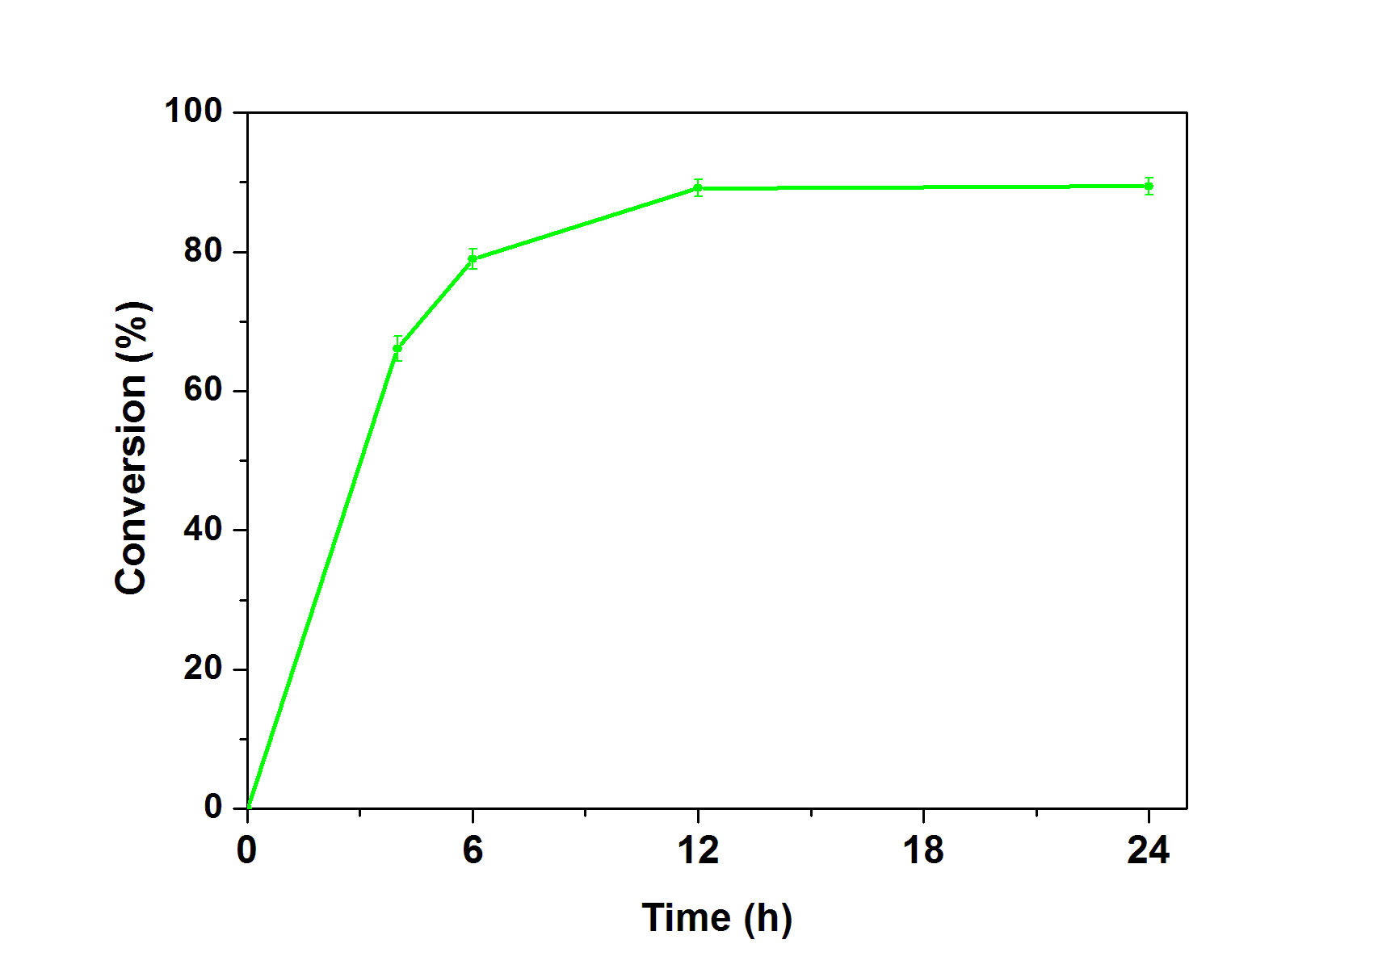

*Figure 4: Effect of reaction time on wax ester synthesis, catalyzed by immobilized CRL, using FFA from the WCO as substrate and cetyl alcohol. Immobilization conditions: coupling temperature, 4 °C; coupling pH, 7; lipase concentration, 10 µg/ml. Synthesis conditions: reaction temperature, 37 °C; lipase concentration, 10 %.*

* + 1. Catalyst reusability

The reusability is also a key factor in wax ester synthesis (see Figure 5). The immobilized CRL retains 91% of the initial activity for the first 4 cycles. As it can be observed in Figure 5, the biocatalyst almost retains its initial activity up to 4 cycles, showing an excellent reusability.



*Figure 5. Reuse of immobilized CRL. Immobilization conditions: coupling temperature, 4 °C; coupling pH, 7; lipase concentration, 10 µg/ml; time, 5 h. Synthesis conditions: reaction temperature, 37 °C; lipase concentration, 10 %, reaction time, 12 h. Each point represents the mean of three experiments ± S.E.*

* 1. Conclusions

The synthesis of cetyl ester, from WCO and cetyl alcohol with immobilized CRL in [hexane](https://www.sciencedirect.com/topics/chemical-engineering/hexane) medium was studied at different times. Cetyl ester production showed the highest conversion yields until 89 % after 12 h using a hexane as medium system. The properties of WCO derived cetyl esters were comparable with the properties of natural waxes. Although, the achieved yields are very high, it is important to evaluate the effect of the water content, which, moreover, increases during synthesis. This issue is under evaluation and will certainly be the subject of a future paper. On the other hand, the results of this paper demonstrate that the production of wax esters from WCO could be incorporated in future bio-refineries where WCOs could be used for the production of biofuels or oleochemicals.

References

Alves M.D., Cren E.C., Mendes A.A., 2016, Kinetic, thermodynamic, optimization and reusability studies for the enzymatic synthesis of a saturated wax ester, Journal of Molecular Catalysis B: Enzymatic, 133,S377-S387.

Anonymous,2010,. Global wax industry 2010: Market analysis and opportunities, Report Y635A

Bradford M.,1976, A rapid and sensitive method for the quantitation of microgram quantities of protein utilizing the principle of protein-dye binding, Analytical Biochemistry ,|72, 248–254.

Chen J.P., Wang J.B., 1997, Wax ester synthesis by lipase-catalyzed esterification with fungal cells immobilized on cellulose biomass support particles, Enzyme and Microbial Technology, 18, 615-622.

Doan C.D., To C.M., De Vrieze M., Lynen F., Danthine S., Brown A., Dewettinck K., Patel A.R., 2017, Chemical profiling of the major components in natural waxes to elucidate their role in liquid oil structuring, Food Chemistry, 214, 717–725.

Hallberg M.L., Wang D., Harrod M., 1999, Enzymatic synthesis of wax esters from rapeseed fatty acid methyl esters and fatty alcohol, Journal of the American Oil Chemists' Society, 76, 183-187.

Lima C.D.L., Peres G.C.D., Mendes A.A., 2018, Kinetic and thermodynamic studies on the enzymatic synthesis of wax ester catalyzed by lipase immobilized on glutaraldehyde-activated rice husk particles, Bioprocess and Biosystems Engineering, 41, 991–1002

Misra S., Ghosh A., 1991, Analysis of epicuticular waxes. In H.F. Linskens, J.F. Jackson (Eds.), Essential Oils and Waxes, Springer-Verlag Berlin Heidelberg, New York, 205-229.

Nishat R.K., Virendra K.R., 2015, Enzyme catalyzed synthesis of cosmetic esters and its intensification: A review, Process Biochemistry, 50, 1793-1806.

Peter T.R., Robert B., 2001, Beeswax through the ages, Personal Care, 10, 27-31

Petersson A.E.V., Gustafsson L.M., Nordblad M., Borjesson P., Mattiasson B., Adlercreutz P., 2005, Wax esters produced by solvent-free energy-efficient enzymatic synthesis and their applicability as wood coatings Green Chemistry, 7, 837-843.

Poisson L. ,  Jan S. ,  Vuillemard J.C. ,  Sarazin C. ,  Séguin J.P. ,  Barbotin J.N. , Ergan F., 1999, Lipase-catalyzed synthesis of waxes from milk fat and oleyl alcohol, Journal of the American Oil Chemists' Society, 76,1017-1021.

Radzi S.M. ,  Basri M. ,  Salleh A.B. ,  Ariff A.B. ,  Mohammad R. ,  Rahman M.B.A., Rahman R.N.Z.A., 2005, Large scale production of liquid wax ester by immobilized lipase Journal of the American Oil Chemists' Society, 54, 203-209

Salis A. ,  Solinas V. , Monduzzi M.,2003, Wax esters synthesis from heavy fraction of sheep milk fat and cetyl alcohol by immobilized lipases, Journal of Molecular Catalysis B: Enzymatic, 21, 167-174

Sarno M., Cirillo C., Ponticorvo E.,Ciambelli P.,2015,[Synthesis and characterization of FLG/Fe3O4 nanohybrid supercapacitor](https://www.scopus.com/record/display.uri?eid=2-s2.0-84946073728&origin=resultslist&sort=plf-f&src=s&sid=5684b22d4e2eab0b89a010321cc86a46&sot=autdocs&sdt=autdocs&sl=17&s=AU-ID%287003388841%29&relpos=41&citeCnt=12&searchTerm=), Chemical Engineering Transactions, 43, 727-732.

Sarno M., Iuliano M., 2018a, Active biocatalyst for biodiesel production from spent coffee ground, Bioresource Technology 266, 431–438.

Sarno M., Iuliano M., 2018b, Optimized procedure for the preparation of an enzymatic nanocatalyst to produce a bio-lubricant from waste cooking oil, Chemical Engineering Journal, in press, DOI: https://doi.org/10.1016/j.cej.2018.10.210

Sarno M., Iuliano M., 2019, Highly active and stable Fe3O4/Au nanoparticles supporting lipase catalyst for biodiesel production from waste tomato, Applied Surface Science, 474, 135-146.

Sarno M., Ponticorvo E., Cirillo C., 2016, High surface area monodispersed Fe3O4 nanoparticles alone and on physical exfoliated graphite for improved supercapacitors, Journal of Physics and Chemistry of Solids, 99, 138-147.

Shivaraju A., Prasad R.B.N., Kanjilal S., 2011, Synthesis of undecenoic acid-based liquid wax esters, European Journal of Lipid Science and Technology, 43, 64–68.

Steinke G., Kirchhoff R., Mukherjee D., 2000, Lipase-catalyzed alcoholysis of crambe oil and camelina oil for the preparation of long-chain esters, Journal of the American Oil Chemists' Society, 361-366.