 CHEMICAL ENGINEERING TRANSACTIONS  VOL. 76, 2019 | A publication of  
The Italian Association
of Chemical Engineering
Online at www.cetjournal.it
Guest Editors: Sauro Pierucci, Jiří Jaromír Klemeš, Laura Piazza
Copyright © 2019, AIDIC Servizi S.r.l.
ISBN 978-88-95608-73-0; ISSN 2283-9216

A new nanocatalyst for the synthesis of isoindolinone
Maria Sarnoª*, Eleonora Ponticorvoª
ª Department of Industrial Engineering and Centre NANO_MATES University of Salerno
Via Giovanni Paolo II ,132 - 84084 Fisciano (SA), Italy
msarno@unisa.it
PtRh nanoparticles were successfully synthesized by one-step chemical strategy, consisting in the thermolysis of a suitable Pt and Rh precursors in organic solvent in the presence of surfactants. This way provides experimental easiness and potential low-cost production. Transmission electron microscopy – Energy dispersive X-ray spectroscopy (TEM-EDS), thermogravimetric analysis coupled with mass spectromery (TG-DTG-MS) and X-ray diffraction (XRD) were employed for characterization. The nanoparticles showed an average diameter of about 1–3 nm. The result of the EDS analysis confirmed a Pt/Rh atomic ratio in line with the percentages of Pt and Rh in the precursors chosen for the synthesis.
The facile synthesis of amidyl radicals used in intramolecular hydroaminations to produce isoindolinones, using a PtRh cathode in a flow system was demonstrated.
  - Introduction
Isoindolinones have been extensively studied in recent years because the isoindolinone skeleton is present in many natural products and synthetic pharmaceuticals with a comprehensive range of biological activities, such as antitumor, anticonvulsant and so on. Some isoindolinone derivatives have been studied as antitumor drug molecules. Considering isoindolinone derivatives applications, several synthetic methodologies have been widely investigated (Csende et al., 2005; Stajer et al., 2005). A lot of isoindolinones synthesis approaches have been developed, which generally fall into two categories (Hunter et al., 2003) or are divided into eight retrosynthetic cuts (Enders et al., 2001). In the first strategy, phthalimides (Kise et al., 2013) or phthalimidines (Ali et al., 2014) are directly used as starting materials. The second approach is the creation of the lactam ring through many cyclization reactions of functionalized aromatic compounds.
Despite many traditional methods have been efficaciously applied to prepare isoindolinones and enrich the structural diversity as well as the structure-activity relationship, the development of convenient and practical synthetic methods for these compounds continues to remain an active area of research.
Organic electrochemistry is a powerful method for organic synthesis. Anionic and cationic radical species can be formed from neutral organic molecules generating a wide variety of useful reactive intermediates (Horn et al., 2016). As smaller amounts of chemicals are necessary for these reactions, fewer side products are formed.
However there are relevant limitations for electrochemistry in the traditional batch processes: as common organic solvents have typically low conductivity, the use and subsequent removal of supporting electrolytes is necessary, furthermore the large distance between electrodes leads to large current gradients. To overcame these problems, continuous flow reactors can represent an interesting choice (Yang et al., 2012), and it is an example of process intensification, making processes less costly and enabling easier purification: small electrode distances avoid the current gradients and the reactions can be performed with minor amounts or without addition of supporting electrolytes, a high electrode surface-to-reactor volume ratio allows a much improved mass transfer on the surface of the electrodes leading to milder reaction conditions and short reaction times.
Hydroxide generation during electrolysis, as a result of H₂O reduction at the cathode (Sarno et al., 2015a), was found to be the key step during carbamate deprotonation process. Moreover, at the best of our knowledge, a study aimed at the optimization of this step and the design of cathode materials capable of exploiting at best the possibility of anionic radicals to favor the formation of nitrogen radicals, has not yet been carried out.
Amongst noble metals, rhodium can be regarded as an excellent material, being at the top of Trasatti’s volcano plot (Quaino et al., 2014) and because of its oxophilic nature which can provide a lower onset potential (Gurau et al., 1998).
Furthermore, the presence of Rh into the Pt lattice induces the up-shifting of the metal d-band center and increasing repulsive interaction, whereas hydroxide species easily adsorbe on this metal and further improve formation of nitrogen radicals (Van Santen et al., 1990).
Here, in order to exploit the Pt and Rh alloy activity, for the first time, we propose PtRh alloy nanoparticles for facile synthesis of amidyl radicals used in intramolecular hydroaminations to produce isoindolinones. The combination with on-line mass spectrometry has facilitated a much easier evaluation of the chemical steps in a single flow process. A flow reaction in an optimized reactor was performed for 1.2 h leading to 97% yield. Transmission Electron Microscopy (TEM), Thermogravimetric analysis coupled with Mass Spectrometry (TG-DTG-MS) and X-ray diffraction (XRD) were employed for the synthesized nanomaterial characterization.
  - Experimental
PtRh NPs were obtained in 1-octadecene using 1-2 hexadecanediol as reducing agent and oleylamine and oleic acid as surfactants (Chen et al., 2004) by thermal decomposition of platinum(II) acetylacetonate and rhodium(III) nitrate hydrate under N₂ flow. In particular, 0.2 mmol of Pt(C₅H₇O₂)₂ and 0.3 mmol of Rh(NO₃)₃×H₂O were mixed with 15 mL of 1-octadecene, 10 mmol of 1,2-hexadecanediol, 6 mmol of oleylamine and 6 mmol of oleic acid (Sarno et al., 2015b, Sarno et al., 2016). Oleylamine was used not only as a surfactant but also as stabilizer and mild reducing agent, being able to donate electrons at high temperatures (Mourdikoudis et al., 2013).
Figure 1. TG of PtRh sample obtained after the thermal treatment; thermal treatment conditions: 150 °C for 8 h, the sample was heated to the target temperature with a heating rate of 10 °C/min under the continuous flow of air
The mixture was heated to 220 °C for 120 min and then further heated to reflux (~300 °C) for 80 min. Moreover, for comparison, Pt NPs were also prepared with the same procedure by using only platinum(II) acetylacetonate as precursor. The organic chains covering the synthesized samples have the double function of stabilizing and preventing nanostructures aggregation, they yet exhibit a resistive behaviour (Sarno et al., 2019). Therefore, in order to reduce the chains amount PtRh underwent a thermal treatment under air flow, from room temperature up to 150 °C at 10 K/min for 8 h, which allowed the reduction of about 75 wt% of organic chains amount (Sarno et al., 2018a), the TG analysis of PtRh sample after the thermal treatment is shown in Figure 1.

The characterization was obtained by the combined use of different techniques. Scanning electron microscopy (SEM) images were obtained with a LEO 1525 microscope. XRD measurements were performed with a Bruker D8 X-ray diffractometer using CuKα radiation. Electrochemical experiments were carried out by means of an Autolab PGSTAT302N potentiostat equipped with a FRA32M frequency response analyzer module. H NMR and 13C NMR spectra were measured on Bruker DPX 300, 400 or 500 apparatus and were referenced to the residual proton solvent peak (H: CDCl₃, δ7.26ppm; DMSO-d₆, δ2.54 ppm) and solvent 13C signal (CDCl₃, δ77.2ppm, DMSO-d₆, δ39.5ppm).
For the electrochemical measurements 4 mg of catalyst were dispersed in 80 μl of 5 wt. % Nafion solution to form a homogeneous ink. To perform the cyclization of carbamate (see Scheme 1) NBu₄BF₄ (0.1 M) is used as supporting electrolyte and 1.5 equivalents of TEMPO were included.

Scheme 1. Carbamate cyclization
Carbamate 1 was selected as the model substrate and submitted to electrochemical amino-oxygenation. The standard reaction was run at a constant current in a three-necked round-bottom flask.
A flow electrochemical configuration was used, see Scheme 2. A continuous flow of electrolyte was provided by a peristaltic pump (DropSens Peristaltic Pump with 12 roller pump), polyethylene tubes (0.2 mm of diameter) were used for the electrolyte cycle from a vessel to the electrochemical reactor. The electrochemical reactions were carried out in a galvanostatic mode. The in-line gas analysis was carried out using a mass spectrometer. The device comprises a micro-flow electrochemical reactor made out of two aluminium bodies. The bodies have a square space in the centre (20x20 mm², different deepness), where the electrodes are placed. The easy connection of the electrodes and the inlet/outlet of the reaction solution to the reactor is guaranteed by customized holes in the reactor plates.

Scheme 2. Electrochemical flow process for carbamate cyclization
  - Results and discussion
Figure 2 shows the X-ray patterns of PtRh nanocomposite. The X-ray diffraction pattern clearly evidences a slight up-shift of the peaks of pure Pt owing to the alloy formation. This phenomenon is due to the lattice contraction caused by the incorporation of Rh into the Pt lattice, which subsequently implies the purity of the formed PtRh alloy without undesired phases (Sarno et al., 2018b). The peaks lie between both of pure fcc Pt (JCPDS: 04-0802) and pure fcc Rh (JCPDS: 05-0685) at 2θ: 40.4°, 46.8°, 68.5° and 82.1°.
The morphological and structural characteristics of the samples were determined by transmission electron microscopy (TEM). TEM images (Figure 2) at different magnifications (scale bars: 50 and 10 nm) show the formation of very small nanoparticles with an average diameter of about 1–3 nm. The result of the EDS analysis confirmed a Pt/Rh atomic ratio in line with the percentages of Pt and Rh in the precursors chosen for the synthesis.
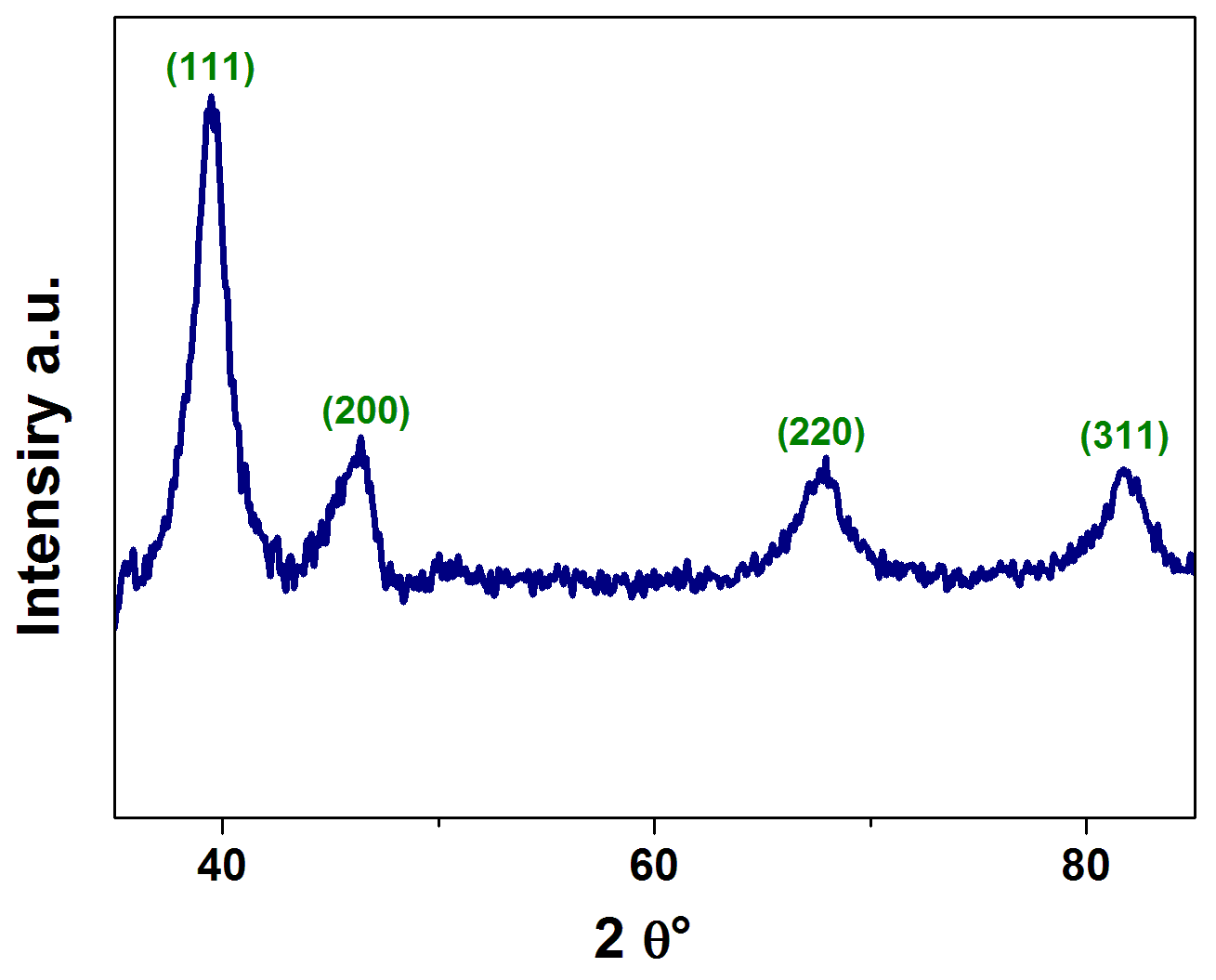
Figure 2. XRD spectrum of PtRh nanocomposite
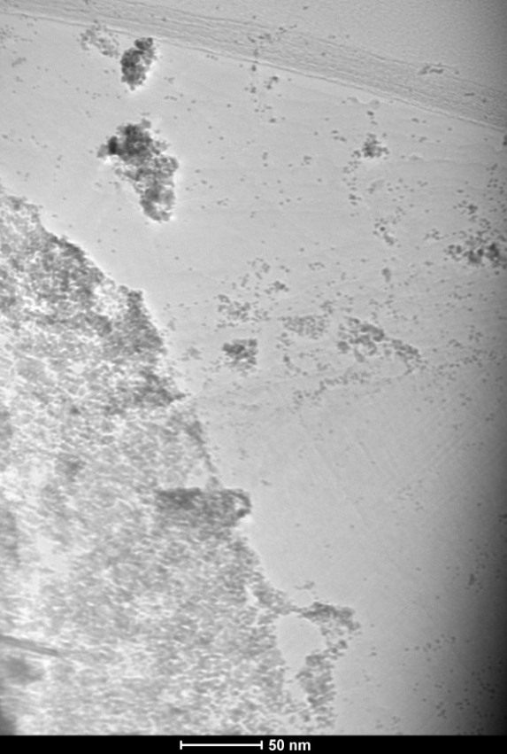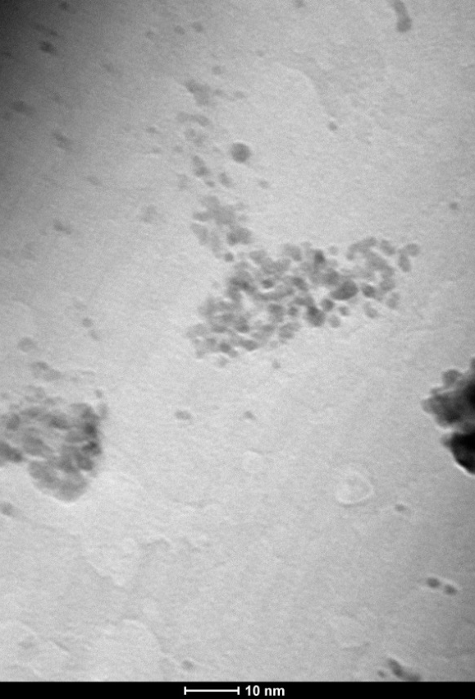

Figure 3. TEM images of PtRh nanocomposite at different magnifications
The cyclization to isoindolinone was easily investigated by the help of an on-line mass spectrometer (MS) analysis, which allow contemporaneous evolution of the reaction media and of the Farad per mole required. For this purpose, the electrochemical cell was connected to an on-line MS, see Scheme 2, permitting to monitor the required amount of electrons.
The electrochemical synthesis was performed with different cathodes and anodes. The results show that by using a platinum cathode, the reaction proceeds in presence of different anode materials. On the other hand, different cathodes materials lead to different results. It is worth noticing that, although the theory requires only 1 Fmol⁻¹ of electricity for the oxidation of one electron, even with 4 Fmol⁻¹ the reaction did not go to completion with Pt cathode (see Figure 3). This is true for the PtRh electrode, which shows a complete conversion at 4 Fmol⁻¹. Thus, the materials of cathode largely impact the reaction more than the working electrode (anode). This can be attributed to the water reduction reaction occurring at the cathode, i.e. to the different activation overpotential for hydrogen evolution on different electrode materials (Washburn, 1926). Indeed, the activation overpotential is lower for PtRh (0.001 V) than for Pt (0.02 V).
During anodic oxidation, bases can be used to favour compounds or its oxides deprotonation, this is because of most anodic oxidations proceed through the loss of electrons and protons. Different organic bases were investigated in the flow cyclizations (Figure 4). Triethylamine inhibited the reaction while with 2,6-lutidine conversions similar to those without base were observed. To accelerate the reaction, benzyltrimethylammonium hydroxide was used. Cyclic voltammetry, not shown here, confirmed this result, as the cyclic voltammogram in the presence of benzyltrimethylammonium hydroxide shows a lower oxidation potential (from 1.65 V to 0.18 V, vs. SCE). The oxidation potential of triethylamine is much lower than of 1, so it will be oxidized first, and the starting material remains unreacted. The oxidation potential of 1 after addition of 2,6-lutidine remains practically unchanged.

Figure 3. Conversion obtained with Pt and PtRh electrode at 4 Fmol⁻¹
Figure 4. Base screening
It was found that to complete the reaction only 0.5 equiv of base are needed, while complete conversion was not achieved with smaller base loading. It is worth noting the lower amount of base required for the flow system if compared with batch conditions, while the base can be easily removed through aqueous work-up.
  - Conclusions
In this paper, in order to improve the hydro-hydroxide generation during electrolysis for carbamate deprotonation process, PtRh nanocatalyst, by an efficient and facile one pot synthesis process, was prepared. The formation of an alloy consisting of Pt and Rh was confirmed by XRD analysis. TEM analysis showed the formation of very small nanoparticles with an average diameter of about 1–3 nm. The result of the EDS analysis confirmed a Pt/Rh atomic ratio in line with the percentages of Pt and Rh in the precursors chosen for the synthesis. Complete conversion to isoindolinone was found at 4 Fmol⁻¹ with the prepared catalyst, which works better than Pt cathode. The role of the base was also explored and elucidated.
References
Ali I. A. I., 2014, Synthesis of 3-substituted N-allylisoindolinone derivatives by the acetate method, Monatshefte für Chemie, 145, 803–810.
Chen M., Liu J.P., Sun S., 2004, One-step synthesis of FePt nanoparticles with tunable size, Journal of the American Chemical Society, 126, 8394–8395.
Csende F., Stajer G., 2005, Approaches to the Formation of Condensed Isoindolones, Current Organic Chemistry, 9, 1261–1276.
Enders D., Braig V., Raabe G., 2001, Asymmetric synthesis of 3-aryl-substituted 2,3-dihydro-1H-isoindol-1-ones, Canadian Journal of Chemistry, 79, 1528–1535.
G. Yang, W. Zhang, 2012, Regioselective Pd-Catalyzed Aerobic Aza-Wacker Cyclization for Preparation of Isoindolinones and Isoquinolin-1(2H)-ones, Organic Letters, 14, 268-271.
Gurau B., Viswanathan R., Liu R., Lafrenz T.J., Ley K.L., Smotkin E.S., 1998, Structural and electrochemical characterization of binary, ternary, and quaternary platinum alloy catalysts for methanol electro-oxidation, Journal of Physical Chemistry B, 102, 9997–10003.
Horn E. J., Rosen B. R., Baran P. S., 2016, Synthetic Organic Electrochemistry: An Enabling and Innately Sustainable Method, ACS Central Science, 2, 302–308.
Hunter R., Richards P., 2003, Stereoselective tetrapyrido[2,1-a]isoindolone synthesis via carbanionic and radical intermediates: a model study for the Tacaman alkaloid D/E ring fusion, Organic & Biomolecular Chemistry, 1, 2348–2356.
Kise N., Kawano Y., Sakurai T., 2013, Reductive Coupling of Phthalimides with Ketones and Aldehydes by Low-Valent Titanium: One-Pot Synthesis of Alkylideneisoindolin-1-ones, The Journal of Organic Chemistry, 78, 12453–12459.
Mourdikoudis S., Liz-Marzán L.M., 2013, Oleylamine in nanoparticle synthesis, Chemistry of Materials, 25, 1465–1476.
Quaino P., Juarez F., Santos E., Schmickler W., 2014, Volcano plots in hydrogen electrocatalysis – uses and abuses, Beilstein Journal of Nanotechnology, 5, 846–854.
Sarno M., Cirillo C., Ponticorvo E., Ciambelli P., 2015a, Synthesis and Characterization of Mo₂C/MoO₃ Nanohybrid as Electrocatalyst for Hydrogen Evolution Reaction, Chemical Engineering Transactions, 43, 943–948 DOI: 10.3303/CET1543158
Sarno M., Cirillo C., Ponticorvo E., Ciambelli P., 2015b, Synthesis and Characterization of FLG/Fe₃O₄ Nanohybrid Supercapacitor, Chemical Engineering Transactions, 43, 272–735 DOI: 10.3303/CET1543122
Sarno M., Ponticorvo E., 2018a, Continuous flow HER and MOR evaluation of a new Pt/Pd/Co nano electrocatalyst, Applied Surface Science, 459, 105–113.
Sarno M., Ponticorvo E., 2019, High hydrogen production rate on RuS₂@MoS₂ hybrid nanocatalyst by PEM electrolysis, International Journal of Hydrogen Energy, 44, 4398–4405.
Sarno M., Ponticorvo E., Cirillo C., Ciambelli P., 2016, Magnetic Nanoparticles for PAHs Solid Phase Extraction, Chemical Engineering Transactions, 47, 313-318 DOI: 10.3303/CET1647053
Sarno M., Ponticorvo E., Scarpa D., 2018b, PtRh and PtRh/MoS₂ nano-electrocatalysts for methanol oxidation and hydrogen evolution reactions, Chemical Engineering Journal, in press DOI: 10.1016/j.cej.2018.12.060.
Stajer G., Csende F., 2005, Advanced Methods for the Synthesis of 3-Substituted 1H-Isoindol-1-Ones, Current Organic Chemistry, 9, 1277–1286.
Van Santen R.A., De Koster A., Koerts T., 1990, The quantum chemical basis of the Fischer-Tropsch reaction, Catalysis Letters, 7, 1–14.
Washburn E. W., 1926, International Critical Tables of Numerical Data, Physics, Chemistry and Technology, National Academy of Sciences, McGraw Hill, New York.

