|  |  |
| --- | --- |
| cetlogo ***CHEMICAL ENGINEERING TRANSACTIONS***  ***VOL. 76, 2019*** | A publication of  aidiclogo_grande |
| The Italian Association  of Chemical Engineering  Online at www.aidic.it/cet |
| Guest Editors: Sauro Pierucci, Jiří Jaromír Klemeš, Laura Piazza  Copyright © 2019, AIDIC Servizi S.r.l. **ISBN** 978-88-95608-73-0; **ISSN** 2283-9216 | |

A Study on Production of Biodiesel from Waste Frying Oil

Jéssica S.A. Costa\*, Oscar J. C. Ariza, Luciana B. Lima

Estácio de Sá University, Rio de Janeiro-RJ, Brazil

jessica.eng.pet@gmail.com

Biodiesel is a highly effective fuel with the same efficiency such as diesel oil derivative only accompanied by moderate engine modifications. This type of biofuel can be obtained from renewable sources such as vegetable, animal or frying oils. In this context, waste frying oils transesterification was studied to obtain the maximum value of biodiesel. Transesterification reactions were carried out between 70 to 90 min using waste frying oils (WFOs), methanol, and sodium hydroxide as catalyst. In order to determine the best conditions for biodiesel production, a series of experiments were carried out, using catalyst percent and temperatures in a range of 0.16 to 1.84% and 40 to 90°C, respectively. The highest biodiesel production was obtained using catalyst percent, temperature and reaction time of 0.5%, 80°C and 90 min, respectively. By statistical experimental design was possible to determine a mathematical model to predict the best operational conditions to maximize biodiesel production.

* 1. Introduction

In Brazil, the main raw material used for the biodiesel process is soybean. According to Ministry of Agriculture soybean production has been exceeded 82 million tons which could lead Brazil to be largest producer of biodiesel in the world (Silva et al., 2018). However, many negative factors have been interfered to increase the production such as large land for planting and its impact with the food industry. Therefore, other raw material alternatives have gained prominence as frying oil (Silva Filho et al, 2018). This type of residue has excellent technical characteristics such as low economical value, easy storage, many pre-treatment processes with same biodiesel production scheme from soybean oil. Daily, waste frying oil are discarded, almost totally in sanitary sewers without control water pollution and this generate an impact environmental. Moreover, the waste oil causes a reduction in the diameter of ducts due to solidification and sewer obstruction.

In cases when is discarded in landfill reaches the water table, water resources, rivers, streams and dams. Studies has reported for one litter of waste frying oil can contaminate about 25,000 litters of water (Bimendra et al., 2017). According to Da Silva et al., (2017), in Brazil about 2 % of waste frying oil is collected, that is, 98% of this material is irregularly discarded in sewerage. Several governmental entities with private companies are organized to incentive for waste frying oil collection programs from the Brazilian population.

For this reason, in this work is study the operational variables effects to aim biodiesel production from waste frying oil by experimental methodology.

* 1. Materials and experimental methodology

Waste Frying oil samples were obtained from a local restaurant at Rio de Janeiro City. The experimental procedure was carried out in three stages: pre-treatment, physicochemical characterization and transesterification reaction.

* + 1. **Pre-treatment**

Samples has contained several contaminants such as water, free fatty acids, particulates and phospholipids. First, sample were dried and filtered to eliminate water and solid particulates. After that, free fatty acid (FFA) were measured by acid-base titration as number of potassium hydroxide (KOH) milligrams required to neutralize the FFA present in 1 g of sample. Finally, density of samples were calculated.

* + 1. **Transesterification reaction**

The effect of catalyst, temperature and reaction time and their quadratic and cubic interactions on the yield of biodiesel and glycerine of waste frying oil samples has been investigated. The catalyst percentage, temperature and reaction time were carried out in the range of 0.5 – 1.0 % w, 50 – 80 °C and 70 – 90 min, respectively. Table 1 shows the experimental statistical planning with the process variables. The statistical software STATISTICA 7 from Statsoft Inc was used to create the design matrix.

Table 1: Design matrix with independent process variables

|  |  |  |  |
| --- | --- | --- | --- |
| Experiment | Catalyst (%w) | Temperature (°C) | Time(min) |
| 1  2  3  4  5  6  7  8  9  10  11  12  13  14  15  16  17 | 0,5  0,5  0,5  0,5  1,5  1,5  1,5  1,5  0,16  1,84  1  1  1  1  1  1  1 | 50  50  80  80  50  50  80  80  65  65  40  90  65  65  65  65  65 | 70  90  70  90  70  90  70  90  80  80  80  80  63  97  80  80  80 |

For each experiment 300 ml of oil and 60 ml of methanol anhydrous (high purity) were used. Moreover, catalyst and methanol were mixed. The percentage of catalyst is proportional to grams of 300 ml of oil. In the other hand, alcohol and catalyst mixture was carried out at 50 ° C in a closed Erlenmeyer flask prior to mix with the oil. After the oil was heated to desire temperature, alcohol and catalyst mixture were added to flask on the reaction time according to experimental statistical planning. Finally, transesterification product was transferred to separatory funnel about 24 hours until form two phases (Figure 1). Biodiesel and glycerin from each experiment were collected and weighed.

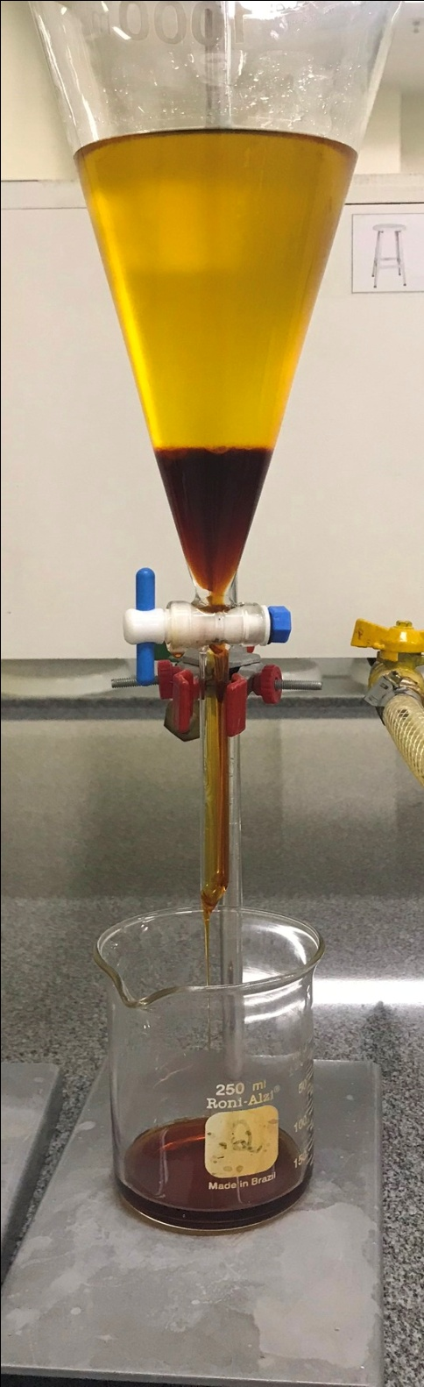 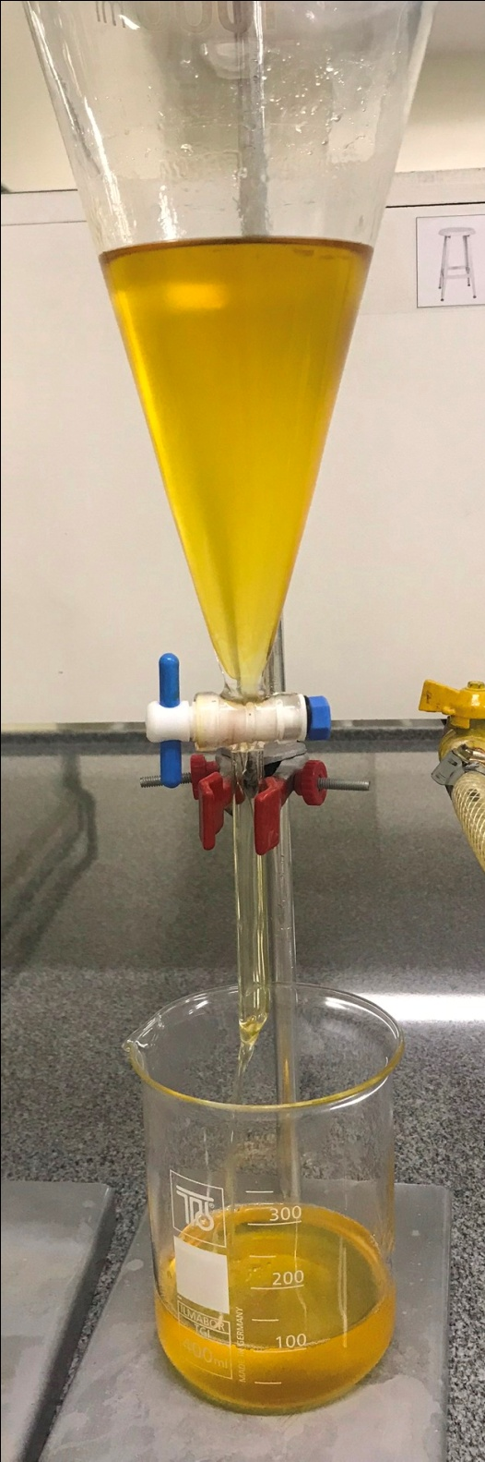

1. *(b)*

*Figure 1: transesterification reaction products: (a) glycerine phases; (b) biodiesel.*

* 1. Results and discussion

The analysis of statistical design of experiment to identify the significant variables was performed by Statistica 7.0 ® software. The linear and quadratic effect of the temperature as well as the quadratic effects of the catalyst and time was most significant at a 95% confidence level. The linear effect of the catalyst and the combination between Temperature and catalyst are not significant. Table 2 shows the results of density, yield of biodiesel and glycerin of the waste frying oil transesterification reaction.

*Table 2: Density, yield of biodiesel and glycerin of the waste frying oil transesterification reaction*

|  |  |  |  |
| --- | --- | --- | --- |
| Experiment | Biodiesel (% w) | Glycerine (% w) | Density (g / ml) |
| 1  2  3  4  5  6  7  8  9  10  11  12  13  14  15  16  17 | 9,87  9,54  60,23  98,43  14,61  9,83  79,76  78,62  13,47  16,46  10,25  61,86  14,59  10,07  11,63  8,97  11,49 | 90,20  91,39  40,60  13,60  87,24  91,41  30,39  30,98  88,34  85,58  90,43  40,95  87,20  90,89  89,87  92,21  90,03 | 0,870  0,860  0,970  0,960  0,880  0,880  0,940  0,930  0,880  0,900  0,850  0,970  0,900  0,880  0,870  0,870  0,870 |

Figure 2 shows the results of response surface as a function of most significant term to biodiesel and glycerine, respectively.

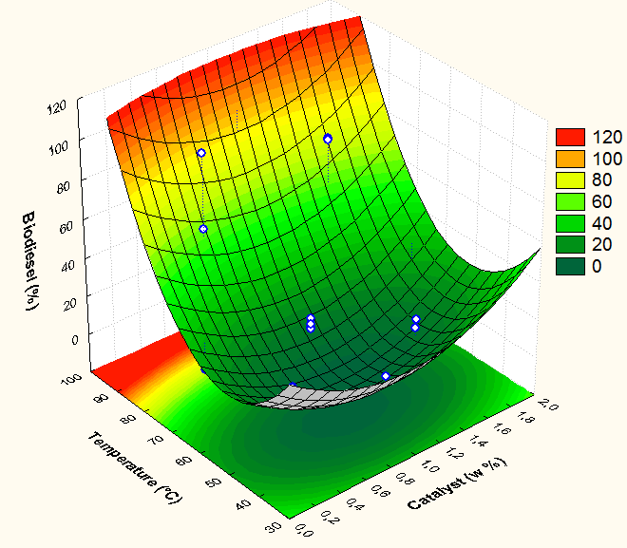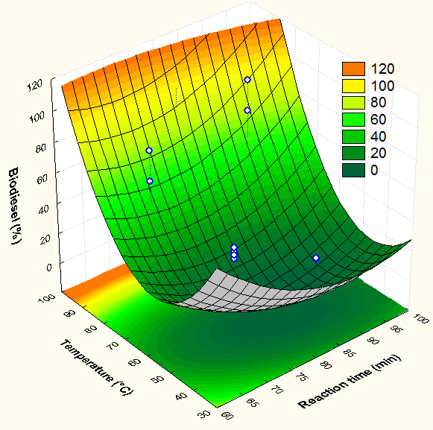

1. (b)

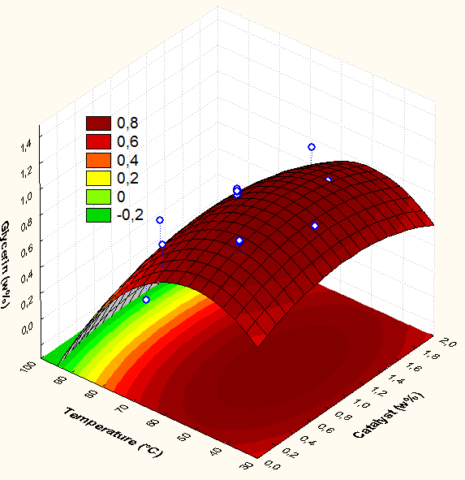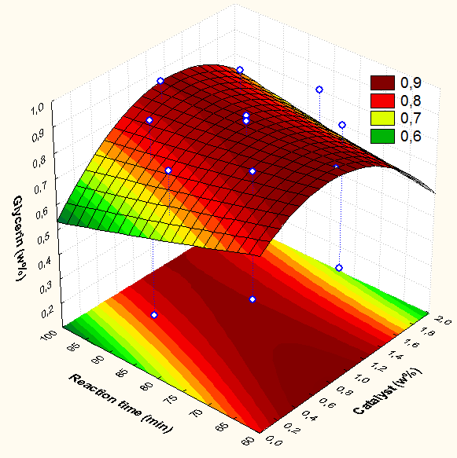

(c) (d)

*Figure 2: Response surface for biodiesel and glycerin (wt %) of waste frying oil transesterification reaction: (a) biodiesel yield: temperature vs catalyst; (b) biodiesel yield: temperature vs reaction time; (c) glycerin yield: temperature vs catalyst; (d) glycerin yield: reaction time vs catalyst.*

According to statistic results, the linear effect of catalyst percent is not significant. In order to optimize the biodiesel production, the reaction must be operated in a range of temperature of 60 - 90 °C. In other hand, maximum glycerin production could be obtained at 50 °C and 1 w% of catalyst. moreover, from Figure 2(d), it is observed that the response surface reaches its maximum point (optimum) in a combination of catalyst in a range between 0.6-1.0 wt% with reaction time about 60-70 min.

Linear and quadratic terms of temperature (T) and time (t), quadratic term of catalyst (C) percent and two-factor interaction of catalyst/time and temperature/time are significant effects for biodiesel yield model (%Cbiodiesel). In addition, linear and quadratic terms of temperature (T), quadratic terms of catalyst (C) percent and reaction time, two-factor interaction of catalyst/time and time/temperature are significant effects for glycerin yield model (%Cglycerin). Table 3 shows the final mathematical models in terms of coded factors by statistical design of experiment with a confidence interval of 95 %. Adjusted R-squared (R2) for the biodiesel and glycerine models shows in the table below was 0.79713 and 0.79052, respectively.

Table 3: Mathematical models for biodiesel and glycerin yield (wt%) waste frying oil transesterification reaction

|  |  |  |
| --- | --- | --- |
| Response term | Mathematical model | Equation number |
| Biodiesel (wt%) | $$\%C_{biodiesel}=673,0705+29,4030C^{2}-9,5136T+0,0651T^{2}-10,5139t+0,0570t^{2}-0,7206C∙t+0,0351T∙t$$ | (1) |
| Glycerin (wt%) |  | (2) |

* 1. Conclusions

The study of the transesterification reaction with base catalysis was performed by 17 experiments with different operational variables (temperature, catalyst percent and reaction time). The highest biodiesel production was obtained using catalyst percent, temperature and reaction time of 0.5%, 80°C and 90 min, respectively. By statistical experimental design was possible to determine a mathematical model to predict the best operational conditions to maximize biodiesel production. In this analysis, higher production of glycerin (about 1.2 wt%) could be obtain in a temperature and catalyst percent of 50 °C and 1 wt%, respectively. Finally, the developed mathematical models are accurate as the percentages of error in prediction are in good agreement.

**References**

Bimendra U., Bandara J., 2017, Fabrication of highly hydrophilic filter using natural and hydrothermally treated mica nanoparticles for efficient waste oi-water separation, Journal of environmental management, 191, 96-104.

Da Silva A., Werderits D. E., Leal G., Silva R. C., 2017, The potential of waste cooking oil as supply for the Brazilian biodiesel chain, Renewable and sustainable energy reviews, 72, 246-253.

KNOTHE, G. et al. Biodiesel Manual. São Paulo, Brazil: Edgard Blucher Ltda., 2006.

LORA, E. E. S.; VENTURINI, O. J. Biofuels. Rio de janeiro, Brazil: INTERCIÊNCIA, 2012.

MAIA, R. R. da S. Biodiesel in Brazil: Cost-benefit analysis. Curitiba, Brazil: Editora e Livraria Appris Ltda.2015.

PINTO, L. F. R. Microalga growth study Desmodesmus sp. aiming at the production of biodiesel CAMPINAS. 2014. 139 p. Tese (CHEMICAL ENGINEERING) — CAMPINAS STATE UNIVERSITY, Campinas, Brazil.

ROSA, A. V. D. Renewable Energy Processes. Rio de Janeiro, Brazil: ELSEVIER, 2013.

Silva A., Conejero M. A., Barros E. C., Batalha M.O., 2018, Competitiveness analysis of “social soybeans” in biodiesel production in Brazil, Renewable Energy, 1147-1157.

Silva Filho S. C., Carvalho A. C., Farias T. A., Araújo F., Rodrigues R., Curvelo J. C., Basile E., 2018, Environmental and techno-economic considerations on biodiesel production from waste frying oil in São Paulo City, Journal of cleaner production, 183, 1034-1042.

UBRABIO. Biodiesel in Focus - ENERGY TO COMBAT CLIMATE CHANGE. Brasília, Brazil: UBRABIO, 2016.