CHEMICAL ENGINEERING TRANSACTIONS  VOL. 76, 2019 | A publication of
The Italian Association
of Chemical Engineering
Online at www.cetjournal.it
Guest Editors: Sauro Pierucci, Jiří Jaromír Klemeš, Laura Piazza
Copyright © 2019, AIDIC Servizi S.r.l.
ISBN 978-88-95608-73-0; ISSN 2283-9216

Framework for sustainable management of agricultural by-product valorization.
Jean-Pierre BELAUD^{a*}, Nancy PRIOUX^{b}, Claire VIALLE^{b}, Patrice BUCHE^{c}, Sébastien DESTERCKE^{d}, Abdellatif BARAKAT^{e} and Caroline SABLAYROLLES^{b}
ªLaboratoire de Génie Chimique, Université de Toulouse, CNRS, INPT, Toulouse, France;
^{b} Laboratoire de Chimie Agro-industrielle, Université de Toulouse, INRA, INPT, Toulouse, France;
^{c}LIRMM GraphIK, INRA, UMR Ingn Agropolymeres & Technol Emergentes 1208, Montpellier, France;
^{d}CNRS UMR Heudyasic, rue Personne de Roberval, F-60200 Compiègne, France
^{e}INRA, UMR Ingn Agropolymeres & Technol Emergentes 1208, Montpellier, France
jeanpierre.belaud@ensiacet.fr

With the increase of the world population, waste production and its impact on the environment increase. Wastes can be an opportunity for the development of a circular economy and an industrial ecology. This paper proposes a framework based on KE, sustainability engineering and life cycle thinking for supporting decisions on agricultural by-product valorization dedicated to engineers, academics, managers and policy decision makers. Five steps describe the framework: the definition of the goal and the scope, the extraction of the relevant information from heterogeneous data source feeding ontologies, the life cycle inventory, the impact calculation assessment and the results ranking. A case study related to agricultural by-product valorization, in the biorefinery area, allows to validate the approach and the associated framework. Rice straw is transformed in glucose for bio-carburant production. Four different rice straw pretreatment processes are analyzed using a collection of data sources. The framework calculates sustainability indicators and allows to ranking the four technologies of case study supply chain.
Introduction and background
Each year, agriculture generates 700 million tonnes of waste in Europe (A. Pavwelczyk, 2005). With the increase of the world population, this number increases. This augmentation of the waste production creates an increase of its environmental impacts. However, a part of this agricultural waste consists in lignocellulosic by-products which can be transformed into bio-energy, biomolecules or biomaterials. A solution to reduce the agricultural waste is to transform these lignocellulosic by-products thanks to sustainable process operations. The assessment of the sustainability is now integrated to more and more agrifood process (Raymond, 2012). The sustainable development for the agricultural by-product valorization must be economically efficient, socially fair and environmentally sustainable like every sustainable development. A new business model appeared recently – the circular economy- to lead to a more sustainable development (Belaud et al., 2017). It contributes to the reconciliation of the environmental, economic and social aspects of sustainability. To help this reconciliation, it is possible to use the Life Cycle Thinking (LCT) which considers the full life cycle of the agriculture supply chain. This thinking is used in the Life Cycle Assessment (LCA) method to evaluate the potential environmental impact of a product or service over its entire life cycle (ISO 14040:2006). The LCA can therefore be used to decrease the environmental impacts of non-food agro-processes (Gillani et al, 2013) and waste management systems.

The LCA is a normed method containing four steps: the goal and scope, the life cycle inventory, the life cycle inventory assessment and the analysis of the results. The life cycle inventory (LCI) is a listing of the amount of pollutant emitted and the resources extracted throughout the life cycle of the product or service concerned. This inventory is generally split into two parts: the data for the background system and the data for the foreground system (Elghali, 2007). The data can be obtained in two ways: directly, by on-site measurement, or indirectly – from different databases. Generally, the data for the foreground system are obtained directly and for the background system indirectly. There are more and more scientific articles published describing agricultural by-product valorization processes and operations. These articles are a high added value data source for the foreground system. As the on-site measurements are expensive and time-consuming, in this way the scientific articles allows the LCA researcher to save time and money. Yet, prospecting a huge quantity of unstructured data is difficult and cannot be done without some degree of automation. The utilisation of the Big Data tools and in particular the Knowledge Engineering (KE) can be relevant to structure knowledge into formal representations for exploitation by computers. KE methods structure the experimental data and their meaning, mainly through the use of a standardized vocabulary. An ontology can represent the experimental data of interest (Noy, 2004) and is the base of the structure used to facilitate the linkage of open data and to provide automated tools for reasoning (Doan, 2012). Following their structuring into ontologies, the collected data are homogenized and can be used to compute criteria for the comparison of processes. Hence, the use of the KE methods allows to structure the data which are used in the LCA. The goal of this work is (1) to benefit from a large quantity of data for a same process thanks to all the experiments carried out by the researchers all around the world (2) to avoid experiments which are time consuming and expensive (3) to place the LCA upstream in a preliminary eco-design approach in order to select agriculture supply chain or to fix trends.
  - Framework for sustainable assessment
The framework proposed in this paper is based on KE, sustainability engineering and life cycle thinking for supporting decisions on agricultural by-product valorization dedicated to engineers, academics, managers and policy decision makers. To our knowledge, the framework proposed is the only to this date which uses KE and LCA methods in this way. Another framework coupling KE and LCA exists but the data extracted by KE methods are used to complete the background system (J.Cooper et al., 2013). The framework is divided into five steps. It is always possible to return to the previous stage to complete the data or to add details.

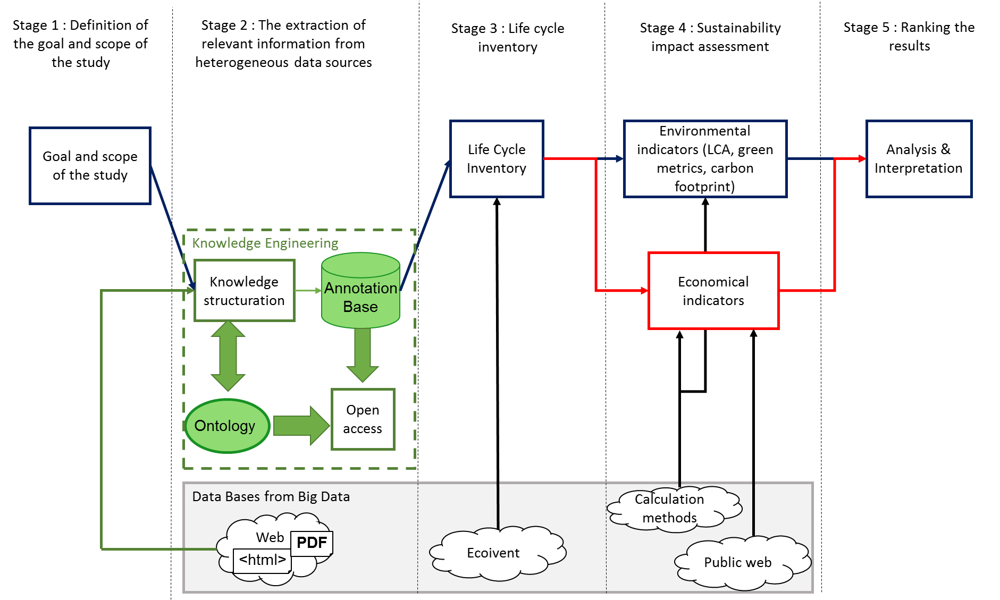
Figure 1 : The five stages of framework

The general framework is presented in figure above. Five general steps are:
- Definition of the goal and scope of the study (LCA method)
- The extraction of relevant information from heterogeneous data sources (KE method)
- Life cycle inventory (LCA method)
- Indicators calculation (Life Cycle Impact Assessments, “Green chemical” metrics or Economic indicators methods)
- Ranking the results and analysis
Iterations are even recommended, as they can be used to complete the data and to improve methodology process, resulting in better results.
    - Stage 1: The goal and scope
The first stage of the framework is the definition of the goal and scope of the study. In this stage, some elements are important to define the next steps of the framework. Firstly, the framework user must identify the goal of the study and the recipients - who the study is being performed for. In this paper, to demonstrate the validity of the framework the recipients using the framework are the researchers. Indeed, this pipeline is particularly suitable for research use because of system boundaries and the laboratory scale of data collection in published papers. It could easily be scaled up for industry (Shibasaki, 2007). After the recipient can define the product or the process studied, the functional unit, the boundaries of the system, the data required, the choice of impact category and the process tree, with inflows/outflows. This first stage also constrains and guides the creation of ontologies in the next stage. Indeed, the definitions already provided structure to the knowledge and narrowed down the selection of scientific papers and data required for the study, overcoming the need to search the whole worldwide web for data.

    - Stage 2: The extraction of relevant information from heterogeneous data sources
This stage, which is divided into several sub steps, is derived from KE methods: Heterogeneous experimental data from a vast array of scientific papers are integrated with @Web. @Web (for Annotated Tables from the web) which relies on an Ontological and Terminological Resource, is a collaborative web platform to share documents with annotated tables. (Lousteau-Cazalet et al.,2016).
Firstly, researchers select documents describing the various processes that they have to compare. They identify all articles thanks to different keywords in scientific databases available in the public Web. Secondly, an assessment of document reliability is done thanks to the meta-information available on the article (data source, data production methods or statistical procedure). A reliability score can be calculated for each article and it is completely configurable by the researcher. Thirdly, an ontological and terminological resource (OTR) must be created to facilitate the use of data from heterogeneous sources and to guide scientific data annotation. Once the OTR has been created, tables of selected documents can be extracted and annotated. Fourthly, using tag analysis, the data tables from the HTML version of the documents are extracted then they are annotated using the concepts of the OTR. Finally, after their extraction and their annotation, data tables are stored in an RDF triple store, making it possible to use the querying interface. RDF (Resource Description Framework) is a standard mode of data interchange via the Internet. It is used as an interface between users and the OTR, enabling users to interrogate the OTR in various ways. Users can use a querying tool to rank the data in a specific order, on the basis of data source reliability, for example, or by selecting a kind of process.
The annotations base contains the foreground data required for the life cycle inventory generated in stage 3. The document reliability score is used, in the last stage, to rank the results, to guide the researcher’s choice.

    - Stage 3 : Life cycle inventory
The life cycle inventory lists and quantifies the various relevant inputs and outputs. ISO standards (ISO 14044:2006) describe the different stages of the LCI: data collection, data calculation, and the allocation of flows and releases. Data collection can be split into two parts: data collection for the foreground system and data collection for the background system. Many methods are available for compilation of the LCI and for the organization of these data (Sush et al., 2005). Hence, ISO has developed a technical specification for data documentation formats for the LCI (ISO/TS 14018, 2002). Thanks to this standard, all the LCI background databases, such as EcoInvent (Frischknecht and Rebitzer, 2005), the US Life Cycle Inventory Database and the International Reference Life Cycle Database (ILCD) use the same data format. Such formatting is useful, as it is simple to fill out the corresponding form. However, many items are not completed, many chemical species are missing (Levy, 2017) and the intermediate flows of many processes are not available. In this work, EcoInvent is used for background data, and the methodology developed concerns the foreground data.
In this case, foreground data are extracted from the Internet in stage 2. The annotations base (also called RDF) provides foreground data related to the unit process and the functional unit. The background data are obtained from the LCA database. Data are validated by a specific data validation method recommended by ISO (ISO 14044), the pedigree matrix approach.
    - Stage 4 : Sustainability Indicators calculation
In this framework, some indicators are described such as LCA indicators, economic indicators and “green chemical” metrics. The framework user can use the indicators as he wants but he must respect the standard calculation for these indicators. Each method has calculation boundaries – the data type, the location where the study take place, the study limits - and the user must be verify if each piece of data is within these boundaries. The method can be mono-criterion like carbon assessment or E-factor indicator which is a green chemical metrics or multi-criteria like LCA. After the calculation of the different indicators selected by the researcher, an important step is the indicator visualization. This visualization can be different following the group-based decision-making, the goal of the study or the choice of the assessment analysis method but it can influence the last step and therefore the decision.
    - Stage 5: Ranking the results
The analysis and interpretation of the results are a key issue. This stage is highly linked to the user, the goal of the study and provides decision support. The user can choose between the first, second or third level of aggregation of LCA indicators, between two different economic indicators or between environmental indicators from LCA methods and “Green Chemical” method. These choices must be taken according to the type of decision to make. This method can be used to compare processes or products. The ranking should take into account both uncertainties (from Monte-Carlo method results for example) in the collected data and the reliability of data (using results from @Web), and should support decision-making.
  - Case study: rice by-product valorisation
To validate the approach and the associate framework, a tool is created with VBA-Excel. This tool allows to extract the process data to @Web, to make the LCI thanks to the EcoInvent v3 database, to calculate the environmental and economic impacts and then to visualize the results for the comparison of lignocellulosic biomass pretreatment processes. The bioconversion of lignocellulosic biomass is a promising method for the production of bio-energy, biomolecules or biomaterials. This bioconversion involves the enzymatic hydrolysis of the biomass to release glucose. Biomass pretreatment is essential, to decrease crystallinity, increase the specific surface area and the porosity, and separate the major constituents. In this paper, the framework is developed for four different kinds of rice straw pretreatment processes and only LCA impacts indicators are shown.

The goal of the study (stage 1) is the comparison of rice straw pretreatments for the glucose production. The function of the system is the glucose production and the functional unit is the “production of 1 kg of glucose”. All results are expressed in terms of this functional unit. The process of biomass pretreatment is a cradle-to-gate approach [40], extending from the milling of the biomass to its enzymatic hydrolysis. Input production (including biomass) is included, whereas the transport of inputs and outputs is excluded. Four different kinds of processes are selected for rice straw: PM (pre-milling), PM-UFM (pre-milling and ultrafine milling), PM-PC-PS (pre-milling, physicochemical and press separation) and PM-PC-UFM-PS (pre-milling, physicochemical separation, ultrafine milling and press separation).

In stage 2, biomass pretreatment experts identify all published articles corresponding to the keywords: “rice straw”, “treatment”, “hydrolyze” and “milling” in scientific databases, such as Web of Science or Science Direct. They select 13 relevant scientific articles. These articles are then sorted by topic, with each topic corresponding to a different type of process. Four types of pretreatment are described in the 13 articles: three articles dealt with pre-milling pretreatment (PM), seven dealt with pre-milling, physicochemical and press separation pretreatment (PM-PC-PS), one dealt with pre-milling, physicochemical, ultrafine milling and press separation pretreatment (PM-PC-UFM-PS) and two dealt with pre-milling and ultrafine milling pretreatment (PM-UFM). These documents are entered into @Web, with their meta-information. Thanks to these metadata, the reliability score is calculated. Then an OTR “Biorefinery” is created and the documents are annotated to be stored in the RDF. The biorefinery ontology includes three tables to be completed with annotations: Biomass composition, enzyme cocktail and process description. All the foreground data require for the next stage —establishment of the life cycle inventory — are provided in the process description table.

In stage 3, the life cycle inventory is done following the LCA method. The foreground data from publications on rice straw pretreatment concerns energy, biomass, water, acid, oxidation, ionic liquids, alcohol, buffer liquid, and output solid. These data are grouped together in the annotation base in @Web. Once they are extracted from @Web, the foreground data are expressed per functional unit. An LCI database is then required to associate foreground data from @Web with background data in the LCI database. Indeed, the production of electricity for biomass transformation involves the extraction and emission of matter and energy, which must be taken into account in life cycle approaches. The EcoInvent v3 database is used in this study to provide the data for the background system.

In stage 4, in the scope of LCA method, there exist several different methods which can calculate different impact categories at different levels of aggregation. For this study, the ReCiPe 2008 Endpoint Hierarchical method is used. This method calculates indicators from the first level of aggregation to the final unique score. The indicators for the second level of aggregation and ReCiPe normalized endpoint indicators for each kind of process are presented in Figure 2 (100% basis chart). Each circle corresponds to an indicator: the first is the human health indicator, the second is the ecosystem quality indicator and the last is the resource indicator.

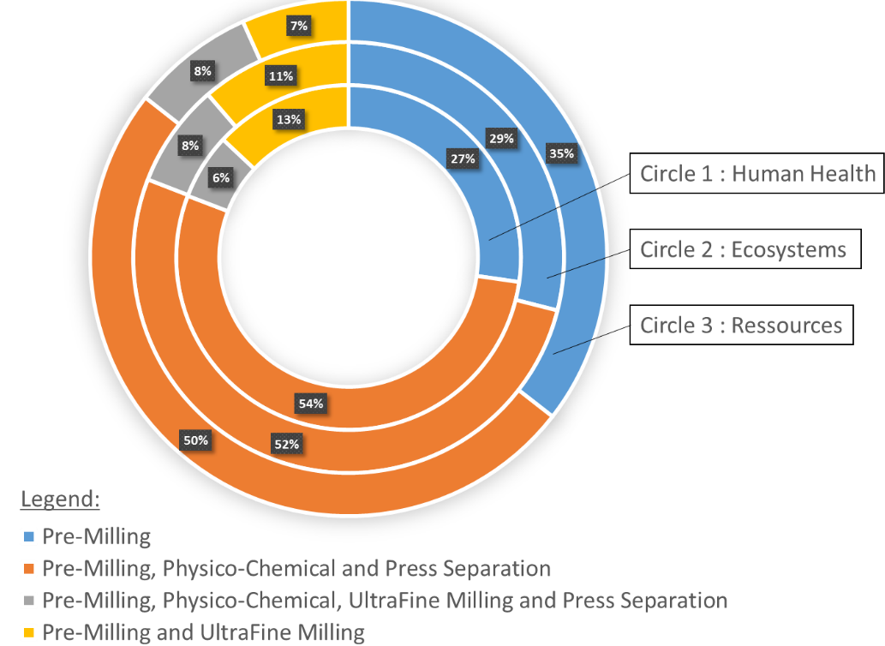
Figure 2 : ReCiPe EndPoint Indicator Results for rice straw pretreatments
  - Results and discussion
According to this representation, the pre-milling, physicochemical and press separation (PM-PC-PS) pretreatment has the greatest environmental impact, followed by pre-milling treatment (PM), then the pre-milling and ultrafine milling (PM-UFM) treatment, and, finally, the pre-milling, physico-chemical, ultrafine milling and press separation pretreatment (PM-PC-UFM-PS) pretreatment. Based on this initial interpretation, researchers would choose the PM-PC-UFM-PS process for rice straw pretreatment. The addition of the different new process can refine the analysis and allows the researcher to choose the pretreatment process with the least environmental impact. Also the addition of interactive visualization can allow to access to midpoint result or the emissions. A huge problem in the case study is the lack of energy data on some process which can influence the results. A first work on the energy data collection to create energy model can be done to enrich the results.
If the researcher wants to detail the results, the visualization allows to compare not the kind of process but the process and its technologies. The framework creates results which must be interpreted and analyzed by the researcher. It is his role to take the final decision with the help of the results’ visualization. To continue the analysis, economic impacts can be added. It would be useful to help choose among different technologies for each operation. The technology used can indeed influence impacts of an operation. The more data in the process base, the more relevant the results are.
  - Conclusion
In this study, a framework is created to couple KE methods and economical or environmental impact calculation. This approach involves five stages: determination of the goal and scope of the study, the extraction of relevant information from heterogeneous data sources, establishment of the inventory, impact assessment and, finally, the analysis and interpretation of the results. This framework is generic, because the ontologies established for exploitation of the foreground data are generic. This coupling of sustainability impact assessment and KE approaches can be applied to all processes. In this study, the example of the comparison of rice straw pretreatment processes illustrates the coupling of KE and an impact calculation from LCA method. The pipeline developed here should enable researchers, and other users, to identify the “best” process for a specific biomass. This methodology could be improved by enhancing ranking procedures and including scaling (to address industry needs). The interactive visualisation also allows the framework user to move in different levels of the results. For example, he or she can move between the impacts categories and the damages. Furthermore, in the tool created, the environmental indicators from LCA could be combined with economic indicators, providing a more general overview of the various processes and technologies regarding to sustainability management.
Acknowledgments
This project was funded by the 3BCAR French Carnot network (http://www.3bcar.fr), which brings together seven French research units (500 researchers) involved in the design of processes for transforming biomass into bioenergy, biomaterials and biomolecules.
References
JP Belaud, C Adoue, C Sablayrolles, C Vialle, A Chorro, Decision making approach for industrial ecology: layout and commercialization of an industrial park, Chemical Engineering Transactions 57, 1561-1566, 2017
J. Cooper, M. Noon, C. Jones, E. Kahn and P. Arbuckle, "Big Data in Life Cycle Assessment," Journal of Industrial Ecology, vol. 17, no. 6, pp. 796-799, 2013.
A. Doan, A. Halevy and Z. Ives, Principes of Data Integration, Morgan Kaufmann Publishers, 2012.
L. Elghali, R. Clift, P. Sinclair, C. Panoutsou and A. Bauen, "Developing a sustainability framework for the assessment of bioenergy systems," Energy Policy, vol. 35, no. 12, pp. 6075-6083, 2007.
R. Frischknecht and G. Rebitzer, "The ecoinvent database system: a comprehensive web-based LCA database," J. Clean. Prod, vol. 13, no. 13-14, pp. 1337-1343, 2005.
S.T. Gillani, J.-P. Belaud, C. Sablayrolles, M. Vignoles et J.-M. Le Lann, A CAPE Based Life Cycle Assessment for Evaluating the Environmental Performance of Non-Food Agro-Processes, Chemical Engineering Transactions, 32, 211-216, 2013
ISO 14040:2006, "Environnement Management - Life Cycle Assessment - Principles and Framework," International Organization for Standardization, Geneva, Switzerland, 2006.
ISO 14044:2006, "Environmental management -- Life cycle assessment -- Requirements and guidelines," International Standardisation Organisation, Geneva, Switzerland, 2006.
ISO/TS 14048, "Environmental Management - Life Cycle assessment- Data Documentation Format," International Organization for Standardization, Geneva, Switzerland, 2002.
M. Levy, "Life Cycle Analysis-Strength and Limitations of LCA," in Encyclopedia of Sustainable Technlogie, vol. 1, Youngstown State University, Youngstown, Ohio, USA, Elsevier, 233-236, 2017
C. Lousteau-Cazalet, A. Barakat, J.-P. Belaud, P. Buche, G. Busset, B. Charnomordic, S. Derveaux, S. Destercke, J. Dibie, C. Sablayrolles and C. Vialle, "A decision support system for eco-efficient biorefinery process comparison using a semantic approach," Computers and Electronics in Agriculture, vol. 127, pp. 351-367, 2016.
N. Noy, "Sematic integration: a survey of ontology-based approaches," SIGMOD rec, vol. 33, no. 4, pp. 65-70, 2004.
A. Pavwelczyk, "EU Policy and Legislation on recycling of organic wastes to agriculture," International Society for Animal Hygiene, vol. 1, 2005
R. Raymond, “Improving food systems for sustainable diets in a green economy,” in Greening the Economy with Agriculture, 2012 United Nations Conference on Sustainable Development: Governance for Greening the Economy with Agriculture. FAO Council Document CL., 2012.
M. Shibasaki, M. Fisher and L. Barthel, "Effects on Life Cycle Assessment – Scale Up of Processes," in Takata S., Umeda Y. (eds) Advances in Life Cycle Engineering for Sustainable Manufacturing Businesses, London, 2007.
S. Sush and G. Huppes, "Methods for life cycle inventory of a product," J. Clean. Prod., vol. 13, no. 7, pp. 687-697, 2005.

