|  |  |
| --- | --- |
| cetlogo ***CHEMICAL ENGINEERING TRANSACTIONS***  ***VOL. 76, 2019*** | A publication of  aidiclogo_grande |
| The Italian Association  of Chemical Engineering  Online at www.cetjournal.it |
| Guest Editors: Sauro Pierucci, Jiří Jaromír Klemeš, Laura Piazza  Copyright © 2019, AIDIC Servizi S.r.l. **ISBN** 978-88-95608-73-0; **ISSN** 2283-9216 | |

Lignin Conversion Into Hydrogen And Biochar Under Microwave Irradiation

Andrey V. Chistyakov, Grigoriy I. Konstantinov, Olga V. Arapova, Mark V. Tsodikov,

Topchiev Institute of Petrochemical Synthesis, R AS, Leninskii pr. 29, Moscow 119991, Russia

chistyakov@ips.ac.ru

Utilization of Kraft lignin is a complex challenge and effective approaches to its solution have not yet been found. One of the promising ways in this area is the processing of lignin into syn-gas and carbon residue, which can be used to obtain sorbents. Processing of lignin into synthesis gas by dry reforming (LDR) under the action of MWI allows for the efficient processing of large-scale waste - lignin and carbon dioxide into an important product of petroleum chemistry like syn-gas with a selectivity exceeding 90%. MWI on the one hand is the source of heat in the reaction volume, on the other hand its effect leads to an increase in the vibrations of the substrate molecules and their polarization, which significantly increases the intensity of the release of hydrogen from the lignin compared to convective heating. Graphite-like conversion of carbon is a valuable raw material for the production of porous carbon sorbents for the treatment of industrial wastewater. It is followed by the fact that it has been measured that it has reached 0.5–0.8 nm. In the case of heat treatment, it is recommended that you follow the short-term heat treatment.

* 1. Introduction

Carbon-based materials are distinguished by their uniqueness in the modern economy due to physicochemical properties such as chemical resistance in aggressive environments, thermal and heat resistance, high mechanical strength at elevated temperatures, as well as the possibility of its increase with increasing temperature, high electrical conductivity, high / low friction coefficient, high porous structure, biological compatibility with living matter, etc. All this allows you to create on the basis of carbon-containing materials the unique design of very complex configuration, the area of ​​use of which in the economy extends from medicine and military technology to solve environmental problems associated with anthropogenic pollution.

The relevance of the work performed is determined by the synthesis of carbon adsorbents from wood processing residues - lignin and the activation of the material by microwave radiation. The use of microwave radiation for heating materials allows for a short time of 20-60 seconds to reach temperatures of 650-850 ° C and maintain them evenly throughout the entire volume of the material. This approach will be applied for the first time in the present work to create an ordered graphitized structure from lignin and to remove few volatile hydrocarbons from the material structure.

* 1. Materials and Methods

Kraft lignin obtained at the pulp-and-paper enterprise of the Kirov region (Russia) was used in the work (elemental composition: С — 58.1%; H — 5.4%; Al-0.2%; Si — 3.1%; Ca-0.6%; Fe — 0.02%; S - 1.2%; N -1.2%; O- 28.9%; other elements (1.28%). Lignin was subjected to preliminary drying at 110 ° C for 4 h, then, using an impregnation method, nickel acetate from an aqueous solution or alcohol acetylacetonate was applied onto it solution. The content of the active components was monitored by atomic absorption spectrometry. from a magnetron, a waveguide, a quartz reactor, and a residual radiation absorption chamber (Tsodikov et al., 2017). During the experiments, carbon dioxide or argon was passed through the reactor at a rate of 60 ml/min, the irradiation time was 10 min at 700-800 ° C. In order to determine the ability to absorb microwave radiation from the initial and metal-containing lignin samples, the heating dynamics were determined when exposed to MWI.

The carbonaceous lignin conversion residue was used to develop a porous adsorbent. For this purpose, 10% hydrochloric acid and a mixture of concentrated nitric and hydrochloric acids of the HNO3 + 3HCl composition (“aqua regia”) were etched at a temperature of 600°C to remove part of the mineral inclusions, followed by washing the residue with distilled water to a neutral wash water and a negative reactions in them to Cl- ions (test with AgNO3). On the surface of the dried sample obtained after etching with 10% hydrochloric acid, ammonium hydroxide was adsorbed by impregnation from a 25% aqueous solution. After impregnation of NH4OH, the sample was subjected to thermal shock while flushing with carbon dioxide. For this, the sample was introduced into a muffle furnace heated to 5000 ° C and held for 30 minutes, after which the sample was unloaded from the furnace and cooled in a desiccator.

The elemental composition of the samples was determined by atomic absorption spectrometry, X-ray fluorescence analysis, and also by chromatography after burning in a dynamic flash using a CHNS-Analyzer using standard techniques.

The equilibrium values ​​of nitrogen vapour adsorption at 77 K on a solid adsorbent in the pressure range from 1 Pa to 0.1 MPa were measured by a gravimetric method on a vacuum adsorption unit.

Determination of sorption pores (the sum of the volumes of micro- and mesopores) was carried out using an exicator method under static conditions at a temperature of 200°C using benzene as a sorbate.

* 1. Results and Discussion

As the initial carbon-containing materials for the development of porous adsorbents, iron-containing residues released during the processing of mixed kraft lignin are used. The processing of iron-containing lignin in gas synthesis occurs in a plasma-catalytic mode with microwave stimulation. Earlier, a study was conducted to study the ability of lignin modified by iron and nickel-containing catalytic systems to absorb microwave radiation. In the studies(Tsodikov et al., 2017; Tsodikov et al., 2018), it was found that nickel-containing lignin absorbs MWI insufficiently to raise the temperature up to 700-800С, which is necessary for carbon dioxide reforming. In this regard, for the implementation of the DLR in the presence of nickel-containing catalytic systems, it was necessary to add a material with large dielectric losses to the microwave-resonator resonator (Tsodikov et al., 2017; Tsodikov et al., 2016). In contrast, in the presence of nanoscale iron-containing particles deposited on the surface of the lignin, the system had a significant absorption of microwave radiation for carbon dioxide reforming in the plasma-catalytic mode. In Fig. 1 presents data on the effect of MWI on the time of temperature increase in the reaction zone. From the data of Fig. 2, it follows that the T ÷ τ dependence is of an extreme nature: the maximum heating rate is observed for a sample containing 0.5% deposited Fe. The catalytic activity in the LDR increases with increasing iron content and corresponds to the maximum value with a content of 2-3%.



*Figure 1: Dynamics of heating of the initial and iron-containing lignin.*

The greatest activity in the transformation of lignin was achieved using mixed catalysts consisting of iron-nickel systems and reached 64% with selectivity in the formation of synthesis gas 91 -92% (Table 1).

*Table 1: Conversion of lignin in the presence of nickel-iron catalytic systems and microwave radiation.*

|  |  |  |  |  |  |  |  |  |
| --- | --- | --- | --- | --- | --- | --- | --- | --- |
| N/N | Composition | Gas | Gaseous products yield, wt.% | Solid residue, wt.% | Liquid products yield, wt.% | H2:CO | Conversion, % | Syn-gas selectivity, % |
| 1 | 1.5Ni+ 0.5Fe | СО2 | 35.6 | 38.3 | 5.6 | 1 | 64 | 91.8 |
| 2 | 0.1Fe + 1.5Ni | СО2 | 33.2 | 42.6 | 6.4 | 1 | 63.7 | 91 |

According to the data of IR spectroscopy after microwave radiation, the intensity of almost all bands of stretching vibrations O – H, C – H, C – C (Ph) and C – C – C decreases, i.e. the spectrum reflects the disappearance of such bonds in the lignin standard.

Using the method of introducing an internal standard to quantify the relative content of various functional groups in lignin allowed us to construct the dependences of the content of various types of chemical bonds (C – H, C – C, C – O, C = O) in the lignin on the conditions of the destruction experiment. It was found that the largest changes in the spectrum under the influence of nickel concentration occur in the absorption region of the aldehyde group (1714 cm-1). This band, which is related to valence vibrations, noticeably decreases in intensity in the spectra as the nickel content introduced into lignin from the salt solution increases. According to IR spectroscopy, when iron-containing particles from the acetylacetonate complex are deposited, a significant decrease in the efficiency of all unsaturated bonds is observed.

According to the data of Raman spectroscopy in the spectra of solid products of deep conversion of lignin in the presence of nickel and iron (Fig. 2), two bands clearly show up at 1600 cm -1 (G) and 1340 cm -1 (D), which characterize graphite-like structures (Ferrari, 2007) . Analysis of the Raman spectra suggests that a small amount of imperfect graphite-like structures is present in the solid lignin residues, i.e. destruction of bonds is accompanied not only by the formation of complex polyphenylene oxide structures but also by the formation of condensed aromatic derivatives. X-ray diffraction data showed an amorphized structure of all residues with a low content of reflections in the area of silicon oxide and graphite (2ϴ-20.87; 26.64; 36.54).

Carbonaceous residues of lignin processing contain inorganic impurities consisting of silicon oxide, metals contained in lignin and supported catalytic systems (Tab. 2). The amount of inorganic impurities increases as a result of processing, which is reflected in the mass loss of the residue, which is 60-70%.

Table 2: The elemental composition of the mineral part of the residues of lignin processing after MWI.

|  |  |  |  |  |  |  |  |  |  |  |
| --- | --- | --- | --- | --- | --- | --- | --- | --- | --- | --- |
| Sample number | Si | Fe | Ni | Al | Na | Са | Other elements | Cl | S | C |
| 1 | 3.90 | 0.087 | 0.026 | 0.307 | 0.094 | 0.417 | 0.194 | 0.102 | 0.329 | 89.01 |
| 2 | 0.719 | 0.978 | 0.301 | 0.169 | 0.08 | 0.386 | 0.159 | 0.162 | 0.249 | 94.71 |
| 3 | 1.15 | 0.615 | 0.237 | 0.171 | 0.112 | 0.077 | 0.091 | 1.12 | 0.143 | 94.17 |
| 4 | 2.18 | 0.427 | 1.090 | 0.211 | 0.06 | 0.098 | 0.066 | 9.69 | 0.111 | 82.66 |

The formation of porous materials from residues of lignin reforming was carried out by the method of acid and base etching. This direction was chosen by us under the assumption that the porous structure will be formed in the process of etching inorganic impurities.

Table 3 presents the processing mode of the sample containing 1.5% Ni and 0.5% Fe and the elemental composition after the processing of lignin residues.

Table 3: The processing mode of the sample containing 1.5% Ni and 0.5% Fe and the elemental composition after the processing of lignin residues.

|  |  |  |  |  |  |  |  |
| --- | --- | --- | --- | --- | --- | --- | --- |
| Sample number | Sample  After MWI |  |  | C | H | N | S |
| 1 | Initial lignin | - | - | 76.22 | 3.22 | 0.32 | 0.10 |
| 2 | Ni-Fe/ lignin | - | - | 70.68 | 2.85 | 0.20 | 0.33 |
| 3 | Ni-Fe/ lignin | HCl (10%) | - | 75.85 | 2.73 | 0.19 | 0.10 |
| 4 | Ni-Fe/ lignin | HNO3+3HCl | - | 61.67 | 1.09 | 0.53 | 0.90 |
| 5 | Ni-Fe/ lignin | HCl (10%) | NH4OH Thermal shock - 500С | 29.79 | 0.44 | 1.07 | 0.45 |

Etching was performed in one step at a temperature of 600°C. Evaluation of the effectiveness of etching on the formation of a porous structure was carried out on the basis of data on the measurement of adsorption capacity and an increase in the specific surface area.

In Fig. 2 shows adsorption isotherms for samples 1, 2, 4 and 5.

The heat of adsorption was determined on the basis of the dependence type (Gregg, 1982)

*lna = f (A2),* (1)

where a - adsorption, mmol / g,

A = RT\*ln(ps / p) - the differential molar work of adsorption, J / mol.

Figure 3 shows nitrogen adsorption isotherms at 77 K in the coordinates of the theory of the volume filling of micropores.

Table 4 presents data on the size of the specific surface area, the group composition of pores and the energy of adsorption, obtained by treating N2 adsorption isotherms. From the data of table 4, it follows that the presence of metal-containing catalytic components up to 2% in a sample. 2 increases the specific surface area of ​​the solid residue of lignin after microwave treatment compared with pure lignin, which is also subjected to microwave irradiation (sample 1). An increase in the specific surface area is accompanied by an increase in the total volume of adsorption pores from 0.008 to 0.04 cm3 / g. The increase in the adsorption volume is due to an increase in the adsorption volume of micropores from 0.024 to 0.18 mmol / g.

Etching sample 1 diluted hydrochloric acid (sample 4), practically, does not change the specific surface area and composition of the pores. Etching the residue of a sample of lignin-containing catalytic components, by melange, of the composition HNO3 + 3HCl (aqua regia) in one step slightly increases the specific surface area to 21 m2 / g. At the same time, the relative concentration of micropores increases to 0.24 mmol / g with a total adsorption volume of 0.05 cm3 / g.

A significant increase in adsorption capacity was achieved for sample 5. After etching with dilute hydrochloric acid, the surface of sample 5 was treated with a 25% solution of NH4OH. After adsorption of the ammonia solution, the sample was subjected to thermal shock at 500°C in a stream of carbon dioxide, after which drying was carried out in vacuum at a temperature of 100°C.

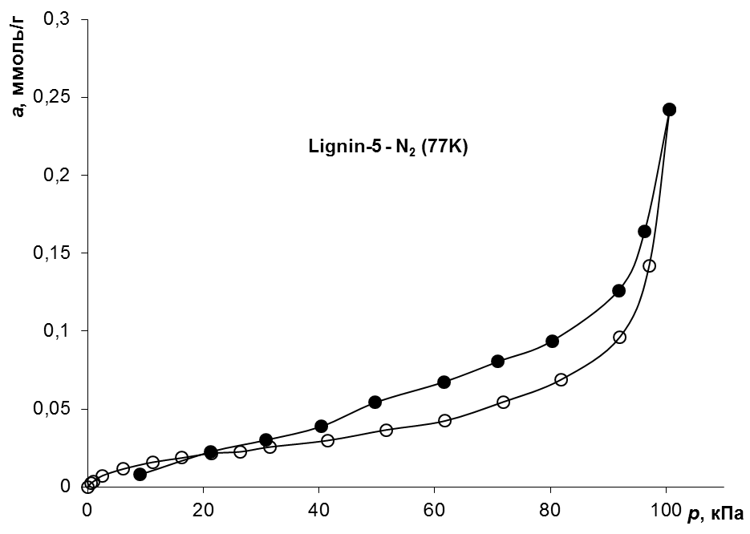 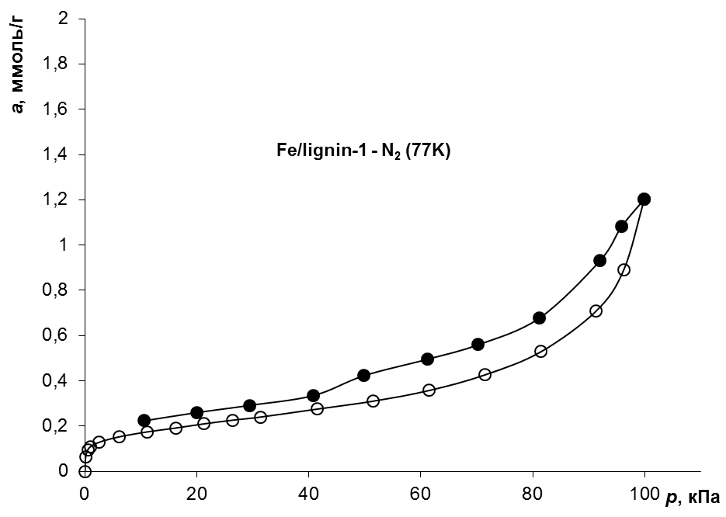

d

c

b

a

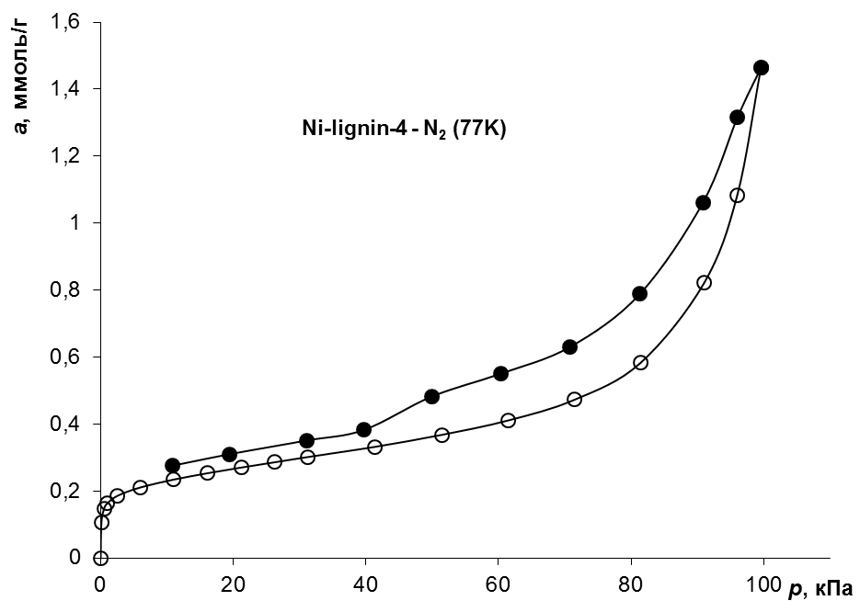 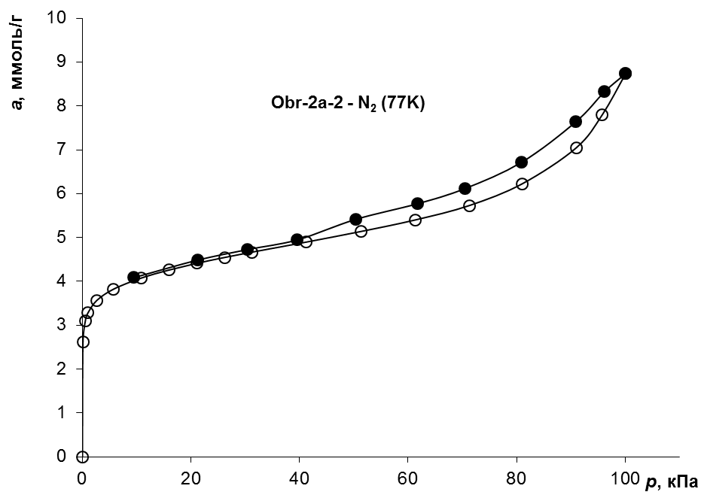

Figure 2: Adsorption isotherms for samples 1 (a), 2 (b), 4 (c) and 5 (d).

It is known that during the decomposition of a compound adsorbed in the pores during thermal shock, the possibility arises of the mechanical action of vapours of decomposition products on the inner walls of pores, leading to their expansion (Yakovlev et. al., 2006). For sample 5, the specific surface area increased to 353 m2/g. The total volume of adsorption pores (micro + mesopores) increased to 0.36 cm3 / g. At the same time, the adsorption volume of micropores increased to 3.98 mmol / g. From Tab. 3 shows a significant decrease in the carbon and hydrogen content after heat treatment in a stream of carbon dioxide. This result indicates the course of the interaction of the carbon residue with carbon dioxide according to the Boudoir reaction:

СО2 + С → 2СО (2)

The decrease in the hydrogen content is most likely due to the subsequent interaction of the residue surface hydrogen with carbon monoxide:

2СО + 10[H] → 2CH4 + H2O (3)

The flow of the interaction of carbon dioxide with carbon atoms of the surface of the residue during a short thermal exposure also leads to an increase in the porous structure.

The shape of the adsorption isotherm of sample 5 is typical for a slit-like pore configuration (Gregg, 1982). Such a pore configuration is characteristic of a layered graphite-like structure, in which pores are most likely formed in the interlayer space and on surface defects.

The pore size distribution was estimated by desorption isotherm processing for samples 1, 3, 4 and 5. From the data on the pore distribution over the radii, it follows that the carbon residue, which does not contain metals and is not etched, is characterized by large super micropores of 1.9 nm and small adsorption volume of mesopores. The increase in specific surface area and adsorption pore volume for metal-containing residue samples 2 and 4, due to the increase in the volume of adsorption pores. The size of micropores for etched specimens is from 0.9 to 0.8 nm. After etching with melange (aqua regia) (sample 4), a wide distribution is observed, in which a small peak appears in the region of 0.9 nm and a blurred region of mesopores in the region of 34 A. the pore size distribution curve significantly increases the peak in the region of small pores with a slight decrease in mesopores in the region of 34 A.

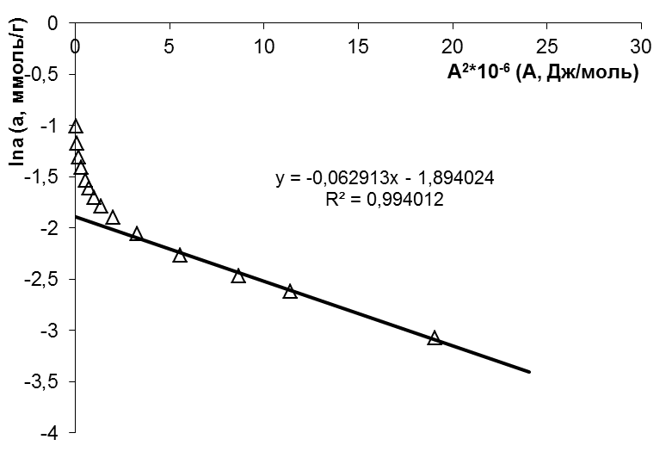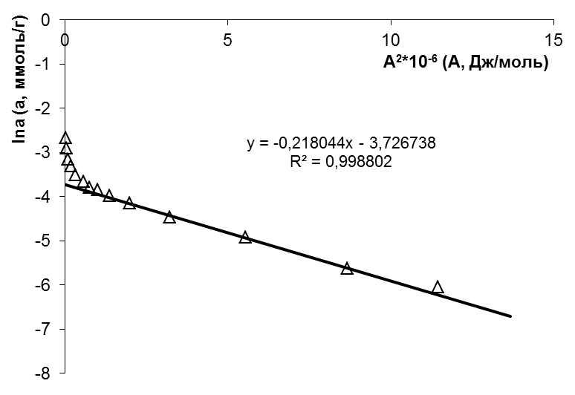 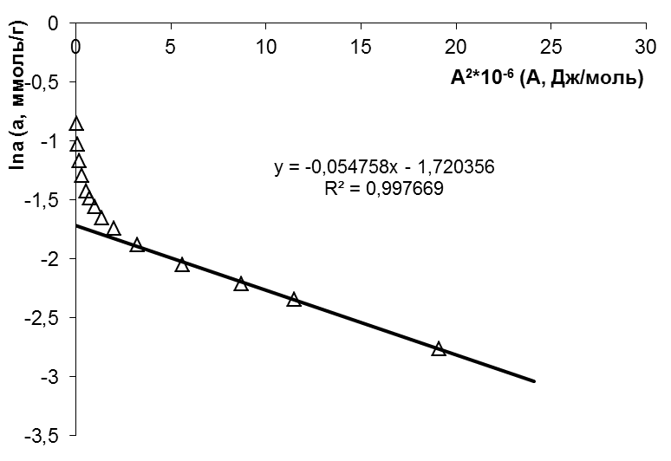 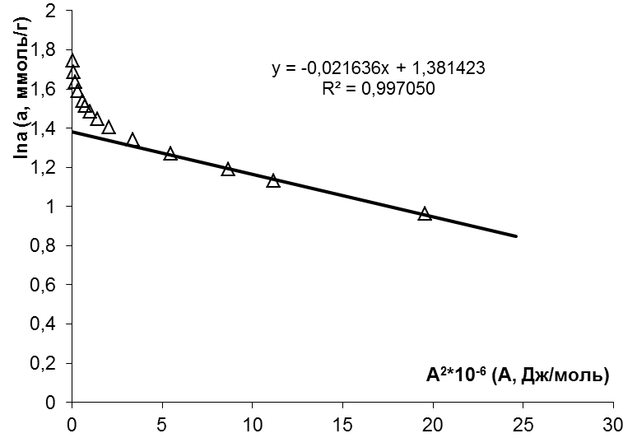

Figure 3: Composition of micropores for samples 1, 2, 4, 5.

Table 4: The value of the specific surface area, the group composition of the pores and the adsorption energy of micropores.

|  |  |  |  |  |  |  |
| --- | --- | --- | --- | --- | --- | --- |
| N/N | *W*cm3/g | *E, J / mol* | *S, m2/g* | *<rmicro>, nm* | a,mmol/g | Half <rме> |
| 1 | 0.008 | 2.14 | 1.96 | 1.85 | 0.024 | 18.137 |
| 2 | 0.04 | 4.27 | 16.2 | 0.93 | 0.18 | 8.828 |
| 3 | 0.04 | 3.99 | 14.4 | 0.99 | 0.15 | 17.339 |
| 4 | 0.05 | 4.85 | 21.2 | 0.82 | 0.24 | 17.336 |
| 5 | 0.30 | 6.8 | 353.5 | 0.58 | 3.98 | 5.888 |

* 1. Conclusions

We have obtained a graphite-like structure of a residue that does not contain catalytic components. After exposure to microwave irradiation, it is characterized by an underdeveloped porous structure, consisting mainly of mesopores with an average size of 80A. Etching with melange (aqua regia) leads to an increase in pore volume with wide size distribution. The thermal shock of a sample containing adsorbed NH4OH leads to an increase in the adsorption volume of micropores, mainly in the region of 5.8A. By the nature of the pore size distribution, it can be assumed that the initial graphite-like structure formed after the transformation of metal-containing lignin, stimulated by microwave radiation, already contains pores in the region of small pores with a size of 0.8 nm. Treatment of the residue by acid etching followed by thermal shock leads to the development of a porous structure in the region of small pores with a size of 0.5–0.8 nm and a decrease in the total volume of mesopores. In order to obtain a highly porous structure based on a graphite-like residue, the most promising direction is the combination of etching with dilute acids followed by short-term heat treatment.

Acknowledgments

This work was done with the financial support of the Ministry of Science and Higher Education of the Russian Federation for the project part of the State Task (Subsidy Agreement no. 14.613.21.0073 of October 23, 2017, unique number: RFMEFI61317X0073).

References

Arapova O.V., Tsodikov M.V., Chistyakov A.V., Konstantinov G.I., 2017, Dry Reforming of Kraft Lignin under MWI Action, *Chemical Engineering Transactions*, *57*, 223-228.

Ferrari A. C., 2007, Raman Spectroscopy Of Graphene And Graphite: Disorder, Electron–Phonon Coupling, Doping And Nonadiabatic Effects, *Solid state communications*, *143*, 47-57.

Gregg S.J., Sing K.S. W., 1982, Adsorption, Surface Area And Porosity. *Academic Press Inc., London*.

Tsodikov M.V., Ellert O.G., Nikolaev S.A., Arapova O.V., Konstantinov G.I., Bukhtenko O.V., Vasil’kov A.Y., 2017, The Role Of Nanosized Nickel Particles In Microwave-Assisted Dry Reforming Of Lignin, *Chemical Engineering Journal*, *309*, 628-637.

Tsodikov M.V., Ellert O.G., Nikolaev, S.A., Arapova O.V., Bukhtenko O.V., Maksimov Y.V., Vasil’kov A.Y., 2018, Fe-Containing Nanoparticles Used As Effective Catalysts Of Lignin Reforming To Syngas And Hydrogen Assisted By Microwave Irradiation, *Journal of Nanoparticle Research*, *20*, 86.

Tsodikov M.V., Konstantinov G.I., Chistyakov A.V., Arapova O.V., Perederii M.A., 2016, Utilization Of Petroleum Residues Under Microwave Irradiation, *Chemical Engineering Journal*, *292*, 315-320.

Yakovlev A.V., Finaenov A.I., Zabud’kov S.L., Yakovleva E.V., 2006, Thermally Expanded Graphite: Synthesis, Properties, And Prospects For Use, *Russian Journal of Applied Chemistry*, *79*, 1741-1751.