CHEMICAL ENGINEERING TRANSACTIONS  VOL. 76, 2019 | A publication of
The Italian Association
of Chemical Engineering
Online at www.cetjournal.it
Guest Editors: Sauro Pierucci, Jiří Jaromír Klemeš, Laura Piazza
Copyright © 2019, AIDIC Servizi S.r.l.
ISBN 978-88-95608-73-0; ISSN 2283-9216

Characteristics of a Falling Liquid Film Flow Using Periodic Jetting Flow
Risa Kajitaniª, Tadahiro Mukaida^{a,b,}, Kunio Kataoka^{b}, Naoto Ohmura^{a,}*
ª Department of Chemical Science and Engineering, Kobe University, 1-1 Rokkodai, Nada-ku, Kobe, Hyogo, 657-8501, Japan
^{b} Kansai Chemical Engineering Co., Ltd., 2-9-7, Minaminanamatsu-cho, Amagasaki, 660-0053, Japan
ohmura@kobe-u.ac.jp
This work tried to form a falling thin film by supplying liquid to the disk attached to the upper part of the device, rotating the disk and jetting liquid onto the wall surface in order to develop a new falling film evaporator without contamination. Heat transfer enhancement is expected by the surface renewal effect of unsteady and/or periodical flow due to the rotating disk with ditches. The influence of the shape and rotation speed of the disk on the flow of the falling thin film was investigated. Four kinds of rotating disk having small two or four ditches with a depth of 1 mm were used. The apparatus consists of a rotating disk, a cylindrical glass tube and a reservoir. An aqueous solution of uranine is supplied from the reservoir to the upper part of the rotating disk by a pump. The flow rate of the aqueous solution was 88 L/h, and the rotation speed of the disk was set at 200 or 300 rpm. The time-dependent flow condition was observed by irradiating a UV lamp from the side of the apparatus and photographing the front test section with the vertical length of 200 mm by a digital camera. The correlation between film thickness distribution and heat transfer characteristics suggested that thinner film thickness, nonuniform film thickness distribution with higher intensity due to large-scale waves, and higher circumferential velocity of liquid film were three major factors to enhance heat transfer.
  - Introduction
Urgent issues for suppression of global warming require development of heat transfer devices with low energy consumption, high efficiency and high performance. From the above background, liquid film technologies that improve the efficiency of heat transfer have been attracting attention (Shirakawa and Kita, 2014, 2016). A falling film evaporator using the liquid film technology has several advantages such as higher evaporation side heat transfer coefficient, less working fluid and smaller temperature difference between the working fluid and the wall than the ordinary evaporator (Gonda et al., 2014). Therefore, the thin film evaporator is suitable for processes such as purification, concentration, decolorization, deaeration, deodorization of materials which are sensitive to heat and substances with high boiling point and high viscosity and it is widely used in many fields such as petrochemical, food, pharmaceutical and desalination industries (Komori et al., 1990, Yang et al., 2016). Conventionally, in a falling film evaporation process, a thin film is formed by using a wiper, but there are problems such as contamination due to abrasion and requirement of relatively high device precision. In order to overcome the above problems, a novel thin film evaporator called “WALL WETTER” has been developed by Kansai Chemical Engineering Co., LTD (Yamaji, 2002). The “WALL WETTER” is simply welling up liquid to the top of the heat transfer area on the wall or coils by rotating watershoot-type blades in the tank. Then the heat transfer area could be fully utilized if the system would be working. In case of a batch evaporation the process time could be reduced by half. In this device, heat transfer can be enhanced by the surface renewal effect of unsteady and/or periodical jetting flow due to the rotating of the watershoot-type blades. However, the effect of jetting flow on heat transfer is still unclear. In order to investigate the influence on the heat transfer characteristics by the periodic jetting flow, this study proposed a flow model using an experimental apparatus with a rotating disk with small ditches. In this flow model, several kinds of geometrical configurations of disk were examined. The experimental apparatus equipped with a rotating disc with small ditches at the upper part of the apparatus. Unsteady disturbances of the liquid surface in the “WALL WETTER” were reproduced by supplying the liquid to the center of the disk and periodically jetting the liquid from the ditches by the centrifugal force.
  - Experiment
The schematic of the experimental apparatus is shown in Figure 1. A cylindrical glass vessel with a water jacket (AGC Inc., Japan) was used. Tap water as working fluid was supplied to the center of rotating disk with small ditches attached to the upper part of the vessel by a liquid feed pump (07528-10, Cole-Parmer Instrument Company, LLC, USA). The flow rate of the pump was varied from 17 to 1700 mL/min. The geometrical configurations of four kinds of disks are shown in Figure 2. In the notation of the disk name, "Disk A-B", in Figure 2, A is the number of ditches and B is the diameter of disk, e.g. “Disk 2-80” means the disk with 80 mm diameter and two ditches. In addition, “Disk 4-80u” means that the disk has 80 mm diameter and four ditches which are not equally distributed. All the disks have depression with diameter of 50 mm and depth of 1 mm at the center, from which ditches of 3 mm in width extend. The rotational speed of disk was varied at 5 to 300 rpm.
The working fluid was supplied to the depression in the center of the rotating disk. The working fluid was jetted from the ditches by centrifugal force to form a liquid film on the heat transfer surface. Due to the rotation of the disk, the heat transfer surface at a certain point is subjected to periodical impingement of jetting flow from the ditches. The liquid flowing down the inner cylinder wall was circulated by returning to the constant-temperature water bath. The test section with 200 mm long for flow visualization was located at the center of the device.
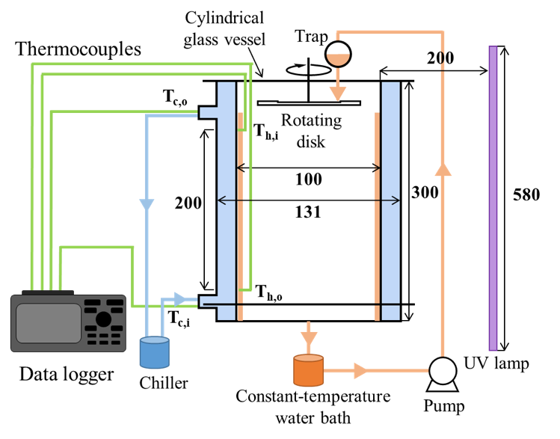

Figure 1: Experimental apparatus with dimensions in mm

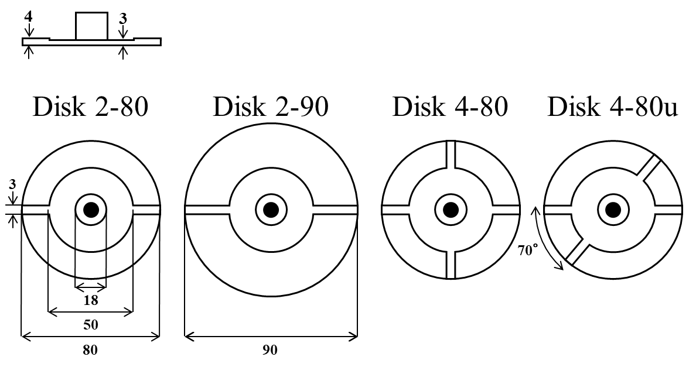

Figure2: Disk configurations with dimensions in mm

The dynamic flow behaviors within the test section were investigated by a flow visualization technique using fluorescence green dye. 7.12×10⁻⁴ M fluorescein sodium salt (uranine, Wako Pure Chemical Industries, Ltd., Japan) was used as fluorescence tracer. The disk rotation frequency was set at 3.3 or 5.0 Hz, and the volumetric flow rate was 88.0 L/h. The dynamic flow behaviors illuminated by an ultraviolet lamp were taken at a frame rate 60 FPS by a digital video camera (LUMIX DMC-GF7, Panasonic Corporation). The time-averaged film thickness was also measured at ranging from z =5 to 20 cm in the perpendicular direction using a laser displacement sensor (LK-G5000, KEYENCE CORPORATION) in order to obtain the time-dependent film thickness from the video image by the following procedures. Under conditions of low concentration of the fluorescent substance and enough small film thickness, the fluorescence intensity, F, is proportional to the film thickness (Hozumi and Kitamura, 1999). By measuring the change of fluorescence intensity for 1 minute at z = 10 cm, the time-averaged value of the fluorescence intensity was determined (F_{ave}). The film thickness at each measuring point was obtained by the following equation.
$$δ=\frac{δ_{ave}∙F}{F_{ave}}$$ | (1)
where δ_{ave} is the time-averaged film thickness at z = 10 cm obtained by the laser displacement sensor.
A heat transfer experiment was conducted to investigate the influence of ditched rotating disk on heat transfer. Tap water was used as the working fluid, and the disk rotation frequency, f_{r}, was set at 3.3 or 5.0 Hz. The working fluid flowing through the inner wall of the inner tube was heated to 30 °C in the thermostatic chamber, and the volumetric feed flow rate of the working fluid was set at 58.7 or 88.0 L/h. Cooling water was introduced at the bottom of the annulus as countercurrent flow. The temperature of cooling water was 5 °C, and the flow rate was fixed at 422.9 L/h. For the temperature measurement, a total of 4 places including the inlet/outlet temperature of the test area of the working fluid and the inlet/outlet temperature of the cooling water were measured using thermocouples.
  - Results and Discussion
Figure 3 shows the average film thickness against the axial direction (z = 0, 5, 10, 15, and 20 cm) when volumetric flow rate is 58.7 mL/h. The average film thickness in all the cases did not have any significant experimental errors in estimation. When f_{r} = 3.3 Hz, the average film thickness in all the cases became maximum at z = 5 cm. When increasing the rotational speed of disk to f_{r} = 5.0 Hz, all the cases except the case using Disk 2-80 have the maximum film thickness at z = 0 cm, while in the case using Disk 2-80 has the maximum value at z = 5 cm. Under all conditions, the film thickness is almost constant after z = 10 cm. It can be, therefore, expected that the flow velocity of the liquid film increases with axial direction until z = 10 cm and becomes constant after that. Figure 4 illustrates snapshots of film thickness distribution in z-θ plane for the case of f_{r} = 3.3 Hz using Disk 2-80. There are red regions which indicate impingement regions of the discharged flow from the disk in the upper right corner, while relatively wide dark blue regions which indicate almost zero of the film thickness can be seen in the upper left corner. The reason why the averaged film thickness at z = 0 cm is smaller than z = 5 cm as shown in Figure 3 might be that there is a moment when the liquid film is not formed at z = 0 cm due to the low velocity of the discharged flow from the disk. After impingement of the discharged flow against the inner wall of cylinder, a U-shaped wave which is indicated as a red dotted line in Figure 4 was formed. The moving feature of the U-shaped wave indicates that the moving velocity downward is almost constant while that circumferential velocity gradually decreases due to shear stress working on the wall.
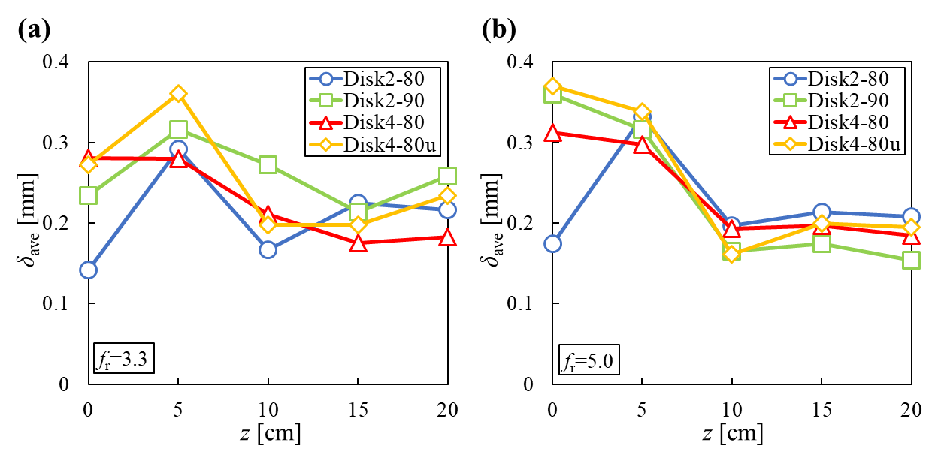

Figure 3: Average film thickness against the axial direction (volumetric flow rate is 58.7 mL/h)
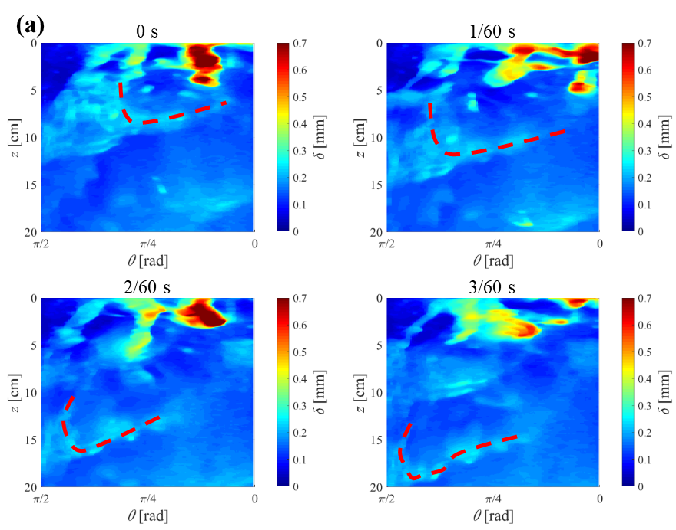

Figure 4: Snapshots of film thickness distribution in z-θ plane for the case of f_{r} = 3.3 Hz using Disk 2-80

Figure 5 shows the effect of the rotational speed of Disk 2-80 on the film thickness distribution. When increasing the rotational frequency to 5.0 Hz, relatively uniform film thickness distribution can be observed as compared with the case of 3.3 Hz. This indicates that the intensity of spatial fluctuation of film thickness becomes small with increasing the rotational speed of the disk. Figure 6 shows the effect of geometrical configuration of disk on the film thickness distribution when the rotational frequency of disk is 3.3 Hz. The film thickness distribution of Disk 2-90 is similar as that of Disk 2-80 but the liquid film in the Disk 2-90 case becomes thicker than in the Disk 2-80 and no region of 0 film thickness (δ = 0 mm) can be observed. When increasing the number of ditches from 2 to 4 (Disks 4-80 and 4-80u), more waves can be observed and the distributions become uniform as compared with the Disk 2-80 case. Furthermore, due to not equally distributed ditches when using Disk 4-80u, the coalescence of waves more frequently can be observed, which resulted in uniform distribution around the coalescence region.
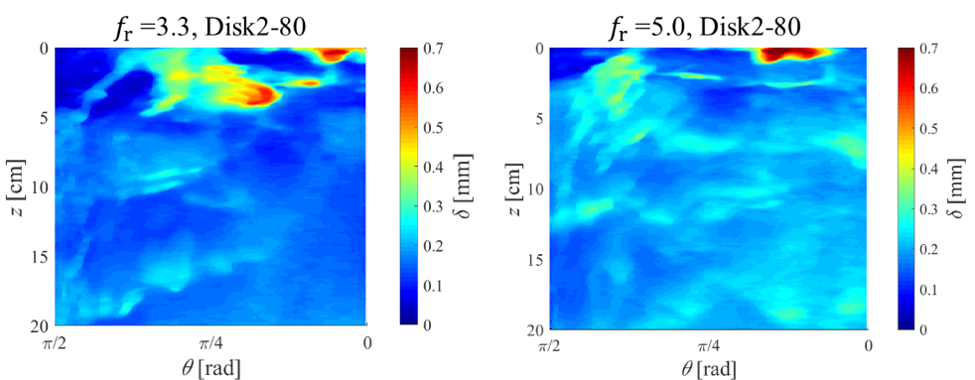

Figure5: Effect of the rotational speed of Disk 2-80 on the film thickness distribution
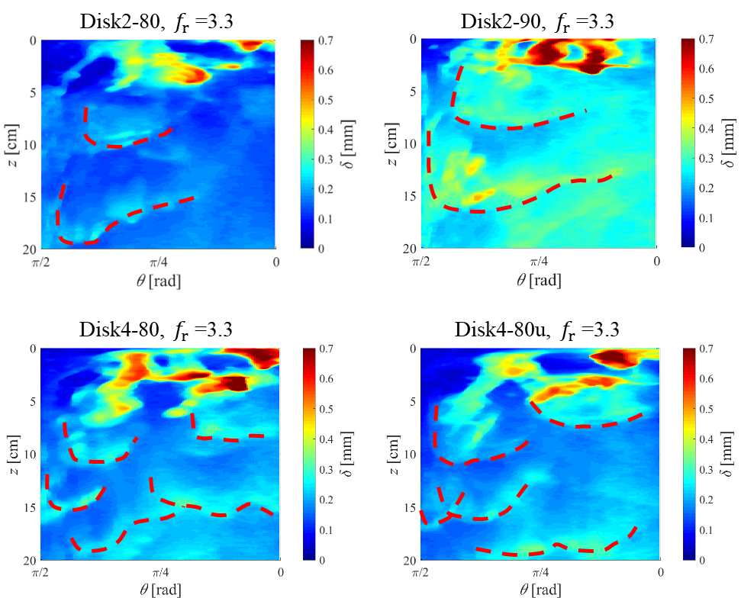

Figure 6: Effect of geometrical configuration of disk on the film thickness distribution

The frequency spectrum was obtained by making a Fourier transformation for the time series data of luminance. The maximum peak frequency at each position in the test section was detected as the characteristic frequency. Figure 7 a) shows the result of the normalized characteristic frequency of each disk at disk rotation frequency of 3.3, 5.0 Hz. Each characteristic frequency is obtained by the power spectrum of temporal variation of film thickness. In all cases except using Disk 4-80u, the number of ditches and the normalized characteristic frequency coincided. From this result, it was found that the characteristic frequency of film thickness depends on the number of ditches and disk rotation frequency.

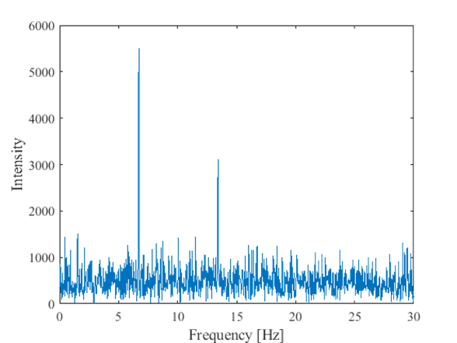
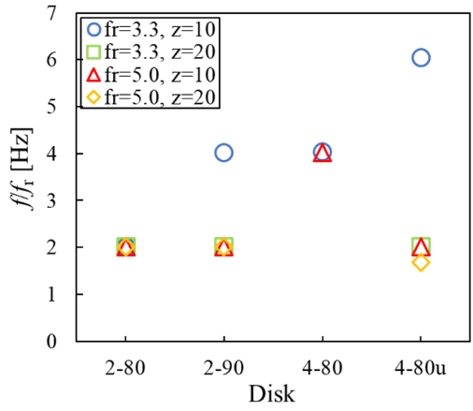
- b)

Figure 7: Normalized characteristic frequency of each disk at disk rotation frequency of 3.3, 5.0 Hz and typical example of power spectra of temporal variation of film thickness (f_{r}=3.3 Hz, z=10 cm, Disk 2-80)

From the heat transfer experiment, the dimensionless heat transfer coefficient (h⁺) for falling film was obtained by the following equation:
$$h^{+}=h_{h}\left(\frac{{μ_{h}}^{2}}{{κ_{h}}^{3}ρ^{2}g}\right)$$ | (2)
Figure 8 shows the effects of geometrical configuration of disk, and rotational frequency and film Reynolds number (Re_{h}) on the dimensionless heat transfer coefficient by taking the case of 3.3 Hz and Re_{h} = 259.3 with Disk 2-80 as the criterion for comparison. Among the cases shown in Figure 8 (a), the case of 3.3 Hz with Disk 2-80 shows the highest performance of heat transfer and the second best is the case of 3.3 Hz with Disk 2-90. On the other hand, as shown in Figure 8 (b), the heat transfer coefficient drastically decreases when the rotational frequency increases to 5.0 Hz or Re_{h} increases to 388.8. According to the previous discussion using the film thickness distribution, the case of 3.3 Hz with Disk 2-80 gives the widest region of very thin film thickness. Although the thickest film thickness distribution among the other conditions with 3.3 Hz can be seen in the case of 3.3 Hz with Disk 2-90, the circumferential velocity of Disk 2-90 is the highest. It can be, therefore, considered that the thinner film thickness, nonuniform film thickness distribution with high intensity due to large-scale wave, and higher circumferential velocity of liquid film are three major factors for heat transfer enhancement.
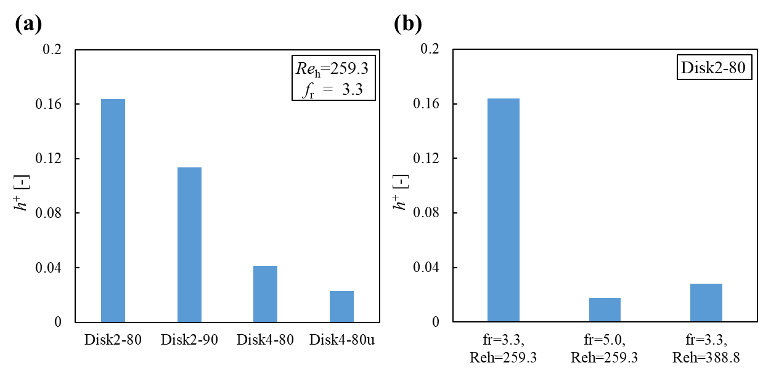

Figure 8: Effects of geometrical configuration of disk, and rotational frequency and film Reynolds number (Re_{h}) on the dimensionless heat transfer coefficient
  - Conclusions
This work investigated the flow states and heat transfer characteristics of the fluid jetted from the rotating disk with small ditches to the wall surface. The average film thickness of the flowing liquid film initially decreases in the axial direction and becomes constant. This means that the falling flow velocity of the liquid film gradually increases and then becomes constant. A U-shaped wave occurred due to periodically jetting flow from the ditches of disk. As the number of ditches of the disk becomes larger, more small waves were formed. As the disk diameter increased, the average film thickness increases and its film thickness distribution lost nonuniformity. The characteristic frequency of film thickness depended on the disk rotation frequency and the number of ditches of the disk. When the disk diameters were the same, higher rotation frequency and more the number of ditches, the smaller heat transfer coefficient. The correlation between film thickness distribution and heat transfer characteristics suggested that thinner film thickness, nonuniform film thickness distribution with higher intensity due to large-scale waves, and higher circumferential velocity of liquid film were three major factors to enhance heat transfer.
Acknowledgments
This research was financially supported by JSPS KAKENHI Grant Number JP18H03853.
References
Gonda A., Lancereau P., Bandelier P., Luo L., Fan Y., Benezech S., 2014, Water falling film evaporation on a corrugated plate, International Journal of Thermal Sciences, 81, 29–37.
Komori S., Takata K., Takao M., Murakami Y., 1990, The effects of scale-up on flow and operating characteristics in an agitated thin-film evaporator, Kagaku Kogaku Ronbunshu, 16, 960–968.
Shirakawa H., Kita Y., 2014, Heat transfer characteristics of falling-film-type heat exchanger, Transactions of the Society of Heating, Air-Conditioning and Sanitary Engineers of Japan, 39, 23–28.
Shirakawa H., Kita Y., 2016, Performance improvement of a falling-film-type heat exchanger by insertion of shafts with screw blade in a heat exchanger tube, Applied Thermal Engineering, 102, 55–62.
Yamaji H., 2002, Total site integration, PhD Thesis, Kobe University, Kobe, Japan.
Yang L., Liu Y., Yang Y., Shen S., 2016, Microscopic mechanisms of heat transfer in horizontal-tube falling film evaporation, Desalination, 394, 64–71.

