|  |  |
| --- | --- |
| cetlogo ***CHEMICAL ENGINEERING TRANSACTIONS***  ***VOL. 76, 2019*** | A publication of  aidiclogo_grande |
| The Italian Association  of Chemical Engineering  Online at www.cetjournal.it |
| Guest Editors: Sauro Pierucci, Jiří Jaromír Klemeš, Laura Piazza  Copyright © 2019, AIDIC Servizi S.r.l. **ISBN** 978-88-95608-73-0; **ISSN** 2283-9216 | |

OPTIMIZATION OF THE COPPER RECOVERY FROM PRINTED CIRCUIT BOARDS USING ARTIFICIAL INTELLIGENCE AS STRATEGY

Tamires P. Bezerraa, Alexandre V. Grillob , Brunno F. Santosa\*

a Department of Chemical and Material Engineering (DEQM). Pontifical Catholic University of Rio de Janeiro (PUC-Rio). Rua Marquês de São Vicente, 225 – Gávea, Rio de Janeiro – RJ, 22430-060, Brazil.

b Federal Institute of Education, Science and Technology (IFRJ), Rua LúcioTavares, 1045 – Centro, Nilópolis – RJ, 26530- 060, Brazil.

[bsantos@puc-rio.br](mailto:bsantos@puc-rio.br)

There is an increasing interest in the secondary sources of metals in order to compensate their potential supply deficit. Copper is the main component of printed circuit boards (PCBs) which is the main part of an electronic device. The manufacture of PCBs often releases huge amount of sludge, which contains copper. The process of copper leaching by hydrochloric acid solution was studied using experimental design methods using the Solver of Excel software. The parameters were simulated and simulated to evaluate the effect of the acid concentration and oxygen flow. The results obtained by prediction were compared with real experimental results. The intelligence modeling was confirmed by analysis of variance (ANOVA) and the model was able to predict the response. Through the investigation of response surface and contour curves, it was identified the conditions optimized for the process.

* 1. Introduction

Nowadays, electronic equipment has a wide range of functionalities, becoming increasingly smaller, but with a high complexity. In order to guarantee all this applicability, it is necessary to construct a quality structure, which allows the passage of current even in complex circuits.

Printed Circuit Boards (PCBs) are present in most electrical and electronic products, is considered the fundamental part of the equipment, since it is on the surface of the board that the compartments responsible for electrical conduction will be inserted. They can be produced from two methods, the additive or subtractive. This way, subtractive is the most used, in the board, which consists mostly of conductive material, the copper, has the circuit image printed from a screen-printing process or by laminating films. Then, the excess copper is removed by a corrosive reaction.

The corrosive agent used to produce printed circuit boards was Ferric chloride (FeCl3). However, the reaction with FeCl3 can be performed only once, which reduces the useful life of the reagent. In addition, the reaction produces as waste, complex substances that require a suitable final disposition.

For this reason, new reagents have now been added to the production lines, such as ammonium persulfate, sulphuric acid with hydrogen peroxide, alkaline solutions, copper chloride II, among others. Some of these reagents, such as cupric chloride, have the ability to regenerate through their interaction with an oxidizing agent; this property plays an important role in the development of sustainable and greener processes.

Yu et al. (2016) investigated the properties of the various reagents used in the industry to produce printed circuit boards. Noting that those who possessed the capacity for regeneration are the most attractive industrially, due to the more environmentally friendly techniques, being less polluting. Among these techniques, the author notes that the use of cupric chloride in an acidic medium has been the most used due to its high reaction capacity and low process cost.

Keskitalo et al. (2007) and Cakir (2006) also investigated the use of the acid solution; however, these authors only studied the use of hydrogen peroxide (H2O2) or sodium chlorate (NaClO3) as an oxidizing agent. The oxidation of CuCl2 is that it allows the renewal and recycling of the solution, however, the use of airflow, as oxidizing agent present, is still incipient.

Nevertheless, the determination of the optimal reaction condition becomes difficult due to the need to perform several tests. The experimental design was the applied solution since it allows an analysis of the experimental conditions in the range in which it is stipulated. This concede a greater knowledge of the studied system, which allows the choice of strategies that will optimize the process. While the genetic algorithm (GA) was used to evaluate the model's ability to predict the response from the comparison with real experimental results. There are studies that have been applied GA as optimization method such as Zang et al. (2018), Campos et al. (2018), Hu (2018), Wang (2018) and others.

The present work aims to investigate how the insertion of the air flow and different concentration of hydrochloric acid can affect the use of copper etching in the printed circuit board fabrication and consequently, in the recovery of the metal.

* 1. Materials and Methods
     1. Process of the printed circuit board production.

The development of the methodology was based on the works of Georgiadou (1993) and Cakir (2006). Firstly, printed circuit boards of size 4 cm by 4 cm were cleaned to remove any impurity and copper oxide present on the surface of the board. Then, a generic circuit designer was chosen, since the main objective of the research was the study of the behaviour and the efficiency of the copper removal reaction. The image of the circuit to the copper plate, on the experimental scale, was made with a Retro Maker OHP of the mark CIS. Whose ink constitutes properties capable of protecting the areas of interest in the copper foil, as well as the photoresist present in industrial production. For the performance of the tests 6 experimental conditions were investigated at room temperature: (i) 1 mol.L-1 HCl, (ii) 2.5 mol.L-1 HCl, (iii) 4.0 mol.L-1 HCl, (iv) 1 mol.L-1 HCl + 0.3 mol.L-1 CuCl2, (v) 2.5 mol.L-1 HCl + 0.3 mol.L-1 CuCl2 e (vi) 4.0 mol.L-1 HCl + 0.3 mol.L-1 CuCl2. Thus, the plates were immersed in a 500 mL beaker containing 300 mL of the solution. The reaction occurred in a shaker under continuous agitation and with the insertion of aeration rate, whose flow complied with the previously proposed experimental design. Aliquots of 25 mL were removed every 5 minutes until the reaction time of 20 minutes to investigate the removal of copper from the printed circuit board. At the end of the reaction time, the plates were cleaned with distilled water and stored, while the collected aliquots were followed for copper determination analysis.

* + 1. Experimental design

A full factorial design 22 with two independent variables (concentration of HCl and Aeration rate) were used to evaluate the copper concentration parameter present in the solution, which characterizes the leaching process of the printed circuit board. In total, seven runs were performed; four runs combinations between levels and three runs in the central points.

Table 1 describes the levels at which the parameters were evaluated. The variables concentration of hydrochloric acid and aeration rate were coded as X1 and X2, respectively.

Table 1: Values used in the experimental design for the copper removal

|  |  |  |  |  |
| --- | --- | --- | --- | --- |
| Variables | Code | -1 | 0 | 1 |
| Concentration of HCl (mol.L-1) | X1 | 1 | 2.5 | 4 |
| Aeration rate (L/min) | X2 | 0.5 | 1.25 | 2 |

The statistical model used in the prediction of the mass of copper removal shows a relation between the independent variables and the response, according to the polynomial equation shown in Eq. (1).

|  |  |
| --- | --- |
| $y= β_{0}+ β_{1}x_{1}$ + $β_{2}x_{2}$ + $β_{12}x_{1}x_{2}$ + e | (1) |

The variable “y” is the concentrations of copper present in the solution, the codes X1 and X2 represents independent variables. The parameters $β_{1}$, $β_{2}$ are the linear effects andβ12 describe the interaction between the independent variables. The random error which corresponds to the combination of levels is represented by *e*. In addition, the other terms represent the parameters of the regression model, which were estimated using the least squares method.

The genetic algorithm (GA) was structured in such a way that the information related to system may estimate the parameters from polynomial equation. It was investigated population size, a number of generations, selection and mutation functions in the restriction range from -10 to 10. GA differ from classical adjustment methods due to the existence of the restriction range. When performing the calculations within the stipulated range there is an overall analysis, which prevents the function from finding a local minimum or maximum. In this way, the values obtained will be a global maximum or minimum points. This reduces the adjustment error and allows an optimized parameter search method.

The process optimization was performed at Solver of Excel software using GA functions. All the parameters were determined through the minimization of the objective function (Eq. (2)), aiming to obtain modelled data as close as possible to the experimental data.

$F_{obj}=\sum{{\left({\hat{y}}_{i}-y_{i}\right)}^{2}}$ (2)

The quality of the model for copper removal content prediction was evaluated by the F-value obtained from the analysis of variance (ANOVA) and by the observed determination coefficient.

* + 1. Determination of copper

The titration technique with EDTA-PAR (4- (2-Pyridylazo) -resorcinol monosodium salt) from Merck E. (1972, pp.33-34) was used to determination of Cu ions present in solution. Samples were collected at different reaction times (t = 0 min, t = 5 min, 10 min, 15 min, and 20 min). These aliquots were diluted 100-fold and 20 mL of the solution was mixed with 0.1 mL of 25% hydrochloric acid, 0.4 g of ammonium acetate and 2 drops of indicator solution. The solution was titrated with 0.1 M EDTA until the yellow-red color changed to violet and then to green. For every 1 ml of 0.1 M solution of EDTA there is 6.354 mg of copper in the solution. Eq (3) shows the calculation of the mass concentration of copper present in solution per mL of EDTA.

|  |  |
| --- | --- |
|  | (3) |

* 1. Results and discussions

Firstly, the ideal titration condition of the solution from the leaching of the printed circuit board was evaluated. According to the methodology used, the technique should be done in solutions with concentrations less than or equal to 0.5 mg / mL. However, it was not specified which ideal pH for the formation of the EDTA-Copper complex required to determine the concentration of the metal present in solution. Thus, a speciation study was made to determine the most appropriate pH range. Figure (1) shows the developed diagram under conditions where there is an excess of EDTA.

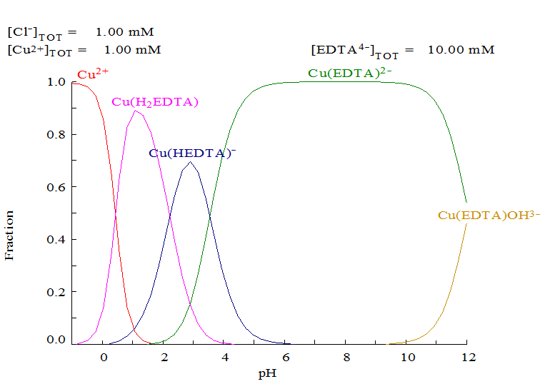

Figure 1: Speciation diagram for EDTA- copper complexes

From the speciation diagram, it is possible to verify that all copper present in solution will be complexed with EDTA in the pH range of 5-10. The pH range 5-6 was defined as ideal for the titration, since the indicator can also be used under these conditions.

After the titration, it was possible to obtain quantitatively the concentration of copper in the solution from the leaching, from these data an experimental *design* was developed with Solver of Excel software. Using the full factorial design, seven experiments were carried out with different values of each variable, to evaluate the influence of the same and their interactions in the leaching process.

Equation 4 describes the mathematical model developed with the genetic algorithm capable of predicting the mass of copper removed in the reaction. The genetic algorithm used to obtain this model presented a population with 1000 individuals with mutation rate in 40% and convergence of 10E-04.

|  |  |
| --- | --- |
| $y= -0.06181+ 0.352991x_{1}$ + $4.412517x_{2}$– *0.70599 $x_{1}x_{2}$* | (4) |

Table 2 shows the mean of the experimental results and the value estimated by the GA simulation to predict the mass of copper removed in the process.

*Table 2: Caparisons between experimental results and the value estimated by the GA simulation*

|  |  |  |  |  |
| --- | --- | --- | --- | --- |
| Runs | Variables |  | Copper Removal (g/L) | |
| Concentration of HCl (mol.L-1) | Aeration rate (L/min) | Experimental | Predicted |
| 1 | 1 | 0.5 | 2.3827 | 2.144447 |
| 2 | 4 | 2 | 4.7655 | 4.527237 |
| 3 | 1 | 2 | 7.9425 | 7.704231 |
| 4 | 4 | 0.5 | 2.3827 | 2.144429 |
| 5 | 2.5 | 1.25 | 3.4947 | 4.130086 |
| 6 | 2.5 | 1.25 | 3.177 | 4.130086 |
| 7 | 2.5 | 1.25 | 4.7655 | 4.130086 |

The first analysis was done through the ANOVA table (Table 3), which determined which of the factors analyzed had a significant effect on the response variable studied (copper concentration), considering the *F- value test*.

Table 3: Analysis of variance (ANOVA) for the prediction model of copper removal

|  |  |  |  |  |
| --- | --- | --- | --- | --- |
| Model Terms | Sum of Square | DF | Mean Square | F-Value |
| Regression | 20.81743 | 3 | 6.939 | 10.71 |
| Error | 1.94297 | 3 | 0.64766 | - |
| Total | 22.76046 | 6 | - | - |

The theoretical F-value for this case is 9.37. The calculated F-value is 10.71 that is larger than the theoretical, which indicates that the statistical model is suitable for the prediction. In addition, the coefficient of determination R2 of 91.46% emphasize that the statistical model can be used to representing the relationship between the variables.

From another perspective, through the Pareto diagram, Figure 2, it is observed that the aeration rate has a greater influence on copper removal. HCl concentration and the linear relationship between HCl concentration and aeration rate have the same value of effect, being this negative. This indicates that these variables did not have a significant influence for the model.

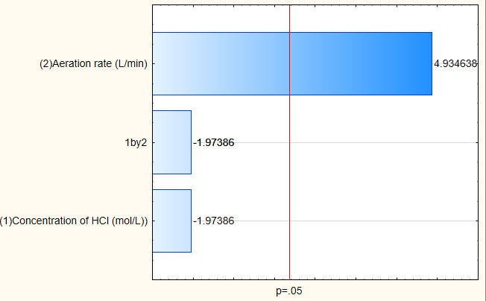

*Figure 2: Pareto Chart for the model obtained from experimental design*

From the analysis of response surface and contour curves, it is possible to verify that the increase of the aeration rate and the decrease of hydrochloric acid concentration leads to the higher value of mass of copper removal, which indicates that at that point, the leaching process was successful. However, for lower values of aeration rate, the surface shows the tendency that leads to a lower removal of copper. The same does not happen for the concentration of hydrochloric acid, which independently of the concentration shows a lower tendency of metal removal. Figure 3 shows the effects of HCl concentration and aeration rate variables on the predicted model

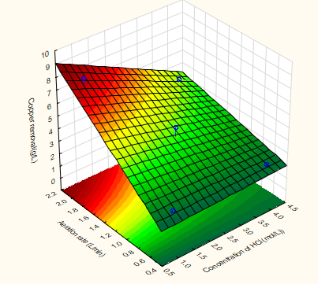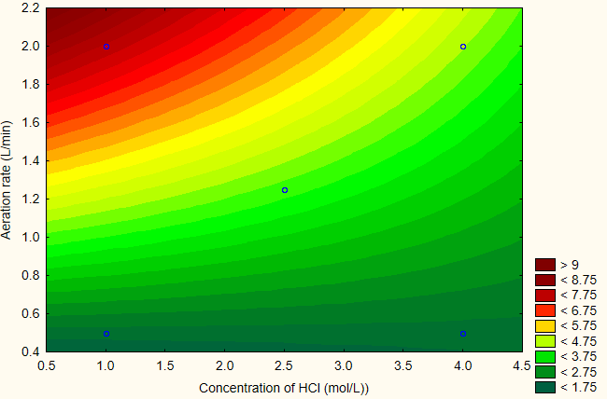

.

Figure 3: Effects of HCl concentration and aeration rate variables on the predicted model of copper removal.

Figure 4 illustrate the comparison of the experimental values ​​as the best result of the GA simulation. Even with several simulations, a significant change in the regression coefficients was not observed, which shows that the model is at its optimal point of adjustment.

1. (b)

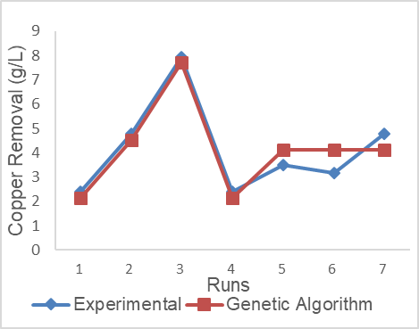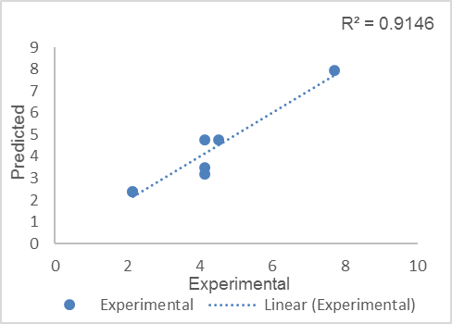

Figure 4: Regression plot of experimental and modelled data (a) and the comparison between experimental values as the best result of the GA simulation (b)

* 1. Conclusions

From the experimental design, it was possible to construct a mathematical model to evaluate the mass of copper removed from the PCB. The model developed with the Genetic Algorithm was satisfactory in the prediction of the metal content removed, with a correlation coefficient of 91.46%. The response surface methodology was used to optimize the process conditions. Thus, the production of Printed Circuit Boards is suitable in solutions of hydrochloric acid in the presence of oxygen flow. Therefore, the optimized process condition is the HCl concentration of 1M and an aeration rate of 2.0 L / min.

* 1. References

Campos A.L., Nogueira J., Coelho F.A., Fileti A.M.F., Santos B. (2018) Genetic algorithm optimization of the parameters involved in biosurfactant production from beet peel as substrate, Chemical Engineering Transactions, 65, 469-474 DOI: 10.3303/CET1865079

Cakir, O. (2006). Copper etching with cupric chloride and regeneration of waste etchant. Journal of Materials Processing Technology, 175(1-3), pp.63-68.

Georgiadou, M. and Alkire, R. C. (1993). Anisotropic Chemical Etching of Copper Foil. Journal of The Electrochemical Society, 140(5), pp.1340-1347.

Georgiadou, M. and Alkire, R. C. (1993). Anisotropic Chemical Etching of Copper Foil. Journal of The Electrochemical Society, 140(5), pp.1348-1355.

Hu M. (2018) Optimizing back propagation neural network with genetic algorithm for man-hour prediction in chemical equipment design, Chemical Engineering Transactions, 66, 877-882 DOI:10.3303/CET1866147

Keskitalo, T., Tanskanen, J. and Kuokkanen, T. (2007). Analysis of key patents of the regeneration of acidic cupric chloride etchant waste and tin stripping waste. Resources, Conservation and Recycling, 49(3), pp.217-243.

Merck, E. Métodos complexométricos de valoración con titriplex. (1972). Darmstadt: Merck, pp.33-34.

Wang G. (2018) A study on optimization of chemical logistics route based on improved genetic algorithm, Chemical Engineering Transactions, 66, 1435-1440 DOI:10.3303/CET1866240.

Yu, M., Zeng, X., Song, Q., Liu, L. and Li, J. (2016). Examining regeneration technologies for etching solutions: a critical analysis of the characteristics and potentials. Journal of Cleaner Production, 113, pp.973-980.

Zhang T., Guo J., Yan Q., 2018, Optimization of hazardous pol transportation problem based on simulated annealing genetic algorithm, Chemical Engineering Transactions, 66, 1471-1476 DOI:10.3303/CET1866246.