CHEMICAL ENGINEERING TRANSACTIONS  VOL. 76, 2019 | A publication of
The Italian Association
of Chemical Engineering
Online at www.cetjournal.it
Guest Editors: Sauro Pierucci, Jiří Jaromír Klemeš, Laura Piazza
Copyright © 2019, AIDIC Servizi S.r.l.
ISBN 978-88-95608-73-0; ISSN 2283-9216

Development of Mathematical Model Based on Artificial Neural Network to Predict Density in Polymerization Process of Styrene
Isabelle C. Valimª, Alessandra M. M. Silvaª, Alexandre V. Grillo^{b}, Brunno F. dos Santos ^{a,}*
ªDepartment of Chemical and Materials Engineering (DEQM), Pontifical Catholic University of Rio de Janeiro (PUC-Rio). Rua Marquês de São Vicente, 225 – Gávea, Rio de Janeiro – RJ, 22430-060, Brazil.
^{b}Federal Institute of Education, Science and Technology (IFRJ). Rua Lúcio Tavares, 1045 – Centro, Nilópolis – RJ, 26530-060, Brazil.
bsantos@puc-rio.br
In the chemical industry is important to control the process in order to guarantee the quality and repeatability of the final product. Using sensors in the industrial plant allows a large volume of data to be captured regarding the process. These data can be used for modelling to better understanding and predict the properties of the product in the process. In this work, two types of Artificial Neural Networks (ANN) and the hybrid model Adaptive Neuro Fuzzy Inference System (ANFIS) were used to predict the density of polystyrene along the styrene polymerization process. The dataset used was extracted from the batch of polymerization reactions performed in open-loop, manual control and closed-loop and monitored in each 5 seconds. The Feedforward and Elman ANN has coefficient of correlation (R) equal 94.2%. However, the best topology obtained to Feedforward ANN presents 2 hidden layers and error index RMSE (Root Mean Squared Error) equal to 2.69x10⁻². The Elman ANN presents only 1 hidden layer and RMSE of 3.39x10⁻². The ANFIS model, in turn, presented R equal to 91% and RMSE of 0.2123. Therefore, ANFIS model did not prove to be the most adequate for the prediction of the polystyrene density in the studied process.
  - Introduction
Polystyrene is the styrene polymerization product that can be used in fiberglass, laminates, rubber and resins found in consumer products and commercial and residential building materials (Werder et al., 2018). Polystyrene is also used by painters and vehicle repair shop works and in sewer pipe reconstruction as well (Persoons et al., 2018). Furthermore, polystyrene can be used in the food processing and packaging industry (Sanahuja-Parejo et al., 2018).
Polymerization process pose significant challenges to the industrial community as it is difficult to control with high nonlinearity behaviour and fast dynamic response. The monitoring and control of polymer processes guarantee to the final product the qualities required by the market. Muhammad and Aziz (2017), for instance, studied the production of low density polyethylene (LDPE) and presented a review of the control strategies developed for the LDPE process. The strategies presented were developed in tubular and autoclave reactors and highlights the importance of nonlinear control in polymerization process.
The use of sensors to monitor production allows a large volume of process data to be collected. Therefore, it is necessary to construct mathematical models of prediction to interpret and correlate significant patterns, indispensable to assist in the management of decisions and risk analysis.
The development of phenomenological models for polymerization is complex and requires deep knowledge about the processes involved in each step. Modelling using artificial intelligence is a strategy that can provide valuable information about the process and allows the construction of an intelligent model capable of predicting process response based on parameters provided. ANN and ANFIS are artificial intelligence tools that can be used to build predictive models. In supervised learning, the data are presented to the network and its main objective is to provide a model that correctly correlates the pairs inputs - outputs of the problems. The use of ANN and ANFIS to predict the density of the polystyrene produced in the process becomes attractive since it is a type of non-linear modelling.
Jumari and Mohd-Yusof (2017) presents models to measure melt flow index (MFI) in industrial polypropylene loop reactors using first principle (FP) model and ANN model. The authors state that the prediction of the ANN model is more accurate compare to the MFI calculated by the FP model. Furthermore, the CPU time recorded that ANN model is much faster than FP model.
This work aims to develop direct and recursive ANN and ANFIS models from a set of experimental data from a controlled styrene polymerization plant capable of predicting the density of the product satisfactorily.
  - Materials and Methods
The experiments were performed according Santos et al., 2013. Figure 1 shows the prototype used to study the behaviour of the polystyrene density in the batch styrene polymerization process.
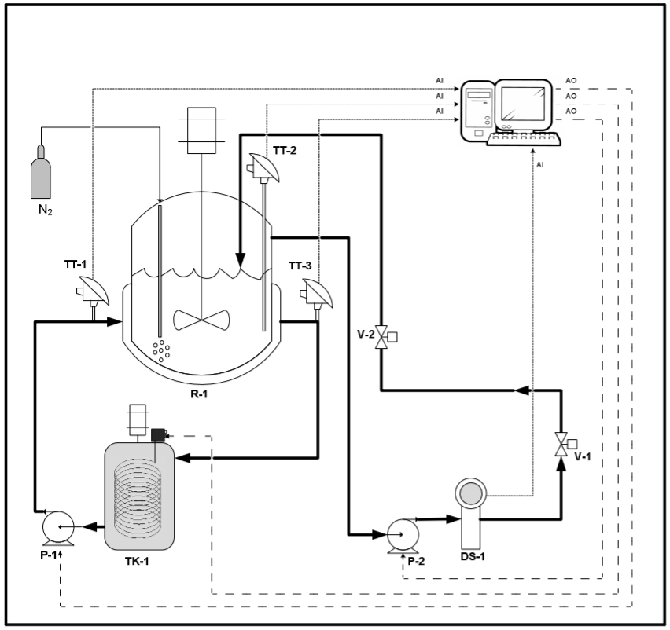
Figure 1. Scheme of the polymerization experimental prototype

This prototype was composed by a jacketed stainless steel reactor (R-1) with 2L, a 7L thermal fluid storage tank (TQ-1) with agitator and system of heating, two positive displacement pumps (P-1 and P-2), a thermal oil circulation through the reactor jacket and another for the reaction mixture to pass through a specific mass sampling (DS-1), three temperature sensors located inside the reactor (TT-2), at inlet (TT-1) and at outlet of the jacket (TT-3) and a nitrogen (N₂) bubbling system.
The reaction mixture of 1100 mL, consisting of 50% styrene and 50% toluene in volume, was heated by thermal exchange until reaching 90ºC, which is the condition to start the reaction. The nitrogen was bubbled into the mixture all the time. To initiate the reaction by free radical, was added 6.57g of benzoyl peroxide. In this process, the controlled variable was the temperature of the reactor by manipulating the power of the resistance in the tank. The supervision of the system was adopted every 5 seconds.
In this work, two types of neural models (Feedforward and Elman) and ANFIS model were developed for the prediction of polystyrene density behaviour. The dataset used for training and testing of the neural models totalizes 6,732 information arrays extracted from 3 experiments randomly selected from the batch of polymerization reactions performed in open-loop, manual control and closed-loop with a conventional controller tuned by Ziegler-Nichols method.
For all types of ANN and ANFIS developed, the input variables were temperature inside the reactor, temperature input and temperature output of the jacket and power variation. The output variable was the behaviour of the polystyrene density. In ANN models, the activation functions for the hidden layer neurons tested were tansig and logsig and the training algorithms were trainbr and trainlm. In ANFIS model, the Sugeno inference method with subtractive clustering and the hybrid training algorithm was used. To evaluate the performance of the ANN and ANFIS models, the value of coefficient of correlation (R) and error index RMSE (Root Mean Squared Error) was observed.
  - Results and Discussion
The data set used to develop the neural models was normalized between 0 and 1 and was divided in approximately 70% for training and 30% for testing of the models.

The Feedforward ANN was used to develop the first model studied. Table 1 shows several topologies with one and two hidden layers were heuristically tested.
Table 1: Several topologies tested with one and two hidden layers for Feedforward ANN
Model | Hidden layer 1 |  | Hidden layer 2 |  | Training algorithm | R | RMSE
 | Neurons | Activation Function | Neurons | Activation Function
ANN1 | 6 | tansig | - | - | trainbr | 93.80 | 3.12E-02
ANN2 | 6 | tansig | - | - | trainlm | 64.16 | 3.28E-02
ANN3 | 6 | logsig | 6 | logsig | trainbr | 86.84 | 2.77E-02
ANN4 | 6 | logsig | 6 | tansig | trainlm | 94.20 | 2.69E-02
ANN5 | 8 | logsig | - | - | trainlm | 82.71 | 2.85E-02
ANN6 | 10 | logsig | 8 | tansig | trainlm | 84.14 | 2.38E-02
ANN7 | 8 | logsig | 10 | tansig | trainlm | 87.02 | 2.33E-02
ANN8 | 12 | logsig | - | - | trainbr | 76.27 | 2.87E-02
ANN9 | 10 | tansig | 8 | tansig | trainlm | 85.89 | 2.61E-02
ANN10 | 10 | logsig | 8 | logsig | trainlm | 92.27 | 2.48E-02
ANN11 | 25 | tansig | - | - | trainbr | 67.70 | 2.80E-02
ANN12 | 20 | logsig | 20 | tansig | trainlm | 81.04 | 2.44E-02

In this model, the use of a large number of neurons in the hidden layers did not provide an improvement in the R. However, the use of the second hidden layer was efficient in order to obtain a lower RMSE. Figure 2 presents the coefficient of correlation for the topology ANN4, best suited to the problem, as well as the behaviour of the predicted response with respect to the experimental response. This topology presented 6 neurons in the first hidden layer and 6 neurons in the second hidden layer. The activation functions used were logsig and tansig, respectively and the training algorithm used was trainlm. This model presents R equal to 94.20% and RMSE of 2.69x10⁻².
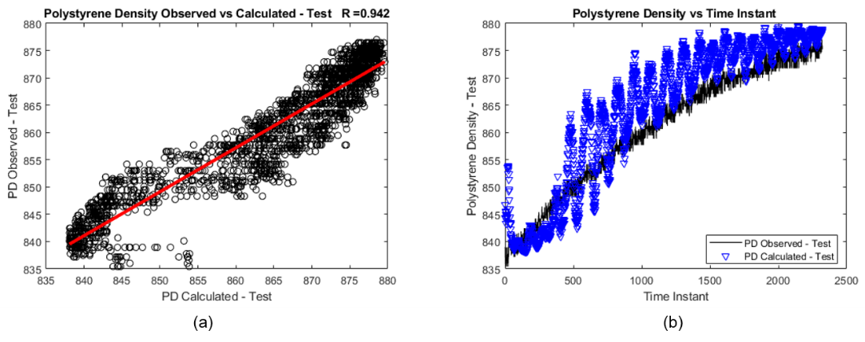
Figure 2. Regression diagram for the Feedforward ANN4 test step (a) and representation of the behaviour of the predicted data in relation to the experimental data of each sample (b)
In parallel, the Elman ANN was used to develop a second neural model. Table 2 shows several topologies with one and two hidden layers were heuristically tested.
Table 2: Several topologies tested with one and two hidden layers for Elman ANN
Model | Hidden layer 1 |  | Hidden layer 2 |  | Training algorithm | R | RMSE
 | Neurons | Activation Function | Neurons | Activation Function
ANN1 | 6 | tansig | - | - | trainlm | 94.20 | 3.39E-02
ANN2 | 6 | tansig | - | - | trainbr | 70.92 | 3.62E-02
ANN3 | 6 | logsig | 6 | logsig | trainlm | 87.87 | 2.93E-02
ANN4 | 6 | tansig | 6 | logsig | trainlm | 93.04 | 3.14E-02
ANN5 | 8 | logsig | - | - | trainlm | 91.12 | 3.43E-02
ANN6 | 10 | logsig | 8 | tansig | trainlm | 92.68 | 2.93E-02
ANN7 | 8 | logsig | 10 | tansig | trainlm | 86.30 | 2.96E-02
ANN8 | 12 | logsig | - | - | trainbr | 80.20 | 3.34E-02
ANN9 | 10 | tansig | 8 | tansig | trainlm | 52.62 | 2.99E-02
ANN10 | 10 | logsig | 8 | logsig | trainlm | 77.85 | 2.79E-02
ANN11 | 25 | tansig | - | - | trainbr | 91.92 | 3.11E-02
ANN12 | 20 | logsig | 20 | logsig | trainlm | 87.97 | 3.00E-02

In this model, as in the previous case, the use of a large number of neurons in the hidden layers did not provide an improvement in the R. The use of the second hidden layer was efficient in order to obtain a lower RMSE. However, is observed a diminution in the R value. Figure 3 presents the coefficient of correlation for the topology ANN1, best suited to the problem, as well as the behaviour of the predicted response with respect to the experimental response. This topology presented 6 neurons in the hidden layer. The activation function used was tansig and the training algorithm used was trainlm. This model presents R equal to 94.20% and RMSE of 3.39x10⁻².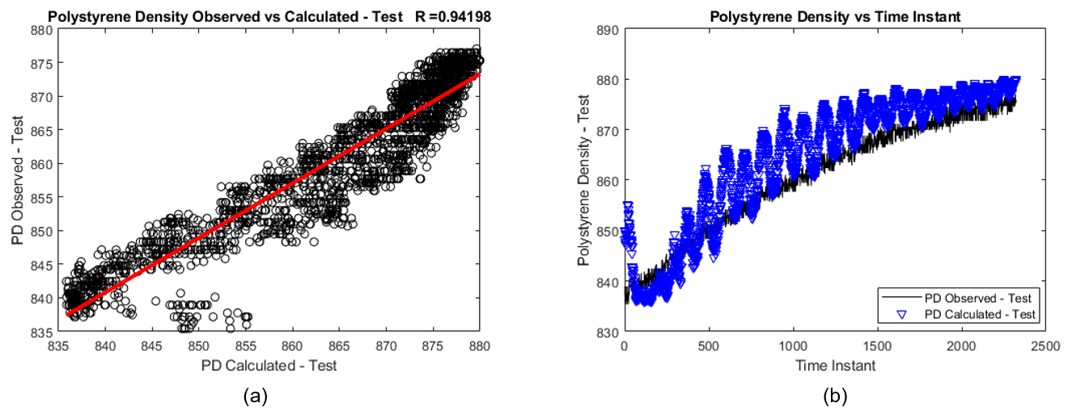
Figure 3. Regression diagram for the Elman ANN1 test step (a) and representation of the behaviour of the predicted data in relation to the experimental data of each sample (b)

In the Feedforward and Elman ANN models, the prediction behaviours seen in Figure 2(b) and Figure 3(b) did not show a good correlation with the experimental data. However, the trend of observed experimental behaviour was followed and, in a process with a big data scenario, these results are satisfactory.

As well as the ANN models, the ANFIS model also concerned the prediction of polystyrene density behaviour. Figure 4 shows the coefficient of correlation for this model and the behaviour of the predicted response with respect to the experimental response. In this model, the Gaussian curve membership function with 4 rules was obtained (the logical operation is and), presenting R equal to 91.03% and RMSE of 0.2123.

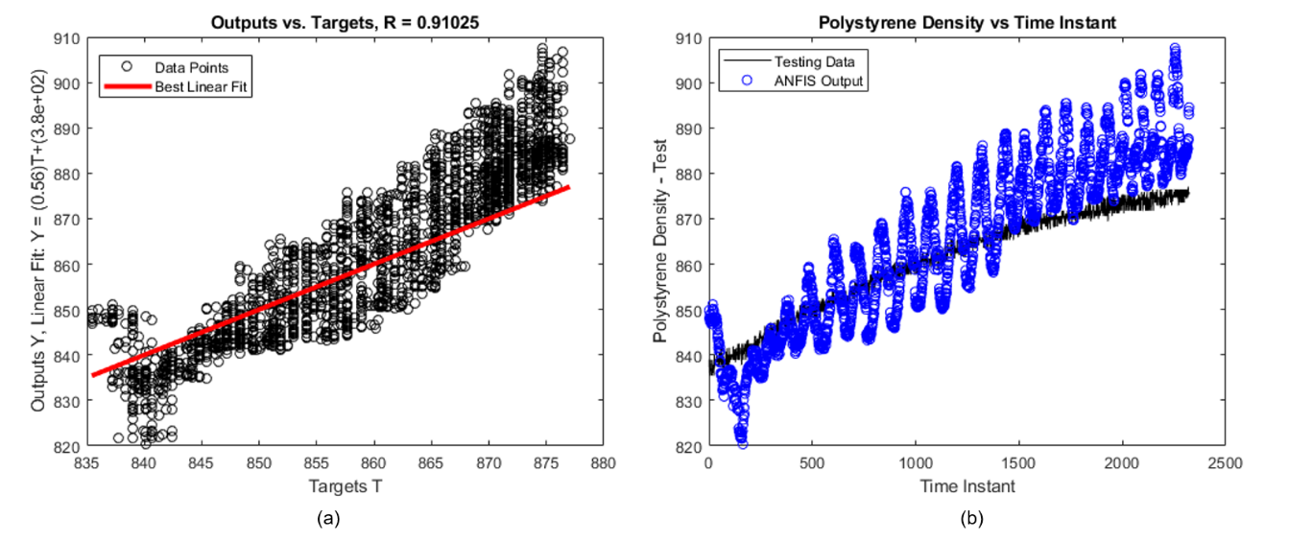
Figure 4. Regression diagram for the ANFIS model test step (a) and representation of the behaviour of the predicted data in relation to the experimental data of each sample (b)
It is important to emphasize that the ANFIS model presented a distinct dynamic of the neural models. While the ANN models best fit the data at the upper end of the curve, the ANFIS model presents better fit in the inflection region of the experimental curve.
Figure 5 presents the best topologies used in all studied models. Figure 5(a), 5(b) and 5(c) represent the best topologies to Feedforward ANN, Elman ANN and ANFIS model, respectively.
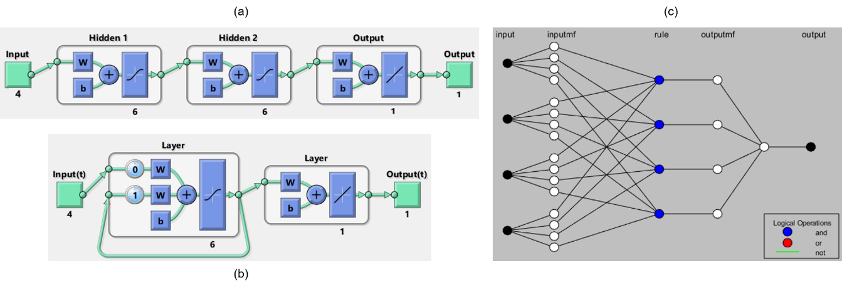

Figure 5. Best topologies to Feedforward ANN (a), Elman ANN (b) and ANFIS model (c).
Few studies report the use of ANN as a tool for the construction of prediction models in the polymer industry. In Altarazi et al. (2018), Feedfoward ANN was used to predict and optimize three properties (tensile strength, ductility and density) of PVC composites. There are no reports of work on the use of Elman ANN and ANFIS as tools to model the behaviour of polystyrene density. Studies in this area are relevant, since the developed models allow the prediction of the final properties of the polymers. With models, it is possible to construct response surfaces from which optimal conditions can be inferred to achieve higher yield and product quality.
  - Conclusions
The ANN and ANFIS models presented good prediction efficiency with RMSE values close to 0 and R values close to 1. The Feedforward ANN for polystyrene density behaviour prediction had a better performance when compared with the others. The model developed with Feedforward ANN presented two intermediate layers, while the model developed with Elman ANN presented satisfactory using only one intermediate layer. However, even with distinct topologies, these models showed trends of predictions very similar with R of 94.2%. The ANFIS model, on the other hand, was not shown to be the most suitable for predicting the polystyrene density in the process, presenting R of 91%. It is important to note that the polystyrene density is a value that corrects itself ahead throughout the time. Thus, it is recommended to use time series to predict this variable, as well as to use a more appropriate ANN type, such as the NARX ANN.
Acknowledgments
The authors would like to acknowledge the financial support of Coordination for the Improvement of Higher Education Personnel (CAPES).
References
Altarazi, S., Ammouri, M., Hijazi, A., 2018, Artificial neural network modeling to evaluate polyvinylchloride composite’s properties, Computational Materials Science, 153, 1 – 9.
Jumari, N. F., Mohd-Yusof, K., 2017, Comparison of Melt Flow Index of Propylene Polymerisation in Loop Reactors using First Principles and Artificial Neural Networks Models, Chemical Engineering Transactions, 56, 163 – 168.
Muhammad, D., Aziz, N., 2017, Review: Control Schemes for Low Density Polyethylene Reactor, Chemical Engineering Transactions, 56, 769 – 774.
Persoons, R., Richard, J., Herve, C., Montlevier, S., Marques, M., Maitre, A., 2018, Biomonitoring of styrene occupational exposures: Biomarkers and determinants, Toxicology Letters, 298, 99 – 105.
Sanahuja-Parejo, O., Veses, A., Navarro, M. V., López, J. M., Murillo, R., Callén, M. S., García, T., 2018, Drop-in biofuels from the co-pyrolysys of grape seeds and polystyrene, Chemical Engineering Journal, <https://doi.org/10.1016/j.cej.2018.10.183>.
Santos, R. R. C., Santos, B. F., Fileti, A. M. F., Silva, F. V., Zemp, R. J., 2013, Application of Artificial Neural Networks in an Experimental Batch Reactor of Styrene Polymerization for Predictive Model Development, Chemical Engineering Transactions, 32, 1399 – 1404.
Werder, E. J., Engel, L. S., Richardson, D. B., Emch, M. E., Gerr, F. E., Kwok, R. K., Sandler, D. P., 2018, Environmental styrene exposure and neurologic symptoms in U.S. Gulf coast residents, Environment International, 121 Part 1, 480 – 490.

