|  |  |
| --- | --- |
| cetlogo ***CHEMICAL ENGINEERING TRANSACTIONS***  ***VOL. 76, 2019*** | A publication of  aidiclogo_grande |
| The Italian Association  of Chemical Engineering  Online at www.cetjournal.it |
| Guest Editors: Sauro Pierucci, Jiří Jaromír Klemeš, Laura Piazza  Copyright © 2019, AIDIC Servizi S.r.l. **ISBN** 978-88-95608-73-0; **ISSN** 2283-9216 | |

Thermogravimetric study of raw and recycled polyethylene using genetic algorithm for kinetic parameters estimation

Artur S. C. Regoa, Alessandra de Santanab, Alexandre V. Grillob, Brunno F. Santosa,\*

aDepartment of Chemical and Materials Engineering (DEQM), Pontifical Catholic University of Rio de Janeiro (PUC-Rio). Rua Marquês de São Vicente, 225 – Gávea, Rio de Janeiro – RJ, 22430-060, Brazil.

bFederal Institute of Education, Science and Technology (IFRJ), Rua Lúcio Tavares, 1045 – Centro, Nilópolis – RJ, 26530-060, Brazil.

bsantos@puc-rio.br

Long-life packages are composed by two main materials: paper and low-density polyethylene (LDPE) with aluminium composite. Usually, the packages are disposed in landfills, generating an environmental impact due to its increasing consume. Recycling could be a solution if the recycled and raw materials used in the production have the same properties, being necessary to perform tests to identify the similarities and differences of each material. This study aims the study of thermal decomposition behaviour and kinetic parameters estimation of raw and recycled long-life packages low-density polyethylene using thermogravimetric analysis (TGA) under inert condition in temperature range of 25 – 700 °C. Classical methods, for example Kissinger and Ozawa, depend on many heating rates to determine kinetic parameters. Stochastic global search algorithms, such as Genetic Algorithm (GA), have great potential in parameter estimation using only one heating rate. The software Matlab 2018b was used to calculate all the models and the efficiency was evaluated using the determination coefficient (R²). The results showed a difference in the reaction order but similar pre-exponential and activation energy values.

* 1. Introduction

Plastics have a major role in the industry, due to their properties, such as light weight, low costs and good mechanical properties. On the other hand, the increasing consume of plastic is continuously causing a waste management problem, because of long degradability time. Most of the plastic waste material is dumped in landfills causing environmental concern (Saadan et al., 2017). One of these is long-life packaging which has a multi-layered structure constituted by three different materials: paper, LDPE and aluminium. That combination is a good protection for packing food, but also represents a problem when it comes to separate the materials for recycling. The paper can be easily degraded and used in the cellulosic industry. However separation of aluminium and LDPE is not simple, normally ending up with incineration of the material, which causes effects on greenhouse gas emissions (Santana, 2010).

As these components can have further application when recycled, and its thermal behaviour is one of the most important elements for waste management (Bujak, 2015). In order to have good knowledge of the material decomposition, it is necessary to perform a thermogravimetric analysis (TGA). This is the most common technique used to study the kinetics of devolatilization of different materials, such as natural fibres, various types of biomass and plastics (Slopiecka et al., 2012). Monteiro et al. (2018) reported the use of TGA to study thermal decomposition of green coconut fibre with a catalyst, to obtain the kinetic parameters values, reaction order, pre-exponential factor and activation energy. The classical approach to determine these parameters involves performing TGA in various heating rates and applying the acquired data in different graphical methods, used for example by Ozawa (Ozawa, 1970) and Kissinger (Kissinger, 1957). Recent studies using Artificial Intelligence (AI) can help to optimize problems with parameters required by classical methods. In this study, genetic algorithm (GA) was used as an optimization method for achieving the kinetic mechanism of raw and recycled LDPE. This method is based in biological principles, each candidate solution representing an individual in a population. In this case, the candidate solution represents a set of kinetic parameters and the environment is the mathematical formulation of the problem. Comparing this method with the classical optimization ones for non-linear problems, GA is a method that has a good capacity of finding the global minima (Rein et al., 2006).

Campos et al. (2018) used GA to optimize kinetic parameters related to the biosurfactant production from beet peel and Saha et al. (2008) used the same method to find the best model and kinetics parameters of thermal decomposition of plastics.

* 1. Materials and methods
     1. Determination of aluminum amount in recycled LDPE

In order to determine the aluminum quantity present in the recycled material, calcination was performed. Both materials (raw and recycled LDPE) were tested in the analysis for comparison. The material (1.0 g) was weighted in a crucible and placed in a muffle at 600 °C for 3 h. The mass difference of the crucible before and after the test represents the aluminum amount in the sample. The tests were performed in triplicates.

* + 1. Thermogravimetric analysis

Thermal degradation study was carried out using TGA in inert environment (nitrogen gas) at 10 °C/min heating rate in a temperature range of 25 – 700 °C. Around 10 mg of both materials were used in the analysis in order to acquire data for kinetic study. The tests were performed in triplicates.

* + 1. Modelling of TGA data

The mass balance for the decomposition of raw and recycled LDPE followed Eq.(1) (Speyer, 1993).

$\frac{df}{dt}=k_{0}.m_{0}^{n-1}{\left(1-f\right)}^{n}e^{-\frac{E_{A}}{RT}}$ (1)

Where $f$ is the normalized weight loss, $k_{0}$ is the pre-exponential factor of Arrhenius equation in min-1, is the initial mass of the sample in mg, $n$ is the reaction order, $E_{A}$ is the activation energy in J, $T$ is the temperature in K and $R$ is the universal gas constant in J.mol-1.K-1.

The process optimization was performed in Matlab 2018b using GA functions. Different migration and crossover fractions values were tested in the kinetic study of both raw and recycled LDPE. The population size for raw LDPE was 10000 and for recycled LDPE was 50000 due to the complexity of the problem. All the parameters were determined through the minimization of the objective function (Eq. (2)), aiming to obtain modelled data as close as possible to the experimental data.

$F_{obj}=\sum{{\left({\hat{y}}_{i}-y_{i}\right)}^{2}}$ (2)

Where ${\hat{y}}_{i}$ is the experimental value and $y_{i}$ is the predicted data from the model.

* 1. Results and discussion

The values related to the calcination are shown in Table 1. As expected, the recycled material ended up with higher amount of weight at the end of the test, due to the presence of aluminum. From the data collected, the recycled LDPE had around 7.5 %wt. in its composition.

Table 1: Results of calcination analysis for raw and recycled LDPE.

|  |  |  |  |  |  |  |
| --- | --- | --- | --- | --- | --- | --- |
|  | LDPE | | | LDPEAl | | |
|  | Initial wt. (g) | residual wt. (g) | residual wt. (%) | Initial wt. (g) | residual wt. (g) | residual wt. (%) |
| 1 | 1.0008 | 0.0005 | 0.05 | 1.0018 | 0.0802 | 8.00 |
| 2 | 1.0098 | 0.0007 | 0.07 | 1.0016 | 0.0677 | 6.76 |
| 3 | 1.0015 | 0.0004 | 0.04 | 1.0013 | 0.0788 | 7.87 |
| Average | 1.0040 | 0.0005 | 0.05 | 1.0016 | 0.0756 | 7.54 |
| Standard deviation | 0.005 | 0.00015 | 0.02 | 0.00025 | 0.0068 | 0.68 |

LDPEAl: Low density polyethylene with residual aluminum.

Figure 1 shows TGA result for both raw and recycled LDPE. As expected, the two curves follow the same pattern, with the decomposition starting around 400 °C and ending around 460 °C. Also, as expected, recycled LDPE ended with weight fraction higher than the raw material due to the presence of aluminum in its structure.



Figure 1: TGA result for raw and recycled LDPE.

For the mathematical modelling of TGA analysis, the objective function used was difference of experimental and simulated values of $\frac{df}{dt}$ as shown in Eq. (1). The best result GA simulation for the raw LDPE is depicted in Figure 2. The graphic on the left shows that experimental and simulated values have good agreement with the scatter points close to a linear curve. The graphic on the right shows the values of $\frac{df}{dt}$ for each sample analysed, also showing that the kinetic parameters are well adjusted in the model given the proximity of experimental and simulated data.

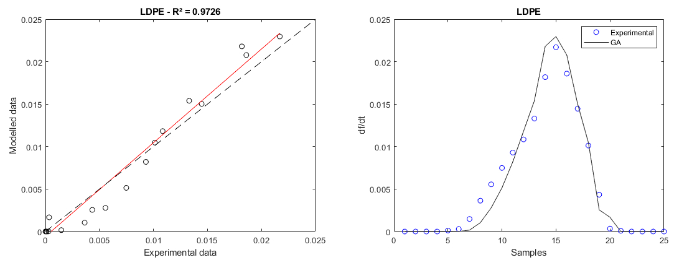

Figure 2: Regression plot of experimental and modelled data (left) and the value in each sample (right) for raw LDPE.

The models specifications and results are shown in Table 2. All models have determination coefficient value above 0.9, exhibiting the good adjustment reached by GA algorithm. Furthermore, changing the migration and crossover fraction values did not result in great impact in the models fitting in this case. The reaction order values presented a small difference between models, ranging from 0.7 to 1.0, but the pre-exponential factor and activation energy showed values in the same order of magnitude. These values are in the same range to the ones reported by Das and Tiwari (2017) and Kayacan and Dogan (2008) that used classical modelling to determine the kinetic parameters of LDPE decomposition.

Table 2: Reaction order (n), pre-exponential factor (K0), activation energy (EA) and determination coefficient for each proposed model for raw LDPE.

|  |  |  |  |  |  |  |
| --- | --- | --- | --- | --- | --- | --- |
| Model | Migration fraction | Crossover fraction | n | K0 (min-1) | EA (J.mol-1) | R² |
| 1 | 0.3 | 0.7 | 0.9 | 4.86E+20 | 3.01E+05 | 0.9726 |
| 2 | 0.4 | 0.7 | 0.8 | 2.27E+20 | 2.97E+05 | 0.9711 |
| 3 | 0.2 | 0.85 | 0.7 | 4.76E+20 | 3.01E+05 | 0.9360 |
| 4 | 0.4 | 0.6 | 1.0 | 2.9E+20 | 2.99E+05 | 0.9677 |

The best result of the kinetic parameters optimization using GA algorithm for recycled LDPE is depicted in Figure 3. Despite having a worse adjustment compared with raw LDPE, the model showed good capacity in determining reaction order, pre-exponential and activation energy. The graphic on the left shows scatter points and trend line next to linearity and the graphic on the right shows that even though the model was not capable of having the exact values as the experimental data, the simulated data follows the expected pattern.

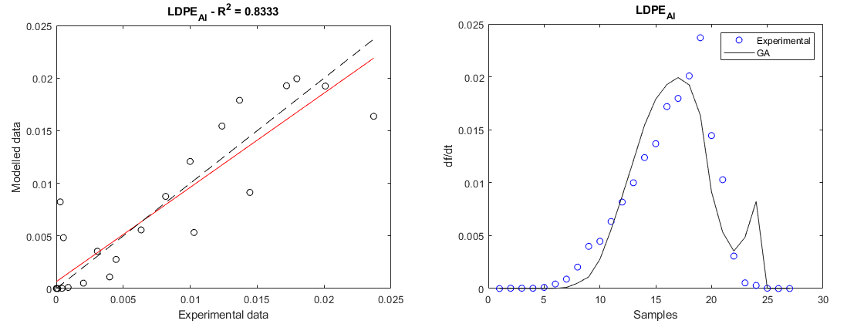

Figure 3: Regression plot of experimental and modelled data (left) and the value in each sample (right) for recycled LDPE.

Table 3 shows the results and specifications of each tested model. The majority of the models presented determination coefficient value higher than 0.8, smaller when compared to the ones obtained in the raw LDPE model, but also with a good agreement between experimental and simulated data. As observed in the previous models, changing the migration and crossover fraction values didn’t cause great impact in the models’ fitting.

As seen in the raw LDPE models, the reaction order values showed reasonable variance, with 1.2 for model 4 and 1.6 for model 2. But pre-exponential factor and activation energy presented values in the same order of magnitude between the recycled LDPE models and also close to the ones found in raw LDPE optimization, showing that despite having aluminum in its structure, the composite presented thermal behavior close to the one observed in the raw material, also agreeing with TGA showed in Figure 1.

Table 3: Reaction order (n), pre-exponential factor (K0), activation energy (EA) and determination coefficient for each proposed model for recycled LDPE.

|  |  |  |  |  |  |  |
| --- | --- | --- | --- | --- | --- | --- |
| Model | Migration fraction | Crossover fraction | n | K0 (min-1) | EA (J.mol-1) | R² |
| 1 | 0.3 | 0.7 | 1.3 | 2.95E+20 | 3.04E+05 | 0.8332 |
| 2 | 0.3 | 0.7 | 1.6 | 4.33E+20 | 3.07E+05 | 0.7787 |
| 3 | 0.2 | 0.85 | 1.4 | 4.54E+20 | 3.07E+05 | 0.8249 |
| 4 | 0.4 | 0.6 | 1.2 | 2.25E+19 | 2.88E+05 | 0.8333 |

Figure 4 shows the normalized weight loss of the experiments and simulations. Even though the raw material had better performance in the optimization, with higher determination coefficient values, in both cases, the model showed good agreement with the experimental data beyond 700 K but not so good to temperature values below 700 K. Different kinetic models could show a better result in this decomposition, but, nevertheless, GA algorithm had a good capacity in determining the kinetic parameters.

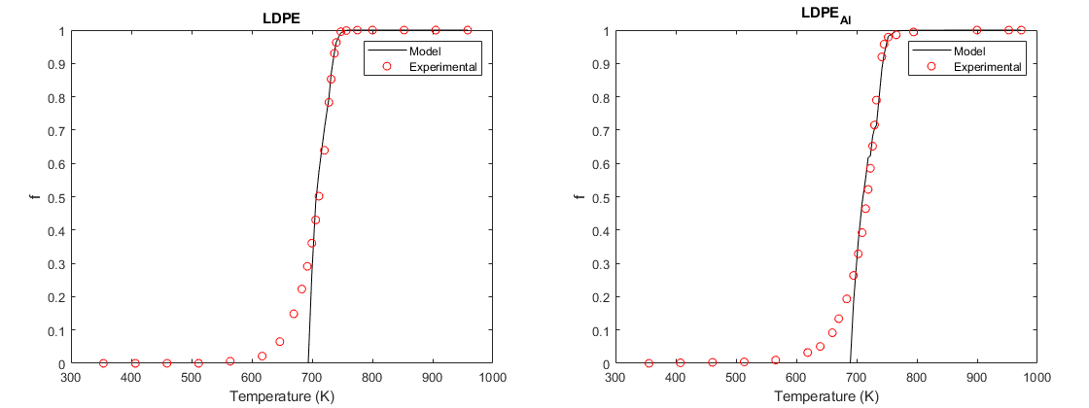

Figure 4: Experimental and modelled conversion profiles for raw LDPE (left) and recycled LDPE (right).

* 1. Conclusions

The modelled data based in the Speyer’s model showed good agreement for both raw and recycled LDPE, reaching determination coefficient values higher than 0.9 and 0.8, respectively. Due to the similarity of the material studied, pre-exponential and activation energy were all in the same order of magnitude, and the reaction order showed a divergence that can be caused by the difference in the material structure. Hence, the optimization using stochastic strategy was satisfactory with parameters close to the ones found by using classical methods.

Acknowledgments

The authors would like to acknowledge the financial support of CAPES.

References

Bujak, J.W., 2015, Thermal utilization (treatment) of plastic waste. Energy, 90, 1468-1477.

Campos A.L., Nogueira J., Coelho F.A., Fileti A.M.F., Santos B., 2018, Genetic algorithm optimization of the parameters involved in biosurfactant production from beet peel as substrate, Chemical Engineering Transactions, 65, 469-474 DOI: 10.3303/CET1865079

Das, P., & Tiwari, P., 2017, Thermal degradation kinetics of plastics and model selection. Thermochimica Acta, 654, 191-202.

Kayacan, I., & Doğan, Ö. M., 2008, Pyrolysis of low and high density polyethylene. Part I: non-isothermal pyrolysis kinetics. Energy Sources, Part A, 30(5), 385-391.

Kissinger, H. E., 1957, Reaction kinetics in differential thermal analysis. Analytical chemistry, 29(11), 1702-1706.

Monteiro F.Z., De Siqueira R., Moura F.J., Grillo A., 2018, Study of the thermal decomposition of green coconut fiber in the presence of a nanostructured catalyst, Chemical Engineering Transactions, 65, 457-462 DOI: 10.3303/CET1865077

Ozawa, T., 1970, Kinetic analysis of derivative curves in thermal analysis. Journal of Thermal Analysis and Calorimetry, 2(3), 301-324.

Rein, G., Lautenberger, C., Fernandez-Pello, A. C., Torero, J. L., & Urban, D. L., 2006, Application of genetic algorithms and thermogravimetry to determine the kinetics of polyurethane foam in smoldering combustion. Combustion and flame, 146(1-2), 95-108.

Saadan M.Z.H., Mohamad Z., Jusoh M., Majid R.A., Baharulrazi N., Man S.H.C., 2017, Degradable polyethylene/rice bran film: effect of glycerol, Chemical Engineering Transactions, 56, 49-54 DOI:10.3303/CET1756009

Saha, B., Reddy, P. K., & Ghoshal, A. K., 2008, Hybrid genetic algorithm to find the best model and the globally optimized overall kinetics parameters for thermal decomposition of plastics. Chemical Engineering Journal, 138(1-3), 20-29.

Santana A., 2010, Caracterização das propriedades físicas de misturas de HDPE e LDPEAl de embalagens longa vida pós-consumo, Master Thesis, Federal University of Rio de Janeiro, Rio de Janeiro, Brazil.

Slopiecka, K., Bartocci, P., & Fantozzi, F., 2012, Thermogravimetric analysis and kinetic study of poplar wood pyrolysis. Applied Energy, 97, 491-497.

Speyer R.F., 1993. Thermal Analysis of Materials. School of Materials Science and Engineering, Georgia Institute of Technology, Marcel Dekker, INC. New York.