|  |  |
| --- | --- |
| cetlogo ***CHEMICAL ENGINEERING TRANSACTIONS***  ***VOL. 76, 2019*** | A publication of  aidiclogo_grande |
| The Italian Association  of Chemical Engineering  Online at www.aidic.it/cet |
| Guest Editors: Sauro Pierucci, Jiří Jaromír Klemeš, Laura Piazza  Copyright © 2019, AIDIC Servizi S.r.l. **ISBN** 978-88-95608-73-0; **ISSN** 2283-9216 | |

Adsorption of Cr (VI) Pollutants in Water Using Natural and Modified Attapulgite Clay

Shepherd M Tichapondwa\*, James B van Biljon

Department of Chemical Engineering, University of Pretoria, Pretoria 0002, South Africa

Shepherd.Tichapondwa@up.ac.za

Attapulgite clay also known as palygorskite is a mineral clay which possess good adsorption properties based on its adsorption capacity, porous structure and moderate cation exchange properties. The study investigated the effectiveness of naturally occurring and hydrochloric acid modified attapulgite as adsorbents for Cr (VI) remediation in wastewater. The physical properties of the clay were characterized using a range of techniques. X-ray diffraction confirmed the purity of the clay while BET analysis indicated an increase in surface area from 131.4 to 183.2 m2/g after acid modification. The modified attapulgite was predicted to have an adsorption capacity of 75 mg/g compared to 2.1 mg/g for the naturally occurring attapulgite. The increase in adsorption capacity was attributed to a change in surface area as well as changes in the surface chemistry of the clay. The adsorption isotherms were best described by the Langmuir mono-layer adsorption model while the kinetics fit the Langren first order kinetics model.

* 1. Introduction

Chromium (VI) is one of the major sources of heavy metal contamination found in industrial wastewater. In nature chromium is mostly found in the trivalent Cr (III) state, however, the more mobile Cr (VI) is discharged in wastewater from various anthropogenic activities such as mineral processing operations, electroplating, leather tanning and pigment production (Patterson et al., 1997). Cr (VI) is a non-biodegradable and persistent pollutant which has mutagenic and carcinogenic effects. It is highly toxic to most living organisms even at concentrations as low as 0.05 ppm (Yang et al., 2013). While the organic biodegradable contaminants can be treated with relative ease using conventional biological wastewater treatment processes, the same cannot be said for Cr (VI)-based contaminants. Most wastewater treatment plants are designed to use conventional biological treatment processes to remediate harmful pollutants, however, these are ineffective towards heavy metals. One of the most widely used Cr(VI) remediation techniques employs the reduction of Cr(VI) to Cr(III) followed by precipitation at high pH. However, this tends to consume a significant amount of chemicals whilst generating large volumes of sludge. Alternative methods such as ion exchange and membrane processes have been shown to be effective but they are not economic. Remediation via adsorption based processes is widely used due to the low operational cost, simplicity, high efficiency, ease of handling, low energy consumption, minimal sludge generation and the possibility of regeneration (Yin et al., 2016; Carpa et al., 2018). Adsorption based wastewater treatment plants have been shown to be socially acceptable (Giuliano et al., 2018) and present a small carbon footprint (Da Silva, 2019).

Natural and modified clays are known to have remarkable adsorption properties owing to the features of their structure and chemical composition. Adsorption of materials from aqueous media using clay material can be achieved through one or a combination of the following mechanisms: physical or chemical adsorption as well as ion exchange. The adsorption properties of clays makes them an attractive option in the treatment of industrial wastewater contaminated with heavy metal pollutants. Attapulgite is a magnesium aluminium phyllosilicate with the general chemical formula {(Mg,Al)4Si8(O,OH,H2O)24.nH2O} (Nefzi et al. 2018) has been widely studied for its adsorption properties. This has been driven by its properties such as a high adsorption capacity, porous structure, high surface area, fibrous morphology and moderate cation exchange capacity (Zhang et al., 2015). Clay modification by acid treatment has been shown to increase the surface area and porosity of clay minerals. Acid treatment also increases the Si-OH surface bonds of the clay surfaces, these groups can play a role in the adsorption of heavy metals from solution (Frini-Srasra and Srasra, 2010). Numerous studies have investigated the effectiveness of natural and modified attapulgite clays towards the adsorption of various species from aqueous solutions. Table 1 summarizes some of the recent studies. This paper focuses on the adsorption of Cr (VI) using natural and modified attapulgite sourced from a local South African mine. This forms part of a greater study investigating the use of alternative adsorbents to activated carbon which can be used for the remediation of both heavy metal and organic pollutants (Tichapondwa et al, 2018).

Table 1: Summary of recent studies on pollutant remediation using attapulgite as an adsorbent

|  |  |  |
| --- | --- | --- |
| Clay Description | Pollutant | Reference |
| Modified | PO43- | Li et al,2016 |
| Natural, Modified | Pb(II), Ni(II), Cr(VI), Cu(II) | Potgieter et al., 2006 |
| Natural, Modified | Toulene | Zhu et al., 2018 |
| Modified | Cu(II) | Chen et al., 2007 |
| Natural | Fe(III) | Middea et al., 2013 |
| Modified | Cd(II) | Wang at al., 2017 |
| Modified | Phenol | Rusmin et al., 2016 |
| Natural | Th(IV) | Chen & Gao, 2009 |

* 1. Materials and Methods
     1. Materials

The attapulgite was sourced from Sun Silicates (South Africa). The clay had a d50 particle size of 45 µm. X-ray fluorescence analysis indicated that the main chemical elements in the clay structure were; SiO2 (62%), Al2O3 (7%), Fe2O3 (3%), MgO (9%) and CaO (1.5%). The simulated wastewater was prepared using potassium chromate (K2CrO4) obtained from Merck (South Africa). The changes in Cr (VI) concentration were analysed using a standard method described by Federation and Association (2005). This method requires the use of sulphuric acid (H2SO4) and 1,5-diphenyl carbazide (DPC) , both were sourced from Saarchem (South Africa). Hydrochloric acid was also used for the acid leaching clay modification process. Ultra-pure distilled water was used for the preparation of all the solutions.

* + 1. Acid leaching

Clay modification was carried out by contacting the natural attapulgite with 4 M hydrochloric acid. Ten grams of natural clay was added to 100 ml of the acid and the resultant slurry was stirred continuously for 2 hours. The hydrochloric acid was decanted and the recovered solid particles were washed several times with ultrapure water before being oven dried at 70°C.

* + 1. Adsorption studies

The adsorption of Cr (VI) was studied under batch reactor conditions. The simulated wastewater was prepared using potassium chromate (K2CrO4). The effect of clay loading on the Cr (VI) removal efficiency was investigated by varying the amount of natural and modified attapulgite added whilst maintaining a constant volume of 50 ppm Cr (IV) concentration solution. The experiments were carried out over a 24 hour period. Samples were collected at 20 minute intervals in the first hour and at one hour intervals thereafter. Upon identification of the optimum loading, the effect of initial concentration was determined by maintaining a constant adsorbent loading and vary the Cr (VI) concentration according to the following values 10, 30, 50 and 100 ppm. All the experiments were carried out in triplicate for statistical purposes. The adsorption capacity was then calculated using the relationship shown in equation (1).

|  |  |
| --- | --- |
| $$Q_{e}= \frac{V \left(C_{0}- C_{e}\right)}{M}$$ | (1) |

Where Qe is the adsorbed pollutant concentration (mg/g), V is the volume of solution (L), M is the mass of exfoliated graphite used (g), Co and Ce are the initial concentration and equilibrium concentrations of the pollutant (mg/L).

* + 1. Characterization and analysis

The specific surface areas of the natural and modified attapulgite were determined using a Micrometrics TriStar BET in liquid N2 at 77 K. The morphology of the adsorbent was studied using an ultrahigh resolution field emission scanning electron microscope (HR FEGSEM Zeiss Ultra Plus 55). Changes in Cr (VI) concentration where analysed using a standard method described by Federation and Association (2005). A sample volume of 0.1 mL is first acidified with 1 N H2SO4 before reacting it with 1,5-diphenyl carbazide to produce a purple colour. The resultant samples were then analysed using a WPA, LIGHT Wave, Labotech UV-vis spectrophotometer at a 540 nm wavelength.

* 1. Results and discussion
     1. Attapulgite characterization

The BET surface area of the natural and acid modified attapulgite were 131.4 and 183.2 m2/g. respectively. This translates to a 39.4% increase in surface area. It is postulated that the besides ion exchange taking place in the gallery of the clay structure, acid modification process increased the porosity of the clay. Frini-Srasra & Srasra (2010) theorized that acid modification results in an isomorphic replacement that gives attapulgite a dioctrahedral character. This in turn causes a change in the physico-chemical properties of the clay. The morphology of the clay before and after modification is shown in Figure 1. The acid leached clay had a rougher surface texture compared to the natural clay.

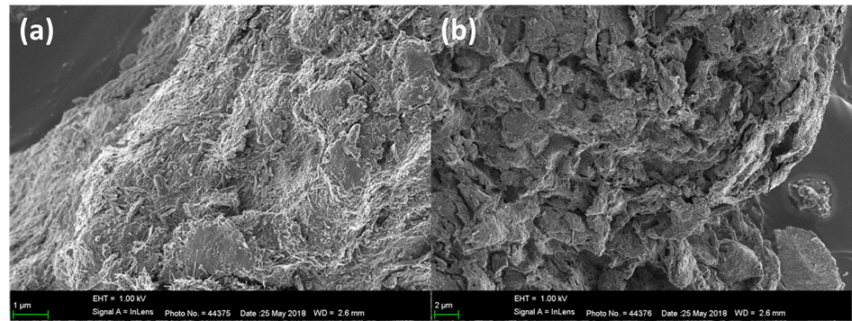

*Figure 1: Scanning electron microscopy images for (a) Natural attapulgite and (b) Acid modified attapulgite*

* + 1. Adsorption studies

Figure 2 shows the effect of clay loading on the adsorption of Cr (VI) from a 50 ppm aqueous solution using both natural and acid activated attapulgite. An optimum adsorbent dosage of 1 g/L was observed for both adsorbents. The acid modified adsorbent had a significantly higher adsorption capacity (22.9 mg/g) compared to the natural clay (4.2 mg/g) at a 1 g/L loading. The marked increase in adsorption capacity can be partially attributed to the increase in BET surface area recorded after acid leaching. The increased surface area is likely to be complimented by changes in the surface properties of the adsorbent which aids in adsorption. Another contributing factor to the higher adsorption capacity in the modified attapulgite adsorbent is the decrease in solution pH when the modified clay is added to the aqueous solution. It is widely reported in literature that Cr (VI) adsorption is more efficient at lower pH values (Babel & Opiso, 2007). This can be attributed to the fact that the Cr (VI) is present as CrO42- anion in solution, therefore the lower pH renders the adsorbent surface more positive due to the presence of the H+ ions which in turn attract the Cr (IV) anions.

The effect of initial Cr (VI) concentration on the adsorption capacity of a fixed loading of acid modified clay is presented in Figure 3. The rate and extent of Cr (VI) removal was faster and more efficient for the 10 ppm Cr (VI) solution. The percentage Cr (VI) removal was 66% for the 10 ppm solution after 60 minutes compared to 56% for the 100 ppm solution in the same duration. However, the equilibrium adsorption capacities associated with the initial concentrations of 10 and 100 ppm were 6.6 and 55.6 mg/g, respectively. Figure 4 shows the equilibrium isotherm for the adsorption of Cr (VI) on acid leached attapulgite. It is clear that the range of concentrations used in the study was not wide enough since a constant maximum adsorption capacity value was not obtained.

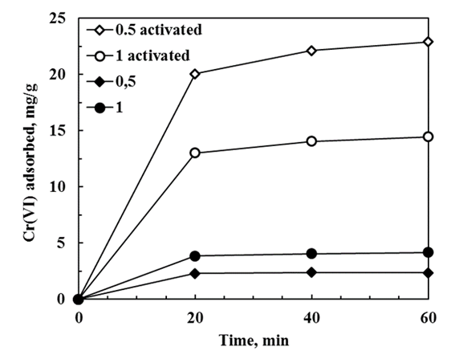

*Figure 2: Cr (VI) adsorption capacity of natural and modified attapulgite as a function of time and adsorbent loading*

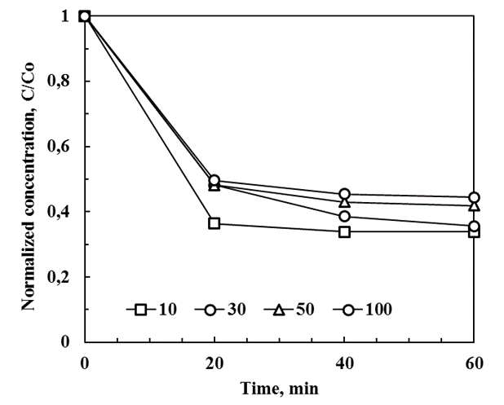

*Figure 3: Adsorption capacity of natural and modified attapulgite as a function of time and initial Cr (VI) concentration*

* + 1. Adsorption modelling

The widely used Langmuir isotherm model which describes monolayer adsorption was fitted to the data obtained from the variation of initial concentration experiments. The relationship is shown in equation 2.

|  |  |
| --- | --- |
| $$Qe= \frac{Q_{m}C_{e}}{C_{e}+\frac{1}{b}}$$ | (2) |

Where Qe is the amount of adsorbate at equilibrium per unit mass of adsorbent in mg/g and Ce the equilibrium concentration of Cr(VI) in mg/L. Qm refers to the maximum adsorption capacity required to form a monolayer adsorbed per unit mass of adsorbent mg/g. The constant b is the equilibrium constant in L/mg. The model had a fairly good fit with an R2 value of 0.984. Figure 4 shows the relationship between the experimental data with the fitted curve. The maximum adsorption capacity (Qm) was predicted to be 75 mg/g whilst the equilibrium constant was 0.04 mg/L. The mismatch between the experimentally determined maximum adsorption capacity and the predicted capacity is further evidence that the concentration range tested was not wide enough.

The adsorption kinetics were established by fitting the experimental data to several models reported in literature. These include the pseudo first order, pseudo second order as well as the intraparticle diffusion model (Gupta & Balomajmder, 2015). The results indicated that the adsorption kinetics of Cr (VI) were best depicted by the pseuedo first order model, which is expressed as equation (3). The adsorption rate constant K was 3.1 x 10-4 (g mg-1 min-1).

|  |  |
| --- | --- |
|  | (3) |

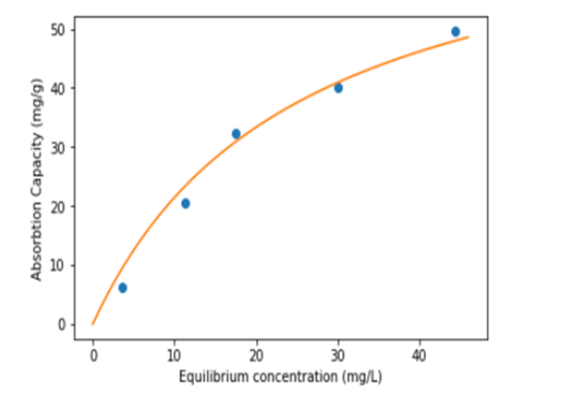

*Figure 4: Cr(VI) adsorption capacity of natural and modified attapulgite as a function of time and adsorbent loading*

* 1. Conclusions

Acid leaching of natural attapulgite clay was found to be an effective way to increase the adsorption capacity of the clay. The naturally occurring clay had an adsorption capacity of 2.1 mg/g whilst the acid modified clay was predicted to be capable of achieving a maximum adsorption capacity of 75 mg/g. This drastic increase was attributed to an increase in surface area and porosity as well as a change in the surface chemistry of the modified clay. The adsorption results were best described by the Langmuir adsorption isotherm whilst the adsorption kinetics fit the pseudo first order kinetics model. Acid modified attapulgite can be considered as a possible adsorbent for the remediation of Cr (VI) as it has good adsorption capacity and is cheaper to process compared to activated carbon.

References

Babel S., Opiso E.M., 2007, Removal of Cr from synthetic wastewater by sorption into volcanic ash soil. International Journal of Environmental Science & Technology, 4(1), 99-107.

Capra L., Manolache M., Ion I., Stoica R., Stinga G., Doncea S., Alexandrescu E., Somoghi R., Calin M., Radulescu I., Ivan G., 2018, Adsorption of Sb (III) on Oxidized Exfoliated Graphite Nanoplatelets. Nanomaterials, 8(12), 992.

Chen H., Zhao, Y., Wang A., 2007, Removal of Cu (II) from aqueous solution by adsorption onto acid-activated palygorskite. Journal of Hazardous Materials, 149(2), 346-354.

Chen L., Gao X., 2009, Thermodynamic study of Th (IV) sorption on attapulgite. Applied Radiation and Isotopes, 67(1), 1-6.

Da Silva R. G., Giuliano A., Errico M., Rong B. G., Barletta D., 2019, Economic value and environmental impact analysis of lignocellulosic ethanol production: assessment of different pretreatment processes, Clean Technologies and Environmental Policy, 1-18.

Federation W. E., & Association, A. P. H., 2005, Standard methods for the examination of water and wastewater. American Public Health Association (APHA): Washington, DC, USA.

Frini-Srasra N., Srasra E., 2010, Acid treatment of south Tunisian palygorskite: removal of Cd (II) from aqueous and phosphoric acid solutions. Desalination, 250(1), 26-34.

Giuliano A., Gioiella F., Sofia D., Lotrecchiano N., 2018, A novel methodology and technology to promote the social acceptance of biomass power plants avoiding Nimby Syndrome, Chemical Engineering Transactions, 67

Gupta A., Balomajumder C., 2015, Simultaneous adsorption of Cr (VI) and phenol onto tea waste biomass from binary mixture: multicomponent adsorption, thermodynamic and kinetic study. Journal of Environmental Chemical Engineering, 3(2), 785-796.

Li F., Wu W., Li R., Fu X., 2016, Adsorption of phosphate by acid-modified fly ash and palygorskite in aqueous solution: experimental and modeling. Applied Clay Science, 132, 343-352.

Middea A., Fernandes T.L., Neumann R., da FM Gomes O., Spinelli L.S., 2013, Evaluation of Fe (III) adsorption onto palygorskite surfaces. Applied Surface Science, 282, 253-258.

Nefzi H., Abderrabba M., Ayadi S., Labidi J., 2018, Formation of Palygorskite Clay from Treated Diatomite and its Application for the Removal of Heavy Metals from Aqueous Solution. Water, 10(9), 1257.

Patterson R.R., Fendorf S., Fendorf M., 1997, Reduction of hexavalent chromium by amorphous iron sulfide. Environmental Science & Technology, 31(7), 2039-2044.

Potgieter J.H., Potgieter-Vermaak S.S., Kalibantonga P.D., 2006, Heavy metals removal from solution by palygorskite clay. Minerals Engineering, 19(5), 463-470.

Rusmin R., Sarkar B., Biswas B., Churchman J., Liu Y., Naidu R., 2016, Structural, electrokinetic and surface properties of activated palygorskite for environmental application. Applied Clay Science, 134, 95-102.

Tichapondwa S.M., Tshemese S., Mhike W., 2018, Adsorption of Phenol and Chromium (VI) Pollutants in Wastewater using Exfoliated Graphite. Chemical Engineering Transactions, 70, 847-852.

Wang H., Wang X., Ma J., Xia P., Zhao J., 2017, Removal of cadmium (II) from aqueous solution: A comparative study of raw attapulgite clay and a reusable waste–struvite/attapulgite obtained from nutrient-rich wastewater. Journal of hazardous materials, 329, 66-76.

Yin N., Wang K., Wang L., Li Z., 2016, Amino-functionalized MOFs combining ceramic membrane ultrafiltration for Pb (II) removal. Chemical Engineering Journal, 306, 619-628.

Yang J., Dai J., Li J., 2013, Visible-light-induced photocatalytic reduction of Cr (VI) with coupled Bi2O3/TiO2 photocatalyst and the synergistic bisphenol A oxidation. Environmental Science and Pollution Research, 20(4), 2435-2447.

Zhang Y., Wang W., Zhang J., Liu P., Wang A., 2015, A comparative study about adsorption of natural palygorskite for methylene blue. Chemical Engineering Journal, 262, 390-398.

Zhu J., Zhang P., Wang Y., Wen K., Su X., Zhu R., He H., Xi Y., 2018, Effect of acid activation of palygorskite on their toluene adsorption behaviors. Applied Clay Science, 159, 60-67.