|  |  |
| --- | --- |
| cetlogo ***CHEMICAL ENGINEERING TRANSACTIONS***  ***VOL. 76, 2019*** | A publication of  aidiclogo_grande |
| The Italian Association  of Chemical Engineering  Online at www.cetjournal.it |
| Guest Editors: Sauro Pierucci, Jiří Jaromír Klemeš, Laura Piazza  Copyright © 2019, AIDIC Servizi S.r.l. **ISBN** 978-88-95608-73-0; **ISSN** 2283-9216 | |

Sugarcane bagasse fast pyrolysis simulation: a thermodynamic equilibrium approach

Nahieh T. Miranda\*, Rubens Maciel Filho, Maria Regina W. Maciel

Laboratory of Optimization, Design, and Advanced Control (LOPCA)/Laboratory of Development of Separation Processes (LDPS), School of Chemical Engineering, University of Campinas, Av. Albert Einstein 500, Campinas, 13083-852, Brazil.

nahieh.tmiranda@gmail.com

This paper investigates the capability of thermodynamic equilibrium approach to simulate fast pyrolysis of sugarcane bagasse in Aspen PlusTM. The Gibbs energy minimization reactor was used to evaluate the effect of temperature (523–773 K), pressure (1–5 atm), and moisture content (10–25 wt%) on pyrolysis products distribution, using a 23 central composite design (sensitivity analysis). High temperature (500 °C) and low pressure (1 atm) produced the highest yield of gases (~70 %) while low temperature (250 °C) and high pressure (5 atm) achieved the highest liquid yields (~53 %), and moisture content demonstrated little influence for both products because the reactor was held isothermal. However, for gases production, high moisture content (25 %) can be combined either with higher temperatures to promote CO production or higher pressure for CO2 production. The results suggested that the temperature was the only significant parameter for pyrolysis products distribution for 95 % confidence level, and the equilibrium approach predicted gas yields more efficiently than liquid yields.

* 1. Introduction

Sugarcane bagasse, the main by-product of the sugar-alcohol industry, has the potential to be a source of biomass for biofuel production in several countries that are significant producers of sugarcane, such as Brazil (the largest producer), India, China, Thailand, and Pakistan (Food and Agriculture Organization of the United Nations, 2018); (Motta et al., 2018). Its properties and abundance favor its application. Energy cogeneration generally uses this by-product by burning it in boilers, contributing to the energy integration in sugar-alcohol plants (Sun et al., 2003). In an attempt to bring other alternatives to process this residue, some innovative technologies have been developed to improve the efficiency of biofuel production processes: thermochemical, biochemical, chemical, and physical pathways. Among these biomass conversion routes, pyrolysis has been widely studied after the two oil crisis in the 1980s (Islam et al., 2010). This thermochemical process is an attractive alternative for biofuels production because it uses several biomass types for feedstock (mostly agricultural wastes), reducing competition with food (Gollakota et al., 2016), and providing a better use for such residues.

Recent studies have improved the efficiency of pyrolysis in processing low-cost raw materials and wastes. However, there is a necessity to verify the feasibility of this process before introducing it in a biorefinery. Computer simulations aid in this implementation study, which not only provide a better understanding of how to perform pyrolysis but also allow a variation in operating parameters without expenses, resulting in a better understanding of how some operational variables may affect the products yields. Sugarcane bagasse properties along with pyrolysis operating conditions may directly change pyrolysis products properties, distribution, and further application as fuels and chemicals, which require a thorough study on these topics.

Consequently, the use of computational tools, such as commercial process simulators (e.g., Aspen Plus™, Aspen HYSYS™, and Unisim™), can achieve a more detailed study of pyrolysis processes. The use of computational tools presents many advantages: the definition of optimum operational conditions to obtain products of interest; a better comprehension of how thermochemical reactions take place; less costly since experimental tests are expensive (Mabrouki et al., 2018); simultaneous tests of different variables in a faster way; and, the assessment of the scaling-up of a process under study. Therefore, simulation investigation of this process is essential to avoid additional costs when industries have to test new operating conditions. Several authors have used simulation tools on pyrolysis processes (Nikoo et al., 2008); (Ramzan et al., 2011); (Ardila et al., 2014); (Kabir et al., 2014). However, most of the previous simulation studies on thermochemical processes have tended to focus on gasification rather than on pyrolysis due to pyrolysis reactions complexity and few data available about products distribution and composition.

The purpose of the present study is, therefore, to investigate the capability of thermodynamic equilibrium approach to simulate the fast pyrolysis process of sugarcane bagasse and the effects of pyrolysis temperature, pressure, and sugarcane bagasse moisture content on products distribution when using the Gibbs energy minimization reactor and 2³ factorial design.

* 1. Simulation methodology
     1. Pyrolysis simulation methodology using proximate and ultimate analyses

The simulation was performed in Aspen Plus™ V8.6. Once sugarcane bagasse is a nonconventional component in the software, it is necessary to follow some steps (Figure 1) to simulate the pyrolysis of sugarcane bagasse.

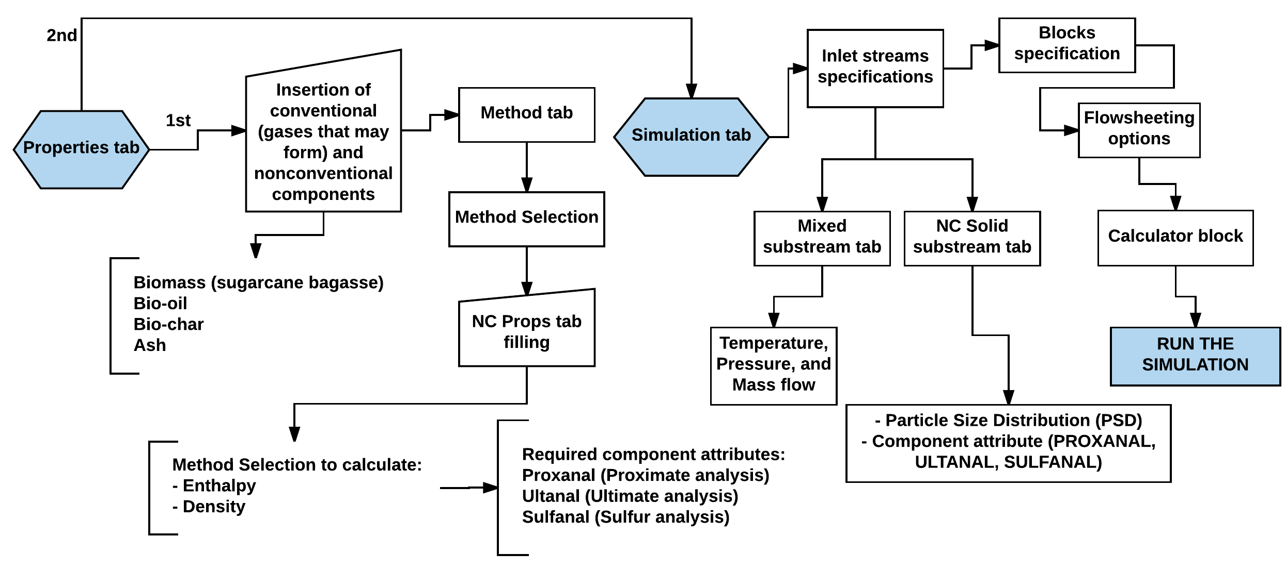

Figure 1: Flowchart of simulation methodology (Miranda, 2018)

In Aspen PlusTM, to initiate the simulation of the pyrolysis process, the conventional (N2, O2, H2O, H2, Cl2, S, benzene, naphthalene, toluene, H2S, CO, CO2, and solid carbon) and nonconventional components (sugarcane bagasse and ash) and their properties are inserted in the *Properties* tab. Second, the next step is the thermodynamic method selection in the *Methods* tab to perform the simulation (see section 2.2). The presence of nonconventional components in the simulation requires the definition of their properties in an advanced properties method (*NC Props*). Thus, physical properties, such as enthalpy and density of the nonconventional components must be considered, which do not enter into chemical or phase equilibrium. Aspen PlusTM uses component attributes to represent nonconventional components and calculate their physical properties. In this part of the simulation, the *NC Props* tab requires the appropriate model type for enthalpy and density calculations of each nonconventional compound. Depending on the method type chosen, it requires proximate analysis (*PROXANAL*), ultimate analysis (*ULTANAL*), and sulfur analysis (*SULFANAL*) for enthalpy calculations. In the same tab, there is a box in which “*Option codes*” can be inserted, which serves to define how the method chosen calculates some parameters (heat of combustion, heat capacity, standard heat of formation, and enthalpy basis) for the nonconventional component. For sugarcane bagasse, the enthalpy model chosen was “coal enthalpy model” (*HCOALGEN*) and density model was “general density model for a nonconventional component” (*DNSTYGEN*). For ash, the enthalpy model was the same as sugarcane bagasse, and the density model was “coal density model, based on the IGT correlation” (*DCOALIGT*). After filling all the parameters required in the *Properties* tab, the simulator allows the user to go to the simulation environment (*Simulation* tab).

In the *Simulation* tab, after designing the process, the simulator asks for the inlet streams specifications. Since both conventional and nonconventional components with *Particle Size Distributions* (*PSD*) are present, a stream class denominated “*MIXNCPSD*” was chosen. The *Mixed* tab set the biomass stream temperature, pressure, and mass flow rate. Since the simulation contains solids, there is a space to fill with the *PSD* (Table 1) of the solid raw material on the *NC Solid* tab. The *Biomass inlet stream input* tab set all of this information. In the same *NC solid* tab, there is also a possibility of inserting the component attributes *PROXANAL*, *ULTANAL*, and *SULFANAL*. Firstly, the *PROXANAL* asks to include the values (as weight % on a dry basis) of moisture, fixed carbon, volatile matter, and ash (Table 1). Secondly, *ULTANAL* establishes the values of ash, carbon, hydrogen, oxygen, nitrogen, and sulfur of the raw material (Table 1). Lastly, *SULFANAL* fills the spaces for pyritic, sulfate, and organic values, but it is possible to complete only the general sulfur content (Table 1).

The next step is the blocks specification (see section 2.2). The last thing is the calculator block to control the variation of parameters. In this regard, Fortran statements are necessary to introduce correlations.

* + 1. Simulation description

The thermodynamic model was the Peng-Robinson with Boston-Mathias (PR-BM) because it is the most used method for thermochemical processes in the literature. The pyrolyzer is isothermal and operates at steady state. Biochar is composed of ash and fixed carbon of sugarcane bagasse (Table 1). Fortran statements through calculator blocks defined the biomass drying and decomposition. The decomposition process is the conversion of a nonconventional component in the simulator (sugarcane bagasse) into conventional components, taking into account all data from the proximate and ultimate analysis (Table 1). This decomposition process is necessary since the reactor blocks cannot perform phase and chemical equilibrium calculations with nonconventional components. The simulation (Figure 2) used characterization data of sugarcane bagasse (Table 1), which is present in the previous work of authors (Miranda, 2018).

Table 1: Proximate and ultimate analysis of sugarcane bagasse

|  |  |  |  |  |  |
| --- | --- | --- | --- | --- | --- |
| Proximate analysis  (dry basis) | Sugarcane bagasse | Ultimate analysis  (dry basis) | Sugarcane bagasse | Particle medium  diameter (mm) | Weight fraction |
| Volatile matter (%) | 88.87 ± 0.91 | Carbon (%) | 37.01 ± 2.08 | 0.00 – 0.22 | 1.12 |
| Fixed carbon (%) | 1.14 | Hydrogen (%) | 5.32 ± 0.41 | 0.22 – 0.28 | 1.21 |
| Ash (%) | 10.00 ± 2.80 | Oxygen (%) | 43.25 ± 2.28 | 0.28 – 0.36 | 3.04 |
| Moisture content (%) | 10.00 | Nitrogen (%) | 0.44 ± 0.06 | 0.36 –0.46 | 1.91 |
|  |  | Sulfur (%) | 0.47 ± 0.37 | 0.46 – 0.55 | 1.59 |
|  |  |  |  | 0.55 – 0.66 | 1.66 |
|  |  |  |  | 0.66 – 0.78 | 0.81 |
|  |  |  |  | 0.78 – 1.02 | 2.05 |

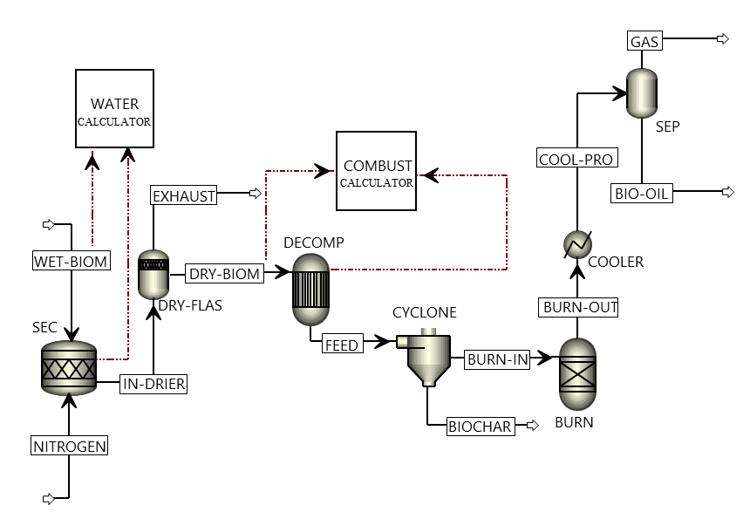

Figure 2: Pyrolysis simulation flow diagram

23 factorial design (sensitivity analysis – 95.0 % confidence level – *Statistica 7.0*) (Table 2) was applied to evaluate the influence of temperature (T), pressure (P), and moisture content (MC) on yield and product compositions.

Table 2: Operating conditions for sensitivity analysis and 2³ factorial design

|  |  |  |
| --- | --- | --- |
| Parameter | Level -1 | Level +1 |
| Temperature (°C) | 250 | 500 |
| Pressure (atm) | 1 | 5 |
| Moisture content (%) | 10 | 25 |

The products yield was calculated according to Eq(1).

|  |  |
| --- | --- |
| $$Products Yield (\%)=\frac{kg product}{kg biomass-dry (10 \%wt H_{2}O)}$$ | (1) |

The SEC (*RStoic*) and DRY-FLAS (*FLASH2*) blocks perform the sugarcane bagasse drying. SEC (*RStoic* block) converts part of bagasse into water with a nitrogen stream (NITROGEN). Then, DRY-FLAS removes the bagasse moisture content and nitrogen (EXHAUST) from IN-DRIER, producing dry bagasse (DRY-BIOM). WET-BIOM stream is 2 kg/h and NITROGEN is 10 kg/h. The SEC block requires a Calculator block to remove the moisture present in the bagasse, described elsewhere (Aspen Tech, 2013). Therefore, the WATER calculator block defined the variables. The pyrolysis process uses DECOMP, CYCLONE, and BURN blocks. DECOMP (*RYield* block) converts nonconventional DRY-BIOM stream into conventional components (FEED). The DECOMP block configured the yields by a COMBUST calculator block, which uses the results of the ultimate analysis of sugarcane bagasse (Table 1). The next block, CYCLONE, separates the biochar from the gases. The BURN block (*RGibbs* block) performs the pyrolysis of the BURN-IN. The BURN block produces the BURN-OUT stream, which must enter into the COOLER to recover liquids by the condensation process. After cooling, the SEP block (*FLASH2*) separates liquids (bio-oil) and gases.

* 1. Results and Discussion

Only the temperature was a significant parameter for products distribution for the 95 % confidence interval (Figure 3). High temperature (500 °C) promoted gases over liquids due to the reactions affected by temperature: secondary reactions of decomposition, reducing bio-oil and biochar yields (Akhtar and Amin, 2012). However, if combined with high pressure (5 atm), it promotes liquid production while combined with high moisture content decreases liquid yields. The last also happens for the combination of high pressure with high moisture content.

(a)

(b)

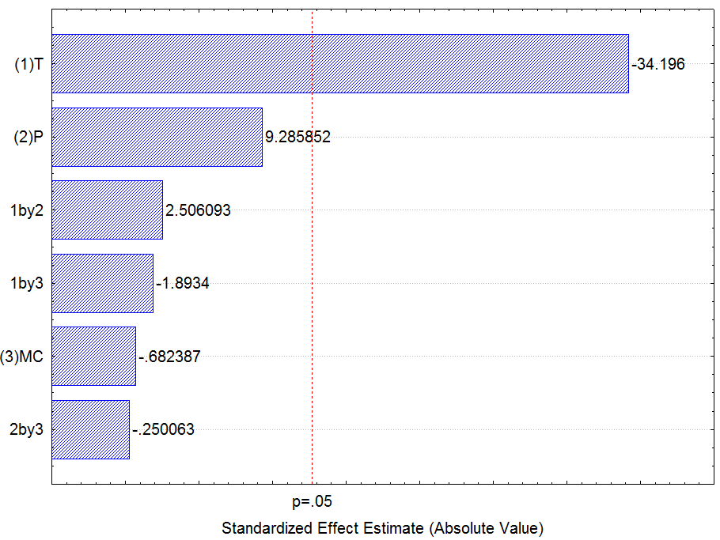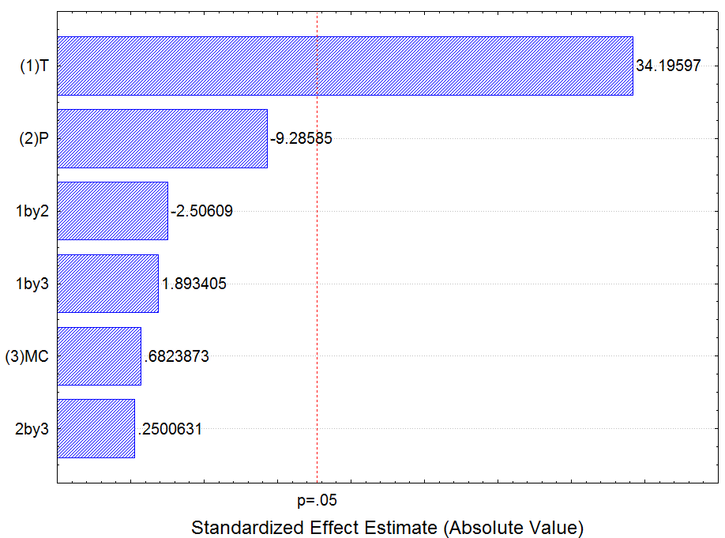

Figure 3: Pareto chart of effects of 2³ factorial design analyses on (a) liquids and (b) gas production

Since the simulation used an isothermal reactor, the moisture content present in the biomass does not affect the temperature of the reactor. Consequently, there is a slight variation in the products yields. Therefore, temperature and pressure were the most influenced parameters to evaluate products distribution (liquid and gases). Then, the results demonstrated that high pressure by itself (Figure 3) and its combination with moderate temperature are the best options when liquids are desired (Figure 4a). Consequently, the opposite of both parameters promotes gases production (Figure 4b).

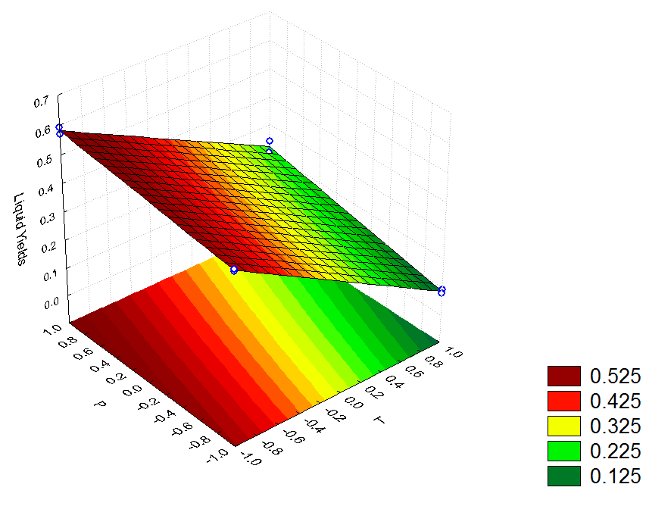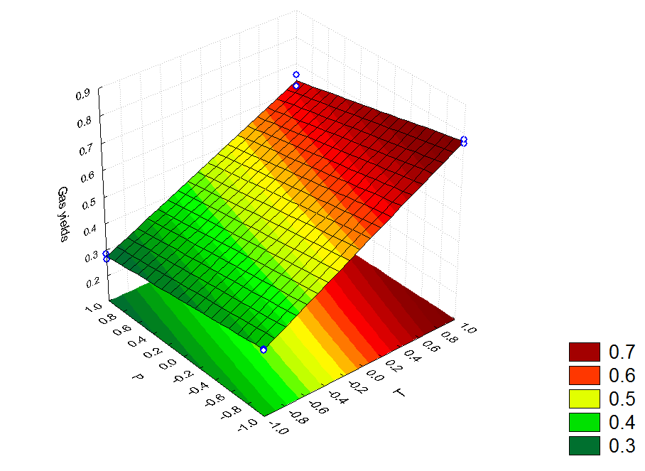

(a)

(b)

Figure 4: Surface graphs of (a) liquid and (b) gas yields

The gas yield was more than 70 % at 500 °C (Figure 5a). The best temperature for liquids production was 250 °C (more than 50 %). Several authors also demonstrated the same behavior (Doherty et al., 2009); (Kan et al., 2016); (Li et al., 2007).

(a)

(b)



(d)

(c)



Figure 5: Sensitivity analyses – Influence of (a) temperature on products, (b) temperature on gases, (c) pressure on products, and (d) pressure on gases

The production of CO increased as temperature increased, and the CO2 yield increased up to 400 °C (Figure 5b). Doherty et al. (2009) verified similar behavior for gases. Gases achieved almost 80 % of yield at 1 atm, but gases yields decrease at higher pressure. Concerning liquids: the best option was at 5 atm, reaching more than 25 % of yield (Figure 5c). High pressure decreased CO yield and increased CO2 yield (Figure 5d). Hydrogen presented a slight variation for both temperature and pressure.

* 1. Conclusions

The equilibrium approach was an alternative analysis to investigate the behavior of temperature, pressure, and moisture content on pyrolysis products distribution. The results demonstrated the potential of sugarcane bagasse on the production of biofuels, especially gases. The temperature was the only parameter with a 95 % confidence interval due to the approach used. Nevertheless, this was not a problem because the temperature range defines and differentiates the types of thermochemical processes. Furthermore, the thermodynamic equilibrium method approach can perform the process when there is not much data, in a simplified manner. This approach does not predict liquids yield with high accuracy once liquid production reactions do not strictly follow chemical equilibrium; however, it can efficiently predict the gases yield. Therefore, this approach fits well for simulation of other thermochemical processes that aim gases production (e.g., gasification). From the findings, moderate temperature with high pressure can maximize liquids production, while high temperature with low pressure should be avoided. Pyrolysis of biomass has the opportunity to become an advantageous alternative if proper operating conditions are used depending on the desired product.

Acknowledgments

The authors thank CNPq and São Paulo Research Foundation (FAPESP)/CAPES (grants #2016/18546-8 and #2015/20630-4) for financial support. Additionally, Nahieh T. Miranda (first author) thanks Rubens Maciel Filho and Maria Regina W. Maciel (the two last authors of this paper) for being the supervisors of Miranda Master’s Thesis (2018).

References

Akhtar J., Amin N.S., 2012, A review on operating parameters for optimum liquid oil yield in biomass pyrolysis, Renewable and Sustainable Energy Reviews, 16, 5101–5109.

Ardila Y.C., Figueroa J.E.J., Lunelli B.H., Maciel Filho R., Maciel M.R.W., 2014, Simulation of ethanol production via fermentation of the synthesis gas using Aspen Plus™, Chemical Engineering Transactions, 37, 637–642.

AspenTech, Getting Started Modelling Processes with Solids, 2013.

Broido A., Nelson M.A., 1975, Char yield on pyrolysis of cellulose, Combustion and Flame, 24, 263–268.

Doherty W., Reynolds A., Kennedy D., 2009, The effect of air preheating in a biomass CFB gasifier using ASPEN Plus simulation, Biomass and Bioenergy, 33, 1158–1167.

Food and Agriculture Organization of the United Nations, FAO Statistics (http://www.fao.org/faostat/en/#rankings/countries\_by\_commodity), 2018.

Gollakota A.R.K., Reddy M., Subramanyam M.D., Kishore N., 2016, A review on the upgradation techniques of pyrolysis oil, Renewable and Sustainable Energy Reviews, 58, 1543–1568.

Islam M.R., Parveen M., Haniu H., 2010, Properties of sugarcane waste-derived bio-oils obtained by fixed-bed fire-tube heating pyrolysis, Bioresource Technology, 101, 4162–4168.

Kabir M.J., Chowdhury A.A., Rasul M.G., 2015, Pyrolysis of municipal green waste: A modelling, simulation and experimental analysis, Energies, 8, 7522–7541.

Kan T., Strezov V., Evans T.J., 2016, Lignocellulosic biomass pyrolysis: A review of product properties and effects of pyrolysis parameters, Renewable and Sustainable Energy Reviews, 57, 126–1140.

Li J., Yan R., Xiao B., Wang X., Yang H., 2007, Influence of temperature on the formation of oil from pyrolyzing palm oil wastes in a fixed bed reactor, Energy and Fuels, 21, 2398–2407.

Mabrouki J., Abbassi M.A., Guedri K., Omri A., Jeguirim M., 2015, Simulation of biofuel production via fast pyrolysis of palm oil residues, Fuel, 159, 819–827.

Miranda N.T., 2018, Investigation about operational conditions for bio-oil and biochar production from sugarcane bagasse through simulation and application in pilot plant, Master’s Thesis in Chemical Engineering – University of Campinas (UNICAMP). Sao Paulo, 312 pages.

Motta I.L., Miranda N.T., Maciel Filho R., Maciel M.R.W., 2018, Sugarcane bagasse gasification: thermodynamic modelling and analysis of operating effects in a steam-oxygen-blown fluidized bed using Aspen Plus™, Chemical Engineering Transactions, 65, 169–174.

Nikoo M.B., Mahinpey N., 2008, Simulation of biomass gasification in fluidized bed reactor using ASPEN PLUS, Biomass and Bioenergy, 32, 1245–1254.

Ramzan N., Ashraf A., Naveed S., Malik A., 2011, Simulation of hybrid biomass gasification using Aspen plus: A comparative performance analysis for food, municipal solid and poultry waste, Biomass and Bioenergy, 35, 3962–3969.

Sun X.F., Sun R.C., Tomkinson J., Baird M.S., 2003, Preparation of sugarcane bagasse hemicellulosic succinates using NBS as a catalyst, Carbohydrate Polymers, 53, 483–495.