|  |  |
| --- | --- |
| cetlogo ***CHEMICAL ENGINEERING TRANSACTIONS***  ***VOL. 76, 2019*** | A publication of  aidiclogo_grande |
| The Italian Association  of Chemical Engineering  Online at www.cetjournal.it |
| Guest Editors: Sauro Pierucci, Jiří Jaromír Klemeš, Laura Piazza  Copyright © 2019, AIDIC Servizi S.r.l. **ISBN** 978-88-95608-73-0; **ISSN** 2283-9216 | |

Validation of an experimental procedure to quantify the effects of powder spreadability on selective laser sintering process

Daniele Sofiaa\*, Marco Lupo, Diego Barletta, Massimo Poletto

aUniversità Degli Studi di Salerno, Dipartimento di ingegneria industriale, Fisciano (SA), Via Giovanni Paolo II, 132, I-84084 Fisciano (SA), tel. +39 089964132.

[\*dsofia@unisa.it](mailto:*dsofia@unisa.it)

Glass beads powders of different particle size were spread with a procedure similar to the one adopted for Selective laser sintering in order to verify the effect of the powder compression produced with a roller spreading tool. The effect is verified in terms of indentation strength and of mechanical strength of the sintered specimens. Results indicate a significant effect of powder compression on the SLS process with fine powders.

* 1. Introduction

Selective laser sintering (SLS) of powders is an additive manufacturing technique, which allows the construction of three-dimensional objects by adding powder and sintering it layer by layer. SLS is based on the possibility of selectively sintering with a laser beam the particles arranged on a planar thin layer. Layer by layer deposition and selective sintering of powder material makes it possible the production of solid forms, even with very complex geometries.

The granular material used in this process must have well-defined characteristics. In particular, it must allow the production of a thin and homogeneous layer of about 100 microns. The main factors that determine the ability of the particles used to form relatively homogeneous layers are the average diameter, the shape and the interparticle forces (O. Molerus et al., 1975) (H.C.H Rumpf et al., 1970). All these parameters directly or indirectly define the flow properties of the powder used to form the layers. With fine powders, the quality of the powder layer spread in each cycle depends not only on the material, but also on the procedure followed. Unfortunately, in general the numerous techniques used to measure the powder spreadability adopt measuring conditions that are very different from those occurring during the layer formation in LS (D Sofia et al., 2015).

The development or adoption of new powders for their use in SLS processes is complex, because of the many properties they should have, including optical, thermal and rheological properties. With reference to these latter, it is expected an appropriate spreadability, intended as the ability of powders to form a uniform bed when spread (D. Sofia et al, 2018b). It is very important that the powder bed formed has a uniform surface and has a high packing density in order to reduce the porosity of the sintered material. Inadequate powder distribution during the preparation of the layer can lead to some inhomogeneity of the sintered material and to geometrical imperfections of the final object (Thornton, C., 2015). Many factors can affect the flow properties of a powder such as, for example, the particle size, the particle shape, the forces between the particles, the humidity and the temperature. Furthermore, to date there is no established criterion to relate quantitatively the particle properties to the ability of the powder to form a good layer. Therefore, the powder spreadability is characterized by bulk properties such as the angle of repose, bulk and tap densities, or powder flow properties measured on shear cells (Tomasetta et al. 2014). The same authors also show that electrostatic forces, temperature and humidity have a significant effect on the powder spreadability for layer preparations in SLS applications.

This paper proposes a characterization technique of powder quality for SLS application by using a set up that mimics the movements in an SLS apparatus. A roller is used to spread the powder in layer. It works by advancing against a pile of the powder. The set up allows to independently control the advancement and the rotational speed of the roller. The quality of the powder layer produced is characterized by means of an indentation tests carried out with a dynamometer. In particular, the dynamometer allows to assess the degree of compaction of the layer, measuring the force required to penetrate the layer. Subsequently, the tests of mechanical strength carried out on the sintered specimen are used to correlate the characteristics of the powder bed to the final product properties.

* 1. Experimental

The materials used for the powder sintering tests are all made of glass beads (soda-lime glass) obtained by means of atomization of fused material. Three powder batches characterized by a wide particle size distribution (<50, 10 to 100 µm and 100 to 200 µm) were sieved to obtain 3 cuts characterized by narrower particle size distributions. Particle size distributions of these cuts were measured with a Malvern Mastersizer 2000 laser diffraction granulameter. Table 1 reports the main properties of the three cuts identified by the by their mean Sauter diameter of 16, 45 and 125 µm. Figure 1 reports optical microscopy images of samples of these three cuts.

Table 1. Sauter diameters, original batch, sieve meshes used to obtain the different glass bead samples and bulk densities.

|  |  |  |
| --- | --- | --- |
| ds, µm | Original cut size range, µm | ρ, kg m-3 |
| 16 | <50 | 1368 |
| 45 | 10-100 | 1504 |
| 125 | 100-200 | 1536 |

|  |  |  |  |
| --- | --- | --- | --- |
| dp, [µm] | 16 | 45 | 125 |
| Optical microscopy images |  |  |  |

**Figure 1**. Optical microscopy images of glass beads.

The experimental apparatus was purposely built to be able to reproduce different possible techniques of powder layer formation. In this paper we will discuss only the powder layer formation by means of a moving roller. The base of the apparatus is a horizontal aluminium plane on which, a horizontally scrolling roller is used to distribute the powder material in a layer. The scrolling speed was set at 10 mm s-1 and the speed rotation was set at 5 mm s-1. The roller runs with the direction of rotation opposite to the direction of displacement.

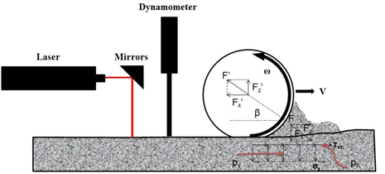

**Figure 2**. Process steps

As shown in Figure 3 experimental procedure consists of three steps. The first step is to compress the powder bed with a roller (Figure 3a). Subsequently a instron dynamometer makes an indentation test, to evaluate the level of compression (Figure 3b). To evaluate the effect of compression of the powder on the laser sintering process, sintered specimens are produced (Figure 3c) . The resistance of the sintered samples is tested for mechanical resistance. The whole procedure is repeated using powder characterized by different mean particle diameters.



**Figure 3**. (a) The first step is to compress the powder bed with a roller. (b) Indentation test with instron dynamometer. (c) Produced sintered with different mean diameters of of the starting powders by the laser sintering process.

Figure 4 reports macro photographs of the sintered specimens using a laser beam of 10 W and a scan speed from 100 mm s-1. Details of the apparatus are reported by Sofia et al. 2018a.

Inspection of Figure 4 indicates that the main effect of changing the particle size of the powder sample is that of changing the process characteristics, starting with particle melting with smaller particles and moving towards particle sintering with increasing particle size. It is evident, in fact, that for powder sample of dp=16 µm the characteristic size of the internal structure of the specimen is much larger than the initial particle size, indicating that the visible lumps of material are produced by the agglomeration of several fused primary particles.

|  |  |  |  |
| --- | --- | --- | --- |
| dp, [µm] | 16 | 45 | 125 |
|  |  |  |  |

Bending tests were carried out on the square shaped sintered specimens to relate the sintering process parameters to the tensile strength of the obtained artifacts. The tests consist in following the three point bending flexural method as sketched in Figure 5. The instrument used to measure forces and displacements is an Instron 5865 dynamometer equipped with a load cell of 2.5 N. Given the small size of the samples, a specifically designed tool, represented in Figure 5b, had to be used. The upper horizontal edges of two vertical plates kept at a known distance by two screws act as lower supports for the bending test. The blade hold at the tip of the load cell stem act as the upper bending tool.

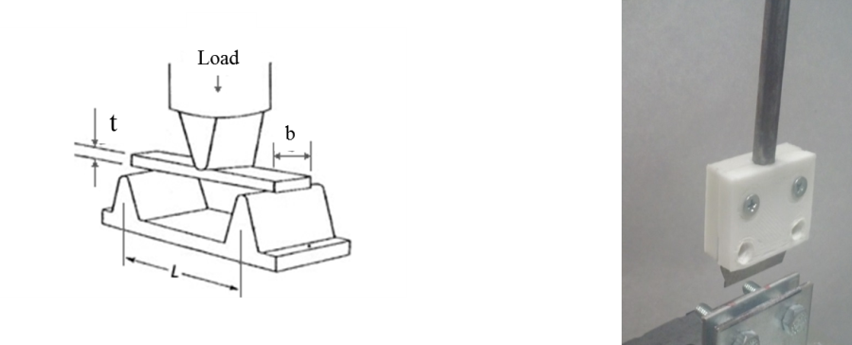

b)

a)

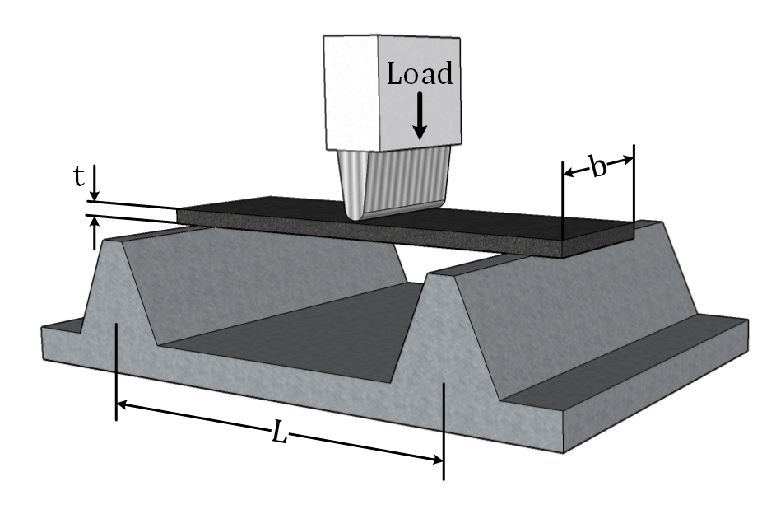

**Figure 5**. Indentation tests with different mead diameter powder: a) 16 µm, b) 45 µm, b) 125 µm.

* 1. Results

Figure 6 reports the results obtained by the indentation test with the compressed powder beds with the roller and the powder prepared without making any compression. The scrolling speed was set at 10 mm s-1 and the rotation speed was set at 5 mm s-1.

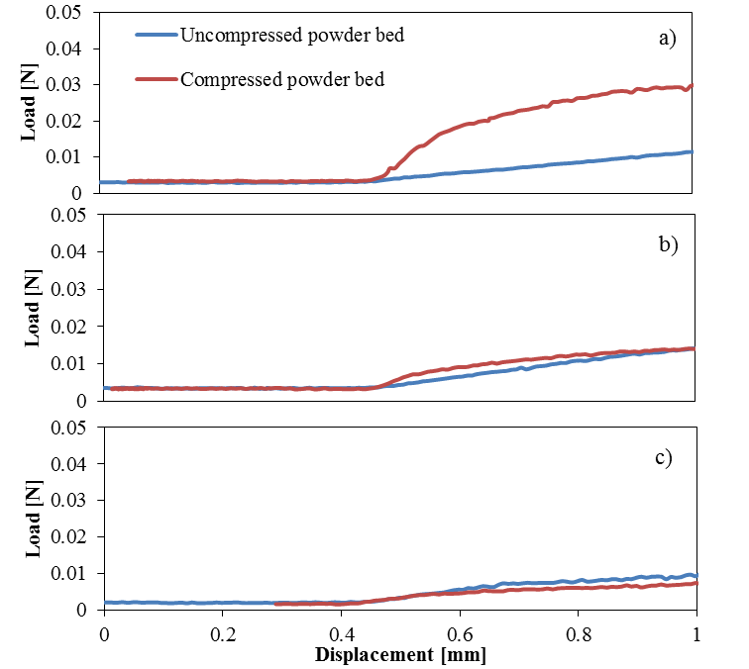

**Figure 6**. Indentation tests with different mead diameter powder: a) 16 µm, b) 45 µm, b) 125 µm.

In Table 2 reports the initial material stiffness calculated as the curve slope at the beginning of the indentation process.

|  |  |  |  |
| --- | --- | --- | --- |
| ds, µm |  | Stiffness, N mm-1 | |
|  | uncompressed | compressed |
| 16 |  | 0.013 | 0.055 |
| 45 |  | 0.015 | 0.022 |
| 125 |  | 0.009 | 0.006 |

For all the materials reported, the test results in Figure 6 and Table 2, indicate some effect of the bed compression. In particular, this effect appears to be more significant with the decreasing particle diameter of the processed powder. More in detail, in the case of ds = 16 µm, both the strength and the stiffenss of the sample are affected by compression. In the case of ds = 45 µm, the effect on the stiffness is significant, but the absolute values of the resistances are not affected significantly. Eventually, in the case of ds = 125 the effect of compression is minimal both in terms of resistance and stiffness, and the consolidation process has very slight, but negative effects on both.

The Fig 7 shows the results of the bending tests carried out on the sintered specimens (starting from powder of 16 µm of mean diameter). The tensile strength in the case of speciments prepared without compression of the initial powder is 0.184 N while in the case of the compressed bed it is 0.365 N, ie 198% more.

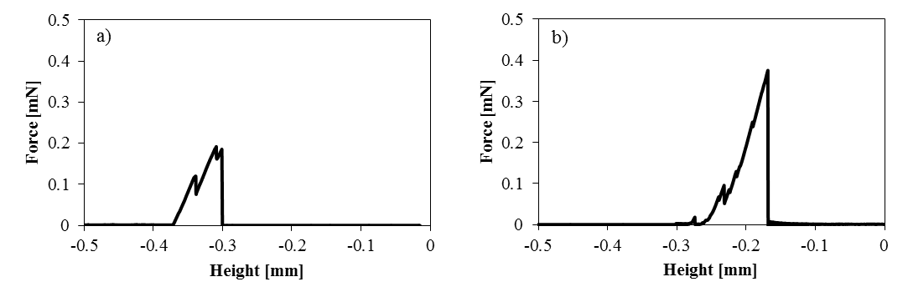 **Figure 7**. Bending test of the sintered specimens (16µm).

* 1. Conclusions

In this work the effect of the compression of the powder bed by means of a roller has been verified for powders characterized by different average particle diameters. In particular, with the increase in the particle diameter, the compression process loses effectiveness. For the finer powder, the case in which the roller was to significantly affect the powder compaction, bending tests were carried out in order to measure the material strength. Results indicate that the final sintered resistance increases by 198% in the case of compressed fine powder.

References

Molerus, O., 1975. Theory of yield of cohesive powders. Powder Technol. 12, 259–275. https://doi.org/10.1016/0032-5910(75)85025-X

Rumpf, H.C.H., 1970. Zur Theorie der Zugfestigkeit von Agglomeraten bei Kraft??bertragung an Kontaktpunkten. Chemie Ing. Tech. 42, 538–540. https://doi.org/10.1002/cite.330420806

Salehi, H., Sofia, D., Schütz, D., Barletta, D., Poletto, M., 2018. Experiments and simulation of torque in Anton Paar powder cell. Part. Sci. Technol. 36, 501–512. https://doi.org/10.1080/02726351.2017.1409850

Sofia, D., Barletta, D., Poletto, M., 2018a. Laser sintering process of ceramic powders: The effect of particle size on the mechanical properties of sintered layers. Addit. Manuf. 23, 215–224. https://doi.org/10.1016/j.addma.2018.08.012

Sofia, D., Chirone, R., Lettieri, P., Barletta, D., Poletto, M., 2018b. Selective laser sintering of ceramic powders with bimodal particle size distribution. Chem. Eng. Res. Des. 136, 536–547. https://doi.org/10.1016/j.cherd.2018.06.008

Sofia, D., Granese, M., Barletta, D., Poletto, M., 2015. Laser sintering of unimodal distributed glass powders of different size, in: Procedia Engineering. pp. 749–758. https://doi.org/10.1016/j.proeng.2015.01.180

Thornton, C., 2015. Granular Dynamics, Contact Mechanics and Particle System Simulations: A DEM study, Granular Dynamics, Contact Mechanics and Particle System Simulations: A DEM study. https://doi.org/10.1007/978-3-319-18711-2

Tomasetta, I., Barletta, D., Poletto, M., 2014. Correlation of powder flow properties to interparticle interactions at ambient and high temperatures. Particuology 12, 90–99. https://doi.org/10.1016/j.partic.2013.02.002