CHEMICAL ENGINEERING TRANSACTIONS  VOL. 76, 2019 | A publication of
The Italian Association
of Chemical Engineering
Online at www.cetjournal.it
Guest Editors: Sauro Pierucci, Jiří Jaromír Klemeš, Laura Piazza
Copyright © 2019, AIDIC Servizi S.r.l.
ISBN 978-88-95608-73-0; ISSN 2283-9216

Study on the Thermal Decomposition of Plastic Residues
Alessandro A. Casazza*, Elena Spennati, Attilio Converti, Guido Busca
ª Department of Civil, Chemical and Environmental Engineering (DICCA), University of Genoa, via Opera Pia 15,16145 Genoa, Italy
alessandro.casazza@unige.it
The use of plastics in the last decades significantly increased, thus plastic recycling processes are needed. Generally, mixtures of plastic materials are disposed together, hence the recovery of the polymeric material is difficult and expensive. Plastic residues could be valorized by thermal degradation processes aimed at recovering energy and/or valuable compounds for chemical industry. The main technologies used for this purpose are gasification and pyrolysis. The latter is a thermal degradation process that occurs in the absence of oxygen at moderate temperature (300-700°C), that could be used to recover the thermal power of biomasses. The reaction products are bio-oil, biogas and biochar. The aim of this work was to employ pyrolysis to energetically exploit different pure plastic materials, namely polyethylene terephthalate (PET), polyamide (Nylon-6), polyvinyl chloride (PVC) and polyurethane (PU), as well as a complex one such as end of life tyres (ELT). The reaction was performed at 400 °C for 90 min. The pyrolysis system was composed by a tubular quartz reactor heated with a tubular vertical oven. An integrated condenser was used to separate the liquid reaction products, while the incondensable gases were collected in a latex balloon. The reaction products were quantified gravimetrically and, in order to evaluate the functional groups, characterized by FTIR analysis. The reaction gases were also analyzed by GC-MS to determine the composition of this fraction. Results obtained from the different plastics were significantly different in terms of distribution and composition. In particular, PET produced a biogas consisting mainly of acetaldehyde and hydrocarbons, while the liquid fraction was composed of benzoic and terephthalic acids. Nylon-6 degraded producing a large amount of reaction gas (65 g/100g) composed of ammonia and light hydrocarbons, while the reaction liquid was mainly caprolactam. Around 53 g/100g of PVC reaction products were gaseous, mainly hydrochloric acid, followed by toluene and benzene at high concentrations. The degradation of PU produced a reaction gas, mainly composed by formic and acetic aldehydes. ELT pyrolysis was responsible for the production of high amounts of solid residue, while reaction gas and liquid seemed to be mainly constituted by hydrocarbons. In general, the study of pure plastic pyrolysis could help to better understand the thermal decomposition of complex plastic residues such as ELT.
  - Introduction
In the last decades the plastic consumption is continuously increasing, because it plays a fundamental role in many products in various sectors such as packaging, healthcare, construction, etc. On the market there are several plastic materials, with different properties and applications depending on their use (Williams et al., 1997). Polyethylene terephthalate (PET), which is the standard plastic with the highest consumption, is used especially in the packing sector (Grause et al., 2011). Nylon-6 is generally used for products that need high resistance, like wheels, connections and bearing (Ahn et al., 1997). Polyvinylchloride (PVC) is a polymer with high chemical resistance that can be mixed with several additives, allowing the production of plastic material with several chemical and physical properties (Xu et al., 2002). Polyurethane (PU) is widely used because it can be expanded as foam and can be utilized as filler in different sectors (Saha et al., 2008). ELT are mainly composed by hydrocarbons and they are considered as non-hazardous wastes (Antoniou and Zabaniotou, 2015).
The huge plastic demand led to growing accumulation of plastic wastes, which take very long to degrade naturally. Therefore, the continuous disposal of plastics in landfill is a false solution (Pinto et al., 1999). One of the possible means to mitigate this problem is to increase plastic recycling. Generally, mixtures of plastic materials are disposed together, and the recovery of the polymeric material is difficult and expensive (Arena et al., 2003). A promising alternative is the recovery of the energetic potential of the polymeric material through thermal degradation processes (López et al., 2010).
Pyrolysis is a thermochemical process carried out in absence of oxygen, whose resulting products are a liquid fuel, a gas and a char with composition and proportions depending on process conditions and feedstock characteristics (Bhaskar et al., 2003). Pyrolysis of plastic residues enables the thermal degradation of long chain polymeric molecules into smaller ones; moreover it is considered a green technology when the pyrolysis by-products have a calorific value that can be reused to compensate the overall energy demand of the process (Sharrudin et al., 2016).
The aim of this work was to investigate the pyrolysis of different pure plastic materials such as PET, Nylon-6, PVC and PU as well as of a complex one like end of life tires.
  - Materials and methods
    - Polymeric materials
The pyrolysis reaction was performed on different pure plastic residues such as polyethylene terephthalate (PET), polyamide (Nylon-6), polyvinyl chloride (PVC) and polyurethane (PU)), as well as a complex one like end of life tyres (ELT).
    - Experimental design
Thermal pyrolysis was performed in a tubular quartz reactor connected to a condenser able to separate liquid from gaseous products, connected at the top to a reflux condenser (Figure 1). Briefly, about 10 g of sample were charged into the reactor, and then the system was purged with nitrogen. The rector was put into an oven (Carbolite, MTF 10/25/130, Pocklington, UK), and the reaction temperature set at 673 K for 90 min. The incondensable gases, called reaction gas (RG), were collected into latex balloons located on the top of the reflux condenser and after the condenser. The condensable gases, called bio-oil (RL), were condensed and collected in a flask. After pyrolysis, the solid residue (SR) was collected and washed with ethanol to recover the heavy bio-oil fraction.

Figure 1: Pyrolysis reaction system. 1) Oven with temperature control, 2) quartz reactor, 3) flask (bio-oil collector), 4) condenser, 5) reflux condenser, 6) thermometer, 7) latex balloon (reaction gas collector).
    - FTIR analysis
The polymeric materials (PET, Nylon 6, PVC, PU and ELT) and the reaction products of thermal pyrolysis (RG, RL, RS) were analyzed by Fourier Transform Infrared Spectroscopy (FTIR) using a Nicolet 380 Spectrometer (Thermo Scientific, Madison, WA, USA). All the spectra were elaborated by the Omnic Lite Software (Thermo Electron Corporation, Madison, WA, USA). To analyze the solid residues, samples were mixed with KBr (1:50 w/w) and pressed, while liquid samples were deposited on a KBr pressed disk. RG were forced to pass through an IR glass cell with KBr windows and analyzed by the same spectrometer.
    - GC and GC-MS analyses
All RG samples were analyzed using a gas chromatograph, model 4890 (Agilent Technologies, Santa Clara, CA, USA), with FID detector. The instrument was equipped with a Varian capillary column, model Molsieve 5A/Porabond Q Tandem (Agilent). Helium (purity > 99.9%) was used as a carrier gas at a flow rate of 1.6 mL min⁻¹. The column temperature was initially set at 343 K, increased up to 503 K at 10 K min⁻¹. Using a 500 µL gas chromatography syringe, 400 µL of sample were injected with a split ratio of 1:10. RL samples were diluted with CHCl₃ up to a ratio of 1:10 (v/v) and analyzed by a gas chromatography-mass spectrometer (GC-MS), model Focus-ISQ (Thermo Scientific, Milan, Italy) (Romero et al., 2018).
  - Results and discussion
    - Reaction yields
Thermal pyrolysis was performed at 673 K for 90 min, and the reaction products were classified as reaction gas (RG), reaction liquid (RL) and solid residue (SR). Table 1 lists the reaction yields of these fractions obtained from each of the selected plastic residues, namely polyethylene terephthalate (PET), polyamide (Nylon-6), polyvinyl chloride (PVC) and polyurethane (PU). It is possible to observe that the polymer residue that led to the highest RG yield was Nylon-6 (65.69 g/100g), followed by PVC (53.01 g/100g), while the lowest yield of RG was produced by PFU (13 g/100g), while a mixture of them showed a much lower conversion (SR = 82 g/100g).
Table 1: Yields (%) of reaction gas (RG), reaction liquids (RL) and solid residue (SR)
 | RG  (g/100g) | RL  (g/100g) | SR  (g/100g)
PET | 28.02 | 23.00 | 48.80
PVC | 53.01 | 6.71 | 40.28
PU | 25.11 | 19.00 | 55.89
Nylon-6 | 65.69 | 13.73 | 20.59
ELT | 12.89 | 3.91 | 82.20

    - Reaction gas characterization
Figure 2 shows the FTIR spectra of the reaction gases from thermal pyrolysis of the selected plastic materials. All the spectra displayed the typical band of the asymmetric stretching of carbon dioxide at 2342 cm⁻¹, its roto-vibrational deformation (O-C-O) at 669 cm⁻¹ and its overtones at 3726 and 3627 cm⁻¹. The roto-vibrational band of CO stretching mode was visible at 2143 cm⁻¹. Moreover, all the spectra presented the bands of methane stretching deformation at 3016 and 1304 cm⁻¹, and the characteristic one of ethylene at 949 cm⁻¹.

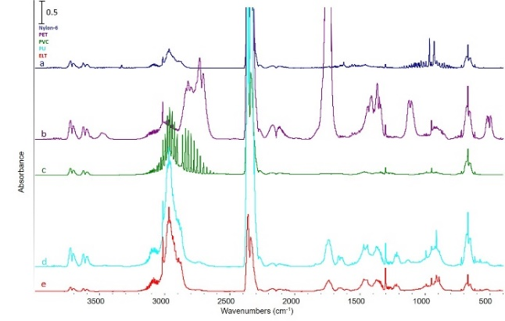
Figure 2: FTIR spectra of reaction gases from thermal pyrolysis of a) Nylon-6, b) PET, c) PVC, d) PU and e) ELT.
Analyzing the PET spectrum, it was possible to observe the characteristic bands of acetaldehyde at 3483 cm⁻¹, the C-H stretching of aldehydes at 2821 and 2730 cm⁻¹, the C=O stretching at 1759 cm⁻¹ and the -CH₂ deformation at 1411 cm⁻¹ likely due to the presence of monomeric ethylene glycol in the reaction gas. The presence of hydrochloric acid can be clearly inferred from the PVC spectrum by the roto-vibrational bands in the region between 3061-2675 cm⁻¹, the bands of -CH₂ scissoring at 1425 cm⁻¹ and that of H-C-H wagging mode at 946 cm⁻¹. The PU spectrum exhibited the stretching band of C=O at 1743 cm⁻¹ and those of -CH₃ deformation at 1473 and 1377 cm⁻¹ that confirmed the presence of acetone. There were also the -CH weak aromatic bands at 3150 and 3016 cm⁻¹ and those of C=C stretching at 1663 cm⁻¹, -CH₂ deformation of alkanes at 1473 cm⁻¹ and N=O stretching at 1232 and 1216 cm⁻¹. The Nylon-6 spectrum revealed the presence of ammonia due to the C-N and amide bonds broken, with the symmetric and asymmetric characteristic bands of C-N between 3487 and 3143 cm⁻¹, the asymmetric H-N-H deformation at 1625 cm⁻¹ and the symmetric N-H deformation at 950 cm⁻¹. The end of life tyres (ELT) spectrum presented the -CH stretching at 3016 cm⁻¹, the -CH bending at 1303 cm⁻¹, the C=C stretching at 1650 cm⁻¹ and the -CH₂ deformation at 1470 cm⁻¹, thereby confirming the presence of alkenes in the reaction gas.
Table 2 lists the percentage composition of main compounds identified in the reaction gases by GC. The results confirmed those of FTIR, in that, the major components for all the plastic residues, except PVC, were carbon dioxide and monoxide, acetal aldehyde and butene, while, as expected, the main RG component from PVC pyrolysis was hydrogen chloride. The RGs were then classified in five different classes: hydrocarbons, acids, oxygenates, nitrogenates and chlorinates.
The largest fraction of hydrocarbons in RG was obtained from pyrolysis of ELT (65.51 g/100g), of which they represented the most abundant class, followed by that of PU (63.2 g/100g), PVC (24.3 g/100g), PET (20.8 g/100g) and Nylon-6 (8.6 g/100g), while the highest fraction of oxygenates came from PET (79.2 g/100g), followed by ELT (34.5 g/100g), PU (31.5 g/100g) and Nylon-6 (20.9 g/100g). The fraction of nitrogenates in Nylon-6 RG was mainly composed by ammonia (70.4 g/100g), while that of chlorinates in PVC RG by hydrogen chloride (73.2 g/100g). RG could be used to produce energy, provided that nitrogenates and chlorinates are removed before use in order to make it cleaner and richer in hydrocarbons (Angelidaki et al., 2018).
Table 2: Main compounds identified by GC analysis in the reaction gases from thermal pyrolysis of different plastic materials.
 | PET  (g/100g) | PVC  (g/100g) | PU  (g/100g) | Nylon-6  (g/100g) | ELT  (g/100g)
Ammonia | - | - | 0.95 | 0.78 | 3.93
Methane | 2.06 | - | 1.90 | 1.72 | 8.27
Carbon monoxide | 19.12 | - | 3.65 | 4.60 | 6.65
Carbon dioxide | 15.25 | - | 29.06 | 59.32 | 9.71
Ethylene | 4.51 | - | 2.85 | 2.58 | 5.30
Ethane | 0.36 | - | 6.20 | 2.09 | 11.41
Formic aldehyde | 0.38 | - | 18.21 | 2.72 | -
Methanol | 0.16 | - | - | 1.57 | -
Acetal aldehyde | 52.62 | - | 21.40 | 19.30 | 15.38
Propane | 0.99 | - | 1.61 | - | 9.91
Butene | - | - | 5.69 | 0.93 | 22.32
Acetone | - | - | 8.46 | 1.35 | 3.80
Hydrogen chloride | - | 75.89 | - | - | -
Furan | 2.88 | - | - | - | -
Ethyl acetate | - | - | - | 0.50 | -
Butane | - | - | - |  | 1.29
Pentane | - | - | - | - | 1.24
Benzene | 0.91 | 22.59 | - | - | 0.81
Styrene | 0.19 | 1.52 | - | - | -
Toluene | 0.29 | - | - | - | 0.42
Cyclopentane | - | - | - | 0.54 | -
Butanol | - | - | - | 2.01 | -
Ethylbenzene | 0.27 | - | - | - | -

    - Reaction liquid characterization
- Figure 3 illustrates the FTIR spectra of reaction liquids from thermal pyrolysis of the selected plastic materials. The PET spectrum displayed the characteristic band of -OH stretching between 3100 and 2548 cm⁻¹ and those of C=O, O-C-O and aromatic C=C stretching at 1962, 1288 and 1600 cm⁻¹, respectively. Similarity of these bands with the characteristic ones of benzoic acid confirms the results obtained by Grause et al. (2011). The PVC spectrum presented aliphatic -CH stretching between 2952 and 2961 cm⁻¹, C=O stretching at 1698 cm⁻¹, C-C stretching between 1200-800 cm⁻¹, aromatic C=C bond between 1589 and 1460 cm⁻¹, C-Cl deformation at 724 cm⁻¹ and Si-O stretching at 1116 cm⁻¹. These bands can be assigned to the presence of ketones, aromatic compounds and unreacted PVC, except that of Si-O band probably due to the use of silicon as polymer filler (Karayildirim et al., 2006). The PU spectrum presented the typical bands of the aliphatic -CH stretching between 2968 and 2929 cm⁻¹, the -NH stretching at 3363 cm⁻¹, the -OH stretching at 3363 cm⁻¹, the C=O stretching at 1711 cm⁻¹, the -CH₂ bending at 1467 cm⁻¹ and the Si-O bond stretching between 1094 and 920 cm⁻¹ likely because of the use of silicon surfactant (Lim et al., 2008). The spectrum of Nylon-6 exhibited the -NH stretching at 3293 cm⁻¹, the aliphatic -CH stretching between 2928 and 2856 cm⁻¹ and the deformation of -NH bond and the C=O stretching at 1663 cm⁻¹, which can be ascribed to its complete depolymerization to caprolactone (Czernik et al., 1998). The ELT spectrum presented at wavenumbers > 3000 cm⁻¹ the aromatic -CH stretching and < 3000 cm⁻¹ the aliphatic -CH stretching, at 1454 cm⁻¹ the -CH₂ bending, at 1600 cm⁻¹ the aromatic C=C bending and its overtones and at 1029 cm⁻¹ the Si-O bond stretching. These bands in the ELT spectrum were likely due to the formation of toluene or its derivates. while the Si-O band to silicon used as a polymer filler.

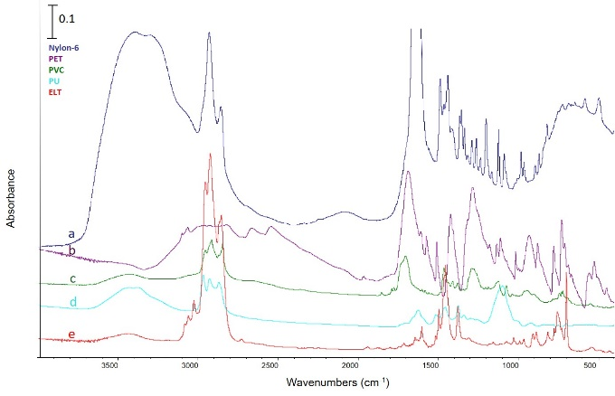
Figure 3: FTIR analysis of reaction liquids from thermal pyrolysis of a) Nylon-6, b) PET, c) PVC, d) PU and e) ELT.
3.4 Solid residue characterization
Except for small variations in the intensity of the peaks and the wavenumber, the spectra of Nylon-6, PU and ELT solid residues presented almost the same bands as the liquid almost the same bands as the reaction liquids (Figure 4). While, the PET spectrum presented the -CH aromatic stretching at 3000 cm-1 and the C-O stretching between 1300 and 1060 cm-1, the last being associated to the formation of polyether from partial depolymerization of PET. In the PVC spectrum it is possible to observe the characteristic bands of water, i.e. those of the -OH asymmetric stretching at 1934 cm-1, the -OH scissoring at 1634 cm-1 and the water release at 534 cm-1. Moreover, there were the bands of -CH stretching between 2952 and 2929 and the -CH bending at 1451 cm-1.
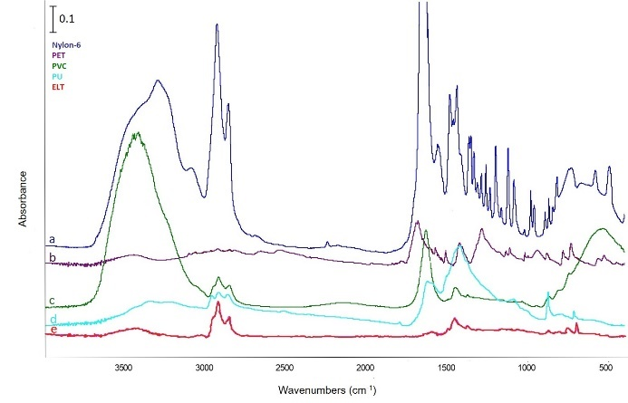
Figure 4: FTIR analysis of solid residue from thermal pyrolysis of a) Nylon-6, b) PET, c) PVC, d) PU and e) ELT.
  - Conclusion
The thermal pyrolysis of different polymeric residues was performed to investigate the distribution of reaction products and their characterization. All the polymeric materials widely decomposed during the pyrolysis at 673 K. The reaction gases were mainly composed of combustible compounds; thus, they could be used as a biofuel to produce energy. The reaction gases released from the pyrolysis of PVC, PU and Nylon-6 that contained also chlorine and nitrogen, should be purified to be used as fuel gases. Moreover, monomers of the different polymer residues could be recovered from reaction liquids and solid residues. Therefore, thermal pyrolysis would offer a solution to solve the problem of plastic waste accumulation into the environment, producing energy through the reaction gases and allowing for monomer recovery from reaction liquids and solid residue.

References
Ahn T. O., Hon S. C., Jeong, H. M., Kim, J. H., 1997, Nylon 6-polyethersulfone-nylon 6 block copolymer: Synthesis and application as compatibilizer for polyethersulfone/nylon 6 blend, Polymer, 38 207–215.
Angelidaki I., Treu L., Tsapekos P., Luo G., Campanaro S., Wenzel H., Kougias P. G., 2018 Biogas upgrading and utilization: Current status and perspectives, Biotechnology Advances, 36, 452–466.
Antoniou N., Zabaniotou A., 2015, Experimental proof of concept for a sustainable End of Life Tyres pyrolysis with energy and porous material production, Journal of Cleaner production, 101, 323-336.
Bhaskar T., Uddin M. A., Mura K., Kaneko J., Hamano K., Kusaba T., Muto A., Sakata Y., 2003 Comparison of thermal degradation products from real municipal waste plastic and model mixed plastics’, Journal of Analytical and Applied Pyrolysis, 70(2), 579–587.
Borsodi N., Miskolczi N., Angyal A., Gerencser A., Lazar I., Bartha L., 2011, Environmental Saving Disposal of Contaminated Plastics Wastes by Their Pyrolysis, Chemical Engineering Transactions, 24,1183-1188.
Czernik S., Elam,C. C., Evans R. J., Meglen R. R., Moens L., Tatsumoto K., 1998, Catalytic pyrolysis of nylon-6 to recover caprolactam, Journal of Analytical and Applied Pyrolysis, 46, 51–64.
Grause G., Handa T., Kameda T., Mizoguchi T., Yoshioka, T., 2011, Effect of temperature management on the hydrolytic degradation of PET in a calcium oxide filled tube reactor, The Chemical Engineering Journal, 166(2), 523–528.
Karayildirim T., Janik J., Yuksel M., Saglam M., Vasile C., Bockhorn H., 2006, The effect of some fillers on PVC degradation’, Journal of Analytical and Applied Pyrolysis, 75(2), 12–119.
Lim H., Kim S. H., Kim, B. K., 2008, Effects of silicon surfactant in rigid polyurethane foams, Express Polymer Letters, 2(3), 194–200.
López A., de Marco I., Caballero B. M., Laresgoiti M. F., Adrados A., 2010, Pyrolysis of municipal plastic wastes: Influence of raw material composition, Waste Management, 30(4), 620–627.
Perugini F., Vivaldi V., 2003, Life Cycle Assessment of a plastic packaging recycling system, The International Journal of Life Cycle Assessment, 8, 92.
Pinto F., Costa P., Gulyurtlu I., Cabrita I., 1999, Pyrolysis of plastic wastes, effect of plastic waste composition on product yield, Journal of Analytical and Applied Pyrolysis, 51(1-2), 39–55.
Romero M., Pizzi M., Toscano G., Casazza A. A., Busca G., Bosio B., Arato E., 2018, Deoxygenation of non-edible vegetable oil to produce hydrocarbons over Mg-Al mixed oxides, Chemical Engineering Transactions 64, 121-126.
Sah, M. C., Kabir M. E. and Jeelani S., 2008, Enhancement in thermal and mechanical properties of polyurethane foam infused with nanoparticles, Materials Science and Engineering, 479(1–2), 213–222.
Sharuddin S. D. A., Abnisa F., Wan Daud W. M. A., Aroua M. K., 2016, A review on pyrolysis of plastic wastes, Energy Conversion and Management, 115, 308–326.
Williams E. A., Williams, P. T.,1997, Analysis of products derived from the fast pyrolysis of plastic waste, Journal of Analytical and Applied Pyrolysis, 40-41, 347–363.
Xu J., Xu, Z. L., 2002, Poly(vinyl chloride) (PVC) hollow fiber ultrafiltration membranes prepared from PVC/additives/solvent, Journal of Membrane Science, 208, 203–212.

