|  |  |
| --- | --- |
| cetlogo ***CHEMICAL ENGINEERING TRANSACTIONS***  ***VOL. 76, 2019*** | A publication of  aidiclogo_grande |
| The Italian Association  of Chemical Engineering  Online at www.cetjournal.it |
| Guest Editors: Sauro Pierucci, Jiří Jaromír Klemeš, Laura Piazza  Copyright © 2019, AIDIC Servizi S.r.l. **ISBN** 978-88-95608-73-0; **ISSN** 2283-9216 | |

Thermal model of cylindrical Lithium-ion batteries

Roberto Bubbicoa, Francesco D’Annibaleb, Barbara Mazzarottaa, Carla Menalea,\*

a Dipartimento di Ingegneria chimica, materiali e ambiente, “Sapienza” Università di Roma, Via Eudossiana 18, 00184, Rome, Italy

b Laboratory for Development of Chemical and Thermal Fluid Dynamics Processes for Energy, ENEA, Via Anguillarese 301, 00123, Rome, Italy

carla.menale@uniroma1.it

Due to their characteristic of providing high energy density and long cycle life, Li-ion batteries are being widely used as power sources for a range of applications, including electric vehicles. The temperature of a Li-ion cell is important for its performance, capacity, efficiency and safety, and it is strongly influenced by the charging and discharging process modalities. Especially during electric vehicle operation, considerable heat is generated in the battery pack that needs to be removed. In the present paper a simplified model for predicting the temperature trend within a battery module with cylindrical cells, is presented. This allows to estimate the requirements for a given cooling system under specific discharge conditions. Three cooling fluids have also been experimentally compared: air, a dielectric oil and a perfluorinated polyether. The best performance was shown by a commercial perfluorinated polyether, by which it was possible to work in safe conditions with a very low pumping power: at 0.02 W, a maximum temperature of 48°C is reached at the end of the discharge using Galden HT135, while 55°C is reached with the Midel ICE. The results also showed that, under the assumed conditions, an air-cooling system needs between 100 and 1700 times more energy than the other methods to keep the same average temperature.

* 1. Introduction

A search for substantially lower automobiles’ fuel consumption and exhaust emissions have motivated a strong interest in technological advancements of electric (EVs) and hybrid-electric (HEVs) vehicles. Due to the high energy density, Lithium-ion batteries represent a viable candidate to increase vehicle performances. Much attention has been focused on the thermal behaviour of Li-ion batteries because temperature plays a significant influence on usable capacity, operation efficiency, and safety of batteries. At high temperature, the electrolyte can decompose leading to performance degradation and thermal runaway (Parhizi et al., 2017, Bubbico et al., 2018a, Kvasha et al., 2018). For this reason, it is necessary to provide the battery pack with an efficient battery thermal management system (BTMS). Recently, a range of heat dissipation technologies have been proposed and studied as BTMS to ensure the battery safety and expand the battery lifespan.

An obvious preliminary approach for limiting the temperature rise is using cold air: Mahamud et al. (2011), used a reciprocating air cooling method, while Xie et al. (2017), analyzed the influence of three factors (the air inlet angle, the air outlet angle and the width of the air flow channel between battery cells) on the heat dissipation of a Lithium-ion battery pack by experiments and computational fluid dynamics (CFD) simulations. Bubbico et al. (2017) showed that, under severe operating conditions, it is not possible to establish a sufficient temperature uniformity within a cell and from cell to cell, using air as cooling fluid, under no conditions.

Another typical heat dissipation technology is the indirect liquid cooling method. Deng et al. (2018) and Malik et al. (2018) analyzed the cooling performance of BTMS with cold plates; the disadvantages of this approach was the high investment costs and the high power consumption. Heat pipes have also been considered as a possible methodology for BTMS: water pipes were designed by Li et al. (2018) and a three-dimensional model was devised; Shah et al. (2016), demonstrated that a heat pipe can successfully prevent overheating in case of sudden increase in heat generation due to malfunctioning such as cell shorting. Although the cooling efﬁciency of the BTMS with heat pipes is high, the system configuration is complex, and a high energy consumption is required. The adoption of Phase Change Materials (PCM) in the BTMS has become a thriving trend due to many merits including simplicity (no need for extra components such as blowers), lightness, and high efficiency. The advancement of PCM-based BTMSs has been brought into focus and extensive studies have been conducted during the past several years (Al-Hallaj et al., 2000; Mills et al., 2006; Wang et al., 2015; Zhao et al., 2017; Bubbico et al., 2018b). Despite the advantages mentioned above, one of the biggest challenges for PCMs is their poor thermal conductivities: this limits PCM applicability in conditions where a fast response to thermal surge is required.

In this paper, as an alternative solution, a direct contact cooling of the batteries has been assumed, and the thermal behaviour of a battery pack with commercial 18650 Lithium Manganese Nickel Oxides cells has been simulated with a simplified model to compare the efficiency of different types of dielectric fluids. A comparison has been made between air, a dielectric oil (Midel ICE) and a perfluorinated polyether (Galden HT135) commonly used for hi-tech applications in the electronics and electrical devices market. The best performance has been shown by the Galden HT135 fluid: at the end of the discharge phase a maximum temperature of 48°C is reached with a very low pumping power (0.023 W).

* 1. Model

A one-dimensional model has been developed to predict the temperature trend during the charge/discharge phases of a battery pack with cylindrical cells. The energy balance for a refrigerated cell (Bubbico et al., 2017) can be written as:

|  |  |
| --- | --- |
| $$MC_{p}\frac{dT}{dt}+hS\left(T-T_{a}\right)+εSσ\left(T^{4}-T_{a}^{4}\right)-\dot{Q}=0$$ | (1) |

The first term $MC_{p}\frac{dT}{dt}$ is the thermal energy variation of the battery, $hS\left(T-T_{a}\right)$ is the heat removed by the fluid flow (where $T_{a}$ is the ambient temperature, S is the battery surface), $εSσ\left(T^{4}-T_{a}^{4}\right)$ is the radiant heat fraction (this term can be neglected under the considered conditions) and the last term $\dot{Q}$ is the dissipation. With reference to the layout represented in Figure 1, it has been supposed that the refrigerating fluid passes through the battery pack from bottom up, (Figure 1a) so the equivalent diameter (see Figure 1b) is equal to:

|  |  |
| --- | --- |
| $$D_{eq}=\frac{4*\left({\left(d+D\right)}^{2}-{πD^{2}}/4\right)}{πD+4d}$$ | (2) |

where D is the diameter of the cylindrical cells and d is the minimum distance between the cells.

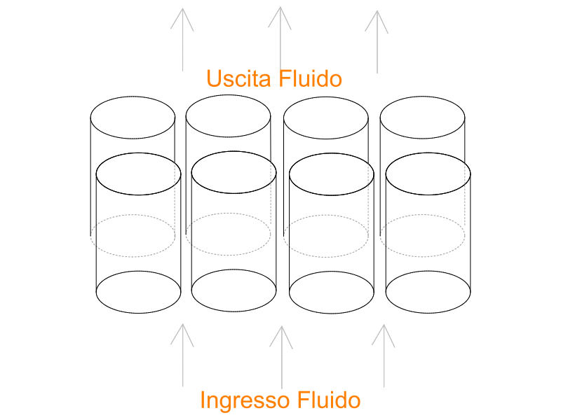

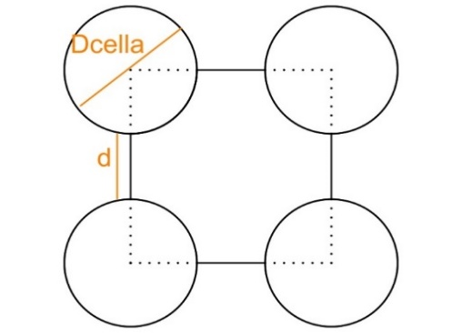

**Dcell**

**d**

**Outflow**

**Inflow**

1. (b)

Figure 1 Flow direction a) and passing area b) of the cooling fluid.

In this paper, the comparison between the temperature trends of the cells allocated in a battery pack has been carried out by varying the distance between the cells, with a specific fluid, and the cooling fluid, for a specific cells spacing. In addition, a constant pumping power has been assumed for all the configurations.

In order to evaluate the influence of the distance between the cells on the heat removal efficiency, it is necessary to correlate the fluid velocity $v$ with $d$.At equal pumping power (Wp), but with two different passing areas:

|  |  |
| --- | --- |
| $$W_{p_{1}}=W_{p_{2}}$$ $${∆P}_{1}*A_{1}*v_{1} = {∆P}_{2}*A_{2}*v_{2}$$ | (3) |

where ∆P are the pressure losses, which can be calculated by the Darcy equation

|  |  |
| --- | --- |
| $$∆P=f \frac{L}{D}\frac{ρv^{2}}{2}$$ | (4) |

In Eqs. (3) and (4), $f$ is the Darcy friction factor, $A$ is the passing area of the fluid [m2], and is the fluid velocity [m/s]. Under laminar flow conditions, $f={64}/{Re}$ , so that the fluid velocity $v_{2}$ for a distance $d_{2}$, is equal to:

|  |  |
| --- | --- |
| $$v_{2}= v_{1}. \sqrt{\frac{{(πD+4d_{1})}^{2}}{\left[4{\left(d_{1}+D\right)}^{2}-{πD}^{2}\right]}*\frac{\left[4{\left(d_{2}+D\right)}^{2}-{πD}^{2}\right]}{{(πD+4d_{2})}^{2}}}$$ | (5) |

Under transitional/turbulent flow conditions $f={0.079*4}/{{Re}^{0.25}}$ and the fluid velocity $v_{2}$ is calculated as:

|  |  |
| --- | --- |
| $$v_{2}=v_{1}\frac{{\left[4{\left(d_{2}+D\right)}^{2}-πD^{2}\right]}^{1/4}{(πD+4d_{1})}^{5/4}}{{\left[4{\left(d_{1}+D\right)}^{2}-πD^{2}\right]}^{1/4}{(πD+4d_{2})}^{5/4}}$$ | (6) |

where $v_{1}$ is the fluid velocity for a distance $d_{1}$.

At equal pumping power ($W_{p_fluid1}=W_{p_fluid2}$) and equal geometrical configuration of the cells (d1=d2), the ratio between the two fluids velocities depends on their flow regimes.

When both fluids are under laminar flow conditions:

|  |  |
| --- | --- |
| $$v_{fluid2}= v_{fluid1}. \sqrt{\frac{μ_{fluid1}}{μ_{fluid2}}}$$ | (7) |

In the case of a fluid under laminar flow conditions and the other fluid under transitional/turbulent flow conditions:

|  |  |
| --- | --- |
| $$v_{fluid2}=\sqrt{\frac{0.079*4}{64}*\frac{μ_{fluid1}^{1/4}.ρ_{fluid1}^{3/4}.v_{fluid1}^{11/4}}{μ_{fluid2}}D_{eq}^{3/4}}$$ | (8) |

Finally, when both fluids are under transitional/turbulent flow conditions:

|  |  |
| --- | --- |
|  | (9) |

* 1. Results and discussion

In this work a 18650 cylindrical cell, with NMC (Lithium Nickel Cobalt Manganese Oxide (LiNiCoMnO2)) cathodic chemistry, has been adopted as a reference. The technical data are shown in Table 1.

*Table 1: Technical data sheet of a 18650 Li-ion cell*

|  |  |
| --- | --- |
| Characteristics | Value |
| Nominal Capacity | 2500 mAh |
| Nominal Voltage | 3.6 V |
| Minimum Voltage | 2.5 V |
| Maximum Voltage | 4.20 +/- 0.05 V |
| Standard Charge current | 1.25 A |
| Continuous maximum discharge current | 20 A |
| Internal resistance | 13 mΩ |
| Lenght of the cell | 65.20 mm |
| Diameter of the cell | 18.35 mm |
| Weight | 44.30 g |
| Specific Heat | 0.95 J/g K |

In the first set of simulations it is considered that the cells are spaced 1 mm apart and that the cooling fluid is air in free convection. In Figure 2 the temperature trend of the cells is shown, for different discharge rates (from 2.5 to 20 A): it can be seen that up to a discharge current of 10 A (a 4 C discharge rate) it is sufficient to use air in free convection to remain within the “safe range“; on the contrary, at higher discharge currents the temperature will exceed 50°C. At a discharge current of 20 A, the temperature of 80°C is reached in only 7 to 8 minutes.



*Figure 2 Comparison between the temperature trends of cylindrical cell, at different discharge rates, using air in free convection, Ta=20°C, d=1mm.*

In Figure 3, a comparison has been made between the temperature trends of the 18650 cylindrical cells spaced apart 3 mm and 1 mm, for two different air velocities, corresponding to the minimum and the maximum pumping power (see Table 2). Almost coincident temperatures are obtained: increasing the distance between the cells does not provide a significant improvement in heat removal. Since the compactness of the battery pack is very important, especially in the automotive applications, from now on, an optimal distance of 1 mm has always been assumed between the cells.

*Table 2 air velocities changing the distances between the cells (from 1 mm to 3 mm) at the same pumping power*

|  |  |  |  |  |
| --- | --- | --- | --- | --- |
| Pumping Power (W) | Vair (m/s). d=1 mm | Vair (m/s). d=3 mm | Re. d=1 mm | Re. d=3 mm |
| 8.20E-05 | 1 | 1.17 | 4.66E+02 | 8.38E+02 |
| 3.28E-04 | 2 | 2.34 | 9.32E+02 | 1.68E+03 |
| 0.023 | 10 | 9.95 | 4.660E+03 | 5.44E+03 |
| 1.909 | 50 | 49.75 | 2.330E+04 | 2.72E+04 |
| 12.842 | 100 | 99.49 | 4.66E+04 | 5.44E+04 |
| 39.164 | 150 | 149.24 | 6.99E+04 | 8.16E+04 |



*Figure 3 Temperature trends for cylindrical cells discharged with a current of 20 A and cooled with air at the minimum and maximum pumping powers. Distances between the cells: d=1mm and d=3mm, Ta=20°C.*

Furthermore, in both cases (1 and 3 mm) it would be necessary to use an air velocity of about 150 m/s to work below the safe working temperature of 50°C with an ambient temperature of 20°C. It’s unthinkable to use such a high fluid velocity to cool a battery pack, so air cannot be used as cooling fluid for a discharge current equal to, or higher than, 20 A.

The thermal behavior of the batteries at a discharge rate of 20 A has then been analyzed using two different cooling liquids (see Table 3):

* a dielectric oil: Midel ICE (Fatty acids, C7-10, esters with neopentyl glycol)
* a perfluorinated polyether (Galden HT135): a dielectric fluid used for hi-tech applications in the electronics and electrical devices market.

*Table 3 Properties of the cooling liquids*

|  |  |  |  |  |
| --- | --- | --- | --- | --- |
|  | Cp (J/kg K) | K (W/m K) | ρ (kg/m3) | µ (kg/m s) |
| Galden HT135 | 962.68 | 0.065 | 1720 | 0.00172 |
| MidelICE | 1947 | 0.13 | 915 | 0.007 |

The velocities of the two liquids at the same pumping power adopted with air, have been calculated:

*Table 4 Liquids velocities and Re numbers at the same pumping power of air*

|  |  |  |  |  |
| --- | --- | --- | --- | --- |
| Pumping Power (W) | Voil (m/s) | VHT135 (m/s) | Reoil | ReHT135 |
| 8,20E-05 | 0.051 | 0.103 | 466 | 734 |
| 3,28E-04 | 0.102 | 0.206 | 932 | 1339 |
| 0,023 | 0.851 | 0.909 | 4660 | 6484 |
| 1,909 | 4.751 | 4.544 | 23300 | 32418 |
| 12,842 | 9.501 | 9.087 | 46600 | 64835 |
| 39,164 | 14.252 | 13.631 | 69900 | 97253 |

Using oil (Midel ICE) as a coolant allows to maintain the temperature below 35°C, with a pumping power of 2 W (see Figure 4a), whereas air under the same operating conditions, would have required 40 W (Figure 3).

Galden HT135 has a very high heat removal efficiency even under severe operating conditions (see Figure 4b), being more efficient than the dielectric oil at equal pumping power: at 0.02 W pumping power, a maximum temperature of 48°C is reached at the end of the discharge using Galden HT135, while 55°C is reached with the Midel ICE.

Besides a very low viscosity, the Galden HT135 also has further very useful properties, such as very low vapor pressure, non-flammability and high thermal stability.



1. (b)

Figure 4 Temperature trends at a discharge rate of 20 A, d= 1mm, Ta=20°C: a) Midel ICE, b ) GaldenHT135.

* 1. Conclusions

During charging and discharging process, a battery’s temperature varies due to internal heat generation: Joule heat and reaction heat are the main heat sources, which largely depend on the operating conditions. In this paper the thermal behavior of a battery pack with commercial 18650 Lithium Manganese Nickel Oxides cells has been studied. High temperatures will rapidly cause the degradation of lithium ion batteries, so that an adequate cooling system is required. Three different dielectric fluids have been compared (air, an oil and a perfluorinated polyether). Under severe operating conditions, an excessive pumping power of about 40 W is necessary to keep the temperature below the limit of 50°C, using air as cooling fluid; using a dielectric oil, a pumping power of about 0.4 W was sufficient to work under safe conditions. Due to its excellent thermal properties, the best performance was shown by the Galden HT135, which allowed to keep the temperature well below the maximum value at a very low pumping power. Though more expensive, the benefits expected, both in terms of prolonged life span of the battery and of operating costs of the cooling system, will more than compensate for its initial cost.

Acknowledgments

The authors are grateful to the Italian Ministry of Economic Development and ENEA for their financial support (project number: RSE PAR 2017: Progetto C.5: Sistemi di accumulo di energia per il sistema elettrico).

References

Al-Hallaj S, Selman JR, 2000, A novel thermal management system for electric vehicle batteries using phase-change material. J Electrochem Soc;147: 3231-6.

Bubbico R., Greco V., Menale C., 2018a, Hazardous scenarios identification for Li-ion secondary batteries, Safety Science, 108, 72-88.

Bubbico R., D’Annibale F., Mazzarotta B., Menale C., 2018b, Analysis of passive temperature control systems using PCM for application to secondary batteries cooling, J. Thermal Sci. Eng. Appl., 10(6):061009-061009-10.

Bubbico R., D’Annibale F., Mazzarotta B., Menale C., 2017, Air cooling of li-ion batteries: an experimental analysis, Chemical Engineering Transactions, 57, 379-384 DOI: 10.3303/CET1757064.

Deng T., Zhang G., Ran Y., 2018, Study on thermal management of rectangular Li-ion battery with serpentine-channel cold plate, International Journal of Heat and Mass Transfer 125, 143–152.

Kvasha A., Gutierrez C., Osa U., de Meatza I., Blazquez J. A., Macicior H., Urdampilleta I., A comparative study of thermal runaway of commercial lithium ion cells, Energy 159 (2018) 547-557

Li K., Yan J., Chen H., Wang Q., 2018, Water cooling based strategy for lithium ion battery pack dynamic cycling for thermal management system, Applied Thermal Engineering 132, 575–585.

Mahamud R., Park C., 2011, Reciprocating air flow for Li-ion battery thermal management to improve temperature uniformity, J. Power Sources 196, 5685–5696

Malik M., Dincer I., Rosen M.A., Mathew M., Fowler M., 2018, Thermal and electrical performance evaluations of series connected Li-ion batteries in a pack with liquid cooling. Applied Thermal Engineering 129, 472–481

Mills A, Farid M, Selman JR, Al-Hallaj S., 2006, Thermal conductivity enhancement of phase change materials using a graphite matrix. Appl Therm Eng; 26:1652-61.

Parhizi M., Ahmed M.B., Jain A., 2017, Determination of the core temperature of a Li-ion cell during thermal runaway. Journal of Power Sources 370, 27-35.

Shah K., McKee C., Chalise D., Jain A., 2016, Experimental and numerical investigation of core cooling of Li-ion cells using heat pipes, Energy Volume 113, Pages 852-860.

Wang Z, Zhang Z, Li J, Yang L., 2015, Paraffin and paraffin/aluminum foam composite phase change material heat storage experimental study based on thermal management of Li-ion battery. Appl Therm Eng; 78:428-36

Xie J., Ge Z., Zang M., Wang S., 2017, Structural optimization of lithium-ion battery pack with forced air cooling system, Applied Thermal Engineering 126, 583–593.

Zhao R., Gu J., Liu J., 2017, Optimization of a phase change material based internal cooling system for cylindrical Li-ion battery pack and a hybrid cooling design, Energy 135, 811-822.