CHEMICAL ENGINEERING TRANSACTIONS  VOL. 76, 2019 | A publication of
The Italian Association
of Chemical Engineering
Online at www.aidic.it/cet
Guest Editors: Sauro Pierucci, Jiří Jaromír Klemeš, Laura Piazza
Copyright © 2019, AIDIC Servizi S.r.l.
ISBN 978-88-95608-73-0; ISSN 2283-9216

Heat transfer between gas and non-coalescent liquid in a bubble column
Martin Žižkaª, Radek Šulc^{*a}, Pavel Ditlª
ªCzech Technical University in Prague, Faculty of Mechanical Enginering, Department of Process Engineering, Technicka 4, Prague, Czech Republic
Radek.Sulc@fs.cvut.cz
Multiphase contactors, e.g. bubble columns, are often used in operations accompanied by heat transfer between the phases. The effect of multi-orifice aerator for the heat transfer between gas and the non-coalescent liquid was investigated for two different aerator patterns. This study was performed on the bubble column 0.15 m in diameter with various liquid levels and for various superficial gas velocities. The aqueous solution of 0.3 M Na₂SO₄ was used as a non-coalescent batch. The gas-to-liquid heat transfer measurements were performed by a non-steady state method based on measurements of the gas- and liquid- temperature in the time for an evaluation of the heat fluxes and heat transfer coefficient.
1. Introduction
Bubble columns are intensively used as multiphase contactors and reactors in the chemical, biochemical and petrochemical industries. In the chemical industry these columns are used mainly in processes involving reactions such as oxidation, chlorination, alkylation, polymerization and hydrogenation. Some very well-known chemical applications are in the famous Fischer-Tropsch process for producing transportation fuels and also in methanol synthesis (Kantarci et al., 2005, Shah et al., 1982, Prakas et al., 2001). The Fischer-Tropsch synthesis is one of carbon capture utilization technologies potentially used to decrease emitted CO₂ and producing synthetic fuels which are environmentally much more favourable than petroleum-derived fuels (Kratky, 2018). In biochemical processes these contactors are used for fermentation, biological wastewater treatment and CO₂ utilization by algae cultivation (Bělohlav et al., 2017, Žáková et al., 2018).
Literature studies published are focused on the determination of (i) bed-to-wall heat transfer coefficients, and (ii) immersed object-to-bed heat transfer coefficients in two- and three-phase systems. In our previous work the gas-to-liquid heat transfer coefficient was determined in the air-water system for two different multi-orifice aerators by own proposed non-steady state method (Žižka et al., 2017). The coalescence of bubbles is a vital phenomenon affecting process characteristics such as hold-up, mass and heat transfer. This papers aims to determine the heat transfer coefficient between gas and non-coalescent liquid for two different aerator patterns. This study was performed on the bubble column 0.15 m in diameter with various liquid levels and for various superficial gas velocities. The aqueous solution of 0.3 M Na₂SO₄ was used as a non-coalescent batch. The gas-to-liquid heat transfer coefficient was determined by a non-steady state method. The obtained results were compared with gas-to-liquid heat transfer coefficients measured for the coalescent liquid batch.
2. Theoretical background
2.1 Coalescence
Approaching two bubbles to each other the liquid is drained from the space between bubbles and liquid film thickness decreases. If the liquid film is ruptured, the bubbles coalesce and form one bigger bubble. Many authors investigated the effect of the salt ions on bubble coalescence (e.g., Marrucci, 1969, Prince and Blanch, 1990, Craig, 2004, Nguyen et al., 2012). Marrucci (1969) found that salts inhibit bubble coalescence by retarding the thinning of the liquid film between bubble pairs. The inhibition effect of salts depends on salt concentration. The salt concentration for which bubble coalescence is dramatically reduced is called molar transition concentration c_{t}. Lessard and Zieminski (1971) defined transition concentration as the concentration corresponding to 50 % coalescence. They found that this concentration is unique for each salt.
The transition concentration can be estimated for various electrolytes using theoretical relations proposed by Marrucci (1969) or Prince and Blanch (1990a).
Prince and Blanch (1990b) investigated the bubble coalescence and bubble break-up in turbulent gas-liquid dispersions. The distilled water and solutions of inorganic salts (sodium chloride, sodium sulphate) were used as the model liquid. The molar concentration of sodium sulphate was changed in the range from 0.004 to 0.033 mol/L. The molar concentration of sodium chloride was changed from 0.035 to 0.1 mol/L. Craig (2004) proposed combining rule for various salt ions enabling to estimated the effect of given salt on bubble coalescence. It can explain that some salts inhibit bubble coalescence (e.g. sodium chloride, lithium chloride) and other salts do not inhibit coalescence (e.g., sodium chlorate). The similar results were obtained by molecular dynamics simulation (e.g., Jungwirth and Tobias, 2006).
Zahradnik et al. (1999) investigated the coalescence phenomena in aqueous solutions of aliphatic alcohols C1-C8 and electrolytes (NaCl, KCl, KI, NaSCN, NaOH, CaCl₂, BaCl₂, Na₂SO₄, MgSO₄) and in viscous aqueous solutions with Newtonian and non-Newtonian behaviour. For sodium sulphate the transition concentration equal to 0.051 mol/L was found experimentally. For sodium sulphate the coalescence percentage was found to be in the range from 10 to 15 % for molar concentration in the range from 0.062 to 0.3 mol/L. Nguyen et al. (2012) reported that the transition salt concentration for bubble coalescence and gas holdup depends not only on the salt properties (i.e., the ion type and their combination), but also on the hydrodynamic conditions. The effect of gas velocity, salt type (NaCl, NaF, NaBr, NaI and CsCl) and salt concentration (0.001-3 mol/L) on bubble coalescence was investigated in a bubble column of 45 mm in inner diameter.
The effect of salts on gas holdup was investigated e.g. by Kelkar et al. (1983), Zahradnik et al. (1997), Ribeiro and Mewes (2007), Orvalho et al. (2009). For tested salt solutions authors report that increasing salt concentration gas holdup increases till the transition concentration is reached. Further increase in salt concentration does not affect gas holdup. The increase of gas holdup observed for salt solutions is caused by two factors: 1) stabilization of homogeneous flow regime, 2) reduced bubble rising velocity (Besagni and Inzoli, 2017). Baz-Rodríguez et al. (2014) investigated the effect of salts (NaCl, MgCl₂, CaCl₂) on oxygen transfer in a bubble column of 95 mm in inner diameter. They found that presence of electrolytes reduces the value of mass transfer coefficient k_{L} and increases value of interfacial surface more intensively thus the volumetric mass transfer coefficient k_{L}a increases up to 40-50 % concerning similar experiments in an air-water system.
2.2 Measurement method
The proposed procedure for experimentally determining the heat transfer between gas and liquid in the column is based on transient heat transfer measurements. The principle of the used method can be shortly described as it follows: The column is filled with a given volume of liquid. A gas at a lower temperature than the liquid is bubbled through the liquid at a constant gas flow rate. Due to the different temperatures of the liquid and the gas, there is heat transfer from the liquid to the gas. The gas is heated and the liquid is cooled. The liquid temperature decreases with time. The exhaust gas temperature changes over time. The inlet gas temperature is practically unchanged and remains constant. If the saturated pressure corresponding to the liquid temperature is higher than the partial pressure of the liquid vapours in the gas stream, there is evaporation of the liquid into the gas stream. Besides, if the temperature of the system is higher than the temperature of the surroundings, there are heat losses to the surroundings.
Volumetric mass transfer coefficient k_{L}.a has often described the gas-to-liquid mass transfer due to difficulties in determining the bubble interfacial area S_{b}. By analogy, the gas-to-liquid heat transfer can be characterized employing volumetric gas-to-liquid heat transfer coefficient α.a (W m⁻³ K⁻¹), which is defined as follows:
(1)
where V_{L0} is the equipment/bed volume that corresponds to the volume of a non-gassed liquid batch (m³).
3. Experimental
The sodium sulphate acting as a surface active substance was used to obtain non-coalescence liquid behaviour. The aqueous solution of sodium sulphate having a molar concentration of 0.3 mol/L was prepared from deionised water and solid sodium sulphate (p.a. quality, Lach-Ner Inc., Czech Republic). The transitional concentration of sodium sulphate is 0.050 mol/L according to Marrucci (1969), 0.061 mol/L according to Lessard and Zieminski (1971) and 0.089 mol/L according to Prince and Blanch (1990a). Zahradnik et al. (1999) found the value of 0.051 mol/L experimentally. For this value, the c/c_{t} ratio equal to 5.9 was used in this work. The air was used as a gaseous phase. The experiments were performed on a PVC tube vertical column 0.15 m in inner diameter in the range of superficial gas velocity from 0.01 m s⁻¹ to 0.03 m s⁻¹. The liquid height was held at four different levels - 0.5 m, 0.65 m, 0.85 and 0.95 m, i.e. the aspect ratio is in the range from 3.3 to 6.3. The scheme of the experimental apparatus is depicted in Figure 1. The two patterns of gas multi-orifice distributor were tested (Figure 2). The diameter of holes was 1 mm. The sparger was located at the bottom of a bubble column.

Figure 1: Schema of the experimental apparatus.
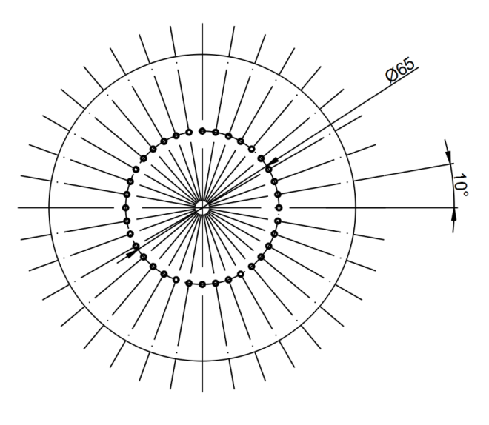 | 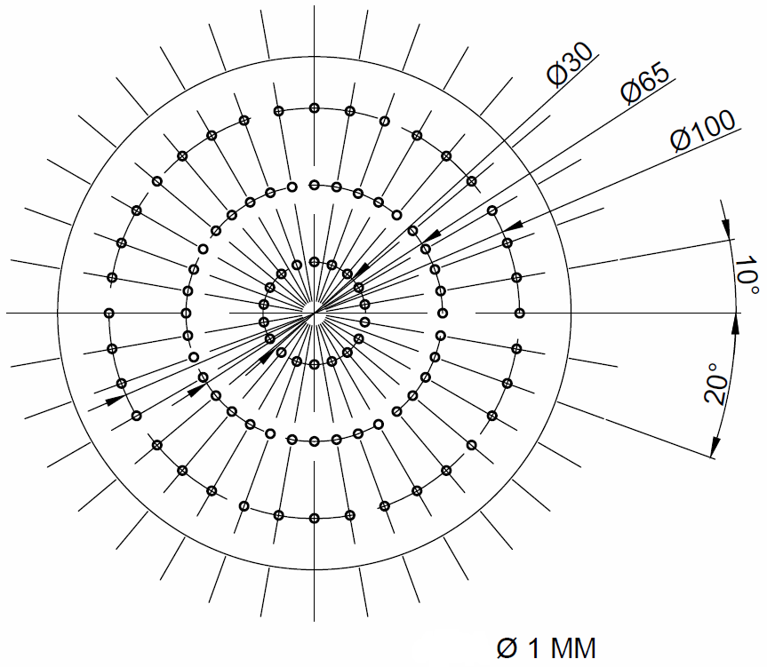
Figure 2: Tested multi-orifice aerator patterns: a) SC (left) and b) CC3 (right).
The column was filled with a warm solution (∝ 50-60°C). The batch was started bubbled by an air flow having a lower temperature (∝ 20-25 °C). Thus, air passing through liquid batch was warmed up and the liquid was cooled, i.e. liquid temperature decreased with time. The outlet gas temperature changed with time, depending on heat transfer. The heat transfer was also accompanied by simultaneous evaporation of the liquid that was taken into account when the heat-transfer coefficient was evaluated. The following experimental data sets were obtained in a discrete form: 1) the liquid batch temperature T_{L} (t_{i}), 2) the inlet air temperature T_{g in} (t_{i}), 3) the outlet air temperature at column outlet T_{g out} (t_{i}), 4) the inlet air pressure p_{g in} (t_{i}), 5) the relative humidity of inlet air ϕ_{g} _{in} (t_{i}), and 6) the relative humidity of outlet air ϕ_{g} _{out} (t_{i}). Time of the measurement was about 20 minutes. The inlet air temperature was found to be practically unchanged and constant. The heat losses to the surroundings were found to be negligible.
4. Results and discussion
4.1 Hold up
The hold-up ε (-) was determined visually and one was obtained as follows:
(2)
where H_{b} is the height of the bubbled liquid batch (m), and H_{L0} is the height of non-gassed liquid batch (m). The dependence of hold up on superficial velocity is depicted for four liquid levels in Figures 2a and 3a for SC and CC3 pattern respectively. This dependence can be expressed by the linear relation regardless of liquid height as follows:
for SC pattern (R = 0.946) | (3)
for CC3 pattern (R = 0.970) | (4)
where u_{g0} is the superficial gas velocity (m s⁻¹). The hold up was found to be practically the same regardless of distributor pattern. Comparing with the air-water system (Žižka et al., 2017) the gas holdup was practically the same for both patterns (see Figures 3a and 4a). This result agrees with Zahradnik et al. (1997) for corresponding gas superficial velocity and similar geometry.

Figure 3: SC pattern: a) the hold up ε (left), b) the volumetric gas-to-liquid heat transfer coefficient α.a (right); (♦) 0.5 m, (■) 0.6 m, (▲) 0.85 m, (•) 0.95 m, (―) model – 0.3 M Na₂SO₄, (- - - -) model - water.

4.2 Volumetric gas-to-liquid heat transfer coefficient
For the air-water system, we found in our previous work that the effect of the liquid height on the volumetric gas-to-liquid heat transfer coefficient α.a can be compensated using aeration VVM as a measure of air flow (Žižka et al., 2017). The dependence of volumetric heat transfer coefficient α.a on aeration VVM can be expressed by the linear relation as follows:
for SC pattern (R = 0.973) | (5)
for CC3 pattern (R = 0.609) | (6)
where α.a is the volumetric gas-to-liquid heat transfer coefficient (W m⁻³ K⁻¹), VVM is the aeration (s⁻¹) defined as a ratio of air flowrate and the volume of a non-gassed liquid batch, i.e. VVM = V•_{g}/V_{L0} = u_{g0}/H_{L0}. For SC pattern the two data items were excluded from regression (data items for 0.5 m and aeration 0.042 s⁻¹ and 0.063 s⁻¹). The comparison of experimental data and proposed correlation is depicted for four liquid levels in Figures 2b and 3b for SC and CC3 pattern respectively. For comparison, the dependence of α.a on aeration VVM for the air-water system is presented in graphs simultaneously. For SC pattern the heat transfer coefficient α.a for sodium sulphate solution was found to be higher compared with the air-water system. Depending on aeration value the α.a coefficient for sodium sulphate solution was 1.33-2.12 times higher in the aeration range from 0.02 to 0.063 s⁻¹. Unlike this, the heat transfer coefficient for CC3 pattern was found to be practically the same compared with air-water system. This fact and lower correlation index were probably caused by unstable gas flow through the sparger observed for applied air flowrates.

Figure 4: CC3 pattern: a) the hold up ε (left), b) the volumetric gas-to-liquid heat transfer coefficient α.a (right) ; (♦) 0.5 m, (■) 0.6 m, (▲) 0.85 m, (•) 0.95 m, (―) model – 0.3 M Na₂SO₄, (- - - -) model - water.

5. Conclusions
The effect of multi-orifice aerator for the heat transfer between gas and a non-coalescent liquid was investigated for two different aerator patterns. The aqueous solution of 0.3 M Na₂SO₄ was used as a non-coalescent batch. The experiments were performed in the bubble column in diameter of 0.15 m with various liquid levels within the range of superficial air velocity varying from 0.01 m s⁻¹ to 0.03 m s⁻¹. The hold up was found to be linearly depending on the superficial gas velocity regardless of liquid height. The hold up for a non-coalescent bath was practically the same for similar experiments in the air-water system.
The volumetric gas-to-liquid heat transfer coefficient was found to be linearly depending on the aeration regardless of liquid height. Depending on aeration value the heat transfer coefficient for sodium sulphate solution was 1.33-2.12 times higher concerning the air-water system in the aeration range from 0.02 to 0.063 s⁻¹ for SC pattern. For CC3 pattern the evaluated heat transfer coefficients in sodium sulphate solution and water were comparable. This fact was probably caused by unstable gas flow through the sparger observed for applied air flowrates.

Acknowledgments
This work was supported by the Ministry of Education, Youth and Sports of the Czech Republic under OP RDE grant number CZ.02.1.01/0.0/0.0/16_019/0000753 "Research centre for low-carbon energy technologies".

Reference
Baz-Rodríguez S.A., Botello-Alvarez J.E., Estrada-Baltazar A., Vilchiz-Bravo L.E., Padilla-Medina J.A., Miranda-López R., 2014, Effect of electrolytes in aqueous solutions on oxygen transfer in gas-liquid bubble columns, Chem Eng Res Des, 92, 2352-2360. DOI: 10.1016/j.cherd.2014.02.023
Belohlav V., Jirout T., Kratky L., 2017, Operational and design parameters of microalgae cultivation systems for its application in industrial scale, In: EUBCE proceedings, 25th European Biomass Conference and Exhibition, June 12-15, Stockholm, Sweden, 1990-1997. DOI: 10.5071/25thEUBCE2017-IDV.3.10
Besagni G., Inzoli F., 2017, The effect of electrolyte concentration on counter-current gas-liquid bubble column fluid dynamics: gas holdup, flow regime transition and bubble size distributions, Chem Eng Res Des, 118, 170-193. DOI: 10.1016/j.cherd.2016.12.012
Craig V.S.J., 2004, Bubble coalescence and specific-ion effects, Curr.Opin.Colloid Interface Sci, 9, 178-184. DOI: 10.1016/j.cocis.2004.06.002
Jungwirth P., Tobias D.J., 2006, Specific ion effects at the air/water interface, Chem. Rev., 106, 1259-1281. DOI: 10.1021/cr0403741
Kantarci N., Borak F., Ulgen K.O., 2005, Bubble column reactors. Review, Process Biochemistry, 40, 2263-2283, DOI: 10.1016/j.procbio.2004.10.004
Kelkar B.G., Phulgaonkar S.R., Shah Y.T., 1983, The effect of electrolyte solutions on hydrodynamic and backmixing characteristics in bubble columns, Chem. Eng. J., 27,125–133. DOI: 10.1016/0300-9467(83)80069-0
Krátký L, 2018, Carbon capture and utilization technologies: a technical state of art, Acta Sci. Pol. Biotechnologia, 17 (1), 59-68. DOI: 10.30825/5.biot.50.2018.17.1
Lessard R.R., Zieminski S.A., 1971, Bubble coalescence and gas transfer in aqueous electrolytic solutions, Ind Eng Chem Fundam, 10, 260-269. DOI: 10.1021/i160038a012
Marrucci G., 199, A theory of coalescence, Chem. Eng. Sci, 24, 975-985. DOI: 10.1016/0009-2509(69)87006-5
Nguyen P.T., Hampton M.A., Nguyen A.V., Birkett G.R., 2012, The influence of gas velocity, salt type and concentration on transition for bubble coalescence inhibition and gas holdup, Chem Eng Res Des, 90, 33-39. DOI: 10.1016/j.cherd.2011.08.015
Orvalho S., Ruzicka M.C., Drahos J., 2009, Bubble column with electrolytes: gas holdup and flow regimes, Ind. Eng. Chem.Res. 48, 8237–8243. DOI: 10.1021/ie900263d
Prakash A, Margaritis A, Li H., 2001, Hydrodynamics and local heat transfer measurements in a bubble column with suspension of yeast, Biochem Eng J, 9, 155–163, DOI: 10.1016/S1369-703X(01)00137-1
Prince M.J., Blanch H.W., 1990a, Transition electrolyte concentrations for bubble coalescence, AIChE J., 36 (10), 1425–1429. DOI: 10.1002/aic.690360915
Prince M.J., Blanch H.W., 1990b, Bubble coalescence and break-up in air-sparged bubble columns, AIChE J., 36 (10), 1485-1499. DOI: 10.1002/aic.690361004
Ribeiro Jr. C.P., Mewes D., 2007, The influence of electrolytes on gas hold-up and regime transition in bubble columns, Chem.Eng. Sci., 62, 4501–4509. DOI: 10.1016/j.ces.2007.05.032
Shah Y.T., Kelkar B.G., Godbole S.P, Deckwer W.D., 1982, Design parameters estimations for bubble column reactors, AIChE J, 28, 353–379, DOI: 10.1002/aic.690280302
Zahradník J., Fialová M., Růžička M., Drahoš J., Kaštánek F., Thomas N.H., 1997, Duality of the gas–liquid flow regimes in bubble column reactors. Chem. Eng. Sci. 52, 3811–3826. DOI: 10.1016/S0009-2509(97)00226-1
Zahradník J., Fialová M., Linek V., 1999, The effect of surface-active additives on bubble coalescence in aqueous media, Chem Eng Sci, 54, 4757-4766. DOI: 10.1016/S0009-2509(99)00192-X
Žáková T., Krátký L., Jirout T., 2018, Technical study of pilot plant and industrial photobioreactors, In: EUBCE proceedings, 26th European Biomass Conference and Exhibition, May 14-17, Copenhagen, Denmark, 214-222. DOI: 10.5071/26thEUBCE2018-1BV.8.33
Žižka M., Šulc R., Ditl P., 2017, Heat transfer between gas and liquid in a bubble column, Chemical Engineering Transactions, 57, 1261-1266. DOI: 10.3303/CET1757211

