 CHEMICAL ENGINEERING TRANSACTIONS  VOL. 76, 2019 | A publication of  
The Italian Association
of Chemical Engineering
Online at www.cetjournal.it
Guest Editors: Sauro Pierucci, Jiří Jaromír Klemeš, Laura Piazza
Copyright © 2019, AIDIC Servizi S.r.l.
ISBN 978-88-95608-73-0; ISSN 2283-9216

A greener olefination process to produce alkenoic acids from levulinic acid
Juliana O. Bahú*, Maria I. R. B. Schiavon, Anderson J. Bonon, Rubens Maciel Filho
INCT - Biofabris - University of Campinas, School of Chemical Engineering, Av. Albert Einstein, 500, CEP 13083-852, Campinas, SP, Brazil.
juliana.bahu@gmail.com
Levulinic acid (LA) is a bifunctional compound with high reactivity that can be produced by acid hydrolysis of biomass. Its ketone group can be functionalized to an olefinic bond via Wittig reaction. However, this reactional system usually involves multiple steps and uses highly toxic raw materials. This study aims to produce alkenoic acids derived from LA via Wittig reaction using a greener process. For this, we evaluated the olefination of LA in the presence of different bases (NaHCO₃, Na₂CO₃, and NaOH) and isopropanol as solvent (reduced toxicity). The products were identified by mass spectrometry, observing positive results for NaHCO₃. The fragmentation mechanisms for the alkenoic acid ions (4-methyl-hex-4-enoic acid, m/z 127, and 4-methyl-hept-4-enoic acid, m/z 141) confirmed their production by the proposed process.

  - Introduction
Biorefineries are key-industries to the future, since it involves the development of a sustainable integrated process of biomass, regarding energetic efficiency, economic competitiveness, reduction of environmental impacts (Yamakawa et al., 2018) and, production of value-added chemical products (Licursi et al., 2018). Considering this, the levulinic acid (LA) that can be obtained by dehydration of hexoses, appears as a promising chemical platform due to its high reactivity (Rackemann and Doherty, 2011). It produces a variety of products for different market segments: fuels (Zhang et al., 2012), additives (Protsenko et al., 2016), pharmaceuticals, solvents, polymers (Hartweg and Becer, 2016), plasticizers (Pileides and Titirici, 2016), and fine chemicals (Yan et al., 2015; Morone et al., 2015; and Chalid et al., 2012). Among the bioproducts generated from LA, its alkenoic acid derivatives have high reactivity and market value, making them interesting to the scientific community.
Currently, alkenoic acids can be produced via Wittig reaction, which is highly regioselective and stereoselective, resulting in olefinic products with well-defined configurations (Carey and Sundberg, 2007). Initially, this reaction requires the Wittig salt formation that is further converted to the active specie (ylide) through proton abstraction with a base. Additionally, purification steps are necessary to isolate the Wittig salts. The classic method of the Wittig reactional system uses organolithium and metallic hydrides as bases, which are non-easy to handle, and the method also uses non-protic polar solvents (i.e. acetonitrile, dimethylformamide, dichloromethane) which are toxic. In this way, a classic methodology for LA olefination to produce cis-jasmone was described by Nakayama et al. (1978). They used a mixture of DMSO-THF as solvent, sodium hydride as base and, 2-carboxy-triphenylethylphosphonium bromide (Wittig salt), representing a not environmentally friendly approach.
Alternatively, a greener olefination process can be achieved. In this paper, we describe a process for LA olefination with a greener approach. First, the Wittig salt step was explored with different alkyl halides (ethyl and n-propyl bromide), with polar protic solvents (ethanol and isopropanol). Second, the LA olefination was conducted with different bases (NaHCO₃, Na₂CO₃, and NaOH) in isopropanol at 80 ºC, since yields above 65 % for the Wittig Salts were observed with this solvent. The olefinic products identified by mass spectrometry indicate that this process is suitable for LA olefination.
  - Material and Methods
    - Materials
Bromoethane (99 %), bromopropane (99 %), ethanol (99 %) triphenylphosphine (99 %), sodium bicarbonate (99.7 %), sodium hydroxide (98 %), and levulinic acid (99 %) were purchased from Sigma-Aldrich. Isopropanol (99.5 %) was obtained from Synth, and sodium carbonate (99.5 %) was obtained from Ecibra. All reagents were used as received.
    - Preparation of Wittig Salts
The nucleophilic substitution reactions were carried out at 120 ºC, under stirring and reflux condition. A stoichiometric amount (1:1) of alkyl halide (bromoethane or 1-bromopropane) (13 mmol) and triphenylphosphine (13 mmol) in isopropanol (25 mL) was reacted for 20h. The Wittig salts were filtered and washed with ethyl acetate. The Wittig salts yield (Y) was expressed as ratio between the amount obtained of the Wittig salt (in moles) and the starting triphenylphosphine (in moles), according to the Equation 1:
$$Y \left(\%\right)= \frac{\left(m_{(Wittig salt)}/{MM}_{(Wittig salt)}\right)}{\left(m_{(TPP)}/{MM}_{(TPP)}\right)}×100$$ | (1)

    - Alkenoic Acids Synthesis
LA olefination via Wittig reaction with ETPB and PTPB was carried out in a thermostatic reactor at 80 ºC in a medium containing isopropanol in the presence of a base (2 eq.), under reflux and vigorous stirring. Different bases (NaHCO₃, Na₂CO₃, NaOH) were used for the ylide formation for 5h. Posteriorly, the LA was added to the reaction medium and reacted at 80 °C for another 20h.
    - Wittig Salt Characterization
The FTIR spectra of the ethyltriphenylphosphonium bromide (ETPB) and propyltriphenylphosphonium bromide (PTPB) were carried out in a Thermo Scientific spectrometer, model Nicolet 6700 (Madison, USA). The samples were analyzed in a scanning range from 4000 to 500 cm⁻¹. The ¹H NMR Wittig salts spectra were recorded by a Bruker Avance spectrometer operating at 500 MHz using deuterated chloroform (CDCl₃) as solvent.
    - Alkenoic Acids Identification
The reaction mixtures of the LA olefination step were analyzed by mass spectrometry using a Shimadzu mass spectrometer, model LC-MS 2010 EV, with electrospray (ESI) ionization. The samples were diluted in isopropanol (1:100). A direct infusion was performed in the mass range of the products (4-methyl-4-hexenoic acid, 127 Da, and 4-methyl-4-heptenoic acid, 141 Da). It was used acetonitrile as the mobile phase at a voltage of -3.5 kV, with capillary temperature at 250 °C, 1 μL of injection volume, and a flow rate of 0.4 mL/min.

  - Results and Discussion
    - Wittig Salts
The infrared spectroscopy is based on the infrared absorption of the chemical bonds of molecules that have a variation of the dipole moment. The vibrations of the functional groups are characteristic of each molecule, which allows the elucidation of its molecular structure. Factors such as atomic properties (atomic mass, electronegativity, and atomic radius) that affect the bonding strength influence the absorptions in the infrared.
The triphenylphosphine derivatives exhibit infrared absorption in the range of 1100 - 1000 cm⁻¹ due to stretches of the P-C bond (Larkin, 2011b), and in the region of 3070 - 3000, 2000 - 1700, 1600 – 1400, and 750 - 700 cm⁻¹, which are characteristic of aromatic compounds (Larkin, 2011a). The alkyl (ethyl and propyl) groups present in the Wittig salts (ETPB and PTPB, respectively), are identified by the absorption of CH₂ and CH₃ groups at 3000 - 2850 cm⁻¹ (Parthasarathy and Gopalakrishnan, 2013). The presence of the water absorption in the infrared (3430 cm⁻¹) is due to the inherent hygroscopicity of the Wittig salts. The complete assignment of the infrared absorption bands of the Wittig salts (ETPB and PTPB - Figure 1) is in Table 1.

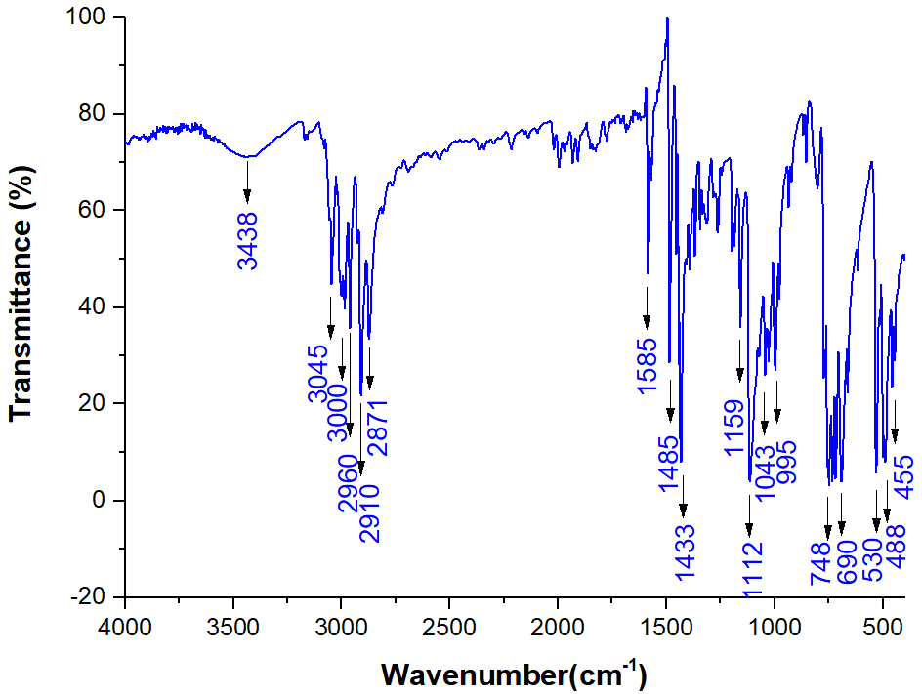 | 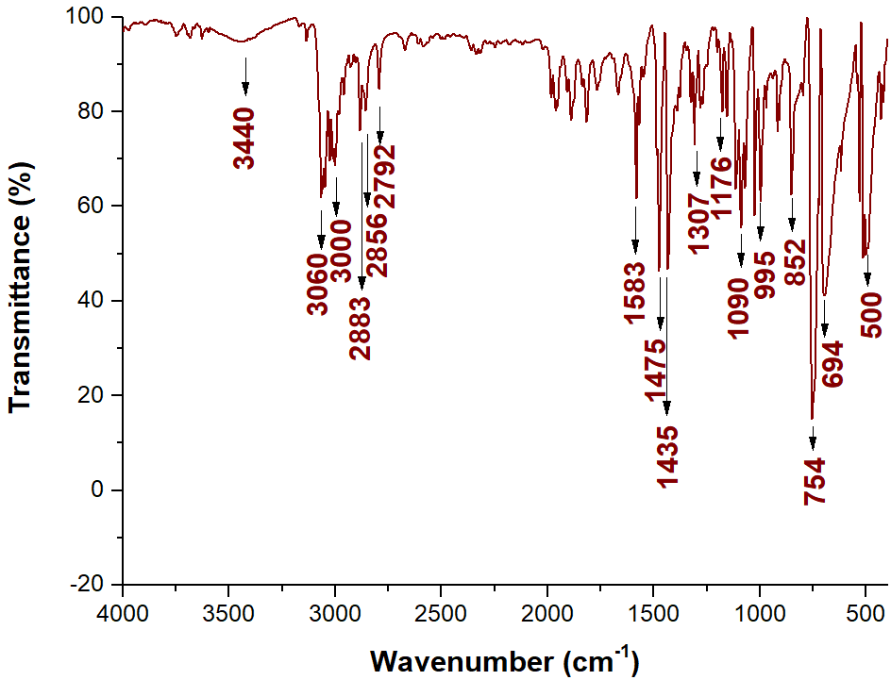
A | B
Figure 1. FTIR spectra of the Wittig salts: A) Ethyltriphenylphosphonium bromide (ETPB); and B) propyltriphenylphosphonium bromide (PTPB).

Table 1. Assignments of Wittig salts infrared absorption bands (Larkin, 2011 a b; Parthasarathy and Gopalakrishnan, 2013.
Wavenumber (cm⁻¹) |  | Bonds | FTIR Assignments
ETPB | PTPB
3438 | 3430 | O-H | OH stretching
3045, 3000 | 3047, 3004 | C-H | Stretching of the Csp² bond of aromatics
2960, 2910, 2871 | 2958, 2883, 2856, 2792 | C-H | Stretching of the C(sp³)-H bond of CH₂ and CH₃ of the ethyl and propyl group
1585, 1485, 1433 | 1585, 1486, 1436 | C-C | C=C stretching from aromatic bonds
1159 | 1162 | C-H | C(sp²)-H bending from aromatic compounds
1112, 1043, 995 | 1112, 997 | P-C | Stretching from P-C bond
748, 690 | 899, 842, 738, 690 | C-H | C(sp²) bending from aromatic compounds
530 | 530, 501 | C-H | Out-of-plane angular deformation of C-H bonds of aromatic compounds

The ¹H-NMR signals of ETPB and PTPB synthesized in isopropanol (Figure 2) confirmed their chemical structure and proved its synthesis. ETPB (Fig. 2A) showed its hydrogens signals of methyl group (δ1.40), methylene group (δ3.82), and aromatic hydrogens (δ7.77). PTPB (Fig. 2B) presented its hydrogens signals of aromatic group (δ7.78), methylene group directly attached to the phosphorus atom (δ3.73), methylene group 2 (δ1.71), and methyl group (δ1.24). ¹H NMR analyses also detected the remaining triphenylphosphine due to the presence of signals at δ7.32 and δ7.5 ppm of ETPB and PTPB, respectively.
Protic polar solvents tend to orientate their hydrogens to stabilize the leaving group in the Wittig salt reaction (Br⁻). Isopropanol, a weak nucleophilic agent, has a significant steric hindrance that disfavors its action on the solvation layer of the substrate. This makes the electrophilic carbon more available to the triphenylphosphine nucleophilic attack, which favors the reaction. On the other hand, less hindered alcohols, such as ethanol, provide a good solvation for the alkyl halide, turning the electrophile carbon less available, and disfavoring the reaction. These factors contributed for the expressive yields of ETPB and PTPB in isopropanol, 65.2 and 71.8 %, respectively. ETPB and PTPB exhibited lower yields in ethanol, 64.5 and 43.7 %, respectively.
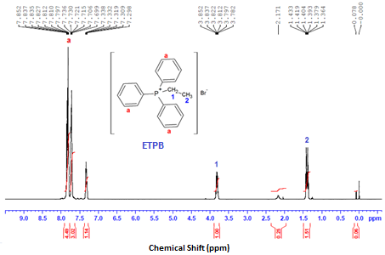
A
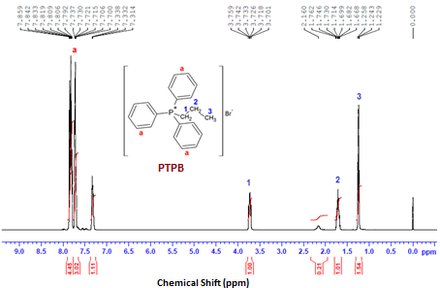
B
Figure 2. ¹H-NMR spectra of Wittig Salts: A) ETPB, and B) PTPB.

    - LA Olefination
The ions of interest (127 and 141 Da) were selected in the sequential mass spectrometer to investigate their fragmentation profiles and thus elucidate their chemical structures. The sequential mass spectra of the LA olefination samples with ETPB and PTPB are shown in Figure 3.
The m/z 81 (Fig. 2 - R1, R2, and R3), and m/z 79 (Fig. 2 - R4, R5, and R6) signals are characteristic for precursor ions of m/z 127 and 141, respectively. These fragmentations are explained by the mechanisms proposed in Fig. 3A and 3B. This is justified by the regioselectivity of the Wittig reaction that produces a compound with Z-configuration starting with non-stabilized ylides, which confirms the synthesis of 4-methyl-hex-4-enoic acid and 4-methyl-hept-4-enoic acid.

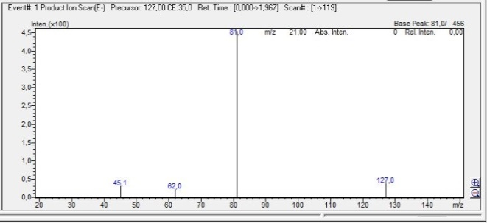 | 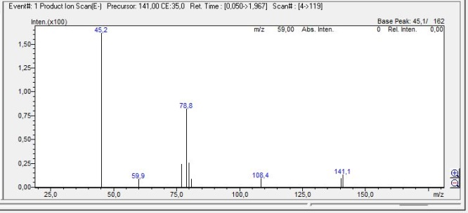
R1 | R4
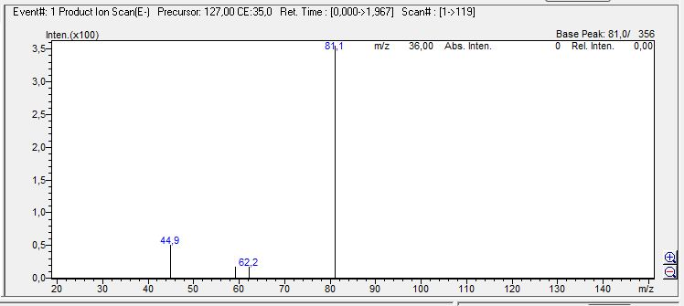 | 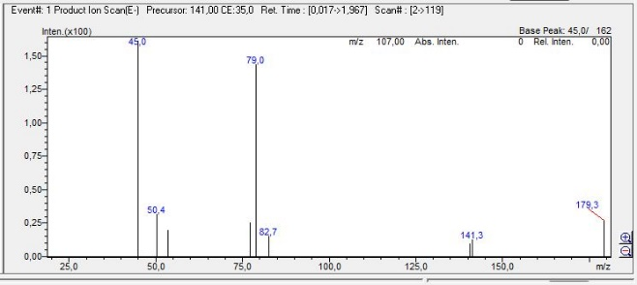
R2 | R5
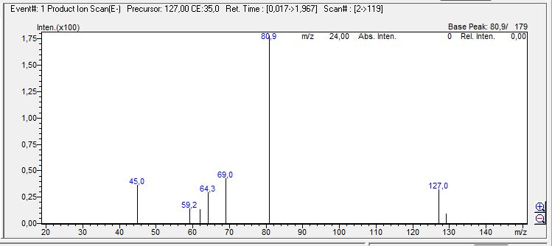 | 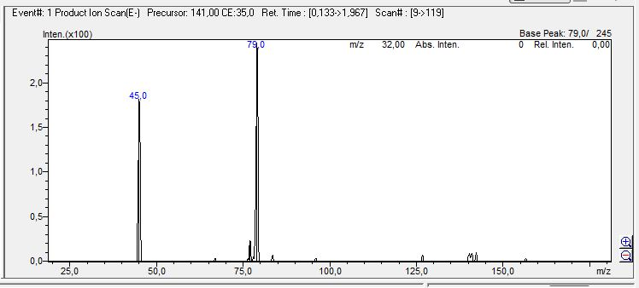
R3 | R6
Figure 3. Sequential mass spectra of the LA olefination samples via Wittig reaction with ETPB (R1 = NaHCO₃, R2 = Na₂CO₃, R3 = NaOH); and with PTPB (R4 = NaHCO₃, R5 = Na₂CO₃, R6 = NaOH).

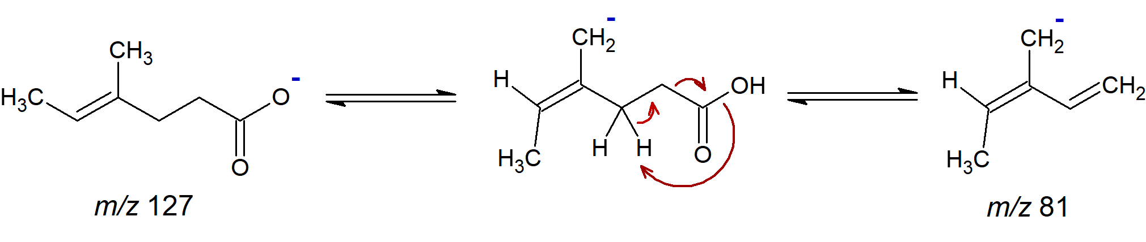 | 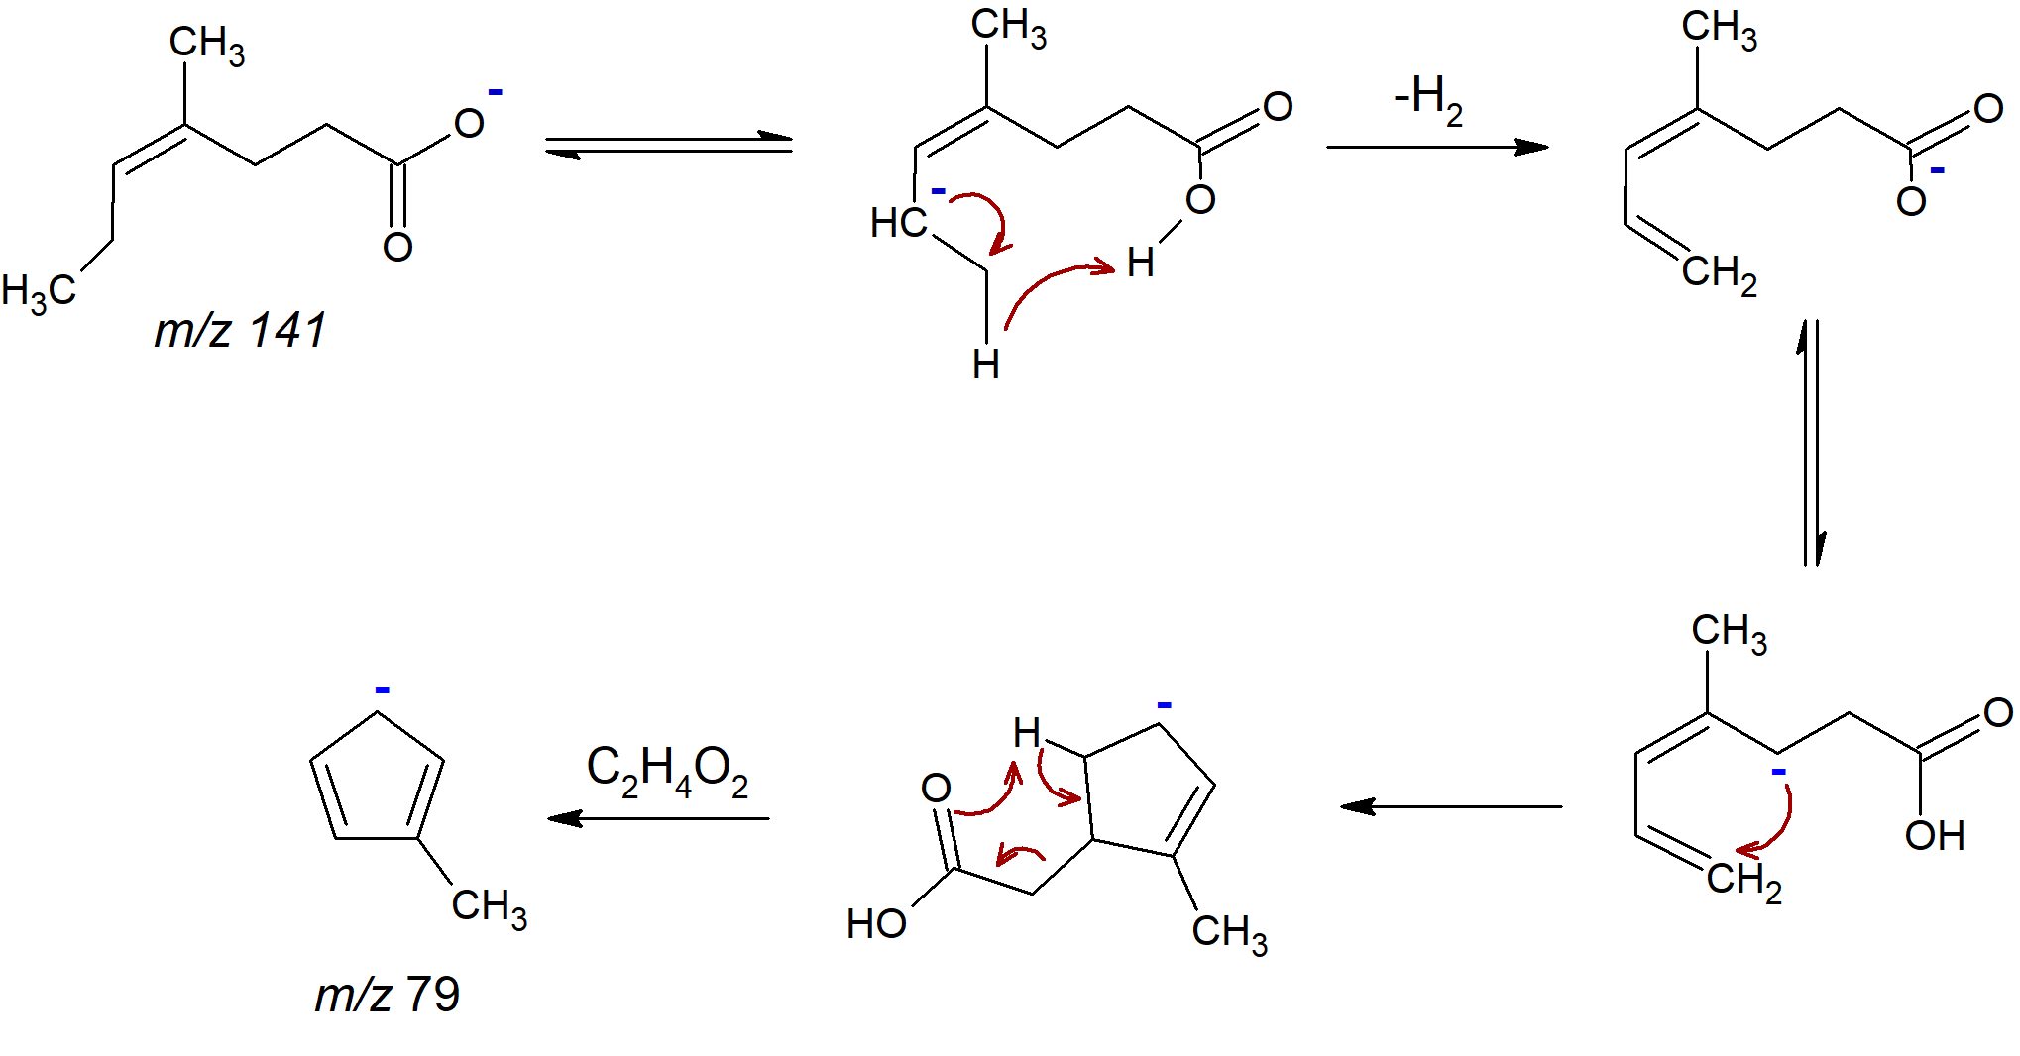
A | B
Figure 4. Fragmentation mechanisms for ions: A) 4-methyl-hex-4-enoic acid, m/z 127; and B) 4-methyl-hep-4-enoic acid, m/z 141.

The ylide formation governs the Wittig reaction, which is dependent on the base employed in the reaction system. Thus, a suitable basis for the Wittig reaction should be strong enough to promote the removal of the proton attached to the alkyl radical adjacent to the phosphorus of the Wittig salt (ETPB and PTPB).
The mass spectra for the olefination reactions of LA with ETPB showed different behaviors for the systems with different bases. In reactions with NaHCO₃ and NaOH (Fig. 2 - R1 and R3), it was observed the presence of the ion of interest (m/z 127), but not in the system using Na₂CO₃ (Fig. 2 - R2) as base. The expected behavior for this reaction would be that Na₂CO₃ presents a better response to the formation of the product of interest, since the order of basicity of the bases used in the systems are: NaOH> Na₂CO₃>NaHCO₃. However, it can be concluded that for the system containing Na₂CO₃ it would be appropriate to use more polar solvents (higher dielectric constants) than isopropanol and with lower steric volume to not prevent the formation of the adduct (Wittig ylide precursor), such as acetonitrile (ε 37.5).
NaHCO₃ and Na₂CO₃ (Fig. 2 – R4 and R5) were successful for the 4-methyl-hept-4-enoic acid, whereas the expected was a greater response for NaOH, since it has the lowest pKb value and, consequently, it is better for proton abstraction (pKb = NaOH - 0.2, Na₂CO₃ - 4.67, NaHCO₃ - 7.63). Thus, it suggests that NaOH rapidly reacted with LA, readily forming sodium levulinate, since right after the addition of LA into the system, the solution produced a white precipitate, characteristic of sodium bromide and sodium levulinate in solution, given the excess NaOH in the system.
  - Conclusions
The greener process for LA olefination via Wittig reaction, containing a less toxic solvent (isopropanol), and milder bases (NaHCO₃, Na₂CO₃ and NaOH) led to the formation of alkenoic acids (4-methyl-hex-4-enoic and 4-methyl-hept-4-enoic acid). The isopropanol, used in the Wittig salts synthesis step showed yields up to 65 %, allowing this reactional system to be suitable for a step economy by one-pot synthesis since the Wittig salts and alkenoic acids occurred in isopropanol. NaHCO₃ was efficient for both systems, but NaOH, a stronger base, was efficient in the LA deprotonation rather than the Wittig ylide formation, which causes the need to protect the carboxylic acid group of LA. These alkenoic acids can lead to a chemical platform for polymers and fine chemicals.
Acknowledgments
We thank São Paulo Research Foundation (FAPESP; grant 2015/20630-4), Unicamp Development Foundation (FUNCAMP, grant 130932-15) for the financial support, and the Coordenação de Aperfeiçoamento de Pessoal de Nível Superior - Brasil (CAPES) - Finance Code 001 for the scholarship to J.O.B.
References
Carey F.A., Sundberg R.J., 2007, Reactions of carbon nucleophiles with carbonyl compounds, Springer US, Boston, 63-214.
Chalid M., Heeres H.J., Broekhuis A.A., 2012, Green polymer precursors from biomass-based levulinic acid, Procedia Chemistry, 4, 260-267.
Hartweg M., Becer C. R., 2016, Direct polymerization of levulinic acid via Ugi multicomponent reaction, Green Chemistry, 18, 3272-3277.
Larkin P., 2011a, Chapter 6 - IR and Raman spectra-structure correlations: Characteristic group frequencies, Infrared and Raman spectroscopy, Elsevier, Oxford, 73-115.
Larkin P., 2011b, Chapter 8 - Illustrated IR and Raman spectra demonstrating important functional groups, Infrared and Raman spectroscopy, Elsevier, Oxford, 135-176.
Licursi D., Antonetti C., Fulignati S., Corsini A., Boschi N., Galetti A. M. R., 2018, Smart valorization of waste biomass : Exhausted lemon peels, coffee silverskins and paper wastes for the production of levulinic acid, Chemical Engineering Transactions, 65, 637-642.
Morone A., Apte M., Pandey R.A., 2015, Levulinic acid production from renewable waste resources: Bottlenecks, potential remedies, advancements and applications, Renewable and Sustainable Energy Reviews, 51, 548-565.
Nakayama M., Ohira S., Shinke S., Hayashi S., 1978, A short synthesis of 2-methoxy- carbonylmethyl-3-methyl-2-cyclopenten-l-one, Agricultural and Biological Chemistry, 42, 2399-2400.
Pileidis F.D., Titirici M.-M., 2016, Levulinic acid biorefineries: New challenges for efficient utilization of biomass, ChemSusChem, 9, 562-582.
Protsenko I. I., Nikoshvili, Matveeva V., Sulman E. M., Rebrov E., 2016, Selective hydrogenation of levulinic acid to gamma-valerolactone using polymer-based Ru-containing catalysts, Chemical Engineering Transactions, 52, 679-684.
Rackemann D. W., Doherty W.O. S., 2011, The conversion of lignocellulosics to levulinic acid, Biofuels, Bioproducts and Biorefining, 5, 198-214.
Yamakawa C., Qin F., Mussato S. I., 2018, Advances and opportunities in biomass conversion technologies and biorefineries for the development of a bio-based economy, Biomass and Bioenergy, 119, 54-60.
Yan K., Jarvis C., Gu J., Yan Y., 2015, Production and catalytic transformation of levulinic acid: A platform for speciality chemicals and fuels, Renewable and Sustainable Energy Reviews, 51, 986-997.
Zhang S. W. J., Li B., Zhang H. D., 2012, Advances in the catalytic production of valuable levulinic acid derivatives, ChemCatChem 4, 1230-1237.
Parthasarathy M., Gopalakrishnan R., 2013, Growth, photoluminescence, thermal and mechanical behavior of Ethyltriphenylphosphonium bromide dihydrate crystal, Optical Materials, 35, 2056-2061.

