|  |  |
| --- | --- |
| cetlogo ***CHEMICAL ENGINEERING TRANSACTIONS***  ***VOL. 76, 2019*** | A publication of  aidiclogo_grande |
| The Italian Association  of Chemical Engineering  Online at www.cetjournal.it |
| Guest Editors: Sauro Pierucci, Jiří Jaromír Klemeš, Laura Piazza  Copyright © 2019, AIDIC Servizi S.r.l. **ISBN** 978-88-95608-73-0; **ISSN** 2283-9216 | |

Active and Stable Ruthenium/Osmium Based Electrocatalysts for Hydrogen Evolution by Seawater Splitting

Maria Sarnoa, Eleonora Ponticorvoa\*, Davide Scarpaa

a Department of Industrial Engineering and Centre NANO\_MATES University of Salerno Via Giovanni Paolo II ,132 - 84084 Fisciano (SA), Italy

eponticorvo[@unisa.it](mailto:msarno@unisa.it)

Ruthenium/osmium based controlled size nanoparticles (NPs), supported on graphene, have been prepared by a simple synthetic strategy consisting in the thermolysis of a suitable precursor in organic solvent under a low oxygen enriched atmosphere. An excellent combination of a low Tafel slope of 28 mV/dec with a negligible overpotential was measured for the prepared nanocomposite (RuOs\_G), due to metal oxides resulting in electron rich Ru and Os islands. The nanocatalyst shows an activity higher than that of common Pt. Additionally, the paper proves that it is possible to use the synthesized nanocatalyst to catalyse directly seawater splitting. RuOs\_G resulted very stable and active in complex solutions during electrolysis under high current density.

* 1. Introduction

Water splitting is a promising technique for clean hydrogen energy harvesting. The preparation of cheap electrocatalysts with high Hydrogen Evolution Reaction (HER) activity and stability is crucial in H2 production by minimizing the reaction overpotential and energy consumption (González-Buch et al., 2013; Sarno et al., 2015). Seawater electrolysis for hydrogen synthesis is one of the most encouraging ways to produce hydrogen. Indeed, about 97% of the water present in nature is easily, abundantly and readily available as seawater (Kalogirou, 2005). Furthermore, the production costs are significantly reduced compared to the conventional water splitting, since purification processes and addition of electrolytes in order to increase conductivity and efficiency of the process are no longer necessary (Niu et al., 2016). In fact, seawater can be directly feed to an electrolyzer for H2 production due to the high presence of charge carriers such as NaCl. In addition, the in situ exploitation of sea waves-generated power (Meier et al., 2014) for the hydrogen production by seawater electrolysis is a very interesting route. Oceans are huge reservoirs of hydrogen atoms: extracting and converting them directly into a form of H2 fuel is a valid choice although it requires many technological advances, one of which is the development of efficient water splitting catalysts operating well in seawater. An effective catalyst would enhance the H2 production through the aforementioned method, because in the unpurified seawater there are hundreds of different impurities which might lead to catalyst poisoning (Zou et al., 2012; Gao et al., 2015).

Pure platinum has been extensively studied due to its remarkable electrocatalytic activity towards a large amount of reactions. Nevertheless, the industrial-scale production and application have been significantly hampered by the high price, the scarce availability of this precious metal and its easiness of poisoning (Ma et al., 2017; Sarno et al., 2018a). As a Pt-group metal, ruthenium is used in different reactions, but there are few studies on using Ru compounds for hydrogen evolution (Sarno et al., 2019; Sen et al., 2018). In particular, Mg-type hcp structure of Ru is resistant to chemical attack during electrocatalytic processes (Zhang et al., 2018). Only some of the noble metals have been studied as electrodes for hydrogen generation from seawater and, at the best of our knowledge, osmium has not been explored yet. The chemistries of ruthenium and osmium are similar (Li et al., 2006). Os is the only other element known to have an oxidation state of 8 and it is a very stable and strong material, with electronegativity at the different oxidation states higher than that of Ru.

A single-step preparation of Ru/Os based electrocatalysts supported on graphene for hydrogen generation from seawater splitting was presented. The synthesized electrocatalyst, thanks to the key role of Ru and Os oxides in improving the charge accumulation on Ru and Os metals and to the graphene in providing stability, electrical conductivity and excellent sea water impurities tolerance, showed very promising performance. The results indicate that the nanocomposites prepared allow to reduce onset overpotentials and Tafel slopes as well as significantly increase exchange current densities.

* 1. Experimental

RuOs\_G nanostructures were produced using the following chemicals: ruthenium acetylacetonate (0.15 mmol), osmium(III) chloride(0.15 mmol), physical exfoliated graphite (3 mmol), benzyl ether (20 mL) as reaction solvent, 1,2-hexadecanediol (10 mmol) as reducing agent, oleic acid (6 mmol) and oleylamine (6 mmol) as surfactants. Physical exfoliated graphite (G) consisting of few layers of graphene, largely monolayer, was obtained by a sonication of graphite powder (microcrystalline,−300 mesh) in N-methylpyrrolidone (Guadagno et al., 2015). Oleylamine here acts also as a stabilizer and mild reducing agent, thanks to its ability to give electrons as temperature increases (Mourdikoudis et al., 2013).

Precursors underwent thermal reduction under N2 flow, carried out by heating the mixture to 200 °C for 2 h and further heating it to 285 °C for 1 h. After the synthesis, the sample was submitted to an additional treatment in order to remove the majority of the organic chains covering the nanostructures, which otherwise would hinder the charge transfer process. The treatment consists in heating up the sample under air flow, from room temperature up to 150 °C at 10 K/min for 8 h (Sarno et al., 2018b).

The characterization was obtained by the combined use of different techniques. Scanning electron microscopy (SEM) images were obtained with a LEO 1525 microscope. XRD measurements were performed with a Bruker D8 X-ray diffractometer using CuKα radiation. For the electrochemical measurements 4 mg of catalyst were dispersed in 80 μl of 5 wt. % Nafion solution to form a homogeneous mixture. Then the catalyst ink was loaded onto DRP-110 Screen Printed Electrode (SPE) consisting of a carbon working electrode, a platinum counter electrode and a silver reference electrode. Graphite SPEs were chosen owing to their superior characteristics over common carbon electrodes (Rowley-Neale et al., 2015). Electrochemical experiments were carried out by means of an Autolab PGSTAT302N potentiostat equipped with a FRA32M frequency response analyser module. Furthermore, in order to evaluate the Tafel slopes, Eq.1 was adopted:

|  |  |
| --- | --- |
| $$μ\text{= a+b∙}\log{j}$$ | (1) |

Where *μ* is the overpotential, *j* is the current density and *b* is the Tafel slope.

* 1. Results and discussion

The X-ray diffraction pattern of the synthesized sample is shown in Figure 1, evidencing the existence of a quaternary nanostructure comprising ruthenium and osmium and the corresponding oxides.

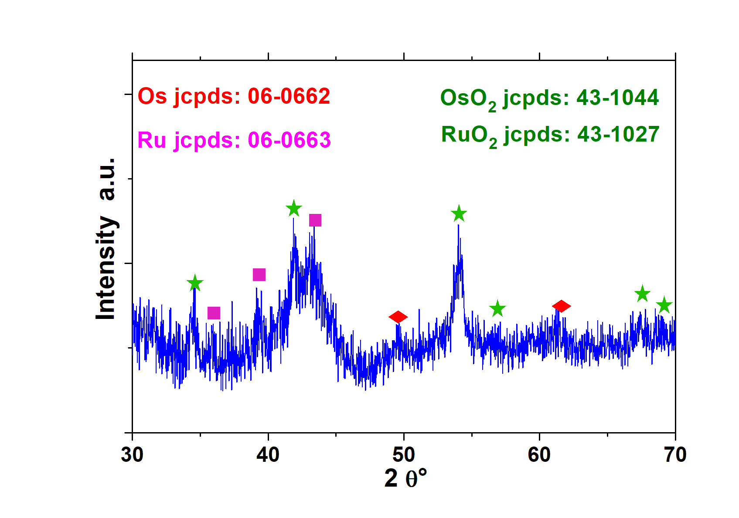

Figure 1: XRD spectrum of RuOs\_G nanocomposite

The peaks broadness is likely due to the low temperatures of synthesis and the nanosizes of the product. The highest detectable diffraction peaks can be attributed to the presence of the tetragonal lattice of both ruthenium and osmium oxide, with the (101) planes at ~34.46° 2θ, the (200) planes at ~41.91° 2θ and the (211) planes at ~54.11° 2θ (JCPDS 43-1027 and JCPDS 43-1044) (Yen et al., 2004). The presence of metallic Ru is evidenced by three diffraction peaks (indicated in magenta in the patter) corresponding to the major planes of the metal hexagonal lattice (JCPDS 06-0663). Furthermore, metallic Os shows also detectable peaks corresponding to the crystalline planes of its hexagonal lattice (JCPDS 06-0662) (Ede et al., 2014).

SEM images of the starting G and of the prepared sample are reported in Figure 2a and 2b, respectively. SEM analysis of the prepared sample (Figure 2b) shows the presence of a three-dimensional network of microflakes strictly connected to each other, which are even more fragmented after the synthesis. A hierarchical construction, likely due to the co-presence of different size pores, is shown. In particular, the mesopores, crucial for providing ion diffusion channels and charge transfer, are visible in the sample images mainly after synthesis. Additional macropores for electrode wettability can be also seen.



**b**

**a**

Figure 2: SEM images of G (a) and RuOs\_G nanocomposite (b)

To investigate the electrocatalytic activity towards HER of our nanomaterial, firstly we reported the polarization curves of RuOs\_G deposited on a SPE in 0.5 M H2SO4 solution (Figure 3). The RuOs\_G electrocatalytic behavior results excellent, also if compared with Pt. In particular, RuOs\_G shows a negligible overpotential for HER and a fast current growth at decreasing voltages.

Moreover, RuOs\_G gives nearly 100% Faradaic yield during HER in 0.5 M H2SO4, as revealed by the fact that the experimentally detected H2 amount is very close to the theoretical H2 amount (which is calculated based on a quantitative Faradaic yield from current density).

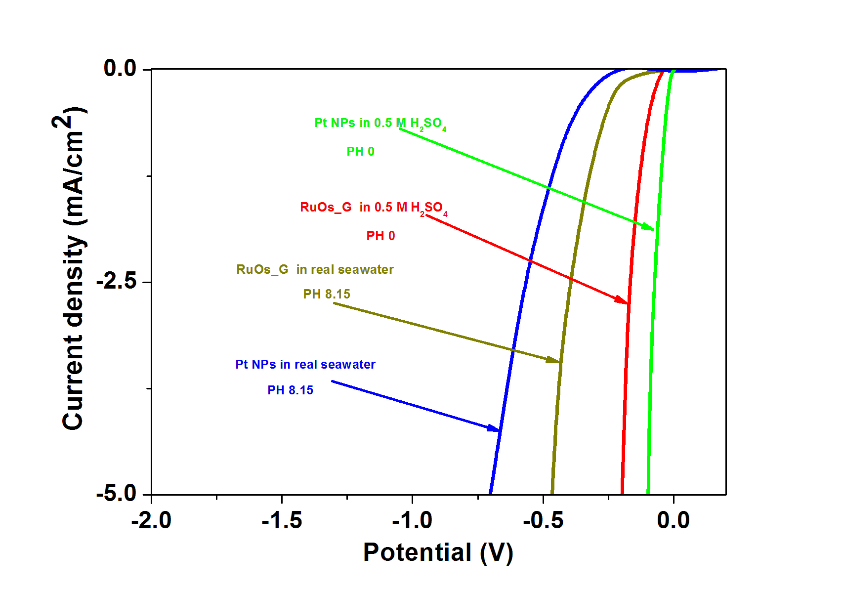

Figure 3: Hydrogen evolution curves for Pt and RuOs\_G recorded at a scan rate of 20 mV s-1 in 0.5M H2SO4 and real seawater

*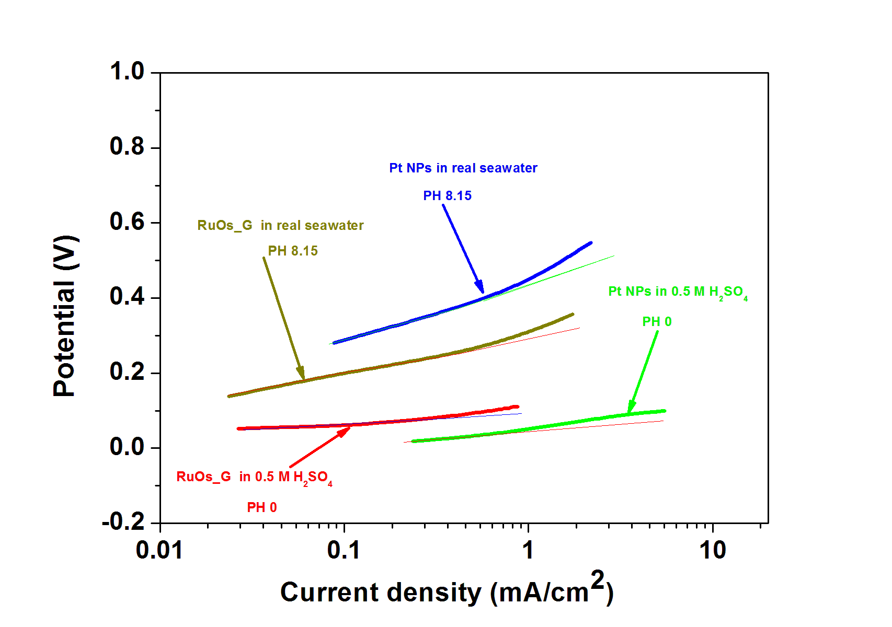*

Figure 4: Tafel plot for Pt and RuOs\_G in 0.5M H2SO4 and real seawater

In view of the high efficacy and excellent stability of RuOs\_G, we investigated its catalytic performance directly using real seawater as the electrolyte. As shown in Figure 3, RuOs\_G still maintains high catalytic activity towards HER in real seawater. The performances of the synthesized nanostructure are even better than those of Pt. For example, the catalytic current density reaches 5 mA cm−2 at an overpotential < 500 mV, which is much less to the value required for Pt electrode (710 mV at 5 mA cm−2). The RuOs\_G sample was also tested in simulated sea water showing a behavior comparable to that obtained in real sea water.

Figure 4 shows the Tafel plots for RuOs\_G at pH 0 and pH 8.15. Since the linear portions of the Tafel plots are fit to the Tafel equation (see Eq.1), the corresponding Tafel slopes in 0.5 M H2SO4 are calculated to be 30 and ~ 28 mV/decade (iR-corrected) for Pt and RuOs\_G, respectively. This result implies that the HER mechanisms are similar and the HER proceeds through the Volmer-Tafel mechanism (Li et al., 2011).

Moreover, the larger Tafel slopes recorded in real seawater suggest that the electrochemical adsorption of hydrogen atoms would possibly be the prominent rate limiting step for the HER.

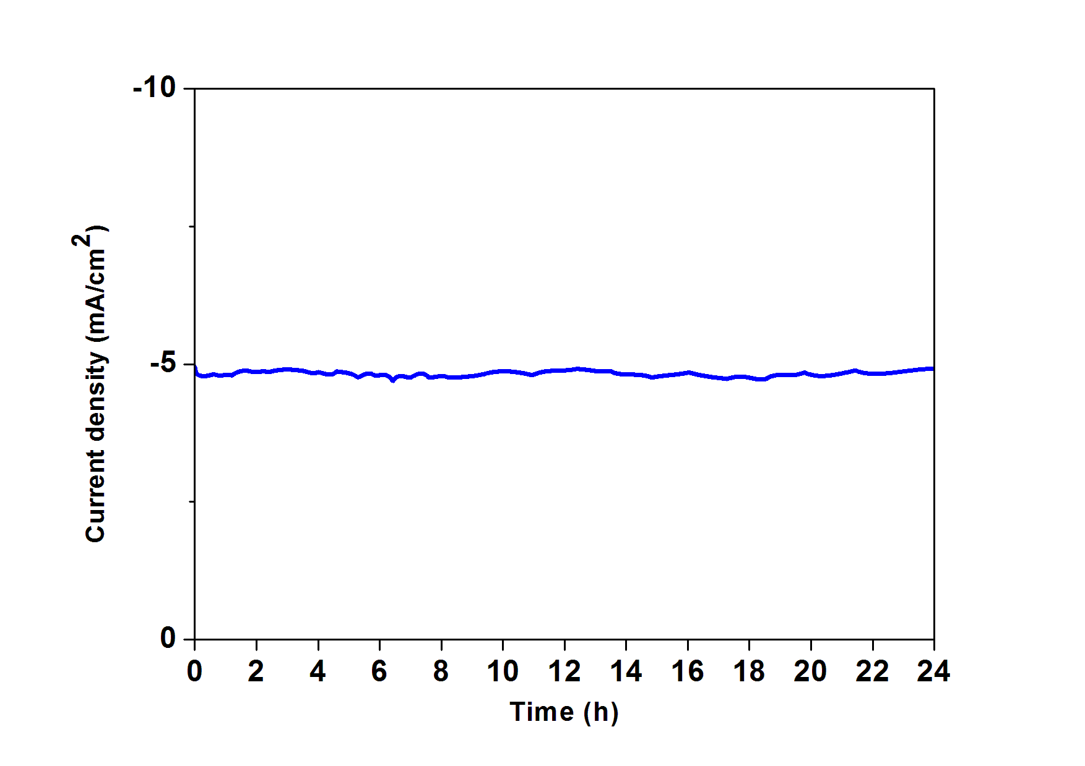

Figure 5: Time dependence of electrocatalytic current density during electrolysis at overpotential 0.14 V for RuOs\_G in real seawater

The stability of RuOs\_G in HER was examined by continuously monitoring the cathodic current at η = 420 mV for several hours (Figure 5), and the result shows that there is no loss of electrocatalytic activity after 24 hours. The high durability of RuOs\_G can be attributed to the excellent tolerance of nanocarbon materials toward the impurities in seawater and the use of very stable and strong metals. In view of the excellent results, RuOs\_G is very promising to directly use in seawater for generating H2, avoiding the cost of seawater desalination and purification.

* 1. Conclusions

RuOs\_G nanocatalyst, consisting of a three-dimensional network of microflakes strictly connected to each other has been prepared, by an efficient and facile one pot synthesis process, for the effective hydrogen generation from seawater. The formation of a quaternary structure consisting of Os and Ru oxides with metallic inclusions was confirmed by XRD analysis. SEM analysis showed a hierarchical construction, because of the co-presence of different size pores. RuOs\_G electrocatalytic behaviour toward HER was evaluated, resulting excellent, also if compared with Pt. In particular, RuOs\_G showed a negligible overpotential, a fast current growth at decreasing voltages and a nearly 100% Faradaic yield. Moreover, aiming to extract the hydrogen atoms from the ocean and converting them directly into a form of H2 fuel, the synthesized nanocatalyst was used to catalyse the HER from seawater without buffering agents, commonly used. RuOs\_G exhibited excellent performance: overpotential value lower than Pt and enhanced durability. The strong proton absorption capacity of the graphene support effectively promoted the HER performance and, simultaneously, protected the catalyst from etching, agglomeration and poisoning in seawater. Moreover the Ru and Os performance resulted improved by junctions and interactions with oxides, opening new perspectives for the development of innovative, durable and high performance electrodes for the cheap use of seawater for H2 generating. The analyses of the system for longer time of use are currently in progress.

References

Ede S.R., Nithiyanantham U., Kundu S., 2014, Enhanced catalytic and SERS activities of CTAB stabilized interconnected osmium nanoclusters, Physical Chemistry Chemical Physics,16, 22723–22734.

Gao S., Li G.-D., Liu Y., Chen H., Feng L.-L., Wang Y., Yang M., Wang D., Wang S., Zou X., 2015, Electrocatalytic H2 production from seawater over Co, N-codoped nanocarbons, Nanoscale, 7, 2306–2316.

González-Buch C., Herraiz-Cardona I., Ortega E. M., García-Antón J., Pérez-Herranz V., 2013, Development of Ni-Mo, Ni-W and Ni-Co Macroporous Materials for Hydrogen Evolution Reaction, Chemical Engineering Transactions, 32, 865–870 DOI: 10.3303/CET1332145

Guadagno L., Sarno M., Vietri U., Raimondo M., Cirillo C., Ciambelli P., 2015, Graphene based structural adhesive to enhance adhesion performance, RSC Advances, 5, 27874–27886.

Kalogirou S. A., 2005, Seawater desalination using renewable energy sources, Progress in Energy and Combustion Science, 31, 242–281.

Li K., Xue D., 2006, Estimation of electronegativity values of elements in different valence states, The Journal of Physical Chemistry A, 110, 11332–11337.

Li Y., Wang H., Xie L., Liang Y., Hong G., Dai H., 2011, MoS2 nanoparticles grown on graphene: an advanced catalyst for the hydrogen evolution reaction, Journal of the American Chemical Society, 133, 7296–7299.

Ma Y.-Y., Wu C.-X., Feng X.-J., Tan H.-Q., Yan L.-K., Liu Y., Kang Z.-H., Wang E.-B., Li Y.-G., 2017, Highly efficient hydrogen evolution from seawater by a low-cost and stable CoMoP@C electrocatalyst superior to Pt/C, Energy & Environmental Science, 10, 788–798.

Meier K., 2014, Hydrogen production with sea water electrolysis using Norwegian offshore wind energy potentials, International Journal of Energy and Environmental Engineering, 5, 104–12.

Mourdikoudis S., Liz-Marzán L.M., 2013, Oleylamine in nanoparticle synthesis, Chemistry of Materials, 25, 1465–1476.

Niu X., Tang Q., He B., Yang P., 2016, Robust and stable ruthenium alloy electrocatalysts for hydrogen evolution by seawater splitting, Electrochimica Acta, 208, 180–187.

Rowley-Neale S.J., Brownson D.A.C., Smith G.C., Sawtell D.A., Kelly P.J., Banks C.E., 2015, 2D nanosheet molybdenum disulphide (MoS2) modified electrodes explored towards the hydrogen evolution reaction, Nanoscale, 7, 18152–18168.

Sarno M., Cirillo C., Ponticorvo E., Ciambelli P., 2015, Synthesis and Characterization of Mo2C/MoO3 Nanohybrid as Electrocatalyst for Hydrogen Evolution Reaction, Chemical Engineering Transactions, 43, 943–948 DOI: 10.3303/CET1543158

Sarno M., Ponticorvo E., 2018a, Continuous flow HER and MOR evaluation of a new Pt/Pd/Co nano electrocatalyst, Applied Surface Science, 459, 105–113.

Sarno M., Ponticorvo E., 2019, High hydrogen production rate on RuS2@MoS2 hybrid nanocatalyst by PEM electrolysis, International Journal of Hydrogen Energy, 44, 4398–4405.

Sarno M., Ponticorvo E., Scarpa D., 2018b, PtRh and PtRh/MoS2 nano-electrocatalysts for methanol oxidation and hydrogen evolution reactions, Chemical Engineering Journal, *in press* DOI: 10.1016/j.cej.2018.12.060

Şen B., Demirkan B., Savk A., Kartop R., Nas M. S., Alma M. H., Sürdem S., Şen F., 2018, High-performance graphite-supported ruthenium nanocatalyst for hydrogen evolution reaction, Journal of Molecular Liquids, 268, 807–812.

Yen P.C., Chen R.S., Chen C.C., Huang Y.S., Tiong K.K., 2004, Growth and characterization of OsO2 single crystals, Journal of Crystal Growth, 262, 271–276.

Zhang Q., Kusada K., Wu D., Yamamoto T., Toriyama T., Matsumura S., Kawaguchi S., Kubota Y., Kitagawa H., 2018, Selective control of fcc and hcp crystal structures in Au–Ru solid-solution alloy nanoparticles, Nature Communications, 9, 510–9.

Zou M.-S., Guo X.-Y., Huang H.-T., Yang R.-J., Zhang P., 2012, Preparation and characterization of hydro-reactive Mg–Al mechanical alloy materials for hydrogen production in seawater, Journal of Power Sources, 219, 60–64.