 CHEMICAL ENGINEERING TRANSACTIONS  VOL. 76, 2019 | A publication of  
The Italian Association
of Chemical Engineering
Online at www.cetjournal.it
Guest Editors: Sauro Pierucci, Jiří Jaromír Klemeš, Laura Piazza
Copyright © 2019, AIDIC Servizi S.r.l.
ISBN 978-88-95608-73-0; ISSN 2283-9216

Development of Fe-Ni-W alloys for steel parts coverings
Camila Z. Castelli*, Ambrósio F. Almeida Neto
State University of Campinas (UNICAMP), 500, Albert Einstein Ave. – Zip Code: 13083-852, Campinas – SP, Brazil
camilazcastelli@gmail.com
The metallic coatings have their importance in the protection of structures against corrosion, gaining relevance as they bring financial benefits to avoid contamination, loss of efficiency, accidents, among other undesirable and costly situations. Electrodeposition is a mechanism used for the application of metallic coatings, and has been widely used industrially for Chromium alloys, which end up being harmful to the environment because of its carcinogenic nature. Thus, this work has as main objective to develop corrosion-resistant Fe-Ni-W alloys, evaluating process parameters such as electrical current density, cathodic rotation and electrolytic bath temperature. The study of the influence of these parameters on the electrodeposition of Fe-Ni-W contemplated the efficiency and rate of deposition. The electrodeposition tests were carried out on previously treated carbon steel substrates, using electrolytic baths with pH adjusted according to a metal speciation study and the application of electric current with the aid of a potentiostat. Fe-Ni-W alloys were characterized by Scanning Electron Microscopy (MEV) with X-ray Dispersive Energy Detector (EDS). The maximum deposition efficiency achieved was 50%. The compositions of Iron and Nickel in the alloy were influenced by variations in temperature and cathodic rotation, with the percentage of Iron being around 40% when using the temperature of 25 ºC and the rotation of 15 rpm.
  - Introduction
Metallic structures and pieces are widely used and are often submitted to corrosive conditions. For example: ocean platforms exposed to sea water, industrial reactors and pipes in contact with basic and acid vapours, dental tools always directly with mouth saliva, and others used in open places such as bridges, car wheels and airplanes metallic plates. These corrosive conditions can be very aggressive for the materials, compromising their lifetime thus generating additional maintenance, accidents, efficiency losses and other costs increasing. In this scenario, metallic coatings gain importance, since they can protect against corrosion and improve other properties such as durability and hardness. Electrodeposition process is already used to obtain coatings and have its benefit in the fact that with just a thin layer the coating is already functional. Also, this process can be used for complex formats, because the piece is submerged so it receives electrodeposition in every superficial area.
Chromium is one of the most common metal used for coating. It is usually applicable for decorative plating and as anticorrosive protection. According with He et al (2006), despite very good Chromium properties such as anticorrosive, good adherence and hardness, its electrodeposition generates carcinogenic effluents containing Cr(III) and Cr(VI). Considering the global need of environmental footprint reduction, there is important to work with alternative coatings that are less toxic. Tungsten alloys stand out as they have similar properties as Chromium (anticorrosive, hardness, adherence) and their electrodeposition does not generate toxic effluent.
He et al. (2006) compared properties of Fe-Ni-W alloys with Chromium deposits used commercially. They developed an amorphous Fe-Ni-W alloy with 35% tungsten mass composition which presented better corrosion resistance than Chromium in three different corrosive ambient: 5% NaCl, 5% H₂SO₄ and 5% NaOH. In 2007, Sriraman et al. studied development of Ni-W and Fe-Ni-W alloys and observed that when electrical current density is increased in the electrodeposition, tungsten mass increased in final composition of the coatings. This leads to better anticorrosive properties. This work aims to develop ternary alloys Fe-Ni-W, varying process parameters in a factorial design of experiment to contribute to find alternative alloys.
  - Experimental Method
3.1 Electrodeposition
Carbon steel 1020 plates with 8cm² area and thickness of around 0,5mm were used as cathodes in electrodeposition reactions. They received mechanical and chemical treatment before the tests. The polishing or mechanical treatment was made with systematic sanding with grit 220 mm, 400 mm and 1200 mm respectively. After that, chemical treatment took place as the substrate was submerged in sodium hydroxide 10% to remove fats and oils and then in sulfuric acid 1% for neutralization and activation. Before start the experiment, the cathode was dried and weighed.
The electrolytic bath contained salts to disperse metallic ions, surfactant 1-dodecyl-sodiumssulphate, amorphizant agent boric acid and complexing agent ammonium citrate. Concentration for each one was defined according to literature (He et al., 2006; Ribic-Zelenovic et al. 2012; He at al., 2007; Oliveira et al., 2015 and Sriraman et al., 2007) for 100 mL volume: Sodium Tungstate (Na₂WO₄) 0,03 mol/L, Iron Sulfate (Fe₂SO₄) 0,1 mol/L, Nickel Sulfate (NiSO₄) 0,2 mol/L, Ammonium Citrate (C₆H₁₄O₇N₂) 0,3 mol/L, Boric Acid (H₃BO₄) 0,15 mol/L and 1-dodecyl sodium sulphate 1,04x10⁻⁴⁻ mol/l. The pH was defined with Hydra / Medusa software to guarantee species optimally complexed for electrodeposition.
The system used for electrodeposition consisted in electrolytic bath positioned in an adjustable platform above the rotative electrode – (Ametek 616 A), which was connected to the potentiostat – (Ametek VersaStat3). The carbon steel substrate previously treated was used as cathode and was connected to the rotative electrode. A cylindric platin mesh was used as counter electrode (anode) and was also connected to the potentiostat. It is positioned around the cathode and concentrically inside the beaker with electrolytic bath. Current density applied by potentiostat used galvanostatically. Electrical current, rotation of the electrode and temperature of electrolytic bath will be managed according to the factorial design of exeriment.
The duration of the test is 60 minutes. After that, system is shut down, substrate is washed with deionized water and dried in greenhouse at 100°C. After drying, substrate was weighed.
3.2 Factorial experimental planning
To evaluate deposition efficiency of the electrodeposition of Fe-Ni-W, a 2³ factorial design was used with central point in triplicate. Temperature, speed rotation and current density were varied between two levels -1 and +1. Please find below described in Table 1. It is also important to highlight the experimental design used, knowed to avaliable the synergy between as well as for optimization of products and processes (Baldesin et al., 2018; Costa et al., 2018; Porto et al., 2017; Amarante et al., 2017).
Table 1: Factorial Design 2³
Parameters | -1 | 0 | +1
Temperature (°C) | RT* | 47,5 | 70
Speed Rotation (rpm) | 15 | 30 | 45
Current Density (A/m²) | 2x10⁻⁶ | 3.5x10⁻⁶ | 5x10⁻⁶

Room temperature (*RT) was around 25 °C.
3.3 Characterization
Fe-Ni-W alloys were characterized by Scanning Electron Microscopy with X-ray Dispersive Energy Detector and X-Ray Diffraction. These tests made possible to measure composition, define kind of structure and also identify cracks or bubbles in the surface of the deposit.
3.4 Calculation of efficiency and deposition rate
The Faradaic efficiency of Fe-Ni-W alloys was calculated according to Equation 1:
$$ε=\frac{Q_{u}}{Q}.100$$ | (1)
In which $Q_{u}$ is the electric charge used to reduced metal ions at the cathode, $Q$ is the total electric charge applied, both in Coulombs (C) and ε, the Faradaic efficiency in %.
The total electric charge $Q$ is obtained by Equation 2:
$$Q=i.t$$ | (2)
In which i is electric current (A) and t is time (seconds).
The electric charge $Q_{u}$ is given by Equations 3, 4, 5 and 6.
$$Q_{Fe}=\frac{n_{Fe}.m_{Fe}.F}{M_{Fe}}$$ | (3)
$$Q_{Ni}=\frac{n_{Ni}.m_{Ni}.F}{M_{Ni}}$$ | (4)
$$Q_{W}=\frac{n_{W}.m_{W}.F}{M_{W}}$$ | (5)

$$Q_{u}=Q_{Fe}+Q_{Ni}+Q_{W}$$ | (6)
m is mass (g) of each metal, M is the molar mass (g/mol) and F is the Faraday constant (F = 96.485,34 C/mol).
The deposition rate in the other hand is estimated considering convection mass transferring. So, the correlation of mass transfer for the system is described by Welty et al. (2007) as Equation 2 gives:
$$\frac{k_{c}.d}{D_{AB}}=0,62{Re}^{\frac{1}{2}}{Sc}^{\frac{1}{3}}$$ | (6)
Where k_{c} is the convective transfer coefficient and Re and Sc are the number of Reynolds and Schmidt calculated according Equations 7 and 8.
$$Re=\frac{d².ω}{ν}$$ | (7)
$$Sc=\frac{ν}{D_{AB}}$$ | (8)
In which $ω$ is cathodic rotation, $ν$ is cinematic viscosity, $d$ is the diameter of agitator and D_{AB} is diffusivity.
Finally, deposition rate is estimated by Equation 9:
$$W_{A}=2.L^{2}.k_{c}.(C_{A0}-C_{Af})$$ | (9)
L is substrate lateral, C_{A0} and C_{Af} are concentration initial and final of specie A.
  - Results and discussion
4.1 Metallic speciation
Hydra / Medusa simulator provides possible compounds in electrolytic bath as function of pH for each metal as Figure 1 shows.
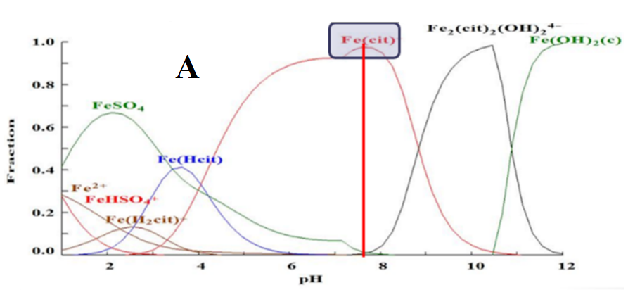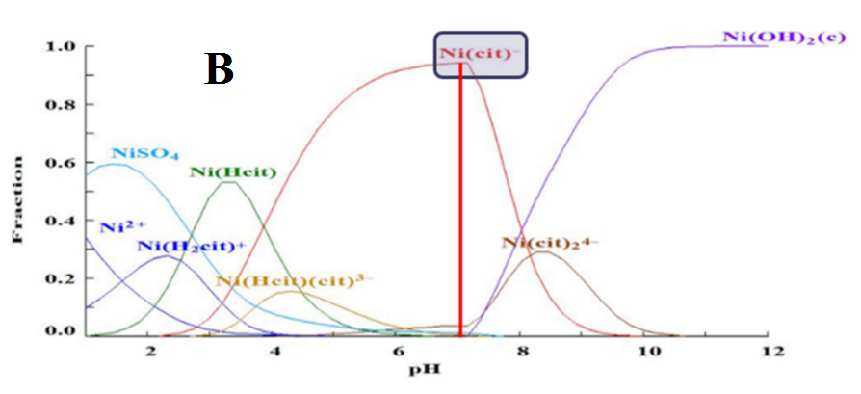
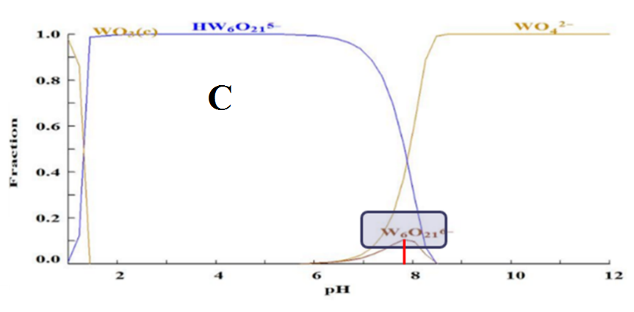
Figure 1. Complexes formed with iron (A), nickel (B) and tungsten (C) ions at different pH values
Complexes formed between metal ions and citrate anions are the most favorable to electrodeposit Fe and Ni to form an alloy. For tungsten, the complex W₆O₂₁⁻⁴ containing oxygen is the most interesting. Thus, pH 7,5 was determined for electrolytic bath.
4.2 Efficiency and effects analysis
The Faradaic efficiencies for factorial design 2³ are presented in Table 2 and Figure 3 and 4 shows Pareto diagram and response surface respectively, obtained from statistics analysys.
The Pareto diagram in Figure 2 was elaborated for 95% and 90% of confidence. For 95% none of the effects were significant and for 90% the significant statistically effect in electrodeposition was combination of temperature and current density.
The response surface presented in Figure 3 shows the significant influence of variation of temperature combined with current density on Faradaic efficiency. The efficiency increases at higher temperature and current density. Maximum Faradaic efficiency (50,6%) was obtained at maximum temperature (70 °C) and electrical current (5x10⁻⁶ A/m²) in study. Temperature may be associated with complex formed among Ni, W and Fe which is crucial to deposition. Oliveira et al (2015) studied influence of temperature and current density in efficiency and concluded that bath temperature had statistically significant influence. The results are different possibly because of the ranges studied and also because of the third variable (rotation speed) that this work included, but temperature was important as well in this factorial design.
Table 2: Factorial design 2³ considering temperature, rotation speed and electrical current density as parameters and efficiency as response.
Test | Temperature (°C) | Rotation Speed (rpm) | Electrical Current Density (A/m²) | Efficiency* (%)
1 | 70 | 45 | 5x10⁻⁶ | 49,8
2 | 70 | 15 | 5x10⁻⁶ | 50,6
3 | RT (25) | 45 | 5x10⁻⁶ | 43,3
4 | RT (25) | 15 | 5x10⁻⁶ | 42,6
5 | 70 | 45 | 2x10⁻⁶ | 42,6
6 | 70 | 15 | 2x10⁻⁶ | 47,4
7 | RT (25) | 45 | 2x10⁻⁶ | 47,4
8 | RT (25) | 15 | 2x10⁻⁶ | 48,6
9 | 47,5 | 30 | 3.5x10⁻⁶ | 50,5
10 | 47,5 | 30 | 3.5x10⁻⁶ | 49,8
11 | 47,5 | 30 | 3.5x10⁻⁶ | 45,6

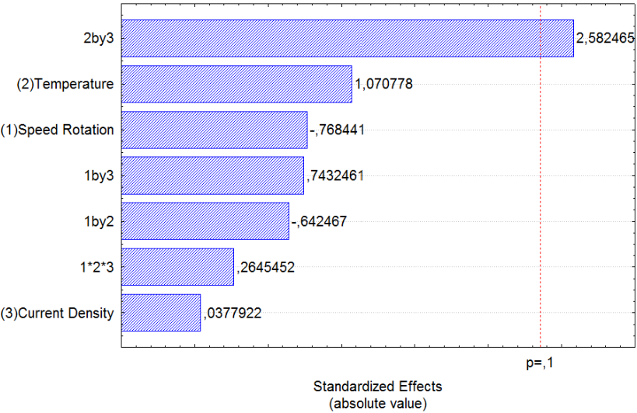

Figure 2. Pareto diagram of offects related to Faradaic efficiency
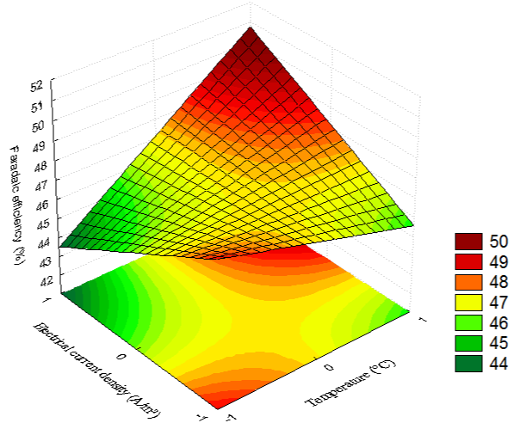

Figure 3. Response surface of Faraidic efficiency as a function of temperature and current density.
4.3 Characterization
Although the best Faradaic efficiency corresponds to sample 2, the only alloys which have adhesion was 5 and 7. In this scenario, only these two points were characterized. As Figure 4 shows, both surfaces had micro crackers which could be improved with drying temperature reduced to avoid thermic-chock.
Chemical composition was estimated by media calculation of three different readings of EDS in each sample. For sample obtained in test 5, 45% Ni, 25% W and 29% Fe considering mass percentual, and for sample obtained in test 7 composition of alloy was 30% Ni, 27% W and 43% Fe also mass percentual.

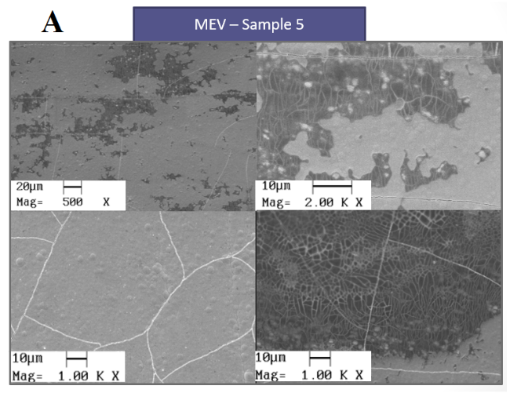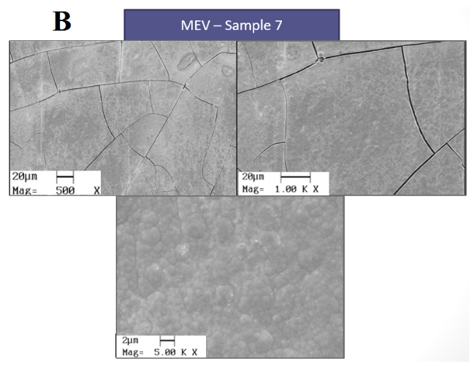
Figure 4. MEV for samples obtained in tests 5 (A) and 7 (B)
4.4 Deposition rate
For tests 1 and 2 deposition rate obtained was the highest, combining with high Faradaic efficiency for these two points when compared to the others. Considering that efficiency is about how much mass is deposited for a value of electrical current density in a certain time, and that deposition rate relates concentration variation (mass) with area, the result matches: alloys with more mass deposited had higher efficiencies and higher deposition rates (media of 4,2x10⁻⁹ kg/s). Deposition rate was calculated considering information in Table 3 and equal deposited mass for the three metals except for experiment 5 and 7 that composition was defined.

Table 3. Parameters for deposition rate calculation.
Especie | D_{AB} | C (mol/L) | M (g/mol)
Ni²⁺ | 6,79x10⁻⁶ | 0,20 | 58,69
Fe²⁺ | 7,19x10⁻⁶ | 0,10 | 55,85
WO⁻⁴ | 9,23x10⁻⁶ | 0,03 | 247,84
  - Conclusions
Best Faradaic efficiency and higher deposition rate was observed for alloy obtained with 70 °C, 5x10⁻⁶ A/m² and 15 rpm. Temperature combined with current density was the most statistically significant effect for efficiency. Therefore, efficiency and deposition rate were not related to adhesion which was better for samples obtained with 45 rpm, 2x10⁻⁶ A/m² and 70 °C / 25 °C. Micro crackers appeared in their surface and it is expected to be improved reducing thermal chocking during drying. Percentual of tungsten for both alloys was similar: 26-27%.
  - References
Amarante, T. A., Silva, S. C., Almeida Neto, A. F., 2017, Influence Assessment of Operating Parameters in Synthesis of Zn-Ni Alloys for Process Electrodeposition. Chemical Engineering Transactions, 57, p. 1651-1656.​
Costa, J. M., Nepel, T. C. M., Almeida Neto, A. F., 2018, Influence of current density and W concentration on Co–W alloys used as catalysts in electrodes for Li–O2 batteries. Chemical Papers (On line). https://doi.org/10.1007/s11696-018-0661-x
He, F., Yang, J., Lei, T., Gu, C., 2007, Structure and properties of electrodeposited Fe-Ni-W alloys with different levels of tungsten content: A comparative study, Elsevier - Applied Surface Science, 253, p. 7591-7598.
He, F., Yang, J., Lei, T., Gu, C., 2006, Properties of electrodeposited amorphous Fe-Ni-W alloy deposits, Science Press - Transaction of nonferrous metals society of China, 16, p. 1289-1294.
Oliveira, A. L. M., Costa, J. D., Sousa, M. B., Alves, J. J. N., Campos, A. R. N., Santana, R. A. C.; Prasad, S., 2015, Studies on electrodeposition and characterization of the Ni-W-Fe alloys coating, Elsevier - Journal of alloys and Compounds 619, p. 697-703.
Porto, M. B., Alvim, L. B., Almeida Neto, A. F., 2017, Nickel removal from wastewater by induced co-deposition using tungsten to formation of metallic alloys, Journal of Cleaner Production, 142, p. 3293–3299.
Ribíc-Zelenovic, L., Cirovic, N., Spasojevic, M., Maricic, A., Pavloviv, V., 2012, Microstructural properties of electrochemically prepared Ni-Fe-W powders, Materials Chemistry and Physics 135, 212-219.
Sriraman, K. R., Raman, S. G. S., Sheadri, S. K.., 2007, Corrosion behavior of electrodeposited nanocrystalline Ni-W and Ni-Fe-W alloys, Elsevier - Materials Chemistry and Engineering, A 460-461, p. 39-45.
Welty, J. R., Wicks, C. E., Wilson, R. E., Rorrer, G. L., 2007, Fundamentals of Momentum, Heat and Mass Transfer, 5th Edition, John Wiley and Sons, p 589-591.

