CHEMICAL ENGINEERING TRANSACTIONS  VOL. 76, 2019 | A publication of
The Italian Association
of Chemical Engineering
Online at www.cetjournal.it
Guest Editors: Sauro Pierucci, Jiří Jaromír Klemeš, Laura Piazza
Copyright © 2019, AIDIC Servizi S.r.l.
ISBN 978-88-95608-73-0; ISSN 2283-9216

Optimization of number and location of sampling points of an air quality monitoring network in an urban contest
Daniele Sofia^{a,b}*, Nicoletta Lotrecchiano^{b}, Aristide Giuliano^{a,b}, Diego Barletta^{b}, Massimo Poletto^{b}
ªSense Square srl, Corso Garibaldi 33, 84123, Salerno (SA), Italy
^{b}Università di Salerno, Dipartimento di Ingegneria Industriale Via Giovanni Paolo II 132, Fisciano (SA) 84084, Italy
*info@sensesquare.eu

In this work an Operational Street Pollution Model was used to define the minimum number and the expected position of the stations for an air quality network with three monitoring stations to be installed in Battipaglia (Italy). The features of the urban background, the type of daily traffic, all the meteorological parameters typical of the investigated area, were implemented in the software to simulate the hourly emissions. These allowed to determine the feasible number of air sampling station and their best location points.
  - Introduction
The environmental theme is one of the most discussed in the recent years. The attention of political groups, associations, and individual citizens is increasingly focused on the air quality. The efforts made to raise awareness of this issue are significant and such as to be able to put in place measures to improve air quality (Sofia et al., 2018a). The effects of environmental pollution on human health are commonly known and people are concerned about the situation around them. In recent years the so called NIMBY (Not In My Back-Yard) syndrome, referred to the public fear of the effects of possible pollution coming from waste treatment plants, has spread widely (Giuliano et al., 2018) and an accurate environmental policy can increase people awareness on the environment. In different industrial applications even if is not strictly required, is warmly recommended to monitor the particulate emissions in the working areas (Kahrizsangi et al., 2015; Sofia et al., 2013). Health protection policies depend on data deriving from air quality monitoring surveys. The major pollutants in urban and extra-urban environments are particulate matter (PM10 and PM2.5). The technology for the determination of the concentrations of pollutants dispersed in the air, after the modelling of the zone of installation, is turning towards the implementation of increasingly efficient and low-cost monitoring systems (Cariou et al., 2016) which can be easily installed in the city's hot spots. In fact, the low cost allows the installation of a higher number of monitoring stations, creating a high spatial resolution network, for a detailed knowledge of the local air conditions (Sofia et al., 2018b).
  - Materials and Methods
    - Methods
The Operational Street Pollution Model (OSPM) was used to evaluate the PM10 concentration on the ground. The OSPM model, developed by Hertel and Berkowicz (1989), is a model of representation of pollutants based on the description of their dispersion and flows in street canyons. The equations used by the model to evaluate the PM10 concentration rely on various parameters that are specific of each street (Sofia et al., 2018).

Background input
For all of the modelled pollutants, the OSPM model requires a background value in input. The value of the urban background can be obtained in several ways such as using a simple large scale dispersion model to evaluate it or measuring the concentration of the pollutant. In this work, the urban background for the PM10 concentrations was evaluated using a monitoring station of the Regional Agency for the Environmental Protection (ARPAC). The ARPAC monitoring station is named as an urban-background station. In fact, it is located in a point (Fig. 1) that is free from the influence of direct sources of local pollution. In this way the only type of pollution considered is carried by long distance transport mechanism and this value represents the fraction of pollutant not dependent from the modelled dispersion.

Figure 1. Location of the monitoring station of the Regional Agency for the Environmental Protection (ARPAC).
Traffic input and Fuel input
An important parameter to evaluate the pollutant concentration and dispersion with the OSPM model is the traffic and other related information. The number of vehicles of the different classes (passenger cars, vans, motorcycles, buses, commercial trucks), the mean vehicular velocity and the hourly traffic volumes were provided to the model for the period of investigation to evaluate the influence of the traffic. As an example, the values of the numbers of vehicles divided by type crossing one of the considered streets in the hour interval is reported in Table 1. In particular, the data for the traffic in Battipaglia were exported from the national vehicle database, which accounts also for the emission class of the vehicle, and used for the concentration evaluation. The vehicular emission factors were calculated by using the OSPM tool for the emissions (Tab. 2).
Table 1. Number of vehicles divided by type crossing one of the considered street in each hour interval.
Time interval | Passenger  cars |  | Vans | Truck <32 ton | Truck >32 ton | Buses
00:00-01:00 | 175 | 12 |  | 2 | 5 | 0,48
01:00-02:00 | 70 | 7 |  | 2 | 2 | 0,17
02:00-03:00 | 43 | 4 |  | 5 | 1 | 0,17
03:00-04:00 | 39 | 5 |  | 3 | 0,5 | 0,08
04:00-05:00 | 83 | 13 |  | 5 | 10 | 0,17
05:00-06:00 | 315 | 55 |  | 12 | 8 | 1,04
06:00-07:00 | 1177 | 240 |  | 37 | 20 | 2,30
07:00-08:00 | 2194 | 284 |  | 62 | 30 | 4,16
08:00-09:00 | 1986 | 242 |  | 71 | 31 | 5,10
09:00-10:00 | 1601 | 265 |  | 68 | 33, | 4,47
10:00-11:00 | 1561 | 267 |  | 74 | 31 | 3,62
11:00-12:00 | 1697 | 284 |  | 82 | 26 | 4,00
12:00-13:00 | 1745 | 279 |  | 75 | 29 | 3,51
13:00-14:00 | 1840 | 256 |  | 88 | 35 | 3,60
14:00-15:00 | 2156 | 270 |  | 71 | 32 | 5,12
15:00-16:00 | 2566 | 302 |  | 57 | 28 | 6,03
16:00-17:00 | 2905 | 245 |  | 52 | 21 | 5,40
17:00-18:00 | 2322 | 163 |  | 33 | 18 | 5,52
18:00-19:00 | 1723 | 134, |  | 16 | 12 | 3,48
19:00-20:00 | 1195 | 104 |  | 10 | 5 | 2,10
20:00-21:00 | 854 | 89 |  | 8 | 5 | 1,61
21:00-22:00 | 909 | 73 |  | 6 | 3 | 1,44
22:00-23:00 | 846 | 71 |  | 3 | 3 | 0,93
23:00-24:00 | 469 | 45 |  | 2 | 5 | 0,45

Table 2. Percentage of vehicles divided by fuel type and vehicles.
 | Gasoline | Diesel | LPG
Passenger Cars | 81% | 17% | 2%
Vans | 15% | 84.9% | 0.1%
Trucks <32t | 0.79% | 99.21%
Trucks <32t | 0.79% | 99.21% | 20
Buses |  | 100% | 12

The methodology for calculations of emission factors that is used in WinOSPM is based on the European Emission Model COPERT. In the COPERT model the emission factors are specified for a number of vehicle sub-categories covering the majority of European vehicle types. The emission factors specified for each of the vehicle categories are assumed to be universal, i.e. they don’t depend on the Country settings. However, the subdivision into the sub-categories is country specific and depends on the composition of the national fleet of vehicles. Emission coming from vehicles considered, for each type of fuel, the coexistence of different European Emission Standards, in particular for Gasoline and LPG were considered Euro I, Euro II, Euro III and, Euro IV standards, while for Diesel was also considered Euro V standard.

Meteorological data input
The month chosen for the simulation was August and in order to take into account, the influence of the ambient conditions of the points modeled, values of temperature, relative humidity, wind speed, and intensity were used in the development of the OSPM model. As an example, all the data used as input for one of the streets are reported in Table 3. All the meteorological parameters were taken from the measuring stations of an Italian Meteorological Association located near the background station.
Table 3. Meteorological data input for one of the street modelled.
Day | Temperature [°C] | Pressure [kPa] | Relative humidity [%] | Wind intensity [m/s] | Wind direction
01 August | 30 | 1006 | 52,27 | 1,55 | ENE
02 August | 28 | 1007 | 58,05 | 2,98 | NE
03 August | 28 | 1006 | 60,07 | 2,60 | NNE
04 August | 30 | 1005 | 59,37 | 5,87 | NE
05 August | 30 | 1006 | 54,17 | 4,06 | NE
06 August | 30 | 1007 | 53,41 | 2,75 | ENE
07 August | 30 | 1007 | 54,32 | 2,05 | E
08 August | 30 | 1007 | 52,85 | 2,05 | ENE
09 August | 30 | 1008 | 49,26 | 1,85 | E
10 August | 31 | 1010 | 55,37 | 1,92 | E
11 August | 30 | 1010 | 56,38 | 1,92 | E
12 August | 30 | 1009 | 55,93 | 1,81 | E
13 August | 30 | 1007 | 52,66 | 1,80 | E
14 August | 28 | 1005 | 54,57 | 2,41 | ENE
15 August | 24 | 1004 | 69,98 | 1,42 | NE
16 August | 28 | 1005 | 63,69 | 5,47 | NE
17 August | 28 | 1006 | 59,14 | 3,52 | ENE
18 August | 28 | 1007 | 54,42 | 2,85 | ENE
19 August | 29 | 1007 | 50,21 | 4,94 | ENE
20 August | 27 | 1005 | 62,94 | 7,72 | NNE
21 August | 28 | 1005 | 65,58 | 7,32 | NNE
22 August | 28 | 1006 | 64,84 | 7,06 | NE
23 August | 28 | 1004 | 54,37 | 3,66 | NE
24 August | 27 | 1002 | 56,90 | 3,27 | ENE
25 August | 28 | 1002 | 55,45 | 1,92 | E
26 August | 26 | 1001 | 60,52 | 2,07 | SE
27 August | 25 | 1003 | 46,28 | 5,44 | N
28 August | 27 | 1007 | 39,16 | 3,24 | NE
29 August | 27 | 1007 | 37,49 | 1,55 | NE
30 August | 27 | 1008 | 42,68 | 0,84 | ENE
31 August | 27 | 1009 | 51,81 | 1,27 | E

Streets description
The city of Battipaglia, the focus of this study, is a town of south-western Italy with a population of almost 50,000 people. The city is known for being one of the most important centers of production of typical agrifood products, which makes it one of the highest intensity production sites of its region. In particular, the city is also characterized by the presence of a major industrial pole, not only related to the transformation of agricultural productions. The sampling point chosen were located in the most representative points of the city. Three points (B2, B3, B4) are located nearby the city center, characterized by a high anthropic activity such as commercial activities and schools. The other streets (B1, B5) are representative of another part of the city as the industrial area and a residential area, commonly found in all cities. All the streets characteristics and geometry are reported respectively in Table 4 and in Figure 2 while the points location on the city map are shown in Figure 3.
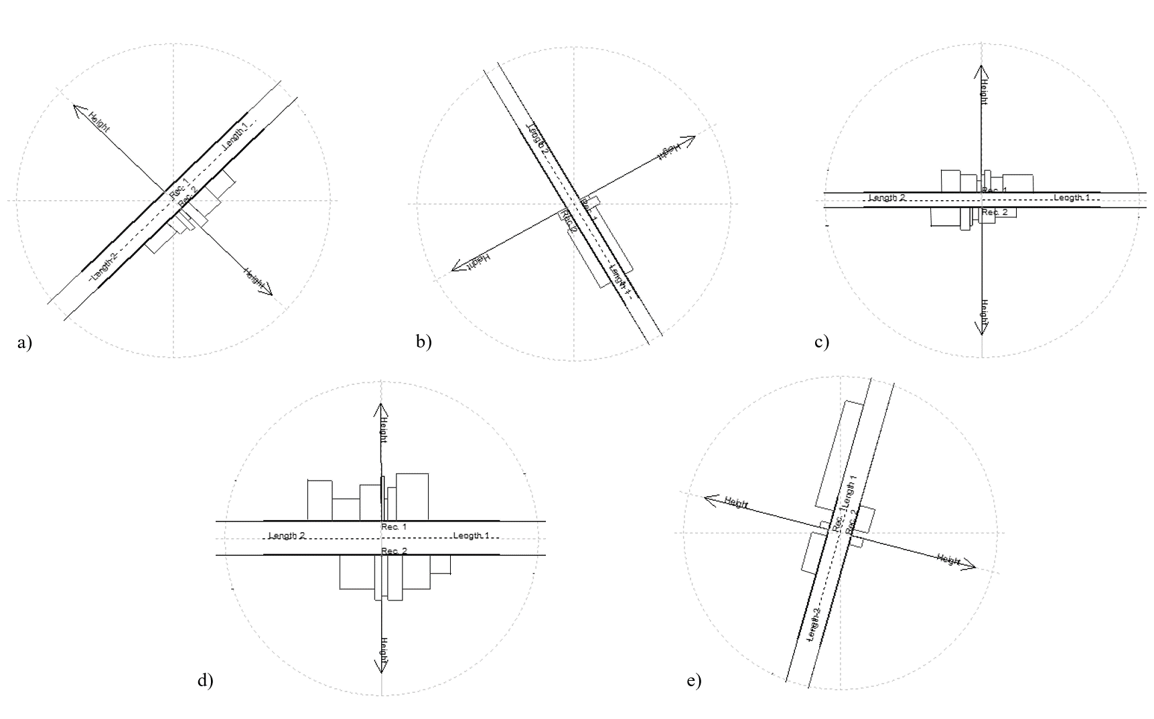
Figure 2. Geometry of the street canyons in the model: a) Viale Danimarca (B1): 45°; b) Via Parmenide (B2): 150°; c) Via Jemma (B3): 90°; d) Via Baratta (B4): 90°; e) Via Gonzaga (B5): 15°.
Table 4. Characteristics of the street canyons in the model
Street name | Length  [m] | Width  [m] | Height  [m] | Receptor height  [m] | Type (respect to receptor) | Zone type
Viale Danimarca (B1) | 100 | 10 | 10 | 6 | Symmetric | Industrial development area
Via Parmenide (B2) | 135 | 10 | 10 | 5 | Asymmetric | Commercial area
Via Jemma (B3) | 150 | 9 | 12 | 10 | Symmetric | City centre
Via Baratta (B4) | 100 | 15 | 20 | 10 | Symmetric | Outskirt
Via Gonzaga (B5) | 97 | 13 | 12 | 6 | Asymmetric | Residential area

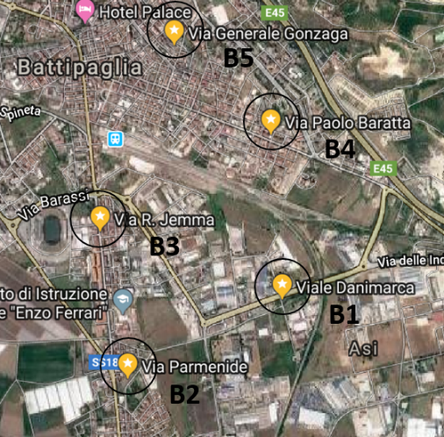
Figure 3. Air quality monitoring station network located in Battipaglia.
  - Results
The output of the OSPM model is given in terms of PM10 concentrations. In order to determine the correct position to install in the future the measuring stations that are representative of the whole city, the concentration profile of PM10 obtained for each of the five positions (B1-B5) selected after the modelling are reported in Figure.4.

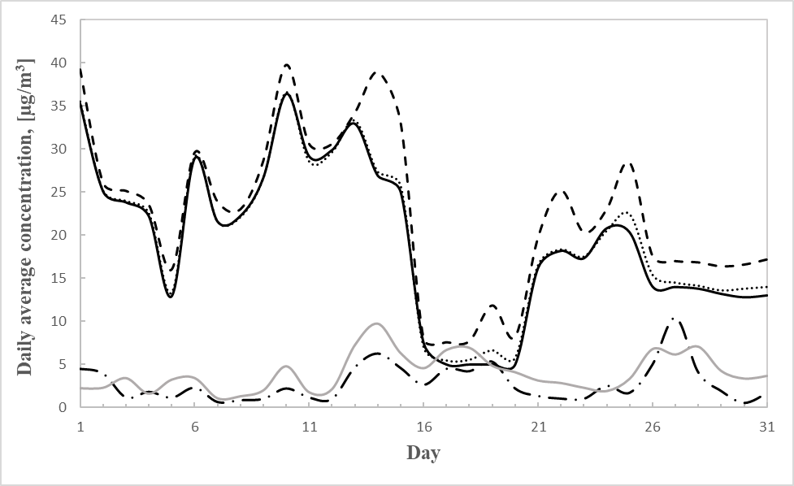
Figure 4. Daily average concentration of PM10 modelled. The solid black line for B1, the black dashed line is for B2, the black dotted line for B3, the black dash-dot line is for B4, the solid grey line is for B5.
Figure 4 shows two main features of the results. In particular, the results for the positions B1, B2, B3 show a significantly higher pollution than those of the sampling positions B4 and B5. This difference makes the positions B1, B2, and B3 more interesting in view of a possible pollution sampling station. In general, the more polluted streets are those characterized by a high anthropic activity. The presence of intense traffic, industrial activities and the high number of exposed subjects who attend the activities presents as shops and local market make the positions B1, B2 and B3 the most polluted and the corresponding streets an interesting area to study. Obviously, the theoretical point of view has to be matched with the practical installation of the monitoring stations in fact, not all the interesting points indicated by the model would be easily reachable for the installation. Weak oscillation in the results highlight the weekly periodicity of some of the anthropic activities, perhaps related to traffic changes in the weekdays.
  - Conclusion
The identification of the exact location of the monitoring station is a necessary preliminary analysis to improve network efficiency. The applied mathematical model based on the local concentration of particulates suggests that the positions B1, B2, B3 are the most significant for the installation of the sensors considering also that they are representative of different kind of anthropic activities, respectively industrial, commercial and residential. A model, like OSPM, gives preliminary information about the positions that are most seriously affected by air pollution and allowed to suggest the best position to install in the future the monitoring stations.

References
ACI vehicle park data for Battipaglia municipality, www.comuniitaliani.it
Cariou S., Fanlo J.L., Stitou Y., Buty D., Saman, D., Akiki R., 2016, Application of ODEMS (odorant dispersion
and emissions monitoring system) to measure odorous emissions from composting plant, Chem. Eng.
Trans., 54, 241–246.
Giuliano A., Gioiella F., Sofia D., Lotrecchiano N., 2018, A novel methodology and technology to promote the
social acceptance of biomass power plants avoiding Nimby Sindrome., Chem. Eng. Trans., 67. ISBN978-88-95608-64-8; ISSN2283-9216.
Hertel, O., and R. Berkowicz, 1989a: Modeling pollution from traffic in a street canyon: Evaluation of data and model development. DMU Luft-A 129, National Environmental Research Institute, Denmark, 77pp.
OSPM User’s guide, vergina.eng.auth.gr/mech/lat/copert/copert.htm
Salehi Kahrizsangi H., Sofia D., Barletta D., Poletto M., 2015, Dust generation in vibrated cohesive powders.
Chem. Eng. Trans. 43, 769–774.
Sofia D., Giuliano A., Barletta D., 2013, Techno-Economic Assessment of Co-gasification of Coal-Petcoke and
Biomass in IGCC Power Plants, Chem. Eng. Trans. 32, 1231–1236.
Sofia D., Giuliano A., Gioiella F., Barletta D., Poletto M., 2018, Modeling of an air quality monitoring network with high space-time resolution, In Friedl A., Klemeš J.J., Radl S., Varbanov P.S., Wallek T. (Eds), Computer Aided Chemical Engineering, 43, 193-198, DOI: 10.1016/B978-0-444-64235-6.50035-8.
Sofia D., Giuliano A., Gioiella F., 2018b, Air quality monitoring network for tracking pollutants. the case study of
Salerno City center, Chemical Engineering Transactions, 68, 67-72 DOI: 10.3303/CET1868012, ISBN978-88-95608-65-5; ISSN2283-9216.

