|  |  |
| --- | --- |
| cetlogo ***CHEMICAL ENGINEERING TRANSACTIONS***  ***VOL. 76, 2019*** | A publication of  aidiclogo_grande |
| The Italian Association  of Chemical Engineering  Online at www.cetjournal.it |
| Guest Editors: Sauro Pierucci, Jiří Jaromír Klemeš, Laura Piazza  Copyright © 2019, AIDIC Servizi S.r.l. **ISBN** 978-88-95608-73-0; **ISSN** 2283-9216 | |

Real-time On-road Monitoring network of air quality

Nicoletta Lotrecchianoa,b, Daniele Sofiaa,b\*, Aristide Giulianoa,b, Diego Barlettaa, Massimo Polettoa

aDiin-Departement of Industrial Engineering, University of Salerno, Via Giovanni Paolo II 132, Fisciano (SA) 84084, Italy

bSense Square srl, Corso Garibaldi 33, 84123, Salerno (SA), Italy

[\*info@sensesquare.eu](mailto:*info@sensesquare.eu)

In this paper an on-road network of monitoring stations for the air quality is organized in order to provide data with high spatial resolution in a wide urban area. On this purpose a dedicated experimental set-up was developed in order to be installed on board of DHL courier vans. The monitoring station is completely automated and transmit continuously environmental data and positions during the daily route of the van. In order to aggregate data, the city map is partitioned into a grid of 1 km2. The system is tested by comparing average concentrations with those of a fixed monitoring station.

* 1. Introduction

Pollution is one of the leading environmental and healthcare threats. Air pollution measurement networks are born to take under control the concentration of the primary pollutants. This type of infrastructures is installed in urban areas in order to have an overall view of the environmental conditions. The attention of population to the environmental state is high, and networks of the air quality monitoring can support the increase of the environmental awareness (Giuliano et al., 2018) by reassuring on the safety of the own environment. An example of high-resolution monitoring network was installed in the city center of Salerno (Sofia et al., 2018). The network is made of three measurement stations displaced over an area of about 1 km2. The purpose of the network was to investigate the air pollution in terms of particulates PM10 and PM2.5, as well as changes over time and, by comparing results of sensor possibly identify direction of propagation of pollution deriving from possible point sources. However, in order to have data with a high spatial resolution, a high number of sensing stations is required, and it would complicate the installation of an effective network, also for need of individual power supply to the network stations. In order to overcome this difficulty a self-powered wireless sensor network is used (Arroyo et al., 2016).

Real-time On-road Monitoring stations (ROMs) are a new kind of air quality monitoring units designed to be mounted on a carrying vehicle in motion within the urban area, in order to catch information on pollutant concentrations distributed in space and time. Some of these units have been used in the Netherlands (Weijers et al., 2004) and Switzerland (Bukowiecki et al., 2003) to prove the efficiency of the networks for the evaluation of the data variability over an extended area. Using a limited number of devices mounted on vehicles moving along established tracks, it is possible to collect space and time distribution of pollutants otherwise unattainable. In this case, increasing the time resolution of the sensors allows to improve the reliability of measurements and the amount of data collected.

* 1. Materials and Methods
     1. Experimental set-up

The mobile monitoring unit was built so that the suction part (Fig. 1b) is located in the upper part of the rear of the van. This position allows to minimize the direct influence on the air sampling of the air flow produced by the vehicle movement. In order to measure concentrations of particulates, NO2 and Organic Volatile Compounds (VOC), the mobile stations are equipped with three sensors. Each of the three sensor is fed by a dedicated air stream generated from the incoming airflow by an air spitting element.

The sensors used to measure particulates concentrations are based on the principle of laser scattering. In these sensors, the airborne particles, hit by the laser beam, diffract light radiation in different directions depending on the particle size. Therefore, detailed information on the concentration of the different particle size of the powder can be obtained. In particular, the built in software of the sensor elaborates the signal in order to provide cumulative concentrations of particles smaller than 10 µm (PM10), and smaller than 2.5 µm (PM2.5).

The sensor chosen to detect NO2 concentration is based on electrochemical principles (Kuberský et al., 2014). The measurement range is between 0 and 200 ppb (volume) with a resolution lower than 20 ppb and a measurement repeatability within ± 3 % of the full scale. The VOC sensor, based on tin oxide sensing component, measures the concentration of the mixed equivalent organic compounds (Mirzaei et al., 2016).

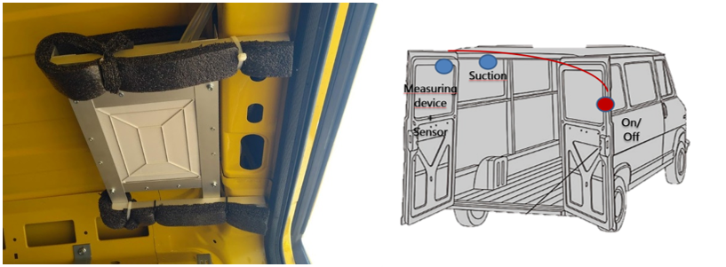

***b)***

***a)***

Figure 1. a) Measuring device lodged on the van. b) Schematic representation of the measuring system.

The sensors were calibrated by direct comparison of the ROMs results with those obtained with the CEL-712 Microdust Pro sensor, which is based on the gravimetry according the UNIEN 12341: 2014 standard.

All mobile monitoring stations are equipped with a mobile meteorological station, which takes records of temperature, relative humidity, and pressure. A GPS unit provides the information on the position of the sensing unit in terms of latitude and longitude. Aggregated data of the sensed concentrations, meteorological information and position are sent to the central server using IoT technologies. The data are collected and stored in real time ([Castell](https://www.sciencedirect.com/science/article/pii/S0013935117316584" \l "!) et al., 2018) continuously for the whole working time of the van every 3 minutes.

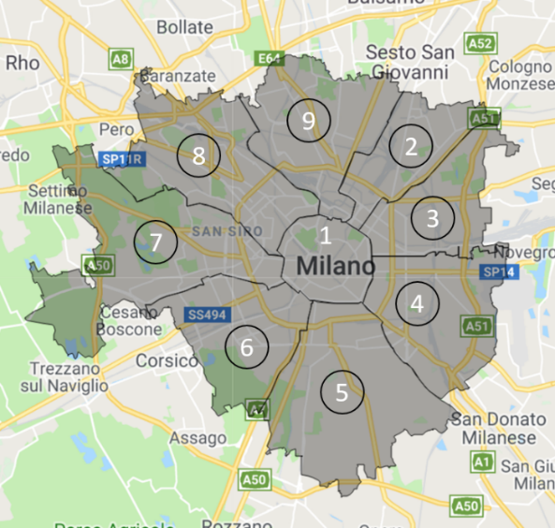

Figure 2. Milan districts.

* + 1. Experimental procedure

Vans belong to the urban network of a mail and parcel delivering company. According to the needs of an effective delivering action, each van has a well-defined route in a limited area. Large area coverages can be obtained by aggregating data coming from different vans. In order to associate data to ground position, irrespectively of the sensing source, the ground surface is divided according to the borders of the nine administrative districts of Milan (Fig. 2). Numbering of districts, starts from the city center and increments in the clockwise direction in the peripheral districts. Name and numbers of the districts and other characteristics, such as surface, and number and density of the resident population, are reported in Table 1. A preliminary analysis of the distribution of the vehicles on the ground and of the routes covered by vans was performed in order to identify the most significant areas for the environmental survey.

Table 1. Milan districts.

|  |  |  |  |  |
| --- | --- | --- | --- | --- |
| # | Name | Surface, km2 | Resident number | Population density, people/km2 |
| District 1 | Centro storico | 9.67 | 97,403 | 10,072.70 |
| District 2 | Stazione Centrale, Turro, Greco, Crescenzago | 12.58 | 159,134 | 12,649.76 |
| District 3 | Città studi, Lambrate, Venezia | 14.23 | 142,939 | 10,044.91 |
| District 4 | Vittoria, Forlanini | 20.95 | 159,750 | 7,625.29 |
| District 5 | Vigentino, Chiaravalle, Gratosoglio | 29.87 | 124,903 | 4,181.55 |
| District 6 | Barona, Lorenteggio | 18.28 | 150,356 | 8,225.16 |
| District 7 | Baggio, De Angeli, San Siro | 31.34 | 173,634 | 5,540.62 |
| District 8 | Fiera Milano, Quartiere Gallaratese, Quarto Oggiaro | 23.72 | 186,179 | 7,849.03 |
| District 9 | Stazione Garibaldi, Niguarda | 21.12 | 186,566 | 8,833.62 |

In order to increase the spatial resolution of the analysis, the investigated area was divided into square cells of 1 km sides represented on the Mercatore projection map reported in Fig. 3. The centroids of each cell form a regular grid, and the cell area of 1 km2 turned out to be the minimum area to aggregate a sufficient number of data, to accurately describe the complex urban context. In fact, cells larger than 1 km2 would be too big and the high spatial resolution would be lost. On the other hand, cells smaller than 1 km2 would collect too few data to produce significant statistics.

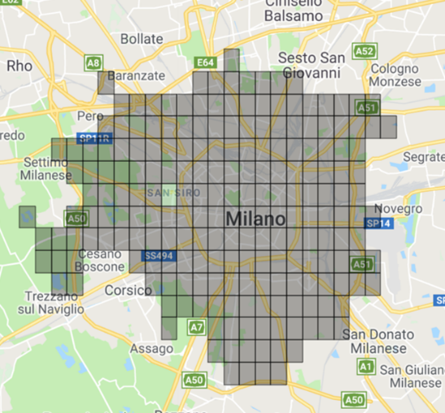

Figure 3. Grid map made of square cell of 1 km side used to describe the pollutant concentration distribution on the ground.

* 1. Results

As an example of the collected results, the daily average concentrations of PM10, PM2.5 and, NO2 in the city districts are reported directly on the map in Figure 4. The mean concentration of PM10 is around 38 µg/m3 for all the districts investigated and around 8 µg/m3 and 15 µg/m3 for the PM2.5 in district 3 and districts 2 and 4, all values below the law limit. The concentration of NO2 is also low, and the average of the three districts is almost 14ppb. Each mean value concentration represents the average value of the data obtained from different vans passed through the same district during the day. In this way, it is possible to have a huge amount of information about the same district from different measuring devices with a traditionally fixed monitoring station is limited.

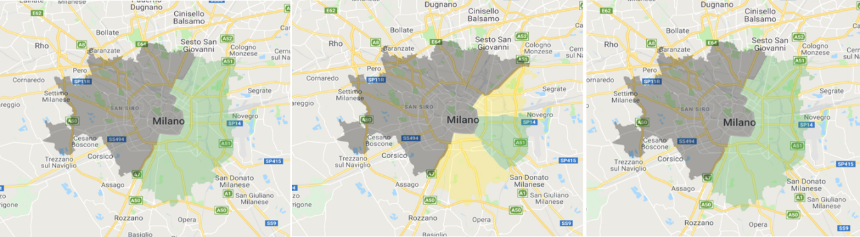

**c)**

**b)**

**a)**

Figure 4. Map of a) PM10 mean concentration, b) PM2.5 mean concentration, c) NO2 mean concentration divided by districts. Color codes are provided in Table 2. Red represents pollutant concentrations above the air quality limits, yellow indicates an almost good air quality and green indicates a good air quality. Grey represents the absence of data.

Table 2. Color codes in Figure 4 to 6.

|  |  |  |  |  |  |  |  |  |  |  |  |  |
| --- | --- | --- | --- | --- | --- | --- | --- | --- | --- | --- | --- | --- |
|  | | PM10 (µg/m3) | | | PM2.5 (µg/m3) | | | NO2 (ppb) | | | VOC (ppb eq) | |
| Color | min | | max | min | | max | min | | max | min | | max |
| Green | 0- | | 20 | 0 | | 14 | 0 | | 99 | 0 | | 10 |
| Yellow | 21 | | 49 | 15 | | 24 | 100 | | 199 | 11 | | 24 |
| Red | 50 | | 999 | 25 | | 999 | 200 | | 800 | 25 | | 100 |

To make the visualization more immediate, the data collected are reported on the map according to a traffic light code reported in Table 2. Red indicates zones overcoming of the law limit for the specified parameter. Yellow indicates zones with an almost good air quality and green indicates zones with a good air quality. The evaluation of the mean pollutant concentrations using the grid method (Fig. 5b) gives detailed information about pollutants and highlight criticalities that are hidden in the overall view of Figure. 5a. In particular Figure 5 shows the differences in results coming from different procedures in data aggregation relative to the concentrations of PM2.5. Data analysis reveals that in cell marked red local averages can exceed of 8.8 µg/m3 the thresholds of 25 µg/m3 of PM2.5 established by the Italian law. Instead, data of district averages hide these critical situations by providing values below 13.33 µg/m3, well within the guideline limit.

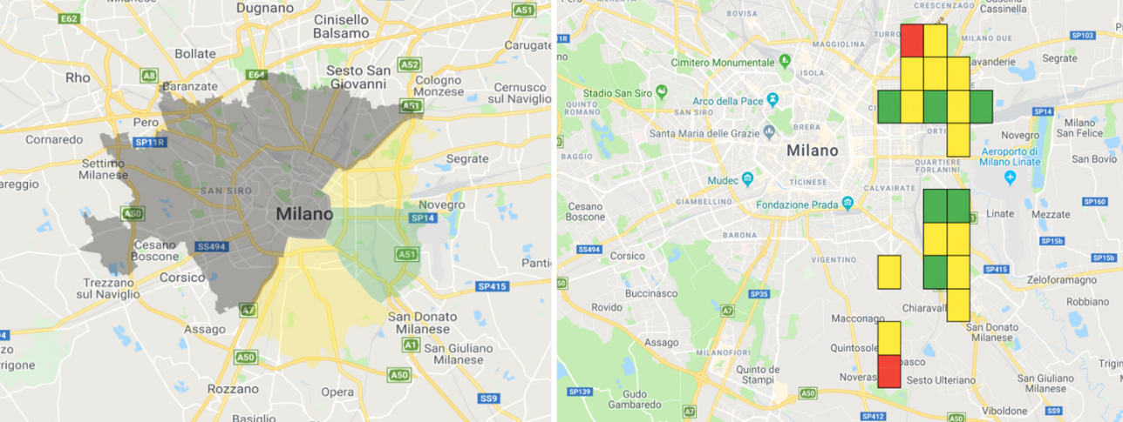

**b)**

**a)**

Figure 5. a) Map of PM2.5 concentrations divided by zones, b) Grid map of PM2.5 concentrations covering 1Km2

In order to investigate the difference of pollution between working days and the weekends, two days were chosen as example. As it is shown in Figure 6, during the weekends, the concentration of pollutants in some areas decrease. Data analysis indicates that the concentration of PM2.5 decreases of about 7% during the weekends (Figure 6b). In fact, the principal source of PM2.5 emissions is the daily traffic that during the weekends decreases. Data analys anso indicate that during weekends, also the concentrations of PM10, NO2 and VOC decrease, too but not as much to determine a change of color in the scale adopted.

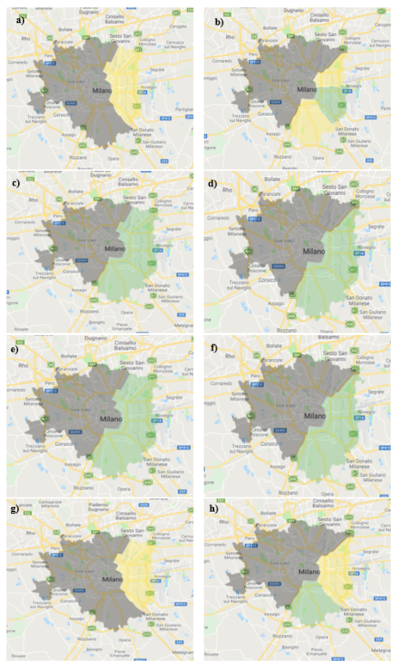

Figure 6. Map of pollutants concentration for a working day (2018/08/23) a) PM2.5, c) PM10, e) NO2, g) VOC and for the weekend (2018/09/28) b) PM2.5, d) PM10, f) NO2, h) VOC.

* 1. Conclusions

An on-road network of monitoring stations (ROMs) for the air quality was set-up in order to provide high spatial resolution data in a wide area. As a result, the average value of the pollutant concentrations can be reported directly on the city map in order to have a clear definition of the environmental situation. Due to the quantity of data collected from the ROMs some information of the weekly pollution behavior can be elaborated. In particular, it is possible to see how the levels of the pollution change during the week.

To provide a more detailed information the city map can be divided into grid or square cells. In each cell it is possible to calculate a representative value of the average concentration of each one of the pollutants taken into consideration.

In order to have the overall view of the environmental situation of the city, the data obtained from the network of mobile stations have to be increased either by increasing the number of ROMs devices or with a combined use of the data given by ROMs and by traditional fixed monitoring stations. However, this last option requires a validation of the ROMs data compared with those of the fixed monitoring network installed in the city because, due to the different sampling methods adopted in the two cases.

References

Arroyo, P., Lozano, J., Suárez, J.I., Herrero, J.L., Carmona, P., 2016, Wireless Sensor Network for Air Quality Monitoring and Control, Chemical Engineering Transactions, 54, 217–222.

Bukowiecki, N., Dommen, J., Prévôt, A.S.H., Weingartner, E., Baltensperger, U., 2003, Fine and ultrafine particles in the Zurich (Switzerland) area measured with a mobile laboratory: an assessment of the seasonal and regional variation throughout a year, Atmospheric Chemistry and Physics, 3, 1477–1494.

Castell N., Schneider P., Grossberndt S., Fredriksen M. F., Sousa-Santos G., Vogt M., Bartonova A., 2018, Localized real-time information on outdoor air quality at kindergartens in Oslo, Norway using low-cost sensor nodes, Environmental Research, 165, 410-419.

Giuliano A., Gioiella F., Sofia D., Lotrecchiano N., 2018, A novel methodology and technology to promote the social acceptance of biomass power plants avoiding nimby syndrome, Chemical Engineering Transactions, 67, 307-312 DOI: 10.3303/CET1867052.

Kuberský P., Syrový T., Hamáček A., Nešpůrek S., Syrová L., 2014, Fully Printed Electrochemical NO2 Sensor, Procedia Engineering, 87, 1043 – 1046.

Mirzaei A., Leonardi S. G., Neri G., 2016, Detection of hazardous volatile organic compounds (VOCs) by metal oxide nanostructures-based gas sensors: A review, Ceramics International, 42, 15119–15141.

Sofia D., Giuliano A., Gioiella F., 2018, Air quality monitoring network for tracking pollutants. the case study of Salerno city center, Chemical Engineering Transactions, 68, 67-72 DOI: 10.3303/CET1868012.

Weijers, E.P., Khlystov, A.Y., Kos, G.P.A., Erismana, J.W., 2004, Variability of particulate matter concentrations along roads and motorways determined by a moving measurement unit, Atmospheric Environment, 38, 2993–3002.