CHEMICAL ENGINEERING TRANSACTIONS  VOL. 76, 2019 | A publication of
The Italian Association
of Chemical Engineering
Online at www.cetjournal.it
Guest Editors: Sauro Pierucci, Jiří Jaromír Klemeš, Laura Piazza
Copyright © 2019, AIDIC Servizi S.r.l.
ISBN 978-88-95608-73-0; ISSN 2283-9216

Re-use of natural clayey waste as supplementary cementitious material
Claudio Ferone^{a,b}, Raffaele Cioffi^{a,b}, Antonio Telesca^{c,d,*}, Milena Marroccoli^{c,d}
ªMaterials Science and Engineering Research Group MASERG, Dipartimento di Ingegneria, Università Parthenope, Centro Direzionale Is. C4, 80133 Napoli, Italy
^{b}INSTM, Consorzio Interuniversitario per la Scienza e Tecnologia dei Materiali, Unità di Ricerca Napoli Parthenope, Via G. Giusti, 9, 50121 Firenze, Italy
^{c}Scuola di Ingegneria, Università degli Studi della Basilicata, Viale dell’Ateneo Lucano 10, Potenza 85100, Italia
^{d}INSTM, Consorzio Interuniversitario per la Scienza e Tecnologia dei Materiali, Unità di Ricerca Basilicata, Via G. Giusti, 9, 50121 Firenze, Italy
*antonio.telesca@unibas.it

In 2015 total world cement manufacture was estimated at 4.6 billion tons and the CO₂ emissions from cement plants were equal to approximately 3.7 billion metric tons, representing about 7% of the global anthropogenic emissions. The utilization of innovative cements and/or supplementary cementitious materials (SCMs) represent a powerful tool for both reducing the CO₂ footprint and producing more durable environmentally friendly materials.
This paper investigates the possibility of using clayey reservoir sediments (RSs) calcined at 830°C as SCMs in a blended Portland cement; this binder, together with a reference one containing natural pozzolan, was submitted to hydration and mechanical tests for curing times ranging from 2 to 56 days. It has been found that RSs are very interesting SCMs inasmuch as their utilization, allowing a clinker dilution, leads to both CO₂ emission decrease and energy saving; furthermore, the hydration behaviour and the mechanical properties of the blended cement were positively affected by the RSs addition.
  - Introduction
All over the World, after water, concrete is the most utilized material and the most widely used building component (Coppola et al., 2018); by the way, it has been estimated that three tons of concrete per person are used each year. Cement represents the concrete’s key component; it is the inorganic glue which, upon hydration, binds together fine sand and coarse aggregates in concrete (Tregambi et al., 2018).
Ordinary Portland cement (OPC) is the most common binder obtained by mixing Portland clinker (PC) with a few percent of calcium sulfate; PC is obtained by heating a mixture of limestone (~80%) and clay in a rotary kiln at about 1450°C. Cement manufacture represents one of the greatest energy-intensive industrial processes; furthermore, due to both limestone thermal calcination and fuel combustion (mainly fossil coal and pet coke), cement production contributes for about 7% of the global anthropogenic CO₂ emissions (Telesca et al., 2017). Therefore, cement industry has been facing many challenges due to environmental concerns and sustainability issues, mainly focused on the reduction of carbon dioxide emissions. For this purpose, both cement producers and scientific community have been suggesting several ways, namely: a) the use of more efficient processes (Xu et al., 2015); b) the utilization of non-traditional fuels (Schneider, 2015); c) the application of the carbon capture and storage technology to cement factories (Perejon et al., 2016); d) the production of low-CO₂ cements (LCCs) (Telesca et al., 2016).
LCCs can be obtained by following three different approaches, namely: 1) the use of a non-carbonated CaO source instead of limestone as a constituent of the PC-generating raw mix; 2) the increased production of blended cements, obtained by mixing PC with significant amounts of supplementary cementitious materials (SCMs, e.g. natural pozzolans, coal fly ashes, blast-furnace slags) (Wang, 2014; Juenger and Siddique, 2015) and 3) a larger use of special cements obtained from non-PCs (Marroccoli et al., 2009; Marroccoli et al., 2010a; Marroccoli et al., 2010b; Telesca et al., 2014).
Water reservoirs are used for various purposes such as power source, irrigation and storage of drinking water; they are subject to silting up phenomena leading to the reduction of dam capacity. Dredging operations, carried out in order to restore the original reservoir capacity, generate high quantities of sediments for which suitable applications, alternative to landfilling, need to be researched. Up to now, the use of dredging sediments as raw material has been explored for the production of bricks, lightweight aggregates, stabilized road-bases, Portland clinker, as SCM for blended cements and as geopolymer precursors (Telesca et al., 2019; Messina et al., 2017; Anger et al., 2017; Faure et al. 2017; Snellings et al., 2016; Peirce et al., 2015; Ferone et al., 2015; Molino et al., 2014).
In this paper thermally treated (TT) sediments collected from an artificial reservoir (RSs) were tested as substitutes for natural pozzolan (NP) in blended cements. NP is a silico-aluminous material able to react with Ca(OH)₂, generated during cement hydration, to form products similar to those produced upon OPC hydration. At the raw (crystalline) state, RSs do not show any pozzolanic activity; thus, a thermal treatment represents a useful tool allowing the transition of the clayey crystalline fraction to a mainly amorphous state (dehydroxylation). The optimal treatment temperature is the one ensuring a total sample dehydroxylation without recrystallization (Mohammed 2017). RSs were TT at temperatures ranging from 750° to 900°C; the burnt products were investigated by means of X-ray diffraction (XRD) analysis. Furthermore, the technical behaviour and hydration properties of two blended cements, respectively containing the most reactive TTRSs and NP (used as reference term), were evaluated by means of Fratini pozzolanicity test, DT-TG analysis and compressive strength measurements.
  - Experimental program
An industrial OPC class 42.5 R (CEM I) and a NP were kindly supplied by an Italian cement factory operating in the South of Italy. Six samples of RSs were drawn from different points inside the bottom of the “Camastra” reservoir, located in Basilicata Region (Italy); the samples were dried in an electric oven at 110°C until a constant mass value was reached; afterwards, they were carefully homogenised and finely milled to pass the 90μm sieve.
The chemical composition of CEM I, NP and RSs, evaluated by means of X-ray fluorescence analysis (BRUKER Explorer S4 apparatus), is reported in Table 1 together with the loss on ignition (l.o.i.) value measured at 950°C; to complete the characterization, NP and RSs were also submitted to DT-TG and XRD (Figure 1) analyses; in this regard, a Rigaku Miniflex 600 diffractometer (CuKα radiation and 0.02°2θ s⁻¹ scanning rate) and a NetzchTasc TG/SDTA 414/3 apparatus (operating in the temperature range 20°–1000°C, at a heating rate of 10°C/min) were employed. In order to assess the optimal treatment temperature allowing the total dehydroxylation, samples of RSs were heated in an electric furnace at temperatures comprised between 750° and 900°C for 2 hours; TTRSs samples were then finely pestles to pass the 90μm sieve.
A blended cement (BC) was obtained by mixing TTRSs, obtained at the best treatment temperature, with 60% by mass of CEM I (C_TTRSs); NP was used for the preparation of a refence BC based on 60% by mass of CEM I (C_NP). BCs, both having a Blaine fineness equal to 380 m²kg⁻¹, were finely homogenized in a laboratory mixer; they were then submitted to pozzolanicity test in order to evaluate the suitability of the pozzolanic addition to be used in mixture with OPC. The pozzolanic activity was evaluated according to the Fratini test, as reported in the EN 196-5 (EN 196-5). Pozzolanicity is assessed by comparing the concentration of Ca ion expressed as CaO present in the aqueous solution (in contact with the hydrated cement for 8/15 days at 40 °C) with the concentration of Ca ion capable of saturating a solution of the same alkalinity. BC is considered to satisfy the test if the concentration of Ca ion in solution is lower than the saturation concentration (Telesca et al., 2017).
Furthermore, BCs were hydrated in order to assess the reactivity of TTRSs, namely their ability to react with Ca(OH)₂ (produced during PC hydration) for generating calcium silicate and calcium aluminate hydrates (the typical hydration products for OPC); C_TRSs and C_NP were paste hydrated with a 0.50 water/cement mass ratio and cast into 15 mm- height and 30 mm-diameter cylindrical molds, placed in polyethylene bags inside a thermostatic bath at 40 °C for 8 and 15 days. At the end of each aging period, the specimens were first crushed and then treated with acetone (to stop hydration) and diethyl ether (to remove water); the pulverized samples were stored in a desiccator over silica gel–soda lime (to ensure protection against H₂O and CO₂) waiting for the simultaneous DT-TG analysis.
For the mechanical tests, BCs mortars were prepared according to the European Standard EN 196-1 and cured, after demolding, under water at 20°±1°C. The compressive strength test on mortars was carried out at 2, 7, 14, 28 and 56 days.

3. Results and discussion
From the chemical composition data (Table 1) it is seen that, similarly to NP, SiO₂ and Al₂O₃ represent the main components for RS. Moreover, as also observed by DT-TG analysis, part of the RS weight loss is ascribed to CaCO₃ content, being the other related to the loss of water of the argillaceous minerals.

Table 1: Chemical composition of CEM I, RS and NP, mass%
 | CEM I | NP | RS
CaO | 62.85 | 8.03 | 9.05
SiO₂ | 20.62 | 59.06 | 51.86
Al₂O₃ | 5.42 | 9.67 | 13.45
Fe₂O₃ | 2.51 | 5.22 | 5.16
K₂O | 0.79 | 1.34 | 1.74
MgO | 1.50 | 1.83 | 2.04
MnO | 0.05 | – | 0.15
Na₂O | 0.21 | 1.66 | 0.81
P₂O₅ | 0.13 | – | 0.15
SO₃ | 3.19 | 0.15 | 0.22
TiO₂ | 0.29 | – | 0.65
l.o.i.* | 2.06 | 11.30 | 14.50
Total | 99.62 | 98.26 | 99.78
*loss on ignition at 950°C

Figure 1 shows the XRD spectra for both RS (left) and NP (right) samples; calcite, kaolinite, muscovite and quartz, were the main crystalline phases for RS; NP, taking also into account its chemical composition, has a marked silico-aluminous nature due to the presence of analcime, augite and quartz.

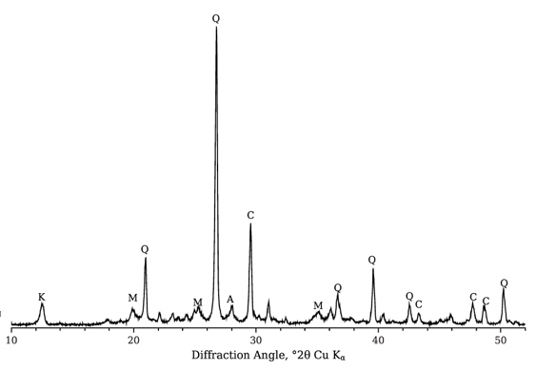 | 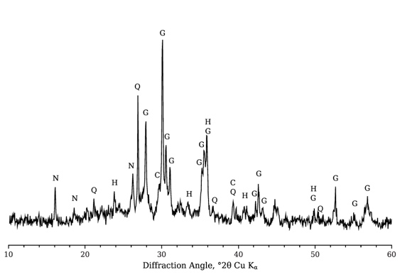
Figure 1: XRD patterns for RS (left) and NP (right). Legend to symbols: A=anorthite (CaAl₂Si₂O₈); C=calcite (CaCO₃); G=augite ((Ca,Mg,Fe²⁺,Fe³⁺,Al)₂(Si,Al)₂O₆); H=hematite (Fe₂O₃); K=kaolinite (Al₂Si₂O₅(OH)₄); M=muscovite (KAl₂(Si₃Al)O₁₀(OH,F)₂); N=analcime (NaAlSi₂O₆·H₂O); Q=quartz (SiO₂)

XRD patterns of RSs samples thermally treated for 2 hours at 750°, 830° and 900°C (Figure 2) show the decomposition of muscovite whose main peaks intensity decrease with the increase of temperature.

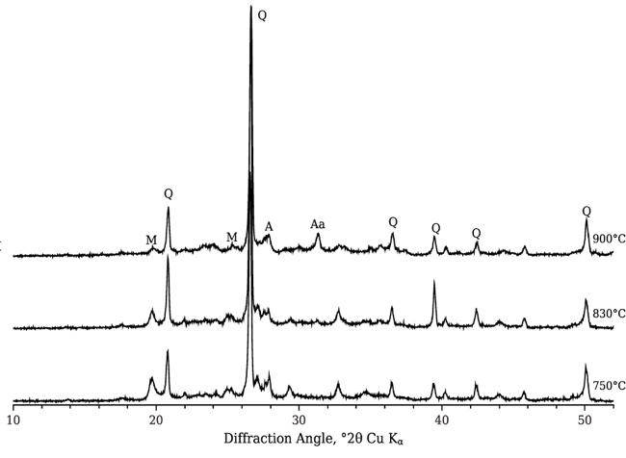
Figure 2: XRD patterns for RS treated at 750°, 830° and 900°C. Legend to symbols: A=anorthite (CaAl₂Si₂O₈); Aa=alumoakermanite ((Ca,Na)₂(Al,Mg,Fe⁺⁺)(Si₂O₇)); C=calcite (CaCO₃); M=muscovite (KAl₂(Si₃Al)O₁₀(OH,F)₂); Q=quartz (SiO₂)
On the contrary, the main peak related to alumoakermanite is identified for the first time in the sample heated at 830°; at 900°C its intensity was higher. Therefore, the best compromise between the undesired formation of a new crystalline phase and the increase of the amorphous phase is obtained at 830°C.
Figure 3 shows the saturation curve together with the indication of the pozzolanicity test results for C_NP and C_TTRSs hydrated for 8 days at 40 °C (according to EN 196-5). It indicates that TTRS showed a reactivity similar to that of NP; as a matter of fact, both C_ TTRS and C_NP satisfied the pozzolanicity test as indicated by the representative points of the related cements (circle and square, respectively), located below the saturation curve (zone “1” in Figure 3). An analogous result was obtained by pozzolanicity test carried out on the same sample hydrated for 15 days at 40 °C.

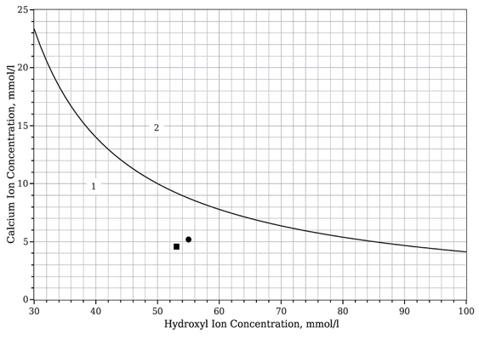
Figure 3: Saturation curve at 40 °C together with the indication of the pozzolanicity test results for C_ TTRS (circle) and C_NP (square). Zone “1” represents the domain in which the test “passes”, zone “2” where it “fails”

Figure 4 illustrates the DT–TG thermograms for C_ TTRS (up) and C_NP (down) cements cured at 8 and 15 days at 40°C. With the increase of DT–TG temperature, five endothermal effects were observed and attributed, in the order, to (I) calcium silicate hydrate (CSH), (II) ettringite (E), (III) monosulfate (M), (IV) calcium hydroxide, (CH) and (V) calcium carbonate (C), through the following dehydration endothermal peaks (Taylor, 1997): 113°±3°C, 143°±2°C, 198°±1°C, 498°±1°C, 725°±2°C, respectively.

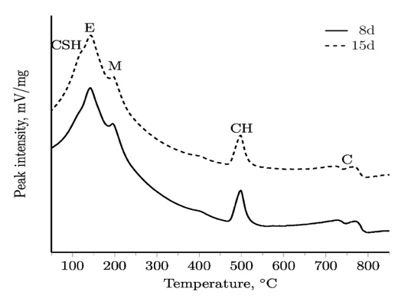 | 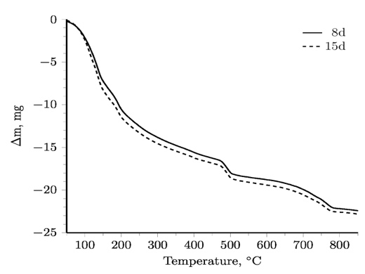
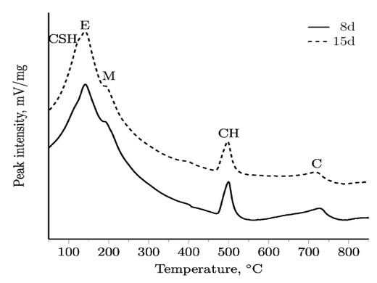 | 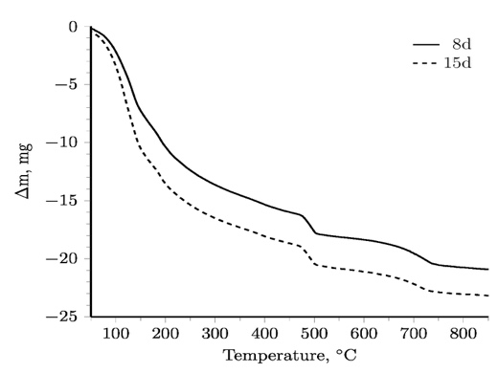
Figure 4: DT (left)–TG (right) thermograms for C_ TTRS (up) and C_NP (down) at 40°C for 8 and 15 days Legend to symbols: CSH=calcium silicate hydrate; E=ettringite; M=monosulfate; CH=calcium hydroxide; C=calcium carbonate

It is withdrawn here that: i) CSHs are the main hydration products of the calcium silicates present in CEM I, a process giving, as secondary product, CH which can react with silica to give more CSHs; ii) E (3CaO·Al₂O₃·3CaSO₄·32H₂O) can be formed through the hydration of calcium hydroxide-alumina-calcium sulfate systems; iii) M (3CaO·Al₂O₃·CaSO₄·12H₂O) can be regarded as the decomposition product of E, in presence of calcium aluminate hydrates and in lack of both sulfates and C. CSHs are considered the main desired hydration products in the cement hydration process.
When compared to the reference cement, the thermograms of C_TTRS pastes displayed qualitative similarities, thus highlighting the TTRS feature of acting as a reactive cementitious material.
Table 2 reports the compressive strength values for C_NP and C_TTRS at different curing times.
Table 2: Compressive strength measurements for C_NP and C_TTRS, MPa
Days | C_NP | C_TTRS
2 | 22.7±0.3 | 19.8±0.5
7 | 31.9±0.2 | 28.0±0.5
14 | 32.6±0.1 | 31.8±0.8
28 | 35.0±0.5 | 34.7±0.7
56 | 39.8±0.7 | 37.8±0.8

It can be easily observed that there are no significant differences in terms of compressive strength values between the two cements at all the investigated curing periods; moreover, they both fulfill the requirements of cement strength class 32.5 R, according to EN 197-1.
  - Conclusions
This paper evaluates the possibility of using clayey reservoir sediments (RSs) as alternative supplementary cementitious materials (SCMs) in ordinary Portland (OP)-blended cements. RSs were thermally treated (TT) at temperatures ranging from 750° to 900°C with the aim of dehydroxylating the silico-aluminate crystalline phases in benefit of an amorphous state; TTRSs are very interesting since their utilization as SCMs, in addition to the saving of raw materials and waste landfilling, allows a OP clinker dilution, thus implying a decreased emission of CO₂ as well as an energy saving per unit mass of cement.
It has been found that, thanks to high silica-alumina content, RSs heated at 830°C satisfied the pozzolanicity test. Furthermore, the hydration behaviour of TTRS blended cement was similar to that of the reference one containing natural pozzolan, characterized by the development of the same hydration products, namely calcium silicate hydrates, ettringite, monosulphate and calcium hydroxide. Due to the strong dependence of the cement technical performance on its hydration features, it can be argued that the similarity in the hydraulic behavior among the investigated cements most likely results in analogous engineering properties as confirmed by the mechanical compressive strength results which fulfill the requirements of strength class 32.5 R according to EN 197-1.
Acknowledgements
This work was supported by the Università di Napoli “Parthenope” [grant within the call “Support for Individual Research for the 2015-17 Period- Annuity 2017” issued by Rector Decree no. 793 (28/11/2017)].
References
Anger, B., Moulin, I., Commene, J.P., Thery, F., Levacher, D., 2017. Fine-grained reservoir sediments: an interesting alternative raw material for Portland cement clinker production. Europ. J. Env. Civ. Eng. DOI: 10.1080/19648189.2017.1327890.
Coppola, L., Bellezze, T., Belli, A., Bignozzi, M.C., Bolzoni, F., Brenna, A., Cabrini, M., Candamano, S., Cappai, M., Caputo, D., Carsana, M., Casnedi, L., Cioffi, R., Cocco, O., Coffetti, D., Colangelo, F., Coppola, B., Corinaldesi, V., Crea, F., Crotti, E., Daniele, V., De Gisi, S., Delogu, F., Diamanti, M.V., Di Maio, L., Di Mundo, R., Di Palma, L., Donnini, J., Farina, I., Ferone, C., Frontera, P., Gastaldi, M., Giosuè, C., Incarnato, L., Liguori, B., Lollini, F., Lorenzi, S., Manzi, S., Marino, O., Marroccoli, M., Mascolo, M.C., Mavilia, L., Mazzoli, A., Medici, F., Meloni, P., Merlonetti, G., Mobili, A., Notarnicola, M., Ormellese, M., Pastore, T., Pedeferri, M.P., Petrella, A., Pia, G., Redaelli, E., Roviello, G., Scarfato, P., Scoccia, G., Taglieri, G., Telesca, A., Tittarelli, F., Todaro, F., Vilardi, G., Yang, F., 2018. Binders alternative to Portland cement and waste management for sustainable construction — Part 2. J. Appl. Biomater. Funct. Mater. 16, 186–202.
EN 196-5. Methods of testing cement. Pozzolanicity test for pozzolanic cements.
Faure, A., Smith, A., Coudray, C., Anger, B., Colina, H., Moulin, I., Thery, F., 2017. Ability of Two Dam Fine-Grained Sediments to be Used in Cement Industry as Raw Material for Clinker Production and as Pozzolanic Additional Constituent of Portland-Composite Cement. Waste Biom. Valor. 8, 2141–2163.
Ferone C., Liguori B., Capasso I., Colangelo F., Cioffi R., Cappelletto E., Di Maggio R., 2015. Thermally treated clay sediments as geopolymer source material, Appl. Clay Sci., 107, 195–204.
Juenger, M.C.G., Siddique, R., 2015. Recent advances in understanding the role of supplementary cementitious materials in concrete. Cem. Concr. Res. 78, 71–80.
Marroccoli, M., Montagnaro, F., Pace, M.L., Telesca, A., Valenti, G.L., 2009. Use of fluidized bed combustion ash and other industrial wastes as raw materials for the manufacture of calcium sulphoaluminate cements. Proc. 20th Int. Conf. Fluid. Bed Comb., 1072-1077.
Marroccoli M., Pace M.L., Telesca A., Valenti G.L., 2010a. Synthesis of calcium sulfoaluminate cements from Al₂O₃-rich by-products from aluminium manufacture, 2nd Int. Conf. Sust. Constr. Mat. Tech., Ancona, Italy, 615–623.
Marroccoli M., Montagnaro F., Telesca A., Valenti G.L., 2010b. Environmental implications of the manufacture of calcium sulfoaluminate-based cements, 2nd Int. Conf. Sust. Constr. Mat. Tech., Ancona, Italy, 625–635.
Messina F., Ferone C., Molino A., Roviello G., Colangelo F., Molino B., Cioffi R., 2017. Synergistic recycling of calcined clayey sediments and water potabilization sludge as geopolymer precursors: Upscaling from binders to precast paving cement-free bricks, Constr. Build. Mater., 133, 14–26.
Molino B., De Vincenzo A., Ferone C., Messina F., Colangelo F., Cioffi R., 2014. Recycling of Clay Sediments for Geopolymer Binder Production. A New Perspective for Reservoir Management in the Framework of Italian Legislation: The Occhito Reservoir Case Study, Materials, 7, 5603-5616.
Peirce S., Santoro L., Andini S., Montagnaro F., Ferone C., Cioffi R., 2015. Clay Sediment Geopolymerization by Means of Alkali Metal Aluminate Activation, RSC Adv., 5, 107662 – 107669.
Perejón, A., Romeo, L.M., Lara, Y., Lisbona, P., Martínez, A., Valverde, J.M., 2016. The calcium- looping technology for CO₂ capture: on the important roles of energy integration and sorbent behavior. Appl. En., 162, 787–807.
Schneider, M., 2015. Process technology for efficient and sustainable cement production. Cem. Concr. Res. 78, 14-23.
Snellings, R., Cizer, Ö., Horckmans, L., Durdziński, P.T., Dierckx, P., Nielsen, P., Van Balen, K., Vandewalle, L., 2016. Properties and pozzolanic reactivity of flash calcined dredging sediments. Appl. Clay Sci., 129, 35–39.
Taylor H.F.W., 1997. Cement Chemistry, Academic Press Publisher, London, UK, 436.
Telesca, A., Marroccoli, M., 2019. Effect of calcined clay reservoir sediments on the behaviour of sustainable calcium sulfoaluminate-blended cements. Proc. 15th Int. Cong. Chem. Cem., Prague, Czech Republic, September 16–20, 2019. Accepted for publication.
Telesca, A., Marroccoli, M., Ibris, N., Lupiáñez, C., Díez, L.I., Romeo, L.M., Montagnaro, F., 2017. Use of oxyfuel combustion ash for the production of blended cements: A synergetic solution toward reduction of CO₂ emissions Fuel Proc. Tech. 156, 211-220.
Telesca, A., Marroccoli, M., Tomasulo, M., Valenti, G.L., Dieter, H., Montagnaro, F., 2016. Low-CO₂ Cements from Fluidized Bed Process Wastes and Other Industrial By-Products. Comb. Sci. Tech. 188 (4-5), 492-503.
Telesca, A., Calabrese, D., Marroccoli, M., Valenti, G.L., Montagnaro, F., 2014. Study of the hydrothermal treatments of residues from fluidized bed combustors for the manufacture of ettringite-based building elements. Fuel Proc. Tech., 126, 188-191.
Tregambi, C., Solimene, R., Montagnaro, F., Salatino, P., Marroccoli, M., Ibris, N., Telesca, A., 2018. Solar-driven production of lime for ordinary Portland cement formulation. Solar En, 173, 759-768.
Wang, S., 2014. Quantitative kinetics of pozzolanic reactions in coal/cofired biomass fly ashes and calcium hydroxide (CH) mortars. Constr. Build. Mater. 51, 364–371.
Xu, D., Cui, Y., Li, H., Yang, K., Xu, W., Chen, Y., 2015. On the future of Chinese cement industry. Cem. Concr. Res. 78, 2-13.

