CHEMICAL ENGINEERING TRANSACTIONS  VOL. | A publication of
The Italian Association
of Chemical Engineering
Online at www.aidic.it/cet
Guest Editors:
Copyright © AIDIC Servizi S.r.l.
ISSN 2283-9216

Management and Treatment of the clean-up water from the scrubber of a coal and biomass gasification plant: an industrial case study
Gabriele Calìª, Paolo Deiana^{b}, Enrico Maggioª, Davide Marottoª, Michele Mascia^{c}, Annalisa Vacca^{c}
ª Sotacarbo S.p.A. – c/o Grande Miniera di Serbariu – 09013 Carbonia, ITALY
^{b} ENEA, Italian Agency for New Technologies, Energy and Sustainable Economic Development, Via Anguillarese 301, 00123 Rome, ITALY
^{c} Università degli Studi di Cagliari, Dipartimentodi Ingegneria Meccanica, Chimica e dei Materiali., Piazza D’Armi, 09123 Cagliari, Italy
michele.mascia@unica.it

This work presents an industrial case-study on the possible application of an on-line treatment of the clean-up waters deriving from a wet scrubber used for the removal of pollutants from the syngas produced by a pilot plant used for test coal and biomass gasification. The wastewater is generated in a pilot-scale plant located in the south west of Sardinia and owned by ENEA and Sotacarbo. The plant platform includes a 5 MWth gasifier equipped with a wet scrubber for syngas clean up in co-current flow conditions and a flare. The plant is used for experimental campaigns with different feedstocks, mainly constituted by mixtures of coal and wood.
The wastewater contains suspended and dissolved solids, which must be removed for a possible reuse of the clean-up water in a closed loop with low make-up. Moreover, the high content of pollutants reduces the effectiveness of the cleaning process and may lead to fouling of surfaces and blocking of the recirculation pumps. Adsorption with carbon-based sorbents has been tested to remove dissolved solids from water.
Commercial activated carbon and different samples of coal were used to obtain sorption isotherms and breakthrough curves at lab scale. Based on the experimental results, a pilot-scale column has been designed and installed in a side stream of the clean-up system. The column was equipped with different carbon samples and tested during several gasification campaigns. The samples of coal do not show enough sorption capacity for a full-plant application, while good results were obtained when activated carbon was used as sorbent. Results show that the proposed approach can be used at full-scale, minimizing the use of external water sources for the gas cleaning system.
  - Introduction
Biomass-based energy sources are achieving relevance, also in industrial power plants. Gasification of biomasses produces clean gas from a wide variety of bio-residues with different gasifier, such as up-draft or down-draft gasifiers, and the gas can be used for heat and power generation. However, the raw gas from gasification reactors contains significant amounts of tars, soot and ash, and it needs a cleaning treatment to remove pollutants. Tar formation is one of the major problems in biomass gasification: it is a mixture containing a wide variety of organic and inorganic constituents. Most of the identified organics are polynuclear aromatic hydrocarbons (PAHs), heterocyclic PAHs, phenolic compounds (cresols, xylenols, etc), and monocyclic aromatic hydrocarbons such as benzene, toluene and xylene (Mahjoub, et al., 2000). The other fraction is composed of pitch, free carbon, metals and other inorganic substances, such as ammonia, hydrogen sulphide and chloride. Coal tar related contamination in the environment is of concern due to the potential toxicological effects of these compounds (Park et al., 2012), some of those are known carcinogens (Luthy et al., 1994). The removal of Tar from syngas is achieved with different approaches, based on hot gas cleaning after the gasifier and treatments inside the gasifier. Wet scrubbers are largely used to perform gas cleaning, since are based on a simple and high effective technology. These processes use water for removal of contaminants from gas, leading to the generation of wastewater which must be treated before reuse or release into the environment.
ENEA and Sotacarbo have developed several joint research activities on coal and biomass gasification for distributed power generation. The Sotacarbo pilot plant is in the south-western part of Sardinia and has been designed with a very flexible and simple layout, to test possible plant solutions under different operative conditions. The Pilot plant is equipped with a fixed-bed and up-draft gasification reactor: Figure 1 shows a simplified view of the plant (Calì et al. 2017).
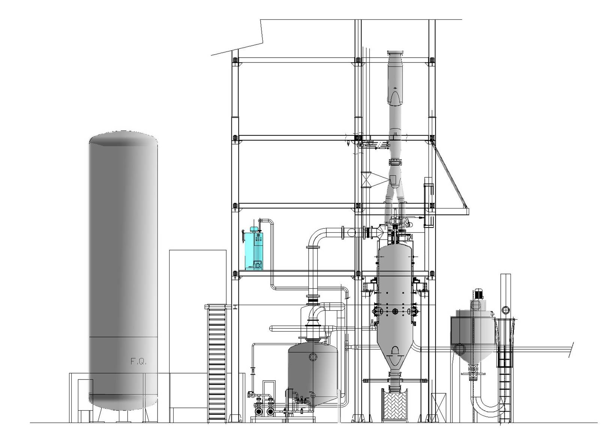
Figure 1: 5MWth Sotacarbo Gasification Demonstrative Plant (Calì et al 2017)
The size is of 5 MW(t), which makes it possible to carry out experimental tests with different composition of the feed: mixtures of coal and biomasses with different coal/biomass ratio have been used. A wet scrubber is used to clean the syngas and prevent backfire. The syngas cleaning system is constituted by a co-current tower equipped with a demister for the separation of water dragged in the purified syngas. The cleaning water is recirculated from a tank throughout the scrubber and back, in a closed loop with level-controlled makeup. The suspended solids in the cleaning water are partially recovered by sedimentation at the bottom of the scrubber and removed through a screw pump. The light fraction of suspended solids is partially separated by flotation induced by disengagement of gas and recovered from the free surface of the tank. At the end of each gasification campaign, the cleaning water mainly contains dissolved organics, and is processed in an off-line wastewater treatment plant. During the gasification tests, the content Tars and inorganic compounds in clean-up water increases, moreover the pH decreases up to a pseudo steady state value of about 3.5. The high content of pollutants reduces the effectiveness of the cleaning process and may lead to fouling of surfaces and blocking of the recirculation pumps. The treatment of the wastewaters generated from the wet scrubber can be difficult, due to the tar characteristic: the significant toxicity of many Tar components makes difficult the application of biological treatments, so, the remediation of coal tar-related contamination can be accomplished by physical and chemical methods: for example, physical treatment involving UV light-induced wet oxidation or adsorption on various coke sorbents was recommended to treat this type of wastewater. Moreover, chemical precipitation using various salts of Fe and Al can promote the formation of flocs then reducing the concentration of colloidal and particulate matter in the wastewater (Mehta and Chavan, 2009). Adsorption on activated carbon is proven to be an effective technology to remove organic pollutants from wastewaters, owing to the large surface area, economic viability and easy operational procedures (Conte et al., 2015). Nevertheless, the difficult and costly regeneration process limits its application, and exhausted carbon incurs a serious disposal problem (Nyazi et al., 2005). The aim of this study is implementation of an in-line treatment for removal of dissolved solids, testing the efficiency of the adsorption process for tar-containing wastewater generated from the Sotacarbo gasification plant. Sorption isotherms and breakthrough curves have been obtained in lab-scale using both commercial activated carbon and different samples of coal. Based on the experimental results, a pilot-scale column has been designed and installed in a side stream of the clean-up system.
  - Experimental
All the experiments were performed with samples of wastewater from the tank of the scrubber, after a gasification campaign, so that present the maximum organic load achievable under the typical working conditions of the plant. The samples were characterised for pH, suspended and dissolved solids. pH values from 3.5 to 4.5 were measured; TSS of 200 mg dm⁻³ were measured by filtration and drying of the samples.
Sorption isotherms were obtained by batch experiments with two samples of coal from the gasification plant, and a sample of commercial activated carbon (AC) from a local supplier. The samples of coal were from Venezuela (VC) and South Africa (SAC) and present similar characteristics (lower calorific value of 25 MJkg⁻¹, carbon content of 54% wt, 15% ashes and 8% humidity).
In the experiments, different amounts of solids, in the range 1 to 12 g, were suspended in 50 ml of wastewater; the suspensions were placed in a magnetic stirrer for 48 h. The equilibrium time was determined by kinetic experiments. The solid were then separated by filtration, and the liquid was analysed to determine the residual content of organics.
The wastewater considered is expected to be polluted by a mixture of different organic compounds: the content of organics has been determined from the absorption at 350 nm with a UV-VIS spectrophotometer (Agilent). The samples were diluted to obtain values of absorbance within the region of linear response, previously obtained by measures of absorbance of the samples with different dilution.
The equilibrium concentrations (C_{e}) were expressed as:
$C_{e}=\frac{ABS}{{ABS}_{0}}$ (1)
Were ABS and ABS₀ are the values of absorbance of the sample and of the raw wastewater, respectively.
The amount of organic retained by the sorbents at the equilibrium (q_{e}) was obtained from the equilibrium concentration values:
$q_{e}=(1-C_{e})\frac{V}{W}$ (2)
Where V is the volume of liquid and W the weight of sorbents in the suspensions.
Breakthrough experiments were carried out on a laboratory scale glass column, with 2 cm inner diameter and 30 cm length. The column was filled with coal or activated carbon; the sorbents were sieved to obtain a size of 0.5-1 mm.
The flow of water was from the bottom to the top, with a peristaltic pump.
The packed bed was washed with distilled water and then fed with wastewater form a reservoir. Samples were collected from the outlet stream of the column and analysed. Flow rates ranging from 5 to 20 ml min⁻¹ were used.
The pilot-scale column has a diameter of 10 cm and can hold up to 2 m of packing. A guard filter is placed upstream the sorption section to avoid residuals of solids in the column. The column was fed with a side-stream of the scrubbing plant.
  - Results and Discussion

Figure 2 shows the sorption isotherms, as 1/q_{e} vs 1/C_{e} of organics onto the two samples of coal and the sample of activated carbon used in batch experiments.
The lines were obtained by linear regression of experimental data with the Langmuir isotherm in the form:
$\frac{1}{q_{e}}=\frac{1}{θ_{max}}+\frac{1}{θ_{max}kC_{e}}$ (3)
Data are well fitted by a Langmuir-type isotherm, showing linear behaviour of 1/q_{e} vs 1/C_{e} in the range of concentration investigated. The values of maximum retention capacity θ_{max} and adsorption constant k, calculated from experimental data are summarized in table 1.

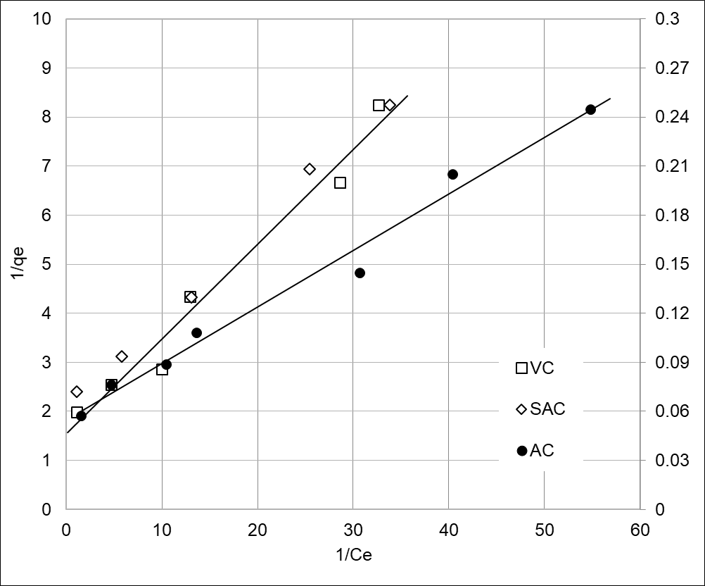
Figure 2: sorption isotherms obtained with batch experiments with the samples of coal (primary axis, empty symbols) and activated carbon (secondary axis, full symbols).
Table 1: values of parameters in equation 3 evaluated by linear regression of data in figure 1
Sample | θ_{max} | k
VC | 0.9 | 0.7
SAC | 0.9 | 0.7
AC | 22.2 | 12.1

From data in the figure the performance of the two samples of coal is very similar; moreover, from the values in table 1, both samples of coal show low retention capacities, which can be a drawback for a practical application. As it can be expected, the activated carbon shows higher retention capacity and constant of adsorption.
The equilibrium data suggest a possible use of carbon-based sorbent for the treatment under investigation. However, further information on the behaviour of the system under working conditions comparable to a real plant is required, for the scaling of the system up to pilot plant.
To evaluate the height of the sorption section in a pilot-scale column, breakthrough curves were obtained with the same sorbents used for the batch experiments. The results are showed in figure 3.
According to the results of the batch experiments, the curves obtained with the samples of coal show very low retention times, which in turn will lead to column height in the order of tens meters.
The experiments in pilot scale were then carried out with activated carbon as sorbent, which needs few meters of columns, depending on the flow rate adopted.
Figure 4 shows the results of the pilot-scale experiments carried out during a gasification campaign of 10 days. The column was inserted in a side-stream of the cleaning water circuit, samples were withdrawn from the outlet stream and analysed. Once the absorbance of the samples reached a steady value, the column was disassembled, the sorbent replaced with fresh carbon and another test was done. Good repeatability of results was obtained, empty symbols in figure 4 show the typical trend observed during one of the tests.

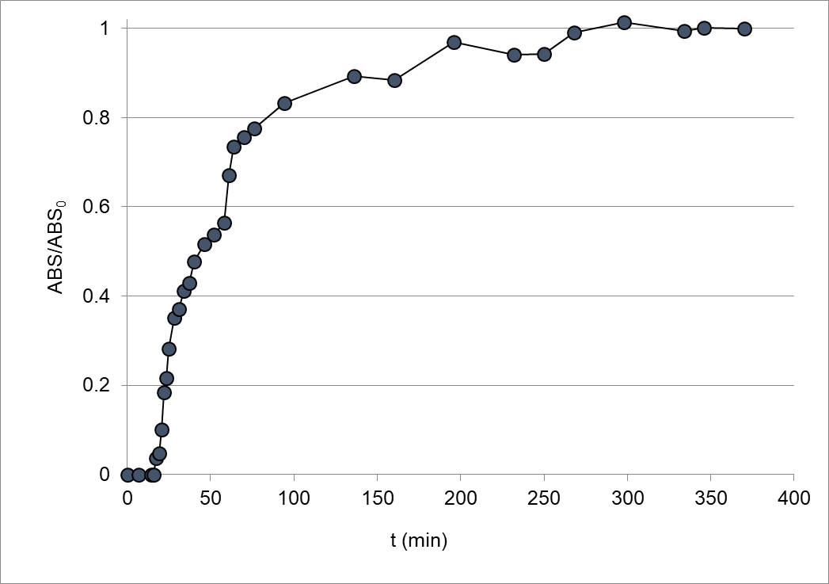
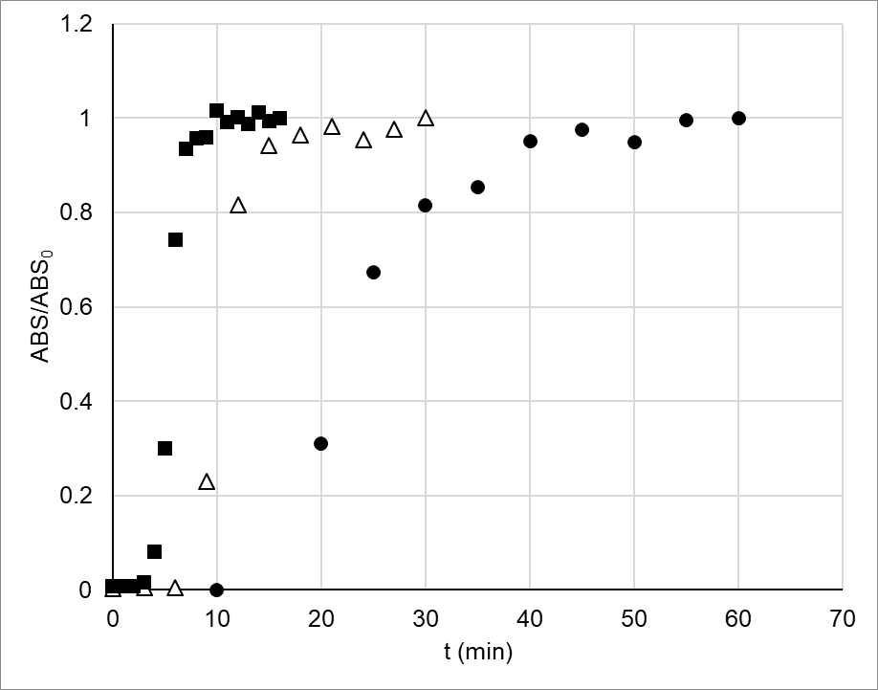

Figure 3 A: breakthrough curves of VC at flow rates of 5 (full circles), 10 (triangles) and 20 ml min-1 (squares). Figure 3 B: breakthrough curve of AC at flow rates 20 ml min-1

As it can be seen from data in Figure 4, the organic load in the inlet stream of the pilot column is not constant with time due to the operative conditions of both gasificator and wet scrubber.
However, the column shows good performance in removing the organic load from the cleaning water during operations. 100% of removal can be achieved, and the column can operate for about two hours before replacing the sorbent. Moreover, the height of the column was 2 m, and in a future implementation of the process higher columns could be used. It should be also considered that the flow rate of the side stream is only 5% of the total flow rate of the scrubber, so that the concentration of pollutants in the water (and then in the inlet stream of the pilot column) is not influenced by the treatment.

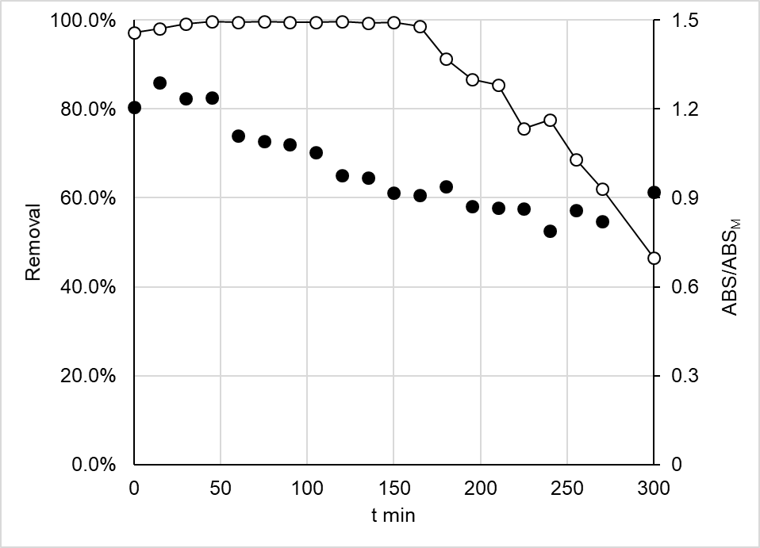
Figure 4: trend with time of organic removal with the pilot-scale column (empty symbols, primary axis) and ratio between ABS of the inlet stream and the corresponding average value (full symbols, secondary axis).
  - Conclusions
The possible implementation of in-line treatment of cleaning water has been demonstrated. The presence of an adsorption column will reduce the accumulation of pollutants in the cleaning water, virtually to zero. This will in turn increase the effectiveness of the cleaning process, with positive effect on the purity of the gas and on other gas treatment processes, such as desulphurization. Other than the implementation of a full-scale plant, future investigation will be addressed on the recycling of the exhaust carbon to the feed of the gasifier, which will further reduce the waste generated by the plant.
Acknowledgments
This work was developed into the RdS Research Program on Electrical Grid coordinated by ENEA and funded by the Italian Ministry of Sustainable Economic Development.
References
Calì G., Deiana P., Bassano C., Maggio E., 2017, Experimental activities on Sotacarbo 5 MWth gasification demonstration plant, Fuel, 207, 671-679.
Conte L., Falletti L., Zaggia A., Milan M., 2015, Polyfluorinated Organic Micropollutants Removal from Water by Ion Exchange and Adsorption, Chemical Engineering Transactions, 43, 2257-2262.
Luthy R.G., Dzombak D.A., Peters C.A., Roy S.B., Ramaswami A., Nakles D.V., Nott B.R., 1994, Remediating
tar-contaminated soils at manufactured gas plant sites-technological challenges, Environmental Science and Technology, 28, 266-276.
Mahjoub B., Jayr E., Bayard R., Gourdon R., 2000, Phase partition of organic pollutants between coal tar and water under variable experimental conditions. Water Research, 34, 3551-3560.
Mehta V., Chavan A., 2009, Physico-chemical Treatment of Tar-Containing Wastewater Generated from Biomass Gasification Plants, International Journal of Chemical and Molecular Engineering, 3, 458-465.
Nyazi K., Baçaoui A., Yaacoubi A., Darmstadt H., Adnot A., Roy C., 2005, Influence of carbon black surface chemistry on the adsorption of model herbicides from aqueous solution, Carbon, 43, 2218–2221.
Park H.I., Wu C.J., Lin L.S., 2012, Coal tar wastewater treatment and electricity production using a membrane-less tubular microbial fuel cell, Biotechnology and Bioprocess Engineering, 17, 654-660.

