|  |  |
| --- | --- |
| cetlogo ***CHEMICAL ENGINEERING TRANSACTIONS***  ***VOL. 76, 2019*** | A publication of  aidiclogo_grande |
| The Italian Association  of Chemical Engineering  Online at www.cetjournal.it |
| Guest Editors: Sauro Pierucci, Jiří Jaromír Klemeš, Laura Piazza  Copyright © 2019, AIDIC Servizi S.r.l. **ISBN** 978-88-95608-73-0; **ISSN** 2283-9216 | |

Modeling and Simulation of Novel Bi- and Tri-Reforming Processes for the Production of Renewable Methanol

Tuan B.H. Nguyen\*, and Edwin Zondervan

Laboratory of Process Systems Engineering, University of Bremen, UFT building, Room 1250, Leobener Str. 6, 28359 Bremen, Germany

nbhuutuan@uni-bremen.de

Flue gases from coal, gas, or oil-fired power plants, as well as many heavy industries, are claimed as primary sources of CO2 emissions. Although CO2 capture and storage can play a role in decreasing CO2, its cost is preventing it from the broad application. Converting flue gases into methanol offers a change to mitigate CO2 emissions and a way to produce useful chemicals. In this study, two novel technologies including bi- and tri-reforming are analyzed for methanol production from CO2. The environmental and economic results are examined as two significant factors for green design. Preliminary evaluations pointed out that the reforming-based routes can be considered as a hopeful method for CO2 treatment during the transition stage from a carbon-based- to the carbon-free program.

1. Introduction

Anthropogenic emissions of CO2 have escalated remarkably in recent years, leading to the rising volume of greenhouse gases in the air. As a result, this situation has increased to global temperature recently. Therefore, converting CO2 into useful chemicals are needed to decrease CO2 emissions. Useful industrial products produced from CO2 can not only allow new processes to become cost-saving but also gradually lessen the dependence on fossil fuels. As a consequence, the capture and synthesis of CO2 into chemicals seems to propose a high opportunity to mitigate CO2 with low cost and friendly environment.

Methanol (MeOH) produced through reforming of CO2 has been broadly targeted as a prospective solution to substitute for gasoline. It is owing to excellent combustion characteristics and lower pollutants than gasoline permits methanol to be an essential substitution as fuel in vehicles. Moreover, methanol is commonly employed in the chemical industry as an intermediate to synthesize other chemicals, especially dimethyl ether, formaldehyde, MTBE and acetic acid (Olah, Goeppert and Prakash, 2009).

In this study, two thermochemical conversion routes including bi- and tri-reforming of CO2 are examined. Designs of sustainable methanol processes utilized these routes are proposed while the net CO2 flow and economic factors of these technologies are compared.

2. Process description

In this study, two methanol production processes are developed and compared. All processes employ captured CO2 of the flue gas from different sources. Normally, flue gases include CO2, N2, O2, H2O, CO, H2, and several trace components of NOx, SOx, and other compounds. However, only captured CO2 from flue gases by absorption or other technologies is utilized as an input to methanol processes in this paper. The details of capturing CO2 from various sources are presented by Tuan (Nguyen and Zondervan, 2018). The captured CO2 must have at least 95 mol% of CO2, not more than 4 mol% of N2 and the remaining to satisfy the pipeline quality specifications (Metz et al., 2005). Natural gas employed in this research has the compositions of 88.71 mol% CH4, 6.93 mol% C2H6, 1.25 mol% C3H8, 0.28 mol% n-C4H10, 0.05 mol% n-C5H12, 0.02 mol% n-C6H14, 0.82 mol% N2, and 1.94 mol% CO2 (Altfeld, Schley and Ruhrgas, 2011). The bi-reforming-based route produces syngas through one reforming stage (combination of steam reforming and dry reforming steps), and methanol is synthesized from the produced syngas. Another way to produce methanol from CO2 is the tri-reforming technology which includes partial oxidation reactions along with reforming reactions. This technology has energy efficiency as a result of using endothermic (reforming) and exothermic (partial oxidation) reactions in one reactor. The advantage of employing the tri-reforming route is to minimize coke formation and lower energy requirement through integrating H2O and O2 in a single reactor. The reactions used for each technology are shown in Table 1.

Table 1: Different reactions to the methanol production

|  |  |  |
| --- | --- | --- |
|  | Reaction equation | Operating conditions |
| Bi-reforming | $$CH_{4}+{CO}_{2}↔2CO+{2H}_{2}$$ | 850 ~ 950 °C |
| $$CH_{4}+H_{2}O↔CO+{3H}_{2}$$ | 20 ~ 30 bar |
| $$CH_{4}+{2H}_{2}O↔{CO}_{2}+{4H}_{2}$$ |  |
| $$CO+H_{2}O↔CO_{2}+H_{2}$$ |  |
|  |  |  |
| Tri-reforming | $$CH_{4}+H_{2}O↔CO+{3H}_{2}$$ | 850 ~ 950 °C |
| $$CH_{4}+{2H}_{2}O↔{CO}_{2}+{4H}_{2}$$ | 20 ~ 30 bar |
| $$CH_{4}+{2O}_{2}↔{CO}_{2}+{2H}_{2}O$$ |  |
| $$CO+H_{2}O↔CO_{2}+H_{2}$$ |  |
|  |  |  |
| Methanol synthesis | $$CO_{2}+3H_{2}↔CH_{3}OH+H_{2}O$$ | 200 ~ 300 °C |
| $$CO+2H_{2}↔CH_{3}OH$$ | 50 ~ 100 bar |
| $$CO_{2}+H_{2}↔CO+H_{2}O$$ |  |

The simulation flow sheet of the two methanol plants have been developed in Aspen plus utilizing standard models for all equipment. RKSMHV2 was used to calculate thermodynamic properties for the high-pressure streams (> 10 bar) while NRTL-RK was exerted for other streams. For bi-reforming technology, a kinetic model for the combined reforming by a Ni-CeO2/MgAl2O4 catalyst is employed to predict the results of syngas synthesis from bi-reforming reactions. These kinetic rates were calculated by experimental data from Park and his colleagues (Park et al., 2014). Regarding the tri-reforming route, a kinetic model developed by Xu and Froment (Xu and Froment, 1989) as well as Trimm and Lam (Trimm and Lam, 1980) over Ni-based catalyst is applied to describe tri-reforming. In addition, a Cu/ZnO/Al2O3 commercial catalyst with the model suggested by Van den Bussche and Froment (Bussche and Froment, 1996), modified by Mignard and Pritchard (Mignard and Pritchard, 2008) is used to simulate the methanol reactor in which methanol is synthesized from syngas from the reforming steps. The kinetic model for methanol synthesis (including hydrogenation of CO2 and CO, and reverse water gas shift (RWGS)) is described by Equations 1 - 5 while the kinetic parameters are shown in Table 2.

|  |  |
| --- | --- |
|  | (1) |
|  | (2) |
|  | (3) |
|  | (4) |
|  | (5) |

Table 2: Parameters values for the kinetic model of methanol synthesis

|  |  |  |
| --- | --- | --- |
| k1 (mol.kg-1s-1bar-2) | A1 | 1.07 |
|  | B1 (J/mol) | 40000 |
| k2 | A2 | 3453.38 |
|  | B2 (J/mol) | - |
| k3 (bar-1/2) | A3 | 0.499 |
|  | B3 (J/mol) | 17197 |
| k4 (bar-1) | A4 | 6.62 x 10-11 |
|  | B4 (J/mol) | 124119 |
| k5 (mol.kg-1s-1bar-1) | A5 | 1.22 x 1010 |
|  | B5 (J/mol) | -98084 |

Where r is reaction rate; ki is the reaction rate constant; A, B are kinetic model parameters; P is the partial pressure in bar; T is the temperature in K; Keq is the thermodynamic equilibrium constant (Keq1 in bar-2, Keq2 in dimensionless); and R is the molar gas constant (8.314 J.mol-1K-1).

In this research, the bi- or tri-reformer is simulated by two parts: the RPLUG model to set up the reforming reactions and the Gibbs reactor to show the combustion of natural gas and air. The heat released from the Gibbs reactor has to match the heat required in the reformer. The pressure drop across the reformer is evaluated by the Ergun equation in Aspen Plus. The catalysts and dimensions of the reformer are displayed in Table 3. In addition, the methanol synthesis reactions are modeled by using the RPLUG model with a constant thermal fluid temperature. The thermal fluid temperature is set up at 264 °C, leading to the production of high-pressure steam (254 °C and 42 bar). The pressure drop across the reactor is also calculated by the Ergun equation in Aspen Plus. The catalysts and dimensions of the methanol synthesis reactor are shown in Table 4.

Table 3: Characteristics of the reactor and catalyst for the reformer

|  |  |  |  |
| --- | --- | --- | --- |
| Parameter | Unit | Bi-reforming | Tri-reforming |
| Reactor length | m | 10 | 10 |
| Reactor tube diameter | m | 0.1016 | 0.1016 |
| Catalyst particle shape |  | Raschig ring | Pellet |
| Catalyst diameter | mm | 17.4131 | 17.4131 |
| Catalyst sphericity |  | 0.6563 | - |
| Catalyst particle density | kgcat/m3 | 2396.965 | 1562.5 |
| Bed voidage |  | 0.605 | 0.605 |

Table 4: Characteristics of the reactor and catalyst for the methanol synthesis reactor

|  |  |  |
| --- | --- | --- |
| Parameter | Unit | Value |
| Reactor length | m | 10 |
| Reactor tube diameter | m | 0.05 |
| Catalyst particle shape |  | Pellet |
| Catalyst diameter | mm | 5.5 |
| Catalyst particle density | kgcat/m3 | 1775 |
| Bed voidage |  | 0.4 |

The reforming based methanol process is shown in Figure 1. The reforming route includes five sections: Syngas synthesis (by bi- or tri-reforming), Methanol synthesis, Separation and Purification, Heat supply, and Heat recovery.

The captured CO2 from flue gases of different sources is sent to the reformer with natural gas and steam (and/or oxygen), and then a synthesis gas is produced through bi or tri-reforming reactions. After the removal of water, syngas is transferred to the methanol reactor in which some syngas is converted into methanol. Next, products from the methanol reactor are fed to a topping column to remove unreacted gas from liquid crude methanol. Pure methanol (purity higher than 99.85 wt%) achieves through the removal of water at a distillation column. Some unreacted gas (CH4, H2, CO, CO2) is recycled to the methanol reactor, and the rest is fed to heat supply section.

In this work, the reforming reactor is set up to operate at 920 °C and 20 bar. A typical methanol synthesis production in industry operates at pressures of 50 - 100 bar and temperatures of 220 - 300 °C. Therefore, produced syngas is compressed to 50 bar in a compressor and preheated up to 240 °C before fed to the methanol reactor. The methanol reactor effluent is expanded and cooled to 35°C before injected into the flash drum to remove most residual gases. Some residual heat is recovered through preheating the feed to methanol reactor. The remaining liquid stream is expanded to 17 bar and fed to the topping column. In this column, unreacted gases and crude methanol are separated into the overhead and bottom, respectively. The final methanol product is purified to 99.85 wt% at the top of the distillation column. The number of trays was calculated at 36 stages, condenser pressure at 1 atm, and reboiler pressure at 1.1 bar

Unreacted gases from the flash drum and the topping column are mixed with natural gas and air, then burned to produce high-pressure steam (42 bar). To keep the methanol reactor at constant temperature requires a cooling system, which also produces high-pressure steam (42 bar). The burner has the operating conditions at 1.2 bar and 1200 °C. The heat released from the hot flue gas of the burner is used to preheat the feed streams and produce the steam for reforming reactions as well as electricity.



Figure 1: Schematic diagram of bi or tri-reforming based methanol process

3. Process evaluation and results

3.1 CO2 abatement

CO2 emissions come from two different sources in the process: 1) CO2 released from flue gases, 2) CO2 discharged by electricity consumption. The first is generally called as direct CO2 emissions while the others are referred to indirect emissions. The value of CO2 emission as a result of using thermal energy and electricity is 205.3 lbCO2/MMBtu and 0.596 tCO2/MWhr respectively (Yang et al., 2018). The net CO2 emission is calculated by the following equation while the details are presented in Table 5.

|  |  |
| --- | --- |
| $$Net {CO}_{2} flow=\sum_{i}{F_{CO_{2},i}^{Generated}}-F_{CO_{2}}^{Input}$$ | (6) |

Table 5: The CO2 emissions of reforming-based processes

|  |  |  |  |
| --- | --- | --- | --- |
| Parameter | Unit | Bi-reforming | Tri-reforming |
| CO2 fed to the methanol plant | kg/h | -22428.93 | -19394.26 |
| CO2 rejected by methanol plant | kg/h | 60028.06 | 55027.37 |
| Electricity consumption | kg/h | 14852.23 | 14134.61 |
| Net CO2 emission | kg/h | 52451.37 | 49767.72 |
| Net CO2 emission | tCO2/tMeOH | 0.839 | 0.796 |

Obviously, the conversion of CO2 into methanol via the bi- and tri-reforming process results in a non-negligible emission of CO2 as illustrated in Table 5. It is common to recognize that direct emission from the burning of natural gas to provide a very high-temperature heat source for the reformer represents the primary source of CO2 emission in the bi- and tri-reforming process. Regarding the bi-reforming, it is more than two times larger than the amount of CO2 utilized in the feed stream. Meanwhile, the tri-reforming shows that the amount of CO2 emission from direct burning of natural gas is around fourth and three times larger than the amount of CO2 created by using electricity as well as the CO2 feed to the process, respectively. However, it is equally important to note that a conventional methanol plant emits typically around 1.8 - 1.9 tCO2/tMeOH (Luu et al., 2015), which means that from the viewpoint of reduction of greenhouse gas emissions, the bi- and tri-reforming can be regarded as a promising strategy for treatment of CO2. Undoubtedly, CO2-based reforming technologies can not only play a vital role to decrease the consumption rate of fossil fuel but also satisfy the ‘methanol economy’.

3.2 Economic analysis

The major assumptions for economic analysis are as follows: 1) A 30 year lifetime was assumed for the process plant, 2) The interest rate was fixed at 8 percent, 3) each plant operates 8000 h in a year, 4) The inflation rate of construction and total product cost were assumed to be 5, 5 and 10 percent, respectively, 5) Pure CO2 was captured at 39.82 €/ton, 6) Natural gas was purchased at 354 €/ton, 7) The cost of electricity and cooling water were 0.1509 €/kWh and 0.31 €/GJ, respectively, 8) The methanol capacity of the plant is approximately 1500 ton/day.

The annualized total cost is calculated as the sum of the annualized capital cost (CAPEX) and the operating cost of the plant (OPEX) as displayed in Equation 7.

|  |  |
| --- | --- |
| $$\min{Annualized total cost=}OPEX+CAPEX\left(\frac{i{\left(i+1\right)}^{N}}{{\left(1+i\right)}^{N}-1}\right)$$ | (7) |

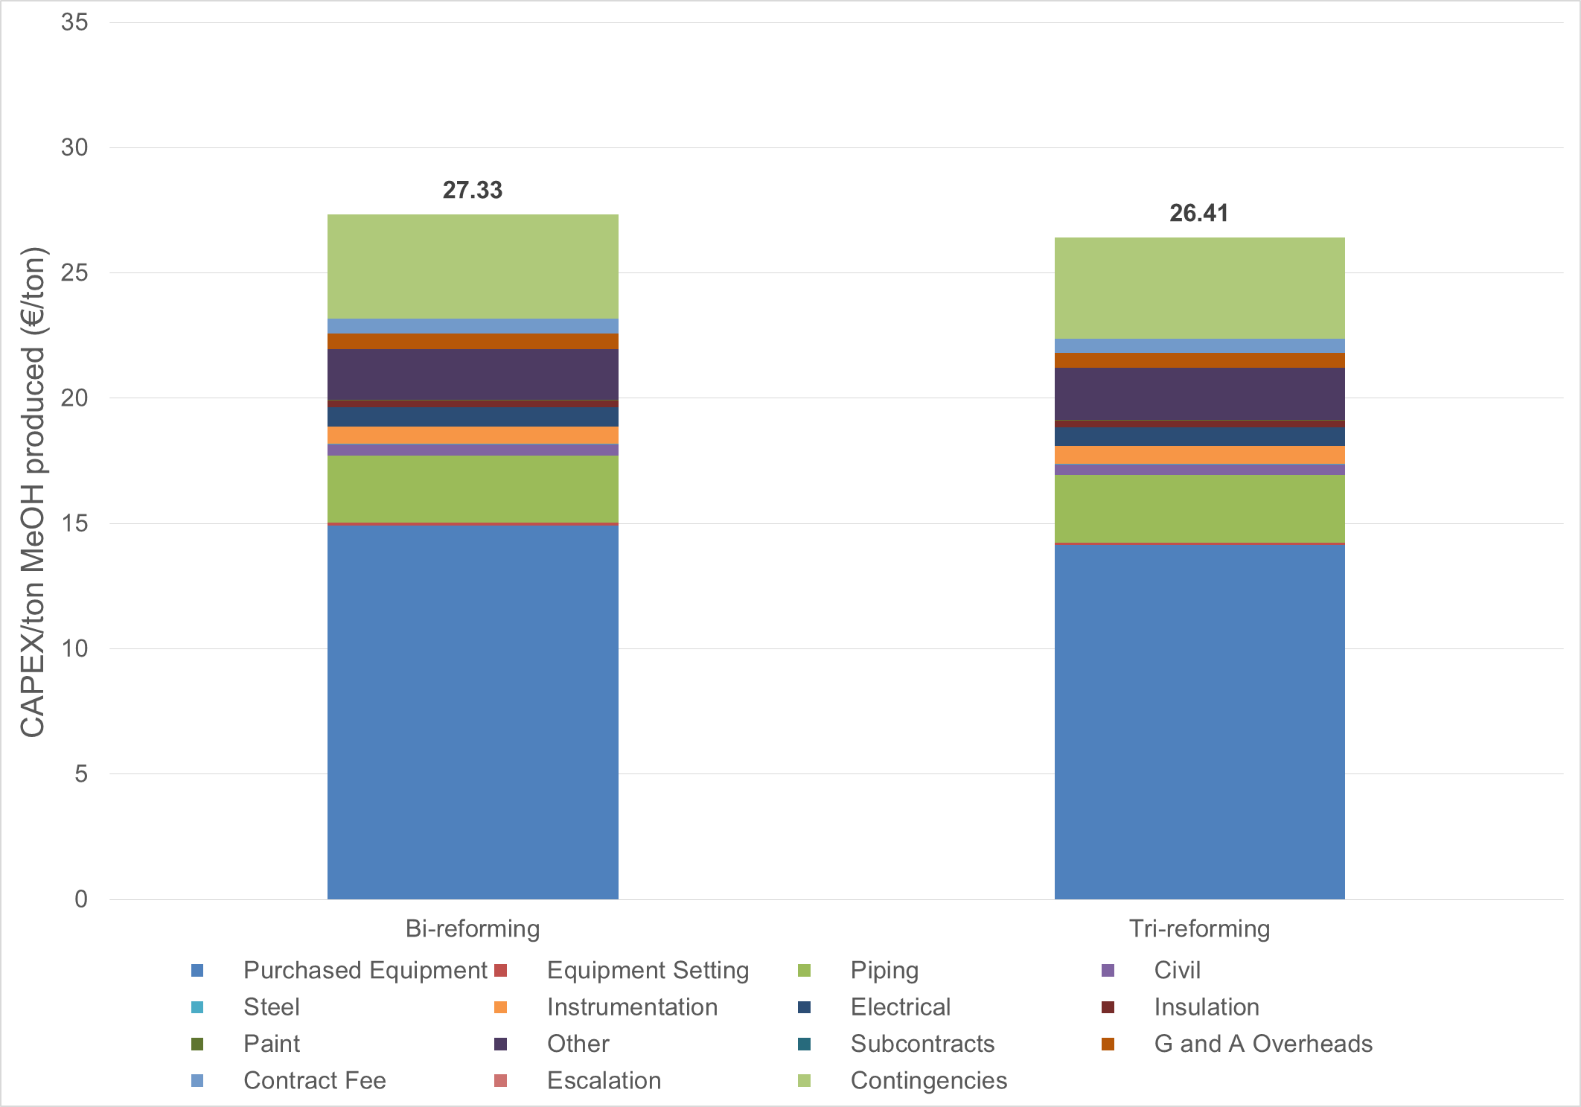

Figure 2: Annualized capital costs comparisons among different CO2-based technologies

Figure 2 and 3 display the capital and operating costs per ton methanol produced from various reforming techniques. As illustrated in Figure 2, the purchased cost of equipment represents 40 % of the total capital costs for all technologies. Regarding the operating cost, the most significant part comes from the cost to obtain raw materials, 61 %, following the utility costs with only 25 %. As shown in these figures, the operating costs account for the highest part of the total cost for both technologies. Only around 3 and 2 % of the total cost are constituted by the capital costs for bi- and tri-reforming respectively. It is important to note that the methanol production costs from the reforming processes are close to the commercial methanol selling price (350 - 450 €/ton, for the year 2017). Obviously, the CO2-based technologies can compete for the conventional process in terms of economy.

4. Conclusion

Nowadays, CO2 conversion technologies are holding attraction as a result of the increasing concerns on CO2 control. In order to find out the feasibility of CO2 conversion routes, two new reactions for methanol production containing bi- and tri-reforming were examined. Processes applied the two reactions were modeled, and their environmental and economic performances were studied. The results from the CO2-based reforming process illustrated that it is potential to produce greener methanol as a consequence of lower CO2 emission as well as cost-saving. In the future, the combination of bi- and tri-reformer in the same process can be implemented in further studies.

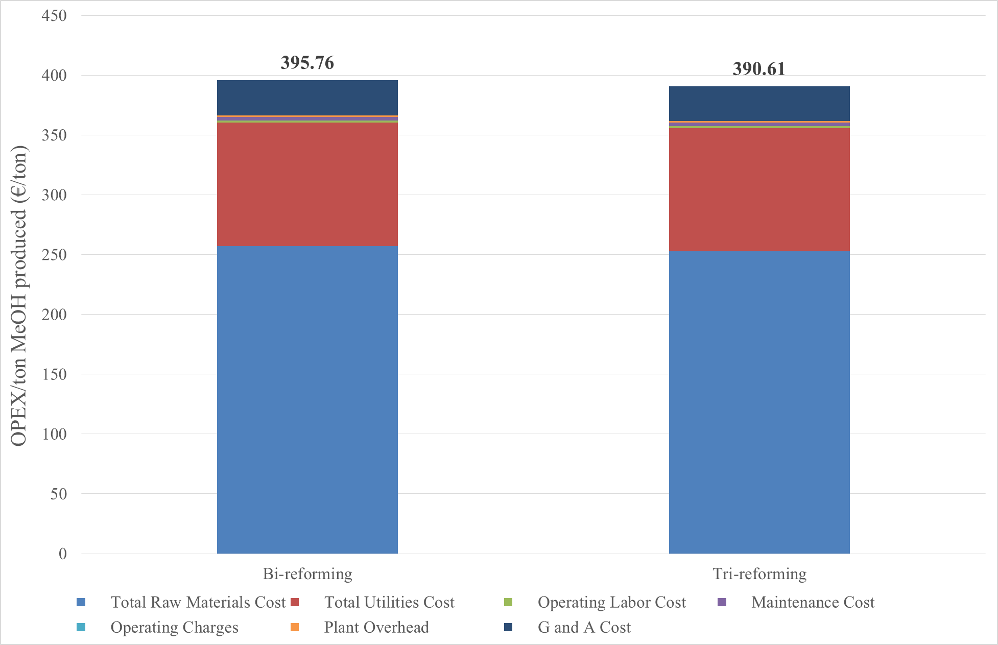

Figure 3: Annualized operational costs comparisons among different CO2-based techniques

References

Altfeld, K., Schley, P. and Ruhrgas, E. O. N. (2011) ‘Development of natural gas qualities in Europe’, Gas Qual, 152, pp. 544-550.

Bussche, K. M. Vanden and Froment, G. F. (1996) ‘A Steady-State Kinetic Model for Methanol Synthesis and the Water Gas Shift Reaction on a Commercial Cu/ZnO/Al2O3Catalyst’, Journal of Catalysis. Elsevier, 161(1), pp. 1-10.

Luu, M. T. et al. (2015) ‘A comparative study of CO2 utilization in methanol synthesis with various syngas production technologies’, Journal of CO2 Utilization. Elsevier, 12, pp. 62-76.

Metz, B. et al. (2005) IPCC special report on carbon dioxide capture and storage. Intergovernmental Panel on Climate Change, Geneva (Switzerland). Working Group III. Available at: www.ipcc.ch/pdf/special-reports/srccs/srccs\_wholereport.pdf (Accessed: 1 July 2017).

Mignard, D. and Pritchard, C. (2008) ‘On the use of electrolytic hydrogen from variable renewable energies for the enhanced conversion of biomass to fuels’, Chemical Engineering Research and Design. Elsevier, 86(5), pp. 473-487.

Nguyen, T. B. H. and Zondervan, E. (2018) ‘Ionic Liquid as a Selective Capture Method of CO2 from Different Sources: Comparison with MEA’, ACS Sustainable Chemistry & Engineering. American Chemical Society, 6(4), pp. 4845-4853.

Olah, G. A., Goeppert, A. and Prakash, G. K. S. (2009) ‘Chemical Recycling of Carbon Dioxide to Methanol and Dimethyl Ether: From Greenhouse Gas to Renewable, Environmentally Carbon Neutral Fuels and Synthetic Hydrocarbons’, The Journal of Organic Chemistry. American Chemical Society, 74(2), pp. 487-498.

Park, N. et al. (2014) ‘Modeling and optimization of the mixed reforming of methane: Maximizing CO2 utilization for non-equilibrated reaction’, Fuel. Elsevier, 115, pp. 357-365.

Trimm, D. L. and Lam, C.-W. (1980) ‘The combustion of methane on platinum-alumina fibre catalysts-I: Kinetics and mechanism’, Chemical Engineering Science. Pergamon, 35(6), pp. 1405-1413.

Xu, J. and Froment, G. F. (1989) ‘Methane steam reforming, methanation and water-gas shift: I. Intrinsic kinetics’, AIChE Journal. Wiley-Blackwell, 35(1), pp. 88-96.

Yang, Y. et al. (2018) ‘High-efficiency utilization of CO2 in the methanol production by a novel parallel-series system combining steam and dry methane reforming’, Energy. Pergamon, 158, pp. 820-829.