|  |  |
| --- | --- |
| cetlogo ***CHEMICAL ENGINEERING TRANSACTIONS***  ***VOL. 76, 2019*** | A publication of  aidiclogo_grande |
| The Italian Association  of Chemical Engineering  Online at www.aidic.it/cet |
| Guest Editors: Sauro Pierucci, Jiří Jaromír Klemeš, Laura Piazza  Copyright © 2019, AIDIC Servizi S.r.l. **ISBN** 978-88-95608-73-0; **ISSN** 2283-9216 | |

Life Cycle Assessment of Separation Methods of Cerium Oxide from Monazite Ore

Dussadee. Ratthanapraa, Unchalee. Suwanmanee\*b

aResearch and Development Division, Thailand Institute and Nuclear Technology, Nakhon Nayok 26120, Thailand.

b Department of Chemical Engineering, Faculty of Engineering, Srinakharinwirot University, Nakhon Nayok 26120, Thailand.

unchalee@g.swu.ac.th

Life cycle assessment was applied to evaluate the environmental impact of cerium oxide (CeO2) production systems from monazite ore using integrating and excluding liquid-liquid extraction methods. It is a heterogeneous rare earths oxides catalyst which can be utilized for catalysed transesterification to produce biodiesel. The impact assessment methodology used for characterization was the midpoint CML baseline method in terms the potentials of abiotic depletion, global warming, ozone layer depletion, human toxicity, freshwater aquatic ecotoxicity, marine aquatic ecotoxicity, terrestrial ecotoxicity, photochemical oxidation, acidification, and eutrophication. The Eco-indicator 99 method was performed an endpoint approach: human health, ecosystem quality, and resources. The data on process was available from a field study conducted in Thailand Institute of Nuclear Technology and applied into SimaPro 8.2.5. The LCA results showed that the removal of solvent extraction process can achievable the higher purity of CeO2 concentration and presented the most attractive process for cerium oxide from monazite ore in term of environmental impact assessment. Approximately 35-85% of the total environmental values and 79% of the total damage scores to human health and resources occurred during the separation step with integrating liquid-liquid extraction. The digestion step is the primary cause of the characterization impacts (30-56% of the total impacts) and damage to human health, ecosystem quality, and resources (37% of the total scores).

* 1. Introduction

Rare earths are a group of seventeen elements including the group of fifteen lanthanides, scandium (Sc) and yttrium (Y). The lanthanides group consisted of the Lanthanum (La), Cerium (Ce), Praseodymium (Pr), Neodymium (Nd), Promethium (Pm), Samarium (Sm),Europium (Eu), Gadolinium (Gd) Terbium (Tb), Dysprosium (Dy), Holmium (Ho), Erbium (Er), Thulium (Tm), Ytterbium (Yb), Lutetium(Lu). The bastnasite, monazite and xenotime ores are three primary sources of rare earths (Jordens et al., 2013). Monazite is a main source of domestic rare earths in Thailand and it is primary found in nature. It is a rare earth phosphate mineral (REPO4) with the composition of rare earth about 70 % rare earth oxide (REO) which primarily includes Ce, La, Pr and Nd (Jordens et al., 2013; Peeman et al., 2016). Rare earths are considered as necessary materials for utilization in numerous applications such as glass polishing, phosphors, lasers, magnets, batteries, high-temperature superconductor, optical glass, as well as catalysts, and its demand and cost are increasing. To meet the utilization of rare earths as catalyst, it is interesting to note that cerium oxide (CeO2), which accounts for 32% of total rare earth oxides when first separated from other rare eaths. There is lack of a study on the environmental impacts for domestic catalyst production, particularly in the environmental impacts of rare earth oxide catalysts from Thai monazite ore. Therefore, this study should be evaluated the performance of the environmental values that would be affected by their production. Life Cycle Assessment (LCA) is the important tool to evaluate and assess the environmental impact occurring throughout the whole life cycle of process. In this work, the objective is to study and assess environmental impacts of CeO2 productions, typically two separation methods including and excluding liquid-liquid extraction, using the LCA technique based on the CML 2 Baseline 2000 and Eco-indicator 99 methods. The results of this study can also be used for product development and policy target of rare earths production and sustainable development of alternative domestic catalysts by evaluating the environmental impact of a product in its entire life cycle.

* 1. Life cycle assessment (LCA)

The methodology of LCA can be described by four steps including goal and scope definition, inventory analysis, impact assessment and interpretation.

2.1 Goal and scope definition

The goal of this work is to assess and compare the environmental performance of the Thai domestic rare earth oxide solid catalysts from CeO2 productions using the life cycle perspective. The studied systems are divided into two scenarios as follows:

* Scenario A: Thai domestic rare earth oxide solid catalysts from CeO2 productions with solvent extraction process
* Scenario B: Thai domestic rare earth oxide solid catalysts from CeO2 productions without solvent extraction process

The system boundaries for all scenarios are presented in Figures 1 and 2. All emissions, materials, energy used for each production and transportation system are normalized to the functional unit of the study is 1,000 kg of CeO2.

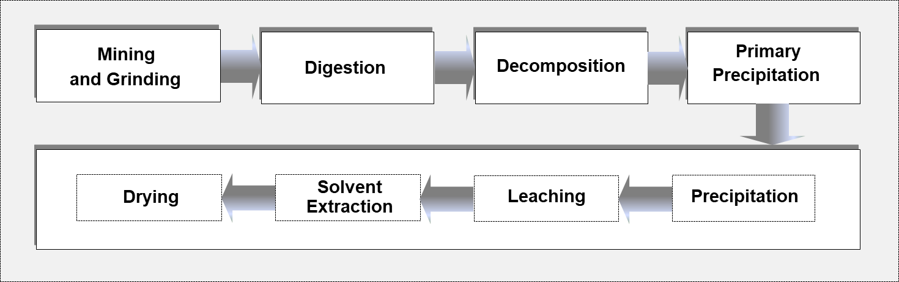

*Figure 1: System boundary for CeO2 1,000 kg (Scenario A)*

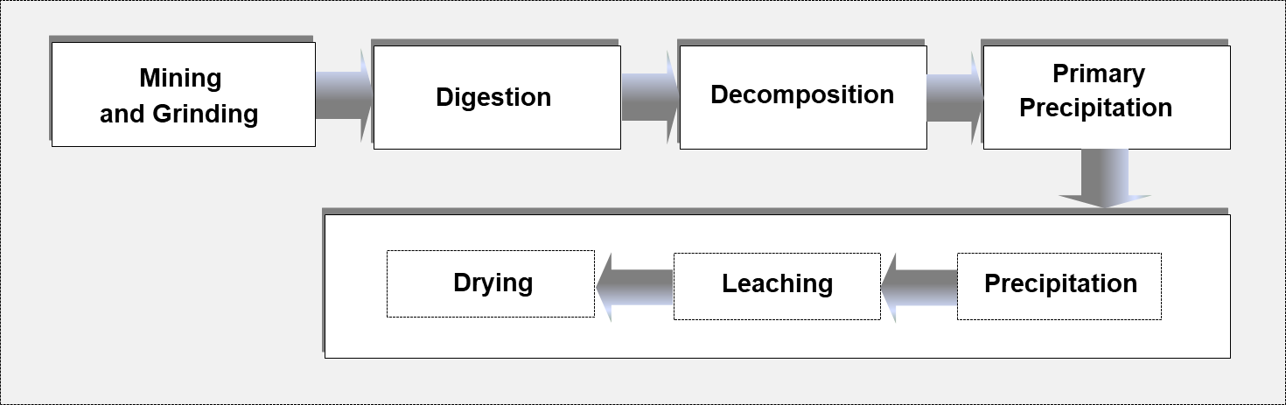

*Figure 2: System boundary for CeO2 1,000 kg (Scenario B)*

2.2 Life cycle inventory analysis

The data necessary for the calculation of the relevant inputs and outputs materials/energy are investigated according to the production of the 1,000 kg of each CeO2 production system. The inventory data for the Thai domestic rare earth oxide solid catalysts from CeO2 productions are retrieved from experiment from Thailand Institute of Nuclear Technology (Thailand Institute of Nuclear Technology, 2015). The average distance for mining field in Chumphon and Prachuapkhirikhan provinces to Thailand Institute of Nuclear Technology in Pathumthani province is about 413 km using 28-ton diesel truck. The LCI of mining and grinding production is available from Ecoinvent 3.2. Data of electricity and diesel used are supplemented from Thai National Life Cycle Inventory Database in 2009 (MTEC, 2009). From Figures 1 and 2, mass allocation was applied by calculating the share in quantity of product. The allocation factor for RECl3 solution during primary precipitation step is 0.98. The allocation factor of CeO2 during separation step is 0.23 for CeO2 production in scenario A and 1.00 for CeO2 production in Scenario B.

2.3 Life cycle impact assessment (LCIA)

The life cycle inventory (LCI) data was applied into SimaPro 8.2.5 to carry out the LCIA (Goedkoop et al., 2004, 2010). The assessment of environmental impacts consists of three main steps: characterization, normalization, and weighting. The major impact assessment methodology used for characterization was the midpoint CML baseline method (Guinée et al., 2002; Koch and Mihalyi, 2018; Biswas et al., 2019). The environmental impact categories quantified in this study were abiotic depletion (ADP), global warming (GWP 100a), ozone layer depletion (ODP), human toxicity (HTP), freshwater aquatic ecotoxicity (FTP), marine aquatic ecotoxicity (MTP), terrestrial ecotoxicity (TTP), photochemical oxidation (POP), acidification (ACP), and eutrophication (EUP). The Eco-indicator 99 method was applied an endpoint approach (Goedkoop and Spriensma, 1999). The normalization and weighting are performed and applied in three damage categories: human health, ecosystem quality, and resources. Each damage category is summarized as follows:

* Human health: climate change, carcinogens, radiation, ozone layer depletion, respiratory organics, and respiratory inorganic
* Ecosystem quality: acidification, eutrophication, ecotoxixity, and land use
* Resources: fossil fuels and minerals
  1. Results and discussion

3.1 Process analysis

In scenario A, cerium oxide production (see Figure 1) consisted of six main stages namely (1) mining and grinding of monazite ore, (2) transportation of monazite ore to Thailand Institute of Nuclear Technology, (3) digestion of monazite ore by alkali method, (4) dissolution process, (5) the separation of U and Th by precipitation method, and (6) separation of cerium oxide. The obtained monazite ore was ground to gain 325 mesh. The ground monazite containing (Ce, La, Pr, Nd, Y, U, Th)PO4 was digested with 50 %w/w NaOH at 140 °C for 4 h. After the reaction was completed, the hydrous metal oxide cake consisting of Ce(OH)4, RE(OH)3, Th(OH)4 and UO2(OH)2 was obtained. Next, the hydrous metal oxide cake obtained from decomposition process (stage 2) was dissolved in H2O and then 35 %w/v HCl was added. The soluble chloride compound containing CeCl4, RECl3, ThCl4, and UCl3 was formed. In this stage, U and Th were separated from rare earth and cerium by selectively precipitation method. A 20% w/w NaOH was added to the chloride solution obtained from stage 3. After the completion of precipitation, the hydroxide cake containing Th(OH)4 and Na2U2O7 was filtrated and then washed with H2O. In filtrate solution, CeCl4 and RECl3 were separated from a daughter product of uranium (radium, Ra) by sulfated precipitation. The filtrate solution was reacted with BaCl2 and H2SO4. After the completion of reaction, a precipitate of (Ba, Ra)SO4 was filtrated off. Finally, the separation of cerium oxide step, the chloride solution after removal of Ra was precipitated with 20 % w/w NaOH at pH 11.0. The hydroxide cake containing Ce(OH)4, Ce(OH)3 and RE(OH)3 was filtrated and then washed with H2O. The reactions were illustrated in Eq(1) − (3). Next, the precipitate was dried at 120 °C and then dissolved in HNO3. The nitrate solution (Eq(4) − (6) containing Ce(NO3)4, Ce(NO3)3 and RE(NO3)4 was filtrated to remove insoluble impurities. The nitrate solution was extracted to separate Ce+4 from Ce+3 and other rare earths. A 50 % w/w TBP was used as an extractant. After extraction, the organic TBP consisting of Ce+4 was stripped with H2O and H2O2. Small amount of H2O2 was used to stabilize Ce+4. The obtained solution was warmed at 100 °C and precipitated with 8 % w/w NH4OH to convert cerium nitrate to hydroxide. After complete precipitation, Ce(OH)4 cake was filtrated and dried at 120 °C. The dried cake was calcined at 800 °C for 3 h to produce 90 % purity of CeO2. The reactions were presented in Eq (7) − (8). The raffinate layer composed of Ce+3 and other rare earths was reacted with 8 % w/w NH4OH and 35 % H2O2 at 80 °C. After the reaction was completed, the Ce(OH)3 precipitate was filtrated and dried at 120 °C. The CeO2 90 % purity was form after being dried and calcined with precipitate at 120 °C and 800 °C, as presented in Eq (8) − (9).

|  |  |
| --- | --- |
| CeCl4 + 4NaOH → Ce(OH)4 + 4NaCl | (1) |
| CeCl3 + 3NaOH → Ce(OH)3 + 3NaCl | (2) |
| RECl4 + 4NaOH → RE(OH)4 + 4NaCl | (3) |
| Ce(OH)4 + 4HNO3 → Ce(NO3)4 + 4H2O | (4) |
| Ce(OH)3 + 3HNO3 → Ce(NO3)3 + 3H2O | (5) |
| RE(OH)4 + 4HNO3 → RE(NO3)4 + 4H2O | (6) |
| Ce(NO3)4 + 4NH4OH → Ce(OH)4 + 4NH4NO3 | (7) |
| Ce(OH)4 → CeO2 + 2H2O | (8) |
| Ce(NO3)3 + 3NH4OH + 1/2H2O2 → Ce(OH)4 + 3NH4NO3 | (9) |

In scenario B, cerium oxide production (see Figure 2) was carried out the same way as scenario A, except for the separation process of cerium oxide in stage 6. Because the nitrate solution containing Ce(NO3)4, Ce(NO3)3 and RE(NO3)4 after precipitated with 20 % w/w NaOH at pH 11.0 and leaching with HNO3 was reacted with 8 % w/w NH4OH at 100 °C to convert cerium nitrate to hydroxide . The hydroxide cake was dried at 120 °C and calcined at 800 °C for 3 h to produce 70 % purity of CeO2

4. Life cycle impact assessment (LCIA)

The LCA was conducted to determine the environmental impact values using CML baseline 2000 and Eco-indicator 99 methods. The materials and energy used for all scenarios studied are evaluated and applied in SimaPro software for life cycle impact assessment (LCIA) calculation.

**4.1 Characterization results**

The comparison results of LCA characterization analysis for each impact category of two scenarios for separation processes of CeO2 catalysts are evaluated and reported in Figure 3. The relative contribution of each life cycle stage to the environmental impact categories is presented in Figure 4(a) and 4(b). The results analysed for each impact category are performed as follows. The characterized result in almost all environmental impacts of CeO2 production in scenario A is 9-52% lower than CeO2 production in scenario B, except for abiotic depletion, human toxicity, freshwater aquatic ecotoxicity, and photochemical oxidation. The abiotic depletion is evaluated for each extraction of natural resources (minerals and fossil) such as iron ore, crude oil, phosphorous etc. The abiotic depletion potential obtained for CeO2 production in scenario A (0.125 kg Sb equivalent) was 5% slightly higher than the abiotic depletion potential of scenario A (0.119 kg Sb equivalent) because the high consumption of fossil fuels, especially natural gas, for TBP and kerosene productions. Human toxicity potential and freshwater aquatic ecotoxicity are caused by toxic substances. Chromium, copper, nickel and steel are primary pollutants which are released during TBP process. This is due to they have important impact on human toxicity and freshwater aquatic ecotoxicity for CeO2 production in scenario A. For scenario A, CeO2 was separated by precipitation and leaching and then purified by liquid-liquid extraction to obtain a high purity of CeO2 concentration. Reducing the consumption of NaOH and HCl during digestion and decomposition stages decreased the global warming, ozone layer depletion, marine aquatic ecotoxicity, and terrestrial ecotoxicity by 30.3-51.7% compared to scenario B. The results revealed that separation stage was major course of the environmental burden in the CeO2 production scenario A, as presented in Figure 4(a). Apparently, the share of environmental impact values from the use of TBP and kerosene is 60 − 89 %. For scenario B, around 30 − 55 % of the total environmental impact occurred during the digestion step. An important factor which caused this step is the usage of NaOH and electricity during production process up to 99 %. Note that the influence of environmental impacts of all studied scenarios from the transportation stage was very low which accounted as 2.4-5.7% of the total environmental values.

**4.2 The single score results**

The single score comparison of CeO2 production system is shown in Figures 5(a) and 5(b). The relative single scores for damage to human health and resources were observed for all studied scenarios, contributing 54-89% and 43-75% to the total impacts, respectively. Because the high usage of fossil fuels and toxic substances which are released during purification stage of CeO2 for scenario A. In conclusion, separation of CeO2 excluding liquid-liquid extraction is better attractive process for CeO2 in terms of environmental impact assessment. However, the potential of fossil fuels and respiratory inorganics remain relatively high, because the consumption of NaOH and electricity to convert rare earths phosphate or (Ce, La, Pr, Nd, Y, U, Th)PO4  to the hydrous metal oxides or Ce(OH)4, RE(OH)3, Th(OH)4 and UO2(OH)2.

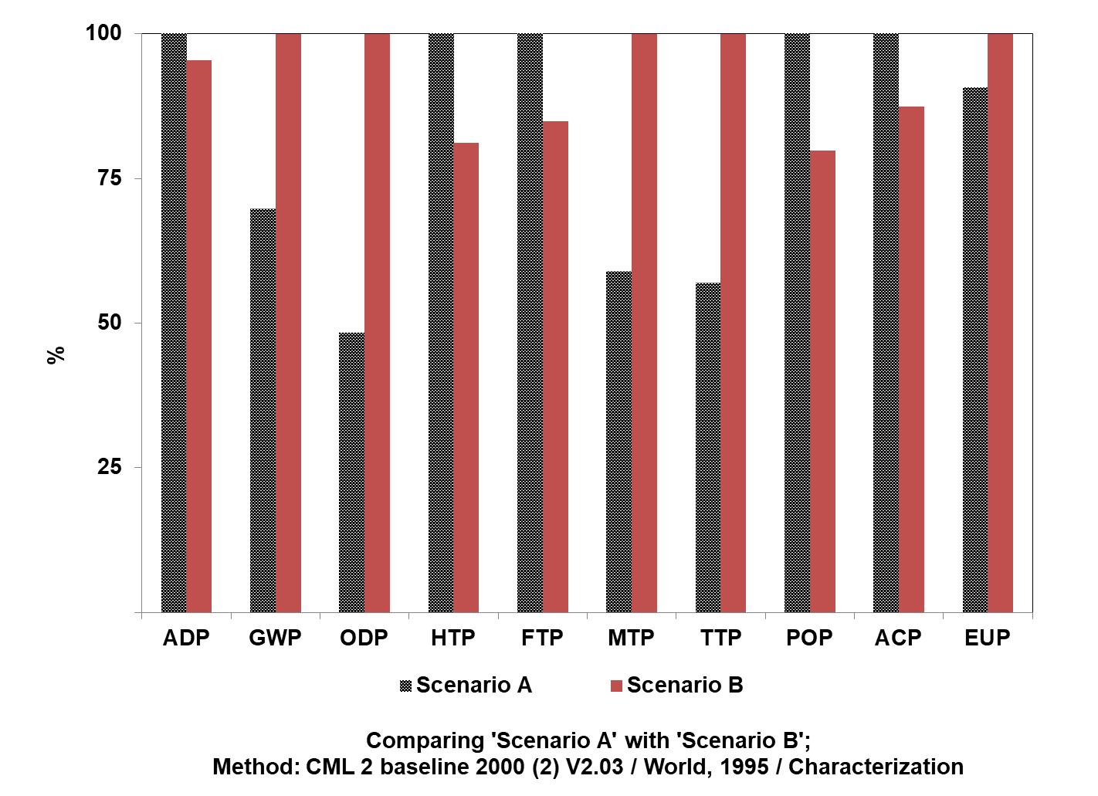

*Figure 3: Characterization results for two scenario of CeO2 production*

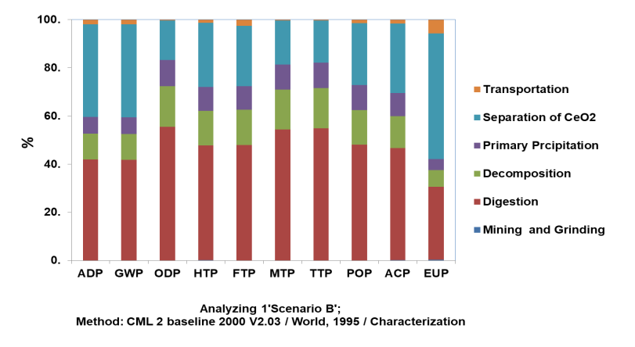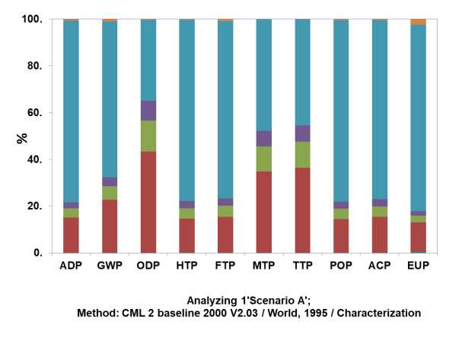

(a)

(b)

Figure 4: Relative contribution of each life cycle stage to the environmental impact categories of CeO2: (a) scenario A and (b) scenario B.

(a)

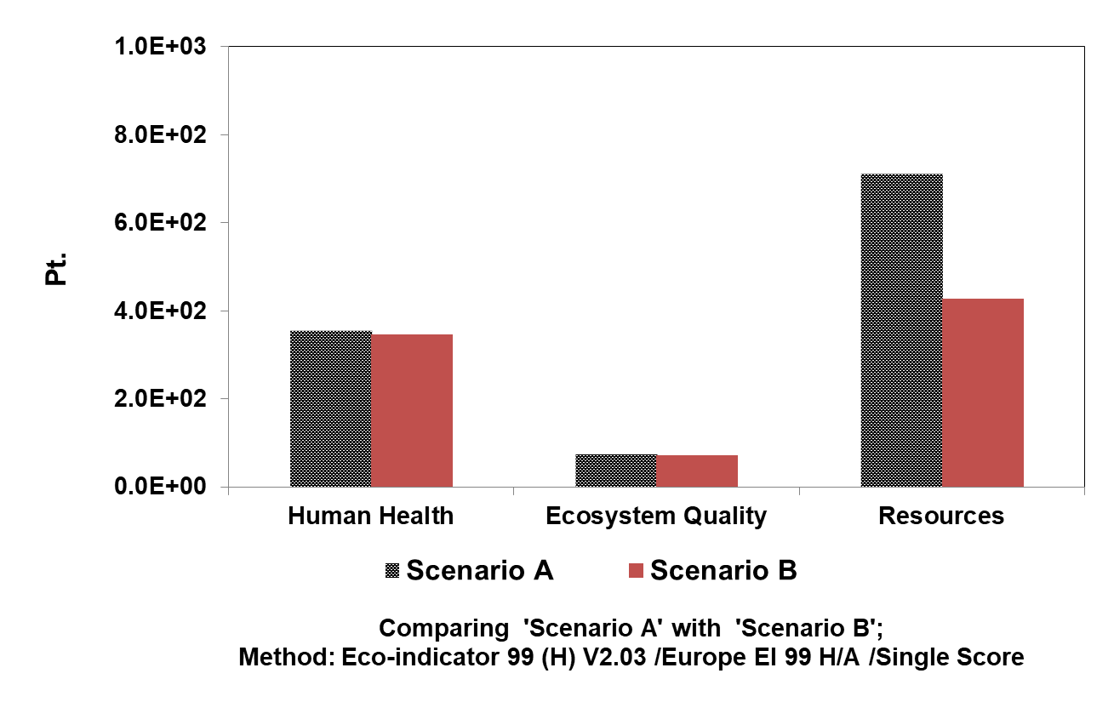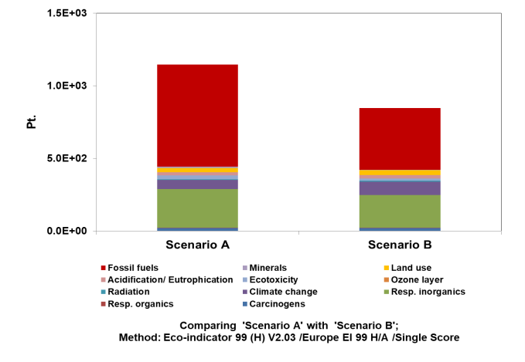

(b)

Figure 5: The single scores results for two scenarios of CeO2 production: (a) the environmental impact categories and (b) damage assessment.

* 1. Conclusion

In this study, the CeO2 production systems integrating and excluding liquid-liquid extraction are mainly conducted to assess the environmental impacts. The liquid-liquid extraction is still relatively low advantage for CeO2 purity and yield in terms of environmental impact assessment. Therefore, the CeO2 production using liquid-liquid extraction presents lower environmental impact than the CeO2 production without extraction process. The discussion of environmental impact of the technology performance and process design for valuable products from rare earths in Thailand are proposed with further respects to the product development, scientist, and governor plans in Thailand.

**Acknowledgments**

This work has been supported by the Thai Research Fund (MRG6180218) Srinakharinwirot University Fund (SWU 314/2561).

Reference

Biswas W.K., Horr Y.A., Joll C., Rosano M., 2019, Assessing the water nexus and sustainability benefits of a closed loop water treatment system in Qatar, Chemical Engineering Transactions, 72, 199−204.

Ecoinvent 3.2 database. <http://www.ecoinvent.org/database/database.html> accessed 10.06.2018.

Goedkoop M., Spriensma R., 1999, The Eco-indicator 99—A damage oriented method for Life Cycle Impact Assessment—Methodology Report, PRé Consultants. Amersfoort, Netherlands. <http://www.pre.nl/eco-indicator99/ei99-reports.htm> accessed 13.04.2018.

Goedkoop M., Oele M., Effting S., 2004, SimaPro database manual methods library. Pre Consultants, Netherlands.

Goedkoop M., de Schryver A., Oele M., Durksz S., de Roest D., 2010, Introduction to LCA with SimaPro 7. Amersfoort, Pre Consultants, Netherlands.

Guinée J.B., Gorrée M., Heijungs R., Huppes G., Kleijn R., de Koning A., van Oers L., Sleeswijk A.W., Sangwon S., Udo de Haes H.A., de Bruijn J.A., van Duin R., Huijbregts M.A.J., 2002, Handbook on life cycle assessment: operational guide to the ISO standards, Dordrecht: Kluwer Academic Publishers.

Gupta C.K., Krishnamurthy N., 1992, Extraction metallurgy of rare earths, International materials reviews, 37(5), 197−248.

Jordens A., Cheng Y.P., Water K.E., 2013, A review of the beneficiation of rare earth element bearing minerals, Mineral Engineering, 41, 97−114.

Koch D., Mihalyi B., 2018, Assessing the change in environmental impact categories when replacing conventional plastic with bioplastic in chosen application field, Chemical Engineering Transactions, 70, 853−858.

MTEC., 2009, Thai national life cycle inventory database. Unpublished data.

Peelman S., Sun Z.H.I., Sietsma J., Yang Y., 2016, Leaching of rare earth elements: review of part and present technologies, Rare Earth Industry, <http:://dx.doi.org./10.1016/B978-0-12-802328-0.00021-8. accessed 13.04.2018.

Thailand Institute of Nuclear Technology, 2015, Rare earth report. Unpublished data.