 CHEMICAL ENGINEERING TRANSACTIONS  VOL. 76, 2019 | A publication of  
The Italian Association
of Chemical Engineering
Online at www.cetjournal.it
Guest Editors: Sauro Pierucci, Jiří Jaromír Klemeš, Laura Piazza
Copyright © 2019, AIDIC Servizi S.r.l.
ISBN 978-88-95608-73-0; ISSN 2283-9216

Confusion due to Contractor Cascading Leads to Major Release of Ammonia During Test of Safety Device
Frank H. Hedlund*, Jan B. Pedersen, Robert S. Selig, Per-Ulrik Holmsen, Eva K. Kragh
COWI, Parallelvej 2, DK-2800 Kongens Lyngby, Denmark
fhhe@cowi.com, fhuhe@dtu.dk
In 2004, a thermal power station experienced a serious leak of anhydrous ammonia while carrying out a mandatory periodic test of a manifold multiport type pressure safety valve. The device incorporated an additional relief valve which allowed removal of any one of the relief valves for servicing without the need to depressurize the vessel. Power station staff were unfamiliar with the device and subcontracted the task to the valve vendor, who in turn subcontracted the job to a specialist contractor. During the procedure, a relief valve separated forcefully from its 2" nozzle resulting in an uncontrolled release from the 400 m³ ammonia storage tank. Members of the public 500 m away were exposed to ammonia vapour. The investigation identified a weakness in the design of the device with allowed erroneous installation of an indicator that was intended to show which of the relief valves could be removed safely. The subcontractor showed a lack of understanding of safety critical details of the valve design. The incident offers several important accident prevention lessons: 1) A valve design vulnerability unknown to all parties involved; 2) Safety systems may be unavailable due to common mode causes (before the job, automatic water curtains to absorb ammonia vapours were disabled); and 3) Knowledge/competence loss when subcontracting. The incident has considerable learning potential and should interest industry and safety professionals due to the widespread usage of the multiport device at major hazard sites (LPG, ammonia etc.). It should interest policy makers because the hazard (ammonia) had been introduced for environmental reasons (flue gas deNO_{x}) and because principles of inherent safety were ignored – less toxic alternatives to ammonia exist. The unavailability of information on this incident from open sources however, suggests that the process of learning from past incidents is challenged.
  - Introduction
Theoretical foundation
This paper draws on at least five lines of theoretical thinking on systems safety. The first relates to the existence of suboptimalities and unanticipated side effects at policy level, particularly if environmental interventions are at odds with safety concerns (Hedlund and Astad, 2015). The second relates to strategies of prevention, of which the paper argues in favour of the principle of inherent safety. Thirdly, the paper briefly touches upon the organization of work, allowing safety critical tasks to be subcontracted. Fourthly, it briefly touches upon the limits of safety, in particular the irony that periodic preventive testing of fully functional safety devices out of well-meaning concern for safety could actually compromise safety.
Finally, the paper subscribes to the view that no system is perfect and undiscovered latent failures can be hidden for years, only to appear when a specific combination of triggers arises. When vulnerabilities become apparent however, every effort should be made to disseminate lessons learned in order to minimize the number of times the same lessons need to be learnt.
Media shifting
Environmental interventions can conflict with safety concerns. Ashford (Ashford, 1997) coined the term media shifting, that the 'resolution' of a problem within one domain, the environmental domain, creates a new problem in another, the workplace safety domain. One such example is the desire to curb the emission of harmful oxides of nitrogen (NO_{x}), a known air pollutant, and a constituent of flue gases from conventional thermal power stations (Hedlund and Astad, 2015).
Selective Catalytic Reduction (SCR) is a well-proven technique for NO_{x} removal at power stations. Many applications of the technology require the injection of a carefully controlled quantity of ammonia into the smokestack where ammonia reacts with NO_{x} in the flue gas to form nitrogen and water. While the SCR technology is very clever, two toxic substances cancel each other out to produce harmless nitrogen, the introduction of toxic ammonia creates new hazards at the workplace.
Anhydrous ammonia is most conveniently stored under pressure as a liquefied gas. The presence of a large pressurized storage tank of toxic gas may also constitute a hazard to the surrounding community. Moreover, consumption of a toxic gas requires a transportation network which may constitute a hazard to the general population along transportation routes.
Inherent safety
Trevor Kletz was the first to clearly articulate a principle of accident prevention which he termed inherent safety (Kletz, 1984). (Ashford, 1997) later argued that inherent safety is similar in concept to pollution prevention. Inherent safety, sometimes referred to as primary prevention, relies on preventing the possibility of an accident. By comparison, secondary prevention relies on reducing the probability of an accident. Mitigation seeks to reduce the seriousness of the consequences.
If principles of inherent safety are applied to SCR, a less toxic or even a non-toxic source of ammonia should be sought, such as an aqueous solution of ammonia, which would not require pressurized storage, or non-toxic urea. Anhydrous ammonia is the least expensive reagent to use from a capital and operating cost basis.
Subcontracting
The outsourcing or subcontracting of safety-critical tasks may present many challenges to safety (Thommesen et al., 2011). It may also provide benefits however, if it stimulates specialization and skills upgrading and hence leads to a professionalization of the safety critical tasks. Cost reduction and increased efficiency are important drivers for subcontracting (Hasle, 2007) and may lead to loss of competence and cutting of corners. In the aviation industry, it has been argued (Wagner, 2007) that there is an undeniable correlation between the rising levels of outsourced maintenance work and resulting aircraft accidents.
Subcontracting, almost by definition, involves a loss of control by the operator over the execution of work (Hasle, 2007), and as contractors are unfamiliar with the site, context and history of the task, their presence may create disorganization and confusion at the workplace. In a damning review (Haddon-Cave, 2009), the crash of a Nimrod aircraft was attributed to subcontracting, which led to a convoluted procurement chain with extensive loss of information on e.g. the proper material specification of a critical neoprene seal.
The limits of safety
In an influential book, James Reason (Reason, 1997) devoted an entire chapter with the disheartening title: "Maintenance can seriously damage your system" to case stories where preventive maintenance such as inspection, calibration and testing, seriously deteriorated overall safety performance. Accidents have taken place during testing of pressure safety valves (Okoh and Haugen, 2013; Okoh, Haugen and Vinnem, 2016).
Wildawsky (Wildavsky, 1988) was probably the first to note that the Chernobyl nuclear disaster was caused by the testing of a safety device. Plant management was genuinely concerned that that the nuclear power station was operating with an important safety device inoperable, for an excellent exposition see (Medvedev, 1992). Later, Scott Sagan (Sagan, 1995) offered a theoretical argument that adding redundant safety devices may backfire because the effort can inadvertently increase the complexity of the system and produce unanticipated failure modes that the individuals involved may find difficult to comprehend.
Learning
Learning from past mistakes is man's perhaps oldest accident prevention strategy. Having paid the price of an accident, we should use the opportunity to learn from it. Entire books have been dedicated to the sharing of accident case stories in the process industry and it is difficult not to mention the contributions of Trevor Kletz (Kletz, 1998, 2003). The benefits of such learning are obvious – to share the lessons learned in order to minimize the number of times the same lessons have to be re-learned. What is not so obvious, however, is how to make this seemingly simple and straightforward idea work in practice (Hedlund and Andersen, 2006).
  - Material and methods
Information on the 2004 ammonia incident at Enstedværket is based on documents from the Danish Working Environment Authority (DWEA) and the Police obtained through the Danish equivalent of a Freedom of Information Act unless otherwise noted. Coverage in reputable media have been used sparingly.
  - The ammonia storage at the power station
The ammonia storage
Enstedværket was originally a coal and oil, and later a biomass fired power station located at the outskirts of the town of Aabenraa, Denmark. There were three blocks, commissioned in 1958, 1969 and 1979 respectively. Power generation terminated in 2013. A deNO_{x} unit was commissioned in about 1995 using SCR technology and the injection of ammonia. This included two anhydrous ammonia storage tanks, each of 400 m³ (capacity 225 t), design/test pressures of 24/32 barg. The actual storage pressure typically varied between 2 and 9 barg, depending on the time of year.
Safety measures were extensive. A sprinkler system was designed to protect the tanks from heat radiation in the event of a nearby fire. Water was collected in a bund with concrete walls. The tanks were under roof cover with walls extending about halfway down to give shade against solar radiation and to prevent rain water from filling the bund. A water mist system was installed to absorb any released ammonia vapours. Ammonia gas detectors would initiate sprinkling and the water mist system in the event of an ammonia release.
The pressure safety valves
Each ammonia storage tank was fitted with RegO Multiport® Pressure Relief Valve Manifold Assemblies type 8560-26T rated for use with LP-Gas and anhydrous ammonia. The multi-port device incorporates a redundant nozzle and relief valve, not included in the flow rating, allowing for servicing or replacement of any one of the relief valves whilst the remaining relief valves provide full overpressure protection and the pressure vessel remains in service. A handwheel on the manifold moves a closure disc that selectively closes off the inlet port to the relief valve to be removed. Raised numbers on the handwheel indicate the position of the closure disc.
A small bore bleeder valve allows the depressurisation of the small volume of ammonia gas trapped in the space between the closure disc and the relief valve to be removed. Complete depressurization of that space confirms that the closure disc has seated correctly, and it is safe to remove the valve.
Seveso directive establishment
The ammonia storage capacity resulted in the power station being classified a lower-tier establishment under the then EU Seveso I directive (EC, 1982) in force in 1993. Revised threshold quantities for ammonia introduced by the Seveso II Directive (EU, 1997) would cause the site to be re-classified as upper-tier, but as filling levels were reduced, the site was administratively allowed to remain a lower-tier establishment. By implication, there continued to be no requirement for an external emergency plan.
  - The incident
Relief valves were sent to the vendor for overhaul every 4 years. Enstedværket had purchased a set of replacement valves for half of the valves on either tank for that purpose. The task was planned for June 2004 during a general turn-around of the power station. The turn-around did not require the tanks to be emptied and the Multiport arrangement would facilitate valve replacement. Staff at Enstedværket had no prior experience of this operation and requested assistance from the valve vendor. The valve vendor passed on the request to its usual business partner, a specialist contractor, which had carried out many such replacements of similar Multiport valves in LPG service. A technician from Enstedværket was assigned to supervise the job.
Two specialist contractor technicians commenced the job on June 2, 2004, wearing full facial mask respiratory protection. The valves on tank 1 were replaced without incident. The next day, June 3, 204, while replacing the first valve on tank 2, the valve suddenly blew off with great force. A jet of ammonia vapour shot up from the open nozzle followed by a deafening noise. The Enstedværket technician, who was monitoring the work of the contractors from some distance, immediately fled the scene. Because ammonia gases vented from the bleeder arrangement might be picked up by the gas detectors and initiate sprinkling he had closed a valve in the water mains not to shock the contractors, and perhaps create a dangerous situation. He rushed down to re-open the valve and set-off the alarm. The two contractors were able to flee the scene unharmed.
Following the power station's internal emergency plans, two employees donned hazmat suits, went to the tank and operated the handwheel on the Multiport manifold to move the closure disc to the correct position and seal the entrance port to the open nozzle, thus stopping the release. They then refitted the safety valve.
The release duration was 20 minutes, tank pressure 5.5 barg and nozzle aperture 2" (50 mm). The total release quantity reported was 500 kg ammonia, of which an estimated 300 kg were absorbed by water sprays.
  - Investigation
The investigation discovered that it was possible to install the handwheel incorrectly, such that it would not indicate the correct position of the closure disc. Testing revealed a similar incorrectly installed handwheel on one of the other Multiport devices on tank 2. An inspector from the Danish Working Environment Authority (DWEA) interviewed the experienced contractor chief technician, who claimed he could "feel" when the closure disc sealed the inlet port. He then opened the bleeder valve to vent the gasses trapped above the closure disc. In his experience, the closure disc never sealed perfectly. He had therefore adopted an informal workaround where he slowly unscrewed the relief valve while gently rocking it from side to side, to vent the remaining overpressure under the valve via the thread.
The inspector realized that the contractor did not understand the somewhat unusual design of the bleeder valve. The normal position of the bleeder valve was with the valve knob turned outwards, i.e. in the fully "open" position. In this back-seated position, the rear part of the plug would seal tight against the bonnet. With the knob turned inwards in the fully "closed" position, the plug firmly positioned in the valve seat, it would allow bleeding of the space above the closure disc (Figure 1).
When the contractor opened the bleeder valve, he was in effect attempting to bleed away the contents of the tank. Depressurization would never occur, which he interpreted as a leaking closure disc. This simple but very plausible misunderstanding rendered the safety function of the bleeder valve ineffective.
A)
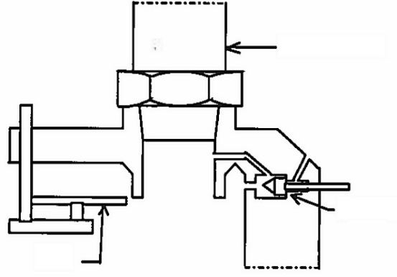  Pressure safety  valve (PSV)  in service  Bleeder valve in "open"  position  Closure disc in park position  Hand-  wheel | 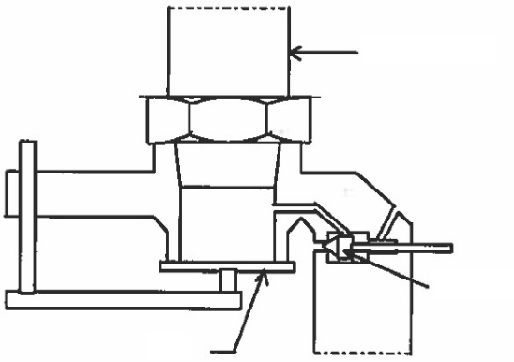  Pressure safety  valve (PSV)  ready for removal  Bleeder valve in "closed" position  Closure disc seals PSV inlet port  Hand-  wheel  B)
Figure 1. Bleeder valve detail of the RegO Multiport® Pressure Relief Valve Manifold Assembly. A) Normal position: Closure disc in park position, PSV protects the vessel, bleeder valve turned outwards in the "open" position. B) Service position: Closure disc seals the PSV inlet port, bleeder valve turned inwards in the "closed" position allowing bleeding of vapour trapped in the space between the closing disc and the PSV.
Source: Drawing by DWEA Inspector Bent Schmidt.
  - Offsite consequences
The investigation states that 8 persons were admitted to hospital for ammonia inhalation. Two contractors were working on a conveyor belt some 250 m downwind. Three plumbers were working on a sewer about 500 m downwind. In addition, a power station employee, a contractor and a member of the public – their location is not stated. The ammonia cloud was reported to drift over a car dealership, about 600 m downwind.
Calculation using PHAST (ver. 8.1) yields a release rate of about 2 kg/s (total release 2.4 t). The weather was fair, wind 3.5 m/s due east and ambient temperature 17 °C. As tanks were under cover, the jet release is assumed to have lost considerable momentum. Pasquill stability class set to D. Dispersion modelling (Figure 2) indicates that the maximum ammonia concentration at the property line (500 m) was about 150 ppm.
  - Discussion
Learning potential revisited
Most accident prevention professionals would consider a design that allows the handwheel to be installed incorrectly and the counter-intuitive operation of the bleeder valve to be prime candidates for information exchange and lessons learned throughout the ammonia and LPG industry where this valve type is in common use. It is therefore remarkable, that as per Jan 2019 this information appears to be entirely absent in open sources.
The incident is absent from eMARS, the EU Seveso major accident reporting system. The incident is superficially mentioned in a report for the Danish EPA on chemical facility hazard analysis (Taylor, 2007); as a "valve leakage" with six persons (not eight) being admitted to hospital, likely because the report is based on notoriously inaccurate media reporting. Vendor catalogues retrieved July 2015 duly warn that if vapour continues to bleed for more than one minute, the manifold closure disc is either not fully seated or not properly positioned. The caveat is correct, but bland. The message would be much stronger if the plausible misunderstandings of the individuals in the Enstedværket case were mentioned.

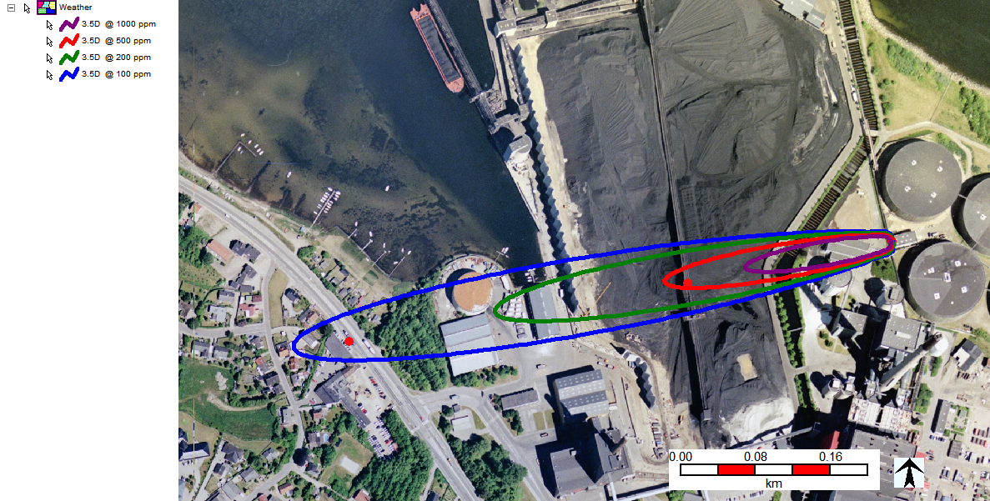
Car dealer
approx. 600 m
Plumbers
450-550 m (?)
Workers at coal
conveyor, 250 m
Ammonia storage tanks
Figure 2. Modelling of ammonia vapour dispersion before activation of water curtains and sprinkler systems. Map: © COWI/DDOland 2004
Subcontracting revisited
Enstedværket was widely respected for paying genuine attention to occupational health and safety. Requiring the assistance of a specialist contractor however, led to loss of control over the execution of work. Naturally, they saw no reason to scrutinize the qualifications of the specialist contractor chief technician, who ironically turned out to be insufficiently qualified, as he was recommend by the valve vendor.
Although the contractors were thoroughly briefed before starting the job, they were inevitably unfamiliar with the site, emergency plans etc. Some degree of confusion and disorganization is unavoidable and it is only by sheer luck, and well-rehearsed internal emergency response routines, that the outcome was not much worse. After the incident, Enstedværket decided that their own staff would carry out the task in the future.
Inherent safety revisited
The EU Seveso Directive was implemented to provide improved regulatory oversight of major hazard facilities, in particular the siting of storages facilities for large quantities of dangerous substances. The concept of inherent safety was unremittingly promoted by Trevor Kletz after the 1984 Bhopal disaster (Kletz, 1994). In Denmark, there were many pressurized storage spheres containing ammonia, mostly due to its agricultural use as a fertilizer, sometimes adjacent to urban areas. Most ammonia tanks disappeared in the late 1980s, conveniently because its usage as fertilizer became unpopular, not due to intervention by Seveso-authorities.
It is therefore remarkable, for a pressurized storage facility comprising 2 x 225 t ammonia to be located close to a small town more than 10 years after the first Seveso directive came into force. Particularly so, as safer and even non-toxic (urea) alternatives exist.
It is noteworthy, that the power station later faced major difficulties with the Seveso authorities who demanded that one tank be taken out of service and the remaining one to operate at much reduced filling levels – culminating in 2011 with demands for a buried double walled tank or the use of an aqueous solution of ammonia. Had the power station been foresighted, it would have made more sense economically to adopt inherent safety in the first place.
  - Conclusion
This incident at Enstedværket offers a wealth of information for safety professionals and policy makers. At face value, a mishap during valve maintenance led to a serious release of ammonia. Due to prompt and competent intervention by staff, the situation was quickly brought under control. Dig a little deeper and the incident was caused not by mishap but by a safety valve design weakness, a latent condition that had been hidden for years only waiting for the wrong set of circumstance to occur to trigger its appearance.
Dig yet deeper, and this safety valve is in use at many hazardous storage sites. The mistakes made at Enstedværket are unlikely to be the first of their kind, yet there does not appear to be any mention of them in open literature.
It is useful to paraphrase Trevor Kletz to emphasize the importance of sharing case stories on such mishaps. Because it is possible for people not to agree with principles, but stories can’t be denied. Anyone is far more likely to be shocked into action by a story than by prescriptions in a code or model procedure. As this case shows however, information was not shared and lessons may well have had to be re-learned elsewhere.
The incident also offers lessons for policy makers. The ammonia storage was required to solve the environmental challenge of NO_{x} emissions, an air pollutant. In doing so, a hazard for the workplace and the local community was created. This is a prime example of side-effects and media shifting. Had principles of inherent safety been observed, media shifting effects would have been reduced, or perhaps avoided altogether.
Overly optimistic assessments by engineers and others of the ability to control technological hazards can result in severe under-appreciation of risk. Important contemporary issues concern the introduction of LNG fuel on passenger vessels and proposing hydrogen as an energy carrier in the society in general. The incident at Enstedværket shows that despite abundant technical safety features, there are limits to safety. It is ironic that the incident occurred during efforts to verify safety – during a preventive test of an otherwise fully functional safety device.
Acknowledgements
The authors are grateful to COWI for covering the conference fee. The contents of this paper including any opinions and/or conclusions expressed, are solely those of the authors, not of their organizations.
The authors declare that they have no conflicts of interests.
  - References
Ashford N. A., 1997, Industrial safety: the neglected issue in industrial ecology, J. Clean. Prod. 5(1), 115–121.
EC, 1982, Council Directive 82/501/EEC of 24 June 1982, Off. J. Eur. Communities, L 230, 1-18.
EU, 1997, Council Directive 96/82/EC of 9 December 1996, Off. J. Eur. Communities, L 10, 13–33.
Haddon-Cave, C., 2009, An independent review into the broader issues surrounding the loss of the RAF Nimrod MR2 Aircraft XV230 in Afghanistan in 2006, The Stationery Office, London, U.K.
Hasle, P., 2007, Outsourcing and employer responsibility: A case study of occupational health and safety in the Danish public transport sector, Relations Ind., 62(1).
Hedlund, F. H., Andersen, H. B., 2006, Institutional support of learning from accidents: Some obstacles to getting a useful community-wide database in the EU, Soc. Risk Anal. SRA Eur. Annu. Conf. 2016. Ljubljana, Slovenia, 1–21.
Hedlund, F. H., Astad, J., 2015, Solid Biomass Climate Change Interventions Examined in a Context of Inherent Safety, Media Shifting, and Emerging Risks, Hum. Ecol. Risk Assess., 21(5), 1410–1427.
Kletz, T. A., 1984, Cheaper, safer plants. Or wealth and safety at work. Notes on inherently safer and simpler plants, The Institution of Chemical Engineers (IChemE). Rugby, Warwickshire, England.
Kletz, T. A., 1994, Flixborough - 20 years after, in Second Bienn. Can. Conf. Process Saf. Loss Prev.
Kletz, T. A., 1998, What Went Wrong?: Case Studies of Process Plant Disasters, Gulf, Houston, TX, U.S.A
Kletz, T. A., 2003, Still going wrong!: Case histories of process plant disasters and how they could have been avoided, Elsevier, Amsterdam, The Netherlands.
Medvedev, Ž., 1992, The Legacy of Chernobyl. W. W. Norton, New York, NY, U.S.A.
Okoh, P., Haugen, S., 2013, The influence of maintenance on some selected major accidents, Chem. Eng. Trans., 493–498.
Okoh, P., Haugen, S., Vinnem, J. E., 2016, Optimization of recertification intervals for PSV based on major accident risk, J. Loss Prev. Process Ind., 150–157.
Reason, J., 1997, Managing the Risks of Organizational Accidents, Ashgate, Hants (Hampshire), England.
Sagan, S. D., 1995, The Limits of Safety, Princeton University Press, U.S.A.
Taylor, R., 2007, Afdækning af muligheder for etablering af standardværktøjer, Rambøll for Miljøstyrelsen.
Thommesen, J., H.B. Andersen, K. Øien, Y. Dien, 2011, A survey of the literature on challenges to safety posed by outsourcing or subcontracting of critical tasks, DTU, Lyngby, Denmark.
Wagner, K. Van, 2007, Cutting Costs and Cutting Corners - The Safety Risks Associated with Outsourcing Aircraft Maintenance and the Need for Effective Safety Oversight by the Federal Aviation Administration, J. Air Law Commer, 72(3), 631–658.
Wildavsky, A. B., 1988, Searching for Safety, Transaction Publishers. New Brunswick, NJ, U.S.A.

