 CHEMICAL ENGINEERING TRANSACTIONS  VOL. 76, 2019 | A publication of  
The Italian Association
of Chemical Engineering
Online at www.aidic.it/cet
Guest Editors: Sauro Pierucci, Jiří Jaromír Klemeš, Laura Piazza
Copyright © 2019, AIDIC Servizi S.r.l.
ISBN 978-88-95608-73-0; ISSN 2283-9216

Formulation of the Biosurfactant Produced by Candida sphaerica for Application as a bioremediation agent
Emília Mendes da S. Santosª , Isabela Regina Alvares da S. Liraª , Maria Isabel S. Pintoª, Fabiola C. Almeida^{a,b}, Darne G. Almeida^{a,b} , Raquel D. Rufino,^{a,b} Leonie A. Sarubbo^{a,b} Juliana M. de Luna ^{a,b}
ª Catholic University of Pernambuco, Rua do Príncipe, n. 526, Boa Vista, Cep: 50050- 900, Recife, Pernambuco, Brazil
^{b} Advanced Institute of Technology and Innovation (IATI), Rua Joaquim de Brito, 216, Code: 50070-280, Boa vista, Recife-PE, Brazil
emiliamendes.farma@gmail.com

Oil spills in oceans cause irreparable damage to marine life and harm to the coastal populations of affected areas. It is therefore fundamental to develop treatment strategies for such spills. Currently, chemical dispersants have been used during oil spills, although these agents have been increasingly restricted due to their toxic potential. Thus, the aim of the present study was to formulate a biodegradable commercial biosurfactant for application as a bioremediation agent. Biosurfactants are scientifically known biomolecules produced by microorganisms capable of allowing water-oil interaction. Thus, a biosurfactant was produced by the yeast Candida sphaerica UCP0995 cultivated in industrial waste and formulated with the addition of a potassium sorbate preservative. After formulation, samples were stored for 120 days, followed by surface tension and emulsification measurement, and oil dispersant tests in seawater. The results were promising for the biosurfactant formulated with the preservative, which demonstrated stability and dispersion of the engine oil by the biosurfactant stored with potassium sorbate only, with values above 100% dispersion at the beginning of the experiment. The commercial biosurfactant was tested at different pH values, temperatures and in the presence of salt, demonstrating potential industrial application at a cost compatible with the environmental field.
  - Introduction
Spills, leaks, and other releases of heavy oil result in serious ecological problems for marine life and populations of coastal areas (Geetha et al., 2018). Petroleum-based compounds are highly pollutant when released to the environment and are considered largely responsible for the main causes of global pollution. A large number of these compounds are toxic and carcinogenic and may cause harm to human and animal health (Almeida et al., 2016).
Bioremediation played an important role in the cleaning of the spillage of 41 million liters of oil by the oil tanker Exxon Valdez in the Gulf of Alaska in 1989, giving rise to the development of this technology and demonstrating that there are good reasons to believe in the effective application of this method for the treatment of future oil spills under appropriate circumstances. While it was difficult to evaluate the effects of treatment due to the heterogeneity of the contamination, other studies have demonstrated the importance of the use of surfactants to enhance the biodegradation of oil (Luna et al., 2018). Thus, surfactant compounds have become an attractive alternative for the removal of hydrophobic contaminants generated by the petroleum industry (Akbari et al., 2018).
Thus, it is possible imminent to find sustainable and eco-compatible solutions for a remediation of these environments. Bioremediation is a low-cost and ecologically correct strategy with high potential to contain potential contamination (Soares da Silva et al., 2018). Thus, in seek of nontoxic and eco-friendly demulsifier, biosurfactant is gaining much attention in petroleum industries (Olasanmi and Thring, 2018).
Biosurfactants are amphipathic surface-active molecules, and they can be produced by a wide variety of microorganisms which have the capacity to reduce surface and interfacial tensions of solutions (Silva et al., 2018). There are many reasons that make biosurfactants promising alternative agents for remediation purposes. These are their less toxic nature, better environmental compatibility and biodegradability. Other advantages include their production from inexpensive agro-based raw materials and organic wastes and retention of their activity even at extremes of temperature, pH and salt concentration (Pinto et al., 2018).
The stability of a biosurfactant is an essential factor to the viability of long-term storage, especially for a biotechnological product that must meet rigorous criteria for its production and application in the industrial environment. Durability needs to be high in order to maintain the product in stock with its initial properties so that it is readily available for immediate use in cases of urgent application in the occurrence of an oil spill. It is therefore of fundamental importance to develop strategies that enable the production, formulation and application of biosurfactants in industrial processes (Chaprao et al., 2018).
Thus, the aim of the present study was to formulate a commercial biosurfactant produced by the yeast Candida sphaerica cultivated in industrial waste as substrate with the aim of applying this biomolecule the remediation processes of hydrophobic pollutants.
  - Materials and Methods
    - Microorganism
Candida sphaerica (UCP 0995) was obtained from the culture collection of the Catholic University of Pernambuco, Brazil. The micro-organism was maintained at 5 ºC on Yeast Mold Agar (YMA) slants containing
(w/v): yeast extract (0.3 %), malt extract (0.3 %), tryptone (0.5 %), D-glucose (1.0 %) and agar (5.0 %).
    - Substrates
Two types of industrial waste were used as substrates to produce the biosurfactant. Corn steep liquor was purchased from Corn Products of Brazil (municipality of Cabo de Santo Agostinho, Pernambuco, Brazil) and Ground nut oil refinery residue, provided by ASA LTDA in the city of state Recife-PE.
    - Growth Conditions
The biosurfactant production conditions used in this work were previously established according to Luna et al. (2015). The inoculum of C. sphaerica was prepared by transferring cells grown on aslant with 50mL of yeast mold broth (YMB). The seed culture was incubated for 24h at 28 ºC and agitated at 200rpm. The basal medium was composed 9.0% ground nut oil refinery residue and 9.0% corn steep liquor dissolved in distilled water. The medium was sterilized by autoclaving at 121°C for 20min. The final pH of the medium was 6.0. The inoculum (1.0%, v/v) was added to the cool medium at the amount of 10⁴ cells/mL. Cultivation was carried out in Erlenmeyer flasks at 30 °C with shaking at 200 rpm for 144 h.
    - Formulation of Biosurfactant
After fermentation, the cell-free broth was submitted to conservation method: addition of 0.2% potassium sorbate (preservative for inhibiting microbial growth and is considered safe and nontoxic). After the treatment of the crude biosurfactant in each conservation method, the broth was stored at room temperature (28 °C) for 120 days, with samples withdrawn at 0, 10, 20, 30, 60, 90 and 120 days (long term stability study). After each storage time, biosurfactant was subject to changes on pH (5.0, 7.0 and 9.0), addition of NaCl (1.0, 3.0 and 5.0% w/v) and heating at 40 and 50 °C (Freitas et al., 2016).
2.5 Determination of Surface Tension
Surface tension of the biosurfactant was determined with a Tensiometer (Sigma 700, KSV Instruments Ltd., Finland), using the Du Nouy ring method at room temperature (Soares da Silva et al., 2017).
    - Emulsification Activity with Motor Oil
The emulsification index was determined using the method described by Cooper and Goldenberg (1987). Motor oil used as contaminant was obtained from a local automotive manufacturer in the city of Recife, Brazil. This oil is commercially available for use in flex engines (gasoline, VNG and alcohol), type SAE20 W-50. It consists of a paraffinic base lubricating oil (a complex mixture of hydrocarbons) and performance enhancing additives.
    - Oil Displacement Test (Dispersant Test)
The dispersion capacity of an oil slick was simulated in the laboratory by contaminating samples of water with motor oil in a Petri dish. The formulated biosurfactant at a concentration of 1.0% was added at biosurfactant-to-oil proportions of 1:2, 1:8 and 1:25 (v/v). The mean diameter of the clear zones of triplicate experiments was measured and calculated as the rate of the Petri dish diameter (Rocha and Silva et al., 2014).

  - Results and Discussion
3.1. Stability of the formulated biosurfactant

Long-term stability is one of the requirements for developing a new biotechnological product and putting it on the market. The properties of a stable commercial product should not change drastically with the fluctuations in pH, temperature and salinity encountered in the industrial environment (Soares da Silva et al., 2018). To ensure a commercial bioproduct, the crude biosurfactant produced by C. sphaerica was submitted to conservation method and its tensioactive properties were analysed for a period of 120 days. The behaviour of the biosurfactant after its formulation was evaluated under specific environmental conditions of pH, temperature and the presence of salt. The tensioactive properties (i.e., surface tension, emulsification activity and dispersion capacity) were evaluated.
Figure 1 displays surface tension results of the biosurfactant produced by C. sphaerica submitted to the conservation process with the addition of 0.2% potassium sorbate after storage for different periods of time followed by exposure to variations in pH (5.0, 7.0 and 9.0), temperature (40 and 50 °C) and concentrations of NaCl (1.0, 3.0 and 5.0%). The biosurfactant demonstrated stability in the surface tension when exposed to the different pH, temperatures and concentrations of Nacl values tested throughout the entire storage time, when compared to control, with the surface tension maintained around 27 mN/m.

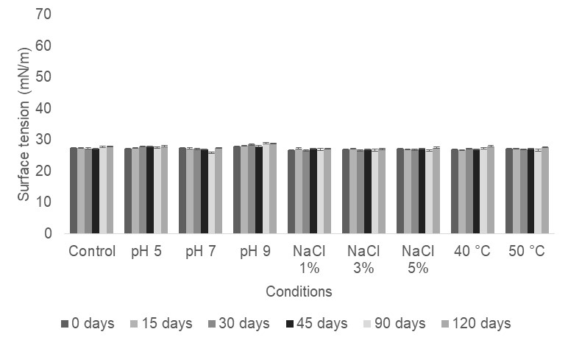
Figure 1: Surface tension of biosurfactant produced by C. sphaerica over 120 days of storage submitted to addition of 0.2% potassium sorbate. Error bars illustrate experimental errors (standard deviations), calculated from three independent experiments.

3.2. Emulsification Activity with Motor Oil

Figure 2 displays emulsification activity results of biosurfactant submitted to the conservation processes (addition of 0.2% potassium sorbate after storage for different periods of time followed by exposure to variations in pH (5.0, 7.0 and 9.0), temperature (40 and 50 °C) and NaCl concentrations (1.0, 3.0 and 5.0%). The biosurfactant remained stable under all conditions tested, reaching approximately 100% emulsification of the motor oil with both conservation method throughout the 120 days of storage. A discrete reduction in emulsification activity occurred in the presence of salt at concentrations of 1.0 and 3,0% at the day 15 of evaluation after the addition of the potassium sorbate, which did not invalidate the efficiency of the biomolecule when considering the other results throughout the storage time. The biosurfactant submitted to variation in pH (7.0 and 9.0), however, achieved 100% emulsification during 120 days.
Biosurfactants are emerging as a promising alternative to chemical dispersants, accelerating the natural dispersion and degradation of hydrocarbons released into the environments through the solubilisation of oily compounds (Freitas et al., 2016).

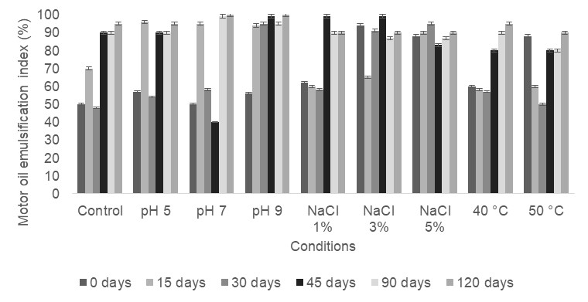
Figure 2: Emulsification capacity of biosurfactant produced by C. sphaerica over 120 days of storage submitted to addition of 0.2% potassium sorbate. Error bars illustrate experimental errors (standard deviations), calculated from three independent experiments.

3.3. Application of biosurfactant as dispersant

Figure 3 displays the motor oil dispersion capacity of the biosurfactant produced by C. sphaerica submitted to the conservation process with the addition of 0.2% potassium sorbate after storage for different periods of time followed by exposure to variations in pH (5.0 7.0 and 9.0), temperature (40 and 50 °C) and concentrations of NaCl (1.0, 3.0 and 5.0%) at biosurfactant-to-oil proportions of (A) 1:2, (B) 1:8 and (C) 1:25 (v/v). The three proportions of the biosurfactant demonstrated similar behaviour under all conditions evaluated. The formulated biosurfactant demonstrated the best dispersant capacity after 120 days of storage. The best performance was achieved at biosurfactant- to-oil proportions of 1:8 and 1:25 (v/v), reaching 90% dispersion. The stability evaluations in the present study revealed that the tensioactive properties of the biosurfactant produced by C. sphaerica remained practically constant throughout the 120 days storage time, demonstrating the long-term stability of the biosurfactant. Freitas et al. (2016) submitted a biosurfactant from Candida bombicola to conservation procedures and found that the addition of potassium sorbate and heat treatment were the most promising. Soares da Silva et al. (2018) studied a biosurfactant produced by the bacterium Pseudomonas cepacia and found that the biotensioactive agent was stable under all conditions investigated, especially after being submitted to fractionated tindallization and the addition of potassium sorbate.
The ability of a biosurfactant to disperse oils is of extreme importance in the treatment of environments contaminated with hydrocarbons, since this property accelerates the mobilization of the oil by breaking up the droplets and consequently increasing the surface area of the oil in contact with oil-degrading microorganisms.
When, treating industrial environments contaminated by spilled petroleum based products, the time and costs involved make the treatment of large amounts of contaminants unviable. Therefore, any product that assists in the clean up should be maintained in stock so that it is available for immediate use in the occurrence of an unexpected accident.

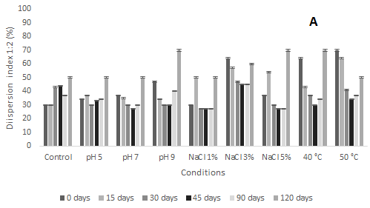
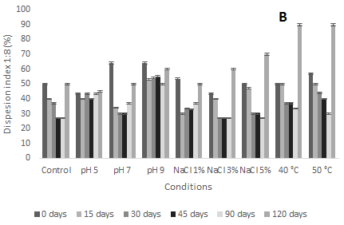

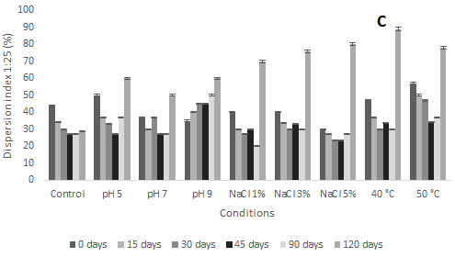

Figure 3: Dispersion capacity of motor oil by biosurfactant over 120 days of storage submitted to conservation method with addition of 0.2% potassium sorbate at biosurfactant-to-oil proportions of (A) 1:2, (B) 1:8 and (C)1:25 (v/v). Error bars illustrate experimental errors (standard deviations), calculated from three independent experiments.

  - Conclusions
The biosurfactant formulated exhibited excellent stability under extreme environmental conditions. Salinity, temperature and pH variations, maintains its tensioactive properties over a long storage period at a sufficient level to ensure its application as a non-toxic dispersant of petroleum. Thus, this product could be considered promising in the use of marine environmental pollution control.
Acknowledgments
This study was funded by the Research and Development Program from National Agency of Electrical Energy
(ANEEL) and Thermoelectric EPASA (Electrical Central of Paraíba), the Foundation for the Support of Science and Technology of the State of Pernambuco (FACEPE), the National Council for Scientific and Technological Development (CNPq), and the Coordination for the Improvement of Higher Level Education Personnel (CAPES).The authors are grateful to the Centre of Sciences and Technology of the Catholic University of Pernambuco and to the Advanced Institute of Technology and Innovation (IATI), Brazil.

References

Akbari, S., Abdurahman, N., Yunus, R., Fayaz, F. and Alara, O, 2018, Biosurfactants—a new frontier for social and environmental safety: a mini review. Biotechnology Research and Innovation, 2, 81-90.
Almeida D.G., Soares da Silva R.C.F., Rufino R.D., Luna J.M., Santos V.A., Banat I.M., Sarubbo L.A., 2016.
Biosurfactants: promising molecules for petroleum biotechnology advances, Frontiers in Microbiology, 7, 1718.
Chaprão M.J., Soares da Silva R.C.F., Rufino R.D., Luna J.M., Santos V.A., Sarubbo L.A., 2018. Formulation and application of a biosurfactant from Bacillus methylotrophicus as collector in the flotation of oily water in industrial environment, Journal of Biotechnology, 285, 15-22.
Cooper D.G., Goldenberg B.G., 1987, Surface-active agents from two Bacillus species, Applied Environmental Microbiology, 53, 224–229.
Freitas B.G., Brito J.G.M., Brasileiro P.P.F., Rufino R.D., Luna J.M., Santos V.A., Sarubbo L.A., 2016, Formulation of a commercial biosurfactant for application as a dispersant of petroleum and by-products spilled in oceans, Frontiers in Microbiology, 7, 1–9.
Geetha S.J., Banat I.M., Joshi S.J., 2018 Biosurfactants: Production and potential applications in microbial enhanced oil recovery (MEOR), Biocatalysis and Agricultural Biotechnology, 14, 23–32.
Luna J.M, Rufino R.D, Jara A.M.A.T, Rufino R.D., Sarubbo L.A, 2015, Environmental applications of the biosurfactant produced by Candida sphaerica cultivated in low-cost substrates, Colloids Surfaces A, 480, 413–418.
Luna J.M., Pinto A.L., Pinto M.I.S., Brasileiro P.P.F., Rufino R.D., Sarubbo L.A., 2018, Production in Bioreactor and Application of Biosurfactant in Dissolved Air Flotation for the Treatment of Industrial Effluents, Chemical Engineering Transactions, 64, 595-600.
Olasanmi, I. and Thring, R, 2018, The Role of Biosurfactants in the Continued Drive for Environmental Sustainability. Sustainability, 10, 4817.
Pinto M.I.S., Ribeiro B.G., Guerra J.M.C., Rufino R.D., Sarubbo L.A., Santos V.A., Luna J.M., 2018, Production in Bioreactor, Toxicity and Stability of a Low-cost Biosurfactant, Chemical Engineering Transactions, 64, 595-600.
Rocha e Silva, N.M.P., Rufino, R.D., Luna, J.M., Santos, V.A., Sarubbo, L.A., 2014. Screening of Pseudomonas species for biosurfactant production using low-cost substrates. Biocatalysis and Agricultural Biotechnology, 3, 132–139.
Silva I. A., Resende A. H. M., Rocha e Silva, N. M. P., Brasileiro P.P.F., Amorim J.D.P., Luna J.M., Rufino R.D., Santos V.A., Sarubbo L.A, 2018, Aplication of Biosurfactants Produced by Bacillus cereus and Candida sphaerica in the Bioremediation of Petroleum Derivative in Soil and Water, Chemical Engineering Transactions, 64, 553-558.
Soares da Silva, R., de, C.F., Almeida, D.G., Meira, H.M., Silva, E.J., Farias, C.B.B., Rufino, R.D., Luna, J.M., Sarubbo, L.A., 2017, Production and characterization of a new biosurfactant from Pseudomonas cepacia grown in low-cost fermentative medium and its application in the oil industry, Biocatalysis and Agricultural Biotechnology, 12, 206–215.
Soares da Silva, R.C.F.S., Almeida, D.G., Brasileiro, P.F., Diniz, R., 2018, Production, formulation and cost estimation of a commercial biosurfactant, Biodegradation, 1-11.

