 CHEMICAL ENGINEERING TRANSACTIONS  VOL. 76, 2019 | A publication of  
The Italian Association
of Chemical Engineering
Online at www.aidic.it/cet
Guest Editors: Sauro Pierucci, Jiří Jaromír Klemeš, Laura Piazza
Copyright © 2019, AIDIC Servizi S.r.l.
ISBN 978-88-95608-73-0; ISSN 2283-9216

Effect of the Number of Stages and Feed Composition on Offshore Oil and Gas Separation Train
Marco Maschietti
Aalborg University, Department of Chemistry and Bioscience, Section of Chemical Engineering, Niels Bohrs Vej 8, 6700, Esbjerg, Denmark.
marco@bio.aau.dk
A process analysis of multistage gas-oil separation coupled with gas re-compression was carried out, with reference to offshore oil and gas applications. Two feed types (light oil and gas condensate), different feed conditions (30 bar and 60 bar; 48 °C and 58 °C) and 1 to 4 separation stages were considered. The net profit (oil and gas sales minus operating costs) was mapped as a function of the pressures of the separators with reference to 32 distinct case studies. The maps were generated by means of a brute-force optimization method run by an external routine coupled to Aspen HYSYS. The total number of solved simulation setups was in the order of 10⁶. The maps allowed to evaluate the effect of the number of stages and the feed composition on the optimal pressures of the separators, as well as the profit losses caused by sub-optimal operation of single separators in the train.
  - Introduction
The separation of gas and oil in offshore topside units is accomplished in a sequence of separators (the separation train) where the oil exiting one separator is fed to the subsequent one, which operates at lower pressure in order to allow further gas to be released and the oil to be stabilized. The oil exiting the last separator of the train is typically stored at ambient, or close to ambient, conditions prior to export (stock tank oil). If significant amount of gas is produced in the separation train, there is the need of its recovery and recompression, as flaring would consist in both financial loss and environmental concern. In these cases, the separation train is coupled with a gas recompression train, where the gas is compressed in a series of compressors, with coolers in between. The separation train typically consists of one to five stages, with two or three stages being most typical in offshore oil and gas production, where space occupation and weight are limiting factors. The objectives of the gas-oil separation train can be stated as: 1) removing methane and ethane from the oil phase; 2) maximizing the recovery of intermediate components (C3, C4, C5) in the oil, while complying with its stability criterion; 3) minimizing the loss of heavier components (C6+) in the gas (Kim et al., 2014). The oil stability criterion typically requires the stock tank oil to exhibit a Reid Vapor Pressure (RVP) at 100 °F (37.8 °C) not exceeding 12 psia, i.e. 82.7 kPa (Elsheemy et al., 2018). For given feed conditions (i.e. overall composition, pressure and temperature), the above-mentioned recoveries and the fulfilment of the oil stability criterion depend on the number of separation stages and on their operating pressures and temperatures. In most offshore applications, however, heat exchangers in between oil separation stages, with the function of setting the temperatures of the separators, are not installed (Bothamley, 2004). Thus, the number of stages and the pressure of the separators are typically the only process variables, with the operating temperatures being determined by isenthalpic expansions in between separators.
Thus, the problem of locating optimal operating pressures of the gas-oil separation train is relevant for offshore oil and gas separation, with respect to both the design of new facilities, where the number of stages and their operating conditions need to be specified, and production, where the pressure of the separators can be adjusted in response of changes over time of the feed composition. Classical approaches in use in the oil and gas industry were based on thumb rules aimed at maximizing oil production, which is to say disregarding the operating costs of the gas re-compression train (Whinery and Campbell, 1958). On the other hand, recent approaches take into
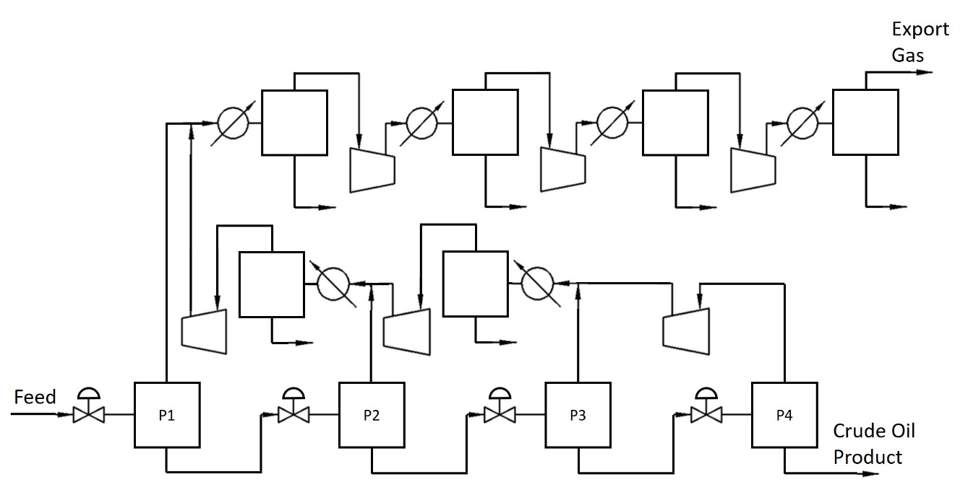
Figure 1: Conceptual process flow diagram for the case N = 4.

account the coupling of the separation and recompression trains, with the aim of locating the values of the design variables maximizing the net profit (i.e. the revenues from oil and gas sales minus the operating costs). Relevant examples are reported by Kylling (2009), who applied brute-force optimization for a 2-stage separation train and three different feed compositions compatible with a North Sea platform, and Kim et al. (2014), who applied a stochastic optimization method to optimize 3- and 4-stage separation trains also including the constraint of the oil stability at stock tank conditions.
The aim of this work is to analyse the effect of the number of separation stages, as well as feed composition and conditions, on the net profit of typical offshore topside units, consisting in a separation train coupled with a gas recompression train. This work accounts for both optimal conditions and the profit losses due to sub-optimal functioning of single separators in the train.
  - Methodology
The conceptual process flow diagram, showed in Fig. 1, consists of N oil-gas separation stages (N from 1 to 4) operating at pressures (P₁,…, P_{N}), with isenthalpic expansions in between separators. The oil exiting the last separator (crude oil product) is conveyed to the stock tank. The gas exiting each separator (stage i) is mixed with the re-compressed gas coming from the subsequent separator (stage i+1), cooled down in a heat exchanger, separated from possible condensates, and re-compressed to the pressure of the previous stage (stage i-1). The re-joined gas stream at pressure P₁ is compressed in three stages up to export specifications, with coolers and condensate separators between compression stages and before export. The oil stability constraint on the stock tank oil was set as RVP not exceeding 12 psia. All heat exchangers are set to cool the gas streams down to 25 °C, which is a temperature compatible with the use of cooling water available on offshore platforms. The cooling water was set to enter the heat exchangers at 15 °C and to exit them at 35 °C. The export pressure and temperature were set at 120 bar (P_{exp}) and 25 °C (Manning, 1995), with the compression ratio of the compressors in the recompression unit from P₁ to P_{exp} set constant. Pressure drops in heat exchangers for the gas (tube side) and cooling water (shell side) were set at 0.35 bar and 1 bar, respectively (Seider et al., 2004). The isentropic efficiency of the centrifugal compressors and the pumps for cooling water circulation was set at 75 %. The PT-flash calculations at each separator were based on the Peng-Robinson equation of state. The pressures of the separation train (P₁,…, P_{N}) were taken as design variables. The objective function was defined taking into account both the revenues from oil and gas sales (S_{oil}, S_{gas}) and the operating costs associated with the gas recompression train (U_{r}) as well as pumping of the cooling water (U_{p}). The crude oil and gas prices were set at 51.93 USD/bbl and 2.98 USD/MMBTU, respectively. The cost of compression and pumping (0.06 USD/kWh) was taken from Kim et al. (2014). The objective function was therefore set as:
$$ϕ\left(P_{1},…,P_{N}\right)=S_{oil}+S_{gas}-U_{r}-U_{p} subject to RVP(P_{1},…,P_{N})<12 psia$$ | (1)
For each value of N, a constrained nonlinear optimization problem based on deterministic continuous variables (P₁,…, P_{N}) was solved. The optimization was done using a hierarchical brute-force optimization method. The algorithm scanned the whole range of possible pressures between the feed pressure and 1 bar, with the restriction P_{i} < P_{i-1}. The step-size of pressure variations in the map was set at 1 bar for separation stages P₁ to P_{N-1} and 0.1 bar for the last stage P_{N}. Each simulation setup was solved using Aspen HYSYS, called by an external routine. The study was conducted for two different types of feeds: a light oil and a gas condensate. Data regarding the feeds are reported in Table 1. Each feed was considered at four different conditions: low pressure and low temperature (LP, LT: 30 bar, 48 °C), low pressure and high temperature (LP, HT: 30 bar, 58 °C), high pressure and low temperature (HP, LT: 60 bar, 48 °C), high pressure and high temperature (HP, HT: 60 bar, 58 °C). These conditions were selected within the most common range of values in topside applications. Combining the two different compositions with the four possible inlet conditions, and with the four possible process configurations (N from 1 to 4) resulted in 32 distinct case-studies. The total number of solved simulation setups, for all case-studies and all possible pressure combinations, was in the order of 10⁶. The computational time for generating one map, using a processor operating at 3.40 GHz, was around: 10 s for N = 1; 90 to 280 s for N = 2; 6 to 20 min for N = 3; 2 to 6 hours for N = 4. In the reported ranges, longer times refer to HP cases. The application of a brute-force method was motivated by reasonable computational times together with the aim of obtaining a full map of the objective function, thus allowing not only to locate the optimal operating conditions but also to quantify the profit loss caused by single separators operating away from their optimal pressure.
  - Results and Discussion
The maximum net profit (per unit mass of feed), together with optimal values of the pressures and the corresponding RVP values, are reported in Table 2. As can be seen, the optimal pressure values depend remarkably on the feed type and, to some extent, also on the feed temperature (for a given feed pressure). In most cases, the lighter feed (i.e. the gas condensate) and the higher feed temperature are associated to higher
Table 1: Composition of the feeds, with molar mass and density (15 °C, 1 bar) of the lumped fractions. Light oil data are adapted from Kim et al. (2014). Gas condensate data are taken from Pedersen and Christensen (2007).
 | Light Oil |  |  | Gas Condensate
Component | Mole  fraction, % | Average  molar mass, g/mol | Density,  g/cm³ | Mole  fraction, % | Average  molar mass, g/mol | Density,  g/cm³
N₂ | 0.44 | - | - | 0.12 | - | -
CO₂ | 3.26 | - | - | 2.49 | - | -
C₁ | 47.24 | - | - | 76.43 | - | -
C₂ | 6.49 | - | - | 7.46 | - | -
C₃ | 5.76 | - | - | 3.12 | - | -
i-C₄ | 1.10 | - | - | 0.59 | - | -
n-C₄ | 3.23 | - | - | 1.21 | - | -
i-C₅ | 1.43 | - | - | 0.50 | - | -
n-C₅ | 1.57 | - | - | 0.59 | - | -
n-C₆ | - | - | - | 0.79 | - | -
C₆* | 2.31 | 86 | 0.665 | - | - | -
C₇* | 3.19 | 96 | 0.743 | 0.95 | 95 | 0.726
C₈* | 3.52 | 107 | 0.756 | 1.08 | 106 | 0.747
C₉* | 2.75 | 121 | 0.768 | 0.78 | 116 | 0.769
C₁₀* | - | - | - | 0.59 | 133 | 0.781
C₁₁* | - | - | - | 0.47 | 152 | 0.778
C₁₂* | - | - | - | 0.35 | 164 | 0.785
C₁₃* | - | - | - | 0.38 | 179 | 0.802
C₁₄* | - | - | - | 0.30 | 193 | 0.815
C₁₀₋₁₄* | 7.76 | 158 | 0.807 | - | - | -
C₁₅* | - | - | - | 0.24 | 209 | 0.817
C₁₆* | - | - | - | 0.21 | 218 | 0.824
C₁₇* | - | - | - | 0.22 | 239 | 0.825
C₁₈* | - | - | - | 0.17 | 250 | 0.831
C₁₉* | - | - | - | 0.14 | 264 | 0.841
C₁₅₋₂₀* | 4.78 | 238 | 0.850 | - | - | -
C₂₀₊* | - | - | - | 0.83 | 377 | 0.873
C₂₁₋₂₉* | 3.38 | 336 | 0.890 | - | - | -
C₃₀₊* | 1.79 | 535 | 0.946 | - | - | -
Table 2: Optimization results for the light oil and the gas condensate feeds. Feed pressure: LP = 30 bar; HP = 60 bar. Feed temperature: LT = 48 °C; HT = 58 °C.
 | Light Oil |  |  |  |  |  | Gas Condensate
 | P1,  bar | P2,  bar | P3,  bar | P4,  Bar | RVP,  psia | $ϕ$,  USD/kg | P1,  bar | P2,  bar | P3,  bar | P4,  Bar | RVP,  psia | $ϕ$,  USD/kg
LP, LT
N=1 | 1.1 | - | - | - | 11.98 | 0.3139 | 1.0 | - | - | - | 11.37 | 0.2136
N=2 | 13 | 1.2 | - | - | 11.96 | 0.3349 | 25 | 1.2 | - | - | 11.83 | 0.2467
N=3 | 26 | 4 | 1.2 | - | 11.57 | 0.3398 | 30 | 5 | 1.3 | - | 11.95 | 0.2500
N=4 | 27 | 6 | 2 | 1.2 | 11.42 | 0.3413 | 30 | 8 | 3 | 1.3 | 11.81 | 0.2507
LP, HT
N=1 | 1.2 | - | - | - | 11.80 | 0.3087 | 1.1 | - | - | - | 11.40 | 0.2077
N=2 | 15 | 1.4 | - | - | 11.81 | 0.3318 | 27 | 1.4 | - | - | 11.86 | 0.2427
N=3 | 27 | 5 | 1.5 | - | 11.77 | 0.3375 | 30 | 5 | 1.5 | - | 11.76 | 0.2458
N=4 | 30 | 8 | 3 | 1.5 | 11.51 | 0.3391 | 30 | 8 | 3 | 1.5 | 11.53 | 0.2464
HP, LT
N=1 | 1.0 | - | - | - | 11.64 | 0.3152 | 1.0 | - | - | - | 12.14 | -
N=2 | 12 | 1.1 | - | - | 11.91 | 0.3360 | 24 | 1.0 | - | - | 11.73 | 0.2500
N=3 | 26 | 4 | 1.1 | - | 11.60 | 0.3407 | 35 | 4 | 1.1 | - | 11.98 | 0.2536
N=4 | 48 | 10 | 3 | 1.2 | 11.99 | 0.3424 | 35 | 7 | 2 | 1.1 | 11.90 | 0.2544
HP, HT
N=1 | 1.1 | - | - | - | 11.47 | 0.3102 | 1.0 | - | - | - | 11.30 | 0.2129
N=2 | 14 | 1.3 | - | - | 11.77 | 0.3330 | 25 | 1.2 | - | - | 11.70 | 0.2462
N=3 | 27 | 4 | 1.4 | - | 11.84 | 0.3387 | 35 | 5 | 1.3 | - | 11.66 | 0.2497
N=4 | 30 | 8 | 3 | 1.4 | 11.63 | 0.3402 | 38 | 9 | 3 | 1.4 | 11.99 | 0.2508

pressures for given N. However, there are exceptions indicating that the overall behaviour of the system is not predictable by simple thumb rules. It is noted that, for both feeds, the optimal pressure of the first separator is lower than the feed pressure, with the exception of most of the LP cases with 3 or 4 stages. Therefore, it is in general recommended to include the pressure of the first separator in the design variables, which is to say not to fix it only on the basis of other considerations. In addition, it is evident that the pressure of the last-stage separator has a little range of possible variation, since pressures higher than 1.5 bar do not allow to meet the RVP specification. In the case of the gas condensate (HP, LT) and N = 1, it was not possible to find any pressure values that allow to meet the RVP constraint. This case is therefore excluded from further discussion. For the higher feed temperature and for both feeds, the pressure of the last stage can be increased as a higher amount of volatile components are removed at the earlier stages. Also noticeable that the values of the net profit, for a given feed type and number of stages, are lower at higher feed temperatures. This can be explained by the higher operating temperature of the separators causing an increased presence of intermediate components (C₃-C₅) in the gas phase, which is to say a lower recovery of said components in the oil phase. As expected, the profit increase is large when increasing from 1 to 2 stages (in the range 6.0 % to 7.5 % for the light oil and 15 % to 17 % for the gas condensate), whereas further increasing the number of separation stages offers progressively less benefit, albeit values are still remarkable. From 2 to 3 stages the profit increase is in the range 1.4 % to 1.7 % and 1.30 % to 1.45 % for the light oil and the gas condensate, respectively. Finally, from 3 to 4 stages the additional profits are in the range 0.45 % to 0.50 % and 0.25 % to 0.45 % for the light oil and the gas condensate, respectively. The revenues associated to the gas are relatively small in the case of the light oil, whereas they are relevant in the case of the gas condensate feed. Therefore, the use of classical approaches for the optimization of the separation train, which are only based on the maximization of the oil and disregard the gas re-compression train, can only be justified as a first approximation method for light oils (or heavier feeds).
Figures 2-3 account for the relative amounts of the different streams produced by the topside unit, consisting in stock tank oil, export gas, and condensates, which are the liquid products recovered in the gas recompression train. Increasing the number of stages leads to more oil complying with the RVP specifications, less gas, and less condensates. In addition, at higher feed temperatures the condensates increase due to more of the intermediate components (C3-C5) ending up in the gas stream at the early stages of separation. In offshore installations, condensates are typically not exported. They may be recycled in the train (case not studied here), used as internal fuel or flared, depending on the amount. In this scenario, the optimal distribution of the C3-C5

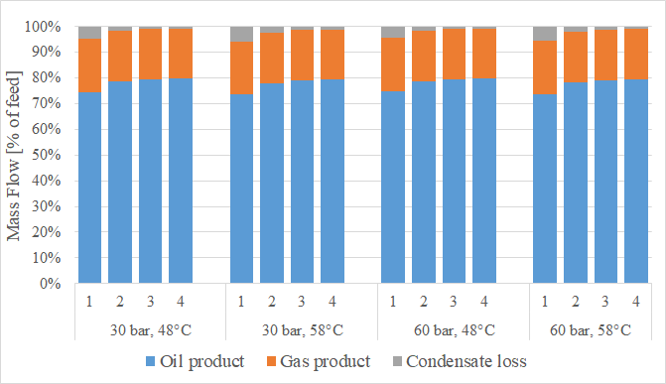
Figure 2: Distribution of the output streams (stock tank oil, export gas, condensates) for the light oil feed at optimal pressures. The total height of a column represents the feed (100 %).

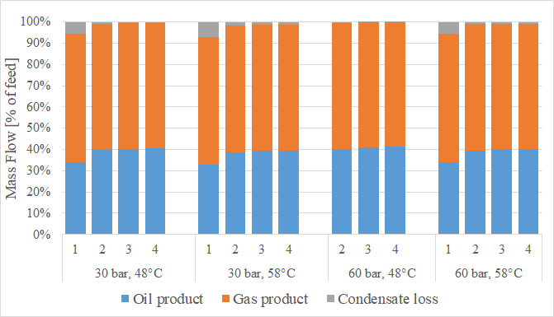
Figure 3: Distribution of the output streams (stock tank oil, export gas, condensates) for the gas condensate feed at optimal pressures. The total height of a column represent the feed (100 %).

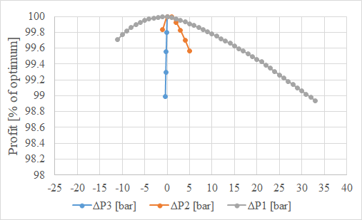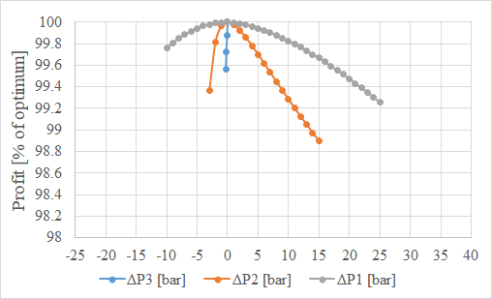
Figure 4: Effect of sub-optimal pressures: a) light oil (HP, HT, N = 3); b) gas condensate (HP, HT, N = 3).

fraction is crucial for profit maximization, requiring the maximum possible recovery of this fraction in the oil, provided that the RVP constraint is fulfilled. The effect of the number of stages on the distribution of the C3-C5 class is evident from the following data: for the light oil, the recovery of C3-C5 in the oil increased from 11-15 % to 44-49 % for N from 1 to 4; the analogous increase for the gas condensate is from 2-4 % to 18-25 %.
A number of plots were generated with the focus on the quantitation of the profit loss when one separator of the train operates away from the optimal pressure, while the other separators are kept at the optimal values. Only pressure combinations resulting in respecting the RVP constraint on the oil product were taken into account. Figure 4 shows an example of this type of plots for N = 3, which is a frequent case in offshore oil and gas operations. The end point of the curves is explained by one of the following reasons: further increasing or decreasing the pressure of the given stage would result in: 1) the RVP constraint no longer being respected; or 2) reaching the optimal pressure of the following or previous separator; or 3) reaching the pressure of the well feed or 1 bar. Moreover, increasing the pressure of the last stage to values higher than the optimal would always result in a higher RVP value than allowed, consequently the last stage pressure can never be seen varied in the over-pressure region. As can be seen by the slope of the curves, operating at sub-optimal pressures causes larger profit losses at the later stages of the separation train. This puts relatively larger emphasis on the accuracy of the pressure control on the last stage of the train: even as low deviation as 0.4 bar can cause up to 1 % loss of overall profit. In case of 3 or 4 stages of separation, the second to last stage pressure (P_{N-1}) is almost just as crucial: 0.5 bar under-pressure can cause up to 0.5 % loss. In addition, the curves in the negative ∆P region are generally much steeper, meaning that the profit loss is more susceptible to under-pressures than to over-pressures. Comparing the two feed compositions, the profit loss in the case of the light oil shows more sensitivity towards sub-optimal pressure conditions than the gas condensate.
  - Conclusions
An extensive analysis of the performance of oil-gas separation trains, coupled with gas re-compression trains, was carried out in this work. The optimization results quantitate the incremental profit that is obtained when additional stages in the separation train are installed, with values in the range 6 % to 17 %, for N increased from 1 to 2, 1.3 % to 1.7 %, for N increased from 2 to 3, and 0.25 % to 0.50 %, for N increased from 3 to 4. The results also show the importance of the optimal distribution of the C3-C5 components, which should be recovered as much as possible in the oil, while complying with the RVP constraint. It was shown that their recovery is extremely dependent on the number of stages, with values increasing from 11-15 % to 44-49 % for the light oil and from 2-4 % to 18-25 % for the gas condensate, as N increases from 1 to 4. In addition, it is observed that the optimal pressures of the separation train depends remarkably on the feed type, as well as on the feed pressure and temperature, thus making thumb rules in use in oil and gas industry not satisfactory. The availability of the full-maps allows the evaluation of the relative importance of accurate pressure control in different separators of the train, with profit loss increasing with pressure deviations at higher stage numbers. Moreover, with reference to the first two separators, the results show that the profit loss is higher for negative pressure deviations than for positive deviations of the same amount. The full mapping of the objective function proved to be feasible within reasonable computational times (up to 6 hours), for pressure optimization of trains up to four stages. This makes the full-map screening worth applying in a number of offshore oil and gas applications, since it can lead to increased profits by adjusting the pressure values of the separators, in response to changes of pressure, temperature, and composition of the feed during the field life.
Acknowledgments
The research was supported by the Danish Hydrocarbon Research and Technology Centre (DHRTC). The students Bence Vizi and György Imrény are acknowledged for running the simulations. Bence Vizi is also acknowledged for preparing some of the figures.
References
Bothamley M., 2004, Offshore processing options vary widely, Oil and Gas Journal, 102, 47-55.
Elsheemy A.A., Ashour F.H., Gadalla M.A., 2018, Maximization of condensate production by revamping of gas-oil separation plant in Gulf of Suez, Chemical Engineering Transactions, 70, 343-348.
Kim I.H., Dan S., Kim H., Rim H.R., Lee J.M., Yoon E.S., 2014, Simulation-based optimization of multistage separation process in offshore oil and gas production facilities, Industrial and Engineering Chemistry Research, 53, 8810-8820.
Kylling Ø.W., 2009, Optimizing separator pressure in a multistage crude oil production plant, Master Thesis, Norwegian University of Science and Technology, Trondheim, Norway.
Manning F.S., Thompson R.E., 1995, Oilfield Processing Volume Two: Crude Oil, PennWell Publishing Company, Tulsa, Oklahoma, USA.
Pedersen K.S., Christensen P.L., 2007, Phase Behavior of Petroleum Reservoir Fluids, CRC Press, Taylor and Francis Group, Boca Raton, FL, USA.
Seider W.D., Seader J.D., Lewin D.R., 2004, Product and Process Design Principles: Synthesis, Analysis, and Evaluation, 2nd ed., Wiley, Hoboken, NJ, USA.
Whinery K.F., Campbell J.M., 1958, A method for determining optimum second stage pressure in three stage separation, Journal of Petroleum Technology, 10, 53-54.

