|  |  |
| --- | --- |
| cetlogo ***CHEMICAL ENGINEERING TRANSACTIONS***  ***VOL. 76, 2019*** | A publication of  aidiclogo_grande |
| The Italian Association  of Chemical Engineering  Online at www.cetjournal.it |
| Guest Editors: Sauro Pierucci, Jiří Jaromír Klemeš, Laura Piazza  Copyright © 2019, AIDIC Servizi S.r.l. **ISBN** 978-88-95608-73-0; **ISSN** 2283-9216 | |

Steel Mills as Syngas Source for Methanol Synthesis: Simulation and Practical Performance Investigations

Kai Giroda,\*, Klaas Breitkreuza, Torsten Henniga, Heiko Lohmanna, Stefan Kaluzaa,b, Stefan Schlütera

aFraunhofer UMSICHT, Oberhausen, Germany

bHochschule Düsseldorf, University of Applied Sciences, Faculty of Mechanical and Process Engineering, Germany

kai.girod@umsicht.fraunhofer.de

* 1. Introduction

Syngas derived from steel mill gases provides a promising feedstock for the production of valuable chemical products such as methanol, higher alcohols, oxymethylene ethers or polymers. The utilization of these syngas sources reduces not only the carbon footprint of a steel mill but also avoids the use of fossil resources such as coal, oil, and gas for the production of chemicals.

Within the scope of the ongoing project Carbon2Chem®, funded by the German Federal Ministry of Education and Research (BMBF), the potential of using steel mill gases as sources for the synthesis of chemical products are being investigated and evaluated (Deerberg et al., 2018). One important target product of the Carbon2Chem® project is methanol. Methanol is not only an important future platform chemical for the chemical industry, but is also expected to be a key energy carrier for the future fuel sector. This is shown by the fact that the global demand for methanol is increasing. Market experts predict a steady annual growth rate for methanol of 5.5% until 2027, which corresponding to an increase of the methanol production from 90 Mt in 2017 to 135 Mt in 2027 (Nestler et al., 2018; Schittkowski et al., 2018). The established synthesis route to methanol is the conversion of natural gas-derived synthesis gas over Cu-based catalysts. Therefore, the feasibility of applying a commercial Cu-based catalyst for the conversion of syngas derived from steel mill gases was evaluated.

There are three main syngas sources at steel mill sites: coke oven gas (COG), basic oxygen furnace gas (BOFG) and blast furnace gas (BFG). The averaged compositions are given in Table 1.

Table 1: Main components of steel mill gases [mol-%] (Schlüter and Hennig, 2018)

|  |  |  |  |  |
| --- | --- | --- | --- | --- |
| Component | Coke Oven Gas | Basic Oxygen Furnace Gas |  | Blast Furnace Gas |
| H2 | 63 | 5 |  | 4 |
|  |  |  |  |  |
| CO | 7 | 64 |  | 25 |
|  |  |  |  |  |
| CO2 | 2 | 17 |  | 23 |
|  |  |  |  |  |
| CH4 | 22 | 0 |  | 0 |
|  |  |  |  |  |
| N2 | 6 | 14 |  | 48 |

COG is hydrogen-rich and contains a significant percentage of methane. The amount of carbon monoxide and carbon dioxide is comparatively low. In contrast to coke oven gas, the BOFG is carbon monoxide-rich and contains a significant fraction of nitrogen. The highest fraction of nitrogen and comparable amounts of carbon monoxide, carbon dioxide and very little hydrogen characterize BFG. Table 2 shows the percentage of the different gas streams relative to the total quantity. Obviously, BFG is by far the biggest stream and - with respect to its carbon content - the most significant feedstock for chemical production in a steel mill. Due to its significance in comparison to the other steel mill gases, this work focuses on BFG-derived syngas.

Table 2: Share of different steel mill gas sources [% of total flow] (thyssenkrupp AG, 2017)

|  |  |  |  |
| --- | --- | --- | --- |
| Coke Oven Gas | Basic Oxygen Furnace Gas |  | Blast Furnace Gas |
| 8 | 5 |  | 87 |

Commercial Cu-based catalysts applied in conventional world-scale methanol plants are optimized for constant streams of high-purified natural gas-derived synthesis gas with a fixed gas composition (Schittkowski et al., 2018). In contrast, BFG-derived syngas contains high CO2 concentrations. It is known that the catalytic conversion of high CO2 amounts in syngas leads to pronounced water formation at the active sites of the methanol catalyst. This may results in catalyst deactivation (Ganesh, 2014). Therefore, the composition of a model syngas was varied in order to investigate the influence of different CO/CO2 ratios and high water contents on the catalyst activity and stability. Another aspect that has to be taken into account is the presence of possible inert compounds such as nitrogen or methane in BFG-derived syngas. The accumulation of inert compounds in the inlet gas stream due to the recycling of unconverted syngas may have a detrimental effect on the efficiency of a future industrial process. For this reason, a process simulation of a large-scale methanol synthesis plant was conducted and the impact of different gas recycle ratios on the efficiency of the overall process was investigated. Afterwards, the obtained simulation results were used to determine reasonable operation points for long-term catalyst testing.

* 1. Investigation of high Carbon Dioxide Concentrations on the Catalyst Performance
     1. Influence of Carbon Dioxide on Methanol Formation – Equilibrium calculations

Equilibrium gas compositions were calculated using a reference gas with a molar composition of 17 mol % COx, 73.5 mol % H2 and 9.5 mol % N2. COx is the sum of the molar fraction of CO and CO2, which was kept constant at 17mol %. A reaction temperature of 553 K and a pressure of 5 MPa were applied. The CO2 concentration was increased stepwise, starting from 0 mol % up to 17 mol %. The highest methanol concentration of 16.05 mol % was calculated with 17 mol % CO and no CO2 at all. With an increasing CO2 concentration, the methanol concentration decreases steadily and reaches a minimum at 17 mol % CO2. The corresponding methanol concentration amounted to 4.2 mol %.

* + 1. Experimental Investigation

The tests were conducted with a commercial CuO/ZnO/Al2O3 methanol synthesis catalyst at a temperature of 553 K and a pressure of 5 MPa applying a specific gas flow rate of 0.5 Nl gcat-1 min-1. A reference gas with a molar gas composition of 13.5 mol % CO, 3.5 mol % CO2, 73.5 mol % H2 and 9.5 mol % N2 was used in the beginning of the test campaign. The conditions were chosen to provide measurement in the kinetic regime. After a start-up period of approximately 500 h on stream, the CO2 concentration was increased stepwise, starting from 3.5 mol % up to 17 mol % while keeping the overall COx concentration constant at 17 mol % (step 1, 2, 3, 5, 6). The normalized values of the resulting product concentrations are shown in Figure 1 (left). Methanol formation is reduced with every step of increasing CO2 concentration. In order to evaluate whether the catalyst was irreversibly deactivated by high CO2-concentrations, the gas composition was switched back to the initial gas composition after several steps (step 4, 7, 9). The observed methanol concentration was slightly lower than the concentration at the end of the start-up period. In order to determine whether the observed reduction of methanol formation is caused by an irreversible deactivation due to high CO2-concentration or by a concentration-independent thermal effect, usually occurring during the start-up period after activation of the catalyst, a second test was conducted. In this test, the reference gas composition and all other parameters were kept constant over a long period. Figure 1 (right side) shows the measured results of this second test series with constant reference gas composition and compared to the methanol concentrations of the test with altered CO2 concentration. The areas marked by the dotted circles show the methanol concentration referring to step 4 and 7 (Figure 1 left). Here, it was switched back to the initial gas composition. It becomes obvious that the methanol concentration of the start-up period is not reached again. The resulting methanol concentration is approximately 20 % lower compared to the test series with constant gas composition. It seems that the catalyst deactivates faster when it is exposed to high CO2 concentrations.

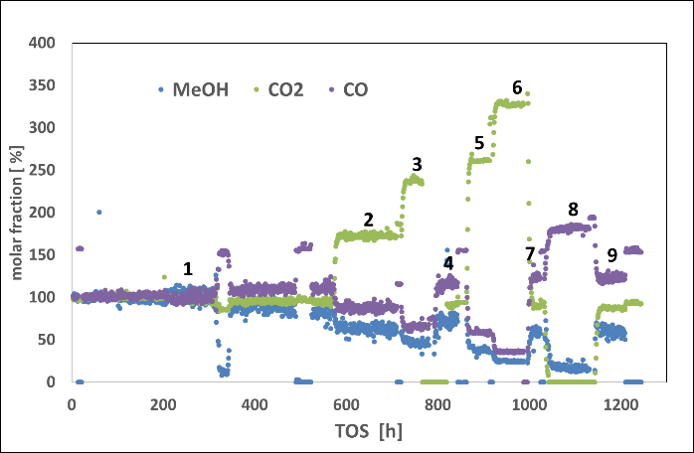 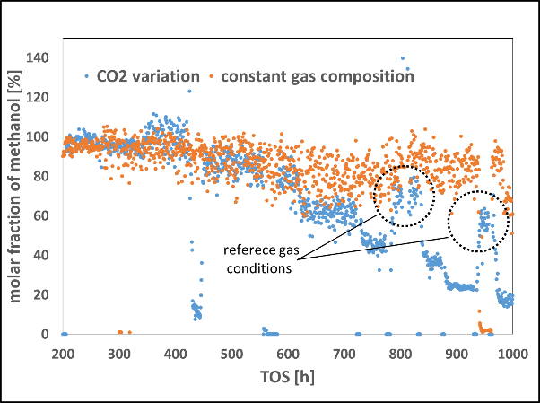

*Figure 1: MeOH formation depending on the CO2/CO ratio (left); MeOH formation with altered CO2 concentration in comparison to a reference test with constant gas composition (right)*

In addition, a syngas with 17 % CO and no CO2 was applied. The resulting concentrations at the reactor outlet are shown in Figure 1 (left, step 8). In this case, the methanol concentration is reversibly lowered about 35 % compared to the test with pure CO2. This result is contradictory to the calculated equilibrium methanol concentration where the highest methanol concentration is predicted without CO2. The presence of CO2 in a certain range is assumed beneficial for the activity of the catalyst. It is described in the literature that the hydrogenation of CO2 to methanol proceeds much faster than CO hydrogenation (Kagan et al., 1976). Furthermore, in absence of or at very low concentrations of CO2, the catalyst activity is reduced by overreduction. In this case, a Cu/Zn alloy might form leading to deactivation of the catalyst (Klier, 1982).

* 1. Impact of High Water Concentrations on the Catalyst Stability

The same reference gas composition and test conditions as for the CO2-variation were applied for investigating the influence of high water concentrations on the catalyst performance and stability. A long start-up period of 54 days under constant reaction conditions was chosen in order to eliminate thermal deactivation influences which usually occurs within the first weeks after catalyst activation. Subsequently, the amount of nitrogen in the syngas was stepwise substituted by water. In a first test, the water concentration was increased from 1 mol % up to 3 mol % within 12 days followed by a switch back to the reference gas without water. In a second test, the water share was additionally increased from 4 mol % to 5 mol % and followed by a second switch back to the reference conditions.

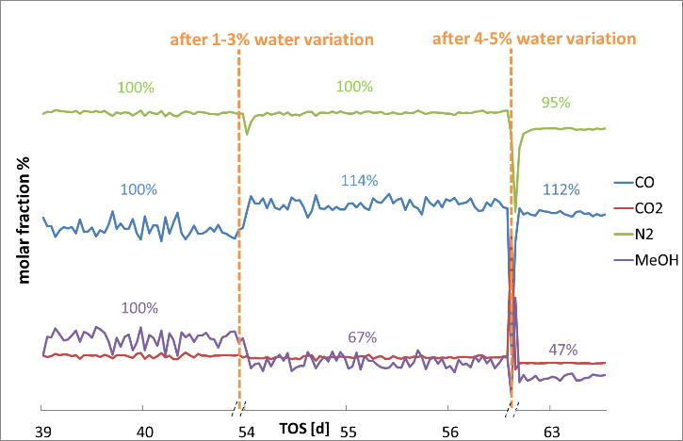

*Figure 2: Normalized gas composition after exposure of the catalyst to high water concentrations*

In Figure 2, the change of gas composition before and after water dosing is shown. For clarity, the water dosing period was omitted in the diagram. The parallel dotted lines mark the period when water was added during the experiment. The diagram shows the response of the catalyst after it has been exposed to elevated water concentrations. A distinct decrease of activity was observed after the catalyst was exposed to 3 mol % of water in the syngas. The methanol concentration dropped to 67 % of the initial value. Higher water contents of up to 5 mol % further decreased methanol formation down to 47 % of the initial value. It is assumed that the catalyst is irreversibly deactivated by high water concentrations under the applied test conditions. In the literature, several references can be found describing elevated water contents to be detrimental to the Cu/Zn/Al2O3 methanol synthesis catalyst (Behrens, 2015; LIU, 1985).

* 1. Utilization of Blast Furnace Gas – Process Simulation and Experimental Investigations
     1. Process Simulation

Using COMSOL Multiphysics®, a large-scale methanol synthesis process model was developed at Fraunhofer UMSICHT (Schlüter and Hennig, 2018). Data for reaction kinetics were taken from literature. For reactor modeling, a 1-D axial formulation was used. The process model also comprises a product separation and a gas-recycling loop. A basic flow scheme of the model is shown in Figure 3. Due to the lack of hydrogen in BFG, an additional enrichment with hydrogen is required in order to obtain a suitable make-up gas. For methanol synthesis a stoichiometric number of S = 2.05 for the make-up gas is targeted (eq. 1). By mixing the make-up gas with recycle gas, the nominal reactor feed is provided.

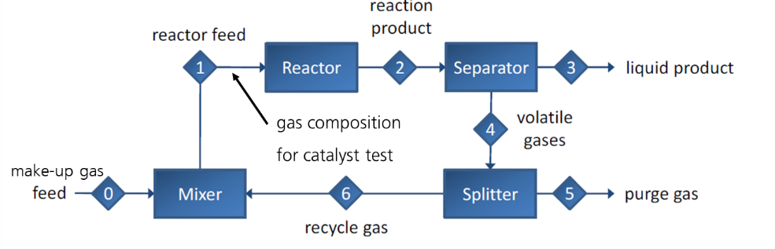

*Figure 3: Flow scheme of the simulated methanol synthesis loop*

For the reactor unit, a boiling water-cooled tube bundle reactor with a total number of 8,444 single pipes was simulated. A cooling water temperature of 523 K and a pressure of 8.4 MPa were chosen as synthesis conditions.

|  |  |
| --- | --- |
| $$S=\frac{[H_{2}]-[{CO}_{2}]}{\left[CO\right]+[{CO}_{2}]}$$ | (1) |

In order to evaluate the suitability of different syngas sources, it is important to differentiate between the gas composition of the make-up gas and the actual gas composition at the reactor entrance. The actual gas composition depends on the product separation and the recycling of the unconverted syngas. The process simulation was used to identify reasonable methanol synthesis scenarios with BFG. As the parameters of the kinetic approach in the simulation were determined for a conventional synthesis gas, experimental validation is important in order to obtain realistic performance parameters, i.e. productivity and selectivity of the catalyst. In addition, experimental testing is required in order to reveal whether the methanol synthesis catalyst deactivates faster with the non-conventional syngas.

* + 1. Simulation Results

The primary target of the entire research project is the complete reduction of CO2 emissions of the steel mill process. In order to evaluate different process scenarios, a performance parameter was introduced. The carbon efficiency is defined as the amount of COx in the make-up gas, which is converted to methanol.

|  |  |
| --- | --- |
| $$C_{efficiency}=\frac{{[MeOH]}_{product}}{{{[CO}_{X}]}_{make-up}}$$ | (2) |

For the simulation, hydrogen-enriched BFG with a stoichiometric number of S = 2.05 was fed as make-up gas into the methanol synthesis loop. This gas stream was further mixed with non-converted syngas. The ratio between these streams is denoted as recycle ratio in the following. With increasing recycle ratio, the inert compound N2 accumulates in the gas stream. In Figure 4 (right), the simulation results are depicted. A recycle ratio of zero refers to a one-pass process in which the make-up-gas composition equals the reactor inlet concentration. An increase of the recycle ratio leads to a distinct dilution of the syngas with nitrogen. Compared to a one-pass process, the N2 share is more than doubled for a recycle ratio of 8. An increasing dilution of the syngas also leads to a reduced reactor productivity, as shown in Figure 4 (left). On the one hand, if a certain amount of produced methanol is targeted, the reactor size must be increased by the same factor the catalyst productivity is reduced, most likely resulting in a negative effect on Capex and Opex. On the other hand, a high recycle ratio is beneficial for a high degree of carbon efficiency, which is a major task within the Carbon2Chem® project. Determining the optimum remains a complex task and requires a detailed economic analysis, which is not within the scope of the presented work, but further considerations on this subject can be found in (Stießel et al., 2018). For experimental testing, reasonable operation points corresponding to a medium recycle ratio were identified and the reactor inlet conditions were subsequently extracted from the simulation results.

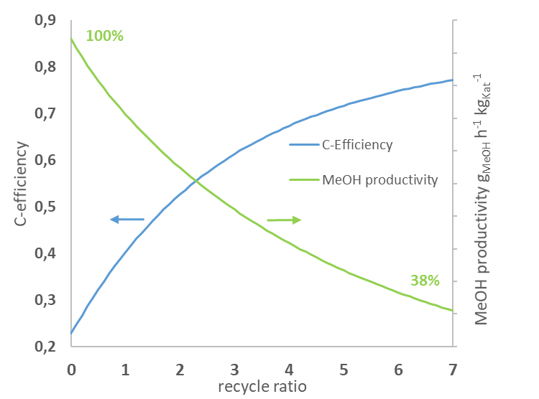 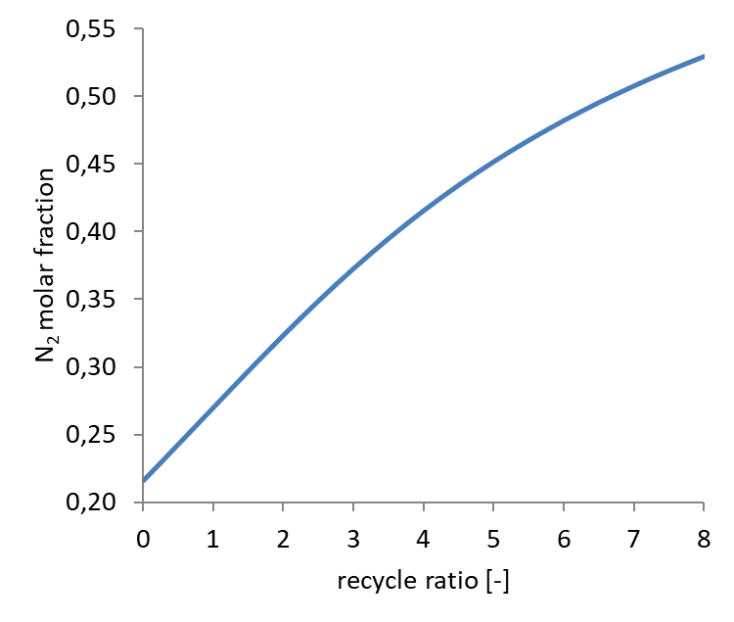

*Figure 4: Carbon efficiency (left) and N2 share (right) as a function of the recycle ratio*

A medium recycle ratio of 5 led to a reactor inlet gas composition of 5.1 mol % CO, 8.4 mol% CO2 % and 40.5 mol % H2. The N2 share was more than doubled compared to the make-up-gas reaching 45.2 mol %. The carbon efficiency was comparatively high with values > 70 %.

* + 1. Experimental Testing with Synthetic Blast Furnace Gas

Practical tests were conducted in a one-pass tubular reactor with an inner diameter of 19 mm and a catalyst bed height of 60 cm. 30 g of a commercial Cu/ZnO/Al2O3  catalyst were diluted with 210 g of SiC and a specific gas load of 0.104 Nlgcat-1min-1 was applied.

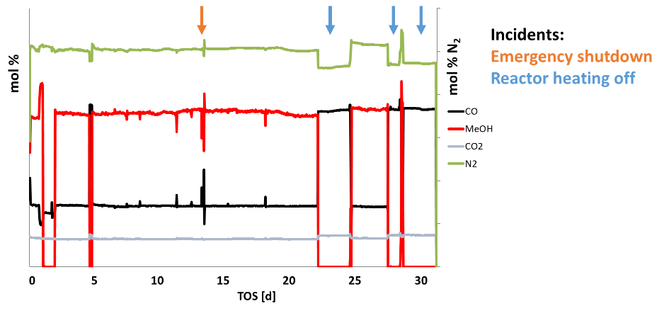

*Figure 5: Methanol synthesis long-term test with H2-enriched Blast Furnace Gas: Reactor outlet gas composition at an assumed recycle ratio of 5*

The specific gas load, reaction temperature and pressure corresponded to the reaction conditions applied for the process simulation described above. The test ran for a period of approximately one month. Within this test period, significant deactivation did not occur. Figure 5 shows the development of the gas composition over time at the reactor outlet. Due to secrecy agreements among the Carbon2Chem® project collaborates, no absolute values can be presented. The concentration of methanol within the period directly after the activation period equals the concentration level in the end of the test period. During the test campaign several drops in concentration occurred. In Figure 5, the first drop was caused by a switch over to the reactor inlet stream in order to provide data for the mass balances. The other drops in concentration, marked by the arrows were caused by special incidents within the test period. An emergency shut down lead to an instantaneous pressure and temperature decrease. Several days later, technical problems with the electrical heating system caused a cool-down of the reactor. The methanol production stopped immediately. However, after returning to the targeted operation conditions a decline of the catalyst performance was not detected. The industrial Cu/Zn/Al2O3-catalyst seems to work quite stable even under the described conditions. This information might be important in the case of non-stationary operation mode in future processes. Additionally, a gas composition according to a high recycle ratio of 8 was adjusted. The catalyst worked stable, but the methanol productivity decreased by nearly 20 %, which can be explained by the increased N2 share and the reduced COx concentration.

* 1. Conclusions

Simulation of a methanol process using steel mill gases as the syngas source provides a helpful tool in order to investigate driving factors of the process and to obtain reasonable operation points. However, in order to validate these operating points it is crucial to obtain experimental data and to reveal an operation range in which the available catalysts show sufficient activity and long-term stability. Tests show, that the activity of the catalyst is negatively affected by high CO2- and H2O-concentrations within the examined range. The use of a CO-rich feed gas without CO2 leads to a reversible activity decrease, which does not correspond to the equilibrium calculations. In fact, first promising long-term tests with synthetic H2-enriched BFG reveal that methanol synthesis utilizing steel mill gases is possible without noticeable deactivation over several weeks.

Acknowledgments

We gratefully appreciate the support received from the Federal Ministry of Education and Research (Bundesministerium für Bildung und Forschung, BMBF, Verbundvorhaben Carbon2Chem®).

References

Behrens, M., 2015. Chemical hydrogen storage by methanol: Challenges for the catalytic methanol synthesis from CO2. Recyclable Catalysis 2 (1). 10.1515/recat-2015-0009.

Deerberg, G., Oles, M., Schlögl, R., 2018. The Project Carbon2Chem®. Chemie Ingenieur Technik 90 (10), 1365–1368. 10.1002/cite.201800060.

Ganesh, I., 2014. Conversion of carbon dioxide into methanol – a potential liquid fuel: Fundamental challenges and opportunities (a review). Renewable and Sustainable Energy Reviews 31, 221–257. 10.1016/j.rser.2013.11.045.

Kagan, Y.B., Rozovskij, A.Ya. Liberov, L.G., Slivinskij, E.V., Lin, G.I., Loktev, S.M., Bashkirov, A.N., 1976. Study of mechanism of methanol synthesis from carbon monoxide and hydrogen using radioactive carbon isotope C14. Kinet. Catal. (17), 1314–1320.

Klier, K., 1982. Catalytic synthesis of methanol from CO/H2 IV: The effects of carbon dioxide. Journal of Catalysis 74 (2), 343–360. 10.1016/0021-9517(82)90040-9.

LIU, G., 1985. The role of CO2 in methanol synthesis on Cu;Zn oxide: An isotope labeling study. Journal of Catalysis 96 (1), 251–260. 10.1016/0021-9517(85)90378-1.

Nestler, F., Krüger, M., Full, J., Hadrich, M.J., White, R.J., Schaadt, A., 2018. Methanol Synthesis - Industrial Challenges within a Changing Raw Material Landscape. Chemie Ingenieur Technik 90 (10), 1409–1418. 10.1002/cite.201800026.

Schittkowski, J., Ruland, H., Laudenschleger, D., Girod, K., Kähler, K., Kaluza, S., Muhler, M., Schlögl, R., 2018. Methanol Synthesis from Steel Mill Exhaust Gases: Challenges for the Industrial Cu/ZnO/Al2O3 Catalyst. Chemie Ingenieur Technik 90 (10), 1419–1429. 10.1002/cite.201800017.

Schlüter, S., Hennig, T., 2018. Modeling the Catalytic Conversion of Steel Mill Gases Using the Example of Methanol Synthesis. Chemie Ingenieur Technik 90 (10), 1541–1558. 10.1002/cite.201800021.

Stießel, S., Berger, A., Fernández Sanchis, E.M., Ziegmann, M., 2018. Methodology for the Evaluation of CO 2 -Based Syntheses by Coupling Steel Industry with Chemical Industry. Chemie Ingenieur Technik 90 (10), 1392–1408. 10.1002/cite.201800030.

thyssenkrupp AG, 2017. Statistical Analysis of Steel Mill Gases: Internal Communication.