|  |  |
| --- | --- |
| cetlogo ***CHEMICAL ENGINEERING TRANSACTIONS***  ***VOL. 76, 2019*** | A publication of  aidiclogo_grande |
| The Italian Association  of Chemical Engineering  Online at www.cetjournal.it |
| Guest Editors: Sauro Pierucci, Jiří Jaromír Klemeš, Laura Piazza  Copyright © 2019, AIDIC Servizi S.r.l. **ISBN** 978-88-95608-73-0; **ISSN** 2283-9216 | |

Recovery of Palladium (II) by Biodeposition Using a Pure Culture and a Mixed Culture

Khanyisile B. Malunga\*, Evans M.N. Chirwa

Water Utilization and Environmental Engineering Division, Department of Chemical Engineering, University of Pretoria 0002, South Africa.

k.kalindalale@gmail.com

Despite limited availability of platinum group metals such as palladium (Pd), there is an increasing demand to use them especially as catalysts. However, conventional recovery of these metals has proven detrimental to the environment, therefore, sustainable recycling and production is required. Biological synthesis of Pd (0) has proven to be an innovative method for recovery of palladium. This study aims to investigate the deposition of Pd at different concentrations by a pure isolate of Desulfovibrio desulfuricans and a consortium of Sulphate-reducing bacteria. The reduction was accelerated at the expanse of formate as an electron donor at a pH of 4. The results showed that after 12 hours of incubation a black precipitate of reduced Pd formed, the consortium produced a higher percentage reduction of 90% at a concentration of 2mM while the pure isolate had a percentage reduction of 77%. SEM showed electron oblique deposits on the surface of the bacteria, the deposits were between 40nm and 50nm in size. The use of the consortium proved to be highly efficient for the potential bioremediation of palladium contaminated environments.

* 1. Introduction

There has been a growing interest in the recovery of platinum group metals because of their extensive use in various industries such as agriculture, medicine, electronics, energy and space industries (Irvani, 2014). The metals are both economically and historically important as currency and investment commodities (Das, 2010). However, due to their increased use their availability has become limited and caused extreme price volatility (De Corte et al., 2012). In South Africa, the largest producer of platinum group metals, there has been an increase in the release of metal compounds into the environment directly or indirectly by various industrial and mining activities. Recovery of these metals from leachates of urban mines and liquid waste streams has become an economically attractive recycling process and important in detoxifying aquatic environments (Okibe et al., 2017). Conventional cycling techniques such as pyrometallurgical and hydrometallurgical processes have been widely used to recover metals. However, these methods are expensive as they are labor intensive and time consuming. Furthermore, they are not environmentally friendly as they generate large quantities of contaminants in the environment (Das, 2010). Recently, biological methods have received much attention because they are considered eco-friendly and cost effective at recovering metal ions from aqueous solutions (Foulkes et al., 2016).

A few studies on the biorecovery of metallic species has been well documented for example the use of Thauera selanatis was described for the remediation of selenium oxyanions in San Joaquin drainage water by Marcy (1994), the reduction of U (VI) by Micrococcus latilyticus was documented by Woolfolk and Whiteley (1962), Lloyd et al. (1997) investigated the reduction of Tc (VII) by Escherichia coli, Shen and Chirwa (2018) demonstrated the biosorption and desorption potential of gold (II) by fresh water algae Scenedesmus Obliquus, Guibal et al. (1999) reported good biosorption of Pt unto a chitosan based biosorbent material, while Lloyd et al. (1998) noted the bioreductive deposition of Pd unto Desulfovibrio desulfuricans biomass.

Previous research done on Sulphate-reducing bacteria has demonstrated that they have a broad metal reducing capability coupled to hydrogenases and cytochromes which results in metal deposition attributed to biosorption (Da Vargas et al., 2004). Biosorption can be an independent complex metabolism process, that results in physical or chemical sorption onto the cell wall, or dependent cell metabolism process which includes physico-chemical mechanisms such as ionic interactions, complexation, coordination and chelation between metal ions and ligands, metal precipitation as sulfides or phosphates, sequestration by metal binding proteins, peptides or siderophores, transport and internal compartmentalization depending on specific properties of the biomass whether it is dead, alive, or derived from a product ( White et al., 1995). In view of the above background, this study aims at investigating the deposition of Pd (0) from Pd (II) by a mixed consortium of Sulphate-reducing bacteria (SRB) isolated from sludge and a pure isolate of Desulfovibrio desulfuricans DSM642. The work presented in this paper suggests a potential application of the bacteria for the recovery of palladium.

**2. Methods and Materials**

**2.1 Bacterial preparation**

Desulfovibrio desulfuricans DSM642 was cultured using modified Postgate medium C (0.5 g K2HPO4, 1.0 g NH4Cl, 1.0 g Na2SO4, 0.1 g CaCl2 x 2 H2O, 2.0 g MgSO4 x 7 H2O, 2.0 g Na-DL-lactate, 1.0 g Yeast extract, 0.5 ml Na-resazurin solution (0.1% w/v), 0.5 g FeSO4 x 7 H2O, 0.1 g Na-thioglycolate, 0.1 g Ascorbic acid in 1 L distilled water) in butyl-rubber sealed 100ml serum bottles at 30 ⁰C under 120rpm (Ngwenya and Chirwa, 2015). Mid-logarithmic phase cultures were prepared by anaerobic withdrawal of 10 mL of an actively growing culture into 100 mL of Postgate’s medium C under oxygen free nitrogen and grown at 30 °C for 48 h. The cells were harvested by centrifugation, kept on ice before and after centrifugation and washed with 20 mM MOPS-NaOH buffer (pH 7.0) three times. Then resuspended in 20 mM MOPS-NaOH buffer to provide the stock suspension for the preparation of bio-Pd (0), then stored at 4 °C until use within 24 h (Mabbett et al., 2006). 0.2 g of sludge from the Brits wastewater treatment plant was placed in a butyl-rubber sealed 100 ml serum bottle, filled up to brim with fresh medium B so that no air was trapped in the bottle. Incubated at 30 ⁰C shaken at 120 rpm for 5 days (Molokwane and Chirwa, 2009). The presence of Sulphate-reducing bacteria was indicated by the blackening of the medium which was the production of FeS (Postgate, 1979) as shown in Fig. 1a. Mid-logarithmic cultures were prepared as above.

**2.2 Reduction of Pd (II) metal ions**

The concentrated cell suspension of 2 mL with an OD600 of 0.3 was diluted in a 5 mL buffer containing 2 mM, 4 mM, and 8 mM at a pH of 4 of Pd(NH3)4Cl2 from Sigma-Aldrichand 25 mM of formate, sparged with nitrogen for 6 min in a 100 mL serum bottles to form the headspace gas, incubated at 30 ⁰C, 120 rpm for 12 h. Then sparged with air immediately to stop the reduction, centrifuged at 9000 rpm for 10 min then analyzed (Yong et al., 2002).

**2.3 Assay of metal ions**

Pd (II) levels in the supernatants were determined by Atomic Absorption Spectrometry, Spectrometer model AAnalyst 400, S/N 201S8070301 Auto sampler Model 510. Using a Parkin-Elmer, Lumina Pd hallow cathode lamp at a wavelength of 244.79 nm at an energy of 79.

**2.4 Analytical methods**

Analysis was done by Scan Electron Microscopy (SEM). Pd-loaded bacteria were fixed in 2.5% (w/v) GA/FA fixative, centrifuged and re-suspended in 1.0 mL osmium tetroxide. Samples were dehydrated in ethanol, then fixed in 100% HMDS for 1 h, a drop of the sample was placed on the cover slip and allowed to dry overnight, then coated with carbon and viewed using Zeiss Ultra Plus FEG-SEM.

3. Results and Discussion

**3.1 Choice of bacteria for palladium reduction**

A previous study on bioreduction of palladium by Sulphate-reducing bacteria has revealed a total conversion of Pd (II) to Pd (0) within 5 min of incubation (Yong et al., 2002). This was a much-reduced time compared to chemically derived methods of production that often reflux hazardous chemicals which lead to higher costs (Capeness et al.,2015). The bacteria have been reported to reduce U (VI) to U (IV) (Payne et al., 2002),) and Pt (VI) to Pt (0) (Rashamuse and Whiteley, 2007). The bacteria have demonstrated to be resistant to a wide range of metals making it the optimal organism to utilize in situ. Thus, it was chosen for this study.

**3.2 Palladium reduction**

Cells tested with Pd(NH3)4Cl2  produced a black precipitate after 12 h of incubation as shown in Fig. 2b, which is suggested to be made up of extracellular Pd nanoparticles that are attached to the cell wall (Yong et al., 2002). The reduction of Pd was mediated by a hydrogenase enzyme since the reaction happens at the expanse of H2 (Lloyd et al., 1998). In this study, formate was used as a source of hydrogen at a pH of 4. There was 90% reduction of Pd (II) by Sulphate-reducing bacteria at 2mM, as the concentration increased from 4 mM to 8 mM reduction decreased to 74% and 72% respectively as shown in Fig. 3. This suggests that with increasing Pd(II) concentration there must be an increase in biomass to effectively reduce the metal. The same trend was observed for Desulfovibrio desulfuricans as also shown in Fig. 3. Comparing the two it is evident that the consortium of Sulphate-reducing bacteria had a higher Pd reducing efficiency than Desulfovibrio desulfuricans which was 90% and 77% respectively at 2Mm. This can be attributed to mutual interactions between species in a consortium of Sulphate-reducing bacteria making them less liable to contamination from other organisms and offering adaptability to minor environmental changes (Rashamuse and Whiteley, 2007). Thus, they have an advantage over a pure culture in environmental biotechnology.

Previous reports suggest Pd reducing cells play a tri-functional role. Firstly, as enzyme catalysts where formate hydrogenase or hydrogenase activity provide electrons. Secondly, as nucleation sites for foci of Pd (0) metal deposition for subsequent crystal growth. Thirdly, as a scaffold for crystals of Pd (0) able to autocatalyze further reaction by acting as a sink for formate and hydrogen trapping and production of highly active H+ from formate (Yong et al., 2002).

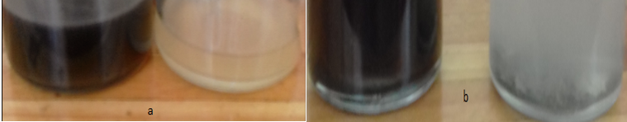

*Figure 1: Blackening of the medium due to bacterial growth: (a) Suphate-reducing bacteria in Postgate medium C, (b) Desulfovibrio desulfuricans in modified Postgate medium C.*

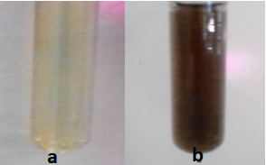

*Figure 2: (a) buffer containing Pd(NH3)4Cl2 , and formate before inoculation with bacteria, (b) Blackening of the buffer due to Pd nanoparticle formation by sulphate-reducing bacteria.*

*Figure 3: The effects of Pd (II) concentration on the reducing efficiency of Sulphate-reducing bacteria and Desulfovibrio desulfuricans after 12 h of incubation.*

3.3 Palladium localisation

Pd bioreduction is an enzymatically accelerated biomineralization process in which the activation energy for nucleation could be reduced by lowering the interfacial energy. This leads to target ions forming crystal nuclei which interact initially with local size binding sites resulting into reduction via hydrogen using the reducing power focused by hydrogenase activity (Yong et al., 2002). As shown in Fig 5 (e) SEM showed deposits on the surface of the Pd challenged bacteria. This is in accordance with observations by Yong et al. (2002) which were found to be between 40 nm and 50 nm in size. It can be assumed that Pd (II) crossed the outer membrane and the reduction happened via a periplasmic hydrogenase as reported previously for the reduction of Pd (Lloyd at al., 1998). The architecture of the cell surface thus provided a template for the organisation of the growing crystals, which presented a larger surface area which may function as enhanced chemical catalysts as illustrated in Fig 4.

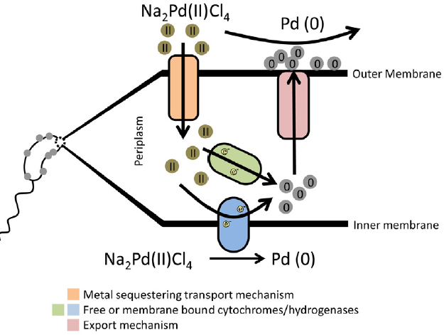

*Figure 4: Proposed method for palladium reduction to Pd (0) in the periplasm of Desulfovibrio. Pd (II)ions are taken by the bacterium across the outer membrane to the periplasm where they are reduced by cytochromes and hydrogenases to form Pd (0). (Capeness et al., 2015).*

*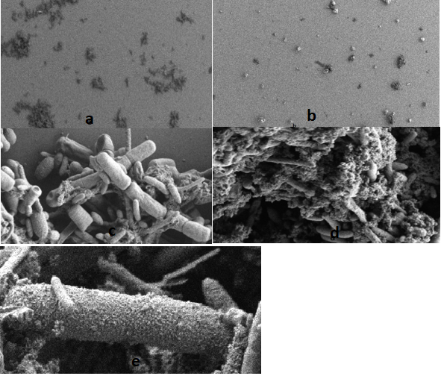*

*Figure 5: SEM study of bio-Pd: (a) Unchallenged Sulphate-reducing cells from a low magnification of 100 $μm$; (b) Cells challenged with 2mM of palladium produced microcrystals of palladium from a magnification of 200 $μm$; (c) Unchallenged cells from a higher magnification of 2 $μm$; (d) Palladium challenged cells with Pd (0) deposits attached to the cells (e) Palladium deposits on the cell wall.*

Sulphate-reducing bacteria have demonstrated that they can efficiently reduce Pd and other metals. However, ensuring the long-term stability of the product (bio-Pd or Pd) for future use is a topic that requires more in-depth studies. The greatest limitation that poses a threat to bio-Pd is poisoning of the catalyst. Sulfides are known to have a strong affinity for the Pd metal and may block the active sites of the catalyst via formation of strong Pd–S bonds and layers of sulfide around the Pd clusters (Alfonso et al., 2003). Thus, sulfide induced catalyst deactivation is a crucial challenge which hinders the full exploitation of the catalyst potential as a treatment technology for remediation of water (Angeles-Wedler et al., 2009). Therefore, a possible approach to prevent sulfide poisoning is the oxidative removal of sulfide prior to any contact with the noble metal (Angeles-Wedler et al., 2009).

**4. Conclusions**

The reduction of Pd by sulphate-reducing bacteria is a metabolic activity which happens via a formate hydrogenase complex. The bacteria utilise the reductive power from electron donors such as formate or hydrogen to form crystalline Pd (0) deposits on the surface of the bacteria. This is proposed to be a biocatalytic biomineralization system. The consortium of sulphate-reducing bacteria converted 90% of Pd(II)to Pd (0) which was compared to the pure isolate of 77%. Thus, the consortium would be the best approach for metal recovery and bioremediation of wastewater. The results of this study suggest a potential application of the sulphate-reducing bacteria for the highly efficient recovery of palladium, which is cost effective and environmentally friendly.

**Acknowledgments**

The authors would like to thank the Water Utilisation and Environmental Engineering Division of the University of Pretoria for the financial support during the study. Research funds were provided through the Sedibeng Water Chair in Water Utilisation Engineering at University of Pretoria.

References

Alfonso D.R., Cugini A.V., Sholl, D.S., 2003, Density functional theory studies of sulfur binding on Pd, Cu and Ag and their alloys, Surface Science, 546, 12–26.

Angeles-Wedler D., Mackenzie K., Kopinke F.D., 2009, Sulphide-induced deactivation of Pd/Al2O3 as hydrodechlorination catalyst and its oxidative regeneration with permanganate. Applied Catalysis B, 9, 613-617.

Capeness M.J., Edmundson M.C., Horsfall L.E., 2015, Nickel and platinum group metal nanoparticle production by *Desulfovibrio alaskensis* G20, New Biotechnology, 32(6), 727-731.

Das N., 2010, Recovery of precious metals through biosorption, Hydrometallurgy, 103, 180-189.

De Corte S., Hennebel T., De Gusseme B., Verstraete W., Boon N., 2012, Bio-palladium: from metal recovery to catalytic applications, Microbial Biotechnology, 5(1), 5–17.

De Vargars I., Macaskie C.E., Guibal S., 2004, Bioabsorption of palladium and platinum by sulfate-reducing bacteria, Journal of Chemical Technology and Biotechnology, 79, 49-56.

Foulkes J.M., Deplanche K., Frank Sargent F., Macaskie L.E., Lloyd J.R., 2016, A novel aerobic mechanism for reductive palladium biomineralization and recovery by Escherichia coli. Geomicrobiology Journal, 33 (3-4), 230-236.

Guibal E., Larkin A., Vincent T., Tobin J.M., 1999, Platinum recovery on chitosan‐based sorbents. In: Amils R., Ballester A., (Ed). Biohydrometallurgy and the environment toward the mining of the 21st century. Part B, molecular biology, biosorption, bioremediation. International Biohydrometallurgy Symposium. IBS'99. Amsterdam: Elsevier Science, 265–275.

Iravani S., 2014, Bacteria in nanoparticle synthesis: current status and future prospects, International Scholarly Research Notices, 2014, 1 – 19

Lloyd J.R., Cole J.A., Macaskie L.E, 1997, Reduction and removal of heptavalent technetium from solution by Escherichia coli, 179(6), 2014-2021.

Lloyd J.R., Yong P., Macaskie L.E., 1998, Enzymatic recovery of elemental palladium by using Sulfate-reducing bacteria, 64(11), 4607-4609.

Mabbett A., Sanyahumbi D., Yong P., and Macaskie L.E., 2006, Biorecovered Precious metals from industrial wastes: Single-step conversion of a mixed metal liquid waste to a bioinorganic catalyst with environmental application, Environmental Science and Technology, 40, 1015-1021.

Macy J.W., 1994, Biochemistry of selenium metabolism by *Thauera selanatis gen*. nov. sp. nov. and use of the organism for bioremediation of selenium oxyanions in San Joaquin Valley drainage water. In: Franjenberger W.T., Benson S., (Ed), Selenium in the environment. New York: Marcel Dekker, 421–444.

Molokwane P.E.M., Chirwa E.M.N., 2009, Cr(VI) reduction in packed-column microcosm reactors using chromium reducing microorganisms. Chemical Engineering Transactions, 18, 863-868.

Ngwenya N., Chirwa E.M.N., 2015, Characterisation of surface uptake of biosorption of cationic fission products in sulphate reducing bacteria, Water SA, 41 (3), 314-324.

Okibe N., Nakayama D., Matsumoto T., 2017, Palladium bionanoparticles production from acidic Pd(II) solutions and spent catalyst leachate using acidophilic Fe(III)‑reducing bacteria, Extremophiles, 21, 1091-1100.

Postgate J.R., (Ed), 1979, Cultivation and growth, In the Sulphate Reducing Bacteria. Cambridge University Press, Cambridge, pp 30–50

Payne R.B., Casalot L., Rivere T., Terry, J.H., Larsen L., Giles B.J., Wall J.D., 2004, Interactions between uranium and the cytochrome c 3 of *Desulfovbrio desulfuricans* strain G20, Archives of Microbiology, 181(6), 398 - 406.

Rashamuse K.J., Whiteley C.G., 2007, Bioreduction of Pt (IV) from aqueous solutions using sulphate-reducing bacteria, Applied Microbial and Cell Physiology, 75, 1429-1435

Shen N., Chirwa E.M.N., Biosorption of Desorption of Gold (III) by freshwater algae *Scenedemus Obliquus* AS-6-1, 2018, Chemical Engineering Transactions, 65, 19-24.

White C., Wilkinson S.C., Gadd G.M., 1995, The role of microorganisms in biosorption of toxic metals and radionuclides. International biodeterioration and biodegradation, 35, 17-40.

Woolfolk C.A., Whiteley H.R., 1962, Reduction of inorganic compounds with molecular hydrogen by Micrococcus lactilyticus. Journal of Bacteriology, 84, 647–658.

Yong P., Rowson N.A., Farr J.P.G., Harris R., Macaskie L.E., 2002, Bioreduction and biocrystallization of pallidum *by Desulfovibro desulfuricans*, Biotechnology and Bioengineering, 80(4), 369-379.