CHEMICAL ENGINEERING TRANSACTIONS  VOL. 76, 2019 | A publication of
The Italian Association
of Chemical Engineering
Online at www.cetjournal.it
Guest Editors: Sauro Pierucci, Jiří Jaromír Klemeš, Laura Piazza
Copyright © 2019, AIDIC Servizi S.r.l.
ISBN 978-88-95608-73-0; ISSN 2283-9216

Application of Raman Spectroscopy in microfluidic devices for on-line determination of ethanol concentration in water and vegetable oil
Adriano G.P. da Silva, Harrson S. Santana*, Rodrigo Bagarolo, Alan C. Rodrigues, Guilherme J. Castilho, Marco A. Cremasco and Osvaldir P. Taranto
School of Chemical Engineering, University of Campinas, 13083-852, Campinas, SP, Brazil
harrison.santana@gmail.com
Microfluidic devices have presented some advantages when compared to conventional processes. The major advantages include the use of reduced amounts of reagents and samples, shorter reaction times, lower manufacturing cost, higher surface area versus volume, higher heat / mass transfer, and greater control over field strengths and concentration of molecules. These devices have been used in a variety of applications including, but not limited to, chemical and biological sensors and chemical processes. To identify molecules and/or compounds, the components are usually identified by techniques characterized as off-line, with the need for sample withdrawals, which in many cases do not allow real-time monitoring of the process. Some alternative techniques such as Raman spectroscopy allow the real-time monitoring of chemical processes being a viable alternative to monitor and quantify chemical species. Thus, this paper evaluates the use of Raman spectroscopy to monitor and quantify the concentration of ethanol in a PDMS (Polydimethylsiloxane) microfluidic device in two different mixtures of compounds: water/ethanol (for control and predictive ability of the spectrometer) and vegetable oil/ethanol in an online way. Spectra of the blends were obtained in glass beaker (batch) and during the flow process in the microdevice (in situ). Through multivariate analysis of the data, PLS (partial least squares) models were constructed. It was possible to demonstrate the on-line detection of ethanol concentration in water and vegetable oil in PDMS microfluidic device with excellent coefficients of determination (> 0.9) and with an analysis time of 45 s.
  - Introduction
Ethanol is one of the organic components with important relevance that is present in several chemical and biological processes, as is the case of fermentation processes and production of biofuels (Samsudin et al., 2017; Mutenure et al., 2016). The use of microfluidics in the investigation of these processes is mainly justified by the reduction of the reaction time and by the low amount of reagents used (Santana et al., 2017), which necessitates in-situ analytical methods of monitoring that provide rapid responses and high prediction (Kant and Abalde-Cela, 2018). Most of the time these analyzes are done by offline measurements, leading to the need for constant sample withdrawals and an increase in response time.
Raman spectroscopy is a technique based on the inelastic Raman dispersion of monochromatic laser light, which varies from visible to near ultraviolet. Laser interacts with molecular vibrations, phonons or other excitations that result in energy changes of the laser photons, providing information on vibrational modes. Raman spectroscopy has often been used for the direct identification and interpretation of different molecules. One of the most significant advantages of Raman spectroscopy is the ability to provide important information easily and quickly, with minimal sample handling problems, being a non-destructive technique (Goh et al., 2017).
Thus, the objective of this work was to apply Raman spectroscopy in the monitoring and quantification of the concentration of ethanol in a PDMS microfluidic device in two different mixtures of compounds: water / ethanol and vegetable oil / ethanol (used in biodiesel synthesis) in an online way (in-situ analysis).
  - Material and methods
  - Chemical and samples
Ethanol (99.5%) obtained by Synth (São Paulo, Brazil) and refined soybean oil produced by Liza (São Paulo, Brazil) were used. Standard samples of ethanol/water and ethanol/oil were prepared to construct the calibration curve composed of 10 samples (10-100% ethanol) for ethanol/water mixtures and (6-15 molar ratio) for ethanol/oil.

  - Instrumentation

Raman spectra were collected on an Avantes Spectrometer (AvaSpec-ULS2048l-TEC-RS-USB2) with laser of 785 nm. The data were recorded at room temperature in the spectral range of 250-1700 cm⁻¹ to ethanol/water and 800-1800 cm⁻¹ to ethanol/oil. The laser potency was 880 mV with integration time of 15 s and 3 averages, totaling 45 s. In the batch way, the samples were placed in a glass beaker to obtain the spectra. The laser was positioned above the liquid level at a height of approximately 9 mm. Samples of ethanol/oil were analyzed by Raman with constant stirring. The in-situ analysis was performed using a microfluidic device (Figure 1), made in our laboratory by the ESCARGOT method (Saggiomo and Velders, 2015). A 1 mm diameter microchannel was used for the flow of the samples. The raman laser was positioned on the upper surface of the microchannel. The samples were transferred to the microdevice through a peristaltic pump (Masterflex 7518-10) at the flow rate of 0.6 mL min⁻¹.
Figure 1. Microfluidic device for in-situ analysis of water / ethanol and oil / ethanol using Raman Spectroscopy.
  - Chemometric data analysis
The chemometric analyzes were performed in The Unscrambler software (version 9.7). Pre-treatment of spectra data were processed in three different ways. Raw spectra, first and second derivatives (Savitzky Golay) were used for comparison purposes and thus select the one that provides the best results. The multivariate analysis of the data was performed by Partial least square regression (PLS). Leave-one-out cross validation was performed to evaluate the performance of PLS models by parameters such as root mean square error (RMSE, Equation 1) of calibration (RMSEC) and cross validation (RMSECV), the coefficient of determination on calibration (R²C) and cross validation (R²V).

$$RMSE \left(\%\right)=\frac{100}{\overline{y}}\left(\sqrt{\frac{\sum_{i=1}^{N}{{(y_{i}-\hat{y_{i}})}^{2}}}{N}}\right)$$ | (1)

where N= number of samples, $y_{i}$ = actual amount, $\hat{y_{i}}$= predicted amount, and $\overline{y}$= average of actual amount values.
- Results and discussion
  - Ethanol/water samples
Spectra of ethanol in water were analyzed as a way of verifying the prediction ability of the spectrometer since the mixture is simple and provides good prediction results according to published work. Figures 2 and 3 shows the ethanol/water mixture spectra obtained in the concentrations analyzed (10-100%) in batch and in-situ, respectively, that were used to construct the calibration and validation models. Each line represents a sample, where the Raman intensity increases as the concentration increases. The region considered for the multivariate analysis was 250-1700 cm⁻¹. As shown in Figure 2, six peaks are commonly present in aqueous solutions of ethanol as observed by Pappas et al., 2016 and Khetani et al., 2013. The region at 880 cm⁻¹ presents the most intense signal attributed to the symmetric C-C-O stretch of ethanol (Nordon et al., 2005). The peak in the 1049 cm⁻¹ region represents the vibrational stretch of the C-C bond. The peak at 1089 cm⁻¹ is due to the vibrational stretch of C-C and the asymmetric vibration of C-C-O. At 1455 cm⁻¹ the asymmetric deformation of -CH₃- and the vibration of -CH₂- occur. The peak at 1277 cm⁻¹ is related to the vibration torsion of -CH₂-. The less intense band at 434 cm⁻¹ is due to vibration of C-O deformation (Socrates, 2001).
In the spectrum of Figure 3 other peaks are observed beyond those mentioned above. The first three peaks are characteristic of PDMS (Alvarado et al., 2009). Prediction performance of PLS models are summarized in Table 1. For the batch data, it is verified that, the largest correlation coefficients and the smallest errors were obtained after the first derivative pre-treatment (R²_{C}=0.999; R²_{V}=0.979). For the spectra obtained in situ, the largest determination coefficients (R²_{C}=0.998; R²_{V}=0.982) associated to the smallest errors were obtained using raw spectra. Figure 4 shows the good agreement between the values obtained experimentally and the values predicted by the model presented in this study, showing that Raman spectroscopy can be applied for on-line quantification of the ethanol concentration in the mixture with water in microfluidic devices.

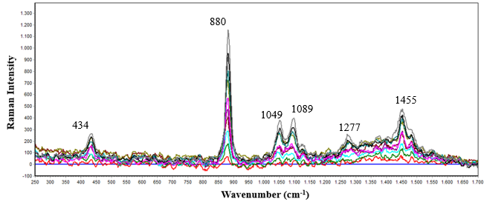
Figure 2. Spectra of ethanol/water mixtures in batch mode (10-100%). Range: 250-1700 cm⁻¹
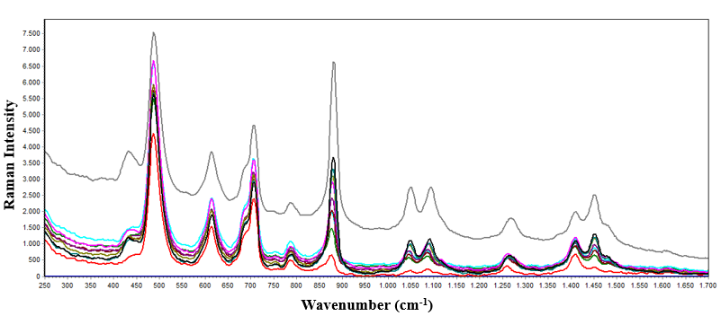
Figure 3. Spectra of ethanol/water mixtures in situ (10-100%). Range: 250-1700 cm⁻¹

Table 1. Determination coefficients and root mean square errors
Heading1 | Pre-treatment | R²_{C} | R²_{V} | RMSEP_{C} | RMSEP_{V}
Batch | Raw spectra | 0.990 | 0.979 | 2.761 | 4.563
 | 1° derivate | 0.999 | 0.979 | 0.595 | 4.577
 | 2° derivate | 0.986 | 0.495 | 3.386 | 22.676
In-situ | Raw spectra | 0.998 | 0.982 | 1.199 | 4.233
 | 1° derivate | 0.942 | 0.894 | 6.905 | 10.379
 | 2° derivate | 0.996 | 0.935 | 1.670 | 8.119
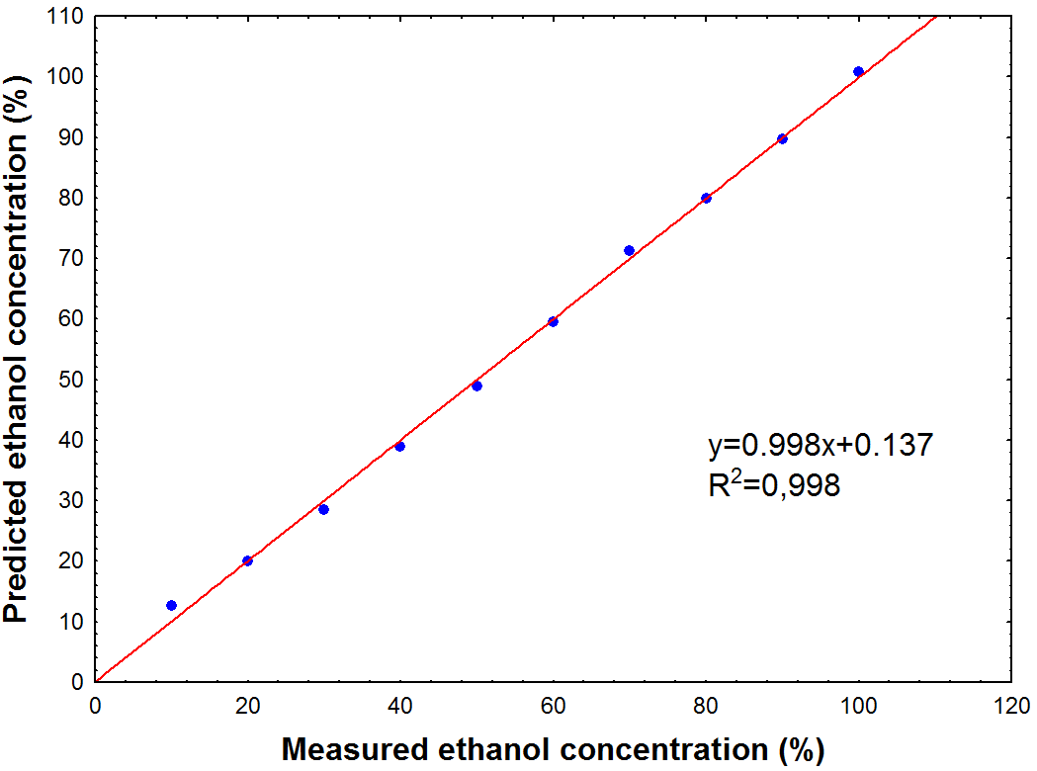
Figure 4. Predicted versus measured ethanol content in water of in-situ analysis.

  - Ethanol/oil samples
The spectra of the ethanol/oil mixture at different molar ratios (6-15) are shown in Figures 5 and 6. Batch analyzes showed peaks similar to those observed in the ethanol/water blends spectra. The PLS model for the batch mode, which presented the highest determination coefficients for calibration and validation, associated with the lowest errors, was obtained after the second derivative was applied to the spectral data (R²_{C} = 0.973, R²_{V} = 0.883). In the in situ analyzes the presence of considerable noise is observed. For these spectra, it was necessary to perform an additional pre-treatment of baseline correction prior to the pre-treatments mentioned in Table 2. The application of the first derivative was the pretreatment that generated the highest determination coefficients (R²_{C} = 0.996, R²_{V} = 0.927). Figure 7 shows the adjustment of the PLS calibration model with the values predicted by PLS model versus the measured values, showing that Raman spectroscopy can be used for the quantification of ethanol concentration in the soybean oil mixture in situ in microfluidic devices.
Therefore it is clear that the method of quantification of ethanol in the mixture with oil is highly predictive and can serve as a basis for monitoring reactions where ethanol is present, as in the reaction of biodisel for example, where the interest is in the detection of ethanol consumption during the reaction.

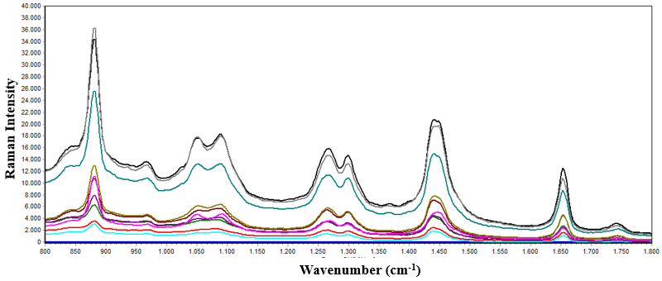

Figure 5. Spectra of ethanol/oil mixtures in batch mode (6-15 molar ratio). Range: 800-1800 cm⁻¹

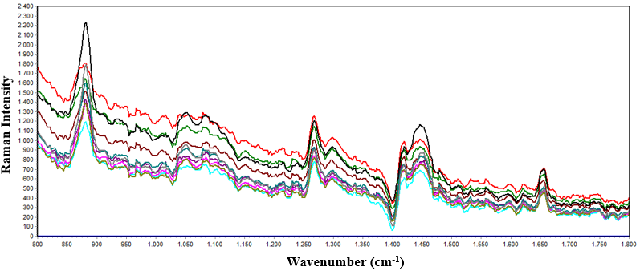

Figure 6. Spectra of ethanol/oil mixtures in situ (6-15 molar ratio). Range: 800-1800 cm⁻¹

Table 2. Determination coefficients and root mean square errors
Heading1 | Pre-treatment | R²_{C} | R²_{V} | RMSEP_{C} | RMSEP_{V}
Batch | Raw spectra | 0.882 | 0.789 | 0.986 | 1.465
 | 1° derivate | 0.842 | 0.814 | 1.138 | 1.375
 | 2° derivate | 0.973 | 0.883 | 0.464 | 1.089
In-situ | Raw spectra | 0.968 | 0.912 | 0.512 | 0.968
 | 1° derivate | 0.996 | 0.927 | 0.168 | 0.856
 | 2° derivate | 0.997 | 0.418 | 0.132 | 2.432
*baseline was applied to all spectra before the pre-treatments tabulated for in situ

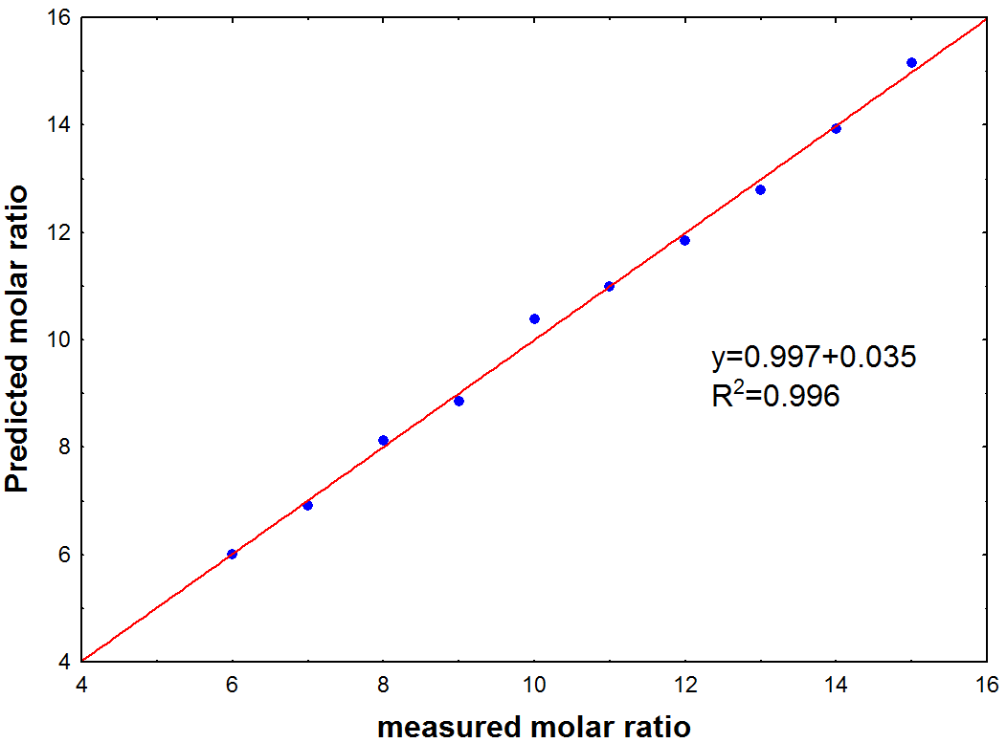

Figure 7. Predicted versus measured ethanol content in oil of in-situ analysis

- Conclusions
In this paper, our main purpose was to determine ethanol content in water and oil mixtures in an in-situ way using a PDMS microfluidic device. A short time frame of 45 s was used and excellent calibration and validation models were observed with high accuracy (>0,9). The multivariate analysis was performed by PLS comparing three different pretreatment techniques. In general, the use of raw spectral data or using the first derivative is sufficient to generate highly reliable prediction models. Such analyzes can be used as a basis for the quantification of ethanol in more complex matrices such as biodiesel and ethanol production by bioprocesses.

Acknowledgments
The authors acknowledge the financial support provided by CNPq (National Council for Scientific and Technological Development, Process 404760/2016-3) and FAPESP (São Paulo Research Foundation, Process 2016/20842-4).
References
Alvarado A.S., Montiel V., Lopez J.M., Ramos J.C., Atencio J.A.D, 2009, Parametric and Scattering Characterization of PDMS Membranes for Optical Applications, Proc. SPIE 7426, Optical Manufacturing and Testing VIII, 742615.

Goh P.S., Ismail A.F., Ng B.C., 2017, Raman Spectroscopy, Chapter In: N Hilal et al., (Ed), Membrane Characterization, Part 1, Chapter 2, Universiti Teknologi Malaysia, Johor Bahru, Johor, Malaysia, 31-46.

Nordon A, Mills A, Burn R.T, Cusick F.M, Littlejohn D., 2005, Comparison of non-invasive NIR and Raman spectrometries for determination of alcohol content of spirits. Anal. Chim. Acta, 548,148-158.

Mutenure M., 2016, Synthesis of South Africa’s Biomass to Bioethanol Supply Network, Chemical Engineering Transactions, 52, 805-810.

Pappas C., 2016, Evaluation of A Raman Spectroscopic Method for the Determination of Alcohol Content in Greek Spirit Tsipouro, Current Research in Nutrition and Food Science, 4, 1-9.

Khetani A., Riordon J., Tiwari V., Momenpour A., Godin M., Anis H., 2013, Hollow core photonic crystal fiber as a reusable Raman biosensor, Opt. Express 21, 12340-12350.

Kant K., Abalde-Cela S., 2018, Surface-Enhanced Raman Scattering Spectroscopy and Microfluidics: Towards Ultrasensitive Label-Free Sensing, Biosensors, 62.

Saggiomo V., Velders A.H., 2015, Simple 3D Printed Scaffold-Removal Method for the Fabrication of Intricate Microfluidic Devices, Advanced Science, 2, 1500125.

Samsudin M.D.M., 2017, Batch Fermentation of Bioethanol from the Residues of Elaeis Guineensis: Optimisation using Response Surface Methodology, Chemical Engineering Transactions, 56, 1579-1584.

Santana, H. S., Tortola, D. S., Silva, J. L., & Taranto, O. P., 2017, Biodiesel synthesis in micromixer with static elements, Energy Conversion and Management, 141, 28–39.

Socrates G., 2001, Infrared and Raman characteristic group frequencies. Tables and charts, 3rd ed. John Willey & Sons Ltd, Chichester (UK).

