CHEMICAL ENGINEERING TRANSACTIONS  VOL. 76, 2019 | A publication of
The Italian Association
of Chemical Engineering
Online at www.cetjournal.it
Guest Editors: Sauro Pierucci, Jiří Jaromír Klemeš, Laura Piazza
Copyright © 2019, AIDIC Servizi S.r.l.
ISBN 978-88-95608-73-0; ISSN 2283-9216

Characterization of Emulsified Non-encapsulated Thermochromic Liquid Crystal Micro-particles
Nataša Djordjević^{a,}*, Jan G. Korvink^{b}, Juergen J. Brandner^{b}, Beatrice Pulvirentiª, Gian Luca Moriniª
ªDIN, Alma Mater Studiorum Università di Bologna, Via del Lazzaretto 15, 40131 Bologna, Italy
^{b}IMT, Karlsruhe Institute of Technology, Campus North, Hermann-von-Helmholtz-Platz 1, 76344 Eggenstein-Leopoldshafen, Germany
natasa.dordevic@unibo.it

In this paper, the process for obtaining non-encapsulated Thermochromic Liquid Crystal (TLC) micro-particles from commercial bulk material (UN R25C10W) is described. The bulk material is analyzed in terms of morphology and rheological properties (i.e. viscosity, maximum shear rate). An experimental evaluation of surface tension values and contact angle measurements is made to complement the rheological data. On the basis of the obtained thermophysical values, an emulsification procedure is proposed and non-encapsulated TLC droplets with a dimension lower than 10 μm were acquired.
Further, attention has been focused on the calibration process of TLC bulk material before and after the emulsification. A relation between the local temperature value, RGB and colour intensities (HSI) is obtained by analyzing the digital images with MATLAB Image Processing Toolbox.
The obtained results indicate that the commercial bulk material UN R25C10W TLC can be used to obtain stable oil-in-water emulsion by proposed emulsification procedure in this paper.
  - Introduction
It is well known that commercial Thermochromic Liquid Crystals (TLCs) allow evaluating the local temperature by means of optical detection of reflected light, which changes its colour as a function of temperature (Behle et al., 1996). Due to the high sensitivity within a specific temperature range, they show promise for applications in a wide range of engineering fields from electronics to biomedical systems (Dabiri, 2009). For example, in microfluidics, some authors in the recent period proposed to use TLCs in order to obtain detailed local temperature data in micro-devices with optical access (i.e. glass micro-channels), for mapping both non-isothermal microstructures and fluid flows (Segura, 2014; Puccetti, 2016).
At first, this technique has been adopted to detect the local wall temperature distribution in micro-devices by using TLCs as a coated paint on the observed surface, in which the heat transfer was activated (Ireland, 1987; Sabatino et al., 2000). In particular, by knowing the fluid temperature, and by measuring the local wall temperature, the local convective heat flux can be calculated along the whole micro-channel. Besides, TLCs can be also proficiently used as local temperature sensors within a flow field, when introduced as seeding into the working fluid (Basson, 2012; Puccetti, 2016). Shortly, the seeding has been utilized for combined measurements of both velocity and temperature by using Micro Particle Image Velocimetry (μPIV, Adrian, 2005), Micro Particle Tracking Velocimetry (μPTV, Kähler, 2012) or Astigmatic Particle Tracking Velocimetry (APTV, Cierpka et al., 2011). These studies evidenced that the main problem of the TLCs usage in micro-devices is related to their minimum size (10 µm), typical low signal-to-noise ratio (especially in presence of encapsulated TLC) and vulnerability if exposed to high shear stresses (especially for non-encapsulated TLC) (Puccetti et al., 2016). Until now, in microfluidics, TLCs have been used mostly in combination with liquids, e.g. water, but their use with gaseous microflows is still limited (Schmeling et al., 2014). The main problem is linked to their minimum size, still too large for small micro-channels. To remove this obstacle, the first goal is to reduce their size below 10 μm. Simultaneously, an optimization of the reflected light reading must be ensured in order to maintain an acceptable signal-to-noise ratio when the TLCs size is reduced. So far, improvements have been proposed for the optical system which allows the light collection by introducing additional polarizing filters, more powerful cameras and optimal light-source’s angle (Segura et al., 2014).
In this paper, we propose an emulsification procedure for obtaining TLC particles with reduced size on the basis of a series of characterization tests on the bulk material. The calibration procedure, related to the translation of the TLC colour in a temperature value, is described for bulk material before and after the emulsification. The results obtained during the characterization and calibration are discussed in order to highlight the typical uncertainty values, expected by using TLC micro-particles in micro-devices as local temperature sensors within a fluid flow.
  - Materials and methods
2.1 TLC bulk material
TLC bulk material used in experiments is based on commercial ‘chiral nematic’ liquid crystals (Hallcrest UN R25C10W), having a declared density of 1.00–1.02 g/cm³, a thermal conductivity of 0.2–0.4 W/mK, and a refractive index between 1.5 and 1.6. A typical size of the bulk material particles is between 50 and 100 µm. The bulk material can be used in the temperature range between 24 and 50 °C, but its colour play is activated from 24.5 °C (visible start) through 25.1 °C (red start), 27.3 °C (green start) and 36.1 °C (blue start).
2.2 Rheological tests
With the aim to optimize the operative parameters for emulsification preparation, the dependence of TLC viscosity on the applied shear rate is an important parameter to acquire. The rheological properties of the bulk TLC material have been measured experimentally by using a controlled stress rheometer (HAAKE RheoStress 1, Thermo Scientific) at a fixed temperature of 25 ºC.
The attained experimental values of the apparent viscosity of TLC bulk material have been correlated to shear rate by using the classical Ostwald-de Waele relationship (Power-law equation):
(1)
where r is the consistency index (cP s^{n-1}) and n is the flow behaviour index. Different values of r and n have been adopted for two separate regions from the relation log (μ) vs. log (), shown in Figure 1a. It is evident how the viscosity of the bulk TLC material tends to decrease if the shear rate is increased by exhibiting the typical behaviour of a shear-thinning non-Newtonian fluid. By observing Figure 1b, it is evident how the behaviour of the TLC bulk material changes when the shear rate is larger than 10 s⁻¹. For < 10 s⁻¹ the shear stress increases with shear rate by following a power law (Eq.(1)) with r=3.8 and n=0.85. For between 9 and 110 s⁻¹ the non-Newtonian behaviour is predicted by means of Eq.(1) by assuming r=3.6 and n=0.66. The “multiple” shear rate behaviour observed in Figure 1b confirms the results presented by Sahoo (2018) in a review paper on the characteristics of LC bulk materials. At high shear rates (= 110–508 s⁻¹), the material shows changes in its structure again until it gets completely destroyed.

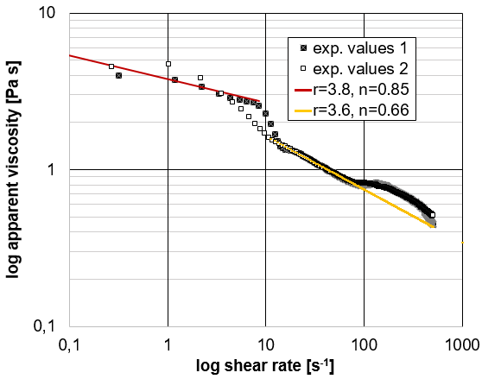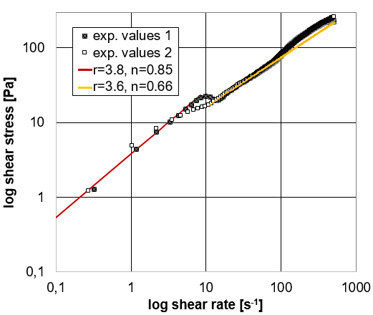
b
a
Figure 1: Rheological properties of bulk TLC material. (a) Apparent viscosity vs shear rate (T=25 °C) compared with Power-law correlations and (b) shear stress vs shear rate (T=25 °C) with a zoomed view of the TLC behaviour for shear rate values between 300 and 460 s⁻¹.
As it has been reported before that more than 50% of non-encapsulated TLC particles are destroyed when applied shear rate is larger than 400 s⁻¹ (Puccetti et al., 2016), a more detailed investigation for values above 300 s⁻¹ has been made (Figure 1b, zoomed view). The experimental measurements confirm that for shear rate values close to 400 s⁻¹, the TLC bulk material tends to change its rheological behaviour and this is due to a modification of the TLC chiral nematic structure.
This observation has been considered particularly noteworthy for determination of emulsification condition parameters in order to limit the impact of the emulsion preparation procedure on the material.
2.3 Contact angle and surface tension measurements
To study the main interaction parameters between TLC bulk material, solid walls and water, a series of tests have been conducted by means of the ‘sessile drop’ technique and vertical scanning interferometry.
When an interface exists between a liquid and a solid, the angle between the surface of the liquid drop and the outline of the contact surface is described as the contact angle θ.
Contact angle values of the sessile water drop, formed on a glass surface coated with bulk TLCs, are presented in Figure 2a. A dynamic variation of the contact angles between 74–96 degrees indicated a non-wetting surface and a low affinity to polar liquids (Dugyala et al., 2016). In particular, after the first 17 s, the contact angle decreased from 96 to 80 degrees due to the evaporation of water and agglomeration of non-wetting TLCs material on the edge of the drop. The analysis of the shape of the liquid drop surface highlights the opposite impact of the interfacial and gravitational forces. In fact, surface tension tends to minimize the surface area by making the drop spherical, while gravity deforms the drop by flattening the sessile drop (Figure 2b). Vertical scanning interferometry, shown in Figure 2b and 2c, accounted for the contact angle results and confirmed the high affinity of bulk TLCs towards fast agglomeration. These results suggest using a high concentration of stabilizing surfactant during the emulsification procedure of TLC bulk material.
In this paper, we used sodium dodecylsulfate (SDS) with M=288.38 g/mol and solubility of 150 g/L in H₂O.

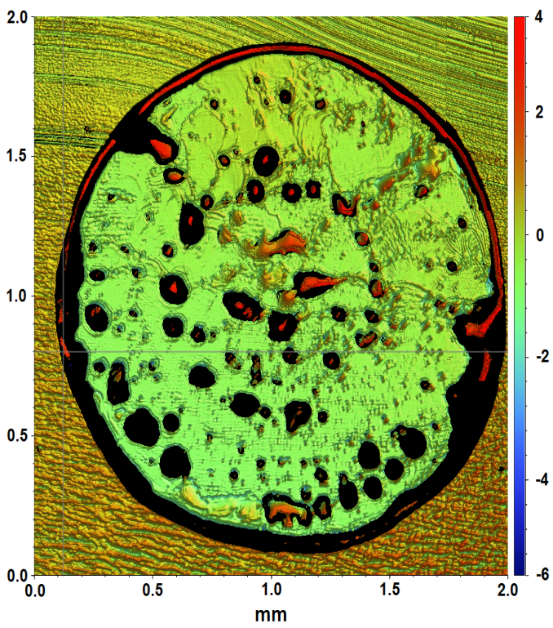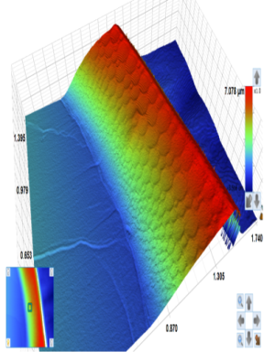
b
c
Figure 2: (a) Contact angle θ of a water droplet on TLC coated glass plate versus time @ T = 25 °C, (b) a top view of the sessile drop (magnification ×5) and (c) a 3D module of the TLCs on the edge of the drop
2.4 Experimental bulk TLC material calibration
A reliable relationship between the TLC particles’ colour play (24–39 °C) and their temperature had to be established. Thus, a simple experimental set-up based on a thin black copper block (12.3 × 6.9 cm, 3 mm thick), heated by means of a series of electrical resistances, was built. Three thermocouples were used in order to measure the temperature of the copper block surface in different locations. Yet, an additional thermocouple was positioned close to the block in order to monitor the room temperature.
The TLC bulk material sample was deposited on the block surface. The reflected light was recorded by a USB camera (Digital USB microscope camera, Conrad Electronic SE, ×800, 2MP). The temperature readings of the three thermocouples attached to the copper block were very close to each other (±0.5 K) by confirming a uniform temperature distribution on the block surface. The temperature of the block surface was modified by changing the electrical voltage applied to the resistances, and the whole colour play of the bulk material sample was obtained.
The captured colour images were transferred in JPEG format from the digital USB camera to a PC and further processed by using a Matlab Image Toolbox algorithm. In Figure 3a,b,c, typical images of the sample on the copper block for different values of the imposed surface temperature are shown. By means of a Matlab routine, the colour is analysed pixel by pixel and decomposed in RGB values. In Figure 4d, the trends of the intensity of the primary colours (Red (R), Green (G) and Blue (B)) were obtained by averaging the data contained in each image for a fixed surface temperature value.

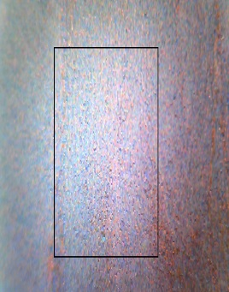  a  25.83 | 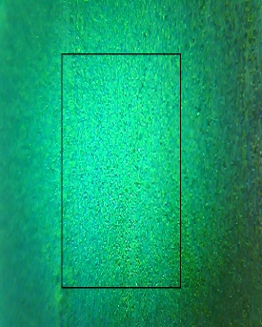  b  28.35 | c  36.52
Figure 3: Images of the bulk TLC sample placed on a copper block in correspondence of: (a) red (R) – 25.83 ºC, (b) green (G) – 28.35 ºC and (c) blue (B) colour – 36.52 ºC. (d) Scatter plot of average RGB values for a region of interest in accordance with results obtained by Segura et al., 2013

In Figure 3d, it is shown that the Red component (R) is present only in the temperature range between 24–28 °C; on the contrary, Green (G) and Blue (B) have an opposite trend as the temperature increases.
In order to obtain the calibration curve for the bulk material, the mean values of RGB intensities were converted into Hue Saturation Intensity (HSI) values by using the rgb2hsv Matlab function.
A fourth-degree polynomial fitting was used in order to link the mean hue value (H_ave) to the temperature measured by the thermocouples. The trend of the TLC bulk material calibration curve is shown in Figure 5b (see Section 3.2).
2.5 Emulsion preparation
In order to use TLC particles for microfluidic applications, Segura et al. (2013) dispersed TLCs as droplets in water, forming an oil-in-water emulsion. He decreased the bulk particles size from 50–100 µm to 13–15 µm by using Shirasu Porous Glass (SPG) membrane with a pore size of 5.5 µm. It was reported as the optimal emulsification technique, where applied shear stress was low enough to avoid the particles destruction, but yet high enough to obtain stable monodispersion. However, up to now, it was not investigated where is the lower limit of the TLC particle size that still can show the colour play, and how to obtain particles small enough for applications in gaseous microflows. Therefore, in this study, an oil-in-water emulsification technique is proposed by employing an Ultra-Turrax rotor-stator homogenizer, instead of costly SPG membranes. The range of the operating conditions was determined according to the research reported by Segura et al. (2013), Joseph et al. (2014), and all information obtained during TLC material characterization (i.e. max shear rate, viscosity and the surface tension between water and TLCs), presented in Section 2.2 and 2.3 of this paper.
The emulsification was initiated by dissolving 2.5 g of surfactant (SDS) in deionized water in a 50-ml glass beaker filled to the brim. The solution was continuously stirred for 3h at 300 rpm, until it was completely clear. Afterwards, approximately 3 g of TLC material was added directly into the solution and further dispersed by using an ‘Ultra-Turrax’ rotor-stator homogenizer at a minimum rotation speed of 11,000 rpm, for 1–2 min at room temperature. The beaker with emulsion was then closed and protected from light with an aluminium foil. Table 1 lists all main devices used for the TLC emulsification experiments.
The newly prepared emulsion consisted of a 10% volume concentration of TLC bulk material, stabilized with 7.5% volume concentration of SDS surfactant in deionized water. Such a high concentration of SDS - mass ratio 4:3 (w/w concentrations) was used in order to avoid a lack of emulsifier during the droplet disruption process and to provide a stable emulsion afterwards.
By using optical microscopy, the obtained emulsion has been characterized, the minimum size of the TLC droplets was measured and the droplet size distribution was obtained. Employing a digital colour camera mounted to an upright microscope, the colour play of the TLC droplets is checked in order to see if the smaller particles are able to maintain their properties in terms of sensitivity to temperature.
Table 1: Experimental instrumentation
Ref. | Component | Model
1. | Magnetic stirrer | IKA-Werke GmbH
2. | Ultra-Turrax  rotor-stator homogenizer | 25T digital- IKA®-Werke GmbH & Company KG
3. | Dispersion tool | S25N-10G- IKA®-Werke GmbH & Company KG
4. | Upright microscope | Leitz ERGOLUX 200, MA: ×20, ×50, ×100, ×200
5. | Digital colour camera | Olympus UC50, 5MP
6. | PC with Software | OLYMPUS Steam Image Analysis
  - Results
3.1 Droplet size distribution and stability
As the density of the liquid crystals and an isotropic liquid (H₂O) are close to each other, relatively stable emulsions can be obtained. The stability of a newly prepared emulsion and the droplets’ size distribution were checked and measured regularly after 1, 2 and 7 days in a steady state condition at room temperature (25 °C), by using a ‘Leitz ERGOLUX 200’ upright microscope with ‘OLYMPUS Steam Image Analysis’ software.
Typical images of the TLC-water emulsion are shown in Figure 4a,b.

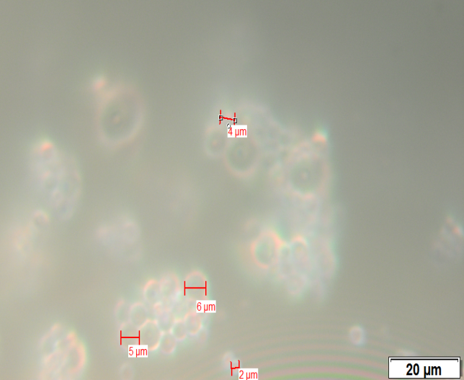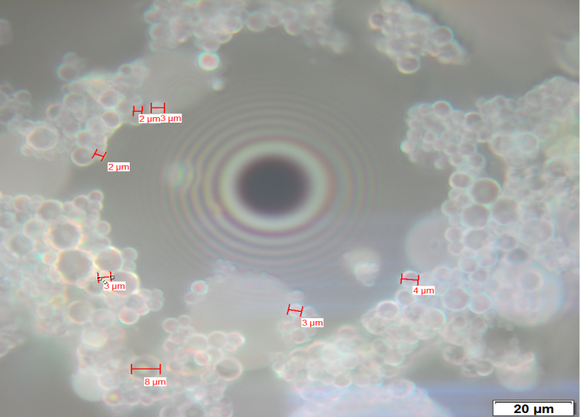
b
a
Figure 4: OM images of measured TLC droplet size with magnification ×100 (a) on a flat surface or (b) in a glass channel around an air bubble, and (c) compared droplet size distribution after 1 and 7 days

The emulsion was found quite stable, with a non-uniform droplet size distribution in the range of 1–25 µm.
In Figure 4c, the comparison of TLC droplet size distribution after 1 and 7 days is shown. The emulsion didn’t change significantly, though it does seem that the number of droplets with a diameter in the range of 2–4 µm decreased. The lowest measured droplet size is in the range of 0.33–0.5 µm, and more than 25% of the TLC particles are characterized by a diameter of 3 µm. The OM images in Figure 4a,b demonstrated that even the smallest TLC particles can still show a colour play, but the intensity of the reflected light becomes very low for particles smaller than 10 µm. This reduction of the reflected light can be due to the high concentration of surfactant needed to stabilize the emulsion, which may limit the portion of the particle that scatters colour.
In Figure 4b, the emulsion was observed in a 1 mm-channel micro-device. It is evidenced that, in the presence of air bubbles in water flow, the TLC droplets gather around the bubbles. Thus, in order to obtain a homogeneous distribution of TLC droplets in a microflow, it is important to completely degas the working liquid before the preparation of the emulsion, and afterwards the prepared emulsion again.
3.2 Experimental TLC emulsion calibration
After testing the emulsion’s stability, the colour play of bulk material and emulsion were compared to verify the impact of the emulsification procedure on the colour play of the bulk material. The same calibration procedure, described in Section 2.4, was repeated but, in the case of the emulsion, the colour of a 4×6 px single micro-droplet has been analysed (Figure 5a). In Figure 5b, the calibration curve associated with the single droplet is compared with the calibration curve obtained by testing the bulk material before emulsification. The results clearly demonstrate that the TLC calibration curve after the emulsification follows the same trend of TLC bulk material, but a slight shift is observed. It is evident that, after emulsification, the small micro-droplets can be still used as local temperature sensors in a flow, as the colour play is well defined in the range 24–36 °C. Unlike the bulk material, the small micro-particles show great accuracy in a red-colour range. However, in both cases, the blue colour appears earlier than declared by the manufacturer, and can be translated into temperature value with good accuracy up to 36 °C for micro-droplets and 39 °C for bulk material.
a
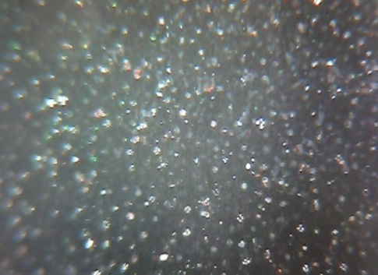 | b
Figure 5: (a) One analysed individual droplet with 4×6 px size and (b) comparison of calibration curves for the TLC bulk material and obtained emulsion
  - Conclusions
In this paper, a procedure for the production of TLC bulk material droplets is presented. The results demonstrate that it is possible to use ‘Ultra-Turrax’ rotor-stator homogenizer in order to obtain a stable oil-in-water emulsion with droplets size below 6 µm. However, the emulsion is not monodispersed and only 25% of particles are characterized by dimensions of 3 µm. The lowest measured droplet size is between 0.33–0.5 µm.
When the colour play of TLC bulk material and its emulsion were compared, the same curve trend was obtained.
Acknowledgments
This work, under the framework of ‘MIGRATE’ project, has received funding from the European Union’s Horizon 2020 research and innovation programme under the Marie Skłodowska-Curie grant agreement No. 643095.
References
Adrian R.J., 2005, Twenty years of particle image velocimetry, Exp Fluids, 39, 159–169, https://doi.org/10.1007/s00348-005-0991-7.
Basson M., Pottebaum T.S., 2012, Measuring the temperature of fluid in a micro-channel using thermochromic liquid crystals, Exp. Fluids, 53, 803–814.
Behle M., Schulz K., Leiner W., Fiebig M., 1996, Color-based image processing to measure local temperature distributions by wide-band liquid crystal thermography, Applied Scientific Research, 56, 113–143.
Cierpka C., Rossi M., Segura R., Kähler C.J., 2011, On the calibration of astigmatism particle tracking velocimetry for microflows, Meas. Sci. Technol., 22, 015401.
Dabiri D., 2009, Digital particle image thermometry/velocimetry: a review, Exp Fluids, 46, 191–241.
Dugyala V.R., Lama H., Satapathy D.K., Basavaraj, M.G., 2016, Role of particle shape anisotropy on crack formation in drying of colloidal suspension, Scientific Reports, 6, 30708.
Ireland, P.T., Jones, T.V., 1987, The response time of a surface thermometer employing encapsulated thermochromic liquid crystals, J Phys E Sci Instrum, 20, 1195–1199.
Joseph S., Bunjes H., 2014, Evaluation of Shirasu Porous Glass (SPG) membrane emulsification for the preparation of colloidal lipid drug carrier dispersions, Eur J Pharm Biopharm., 87, 178-186.
Kähler C.J., Scharnowski S., Cierpka C., 2012, On the resolution limit of digital particle image velocimetry, Exp Fluids, 52, 1629–1639.
Puccetti G., 2016, Optical Techniques for experimental tests in microfluidics, PhD Thesis, UNIBO, Retrieved from: http://amsdottorato.unibo.it/7534/
Puccetti G., Rossi M., Morini G.L., Kähler C.J., 2016, Sensitivity to shear stress of non-encapsulated thermochromic liquid crystal (TLC) particles for microfluidic applications, Microfluid Nanofluid, 20, 19. https://doi.org/10.1007/s10404-015-1694-x.
Sabatino D.R., Praisner T.J., Smith C.R., 2000, A high-accuracy calibration technique for thermochromic liquid crystal temperature measurements, Exp Fluids, 28, 497–505.
Sahoo R., Dhara S., 2018, A Short Review on the Rheology of Twist Grain Boundary-A and Blue Phase Liquid Crystals, Fluids, 3, 26. https://doi.org/10.3390/fluids3020026.
Segura R., Cierpka C., Rossi M., Joseph S., Bunjes H., Kähler C. J., 2013, Non-encapsulated thermo-liquid crystals for digital particle tracking thermography/velocimetry in microfluidics, Microfluid. Nanofluid., 14, 445-456.
Segura R., 2014, Thermo-liquid crystal (TLC) thermography and astigmatism particle tracking velocimetry (APTV) for the simultaneous time-resolved 3D measurements of microscopic temperature and velocity flow fields, PhD Thesis, Shaker Verlag GmbH, Germany
Schmeling D., Bosbach J., Wagner C., 2014, Simultaneous measurement of temperature and velocity fields in convective air flows. Meas Sci Technol, 25, 16.

