|  |  |
| --- | --- |
| cetlogo ***CHEMICAL ENGINEERING TRANSACTIONS***  ***VOL. 76, 2019*** | A publication of  aidiclogo_grande |
| The Italian Association  of Chemical Engineering  Online at www.cetjournal.it |
| Guest Editors: Sauro Pierucci, Jiří Jaromír Klemeš, Laura Piazza  Copyright © 2019, AIDIC Servizi S.r.l. **ISBN** 978-88-95608-73-0; **ISSN** 2283-9216 | |

Visible Light Driven Photocatalytic Hydrogen Evolution Using Different Sacrificial Reagents

Vincenzo Vaiano, Giuseppina Iervolino\*

Department of Industrial Engineering, Univerisity of Salerno, Fisciano (Italy)

giiervolino@unisa.it

In this work the photocatalytic hydrogen production from aqueous solution containing organic compounds, using perovskite based photocatalyst supported on magnetic particles, was studied. In particular a photocatalyst based on Ru doped LaFeO3 was used. The photocatalyst was prepared by solution combustion synthesis using citric acid as organic fuel, and it was characterized by different techniques, such as XRD, UV-Vis DRS and Raman spectroscopy. This semiconductor has shown photocatalytic activity in presence of visible light and it was supported on Fe2O3 magnetic particles in order to remove it easily at the end of the process. The Fe2O3 particles were prepared by combustion flame synthesis, using [citric acid](https://www.sciencedirect.com/topics/chemistry/citric-acid) as organic fuel and metal [nitrate](https://www.sciencedirect.com/topics/chemistry/nitrate) as [iron oxide](https://www.sciencedirect.com/topics/chemistry/iron-oxide) precursor. The Ru-LaFeO3 photocatalyst was coupled with magnetic Fe2O3 particles by a physical mixture in order to ensure a tight contact between the two solid phases (Ru-LaFeO3/Fe2O3). Photocatalytic tests were carried out in a pyrex cylindrical reactor equipped with a N2 distributor device and irradiated by visible-LEDs. Different aqueous solution containing organic compounds such as ethanol, glycerol or methanol were tested. The experimental results evidenced that the higher hydrogen production (about 10000 μmol L-1 after 4 h of irradiation time) was obtained in presence of methanol. The magnetic composite showed a very high stability also after several reuse cycles.

* 1. Introduction

The research of new technologies that enable the production of energy is nowadays one of the topics of greatest interest to the scientific community ([Baleta et al., 2019](#_ENREF_1)). An interesting alternative to fossil fuels is represented by hydrogen ([Cui et al., 2019](#_ENREF_6)), which is benign and recyclable. Several methods for hydrogen production have been investigated ([Ni et al., 2006](#_ENREF_14), [Ruocco et al., 2019](#_ENREF_18)), but in particular, a significant attention has been given to the photocatalysis as a novel method for converting solar energy into H2 ([Iervolino et al., 2016](#_ENREF_8)). Photocatalytic water splitting using semiconductor has received much attention due to the potential of this technology, as well as the great economic and environmental interest for the production of the clean fuel H2 from water using solar energy ([Chiarello and Selli, 2010](#_ENREF_4)). Titanium dioxide was the first material investigated for water splitting reaction ([Kumaravel et al., 2019](#_ENREF_12)) but various other photocatalysts, like mixed oxides and perovskites, have been widely studied for the photocatalytic hydrogen generation reaction ([Chen et al., 2010](#_ENREF_3)). Perovskite photocatalysts are quite encouraging materials for water splitting owing to their stability in water ([Iervolino et al., 2016](#_ENREF_8)). The excellent catalytic activity of LaFeO3 is well known ([Iervolino et al., 2016](#_ENREF_8)), because of its high stability, non-toxicity and small band gap energy ([Li et al., 2007](#_ENREF_13)). In order to enhance the photocatalytic hydrogen production, the use of a sacrificial agent (organic substance) in the photocatalytic system is proposed ([Christoforidis and Fornasiero, 2017](#_ENREF_5)). The photocatalytic reforming of organic compounds may be a good approach since the process can be carried out under mild conditions and driven by sunlight. Organic compounds, such as alcohols and sugars can act as sacrificial agents in the photocatalytic hydrogen production because these substances are able to combine with the holes in the valence band more effectively than water ([Rossetti, 2012](#_ENREF_16)). This process can be useful for water depuration purpose with the hydrogen production from the degradation of the organic compounds present in wastewater ([Iervolino et al., 2018](#_ENREF_9)). For this reason the photoreforming of organic compounds can be seen as a very interesting process for the hydrogen production and, at the same time, for the wastewater treatment. In a paper by Christoforidis and Fornasiero ([Christoforidis and Fornasiero, 2017](#_ENREF_5)) many examples of organic compounds used for enhancing the photocatalytic hydrogen production has been reported. Generally, the photocatalytic process takes place in a batch slurry reactor in which the catalyst is kept in suspension ([Priya and Kanmani, 2009](#_ENREF_15)). The use of suspended and dispersed photocatalysts has some unique advantages such as the high mass transfer of the reactants and products on the catalyst surface, which results in high degradation rates of organic compounds ([Vaiano et al., 2014](#_ENREF_19)). However, the use of suspended semiconductors presents also some disadvantage such as the difficult separation and recovery of photocatalyst after the water treatment. To overcome this drawback, the photocatalysts can be immobilized on supports. Moreover it is important to consider that in the case of photocatalytic reactions for the hydrogen production, the slurry configuration is able to guarantee very high reaction kinetics. For this reason, in order to immobilize the photocatalyst but, at the same time, guarantee the performance of a slurry reactor, an interesting alternative is represented by magnetic particles as supports for the photocatalysts. In this case, the prepared photocatalyst will have both photocatalytic functions under light irradiation and magnetic separation functions by using an external magnetic force. So, in this work it was evaluated the effectiveness of Ru doped LaFeO3 photocatalyst immobilized on magnetic particles for hydrogen production from aqueous solution containing different types of organic compounds in presence of visible light. In literature, there are already reported the performances of this catalytic formulation in the hydrogen production from aqueous solution containing glucose ([Iervolino et al., 2018](#_ENREF_9)). In this case, the aim was to compare the photocatalytic hydrogen production obtained from aqueous solutions containing organic substances different from glucose (ethanol, glycerol and methanol) and evaluate the stability of this photocatalyst after several reuse cycle.

* 1. Experimental
     1. Photocatalyst preparation and characterizations

The procedure for preparing the catalyst used in these tests has already been reported in a previous work ([Iervolino et al., 2018](#_ENREF_9)). In particular, the combustion flame synthesis was used to prepare both Ru doped LaFeO3 (at 0.47 mol% Ru) and magnetic particles Fe2O3. In details, for the Ru doped LaFeO3 synthesis 1.66 g of Fe(NO3)3·9H2O (Riedel-deHaen, 97 wt%), 1.78g of La(NO3)3·6H2O (Fluka, 99%), 0.86g of citric acid (Fluka, 99 wt%) and a specific amount of RuCl3 ( (Sigma Aldrich, 99%) were completely dissolved in 100 ml of bidistilled water. The solution was kept stirred continuously at 60 °C for 5 min. Then, ammonium hydroxide (Carlo Erba, 37 wt %) was slowly added to regulate the pH of the solution up to 7.0. The solution was dried at 130° C and then calcined at 300° C for 3 h to ignite the solution combustion reaction. Also the Fe2O3 particles were prepared by solution combustion synthesis, using citric acid as organic fuel and metal nitrate as iron oxide precursor. The Ru-LaFeO3 photocatalyst was then deposited on the magnetic Fe2O3 particles (Ru-LaFeO3/Fe2O3) through a physical mixture in order to ensure a tight contact between the two solid phases. The best Ru-LaFeO3 amount in the composite (67 wt %) was optimized in a previous work ([Iervolino et al., 2018](#_ENREF_9)). The physical mixture was dispersed in 22.5 ml of distilled water and maintained under mechanical stirring until to obtain a uniform dispersion. Then, 0.45 ml of Tetraethyl orthosilicate (TEOS), 3mL of ethanol and 4.5 ml of NH3 were added to the aqueous suspension. The mixture was kept under stirring for 12 h at 25 °C and then centrifuged. Finally, the recovered sample was calcined at 450° C for 30 min to obtain the Ru-LaFeO3/Fe2O3 composite. The prepared samples were characterized by different techniques. In particular, X-ray diffraction patterns were obtained with an X-ray diffractometer (Assing) using Cu-Kα radiation, UV–vis reflectance spectra of powder catalysts were recorded by a Perkin Elmer spectrometer Lambda 35 using a RSA-PE-20 reflectance spectroscopy accessory (Labsphere Inc., North Sutton, NH). All spectra were obtained using an 8° sample positioning holder, giving total reflectance relative to a calibrated standard SRS-010-99 (Labsphere Inc., North Sut-ton, NH).

The Raman spectra of the samples were obtained with a Dispersive MicroRaman system (Invia, Renishaw), equipped with 785 nm diode-laser, in the range 100-1000 cm-1 Raman shift.

* + 1. Photocatalytic tests

The photocatalytic experiments were carried out with a pyrex cylindrical reactor (ID = 2.5 cm) equipped with a N2 distributor device (Q=0.08 NL min-1). Different organic substances added to the aqueous solution were used to evaluate the photocatalytic hydrogen production: glucose, ethanol, glycerol and methanol. The initial concentration of these organic substances in aqueous solution was equal to 1000 mg L-1. To ensure the complete mixing of the solution in the reactor, a peristaltic pump was used.

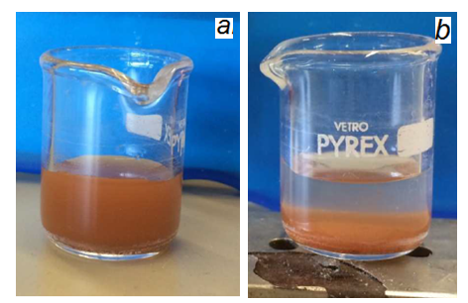

Figure 1: Photocatalysts particles before (a) and after (b) the application of an external magnetic force.

Table 1: Composition and band gap energy value for the photocatalyst and composite

|  |  |  |  |  |
| --- | --- | --- | --- | --- |
| Catalyst | Ru amount  [mol%] | |  | | --- | | Ru-LaFeO3 loading  [wt %] | | Band gap [eV] |
| Ru-LaFeO3 | 0.47 | - | 2.00 |
| Fe2O3 | - | - | 1.85 |
| Ru-LaFeO3 /Fe2O3 | 0.47 | 67 | 1.96 |

The suspension was left in dark conditions for 2 h to reach the adsorption-desorption equilibrium of organic substances on the photocatalyst surface, and then 4 h of experiment under visible light was performed.

The photoreactor was irradiated by a visible LEDs strip (with the wavelength emission in the range 400-700 nm) positioned around the external surface of the reactor. Typically, 67.5 mg of catalyst were suspended in 45 ml of aqueous solution (1.5 g L-1 catalyst dosage) containing the desired sacrificial organic agent.

The analysis of the gaseous phase from the photoreactor was performed by continuous H2 analyzer (ABB Advance Optima). At the end of the photocatalytic test, photocatalysts particles were removed by an external magnetic force (Figure 1). The reusability of the photocatalyst recovered after the test was investigated too.

* 1. Results and discussion
     1. Photocatalyst characterizations

XRD measurement results for Fe2O3 particles, Ru-LaFeO3 and Ru-LaFeO3 /Fe2O3 composite are shown in Figure 2. The XRD patterns for Fe2O3 show the presence both of -Fe2O3 and of Fe2O3 species ([Iervolino et al., 2018](#_ENREF_9)). The -Fe2O3 species are responsible for the magnetic properties of Fe2O3, as also reported in literature ([Basavaraja et al., 2007](#_ENREF_2)).

In particular for the Ru-LaFeO3 /Fe2O3 composite, it is possible to observe the simultaneous presence of the peaks related to Fe2O3 and the Ru-LaFeO3 photocatalyst (at 32.04°, 39.55°, 45.99° and 57.15°).

Figure 3 shows the characterization results performed by Raman spectroscopy. In the case of Ru-LaFeO3 / Fe2O3 sample, only signals associated to the magnetic particles Fe2O3 are present. No signals relatted to the Ru-LaFeO₃ catalyst are detectable, indicating a good dispersion of the catalyst on the Fe2O3 particles.

The data obtained from UV–vis reflectance spectra were used for evaluating the band-gap energy of the photocatalysts. In particular, the band-gap energy determinations of the photocatalysts were obtained from Kubelka–Munk function F(R∞) by plotting [F(R∞) x hν]2vs. hν

The obtained results are reported in [Table 1](https://www.sciencedirect.com/science/article/pii/S0926337317301121?via%3Dihub#tbl0005). It was possible to observe that the band gap of the Ru-LaFeO3/Fe2O3 photocatalyst was equal to 1.96 eV so it is lower than that one of Ru-LaFeO3 photocatalyst (equal to 2.00 eV), but it is higher than that of magnetic Fe2O3 particles (1.85 eV). This difference is an effect of coupling Ru-LaFeO3 photocatalyts with Fe2O3 magnetic particles.

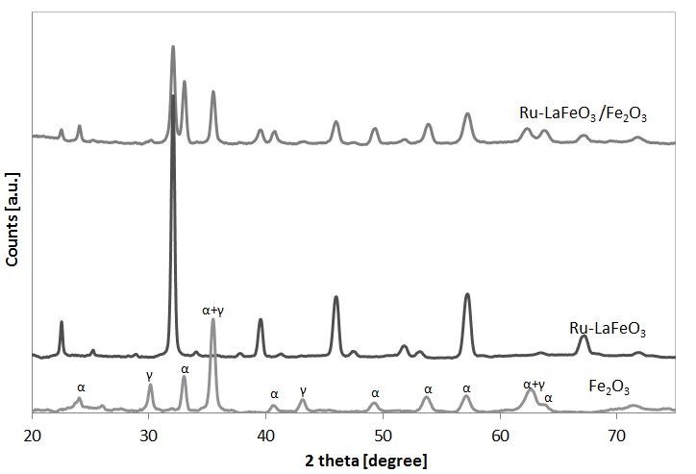

Figure 2: XRD diffractograms

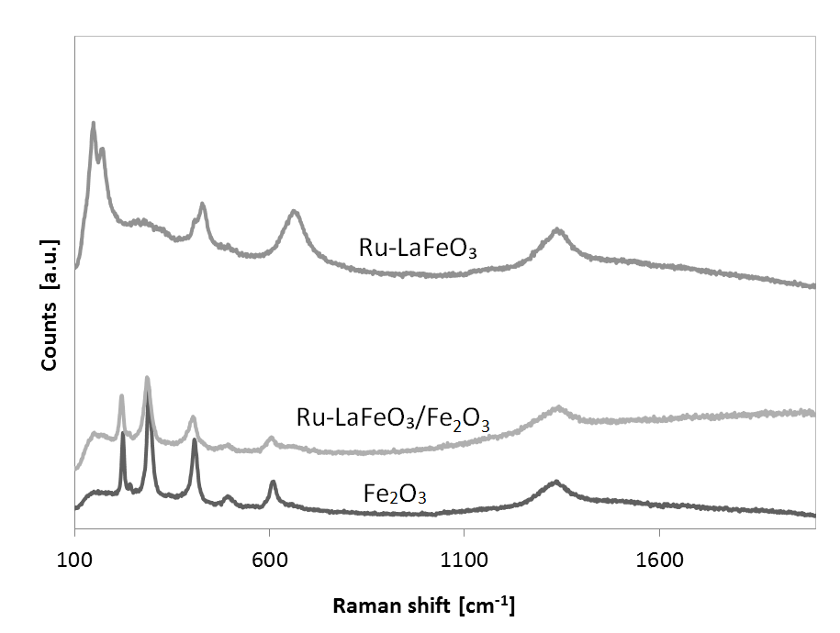

*Figure 3: Raman spectra*

* + 1. Photocatalytic hydrogen production

In Figure 4 it is reported the photocatalytic hydrogen production using Ru-LaFeO3/Fe2O3 photocatalyst in presence of different organic substances in aqueous solution. It is possible to note that, after 4 h of visible irradiation, the hydrogen production was equal to 1500, 2730, 4430 and 10100 µmol L-1 for ethanol, glycerol, glucose and methanol respectively (Figure 4).

In all cases, the amount of hydrogen produced during the photoreactions increased with the irradiation time, indicating that no catalyst deactivation phenomena occurred.

From the results it is evident that glucose is one of the organic substances whose characteristics make it better than ethanol and glycerol in the photocatalytic production of hydrogen, as had already been reported in the literature ([Iervolino et al., 2017](#_ENREF_7), [Kawai and Sakata, 1980](#_ENREF_10)).

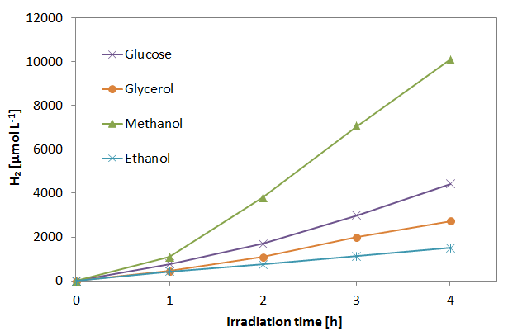

*Figure 4: Photocatalytic hydrogen production with different organic substances. Photocatalyst :* Ru-LaFeO3 / Fe2O3. *Catalyst dosage: 1.5 g L-1. Organic substances initial concentration: 1000 mg L-1.*

However the best hydrogen production (10100 µmol L-1) under visible light was obtained in presence of methanol. In literature it was reported that the photocatalytic mechanism of hydrogen production from methanol could derive from direct oxidation on h+, generating hydrogen ions and aldehydes ([Kočí et al., 2018](#_ENREF_11)). According to Kocí et al., the rapid increase in the generation of hydrogen in presence of methanol is due to the fact that the photogenerated electrons can be used for the reduction of H+ and to the simultaneous presence of the water splitting reaction ([Kočí et al., 2018](#_ENREF_11)). Moreover, the hydrogen production obtained in this work, under visible light and without the addition of noble metals, is higher than that reported in literature in presence of methanol aqueous solution under UV light ([Kočí et al., 2018](#_ENREF_11)) and with Au or other noble metals ([Rossetti et al., 2017](#_ENREF_17)).

Recyclability is one of the most important factors in catalysis research. To confirm the recyclability of Ru-LaFeO3 /Fe2O3 sample, the photocatalytic hydrogen production in presence of methanol after 5 cycles was evaluated (Figure 5).

After the first use, the reduction of hydrogen production percentage was as low as 1-2% after 4 h of irradiation time. So, these results evidenced the stability of the photocatalyst and the reproducibility of the process in the hydrogen production in presence of methanol.

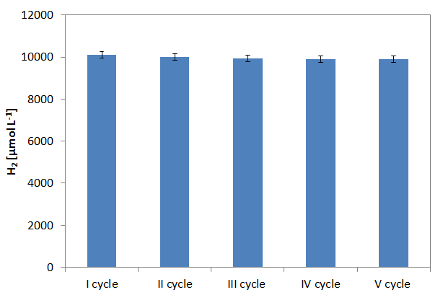

*Figure 5: Recyclability tests. Photocatalyst:* Ru-LaFeO3 /Fe2O3. *Catalyst dosage: 1.5 g L-1. Methanol initial concentration: 1000 mg L-1.*

* 1. Conclusions

The use of a perovskite based photocatalyst, doped with ruthenium, supported on magnetic particles (Fe2O3) for the photocatalytic hydrogen production from organic substances has proved to be very interesting from several points of view. The synthesis of this photocatalyst, although characterized by several steps, was simple and effective, as reported by the characterizations results. In particular, by coupling the Ru-LaFeO3 catalyst with the Fe2O3 magnetic particles, a composite with both the active phases of the two used semiconductors was obtained. The demonstration of this result was highlighted both by XRD results where it is possible to note the presence of the characteristic peaks of both the Ru-LaFeO3 and Fe2O3 but also by the band gap values of the composite (1.96 eV). From the photocatalytic results it was observed that the highest hydrogen production (about 10100 µmol L-1 after 4 h of visible irradiation time) was obtained in the presence of methanol (at 1000 mg L-1 initial concentration) in aqueous solution. In addition, the photocatalyst proved to be effective even after 5 cycles of use, confirming its stability and reusability.

References

Baleta, J., Mikulčić, H., Klemeš, J. J., Urbaniec, K. & Duić, N. 2019. Integration of energy, water and environmental systems for a sustainable development. Journal of Cleaner Production, 215**,** 1424-1436.

Basavaraja, S., Vijayanand, H., Venkataraman, A., Deshpande, U. & Shripathi, T. 2007. Characterization of γ‐Fe2O3 Nanoparticles Synthesized Through Self‐Propagating Combustion Route. Synthesis and Reactivity in Inorganic, Metal-Organic, and Nano-Metal Chemistry, 37**,** 409-412.

Chen, X., Shen, S., Guo, L. & Mao, S. S. 2010. Semiconductor-based photocatalytic hydrogen generation. Chemical reviews, 110**,** 6503-6570.

Chiarello, G. L. & Selli, E. 2010. Photocatalytic hydrogen production. Recent Patents on Engineering, 4**,** 155-169.

Christoforidis, K. C. & Fornasiero, P. 2017. Photocatalytic hydrogen production: a rift into the future energy supply. ChemCatChem, 9**,** 1523-1544.

Cui, X., Su, H. Y., Chen, R., Yu, L., Dong, J., Ma, C., Wang, S., Li, J., Yang, F., Xiao, J., Zhang, M., Ma, D., Deng, D., Zhang, D. H., Tian, Z. & Bao, X. 2019. Room-temperature electrochemical water–gas shift reaction for high purity hydrogen production. Nature Communications, 10, 1-8.

Iervolino, G., Tantis, I., Sygellou, L., Vaiano, V., Sannino, D. & Lianos, P. 2017. Photocurrent increase by metal modification of Fe2O3 photoanodes and its effect on photoelectrocatalytic hydrogen production by degradation of organic substances. Applied Surface Science, 400**,** 176-183.

Iervolino, G., Vaiano, V., Sannino, D., Rizzo, L. & Ciambelli, P. 2016. Photocatalytic conversion of glucose to H2 over LaFeO3 perovskite nanoparticles. Chemical Engineering Transactions, 47**,** 283-288.

Iervolino, G., Vaiano, V., Sannino, D., Rizzo, L., Galluzzi, A., Polichetti, M., Pepe, G. & Campiglia, P. 2018. Hydrogen production from glucose degradation in water and wastewater treated by Ru-LaFeO3/Fe2O3 magnetic particles photocatalysis and heterogeneous photo-Fenton. International Journal of Hydrogen Energy, 43**,** 2184-2196.

Kawai, T. & Sakata, T. 1980. Conversion of carbohydrate into hydrogen fuel by a photocatalytic process. Nature, 286**,** 474-476.

Kočí, K., Reli, M., Edelmannová, M., Troppová, I., Drobná, H., Rokicińska, A., Kuśtrowski, P., Dvoranová, D. & Čapek, L. 2018. Photocatalytic hydrogen production from methanol over Nd/TiO2. Journal of Photochemistry and Photobiology A: Chemistry, 366**,** 55-64.

Kumaravel, V., Mathew, S., Bartlett, J. & Pillai, S. C. 2019. Photocatalytic hydrogen production using metal doped TiO2: A review of recent advances. Applied Catalysis B: Environmental**,** 244, 1021-1064.

Li, S., Jing, L., Fu, W., Yang, L., Xin, B. & Fu, H. 2007. Photoinduced charge property of nanosized perovskite-type LaFeO3 and its relationships with photocatalytic activity under visible irradiation. Materials Research Bulletin, 42**,** 203-212.

Ni, M., Leung, D. Y., Leung, M. K. & Sumathy, K. 2006. An overview of hydrogen production from biomass. Fuel processing technology, 87**,** 461-472.

Priya, R. & Kanmani, S. 2009. Batch slurry photocatalytic reactors for the generation of hydrogen from sulfide and sulfite waste streams under solar irradiation. Solar Energy, 83**,** 1802-1805.

Rossetti, I. 2012. Hydrogen production by photoreforming of renewable substrates. ISRN chemical engineering, 2012, doi:10.5402/2012/964936.

Rossetti, I., Bahadori, E., Villa, A., Prati, L. & Ramis, G. 2017. Hydrogen production by photoreforming of organic compounds, *55-59* .

Ruocco, C., Palma, V. & Ricca, A. 2019. Hydrogen production by oxidative reforming of ethanol in a fluidized bed reactor using a Pt–Ni/CeO2–SiO2 catalyst. International Journal of Hydrogen Energy, DOI: [10.1016/j.ijhydene.2018.12.154](http://dx.doi.org/10.1016/j.ijhydene.2018.12.154).

Vaiano, V., Sacco, O., Stoller, M., Chianese, A., Ciambelli, P. & Sannino, D. 2014. Influence of the photoreactor configuration and of different light sources in the photocatalytic treatment of highly polluted wastewater. International Journal of Chemical Reactor Engineering, 12**,** 63-75.