CHEMICAL ENGINEERING TRANSACTIONS  VOL. 76, 2019 | A publication of
The Italian Association
of Chemical Engineering
Online at www.aidic.it/cet
Guest Editors: Sauro Pierucci, Jiří Jaromír Klemeš, Laura Piazza
Copyright © 2019, AIDIC Servizi S.r.l.
ISBN 978-88-95608-73-0; ISSN 2283-9216

Preliminary analysis of mass dispersion in solid foams: separation of nitrogen/hydrogen mixtures in a packed membrane module as a case study
Maria Anna Murmuraª*, Stefano Cerbelliª, Alexios-Spyridon Kyriakides^{b}, Spyros Voutetakis^{b}, Panos Seferlis^{c}, Simira Papadopoulou^{d}, Maria Cristina Annesiniª
ªUniversity of Rome “Sapienza”, Department of Chemical Engineering, Materials and Environment, Via Eudossiana 18, 00184 Rome, Italy
^{b}Chemical Process & Energy Resources Institute (C.P.E.R.I.), Center for Research and Technology Hellas (C.E.R.T.H.), P.O. Box 60361, 57001, Thermi-Thessaloniki, Greece
^{c}Department of Mechanical Engineering, Aristotle University of Thessaloniki, P.O. Box 484, 54124 Thessaloniki, Greece
^{d}Department of Automation Engineering, Alexander Technological Educational Institute of Thessaloniki, P.O. Box 141, 57400 Thessaloniki, Greece
mariaanna.murmura@uniroma1.it
Membrane reactors for low-temperature hydrogen production are receiving significant attention. The main design challenges include the choice of appropriate membranes, catalysts, and catalyst supports. Research on the mechanical supports has been addressed towards the use of solid foams; however, information regarding mass dispersion within these foams is still lacking, even though the resistance to mass transport in the packed bed may become relevant when using a good catalyst and a high-permeability membrane. The aim of the present work is to carry out a preliminary analysis of mass dispersion in solid foams. To this end, experiments have been carried out for hydrogen separation from binary hydrogen/nitrogen mixtures using a packed membrane separator. The configuration adopted consists in two co-axial cylinders. A Pd-based membrane, permeable to hydrogen only, is placed on the outer wall of the innermost tube. A SiC solid foam is placed in the volume between the two cylinders. Experimental results were analyzed with the support of a 2D isothermal model of a packed membrane separation module, previously developed by some of the same authors of this study. The model has been used to fit an effective Péclet number (Pe_{eff}) in each condition. These values were then compared to the molecular Péclet number (Pe). The solid foams were found to convey lower dispersion than traditional packed beds and the lower axial dispersion favors the overall separation efficiency.
  - Introduction
The main design challenges for membrane reactors for low-temperature hydrogen production include the choice of an appropriate membrane in terms of both material (e.g., Pd, Pd alloy) and support (e.g., stainless steel, ceramic), the identification of catalysts that are active at the lower operating temperature and yet resistant to deactivation (e.g., due to coke formation), and the realization of mechanical supports for the catalysts capable of guaranteeing low pressure drops and high heat transfer rates. With regards to the membrane, it is now well known that Pd-based membranes present high hydrogen permeability, along with infinite selectivity. Ongoing research is focused particularly on the choice of alloys that could reduce inhibition by competitive adsorption without significantly reducing membrane permeability and selectivity (Abir and Sheintuch, 2016; Murmura and Sheintuch, 2018). For the choice of the catalysts’ active components, in the case of steam reforming of light hydrocarbons, catalysts that allow high reaction rates have been successfully identified (Turchetti et al., 2016; Kyriakides et al., 2014).
Open-cell foams are attracting increasing interest for use as catalyst support. These materials consist of a network of interconnected solid struts that form void spaces, known as cells, connected to each other through windows, which allow the passage of fluids. Interest in these materials as mechanical supports for catalysts has been growing in virtue of their high porosity and surface area. In addition, they present high thermal conductivity, high mechanical stability, and chemical resistance. Lucci et al. (2015) compared the catalytic performance of open cell structures and honeycombs and found that the enhanced mass transport characteristics of the former allow the achievement of the same conversion rate as honeycombs with only a fraction of the catalytic surface, meaning that a significant reduction in the amount of catalyst employed can be achieved. This is particularly significant if one considers the high cost of noble metal catalysts. In the same work, the authors also point out the difficulty in comparing the performance of the two types of catalyst supports due to their inherently different structures. For instance, when comparing the trade-off between conversion and pressure drops, the authors find that honeycombs perform better than foams with the same degree of porosity. On the other hand, when the pressure drop is fixed, foams achieve a higher conversion than honeycombs. In fact, a similar study carried out by Patcas et al. (2007) concerning the ratio between conversion rate and pressure drop, predicted a lower performance of foams with respect to honeycombs when considering structures characterized by the same specific surface area. This result confirmed the findings of Giani et al. (2005) who studied the catalytic oxidation of CO on a coated ceramic foam under conditions in which the reactor performance was limited by mass-transport, i.e. when the characteristic time of the reaction was much smaller than that of mass transport. The authors found that the same conversion as the one achieved with honeycombs could be reached in a volume reduce by 2.5-3 times by supporting the catalyst on foam. On the other hand, all of the works cited report the advantage of using foams compared to packed pellet beds.
Despite recent efforts, a clear understanding of the behavior of open-cell foams as catalysts supports is still missing. This is mainly due to the wide variety of characteristics with which these foams can be realized. For example, foams may differ in construction material, mean pore diameter, strut dimension, porosity, and specific surface area. In their study of residence time distribution and tortuosity of flow, Habisreuther et al. (2009) found that structures having identical porosity and specific surface area present different fluid dynamic behaviour, indicating that these two parameters are not sufficient to characterize them. When describing the performance of a reactor packed with an open-cell foam, the description of the system is further complicated by the competition between mass transport by convection, dispersion, and reaction, as well as by the effects of heat transport in a non-isothermal system. The development of realistic models describing such devices cannot be carried out independently from a characterization of mass transport in the solid foams. In this view, the present work focuses on an experimental study of mass dispersion in SiC foams. The study has been carried out using a double-pipe membrane separator. The foam was packed in the annular volume between two tubes and was fed with binary nitrogen/hydrogen mixtures of different composition. A membrane, permeable to hydrogen only, was placed on the outer wall of the innermost tube. The membrane permeability value utilized in the present work for the simulation of the system under consideration was measured in previous studies. The separation of the binary gas mixture was tested in different experimental conditions and results have been analyzed through a two-dimensional CFD model. The temperature was maintained constant throughout the experiments in order to rule out the effects of heat transport. In this manner, it has been possible to fit values for the effective Péclet number (Pe_{eff}), defined as the ratio between the characteristic times of dispersion and convection. This work represents a novel procedure to characterize mass transport in open-cell foams.
  - Experimental study
Experiments have been carried out for hydrogen separation from binary hydrogen/nitrogen mixtures of different total inlet flow rates and compositions using a packed membrane separator. The configuration adopted consists in two co-axial cylinders. A Pd-based membrane, permeable to hydrogen only, was placed on the outer wall of the innermost tube. A SiC solid foam, with a void fraction of 0.85, was placed in the volume between the two cylinders. A scheme of the reactor configuration is shown in Figure 1, whereas a summary of the operating conditions tested during the experimental campaign is reported in Table 1. For each experimental run, the test duration was long enough so that steady state conditions were reached. This was evaluated by analyzing over time the outlet permeate stream composition using a GC analyzer. Moreover, the selectivity of the membrane towards hydrogen was tested after every change in experimental conditions by analyzing the outlet permeate stream composition by means of gas chromatography. Results showed that only hydrogen was present in the permeate side confirming the infinite selectivity of palladium towards hydrogen permeation.
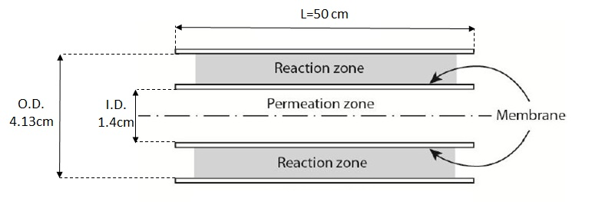
Figure 1: Schematic representation of the reactor.
Table 1: Summary of experimental conditions.
T  [°C] | P retentate  [bar] | P permeate  [bar] | Total inlet flow rate  [Ncc/min] | Inlet composition  [mol fraction] H₂/N₂ | H₂ permeate outlet flow rate  [Ncc/min]
~450 | 4-9 | 1.5 | 3000-7500 | 0.34/0.66-0.86/0.14 | 230-5200

  - Model development
The model was developed under the assumptions of uniform temperature and axial symmetry, based on previous works carried out by some of the same authors on a packed membrane separator (Murmura et al., 2016) and a membrane reactor (Murmura et al., 2017 and 2017a), in which the results had been validated against the experimental data of Mori et al. (2007). The model presented here was extended to account for mass transport in the permeate side. In the retentate side, momentum transport was described through Darcy's law for flow in porous media, accounting for pressure gradients in both the axial and radial directions. Mass transport equations accounted for dispersive and convective transport in both the radial and axial directions. Density variations due to changes in composition and in pressure were accounted for. In this way the momentum and mass balance equations are fully coupled. With regards to hydrogen permeation, Sieverts’ law was applied, according to which the permeating flux is proportional to the difference between the square roots of the partial pressure of hydrogen in the retentate and permeate sides (Ward and Dao, 1999). The model was solved using COMSOL Multiphysics.
The problem was also studied in its dimensionless formulation using the inlet velocity in the retentate side, U, as reference velocity; the inner radius of the separator, R₁, as characteristic dimension; the atmospheric pressure, P_{atm}, as reference pressure; and the molecular weight of hydrogen, W_{h}, as reference mass. In this context, the gradient operator, ∇, is also expressed in its dimensionless form $\tilde{∇}=∇∙R_{1}$. A detailed description of the model development is reported in the past work and the main equations relative to the retentate side are reported again here in their dimensionless form. The continuity, momentum, and mass balance equations are given by Eqs. (1)-(3) and the boundary conditions are given by Eqs. (4)-(6)
$$\tilde{∇}∙\left(\tilde{f}\tilde{P}\tilde{∇}\tilde{P}\right)=0$$ | (1)
$$\tilde{v}=-U_{C}\tilde{∇}\tilde{P}$$ | (2)
$$\tilde{∇}∙\left(-\frac{1}{β}\tilde{f}\tilde{P}ω_{h}\tilde{∇}\tilde{P}-\frac{1}{Pe}\tilde{f}\tilde{P}\tilde{D}∙\tilde{∇}ω_{h}\right)=0$$ | (3)
where f is the average molecular weight, P is the pressure, and U_{c} is the characteristic velocity, defined as $U_{c}=-{}/{}∙{P_{atm}}/{R_{1}}$, in which κ is the bed permeability and μ is the viscosity of the gaseous mixture.
in $\tilde{z}=0$
$${\tilde{v}}_{z}=1 ; ω_{h}=ω_{h}^{0}$$ | (4)
in $\tilde{z}=L/R_{1}$
$$\tilde{P}=P_{L}/P_{atm} ; \frac{∂ω_{h}}{∂\tilde{z}}=0$$ | (5)
in $\tilde{r}=1$
$\left(-\frac{1}{β}ω_{h}\tilde{∇}\tilde{P}-\frac{1}{Pe}\tilde{D}∙\tilde{∇}ω_{h}\right)∙n_{1}=γ\left(\sqrt{\frac{ω_{h}}{\tilde{f}\tilde{P}}}-\frac{1}{\tilde{f}\tilde{P}}\sqrt{\frac{ω_{p,h}{\tilde{f}}_{p}{\tilde{P}}_{p}}{W_{h}}}\right)$ ; $\left(-\frac{1}{β}ω_{h}\tilde{∇}\tilde{P}\right)∙n_{1}=γ\left(\sqrt{\frac{ω_{h}}{\tilde{f}\tilde{P}}}-\frac{1}{\tilde{f}\tilde{P}}\sqrt{\frac{ω_{p,h}{\tilde{f}}_{p}{\tilde{P}}_{p}}{W_{h}}}\right)$ | (6)

in $\tilde{r}=R_{2}/R_{1}$
$\left(-\frac{1}{β}ω_{h}\tilde{∇}\tilde{P}-\frac{1}{Pe}\tilde{D}∙\tilde{∇}ω_{h}\right)∙n_{2}=0$ ; $\tilde{∇}\tilde{P}∙n_{2}=0$ | (7)

In the above equations, n₁ and n₂ are local unit vectors normal to the surface and oriented outward the reaction volume, and the following dimensionless groups appear
$$β=\frac{κ}{μ}\frac{P_{atm}}{R_{1}U}$$ | (8)
which represents the ratio between the characteristic and inlet velocities

$$γ=\frac{P_{m}RTP_{atm}^{-1/2}}{W_{h}U}$$ | (9)
the dimensionless permeability parameter, where $P_{m}$ is the membrane permeability and $R$ is the gas constant

$$Pe=\frac{UR}{D}$$ | (10)
the molecular Péclet number, where $D$ is the molecular diffusivity. The effective Péclet number is defined as

${Pe}_{eff},z=\frac{UR}{D_{zz}}$ ; ${Pe}_{eff},r=\frac{UR}{D_{rr}}$ | (11)

Since the foam was considered to be isotropic, $D_{zz}$=$D_{rr}$ and ${Pe}_{eff,z}={Pe}_{eff,r}$.
  - Results and discussion
The results of the fitting procedure are summarized in Table 3. As shown in Figure 2, a linear correlation was found between the molecular and effective Péclet numbers, which for the foams tested, could be described by

$${Pe}_{eff}=0.24Pe+1.53$$ | (12)

Figure 3 shows, for the range of Pe investigated, a comparison between the Pe_{eff} obtained in the present work for solid foams and the corresponding values, in the axial and radial directions, evaluated for a packed bed through the correlation proposed by Delgado (2006), as described by Eqs (13):

$\frac{1}{{Pe}_{eff,z}}=\frac{1}{τ}\frac{1}{Pe}+\frac{δ}{2}$ ; $\frac{1}{{Pe}_{eff,r}}=\frac{1}{τ}\frac{1}{Pe}+\frac{δ}{12}$ | (13)

where τ is a tortuosity factor, usually considered to be equal to $\sqrt{2}$and $δ$ is the ratio between the characteristic dimension of the packing material and the characteristic dimension of the reactor. The results show that that Pe_{eff} in solid foams is higher than both the axial and radial Pe_{eff} in packed beds.
Table 2: Fitted values of Pe_{eff}.
P retentate  [bar] | H₂ inlet  [Ncc/min] | N₂ inlet  [Ncc/min] | H₂ outlet (retentate)  [Ncc/min] | H₂ outlet (permeate)  [Ncc/min] | Fitted Pe_{eff}
9 | 1500 | 1500 | 360 | 1140 | 15
9 | 1500 | 2000 | 470 | 1030 | 15
9 | 1500 | 2450 | 620 | 880 | 20
9 | 1500 | 3000 | 750 | 750 | 21
4 | 6000 | 1500 | 1800 | 4200 | 35
4 | 4500 | 1500 | 1450 | 3050 | 30
4 | 3000 | 1500 | 1340 | 1660 | 28

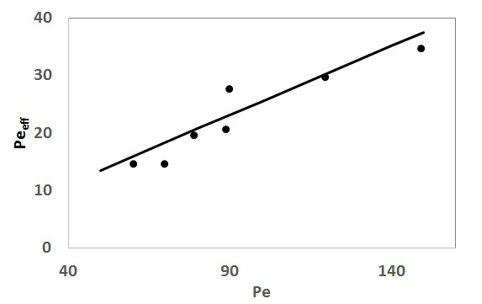
Figure 2: Correlation between the molecular and effective Péclet numbers.
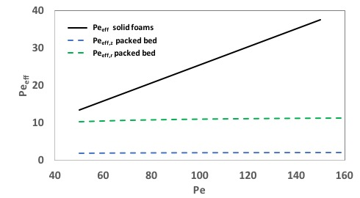
Figure 3: Comparison between the Pe_{eff} correlations in solid foams (solid line) and packed beds (dashed lines).

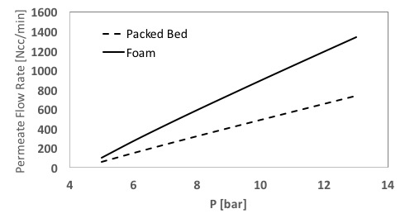
Figure 4: Comparison between separator performances with solid foams and packed beds.
The higher value of the axial Peeff in solid foams indicates a lower axial dispersion, which enhances the separation efficiency, as shown in Figure 4, where hydrogen permeate flow rates of separation modules packed with either pellets or a solid foam are compared. The results refer to a separation module having the same geometric characteristics as those used in the experiments described in the present work, without using sweep gas, at a temperature of 450°C and total pressure in the permeate side of 1.5 bar. Figure 5 shows the hydrogen mass fraction profiles obtained in the two membrane modules when working with a pressure in the retentate side of 10 bar. The lower dispersion in the module packed with solid foams favors the formation of steep concentration gradients and consequently improves the performance of the separator.

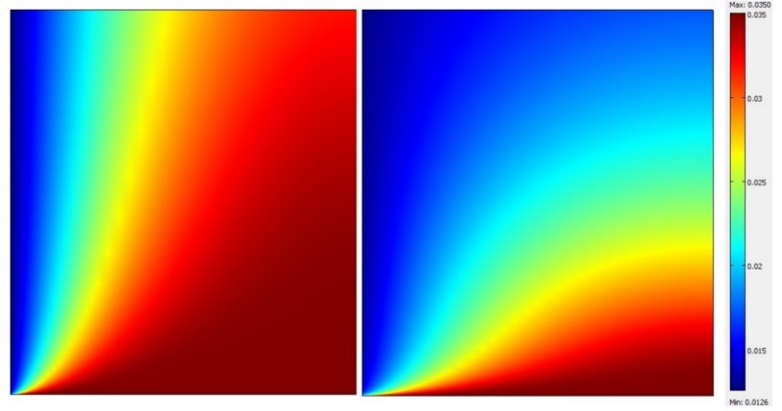
Figure 5: Hydrogen mass fraction profiles in membrane separators packed with pellets (left) and solid foams (right) at 10 bar and 450°C. The z and r axes are not in scale for visualization purposes.
  - Conclusions
In the present work experiments have been carried out on a membrane separation module packed with solid foams with the aim of evaluating Pe_{eff}. The results have shown that, under the conditions investigated, a linear relationship exists between the molecular and effective Péclet numbers, whereas a saturation limit for the Pe_{eff,r} and Pe_{eff,z} is found in packed beds under the same conditions. The solid foams were found to convey a lower dispersion than packed beds, which increased the overall separation efficiency. Future work should be carried out using foams with different geometric characteristics, in order to define the relationship between the coefficients of the linear correlation with the geometric parameters describing the foam.
References

Abir, H., Sheintuch, M., 2016, Modeling H₂ transport through a Pd or Pd/Ag membrane, and its inhibition by co-adsorbates, from first principles, AIChE Journal, 62, 2112-2125.
Delgado, A., 2006, A critical review of dispersion in packed beds, Heat and Mass Transfer, 42, 279-310.
Giani, L., Groppi, G., Tronconi, E, 2005, Mass-transfer characterization of metallic foams as supports for structured catalysts, Industrial & Engineering Chemistry Research, 44, 4993-5002.
Habisreuther, P., Djordjevic, N., Zarzalis, N., 2009, Statistical distribution of residence time and tortuosity flow through open-cell foams, Chemical Engineering Science, 64, 4943-4954.
Kyriakides, A.S., Rodríguez-García, L., Voutetakis, S., Ipsakis, D., Seferlis, P., Papadopoulou, S., Enhancement of pure hydrogen production through the use of a membrane reactor, 2014, International Journal of Hydrogen Energy, 39, 4749-4760.
Lucci, F., Della Torre, A., Montenegro, G., Eggenschwiler, P.D., 2015, On the catalytic performance of open cell structures versus honeycombs, Chemical Engineering Journal, 264, 514-521.
Mori, N., Nakamura, T., Noda, K., Sakai, O., Takahashi, A., Ogawa, N., Sakai, H., Iwamoto, Y., Hattori, T., 2007. Reactor conﬁguration and concentration polarization in methane steam reforming by a membrane reactor with a highly hydrogen-permeable membrane. Industrial & Engineering Chemistry Research, 46,1952–1958.
Murmura, M.A., Cerbelli, S., Turchetti, L., Annesini, M.C., 2016, Transport-permeation regimes in an annular membrane separator for hydrogen purification, Journal of Membrane Science, 503, 199-211.
Murmura, M.A., Cerbelli, S., Annesini, M.C., 2017, Modelling and optimization of hydrogen yield in membrane steam reforming reactors, Canadian Journal of Chemical Engineering, 95, 1676-1682
Murmura, M.A., Cerbelli, S., Annesini, M.C., 2017a, Transport-reaction-permeation regimes in an annular membrane separator for hydrogen purification, Chemical Engineering Science, 162, 88-103.
Murmura, M.A., Sheintuch, M., 2018, Permeance inhibition of Pd-based membranes by competitive adsorption of CO: membrane size effects and first principles predictions, Chemical Engineering Journal, 347, 301-312.
Patcas, F.C., Garrido, G.I., Kraushaar-Czarnetzki, B., 2007, CO oxidation over structured carriers: a comparison of ceramic foams, honeycombs and beads, Chemical Engineering Science, 62, 3984-3990.
Turchetti, L., Murmura, M.A., Monteleone, G., Giaconia, A., Lemonidou, A.A., Angeli, S.D., Palma, V., Ruocco, C., Annesini, M.C., 2016, Kinetic assessment of Ni-based catalysts in low-temperature methane/biogas steam reforming, International Journal of Hydrogen Energy, 41, 16856-16877.

