|  |  |
| --- | --- |
| cetlogo ***CHEMICAL ENGINEERING TRANSACTIONS***  ***VOL. 76, 2019*** | A publication of  aidiclogo_grande |
| The Italian Association  of Chemical Engineering  Online at www.cetjournal.it |
| Guest Editors: Sauro Pierucci, Jiří Jaromír Klemeš, Laura Piazza  Copyright © 2019, AIDIC Servizi S.r.l. **ISBN** 978-88-95608-73-0; **ISSN** 2283-9216 | |

Process measuring, monitoring and control at lab-scale:   
an added value for practical training

Michele Miccioa,\*, Giovanni Casconea, Bartolomeo Cosenzaa, Mariagrazia Fortea, Michela Fraganzaa, Paola Brachib, Antonija Čelanc

aUniversity of Salerno – Department of Industrial Engineering, Via Giovanni Paolo II 132, 84084 Fisciano (SA), Italy

bInstitute for Research on Combustion, (IRC-CNR), P.le Tecchio 80, 80125 Napoli, Italy

cUniversity of Split – Faculty of Chemistry and Technology, Dept. Chem. Engineering, R. Boskovica 35, 21000 Split, Croatia

\*mmiccio@unisa.it

Open loop dynamic testing and closed loop automatic control have been devised, implemented and quantitatively evaluated on a portable laboratory workstation, with the aim of serving Chemical and Process Engineering students with practical training. A basic case study was conceived on level control. Classical evaluations, both qualitative and quantitative, were carried out on the dynamic response experimentally obtained on the workstation, either at open or closed loop, including the quality of the feedback action by means of the controller performance indexes (e.g., IAE; ISE; ITAE; ITSE).

Although conceptually simple, the experimental activities turned out a rather demanding task in terms of time, data elaboration and interpretation work, but they provided a continuous beneficial interaction between the lecturer and the student. The developed technique, the tests with the workstation and the encouraging results obtained so far promise to be a very useful educational tool for undergraduate students in classes on Process Control, with the added value of directly involving and better motivating both students and instructors.

* 1. Introduction

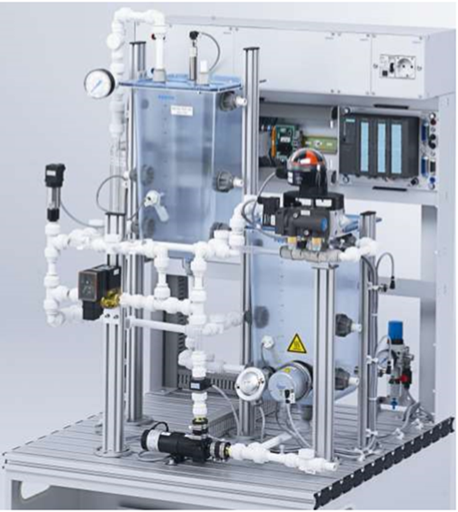

Figure 1: A picture of the compact workstation   
(courtesy of FESTO MPS-PA®)

A huge amount of research papers is available in literature on the basic concept of process control, e.g., 36,679 papers found under the keyword “feedback control” (www.sciencedirect.com): the subject is still hot. However, their number drastically reduces when adding the extra keyword “training”, e.g., 310 papers found under the keyword “training” (www.sciencedirect.com). On the other side, there is a variety of training-oriented, soft-based resources on the web, either academic (e.g., ocw.mit.edu) or from organizations of professionals (e.g., cache.org) or from specialized sites (e.g., demonstrations.wolfram.com). In this framework, Matlab is a well-known and widely used platform (e.g., Arrieta et al., 2017; Cosenza and Miccio, 2017; Miccio and Cosenza, 2014).

The training-oriented, hard-based resources for process dynamics, automatic control, feedback concept, etc. are quite scarce and less renowned. Some authors have tried to build their own facilities (e.g., Ramos et al., 2017). This work is intended to take advantage of a new hard resource, the MPS® PA COMPACT WORKSTATION, and to provide a first exploitation of it as an educational facility. It is a portable laboratory unit for practical training of students in Chemical and Process Engineering, supplied by FESTO CTE Srl to the University of Salerno in 2016 and involved in a starting cooperation with the University of Split.

* 1. Materials and methods

The MPS® PA COMPACT WORKSTATION is equipped with basic hardware and software for modern process measurements and automatic control, in particular (see Figure 1) with:

* a 1x1 m2 wheeled carryon base;
* basic process components like transparent tanks, piping, cocks, an air-to-liquid heat exchanger, etc.;
* sensors of different types with which it is possible to measure temperature, pressure, flow rate and level of liquids (e.g., water);
* final control elements like control valves, a centrifugal pump, a liquid heater, variable-speed fans, etc.;
* actuators like digital/analog driven electric motors, etc.;
* a communication module, i.e., EasyPortUSB, for input/output analogical and digital data exchange;
* a dedicated software, i.e., Fluid Lab-PA®, for on-line monitoring, acquiring and controlling process variables, as well as implementing feedback control loops and a PID regulator;
* a wide technical documentation, including the general Piping and Instrumentation Diagram (P&ID, not reported here) as well as data sheets provided by the manufacturer.

Plain water was used as the process liquid in the experiments with the workstation.

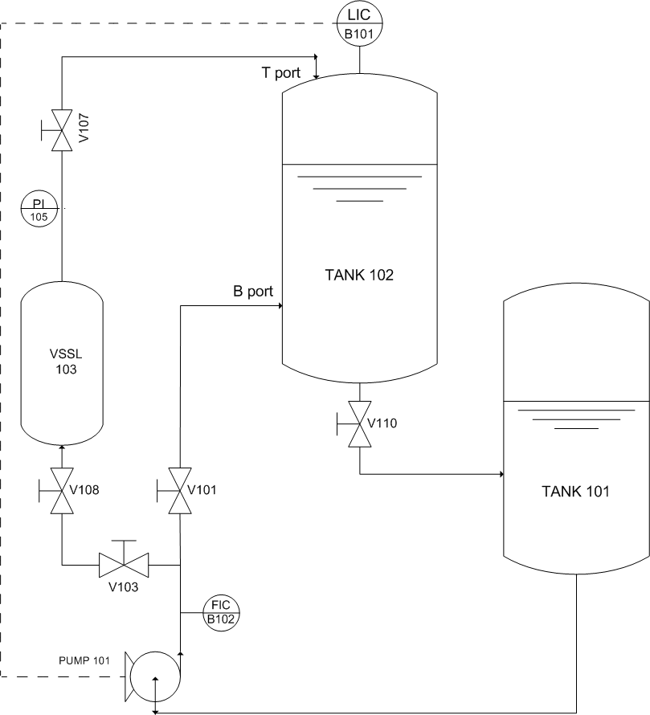

Figure 2: Simplified PI&D of the system recirculating a liquid between two tanks at different heights, with level monitoring and control for the upper tank. T port: feeding from top; B port: feeding from bottom.

The adopted methodology consisted in:

* identify and set up a suitable case study within the architecture of the FESTO MPS-PA workstation
* identify the manipulated variable, the disturbance and the controlled variable within such a case study
* according to the process reaction curve method (Stephanopoulos, 1984), in an open loop configuration, obtain the actual dynamic response to a step change of an input variable on the FESTO MPS-PA workstation
* from the such a dynamic response, fit a first-order-plus-dead-time (FOPDT) model approximating the dynamic system and determine its parameters
* determine the best tuning parameters and implement a PID controller via software
* in the feedback closed loop configuration, test the “disturbance rejection” and the “set point tracking” actual performances on the FESTO MPS-PA workstation
* carry out a qualitative and quantitative analysis of the feedback-controlled system response, making use of the performance indices, too.
  1. Results and discussion
     1. Case Study development

It consists of a continuous system recirculating a liquid (e.g., water) between two tanks placed at different heights, with level monitoring and control for the tank located at a higher elevation. Figure 2 shows the simplified PI&D drawn for this case study.

Simply, the pump P101 delivers water from TANK 101 to TANK 102 through a piping set-up (see Figure 2, T port configuration), which includes the manual valves V103, V108, V107 and V110. An operation is considered for which the level of the liquid in the TANK 102 is always higher than that in the TANK 101. The TANK 102 level is monitored by an ultrasonic sensor at the measuring point LIC-B101 and is transduced as volume [L]. The current signal [4 ÷ 20 mA] from the sensor is sent to a measurement transformer that converts it into a voltage signal [0 to 10 V], which can be used on the pump acting as a final control element. The water flow rate acts as the manipulated variable: it is monitored by an optoelectronic sensor at the point FIC-B102 downstream from the pump P101 and is transduced as L/min. The "Fluid-Lab PA" software allows studying the open loop dynamics through the "Measuring and Control" window, which shows a process time chart (see Figure 3).

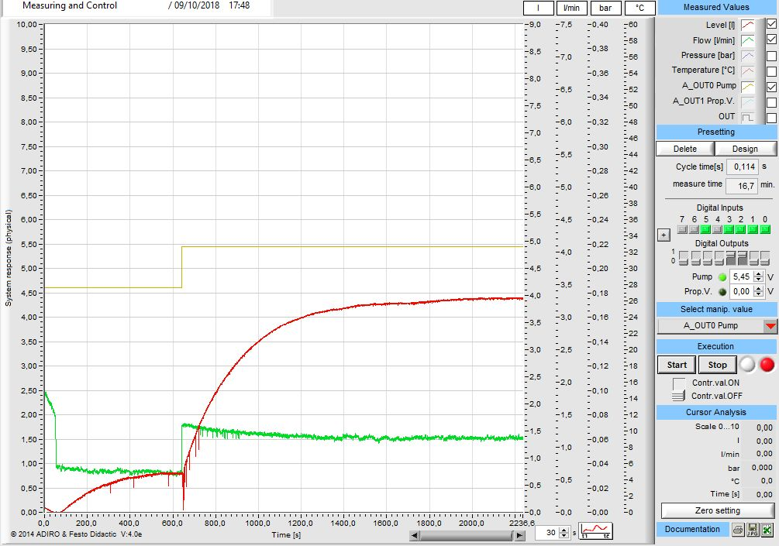

**output variable**: level of the tank located at a higher elevation (red curve)

**input variable**:voltage signal [0 to 10 V] to the pump (ochre curve)

**manipulated variable**: water flow rate delivered by the pump (green curve)

Figure 3: A screenshot from the "Measuring and Control" window of the "Fluid-Lab PA" software showing the main commands and setting (right panel) and the process Time Chart (left panel)

* + 1. Open loop experimental testing

A starting operating condition is considered at rest (t = 0) by which the pump P101 is stopped, the liquid is almost all in the TANK 101 and the TANK 102 almost emptied. When the pump starts working, there is no level increase due to the incoming flow rate in the first 50 s: this "apparent Dead Time" occurs because the liquid needs time to fill the pipes that vertically connect the two tanks. Then, the TANK 102 level gradually increases until it reaches a steady state of 1 L under continuous water recirculation, while keeping the manual valve V110 partially open (see Figure 2) and the manual valves V103, V108 and V107 fully open. It is worth noting that the pump control signal CO=4.60 V (see ochre curve in Figure 3) was set specifically to bring the tank TANK 102 level equal to the visual value of 1 L at steady state.

For open loop testing, the TANK 102 level is the output variable, whereas the pump voltage is the input variable.

A dynamical volume change of 3 L is devised, that is raising the level from 1 L to 4 L. This is carried out, while being at steady state, by applying a step variation of the pump voltage CO from 4.60 to 5.45 V (see ochre curve in Figure 3) at a suitable time (i.e., tustep = 650 s). Correspondingly, the flow rate ${\dot{V}}_{in}$ delivered by the pump suddenly jumps (see green curve in Figure 3) and the TANK 102 level begins to increase. A higher liquid level induces a rise in the hydrostatic head, which increases the outgoing flow ${\dot{V}}_{out}$ until it will equal the inlet flow ${\dot{V}}_{in}$ to the TANK 102, at the settling time (i.e., tsettling ≅ 2000 s), which corresponds to a new steady state (Vss = 4 L). Therefore, the dynamic system studied here is self-regulating.

The time-recorded profile of the output variable after the step change of the input variable (i.e., the system dynamic response) is fitted to a first*-*order*-*plus*-*dead*-*time (FOPDT) linear model approximating the dynamic system (Stephanopoulos, 1984):

$τ_{P}\frac{dV\left(t\right)}{dt}+V\left(t\right)=K_{P}∙CO\left(t-t_{d}\right)$ ()

where the unknownparameters are: the process gain *KP*, the process time constant *τP* and the apparent dead time *td*. They are off-line determined by treating the log file (ASCI format, downloaded by Fluid-Lab PA) of the time-recorded system response with the CONTROL STATION LOOP-PRO® software (Loop Pro® Trainer , 2018), thus yielding: KP = 3.79 $\left[\frac{L}{V}\right]$, τp = 248.74 s, td= 6.51 s, with a goodness of fit that is fully satisfactory, i.e., r2 = 0.9987, SSE = 1.42 L.

Table 1: PID tuning parameters

|  |  |  |  |
| --- | --- | --- | --- |
|  | **KC** | **τi [s]** | **τD [s]** |
| P-Only | 4.53 |  |  |
| PI | 2.09 | 248.74 |  |
| PID Ideal | 2.36 | 252.0 | 3.21 |

Further, the LOOP-PRO software provides the optimal parameters for a PID controller with the IMC formulas (Cooper, 2008), which are in Table 1.

* + 1. Closed loop experimental testing

The above PID parameters can be manually implemented in the "Closed-loop Control - continuous" function inside the Fluid-Lab PA software. In the closed loop configuration, the TANK 102 level is the controlled variable, the pump voltage is the controller output, whereas the set point refers to volume, obviously.

First, the PI controller action is considered in a set point tracking experiment.

The monitoring of the control is shown in Figure 4, where the axis on the right shows the values of set point, controlled variable and manipulated variable in a non-dimensional [0 to 1] form.

The selected initial condition at t=0 is such that the water volume in TANK 102 is 1.4 L, whereas the set point is fixed to 1 L (see the axis scale on the left) or, equivalently, 0.111 (see the axis scale on the right). Under such an initial condition, the test starts with a level higher than the set point value, the TANK 102 (see red curve in Figure 4) and the underlying piping are emptied, the pump P101 is switched off and allows a backflow to the TANK 101. During such a transient, a peculiarity of the chosen feedback control configuration can be noticed: the PI controller does not “feel” the fast rate of volume decrease and does not forecast that the piping will be emptied. Therefore, after it started at t=0 without any control action, it continues to do so (i.e., CO=0) until the measured level falls below the set point value (see Figure 4) at t = 54 s. At this time, the controller output turns on, begins to grow hurriedly (see green curve in Figure 4) and triggers a higher and higher pumped flow rate; such a compensating action, however, is not capable to maintain the set point to SP=1 L and is not fast enough to prevent emptying, of both the TANK 102 (see red curve in Figure 4) and the upstream piping. After an “apparent Dead Time”, the controller action succeeds in a slow rise of the level and, eventually, in reaching the steady state at SP = 1 L, at t = 850 s approximately.

Figure 4 also shows sudden and strong falling peaks in the level measurement and similar fluctuations of CO, in the opposite direction. Again, this phenomenon is due to a peculiarity of the adopted hydraulic circuit, in particular the choice of feeding water to TANK 102 from the top, which causes splashes and turbulence on the surface of the free surface in the tank and, therefore, a disturbance in the measurements of the ultrasonic level sensor B101. They appear as a signal noise (e.g., electromagnetic); actually, they are a “physical” noise acting on the measure of PV (red curve). In turn, they are reflected in the controller error (not shown here) and in CO pattern (green curve), which exhibits a similar noise in Figure 4.

The set point tracking experiment is carried out at tustep=1524 s when the set point is stepped-up to the new value SP=4 L (see black curve in Figure 4). First, a spike in the controller output is noticed up to saturation (CO=100%). Then, the controlled variable (PV) begins to increase and, in an opposed way, the controller output decreases. The desired SP value is met approximately at tsettling≅1700 s, and then maintained. Therefore, the dynamical response of the closed loop controlled recirculation system exhibits a settling time τsettling=(1700 – 1524) ≅ 175 s. It is worth noting that, at the higher values of level, the previous sequence of strong peaks in both PV and CO disappears because there is an actual reduction in water surface turbulence. Only small oscillations remain around a constant value, denoting measurement noise.

The same experimental test was repeated by adopting a PID controller action, with the related parameters. Here, the results are not reported for sake of shortness, but they were characterized by wider and continuous CO oscillations, due to the derivative action of the PID controller, which is known to be very sensitive to noise.

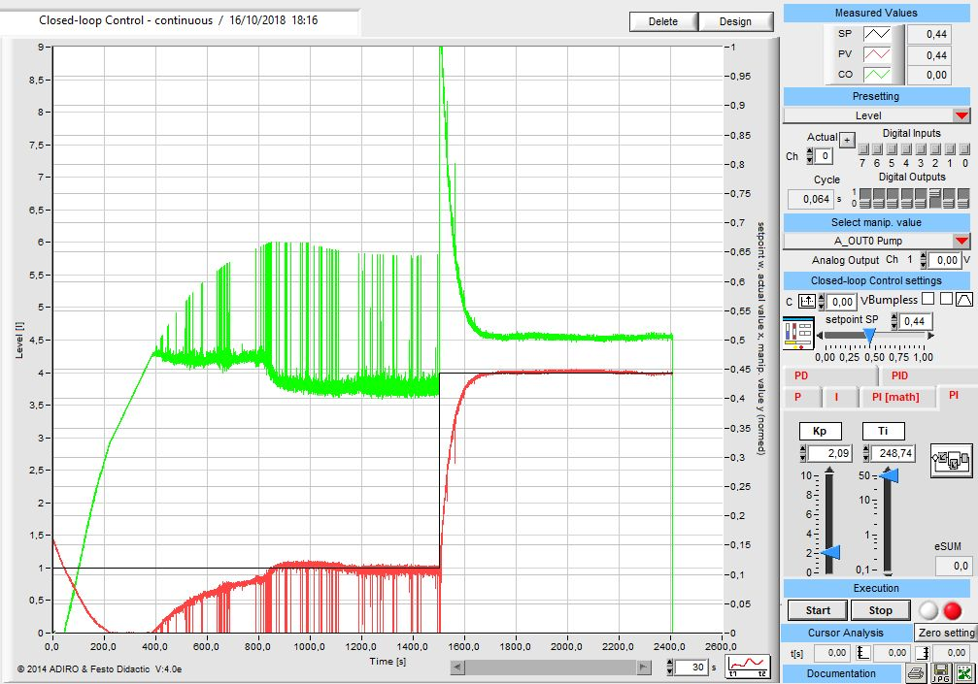

**controlled variable (PV)**: level of the upper tank (red curve)

**controller** **output (CO**:voltage signal to the pump (green curve)

**set point (SP):** water volume in the upper tank (black curve)

Figure 4: A screenshot from the "Closed-loop Control - continuous" window of the "Fluid-Lab PA" software showing the main commands and setting (right panel) and the process Time Chart (left panel)

* + 1. Performance criteria for the closed-loop set point tracking experiment

The adopted performance criteria are based on minimization of error ε(t) = SP(t) – PV(t) over time (Stephanopoulos, 1984) and are defined in Table 2.

Actually, the Fluid-Lab PA software displays (see Figure 4) and logs SP(t) and PV(t) as non-dimensional values, i.e., normalized with respect to the maximum allowed level value (9 L).

The time interval to be considered for error calculation goes from tustep until a time, let us say at tsup, at which the steady state is well established. This latter is a bit controversial and tsup has been determined in two different ways: i. the tsup value is user-defined as the end of the acquisition time after the steady state has been reached; ii. the tsup value corresponds to a time at which the relative error $ε_{rel}={|ε|}/{{|ε}_{max}|}$ becomes less than a predetermined threshold, i.e., εrel = 5%.

Therefore, in the present case it is tustep=1524 s, whereas tsup=2411 s according to the (i) criterion and tsup=1624 s according to the (ii) criterion.

Table 2: Time performance criteria for the closed loop, set point tracking experiments

|  |  |  |  |  |
| --- | --- | --- | --- | --- |
| Criterion | Integral of Absolute Error  IAE | Integral of Squared Error  ISE | Integral of Time-weighted Absolute Error  ITAE | Integral of Time-weighted Squared Error  ITSE |
| User |  |  |  |  |
| Relative error |  |  |  |  |

The calculation of ITAE and ITSE requires that the time starts from zero as the time variable appears within the integral (see Table 2). This entails a change of variable t' = t – tustep. Therefore, the lower extreme of the integrals becomes t'inf=0 s; on the other side, the upper extreme is t'sup=(tsup – tustep)=887 s according to the (i) criterion and t’sup=100 s according to the (ii) criterion.

The integrals were calculated numerically in MS EXCEL® with the trapezoidal rule. The results are in Table 2 and are here compared, for brevity, in relation to the previously discussed choice of tsup. The IAE and ISE indexes are practically the same, with quite reasonable numerical values. The ITAE and ITSE indexes are obviously larger in their order of magnitude; the values calculated according to the (ii) criterion are lower as a consequence of the correspondingly smaller choice made for tsup.

* + 1. Comparison with a different hydraulic circuit configuration

An interesting comparison emerges from the results obtained by Forte (2017), basically the same study case with a slightly different implementation of the hydraulic circuit on the FESTO workstation; in practice, water was recirculated to the TANK 102 below the liquid head, i.e., near the bottom (Figure 2, B port configuration). Again, open and closed loop step tests were carried out and the level of TANK 102 was allowed to vary from 1 to 4 L.

Because of the different configuration, less liquid volume was required to fill the piping supplying the TANK 102; on the other hand, the centrifugal PUMP 101 worked with a smaller pump head and a larger flow rate.

Briefly, the comparison can be summarized as an evident difference in the dynamics both at open and closed loop. As an example, tsettling, i.e., the time required to attain a new steady state after a step change in an input variable, is approximately halved in Forte’s case, both at open and closed loop; as a consequence of this, the optimal PID parameters have conspicuously different values, namely Kc and τI.

As a more general outcome, the dynamics of the recirculation system between the two tanks at different elevations with liquid supply from top is “lazier” than the case with bottom feeding. However, both configurations react as dynamical systems with a self-regulating and overdamped step response.

* 1. Conclusions

The developed methodology, the tests with the workstation and the encouraging results obtained so far promise to be very interesting. They provide added value to conventional teaching of Process Measuring and Control, making easier and more attractive the job of collective lab training, either for a group of students or the whole class. In addition, they lend themselves to be readily available testing and training tools for individual students involved in a practical project work, either at the home University or in a mobility program (e.g., Erasmus).

Acknowledgments

The Authors are thankful to Eng. Faliero Vittorini as well as to students Pierluigi Cesaro and Antonio Vespoli for their assistance. Funding from FondoFunzLab2015, Didactic Council of Chemical Engineering, University of Salerno and from the COST action CA15118 is acknowledged.

References

Arrieta L., Obregon L.G., Valencia-Ochoa G., 2017, A Matlab-based program for the design and simulation of wet cooling towers, Chemical Engineering Transactions, 57, 1585-1590 DOI: 10.3303/CET1757265

cache.org (last accessed January 25, 2019)

Cooper D.J., 2008, Practical Process Control, Control Station Inc., USA

Cosenza B. and Miccio M., 2017, A GUI for dynamics and feedback control studies: focus on chemical reactors, Proc. of the 5th ACSEE, Rome (Italy), May 27-28, 52–56 DOI: 10.15224/978-1-63248-122-1-32

demonstrations.wolfram.com/search.html?query=feedback+control (last accessed January 25, 2019)

Forte M.G., 2017, Bachelor thesis, University of Salerno (IT)

Miccio M. and Cosenza B., 2014, Control of a distillation column by type-2 and type-1 fuzzy logic PID controllers, Journal of Process Control, 24 (5), 475–484 DOI: 10.1016/j.jprocont.2013.12.007

ocw.mit.edu/courses/chemical-engineering/10-450-process-dynamics-operations-and-control-spring-2006/#tech\_requirements (last accessed January 25, 2019)

Ramos V.S., Sena H. J., Fileti A.M.F., Silva F.V., 2017, Teaching multivariable MPC in a laboratory scale three-tank process, Chemical Engineering Transactions, 57, 1579-1584 DOI: 10.3303/CET1757264

Stephanopoulos G., 1984, Chemical process control: An Introduction to theory and practice, Prentice Hall (USA)

www.sciencedirect.com (last accessed January 25, 2019)