CHEMICAL ENGINEERING TRANSACTIONS  VOL. 76, 2019 | A publication of
The Italian Association
of Chemical Engineering
Online at www.cetjournal.it
Guest Editors: Sauro Pierucci, Jiří Jaromír Klemeš, Laura Piazza
Copyright © 2019, AIDIC Servizi S.r.l.
ISBN 978-88-95608-73-0; ISSN 2283-9216

New hybrid unit operation for gas separation membranes application
Matteo Minelliª, Ferruccio Doghieri^{a,*}, Francesco Miccio^{b}, Elena Landi^{b}, Valentina Medri^{b}
ªDept. Civil, Chemical, Environmental and Materials Engineering, University of Bologna, Bologna (I)
^{b}Institute for Science and Technology for Ceramics, National Research Council, Faenza (i)
ferruccio.doghieri@unibo.it
An innovative membrane-based process for the separation of gaseous streams has been developed and tested at lab-scale. The new process can be conveniently carried out on the same modules currently employed for conventional gas separation membrane systems, and it relies on periodic swing of the downstream pressure, while upstream conditions are kept constant. Such new unit operation is run with no need of switching streams, and it allows to process constant flow rate and composition of both feed and retentate, while permeate is collected at assigned frequency, resulting in an overall on-average steady state process. An on-off control strategy over time of permeate collection produces alternate sorption/desorption steps in the membrane, associated to increase/decrease cycles of downstream pressure in the process, in a similar fashion to pressure swing adsorption (PSA). Indeed, consistently with the hybrid nature of the new process, the specific dynamic control of downstream pressure allows the exploitation of both resistive (permeation) and capacitive (adsorption) properties of the membrane, and the associated characteristics in terms of selectivity. By changing the duration of pressure swing period, the resistive or capacitive properties of the membrane can be conveniently tuned in order to explore different performances of the process, in terms of key component recovery and separation factor.
  - Introduction and concept for the new separation process
Membrane-based processes for gas separation were brought to the general attention around fifty years ago and they gained position in the market in view of their low environmental footprint and intrinsic safety (no need of organic volatile solvents) and of their modular nature, which allows for an easier design, transport and settlement with respect to traditional large scale absorption plants (Baker and Low, 2014; Bernardo and Clarizia, 2013). The success of gas separation membranes also derived from the continuous development of better performing materials for the production of new membranes, with more interesting compromise between high recovery for the key component in the process (high membrane permeance) and high purity of the product (high membrane selectivity). In recent years, many of the attempts produced to formulate membrane materials with better separation performances rely on the idea of combining relatively high permeable polymeric materials with high capacity and selectivity inorganic materials in what are known as mixed-matrix membranes (Aroon et al., 2010). However, as long as the separation process is managed in steady state conditions, the effect of increasing the sorption capacity of membrane materials is only indirect (Petropoulos et al., 2014), and a revision of the basics of the membrane separation process is needed in order to take full advantage of high solubility and solubility selectivity characteristics of new hybrid materials. While early attempts to design transient process for membrane gas separation dates several decades back (Paul, 1971), there are few examples of patents build and developed on the idea (Wang et al., 2011).
In this work, the modelling analysis and a first experimental validation is provided for a novel membrane based process for gas separation in which a cyclic variation of the downstream pressure is considered, in order to allow for sorption and release of gases into inorganic domains conveniently included in the membrane (Doghieri et al., 2017), as briefly illustrated in fig. 1. Use of membranes with optimized capacitive properties, in which dense polymers layers are combined with porous inorganic regions, are envisaged in the design of the new process. The specific properties of the membrane play a key role in the cyclic regime obtained through the periodic variation of the downstream pressure that characterizes the new gas separation process. By varying the cycle time for the process, indeed, the capacitive properties of the membrane can be stimulated independently of permeation properties of the same material. The analysis proposed in the next section illustrates the idea that an optimal relation between recovery and product purity can be searched for in the management of the separation through the new process, by varying the cycle time.

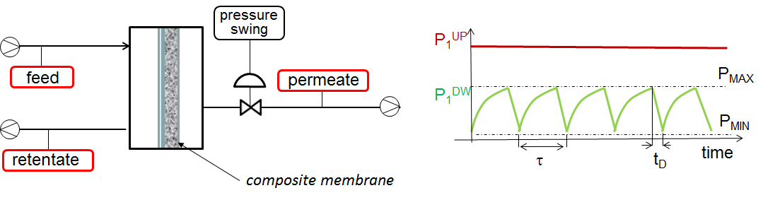
Figure 1: General schematics of the proposed hybrid process for gas separation and time evolution of the pressure downstream during the operation.
In the subsequent section, account is briefly given of the results obtained from the first experimental implementation of the new process in a lab-scale apparatus. The results confirm the relative variation in membrane performances that can be attained through the variation of cycle time as anticipated by the modeling analysis.
  - Modelling analysis
A simplified model for the description of the process performances making use of capacitive membranes for the separation of components A and B in a gaseous mixture is proposed. The model accounts for the permeance of the given species through the dense layer (indicated hereafters as Π_{A} and Π_{B}, respectively) and for capacity of the porous layer for the same components (C_{A} and C_{B}, in what follows). The model relates both the effective permeance of capacitive membrane to key component A (Π_{A}^{E}) and the corresponding selectivity (α_{A/B}^{E} = Π_{A}^{E}/Π_{B}^{E}) to the main process parameter, represented by the ratio between maximum downstream partial pressure of the key component in the operative cycle (P_{A}^{PM}) and the partial pressure of the same component in the feed gas upstream (P_{A}^{F}). The above ratio is indicated as “x” in the following discussion. The analysis refers to the simple condition in which an on/off logic is applied by the control system to manage the valve opening between the lower limit of downstream pressure, assumed here as negligible (p^{min} =0), and the upper limit (p^{max}) corresponding to the specific value of process parameter x chosen. Further simplifying assumptions are the following:
a) negligible sorption capacity of dense layer in the membrane for the key component in the gas mixture with respect to that of the porous domains;
b) negligible resistance to gas flow of porous domains of the membrane with respect to that of the dense layer;
c) constant solubility coefficients for gas species A and B in the porous layer of the membrane in the pressure interval of interest;
d) constant permeability coefficients of gas species A and B in the dense layer of the membrane in the pressure interval of interest;
e) negligible capacity of the dead volumes of the apparatus in the downstream section with respect of that of porous domains in the membrane
After the assumptions (a) and (b) stated above, the flux of key component A through the membrane can be calculated form the pseudo-steady-state approximation during the entire time interval in which the downstream valve is closed: from time t=0, when the downstream pressure is negligible, to time t=t_{c}, in which partial pressure of the key component downstream the membrane reaches the maximum prescribed value P_{A}^{P}(t_{c}) = P_{A}^{PM}. At time t_{c}, the downstream partial pressure of second component also reaches its maximum value P_{B}^{P}(t_{c}) = P_{B}^{PM} and it so does the total pressure p(t_{c}) = p^{max}. The same assumptions above allow to consider that the partial pressures of both components in the porous layer of the membrane are uniform, at any time t from 0 to t_{c}, and equal to the corresponding values downstream the membrane P_{A}^{P}(t) and P_{B}^{P}(t), respectively. The instantaneous flux of each component through the membrane (J_{A} and J_{B} ) can thus be calculated at each time in the same interval as the product of permeance of the dense layer multiplied by the upstream-to-downstream difference in corresponding partial pressure:
(I-a)
(I-b)
After assumption (b) stated above, the duration of component A desorption from porous domains, which follows the valve opening in process cycle allowing the permeate to be collected and downstream partial pressure to drop back to zero, can be neglected with respect to t_{c}.
Accounting for assumptions (a) and (e), the number of moles of component A and B collected within the membrane per unit area, at an arbitrary time t in the interval [0,t] (N_{A}”(t) e N_{B}”(t) respectively), can be expressed by the mass balance according to the following expressions:
(II-a)
(II-b)

From the equations above, the expression for the rate of variation of partial pressure of components A and B downstream the membrane can be easily derived:
(III-a)
(III-b)
Such expressions can be further specified by means of the invariant value of partial pressure of both components in the feed stream, namely P_{A}^{F} and P_{B}^{F}:
(IV-a)
(IV-b)
Eqs.(IV) can be finally integrated accounting for the fact the partial pressures of both components are negligible at the beginning of the cycle ( P_{A}^{P}(t=0) = P_{B}^{P}(t=0) = 0 ), and the maximum values for partial pressure in the cycle P_{A}^{PM} and P_{B}^{PM} can be calculated accordingly :
(V-a)
(V-b)
Equation (V-a) thus allows for the expression of cycle time t_{c} as function of the ratio x between maximum partial pressure reached downstream the membrane for the key component and corresponding feed value.
(VI)
The effective permeance Π _{A}^{E} (average transfer rate in the cycle) for the key component can be finally evaluated accounting for the moles collected, the cycle time and the nominal driving force (partial pressure) for the flux of key component in the process. Indeed, from (II-a) and (VI) it follows:
(VII)
The number of moles collected of component B per unit area in the membrane during the process cycle can be calculated through the evaluation of maximum partial pressure reached for the same component downstream the membrane (see equations V-b e VI):
(VIII)
(IX)
The separation factor, corresponding to the effective selectivity of the membrane α _{A/B} ^{E}, can be calculated from the ratio between moles accumulated for the two components in the cycle with reference to the mole ratio of the same two components in the feed:
(X)
To the aim of managing the valve opening and closing in the cycle, it is interesting to recognize the expression for the maximum total pressure p^{max} downstream the membrane, which corresponds to the value the control valve has to open:
(XI)
Hereafter relations are reported for relative value of both pemeance, (Π_{A}^{E})_{r} ,and separation factor, (α_{A/Β} ^{E})_{r}. The ratio between the effective permeance for the cyclic process and the corresponding value attainable for steady state conditions for the same membrane is here expressed as function of the process parameter x. Toward the same factor, the relation is also reported for the ratio between effective separation reached by the cyclic process and the ideal value corresponding to steady state working conditions with the same membrane:
(XII-a)
(XII-b)
The set of the two equations above defines, in parametric terms, the relation between effective permeability and effective separation factor for the key component in the new cyclic process for the given membrane. Indeed, different values of effective permeability/separation factor can be obtained by means of the new cyclic process, when different values of maximum pressure are imposed in the cycle. It is interesting to observe that the ranges for effective permeability and separation factor that can be explored in the new cyclic process when x is varied in the range [0,1] depend on the ratio (C^{A}/ C^{B})/ (Π^{A}/ Π^{B}). In fact, the new cyclic process clearly recovers the behavior of conventional steady state membrane separation for the case x = 0, corresponding to the conditions in which the maximum value of downstream pressure in the cycle is negligible. The effective separation factors increases when parameter x increases, and it tends to the ratio between (sorption) selectivity in the porous domain for the two components for the case x approaches unit value (maximum downstream pressure reaches the feed value), while the effective permeance decreases indefinitely for the same conditions.
  - Experimental validation
In order to proof the concept the novel hybrid separation process proposed, an experimental validation of the fundamental idea and of the results from basic modelling has been considered, with specific reference to the problem of separating CO₂ from N₂, of interest for the case of post-combustion carbon capture. A two-layer membrane has been prepared applying a dense polydimethylsiloxane (PDMS) coating onto the external surface of a tubular porous ceramic membrane, according to 1:50 ratio between thicknesses of polymeric and ceramic layer. PDMS has been considered as benchmark membrane material for traditional gas separation involving CO₂. A geopolymer matrix, a new class of alkali-bonded ceramics (Miccio et al., 2014), has been then considered as inorganic phase (BET surface area 50-100 m²/g), whose gas adsorptive properties have been already inspected in details for carbon capture application (Minelli et al., 2016). Polymer and ceramic layers confer the desired resistive and capacitive properties, respectively, to the hybrid membrane, which is ultimately endowed by relatively high permeance to carbon dioxide, as well as a significant sorption capacity. Relevantly, the characteristic times for adsorption and permeation phenomena in the membrane are considerably different. Therefore, interesting results of effective membrane performances can be achieved by means of a dynamic control of the process when the pressure swing cycle period is increased from negligible to a significant fraction of characteristic time for the adsorption process in the membrane. The effective permeance and selectivity of the tested hybrid membrane have been measured in lab-scale tests, using dilute CO₂/N₂ mixtures as feed stream. Several runs have been considered for different cycle time, which ultimately bring to different maximum partial pressure value of CO₂ downstream the membrane.
The results obtained show a significant effect of the pressure swing frequency, which is able to increase significantly the CO₂/N₂ selectivity, with a limited loss of gas permeance. Experimental results for effective CO₂/N₂ separation factor measured in effective terms for the cyclic process versus corresponding permeance are indicated in fig.2, in which both factors have been normalized over value measured for steady state conditions (i.e. negligible cycle time). The increase in separation factor for cyclic operations with respect to steady state conditions is evident, as well as the corresponding penalty for permeance. These findings suggest a possible process route for overcoming the technological limitations associated to gas separation membrane materials and the trade-off correlation between permeability and selectivity (Robeson, 2008). In this case, conversely, an interesting spot can be recognized in the results in which a significant increase in separation factor is obtained with just negligible reduction of effective permeance. The latter corresponds to the case of relatively short cycle time (lower separation and high permeance) in the curve reported in fig. 2. Remarkable good agreement is shown between modelling results and experimental data, confirming the solidity of the interpretation, in particular in the description of the variations in separation performance obtained by managing the cycle time/maximum downstream pressure.

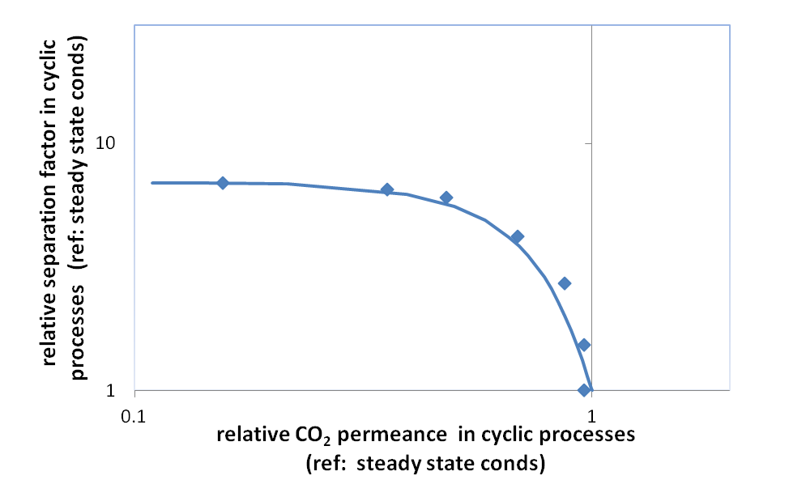
Figure 2: Relative performances obtained by the hybrid membrane in cyclic operation conditions with respect to reference steady state conditions for various swing frequencies: experimental data and model analysis.
  - Conclusions
The idea of a new membrane based process for gas separation is presented in this work which accounts for the management of transport process through the membrane in a cyclic regime in which the pressure downstream the membrane is allowed to change from the minimum value corresponding to the permeate pressure up to a maximum value that can be set freely in the process. Different performance can be obtained in the separation process, in terms of separation factor and recovery, when different values are used for the above process parameter. A modelling analysis has been offered here to illustrate the relation between effective permeance and effective separation factor attainable through the process. An experimental campaign referring to the separation of CO₂ from nitrogen stream has been performed to proof the concept and to validate results from modelling analysis. Results clearly show the potential of the novel hybrid unit operation, identifying an additional flexibility with respect to traditional membrane process, as rather different performances for permeate to selectivity ratio can be explored by properly setting the pressure swing period, for the case of assigned loading and fixed characteristics of the membrane module.
References
Aroon M., Ismail A.F., Matsuura T., 2010, Performance studies of mixed membranes for gas separation: a review, Separation and Purification Technology, 75, 229-242.
Baker R.W., Low B.T., 2014, Gas separation membrane materials: a perspective, Macromolecules, 47, 6999-7013.
Berardo P., Clarizia G., 2013, 30 Years of membrane technology for gas separation, Chemical Engineering Transactions, 32, 1999-2004.
Doghieri F., Landi E., Medri. V., Miccio F., Minelli M., Sarti G. C., 2017, Alternating potential gas separation process with capacitive membranes, and relevant plant WO2017013581A1.
Miccio F., Medri V., Papa E., Murri A.N., Landi E., 2014, Geopolymerization as effective measure for reducing risks during coal ashes handling, storage and disposal, Chemical Engineering Transactions, 36, 133-138
Minelli M., Medri V., Papa E., Miccio F., Landi E., Doghieri F., 2016, Geopolymers as solid adsorbent for CO2 capture, Chemical Engineering Science 148, 267–274.
Paul D.R., 1971, Membrane separation of gases using steady cyclic operation, Industrial and Engineering Chemistry Product Research and Development, 10, 375–379
Petropoulos J.H., Papadokostaki K.G., Minelli M., Doghieri F., 2014, On the role of diffusivity ratio and partition coefficient in diffusional melocular transport in binary composite materials, with specfical reference to the Maxwell equation, Journal of Membrane Science, 456, 162-166.
Robeson L.M, 2008, The upper bound revisited, Journal of Membrane Science, 320, 390-400.
Wang L., Corriou J-P., Castel C., Favre E., 2011, A critical review of cyclic transient membranes gas separation processes: state of the art, opportunities and limitations, Journal of Membrane Science, 383, 170-188.

