|  |  |
| --- | --- |
| cetlogo ***CHEMICAL ENGINEERING TRANSACTIONS***  ***VOL. 76, 2019*** | A publication of  aidiclogo_grande |
| The Italian Association  of Chemical Engineering  Online at www.cetjournal.it |
| Guest Editors: Sauro Pierucci, Jiří Jaromír Klemeš, Laura Piazza  Copyright © 2019, AIDIC Servizi S.r.l. **ISBN** 978-88-95608-73-0; **ISSN** 2283-9216 | |

Design and performance study of a milli-channel vaporizer

Guillaume HENRYa,\*, Alexandra PERE-GIGANTEa, Jacopo SEIWERTb, Solène VALENTINb, Marc WAGNERb, Jean-Marc COMMENGEa

a Université de Lorraine, CNRS, Laboratoire Réactions et Génie des Procédés, UMR 7274, Nancy, F-54000

b Air Liquide, Centre de Recherche Paris-Saclay, 1 chemin de la Porte des Loges, Les Loges-en-Josas, BP 126, 78354 Jouy-en-Josas, France

\* *Corresponding author : guillaume.henry@univ-lorraine.fr*

The most common way to produce hydrogen at an industrial scale is, by far, the Steam Methane Reforming (SMR) process. The ever-growing interest about hydrogen as the fuel of the future has led to a redesign of the process for smaller production capacity. The intensification of the SMR process concerns different pieces of equipment such as the heat-exchanger reactor, the shift reactor or the vaporizer. In this paper, an intensified vaporizer is studied for the vaporization of water in 2 mm diameter channels with semi-circular cross section. The vaporizer is tested, and the effect of the various operating parameters (flowrates, temperatures and pressure) on the vapour quality produced is analysed.

* 1. Introduction

In the case of the SMR process, for hydrogen production, steam reacts with methane on a catalyst at high temperature (around 950 °C) to produce carbon monoxide and hydrogen. The heat remaining in hot exhaust fumes can be integrated to produce steam. In the industrial process, this operation occurs in units called Waste Heat Boilers.

Many heat exchangers rely on phase changes of the working fluid when high heat transfers are needed, because vaporization and condensation typically require much more energy than heating or cooling of a single phase fluid. Additionally, in the last few decades, milli- and microstructures have raised an ever-growing interest for their high performances in boiling heat transfers. Some models relevant to our configuration (boiling of water in millimeter sized channels) have been proposed throughout the years, most notably by Chen (1966) (for water and organic fluids), Shah (1982) or most recently Bertsch & al. (2009).

Some authors tried to establish general correlations for two-phase heat-transfer coefficient (e.g. Kandlikar 1990), others, like Bertsch & al. (2009), tested existing correlations for numerous experimental points available in the literature. Recently, Fang & al. (2017) assessed in their study existing correlation of two-phase heat-transfer coefficients correlation applied to only water experiments available in literature. One of their main conclusion reveals that there a strong need for developing an accurate correlation. These works highlighted the complexity of boiling characterization; none of these correlations can be used as a precise tool for sizing. However, by these correlations, a correct magnitude of two-phase heat-transfer coefficient can be obtained.

In this work, the milli-channel vaporizer studied vaporizes demineralized water and uses silicon oil as the hot fluid to simulate industrial operating conditions. It has a special borosilicate window, which enables a direct visualization of the water flow for a pressure up to five bars. A specific focus on the two-phase heat-transfer coefficient and the vapour quality is done in this work, since they are corner stones of a vaporizer sizing.

* 1. Experiments
     1. Experimental setup

The dedicated test bench set up consists of two closed fluid loops, which contain the test vaporization section and another closed loop to cool down and condensate the global vapour quality produced by the vaporizer (See Figure 1(a)).

The use of a hot-gas loop represents significant technical and security issues; therefore, a hot oil loop is used to recreate a similar thermal exchange situation. The JULABO Thermal HS oil (silicon oil) is stored in a JULABO SE-6 temperature-controlled bath (20 – 300 °C; 3 kW) and is pumped by a MAAG Refinex 22/22 gear pump (1 – 10 L/min). The downstream pump pressure is controlled by a YOKOGAWA pressure transmitter (0 – 20 bars) to ensure safe operation of the pump. The oil flowrate is measured by a YOKOGAWA Rotamass Nano Coriolis flowmeter before passing through the vaporizer and going back to the bath. The oil temperature is measured at the entrance and the exit of the vaporizer by 1/10 DIN PT100 sensors in order to estimate the thermal power transferred by the oil flow.

The vaporized water is stored in a tank and pumped by a HNP Mikrosystem mzr-7205 gear pump (0.048 – 248 mL/min) through a BRONKHORST mini CORI-FLOW Coriolis flowmeter (0.4 – 20 kg/h). The water is preheated passing through 1/4” spires stored in a JULABO ME-6 temperature-controlled bath (20 – 200 °C; 2 kW) before going in the test section. The test section pressure is regulated downstream by a QBS Equilibar discharge pressure controller (1 – 5 bars). The two-phase flow is cooled down and the vapour is condensed in a plate heat exchanger before returning in the storage tank. The condenser is cooled by a flow of water coming from a JULABO FL-1201 cooler (-20 – 40 °C; 1.2 kW).

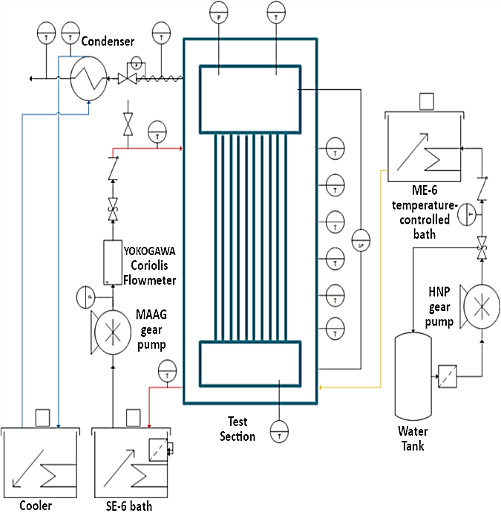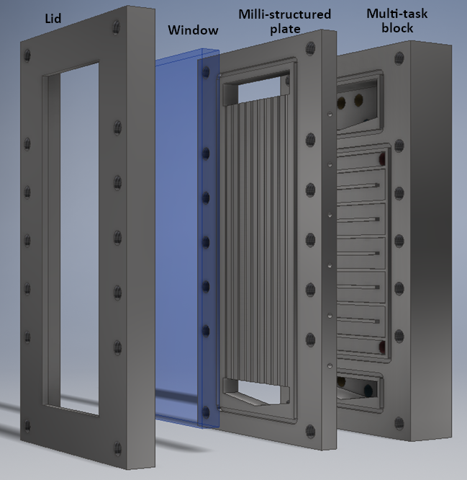

(a)

(b)

Figure 1: PI&D of the test bench (a), exploded view of the test section (b)

The test section, called the “vaporizer”, is presented in Figure 1(b), and has been fabricated in the mechanical workshop of the Reactions and Chemical Engineering Laboratory (LRGP) located in Nancy, France. It consists of three mechanically engraved plates (130 mm x 250 mm x 50 mm): the multi-task block, the milli-structured plate and the visualization window lid.

The multi-task block includes two chambers for the distribution and the collection of water but also a rectangular cross section (2.5 mm x 9 mm) channel where the hot oil flows. The milli-structured plate is constituted by ten 180 mm long, 2 mm semi-circular cross section milli-channels. At both ends of the channels, similar chambers are present to distribute and collect the flow. The lid is used to fasten a 11 mm thick borosilicate window which allows direct observation (with a high-frequency camera) of the boiling flow. The test section is insulated with a customized envelop made of a 6 mm braided fiberglass sheet.

Pressure inside the vaporizer is measured by a YOKOGAWA absolute pressure sensor (0 - 20 bars) in the collection chamber at the top of the vaporizer. Moreover, pressure drop along channels is also measured by a YOKOGAWA differential pressure sensor (0 – 5 bars) between the distribution and collection chambers. In parallel, water temperature is also measured in these chambers by PT 100 sensors. Wall temperature is assessed by six 1/10 DIN PT 100 sensors inserted in dedicated holes present in the milli-structured plate. The test bench is controlled through a LabVIEW interface developed in the LRGP electronic engineering department.

* + 1. Experimental procedure

All operating conditions were investigated using the same experimental procedure. At first, a set of operating conditions is chosen: oil temperature in the bath and flowrate, water-preheating temperature and flowrate. In this paper, only experiments at atmospheric pressure are presented, thus the pressure was not controlled. The steady state was assumed once all temperatures in the test bench were stable over 10 minutes. Since the vaporizer is a massive block of stainless steel, it took more than one hour and a half to reach the first steady state then new steady states could be established within approximately half an hour. Then all the data, such as the oil flowrate, the inlet and outlet oil temperature, the water flowrate, the water flow temperature in the distribution and collection chambers, the wall temperatures, the test section pressure, were collected for post-processing.

* + 1. Experimental range of operating conditions

The Table 1 presents the ranges of operating parameters used in this study.

Table 1: Operating parameters range

|  |  |  |
| --- | --- | --- |
| Operating Parameter | Range | Units |
| Pressure | 1 | (Bar) |
| Water Flowrate | 0.3 - 6 | (L/h) |
| Pre-heating water temperature | 50 - 80 | (°C) |
| Oil flowrate | 70 - 180 | (kg/h) |
| Bath oil temperature | 130 - 180 | (°C) |

* 1. Data reduction
     1. Vapour quality

Vapour quality is one of the crucial boiling data to be determined for several reasons. First, it characterizes the boiling efficiency of the device. Secondly, heat transfer is directly impacted by the vapour quality. It is defined as the mass fraction of vapour phase composing a two-phase flow, for a continuous vaporizer, and is calculated by the ratio of the mass flowrates of both phases:

|  |  |
| --- | --- |
| $$x=\frac{{\dot{m}}_{vapour}}{{\dot{m}}_{vapour}+{\dot{m}}_{liquid}}$$ | (1) |

Where ${\dot{m}}_{vapour}$ is the mass flowrate of the vapour phase and ${\dot{m}}_{liquid}$ is the mass flowrate of the liquid phase

In the literature, test benches used to perform experimental study of a boiling flow are almost exclusively heated by electrical cartridges (see Li & al. (2017)). Then, since the local heat flux is well known (because it can be measured for each heater block), the vapour quality can be easily estimated at every location of the vaporizer by heat balance.

Since the vaporizer studied in this paper uses a hot fluid flow, the temperature of the hot fluid is not constant along its channel. Moreover, as the Figure 1b shows, the internal geometry of the vaporizer is not symmetrical at all, therefore; the heat transfer coefficient between the hot oil flow and the water flow cannot be assumed constant. Nevertheless, a global quality can be estimated by a global heat balance on the vaporizer.

|  |  |
| --- | --- |
| $$Q_{oil}=Q_{preheating}+Q_{vaporization}+Q_{losses}$$ | (2) |

Where $Q_{oil}$ is the heat flux given by the oil, $Q_{preheating}$ the heat flux needed to heat the water flow up to its boiling point, $Q_{losses}$ the heat flux of heat losses and $Q_{vaporization}$ the remaining part of the total heat flux given by the oil to vaporize water.

* $Q_{oil}$ is calculated by:

|  |  |
| --- | --- |
| $$Q_{oil}={\dot{m}}_{oil}^{in}C_{p oil}(T_{oil}^{in}-T_{oil}^{out})$$ | (3) |

Where $C_{p oil}$ is the heat capacity of the oil, $T_{oil}^{in}$ the inlet oil temperature and $T_{oil}^{out}$ the outlet oil temperature.

* $Q_{preheating}$ is defined by:

|  |  |
| --- | --- |
| $$Q_{preheating}={\dot{m}}_{water}^{in}C_{p}(T^{eb}-T^{in})$$ | (4) |

Where $C_{p}$ is the heat capacity of liquid water, $T^{eb}$ the boiling temperature and $T^{in}$ the inlet water temperature.

* $Q_{vaporization}$ is defined by:

|  |  |
| --- | --- |
| $$Q_{vaporization}=x {\dot{m}}_{water}^{in} \overline{∆H_{vap}}$$ | (5) |

Where $\overline{∆H_{vap}}$ is the latent mass heat of vaporization.

Thanks to equations (2), (3), (4) and (5), the vapour quality can be assessed for each set of operating conditions running on the test bench. Specific experiments were carried out to estimate the vaporizer heat losses as a function of operating conditions.

* + 1. Two-phase heat transfer coefficient

As for the vapour quality, and for the same reasons, heat-transfer coefficients presented in this work are estimated by a global approach. The heat flow dedicated to the vaporization is defined by equation:

|  |  |
| --- | --- |
| $$Q_{vaporization}=h_{tp}S_{exch}∆T_{ml}$$ | (6) |

Where $∆T_{ml}$ is the logarithmic mean temperature difference between the wall and the water flow starting from the location where water flow reaches the boiling point to the end of the channel. Assessing the exchange surface ( $S_{exch})$ represents a real issue: hydrodynamics of the boiling flow is directly impacted by the bubbles growth since the cross section of the bubbles is quickly matching, after its nucleation, the cross section of channels. These phenomena create an oscillating flow in the channels, for that reason, the lowest vertical position of the interface is chosen to calculate the exchange surface in order to estimate the two-phase heat-transfer coefficient. Since the estimation of the exchange surface is quite inaccurate using this method, further investigations on the high-speed movies are needed to estimate uncertainty and validate the method.

* + 1. Global HS product

For heat exchangers, the global HS product (W/K) is often used as a characteristic performance, and it is calculated by equation (6). In the case of a vaporizer, the logarithmic mean temperature difference should be estimated only for the single-phase flow. However, in this paper, it is assumed the vaporizer can be considered like a single-phase heat exchanger. Thus, the logarithmic mean temperature difference is calculated for both single and two-phase flow situations. The temperatures used in the calculation are the inlet and outlet temperatures of both sides. Moreover, the HS product is estimated from the heat flux given by the oil flow.

|  |  |
| --- | --- |
|  | (6) |

* 1. Results

Five different operating parameters must be chosen for each experiment: the oil and water flowrates, oil temperature in the temperature-controlled bath, water inlet temperature and pressure (in this work atmospheric pressure).

The global HS product, for all data points, is shown in Figure 2b as a function of water flowrate. The dispersion of the curve is due to the variation of the other parameters (see Table 1). Despite the varying operating conditions, the HS product only varies by approximately +/- 12% around its mean value of 6.8W/K. Therefore, concerning the oil operating parameters, only the measured oil inlet temperature has a real influence on the heat flux given by the oil, and thus on the vapour quality. Experimentally, all things being equal in particular the oil bath temperature, increasing the oil flowrate changes the heat losses of the flow in the test bench piping. The resulting effect is: the higher the flowrate is, the higher the measured inlet oil temperature is and the higher the vapour quality is.

In Figure 2a, the variation of the vapour quality produced by the vaporizer as a function of the inlet oil temperature is plotted versus the water flowrate. The oil flowrate is fixed to 180 kg/h and the water enters the vaporizer at 80 °C.

(b)

(a)

Figure 2: Influence of the inlet oil temperature and water flowrate on the vapour quality (a), Influence of the water flowrate on the HS product (b).

Whatever the inlet oil temperature, vapor quality decreases with water flowrate. This trend can be explained by the distribution of the heat provided by the oil. Indeed, the main heat-transfer resistance is located in the hot oil side, consequently, for a specific inlet oil temperature, the heat power given by the oil is almost constant regardless of the water flowrate. In addition, it is assumed that the heat losses are also constant. According to equation (2), the remaining power is divided between the pre-heating of the flow and the vaporization of the flow. Since a higher water flowrate requires more power to be preheated up to the boiling point (at a given water input temperature), the remaining heat available is reduced and thus the vapor quality drops.

If one focuses on a specific water flowrate, the vapour quality is improved by a higher oil temperature. Indeed, the larger temperature difference between both sides is, the larger the power given by the hot side is, since this difference is the driving force of heat transfer. The vaporizer was pre-designed to vaporise 2 L/h of water: Figure 2 highlights that only 25% of this goal can be reached with an oil temperature of 141 °C.

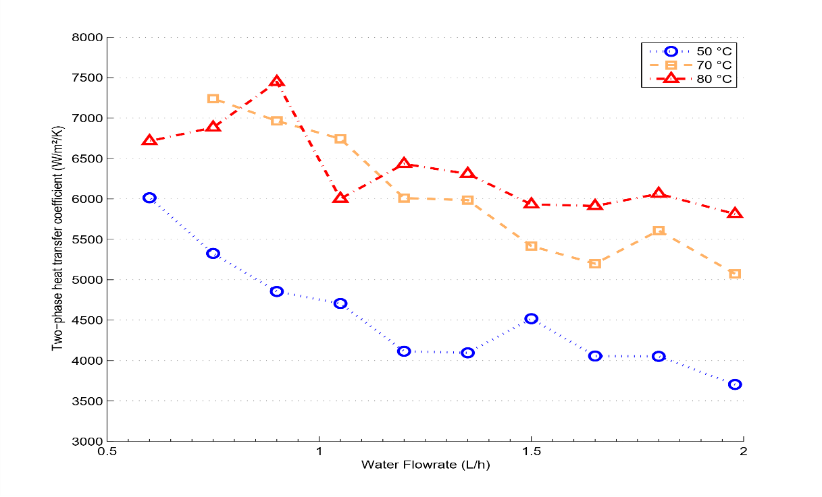

Figure 3: Influence of the pre-heating temperature on the two-phase heat transfer coefficient

Boiling flows enable heat transfer with high heat-transfer coefficients: Figure 3 presents average two-phase heat-transfer coefficients for the boiling water in the vaporizer as a function of the water flowrate and inlet water temperature. In this study, the inlet oil temperature is set to 121°C and the oil flowrate to 110 kg/h.

The values of the heat-transfer coefficient fall within a typical range, several thousands of W/m²/K, for two-phase flow in milli-structures (e.g. Bertsch & al. (2009)). Two different behaviors are observed, depending on the water inlet temperature (50°C or 70°C and more). In the first case, according to equation (2) and (4), the power needed by the flow to reach the boiling point is larger than in the second case. That not only means that the useful power for vaporization is low but also the single-phase/two-phase flow interface is higher in channels and thus a lower exchange surface is available. Nevertheless, the range of the two-phase heat-transfer coefficients is at least twice the range of single-phase heat-transfer coefficients in the same channel geometry.

* 1. Conclusions and perspectives

An experimental study of a vertical milli-channel vaporizer was performed in order to assess its performances in terms of two-phase heat-transfer coefficient and vapour quality. Main results can be summarized as follows:

* For a vaporizer working with hot fluid convection as heat vector, the main heat-transfer resistance has to be determined to understand how the heat flux exchanged can be optimized. However inlet operating conditions of both fluids have a significant impact on the quality determined by heat balance on the vaporizer (e.g. the water temperature for pre-heating or the oil temperature, driving force of the heat exchange).
* The magnitude of global heat-transfer coefficients and two-phase heat-transfer coefficients were estimated in the vaporizer. Further investigations are required to relate more precisely the dependence between heat-transfer coefficients and the heat flux exchanged between both fluids.

The hydrodynamic of the boiling flow on this vaporizer is a real issue for its efficiency. Indeed, visual observation shows that a great part of the liquid is kicked out of the channels during the bubble growth. The main transit time of the liquid is shortened by the boiling phenomena themselves. The hydrodynamic regimes have to be understood more precisely in order to draw a flow regime map of the vaporizer. From this knowledge, new designs of channels could be tested in order to keep the liquid in the channels (as Yi & al. (2017)). Moreover, the effect of the pressure has to be determined to finalize the study.

Acknowledgments

Authors acknowledge BPI France for their financial support of the FAIR Project (“Fabrication Additive pour l’Intensification des Réacteurs”; n°2015-PRSP-16), in the frame of the “Programme d’investissements d’avenir”, and the ENERBATIN Project supported by Région Grand-Est through CPER 2015-2020.

References

Bertsch S. S., Eckhard A. G., and Suresh V. G., 2009. A Composite Heat Transfer Correlation for Saturated Flow Boiling in Small Channels, International Journal of Heat and Mass Transfer 52(7–8):2110–18. (DOI: 10.1016/j.ijheatmasstransfer.2008.10.022)

Chen J.C., 1996, Correlation for boiling heat Transfer to saturated fluids in convective flow, Indus. Eng. Chem. Process Des. Dev., 5, pp. 322–329. (DOI: 10.1021/i260019a023)

Fang X., Yuliang Y., Xu A., Tian L., Wu Q., 2017. Review of correlations for subcooled flow boiling heat transfer and assessment of their applicability to water, Fusion Engineering and Design, vol 122, pp 52-63 (DOI: 10.1016/j.fusengdes.2017.09.008)

Kandlikar S.G., 1990, A General Correlation for Saturated Two-Phase Flow Boiling Heat transfer Inside Horizontal and Vertical Tubes, Journal of Heat Transfer, vol. 112, pp 219-228. (DOI: 10.1115/1.2910348)

Li Y., Xia G., Jia Y., Cheng Y., Wang J., 2017, Experimental investigation of flow boiling performance in microchannels with and without triangular cavities – A comparative study, International Journal of Heat and Mass Transfer, vol. 108, pp 1511-1526. (DOI: 10.1016/j.ijheatmasstransfer.2017.01.011)

Shah M.M.,1982 Chart correlation for saturated boiling heat transfer: equation and further study, ASHRAE Trans., 88, pp. 185–196

Sobierska E., Kulenovic R., Mertz R., Groll M., 2006, Experimental results of flow boiling of water in a vertical microchannel, Experimental Thermal and Fluid Science, 31, 111-119. (DOI:10.1016/j.expthermflusci.2006.03.022)