CHEMICAL ENGINEERING TRANSACTIONS  VOL. 76, 2019 | A publication of
The Italian Association
of Chemical Engineering
Online at www.cetjournal.it
Guest Editors: Sauro Pierucci, Jiří Jaromír Klemeš, Laura Piazza
Copyright © 2019, AIDIC Servizi S.r.l.
ISBN 978-88-95608-73-0; ISSN 2283-9216

Boiling point measurement of $γ$-valerolactone/water and $γ$-valerolactone/ethanol mixtures at different concentrations and pressures
Valter N. Trindade-Jrª, Marcos L. Corazza^{b}, Edson A. da Silva^{c}, Reginaldo Guirardello^{d,*}
ªFederal University of Maranhão, DEQ, Av. dos Portugueses, 1966, Cidade Universitária Dom Delgado, Sao Luis – MA, Brazil, 65076-000
^{b}Federal University of Parana, DEQ, R Coronel Francisco Heráclito dos Santos, 210 - Jardim das Americas, Curitiba – PR, Brazil, 82590-300
^{c}State University of Western Parana, EQ, R. da Faculdade, 645 - Jardim La Salle, Toledo - PR, Brazil, 85903-000
^{d}University of Campinas, Av. Albert Einstein, 500 - Cidade Universitária, Campinas - SP, Brazil, 13083-852
guira@feq.unicamp.br

Gamma-valerolactone (GVL) is used in green technology to produce chemicals and biofuels. Separation of GVL from mixtures within a process is a recurring challenge in chemical plants. Experimental boiling point determination containing its mixtures is fundamental as a preliminary stage of vapor-liquid equilibrium studies. The boiling point of binary mixtures of GVL/water and GVL/ethanol were measured at five compositions each, and range pressure from about 7.0 $kPa$ to 91.0 $kPa (∓0.8kPa)$. Experiments were carried out to determine the boiling point using a simplified ebulliometer. The experimental data were correlated with the Non-Random Two Liquid (NRTL) model. The correlated parameters of the NRTL model were used to calculate the vapor-liquid equilibrium of the mixture using the methodology of Gibbs energy minimization with ideal vapor phase.

Key Words: Gamma-valerolactone, Boiling point, NRTL.
  - Introduction
The use of large quantities of fossil fuels continues to be a major environmental concern (Fridell, 2019). Similarly, there is an ongoing research activity seeking forms of renewable fuels that are strategically and economically feasible, for which new technologies and investments are needed (Ji and Long, 2016). Several technologies have emerged to replace fossil fuels, ethanol production deserving a special mention (Ardila et al, 2014), but one of the most promising methods is the production of carbohydrates from biomass by non-enzymatic route for the subsequent production of ethanol (Luterbacher et al, 2014). This production process of carbohydrates by non-enzymatic route uses acid hydrolysis with solvent gamma-valerolactone. Studying the behavior in vapor-liquid equilibria of blends containing ethanol and GVL in aqueous media is fundamental for ethanol separation and GVL recovery in industrial plant.
Some vapor-liquid equilibrium studies were performed with water GVL and ethanol at different pressures, such as: water+GVL (Horváth et al, 2008, Havasi, Mizsey, and Mika, 2016, and Zaitseva et al, 2016) and ethanol+GVL (Havasi et al, 2016). In this work the boiling behavior of the water + GVL and ethanol + GVL mixture at different pressures was studied, the parameters of the NRTL model were also correlated with the experimental data collected and the vapor-liquid equilibrium of the binary mixtures was calculated through Gibbs Energy minimization.
  - Experimental setup
Experimental boiling points data were obtained in a static evaporator, shown in Figure 1. The equipment consists of an equilibrium cell (flask balloon 3 necks with 125 mL) coupled a jacketed condenser (55 mm) operated at 283.15 K, the apparatus is suitable for low pressure measurements up to atmospheric pressure. The ebulliometer operates in the same way as an Othmer ebulliometer, but there is no conventional recycle of the vapor phase, the recycle is make by the condenser. Experimental apparatus was equipped with a spare mantle heater having manual temperature adjustment (Brand: QUIMIB Q321A23), cooling bath circulator (brand: SPPENCER SCIENTIFIC 521-50), vacuum pump (brand SOLAB CIENTÍFICA SL60), thermocouple (HOLMAN), pressure gauge (brand: Greisinger, model: GDH 12 NA)
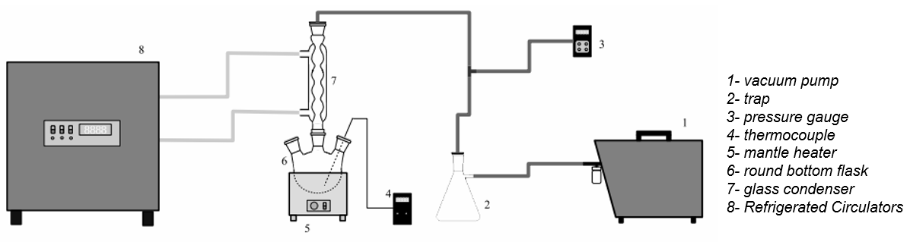
Figure 1: Schematic representation of the experimental set-up (Trindade-Jr, 2015)

An amount of 55 ml of the blend studied was placed round bottom flask. All the vapor formed, as soon as it arrives at the condenser, is cooled and returns to the liquid state. Thus, it was considered that composition of the liquid phase remains unchanged. A great advantage of using a simple ebulliometer is the use of a small amount of components in case the components are expensive.
2.1. Materials
Solutions containing water / GVL and ethanol / GVL mixture were prepared by gravimetry, as presented in Table 1.
Table 1: value of each composition sample.
Water+GVL | Ethanol+GVL
$$x_{H_{2}O}$$ | $$x_{C_{2}H_{6}O}$$
0.8476 | 0.6849
0.5821 | 0.3523
0.3000 | 0.1502
0.2014 | 0.0818
0.1037 | 0.0000
For mass measurements was used analytical balance brand: Shimadzu (AY 220). Chemical $γ$-valerolactone (Sigma Aldrich) 99% purity, ethanol (Merck) with >99.9% purity. Each sample was placed on the bubble point instrument by setting the pressure according to Table 2.
Table 2: Pressures assessed for samples
Water+GVL | Ethanol+GVL
$$P \left(kPa\right)$$ | $$P \left(kPa\right)$$
6.90 | 6.70
8.91 | 8.92
13.89 | 13.82
34.24 | 33.85
69.54 | 69.54
91.52 | 91.45
The temperature of the system was the only variable, considering that the liquid phase composition remains fixed.

2.2. Mathematical Models
2.2.1. NRTL parameters
The determination of the parameters was performed by a global estimation procedure, where a parameter set was correlated with experimental data at different pressures (low pressure) and temperatures all at the same time. In this case, the binary interaction parameters and the parameter related to non-randomness of the compound mixture were adjusted at the NRTL model. In order to correlate the parameters with the experimental data, the criterion of iso-fugacity was used with the vapor phase considered ideal.
min $F_{O}=\sum_{N}^{N^{exp}}{{\left(T_{N}^{calc}-T_{N}^{exp}\right)}^{2}}$ | (1)
subject to:
$\sum_{i}^{NC}{x_{i}=1}$ | (2)
$\sum_{i}^{NC}{y_{i}=1}$ | (3)
$n_{i}^{l}≥0$ | (4)
$$n_{i}^{g}≥0$$ | (5)
$$n_{i}^{l}+n_{i}^{g}=n_{i}^{total}$$ | (6)
$$0.2≤α_{i,ii}≤0.47$$ | (7)
$$-5,000.0{≤A}_{i,ii}≤5,000.0$$ | (8)
$${\hat{f}}_{i}^{l}={\hat{f}}_{i}^{g}$$ | (9)

where $A_{i,ii}$ represents the binary interaction NRTL parameter (K), $α_{i,ii}$ is the randomness NRTL parameter , $n$ is amount of compound (mol), $N$ number of experimental points, $NC$ number of compounds, $x$ liquid phase molar fraction, $y$ vapor phase molar fraction, $\hat{f}$ is fugacity, $T$ is the temperature (K), $l$ is the liquid phase, $g$ is the vapor phase, $i$ and $ii$ is the compounds (water, ethanol, GVL), $calc$ means calculated and $exp$ means experimental.
The deviations between experimental data and calculated values were evaluated using the least squares method given by Eq 1. For the representation of the non-ideality of the liquid phase, the NRTL model (Renon and Prausnitz, 1968) was used, where the parameters of binary interaction given by:
$$τ_{i,ii}={A_{i,ii}}/T$$ | (10)
were evaluated with the temperature variation, and the fitted parameters for each binary were $A_{i,ii}$ , $A_{ii,i}$, $α_{i,ii}$ and $y_{i}$, since the parameter $α_{i,ii}$ is symmetric. The temperature calculation prediction deviation was measured by Eq 11.

$$\text{rmsd}=\sqrt{{\sum_{N}^{N^{exp}}{{\left(T_{N}^{calc}-T_{N}^{exp}\right)}^{2}}}/{N^{exp}}}$$ | (11)
2.2.2. Gibbs energy minimization
Thermodynamic equilibrium is characterized by the absence of any driving force for mass transport, energy or momentum. A state of equilibrium is sought naturally by all systems (ABBOTT et al., 2001). Equation of chemical potentials for non-ideal systems was calculated by:
min $G=\sum_{i}^{NC}{\sum_{j}^{NP}{n_{i,j} μ_{i}^{o}}}+R T ln\left({{\hat{f}}_{i,j}}/{f_{i}^{o}}\right)$ | (12)
subject to the same constraints given by Eq (2) to (6), where$j$ means phase number (vapor, liquid and solid), $NP$ maximum number of phases, $o$ is the standard state.
Main considerations in the optimization were the ideal vapor phase and the non-ideality of the liquid phase represented by the NRTL model, properties of compounds such as vapor pressure, heat capacity and standard chemical potential were taken from Diadem DIPPR v1.2 (2000). The model fed with the initial number of mol of each component, pressure and temperature, obtaining as a response the compositions of the vapor and liquid phase. Some studies have already used this methodology for calculating phase equilibrium (Rossi, Cardozo-Filho and Guirardello, 2009 and Privat et al, 2016).
Both programming, parameter correlation and the Gibbs energy minimization, were made in GAMS language with the CONOPT solver.
3. Results and Discussions
The experimental data set for each composition and pressure were used to fit the parameters of the NRTL model, by comparing the experimental values with the calculated values of vapor phase molar fractions at each data point. Using the estimated parameters of the NRTL model, the vapor-liquid equilibrium of the system for each point was calculated by the Gibbs energy minimization method. All results, experimental and calculated, are shown in Figures 2 and 3.

The fitted parameters for the NRTL model are shown in Table 3. Using these fitted values, the liquid and vapor molar fractions were calculated for both systems (water+GVL, ethanol+GVL), by the Gibbs minimization method. Comparing the experimental values obtained in this work and the calculated values, a maximum absolute error of 0.097 was obtained in both cases. The rmsd values were 2.61 $K$ and 3.21 $K$ for the water + GVL and ethanol + GVL binaries, respectively.

Table 3: Calculated binary interaction parameters of NRTL model
Compounds |  | $A_{i,ii}$ | $$A_{ii,i}$$ | $$α_{i,ii}=α_{ii,i}$$
$$\left(i\right)$$ | $$\left(ii\right)$$
water | GVL | 700.9982 | -60.2021 | 0.4375
Ethanol | GVL | 68.9740 | -36.2957 | 0.4700

It is also interesting to compare the calculated values with other data from literature (Horváth et al, 2008; Havasi et al, 2016). Figure 4 shows the comparison between literature experimental data and calculated values using the fitted parameters presented in Table 3, where all data presented are given at 101 kPa. Relative errors were calculated comparing the results and the literature data. Thus, for both the vapor phase molar fractions and the liquid phase molar fractions, a maximum absolute error of 0.035 was found.
4. Conclusions
Bubble point data were obtained at different compositions and low pressures through a simple ebulliometer and simple methodology, in order to correlate experimental data with the one thermodynamic model, wherein the data of the vapor phase composition were calculated through the correlation of parameters using the NRTL model. Also calculated vapor-liquid equilibrium data using the Gibbs energy minimization, which showed to be able to calculate the behavior of vapor-liquid equilibrium along all compositions of the binary system. This experimental data contributes as a complement to modeling and simulation of processes involving separation of GVL by distillation operations.
Acknowledgements
This work was funded by CAPES (Coordenação de Aperfeiçoamento de Pessoal de Nível Superior - Brazil) and CNPq (Conselho Nacional de Desenvolvimento Científico e Tecnológico - Brazil).

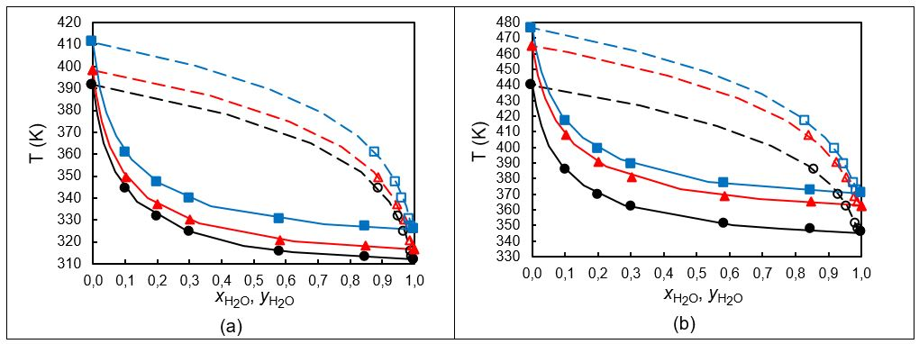
Figure 2: Boiling point and vapor-liquid equilibrium calculated for water+GVL: (a) ● liquid experimental data at 6.9kPa; ○ calculated vapor data by correlation at 6.9 kPa; ■ experimental data at 8.91 kPa; □ calculated vapor data by correlation at 8.91 kPa; ▲ experimental data at 13.89 kPa; ∆ calculated vapor data by correlation at 13.89 kPa; ̶ ̶ calculated liq. data by min Gibbs at 6.9 kPa; ̶ ̶ calculated liq. data by min Gibbs at 8.91 kPa; ̶ ̶ calculated liq. data by min Gibbs at 13.89 kPa; ; --- calculated liq. data by min Gibbs at 6.9 kPa; --- calculated liq. data by min Gibbs at 8.91 kPa; --- calculated liq. data by min Gibbs at 13.89 kPa. (b) Boiling point and vapor-liquid equilibrium calculated for water+GVL. ● liquid experimental data at 34.24 kPa; ○ calculated vapor data by correlation at 34.24 kPa; ■ experimental data at 69.54 kPa; □ calculated vapor data by correlation at 69.54 kPa; ▲ experimental data at 91.52 kPa; ∆ calculated vapor data by correlation at 91.52 kPa; ̶ ̶ calculated liq. data by min Gibbs at 34.24 kPa; ̶ ̶ calculated liq. data by min Gibbs at 69.54 kPa; ̶ ̶ calculated liq. data by min Gibbs at 91.52 kPa; ; --- calculated liq. data by min Gibbs at 34.24 kPa; --- calculated liq. data by min Gibbs at 69.54 kPa; --- calculated liq. data by min Gibbs at 91.52 kPa.
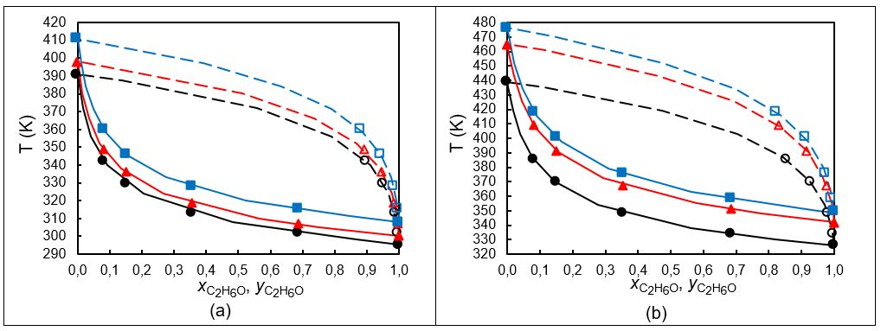
Figure 3: Boiling point and vapor-liquid equilibrium calculated for ethanol+GVL: (a) ● liquid experimental data at 6.7kPa; ○ calculated vapor data by correlation at 6.7 kPa; ■ experimental data at 8.92 kPa; □ calculated vapor data by correlation at 8.92 kPa; ▲ experimental data at 13.82 kPa; ∆ calculated vapor data by correlation at 13.82 kPa; ̶ ̶ calculated liq. data by min Gibbs at 6.7 kPa; ̶ ̶ calculated liq. data by min Gibbs at 8.92 kPa; ̶ ̶ calculated liq. data by min Gibbs at 13.82 kPa; ; - - - calculated liq. data by min Gibbs at 6.7 kPa; - - - calculated liq. data by min Gibbs at 8.92 kPa; - - - calculated liq. data by min Gibbs at 13.82 kPa. (b) Boiling point and vapor-liquid equilibrium calculated for ethanol+GVL. ● liquid experimental data at 33.85kPa; ○ calculated vapor data by correlation at 33.85 kPa; ■ experimental data at 69.54 kPa; □ calculated vapor data by correlation at 69.54 kPa; ▲ experimental data at 91.45 kPa; ∆ calculated vapor data by correlation at 91.45 kPa; ̶ ̶ calculated liq. data by min Gibbs at 33.85 kPa; ̶ ̶ calculated liq. data by min Gibbs at 69.54 kPa; ̶ ̶ calculated liq. data by min Gibbs at 91.45 kPa; ; - - - calculated liq. data by min Gibbs at 33.85 kPa; - - - calculated liq. data by min Gibbs at 69.54 kPa; - - - calculated liq. data by min Gibbs at 91.45 kPa.

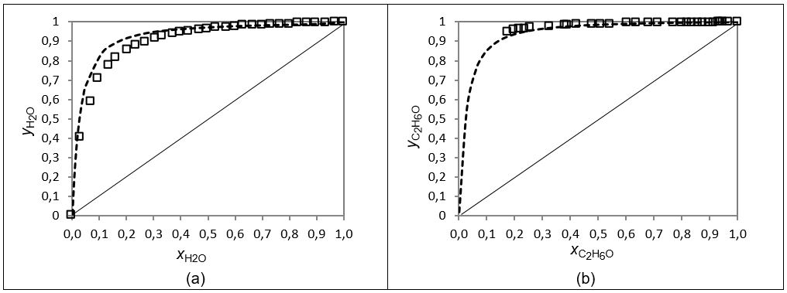

Figure 4: Comparison of calculated and experimental data for the mole fraction of vapor-liquid equilibrium: (a) □ experimental data (Horváth et al., 2008 ),- - - calculated from Gibbs energy minimization, (b) □ experimental data (Havasi et al., 2016 ),- - - calculated from Gibbs energy minimization

References
Abbott, M.; Smith, J.; Ness, H. V., 2001. Introduction to chemical engineering thermodynamics. [S.l.]: McGraw-Hill.
Ardila, Y. C., Figueroa, J. J., Lunelli, B. H., Maciel Filho, R., & Maciel, M. W., 2014. Simulation of ethanol production via fermentation of the synthesis gas using aspen plus TM. Chemical Engineering Transactions, 37, 637-642.
Diadem Public v. 1.2., 2000. The DIPPR information and data evaluation manager.
Fridell, E., 2019. Emissions and Fuel Use in the Shipping Sector. In Green Ports (pp. 19-33). Elsevier.
Havasi, D., Mizsey, P., and Mika, L. T., 2016. Vapor–Liquid Equilibrium Study of the Gamma-Valerolactone–Water Binary System. Journal of Chemical & Engineering Data, 61(4), 1502-1508.
Havasi, D., Pátzay, G., Kolarovszki, Z., and Mika, L. T., 2016. Isobaric vapor–liquid equilibria for binary mixtures of γ-valerolactone+ methanol, ethanol, and 2-propanol. Journal of Chemical & Engineering Data, 61(9), 3326-3333.
Horváth, I. T., Mehdi, H., Fábos, V., Boda, L., & Mika, L. T., 2008. γ-Valerolactone—a sustainable liquid for energy and carbon-based chemicals. Green Chemistry, 10(2), 238-242.
Luterbacher, J. S., Rand, J. M., Alonso, D. M., Han, J., Youngquist, J. T., Maravelias, C. T., and Dumesic, J. A., 2014. Nonenzymatic sugar production from biomass using biomass-derived γ-valerolactone. Science, 343(6168), 277-280.
Privat, R., Jaubert, J. N., Berger, E., Coniglio, L., Lemaitre, C., Meimaroglou, D., and Warth, V., 2016. Teaching the Concept of Gibbs Energy Minimization through Its Application to Phase-Equilibrium Calculation. Journal of Chemical Education, 93(9), 1569-1577.
Renon H., Prausnitz J. M., 1968. Local Compositions in Thermodynamic Excess Functions for Liquid Mixtures, AIChE J., 14(1), S.135–144,
Rossi, C. C. R. S., Cardozo-Filho, L., and Guirardello, R., 2009. Gibbs free energy minimization for the calculation of chemical and phase equilibrium using linear programming. Fluid Phase Equilibria, 278(1-2), 117-128.
Trindade-Jr, V. N., 2015, Análise dos Processos de Separação na Produção de Etanol Celulósico a
Partir de Biomassa por Rota não Enzimática, PhD Thesis (in Portuguese), University of Campinas, Campinas-SP, BR.
Ji, X., & Long, X., 2016. A review of the ecological and socioeconomic effects of biofuel and energy policy recommendations. Renewable and Sustainable Energy Reviews, 61, 41-52.
Zaitseva, A., Pokki, J. P., Le, H. Q., Alopaeus, V., & Sixta, H., 2016, Vapor–Liquid Equilibria, Excess Enthalpy, and Density of Aqueous γ-Valerolactone Solutions. Journal of Chemical & Engineering Data, 61(2), 881-890.

