|  |  |
| --- | --- |
| cetlogo***CHEMICAL ENGINEERINGTRANSACTIONS***  ***VOL. 76, 2019*** | A publication of  aidiclogo_grande |
| The Italian Association  of Chemical Engineering  Online at www.cetjournal.it |
| Guest Editors: Sauro Pierucci, Jiří Jaromír Klemeš, Laura Piazza  Copyright © 2019, AIDIC ServiziS.r.l. **ISBN**978-88-95608-73-0;**ISSN** 2283-9216 | |

Modified Zeolites in Methanol to HydrocarbonsTransformation

Valentin Yu. Doludaa,b, \*, Valentina G. Matveevaa,c, Natalia V. Lakinaa, Ether M. Sulmana, Mikhail G. Sulmana, Roman V. Brovkoa,b

aTver State Technical University, Department of biotechnology and chemistry, 170026, A. Nikitina, 22, Tver, Russia

b Department of physical and colloidal chemistry of Ivanovo state university of chemistry and technology,153000, Sheremetievskiy prosp. 7, Ivanovo, Russia

cTver State University, 170100, Zhelyabova str., 33, Tver, Russia]

[doludav@yandex.ru](mailto:doludav@yandex.ru)

The work is devoted to the modification of H-ZSM-5 samples with sodium hydroxide and oxalic acid to provide the formation of the mesoporous structure of the zeolite and to obtain optimal Si/Al ratio. Moreover, zeolite active sites were modified with Co, Ni, Fe in order to decrease polyaromatic substances formation during methanol transformation into hydrocarbons. The testing of the samples was performed at 350 ºC in a flow reactor, the methanol feed rate was maintained at 0.16 g(methanol)/(g(Cat)\*h). Dimethyl ether transformation rate into hydrocarbons was found to be 0.055-0.1 kg(DME)/(kg(Cat)\*h) for investigated catalysts. Alkali treatment of H-ZSM-5 samples results in the formation of a mesoporous structure with a mean pore diameter of 5 nm. Formation of additional mesopores results in some increase of dimethyl ether to hydrocarbons transformation rate up to 0.09 kg(DME)/(kg(Cat)\*h). Zeolite treatment with oxalic acid results in decreasing of Si/Al ratio from 0.76 to 0.41 that case some decrease of dimethyl ether transformation rate from 0.07 kg(DME)/(kg(Cat)\*h) to 0.05 kg(DME)/(kg(Cat)\*h), however considerable decrease of polyaromatic hydrocarbons concentration in reaction media was achieved for sample with lowest Si/Al ratio. Modification of H-ZSM-5 with Co, Fe, Ni results in some increase of dimethyl ether transformation rate up to 0.07-0.1 kg(DME)/(kg(Cat)\*h) and a considerable decrease of polyaromatic hydrocarbons concentration in reaction media due to active sites modification.The ZSM-5-Ni-0.001M sample showed highest activity 0.1 kg(DME)/(kg(Cat)\*h).

* 1. Introduction

Methanol catalytic transformation into hydrocarbons can be considered as a promising step in biomass and waste utilization processes (Sadeghi et al., 2015). Biomass can be utilized by the gasification process into syngas with further syngas conversion to methanol and final methanol transformation into hydrocarbons (Catizzone et al., 2018). Methanol catalytic transformation process typically results in the formation of aliphatic, aromatic hydrocarbons and olefins. Synthesized hydrocarbons can be used as fuel or as raw material for polymers synthesis including polyethylene, polypropylene, polyethylene phthalate, kaptone and other valuable chemical substances (Ortega et al., 2018). Methanol catalytic transformation process can be realized with the dominant formation of olefins or liquid hydrocarbons (Porterfield et al., 2010).

Deferent zeolites considered to be effective catalysts for intensification of methanol to hydrocarbons transformation processes (Rebrov et al., 2018). H-ZSM-5 zeolite is widely used for methanol transformation into liquid hydrocarbons, however, catalysts activity and stability is a key factor for efficient process application (Doluda et al., 2018). Methanol or dimethyl ether transforms over H-ZSM-5 zeolite catalyst surface, where chain growth, cyclization, aromatization, and isomerization reactions take place (Saxena et al., 2014). However high a diffusion limitation of zeolite pores constrain reaction substances transport that results in fast catalyst deactivation. Zeolite deactivation can be subscribed to formation of polyaromatic substances and their transformation into carbon deposits on catalysts active sites. However, these disadvantages can be diminished by modification of the zeolite surface.

Numerous studies are devoted to the modification of H-ZSM-5 zeolite structure in order to enhance the catalytic stability and decrease the selectivity towards the formation of the aromatic. The change in SiO2/Al2O3 ratio is one of the ways used for the catalyst activity increase. Li et al. (2016) showed that the decrease in Si/Al ratio increases the number of accessible acid sites on both the external and internal surface. However, at the same time, the increase in the coke formation rate is observed. The increase in Si/Al ratio increases the selectivity both towards the aromatic and C5+ formation, meanwhile the formation of gaseous hydrocarbons decreases. The treatment of the ZSM-5 zeolite with NaOH solution leads to the increase of gasoline-range hydrocarbons yield by 40 % as it was demonstrated by Wan et al. (2016). At the same time, the decrease in the formation of aromatics was observed, thus, the catalyst resulted in higher stability.

The other way to modify the ZSM-5 is the incorporation of different metals and their oxides in zeolite structure. The addition of Zn to the H-ZSM-5 led to the increase in the catalyst crystallinity, meanwhile, the decrease in the total surface area and the decrease in the sum of the acid sites were observed. Thus, Zn-H-ZSM-5 catalyst showed higher selectivity towards the liquid hydrocarbons reaching the yield up to 62.5 % and lower deactivation rate. It is noteworthy that no changes in zeolite morphology were observed (Fattahi et al., 2016). Zaidi and Pant (2004) modified ZSM-5 with copper and zinc oxides. It was shown that the addition of the metal-containing modifiers led to an increase in the formation of the aromatics. Sadeghi et al. (2015) also reported that the modification of zeolite with CuO and ZnO led to an increase in the yield of aromatics and octanes and to the decrease in the coke formation. The addition of Pd to the H-ZSM-5 zeolite resulted in an increase of gasoline-range hydrocarbon yield as well as the increase in the rate of alkanes isomerization (Wang et al., 2014). Thus, the modification of the commercial ZSM-5 zeolite with the metals and their oxides results in the increase in the gasoline yield as well as the decrease in the deactivation rate due to the increase in the Lewis acid sites amount on the catalyst surface.

The current work is devoted to the modification of H-ZSM-5 zeolite by acid, alkali or transition state metals (Ni, Fe, Co) to improve catalyst performance in the MTG process.

* 1. Methods
     1. Materials

H-ZSM-5 (HKC corporation, Hong Kong), ɣ - alumina (Reachim, Russia) were purchased from a local supplier and used for catalyst modification. Analytical grade methanol (99.9 wt. %), chemical grade potassium hydroxide (Reachim, Russia), oxalic acid (Reachim, Russia), cobalt acetate (Reachim, Russia), nickel acetate (Reachim, Russia), iron acetate (Reachim, Russia)were purchased from local chemical reagent supplier and used for further catalyst treatment and methanol transformation process. Deionized water was prepared using Millipore water purification system.

* + 1. Catalysts synthesis

Modification with sodium hydroxide

The sample of 30 g H-ZSM-5 (HKC Corp Hong (China), SiO2/Al2O3 = 25) with an average crystal diameter of 70 μm was calcined at 550 °C in air. Subsequently, the sample was suspended in 250 mL of sodium hydroxide solution with a concentration of 0.01, 0.05, 0.1, 0.2, 0.6, 1.1 mol/L on a shaker. After that, the zeolite was filtered and washed with distilled water on the filter until neutral water reaction and dried at 105 °С. The dried sample was treated with 250 mL of 1 M NH4Cl solution than filtered and dried at 105 °С and calcined at 550 °С. Obtained samples were designated as ZSM5-NaOH-0.01M, ZSM-5-NaOH-0.05M, ZSM-5-NaOH-0.1M, ZSM-5-NaOH-0.2M, ZSM-5-NaOH-0.6M, ZSM-5 -NaOH-1.1M depending on the concentration of NaOH used for the modification. The average diameter of zeolite crystals after modification was to be 67-64 µm.

Modification with oxalic acid

Modification of H-ZSM-5 sample was provided the same way as for alkali modification. The samples were suspended in 250 mL of the oxalic acid solution with a concentration of 0.07, 0.3, 0.7, 3.3 mol/L on a shaker. The obtained samples were designated as ZSM5-(COOH)2-0.07M, ZSM-5-(COOH)2-0.3M, ZSM-5-(COOH)2-0.7M, ZSM-5-(COOH)2-3.3M depending on oxalic acid concentration.

Modification with Co, Ni, Fe

Modification of H-ZSM-5 sample was provided the same way as for alkali modification. The sample was suspended in 250 mL of 1 mM solution of cobalt, nickel and iron nitrates on a shaker. The obtained samples were designated as ZSM5-Co-0.001M, ZSM-5-Ni-0.001M, ZSM-5-Fe-0.001M depending on the metal.

* + 1. Liquid nitrogen physisorption study

Determination of the catalysts specific surface area was carried out by low-temperature nitrogen physisorption. Beckman Coulter SA 3100, (Coulter Corporation, Miami, Florida) and sample preparation device - Beckman Coulter Sa-Prep (Coulter Corporation, Miami, Florida) were used for catalysts characterization. The samples were placed in a quartz pre-weighted cuvette, which is installed in the sample preparation device SA-PREP. Sample preparation parameters: 120 °C, purge gas - nitrogen, sample preparation time - 60 min. After completion of the sample preparation, the cuvette was cooled to room temperature and weighed. After what cuvette was transferred to the analytical port of the instrument to provide measurements. T-plot model was used for catalysts surface characterization and Harkins-Jura model was used for pore distribution evaluation.

* + 1. Temperature programmed ammonia desorption

To determine the number of acid sites and their strength programmed ammonia desorption was carried out using Chemosorb 4580 gas chemisorption analyzer (Micrometrics, USA). For the analysis, 0.4 g of catalyst was placed in a quartz cell and cell was flushed with helium at a rate of 50 mL/min and heated to 550 °С at a rate of 50 °С/min, after which sample was held at this temperature for one hour and cooled to 100 °C. Then the sample was flushed with a mixture of ammonia in helium with an ammonia content of 10 vol. % for one hour and was flushed with helium for an hour. To study the ammonia desorption sample was heated to 550 °С with a speed of 10 ºС/min. The amount of desorbed ammonia was determined using a thermal conductive detector and a pre-calculated calibration curve. The amount of ammonia was converted to the number of surface acid sites.

* + 1. X-ray photoelectron spectroscopy study

XPS spectra were obtained using an ES 2403 M – T spectrometer (SKB AP RAS) equipped with hemispherical concentric energy analyzer and low-voltage electron gun. MgKα radiation source was used (hν = 1253.6 eV) for analysis, radiation source power was maintained at 200 Wt. A low-voltage electron gun was used to neutralize the charging of the sample. The spectra were recorded at a pressure of no worse than 10–8 Pa with preliminarily degassed samples.

* + 1. Methanol to hydrocarbons transformation test

Methanol to hydrocarbons catalytic transformation was provided in specially constructed set up consist of mixer 6, the reactor of methanol to dimethyl ether transformation 8 and reactor 10 for dimethyl ether to hydrocarbons transformation (Figure 1). Methanol is fed with a flow rate of 0.02 mL/min by the pump 7 in the mixer 6, heated to 350 °C for the formation of a steam mixture. The methanol vapors enter the reactor 8, filled with aluminum oxide 6.4 g and heated to 350 ° C, where dimethyl ether is synthesized. Dimethyl ether with feed rate 0.16 kg(DME)/(kg(Cat)\*h) is separated from water and methanol in the reflux 9 and enters in the hydrocarbons synthesis reactor 10, filled with zeolite (6.4 g) and heated to the 350 °C. Gas samples were collected once per hour by an automatic valve. Liquid samples were taken in once six hours, sample mass, the hydrocarbons formation rate and the composition of the hydrocarbon fraction were determined. The analysis of liquid hydrocarbons was carried out using a Shimadzu HPMS2010 gas chromatograph mass spectrometer and gas chromatograph «Crystal 2000M» according to ISO R 52714-2007.

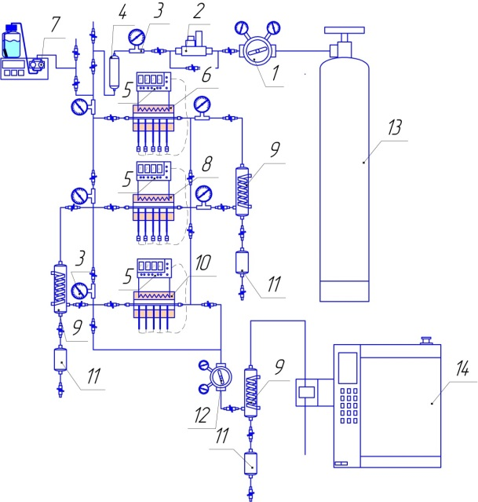

Figure 1: Catalytic set-up for methanol to the hydrocarbons transformation process. 1 - nitrogen pressure reducer, 2 - nitrogen mass flow controller, 3 - pressure gauge, 4 - buffer tank, 5 - temperature controller, 6 - evaporator, 7-pump for methanol feeding, 8 - dimethyl ether synthesis reactor, 9 - reflux, 10 - hydrocarbon synthesis reactor, 11 - fraction collector, 12 - system pressure regulator, 13 - nitrogen cylinder, 14 - chromatograph.

* 1. Results and discussions

Treatment of H-ZSM-5 HKC zeolite with an aqueous solution of sodium hydroxide with a concentration of 0.01-0.6 M (Figure 2a) results in an increase of mesopores volume and decrease of micropores volume that can be subscribed to partial destruction of micropores with the formation of mesopores. The formation of mesopores occurs due to partial dissolution of silicon oxide, which also leads to some decrease in the ratio Si/Al. Decrease in the Si/Al ratio results in an appropriate decrease in active cites quantity. However, zeolite treatment with a concentrated solution of sodium hydroxide leads only to a decrease of micropores volume that can be subscribed to fast dissolution of silica. Pore volume distribution (Figure 2a) clearly shows the formation of mesopores with a diameter of 4-6 nm in case of zeolite treatment with 0.01 to 0.6 M alkali solution, while further increase in alkali concentration to 1.1 M leads to the collapse of formed mesopores structure. Dimethyl ether transformation rate increased from 0.055 kg(DME)/(kg(Cat)\*h) to 0.09 kg(DME)/(kg(Cat)\*h) with an increase of sodium hydroxide concentration from 0.01 M to 0.2 M (Table 1), a further increase in the concentration of sodium hydroxide to 1.1 M led to a significant decrease in the transformation rate of dimethyl ether down to 0.02 kg(DME)/(kg(Cat)\*h), which is in a consequence with degradation of zeolite mesopore structure. The selectivity of the process for liquid hydrocarbons in the presence of zeolites modified with alkali solution is 25-30 %, which is lower by 5-10 % compared to the initial untreated zeolite (Table 1). However, some increase of process selectivity to light liquid hydrocarbons including benzene, toluene and xylenes fraction takes place.

ZSM-5 modification with oxalic acid did not result in considerable change of zeolite surface properties (Figure 2b), however, a slight decrease of active sites quantity take place. Treatment of zeolite with oxalic acid with a concentration of 0.07-0.3 M led to an increase in catalyst activity (Table 1), while a further increase in acid concentration to 3.3 M resulted in a decrease in the activity of the modified zeolite down to 0.045 kg(DME)/(kg(Cat)\*h), that can be attributed to aluminum leaching from zeolite surface.

The incorporation of metals into the zeolite H-ZSM-5 matrix leads to a slight increase in the micropores volume (Figure 2c). The increase of micropores volumes can be explained by the alumina and silica leaching from the zeolite matrix during catalysts modification.

Zeolite modification with metals result in an increase of dimethyl ether transformation rate up to 0.1 kg(DME)/kg(Cat)\*h) for nickel modified samples (Table 1), 0.07 kg(DME)/(kg(Cat)\*h) for cobalt and iron modified samples. The increase of DME transformation rate can be proscribed to active sites modification. Also, some increase of process selectivity to light liquid hydrocarbons including benzene, toluene and xylenes fraction takes place along with the decrease of process selectivity to polyaromatic hydrocarbons.

Table 1: Physical-chemical and catalytic properties of modified zeolites

|  |  |  |  |  |  |  |
| --- | --- | --- | --- | --- | --- | --- |
| Sample | Surface area, m2/g | | Acid sites quantity,  mmol/g | | DME transformation rate, kg(DME)/(kg(Cat)\*h) | Selectivity of liquid hydrocarbons/xylenes formation, % |
| micro-pores | meso-pores | t=310 ºC | t=560ºC |
| ZSM-5 initial | 303 | 55 | 0.84 | 0.4 | 0.055 | 38/6 |
| Alkali modification | | | | | | |
| ZSM5-NaOH-0.01M | 300 | 56 | 0.83 | 0.40 | 0.065 | 35/8 |
| ZSM-5-NaOH-0.05M | 275 | 59 | 0.76 | 0.36 | 0.08 | 32/10 |
| ZSM-5-NaOH-0.1M | 261 | 67 | 0.72 | 0.34 | 0.086 | 30/12 |
| ZSM-5-NaOH-0.2M | 251 | 87 | 0.70 | 0.33 | 0.09 | 28/10 |
| ZSM-5-NaOH-0.6M | 244 | 113 | 0.68 | 0.32 | 0.04 | 27/8 |
| ZSM-5-NaOH-1.1M | 200 | 50 | 0.55 | 0.26 | 0.02 | 25/8 |
| Acid modification | | | | | | |
| ZSM-5-(COOH)2-0.07M | 284 | 56 | 0.76 | 0.32 | 0.07 | 25/7 |
| ZSM-5-(COOH)2-0.3M | 275 | 53 | 0.61 | 0.28 | 0.08 | 24/8 |
| ZSM-5-(COOH)2-0.7M | 261 | 54 | 0.54 | 0.25 | 0.09 | 23/6 |
| ZSM-5-(COOH)2-3.3M | 254 | 58 | 0.41 | 0.18 | 0.05 | 22/4 |
| Metal modification | | | | | | |
| ZSM-5-Ni-0.001M | 291 | 61 | 0.76 | 0.32 | 0.10 | 30/15 |
| ZSM-5-Co-0.001M | 300 | 33 | 0.76 | 0.34 | 0.07 | 28/11 |
| ZSM-5-Fe-0.001M | 280 | 75 | 0.72 | 0.36 | 0.07 | 30/13 |

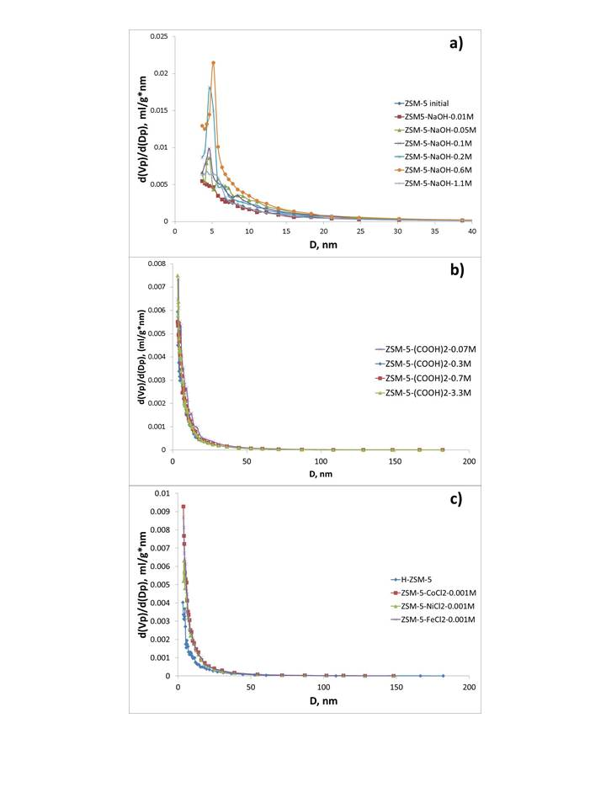

Figure 2: Pore volume distribution for a) alkali b) acid and c) metal modified zeolites

* 1. Conclusions

A series of H-ZSM-5 zeolites modified with sodium hydroxide, oxalic acid and metals were synthesized to enhance the catalytic property of H-ZSM-5 in methanol to the hydrocarbons transformation process. Zeolite treatment with sodium hydroxide results in the formation of mesopores with diameter 4-6 nm that has a positive effect on products diffusion and results in an appropriate increase of dimethyl ether transformation rate. Oxalic acid modification of H-ZSM-5 samples results in some increase of dimethyl ether transformation rate mainly due to aluminum precursor washing from zeolite micropores. Zeolite modification with metal results in modification of zeolite active sites, which result in an increase of dimethyl ether transformation rate and increase of process selectivity to liquid hydrocarbons and xylenes. The sample ZSM-5-Ni-0.001 M showed highest activity 0.1 kg(DME)/(kg(Cat)\*h).

Acknowledgments

Scientific studies were founded by the Ministry of Science and Higher Education of the Russian Federation and the Russian Science Foundation project № 18-79-10157.

References

Catizzone, E., Cirelli, Z., Aloise, A., Lanzafame, P., Migliori, M., Giordano, G., 2018, Methanol conversion over ZSM-12, ZSM-22 and EU-1 zeolites: from DME to hydrocarbons production. Catalysis Today, 304, 39-50.

Doluda, V., Lakina, N., Sidorov, A., Stepacheva, A., Matveeva, V., Sulman, M., Sulman, E., 2018, Influence of the reactor system on the transformation of methanol to gasoline over H-ZSM-5. Chemical Engineering Transactions, 70, 1357-1362.

Fattahi M., Behbahani R.M., Hamoule T., 2016, Synthesis promotion and product distribution for HZSM-5 and modified Zn/HZSM-5 catalysts for MTG process, Fuel, 181, 248-258.

Li M., Zhou Y., Ju C., Fang Y., 2016, Remarkable increasing of ZSM-5 lifetime in methanol to hydrocarbon reaction by post engineering in fluoride media, Applied Catalysis A: General, 512, 1-8.

Ortega, C., Hessel, V., Kolb, G., 2018, Dimethyl ether to hydrocarbons over ZSM-5: Kinetic study in an external recycle reactor. Chemical Engineering Journal, 354, 21-34.

Porterfield, W. W., Zrelak, G. M., Moncure, L. A., Huff, M. D., 2010, Continuous conversion of methanol to higher hydrocarbons at ambient pressure. Journal of Natural Gas Chemistry, 19, 461-462.

Rebrov, E., Hu, G., Sadykov, V. A., 2018, Chapter 9 - Novel Zeolite Catalysts for Methanol to Hydrocarbon Transformation. Advanced Nanomaterials for Catalysis and Energy.Elsevier.

Sadeghi, S., Haghighi, M., Estifaee, P., 2015, Methanol to clean gasoline over nanostructured CuO-ZnO/HZSM-5 catalyst: Influence of conventional and ultrasound assisted co-impregnation synthesis on catalytic properties and performance. Journal of Natural Gas Science and Engineering, 24, 302-310.

Saxena, S. K., Viswanadham, N., Muhtaseb, A. H., 2014, Enhanced production of high octane gasoline blending stock from methanol with improved catalyst life on nano-crystalline ZSM-5 catalyst. Journal of Industrial and Engineering Chemistry, 20, 2876-2882.

Wan W., Fu T., Qi R., Shao J., Li Z., 2016, Coeffect of Na+ and Tetrapropylammonium (TPA+) in Alkali Treatment on the Fabrication of Mesoporous ZSM-5 Catalyst for Methanol-to-Hydrocarbons Reactions, Industrial and Engineering Chemistry Researches, 55 (51), 13040–13049.

Wang C., Zhang D., Fang C., Ge Q., Xu H., 2014, Synthesis of gasoline from syngas in a dual layer catalyst system, Fuel, 134, 11-16.

Zaidi H.A., Pant K.K., 2004, 5. Catalytic conversion of methanol to gasoline range hydrocarbons, Catalysis Today, 96, 155-160.