CHEMICAL ENGINEERING TRANSACTIONS  VOL. 76, 2019 | A publication of
The Italian Association
of Chemical Engineering
Online at www.cetjournal.it
Guest Editors: Sauro Pierucci, Jiří Jaromír Klemeš, Laura Piazza
Copyright © 2019, AIDIC Servizi S.r.l.
ISBN 978-88-95608-73-0; ISSN 2283-9216

On the effect of specific boundary flux parameters on membrane process design
Marco Stoller^{a*}, Angela Marchettiª, Javier Miguel Ochando Pulido^{b}

ª Sapienza University of Rome, Dept. Of Chemical Materials Environmental Engineering Via Eudossiana 18, 00184 Rome, Italy
^{b} University of Granada, Dept. of Chemical Engineering, Avenida de la Fuente Nueva S/N, 18071 Granada, Spain
* marco.stoller@uniroma1.it
The boundary flux concept permits to describe the fouling behaviour of membrane systems as a function of the operating time. The method relies on a set of equations that is possible to integrate in time, thus permitting to evaluate the separation process outcome and performances.
This study focuses on the relationship between the membrane area requirements and specific parameters of the boundary flux concept on different membrane systems characterized by different waste feed streams and operating conditions. The target of the analysis was to identify which parameters of the boundary flux equations are the most influent one on the membrane area requirements. The knowledge of the relevant parameters can strongly assist membrane process designers to minimize the capex of the developed plants.
The study was performed on many different systems, available in literature, and at different operating conditions. In order to avoid the triggering of irreversible fouling, the operation must be performed in sub-boundary operating conditions, and as a consequence, the condition of the permeate flux Jp equal to the boundary flux Jb must be met at the end of operation.
The adopted procedure was as follows:
1. in a first step, by using infinite membrane area, the maximum recovery value Ymax of a specific membrane separation process was determined.
2. afterwards, the separation target was equally fixed at volume unity of feed (1 m³) produced during time unity (1 h) at three different recovery values, that is Y equal to 50% Ymax, 75% Ymax and 90% Ymax, respectively. The required membrane area was calculated by means of the simulation code, using a Newtonian trial&error procedure.
The obtained results show that no particular attention must be given to fouling issues in those systems that are not strongly pushed in terms of recovery. For instance, for systems characterized by a volume recovery factor below 75%, fouling issues can be neglected during process design. This is not the case for all other systems where Y>75%. In this case, the minimization of the membrane area requirements requires a careful evaluation and maximization of the relevant Jb value. Since the boundary flux value depends on many parameters, it appears to be profitable to achieve proper choice of operating conditions and pre-treatment steps to maximize Jb.
  - Introduction
One of main drawback of membrane technologies is membrane fouling, which significantly reduces the membrane performances in a short amount of time.
The phenomenon of membrane fouling is strictly connected to the formation of a gel like cake layer over the surface of the membrane due to polarization; the growth rate and consistency of this fouling layer is a function of different parameters such as feed stream characteristics (including different pretreatment processes, such as prefiltration, adsorption, oxidation, photocatalysis by nanocatalysts, bio-nanotechnologies, Fenton), chemo-physical properties of the solutes, particle sizes, selectivity and pore dimensions of the membrane (Vilardi et al., 2018a; Stoller et al, 2017; Stoller et a., 2018a; Stoller et al., 2018b; Vilardi et al., 2019). It is possible to make a distinction between three types of fouling, called reversible, semi-reversible and irreversible, respectively. The difference of these types is the possibility to clean or wash the membrane in order to completely restore the initial permeability values: this is possible only in case reversible fouling is washed by water. In case of semi-reversible fouling, a partial restore of the permeability values of the membrane is allowed by chemical cleaning (semi-reversible fouling). Finally, when irreversible fouling forms, there is no possibility to gain again back the previous membrane performances. Considering that membrane fouling cannot be completely avoided, it appears to be best practice to operate the membrane process in such operating conditions where only reversible fouling is formed, that is at permeate fluxes below the boundary flux value Jb (Chang et al, 2006). This operating strategy constraints the adoptable value of TMP used during processing (Vilardi et al, 2018b). As a consequence, to meet specific target capacities in term of permeate flow rates of the membrane plant, a proper amount of membrane area must be provided. The choice of this latter requirement is a specific task within the design of membrane processes.
The calculation and specification of the requirement in membrane area is not an easy task, since it should guarantee not only the target capacities of the process but has to consider the decrease in performances given by fouling as a function of time. In other words, membrane fouling, even in its reversible form, will lead to a reduction of the permeability of the membrane, and this aspect needs to be compensated by an additional amount of membrane area which has the objective to host the fouling (Vrijenhoek et al, 2001)
In this work, membrane process operating data was taken from literature and a simulation code was used to calculate the separation outcome and performances of different feed stock streams, in order to determine the membrane area requirements for a specific task. The simulation code was implemented as an Excel spreadsheet including VBasic libraries and enabled macros. In a second step, the influence of membrane fouling expressed as Jb and α values, as well as other membrane characterises such as the pure water permeability w and operating conditions such as the recovery factor Y on the membrane area requirements are checked.

Normally, all these parameters are not a choice of the process designer, since strictly connected to the given system. As a consequence, the key parameter that might be controlled during operation to avoid the formation of irreversible fouling appears to be the applied transmembrane pressure value (TMP).
In conclusion, it can be said that might be interesting investigate further about the economic impact of the different design choices and that only through a continuous study about the fouling formation the membrane plants can become competitive respect to the others common waste treatments (Vuppala et al, 2018).
  - Methods
The phenomenon of fouling is linked mainly to two different possible causes, that is polarization and aging of the membrane. When irreversible fouling is formed, it cannot be eliminated by any cleaning or washing procedure, being the main culprit to premature membrane failure and complete loss of productivity in a short period of time. It appears therefore mandatory to avoid irreversible fouling to permit a long-term operation of membranes (Van der Bruggen et al, 2008)
One method to avoid triggering irreversible fouling on membranes is to operate below the boundary flux. Starting point of the concept is the critical flux introduced by Field et al.(Field et al, 1995). Shortly expressed, the critical flux (Mänttäri and Nyström, 2000) is equal to the one below which no fouling occurs. However, this concept did not always apply well to the observed experimental data, especially on those systems treating wastewater streams (Ochando-Pulido Stoller, 2015). Indeed, it appears that a feedstock characterized by high amounts of suspended solid leads unavoidably to the formation of fouling even operating below the critical point. Successively, Field et al. introduced another concept, that is the threshold flux that divides a low fouling region, characterized by a constant rate of fouling, from a high fouling one (Stoller et al, 2013) . Finally, Stoller and Ochando-Puliudo merges the two concepts into a new one, that is the boundary flux (Stoller and Ochando-Pulido, 2014a).
The correspondent equations are hereafter reported:

$\frac{dm}{dt}=-α ;Jp\left(t\right)≤Jb$ (1)

$\frac{dm}{dt}= -α- β \left(Jp\left(t\right)-Jb\right) ;Jp\left(t\right)>Jb$ (2)

where:
- α, expressed in [l h⁻² m⁻² bar⁻¹], represents the constant permeability reduction rate suffered by the system called the sub-boundary fouling rate index. It is a constant, valid for all flux values;
- β, expressed in [l⁻¹ bar⁻¹], represents the fouling behavior in the exponential fouling regime of the system, called super-boundary fouling rate index. It is variable as a function to the transmembrane pressure (TMP);
- m, expressed in [l h⁻² m⁻² bar⁻¹], represents the membrane permeability;
- Jp(t), expressed in [l h⁻² m⁻²], represents the permeate flux depending on the operating time.

The evaluation of a value for the boundary flux is not possible by theory but requires the interpretation of available experimental data on the specific system under analysis. Once defined, since boundary flux values change as a function of time even on the same system, proper simulation of the process must be performed to assure sub-boundary flux conditions during all operation.
In this work, membrane process operating data was taken from literature and a simulation code was used to calculate the separation outcome and performances of different feed stock streams, in order to determine the membrane area requirements for a specific task. In particular, the separation at different recovery factors Y of 1m³/h in continuous operation at a controlled permeate flow rate was studied. Being Jp* the project value of the desired and controlled permeate flow rate, the membrane area requirement can be calculated as soon as a constraint adopting a value of Jp* equal to Jb was adopted, in order to guarantee that the operation is performed in sub-boundary flux conditions.
The analysis was made using a different membrane classes subdivided in function of the different pore size: ultrafiltration, microfiltration, and nanofiltration (UF, MF, NF) (Stoller et al, 2016). Within each class, the simulation code was used on different feed streams found in literature. In order to run the simulation, some input parameters are required, concerning feed stream characteristics (KP(0)), productivity (ρ1, m1, w), selectivity (σ, γ) and membrane fouling (Jb, TMPb, α). The details of the used equation set and the relevant nomenclature of the used variables within this paper are reported elsewhere (Stoller and Ochando Pulido, 2014b).
In a first step, an infinite membrane area was fixed in order to determine the maximum possible recovery value Ymax for each different feed stream. Then, the required membrane areas to reach pre-determined separation targets, in detail 50%, 75% and 90% of Ymax, respectively, were evaluated by adopting a Newtonian trial&error procedure. At the end, the obtained results in terms of membrane area requirements were analysed on those input parameters resulting the most influent one: the pure water permeability w and the boundary flux value Jb.
  - Results and discussion

The obtained results in terms of membrane area requirement as a function of Y are reported in Figure 1, for MF, UF and NF, respectively. The given reference number of the plotted lines are the respective reference number of the tables reported in the boundary flux handbook (Stoller and Ochando Pulido, 2014b).

It is possible to observe that the all the plots are similar in shape, characterized by a first part ranging from Y50% to Y75% having higher angular coefficient when compared to the second one, from Y75% to Y90%. Consequently, the following analysis to check for some empirical relationship between w and/or Jb will be divided in two parts, regarding the different relative Y ranges.
Concerning the first part, ranging from Y50% to Y75%, to highlight the dependency, selected plots from UF and NF were reported in Figure 2 and the relevant data in Table 1.

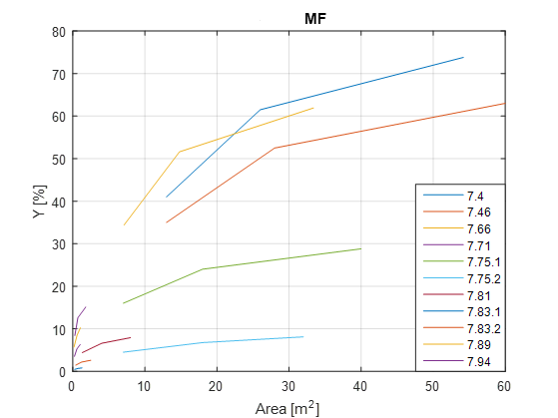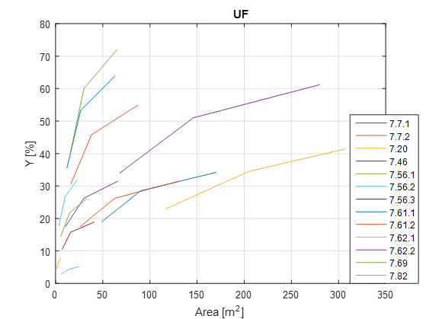
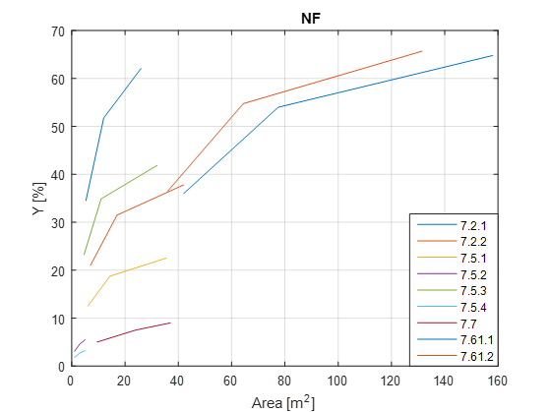

Figure 1: Membrane area requirement vs Y for different feed streams: MF, UF and NF, respectively (caption)

Table 1: Relevant data of the selected plots in Figure 2
UF |  |  |  | NF
Plot ID | ΔA/ΔY | w | Jb | Plot ID | ΔA/ΔY | w | Jb
7,46 | 0.78 | 72.0 | 25.0 | 7.2.1 | 0.27 | 15.3 | 84.0
7.61.1 | 1.64 | 5.2 | 8.2 | 7.2.2 | 0.40 | 14.3 | 45.0
7.61.2 | 1.48 | 5.2 | 10.0 | 7.5.1 | 0.33 | 9.8 | 35.6
7.82 | 0.26 | 234.8 | 84.6 | 7.61.1 | 1.42 | 2.5 | 11.8
 |  |  |  | 7.61.2 | 1.14 | 2.5 | 14.3

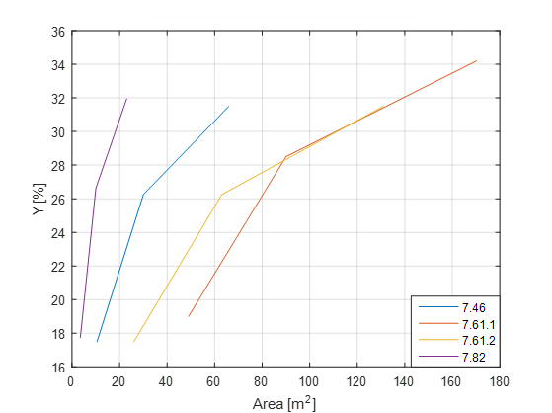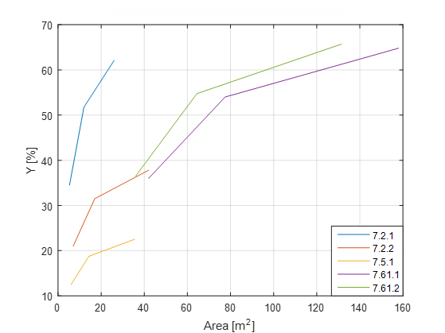

Figure 2: Selected plots from Fig.1, UF (left) and NF (right), respectively

From Table 1 it is possible to observe that for both membrane classes there is a relationship between ΔA/ΔY and w, whereas none can be observed towards Jb. The same property was confirmed for MF, too.

Concerning the second part, ranging from Y75% to Y90%, to highlight the dependency, selected plots from UF and NF were reported in Figure 3 and the relevant data in Table 2.

Table 2: Relevant data of the selected plots in Figure 3
UF |  |  |  | NF
Plot ID | ΔA/ΔY | w | Jb | Plot ID | ΔA/ΔY | w | Jb
7.56.1 | 1.20 | 65.0 | 44.6 | 7.2.1 | 0.93 | 15.3 | 84.0
7.66.2 | 0.73 | 16.0 | 8.3 | 7.2.2 | 1.67 | 14.3 | 45.0
7.82 | 0.87 | 234.8 | 84.6 | 7.5.1 | 1.41 | 9.8 | 35.6
 |  |  |  | 7.5.3 | 1.40 | 14.3 | 81.3

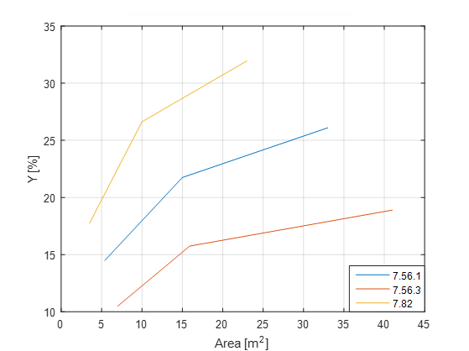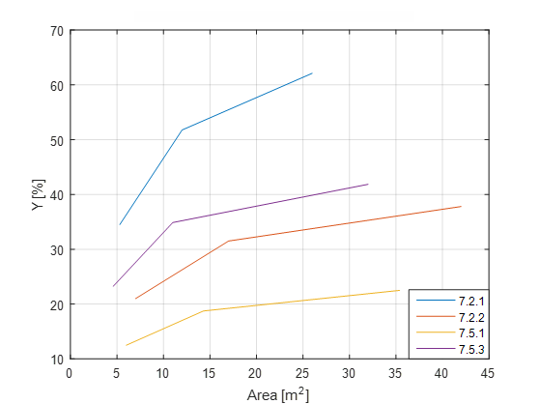

Figure 3: Selected plots from Fig.1, UF (left) and NF (right), respectively

From Table 2 it is possible to observe that for both membrane classes there is a relationship between ΔA/ΔY and Jb, whereas none can be observed towards w. The same property was confirmed for MF, too.
  - Conclusions
The membrane area is the most relevant parameter for a correct design of a relative plant. In fact, the investment costs of a given plant capacity in terms of membrane area and obtainable permeate flow rates are strictly dependent on these values. The performed work by adopting the simulation code has permitted to explore further the relationship between membrane area requirement and specific parameters considering membrane fouling, in order to assist optimized membrane process design.
The obtained results from this study shows that no particular attention must be given to fouling problems in those systems that are not strongly pushed in terms of recovery up to Y75%; in this case, membranes with high w value are preferred and achieves the same plant capacities with a small variance in membrane area within the range Y50%-Y75%. On the contrary, systems that exceeds a Y value of 75% or above, needs a careful estimation and a maximization of the relevant Jb value to allow the minimization of the membrane area requirements. In this case, an increase of the Jb value is desirable, and this can be achieved by pre-treatment tailoring or use of upper membrane classes (Stoller and Bravi, 2010).
References
Chang S., Fane A. G., Waite T. D., 2006, Analysis of constant permeate flow filtration using dead-end hollow fiber membranes. Journal of membrane science, 268(2), 132-141.
Field R. W., Wu D., Howell J. A., Gupta B. B., 1995, Critical flux concept for microfiltration fouling, Journal of membrane science, 100(3), 259-272.
Mänttäri M., Nyström M., 2000, Critical flux in NF of high molar mass polysaccharides and effluents from the paper industry, Journal of Membrane Science, 170(2), 257-273.
Ochando-Pulido J. M., Stoller M., 2015, Kinetics and boundary flux optimization of integrated photocatalysis and ultrafiltration process for two-phase vegetation and olive washing wastewaters treatment, Chemical Engineering Journal, 279, 387-395.
Stoller M., Bravi M., 2010, Critical flux analyses on differently pretreated olive vegetation waste water streams: some case studies. Desalination, 250(2), 578-582.
Stoller M., Ochando-Pulido, J. M., Chianese A., 2013, Comparison of critical and threshold fluxes on ultrafiltration and nanofiltration by treating 2-phase or 3-phase olive mill wastewater, 32, 397-402.
Stoller M., Ochando-Pulido J. M., 2014a, About merging threshold and critical flux concepts into a single one: the boundary flux. The Scientific World Journal, 2014.
Stoller M., Ochando-Pulido J. M., 2014b, The boundary flux handbook: A comprehensive database of critical and threshold flux values for membrane practitioners, Elsevier.
Stoller M., Azizova G., Mammadova A., Vilardi G., Di Palma L., Chianese A., 2016, Treatment of Olive Oil Processing Wastewater by Ultrafiltration, Nanofiltration, Reverse Osmosis and Biofiltration, Chemical Engineering Transactions, 47, 409–414.
Stoller M., Ochando-Pulido J.M., Vilardi G., Vuppala S., Bravi M., Verdone N., Di Palma L., 2017, Technical and economic impact of photocatalysis as a pretreatment process step in olive mill wastewater treatment by membranes, Chemical Engineering Transactions, 57, 1171-1176.
Stoller M., Sacco O., Vilardi G., Ochando-Pulido J.M., Di Palma L., 2018a, Technical–economic evaluation of chromium recovery from tannery wastewater streams by means of membrane processes, Desalination and Water Treatment, 127, 57-63.
Stoller M., Di Palma L., Vuppala S., Verdone N., Vilardi G., 2018b, Process intensification techniques for the production of nano-and submicronic particles for food and medical applications, Current Pharmaceutical Design, 24, 2329-2338.
Van der Bruggen B., Mänttäri M., & Nyström M., 2008, Drawbacks of applying nanofiltration and how to avoid them: a review. Separation and purification technology, 63(2), 251-263.
Vilardi G., Rodriguez-Rodriguez J., Ochando-Pulido J.M., Verdone N., Martinez-Ferez A., Di Palma L., 2018a, Large Laboratory-Plant application of a Tannery wastewater treatment by Fenton oxidation: Fe(II) and nZVI catalyst comparison and kinetic modelling, Process Safety and Environmental Protection, 117, 629-638.
Vilardi G., Ochando Pulido J.M., Verdone N., Stoller M., Di Palma L., 2018b, On the removal of Hexavalent Chromium by olive stones coated by iron-based nanoparticles: equilibrium study and Chromium recovery, Journal of Cleaner Production, 190, 200-210.
Vilardi G., Rodriguez-Rodriguez J., Ochando Pulido J.M., Di Palma L., Verdone N., 2019, Fixed-bed reactor scale-up and modelling for Cr(VI) removal using nano iron-based coated biomass as packing material, Chemical Engineering Journal, 361, 990-998.
Vrijenhoek E. M., Hong S., Elimelech M., 2001, Influence of membrane surface properties on initial rate of colloidal fouling of reverse osmosis and nanofiltration membranes. Journal of membrane science, 188(1), 115-128.
Vuppala S., Stoller M., Chiavola A., Kanaev A., Cheng K., 2018, Synthesis of core-shell nanoparticles for the removal of toxic pollutants in aqueous medium, Chemical Engineering Transactions, 70, 1819-1824.

