|  |  |
| --- | --- |
| cetlogo ***CHEMICAL ENGINEERING TRANSACTIONS***  ***VOL. 76, 2019*** | A publication of  aidiclogo_grande |
| The Italian Association  of Chemical Engineering  Online at www.cetjournal.it |
| Guest Editors: Sauro Pierucci, Jiří Jaromír Klemeš, Laura Piazza  Copyright © 2019, AIDIC Servizi S.r.l. **ISBN** 978-88-95608-73-0; **ISSN** 2283-9216 | |

Development Of A Process For N-Butanol Recovery From Abe Wastewater Streams By Membrane Technology

Marco Stollera\*, Marco Bravia, Paola Russoa, Roberto Bubbicoa, Barbara Mazzarottaa

aSapienza University of Rome, Dept. of Chemical Materials Environmental Engineering, Via Eudossiana 18, 00184 Rome, Italy

marco.stoller@uniroma1.it

The aceton-butyl-ethanolic fermentation process (ABE) is a biotechnological process that leads to the production of acetone, n-butanol and ethanol (ABE compounds) from glucose sources and amides by use of certain biomasses. The process was developed initially during the middle of the last century and suffers from decline due to the greater petrochemical production of products and the lowering of the costs of the sector. Nowadays, the ABE process is regaining great interest because the fraction with the highest concentration, i.e. n-butanol, is an excellent constituent for biofuels.

The ABE process has been optimized over time to obtain maximum yields of n-butanol, but the problem of separating and concentrating the butanol in the outlet stream of the ABE process persists. To allow an adequate use, often distillation by use of more columns is required. Moreover, the contained biomasses and suspended solids, in high quantity, must be eliminated, leading to overall high treatment costs.

This work will report the main idea and some preliminary experimental results for the development and application of a process based on membrane technologies, to separate and concentrate the butanol from ABE process streams to sensibly reduce the difficulty to perform a final distillation.

The proposed treatment process is composed by ultrafiltration, pervaporation, nanofiltration and a final mixing/demixing operation.

Attention was paid to the productivity, selectivity and longevity of the used membranes. The optimization of these three parameters is essential to achieve a level of reliability and feasibility of the proposed process, in particular the avoidance of membrane fouling.

* 1. Introduction

The n-butanol obtained from biomass, known as bio-butanol, is now affirming itself as the main component of the 2nd generation biofuels for improvements in the production process ABE (optimization of the biological reactor, of the microbial biomass used, reduction of water consumption and energy) and the advantages compared to bio-ethanol (higher energy content, lower volatility, hygroscopicity and corrosivity).

Currently, the collaboration between DuPont and BP has led to the formation of a commercial sales plan to produce n-butanol obtained from sugar beets. Other companies that are producing n-butanol are Gevo and Tetravitae in collaboration with the University of Illinois. Greenbiologics has invested in the development of technology recently with a total funding of € 6.23 million in related collaborative projects. Butamax Advanced Biofuels researches production methods starting from lignin. At the European level, there are 7 projects funded in the HORIZON 2020 area, which also focus on the various aspects of the ABE process for the suitable production of n-butanol as a base for biofuels, starting from a further optimization of the basic biological process, starting from diversified sources, with the aim of facilitating the concentration of n-butanol in the post-processing phase. At the national level, the issue captures a strong interest both in terms of projects and seminars and / or congresses. AIDIC, the Italian association of chemical engineering, of which the proponent is a member of the national council, organizes at least one round table event on the topic of energy and biofuels every year.

Despite significant research efforts, the full economic sustainability of bio-butanol production has not yet been achieved. The main problem is the purification of biobutanol from the low concentration of the "broth" coming from the bioreactor up to the high purity required by motor applications (99% and over), currently realized with a train of energetically expensive distillation columns.

The use of membranes in the ABE process has been studied for many years as regards a first filtration placed directly in the biological reactor (integrated membrane bio reactor, I-MBR), through an ultrafiltration membrane that has the task of removing the biomasses and the solid suspended from food (Esfahanian at al., 2012).

The approach certainly has advantages compared to other conventional techniques, but there is a problem of fouling of the membrane (fouling) which is not completely resolved, and which significantly reduces its performance over time. Moreover, this first filtration is not sufficient to reach n-butanol concentrations useful for the production of biofuels, for which necessity of other post-treatment processes.

Also, the use of the pervaporation to concentrate the currents from the ABE process have been studied at the laboratory and industrial level with excellent results. In the present work, the pervaporation will be used on the ultrafiltration permeate previously produced. The choice of the membrane material plays a fundamental role in the process of material transfer and is also responsible for the good solubility of n-butanol. Among the various materials, the polymers PDMS (polydimethylsiloxane) and POMS (polyoctylmethylsiloxane) showed the best performances in terms of both transport properties and selectivity (Qureshi et al., 2014; Lazarova et al., 2012), which however signal sensitive fouling problems.

In this work, membrane performances of an ultrafiltration (UF), pervaporation (PV) and nanofiltration (NF) in series for the recovery of n-butanol from ABE streams are reported.

* 1. Experimental setup

Two different lab scale membrane plants were used during this study.

UF and NF were performed using the plant reported in Figure 1 (left). It consists of a 100 liter feed tank, FT1, in which the pretreated feedstock is carried. The centrifugal booster pump, P1, and the volumetric pump, P2, drive the wastewater stream over the used spiral wounded ultrafiltration (UF model GM supplied by Osmonics) or nanofiltration (NF model DK supplied by Osmonics) membrane, fitted in the housing, M1, at an average flow rate equal to 600 L h−1. The active membrane area of both the modules are equal to 0.51 m2. The maximum allowable operating pressure is equal to 16 bar and 32 bar for UF and NF, respectively.

Acting on the regulation valves, V1 and V2, it is possible to set the desired operating pressure over the membrane with a precision of 0.5 bar, maintaining the feed flow rate constant. Permeate and concentrate streams are cooled down to the fixed feedstock temperature, mixed together and recycled back to the feedstock. In this way, the feedstock composition is kept constant during each experimental batch run. The temperature was controlled for all experiments at the value of 20±1°C.

After each experiment, the membrane was rinsed with tap water for at least 30 min.

For PV a smaller unit was adopted. Compared to the previous one, the PV lab scale plant uses flat sheet membranes type CMC-VP-31 supplied from Celfa (M1), with a surface area equal to 44.2 cm2. The temperature is kept constant at a value of 20 ± 1 °C by the jacket of the feed tank vessel FT1. Only one valve (V1) is available to control the operating pressure on feed side. On the permeate side, a vacuum pump guarantees a constant pressure value equal to 0.05 bar. In order to capture all the permeate stream, a quenching device E1 is connected between the membrane and the pump, operating at -5°C, enough to quickly condensate all the components in the permeate stream and collect them in a collecting vessel within E1. The scheme of the adopted plant is shown in Figure 1 (right).

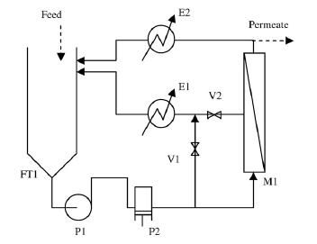

**Figure 1.** Scheme of the experimental setup for UF, NF (left) and PV (right)

The proposed process is as follows: the raw ABE is submitted to a UF membrane, and the permeate stream (UF perm) is collected as feedstock for the subsequent pervaporation. After pervaporation, the concentrate (PV conc) is withdrawn as feedstock to NF. Finally, the final product is the NF concentrate (NF conc).

During all experimental runs, following performances of the membrane were checked:

● Productivity in terms of permeate fluxes, measured by weight of a sample collected within 1 min at the permeate exit line.

● Selectivity on the specific compound S, performed by gas chromatography, and adopting following equation:

R(S) = 1 – [c(S),permeate / c(S),feed] (1)

where c(S) is the concentrate of the compound in the permeate and the feed stream, respectively.

● Longevity (fouling) of the membranes were analyzed by the boundary flux concept. Summarizing, both critical and threshold fluxes divide the operation of membranes in two regions: a lower one, where no or a small, constant amount of fouling (mostly reversible and/or semi-reversible) triggers, and a higher one, where (irreversible) fouling builds up very quickly (Field et al., 1995).

By using a new flux, that is the boundary flux Jb, and being Jp(t) the permeate flux value at a given time t, the critical and threshold flux equations may be merged in one set, and may be written as (Stoller and Ochando Pulido, 2014):

dm/dt = - α ; Jp(t) ≤ Jb (2)

dm/dt = - α - β ( Jp(t) - Jb ) ; Jp(t) > Jb (3)

where:

• α, expressed in [l h-2 m-2 bar-1], represents the constant permeability reduction rate suffered by the system and will be hereafter called the sub-boundary fouling rate index. α is a constant, valid for all flux values.

• β, expressed in [h-1 m-2 bar-1], represents the fouling behaviour in the exponential fouling regime of the system, and will be hereafter called super-boundary fouling rate index. β appears to not be a constant, and changes with the difference of the transmembrane pressure at the boundary point and the adopted one (TMPb - TMP).

Eq.2 is the most relevant one, since only reversible fouling triggers and therefore the membrane longevity results maximized. In this respect, operating below the Jb value is enough to guarantee long-term performances. In a second step, the value of α determines how long the membrane may operate without cleaning procedures. Cleaning membranes represent a cost and an operation stop which is certainly not desired to certain extent. Therefore, low α value membranes are preferred to high α value ones.

* 1. Results and discussion

The characteristics of the raw ABE stream used in this study were reported in Table 1, first line.

Table 1: Characteristics of all the streams

|  |  |  |  |  |  |  |  |  |  |  |
| --- | --- | --- | --- | --- | --- | --- | --- | --- | --- | --- |
| Stream | Water | | Butanol | | Ethanol | | Acetone | | SS | |
|  | Conc |  | Conc | R | Conc | R | Conc | R | Conc | R |
| Raw | 90.28%wt |  | 0.54%wt | - | 0.04%wt | - | 0.14%wt | - | 9.00%wt | - |
| UF perm | 99.34%wt |  | 0.49%wt | 0.09 | 0.04%wt | 0.00 | 0.13%wt | 0.07 | 0.00%wt | 1.00 |
| PV conc | 97.78%wt |  | 1.62%wt | 0.93 | 0.39%wt | 0.98 | 0.11%wt | 0.90 | 0.00%wt | - |
| NF conc | 80.54%wt |  | 15.31%wt | 0.95 | 3.24%wt | 0.66 | 0.91%wt | 0.83 | 0.00%wt | - |

Concerning UF, in a first step the boundary flux and α values were determined by using the pressure cycle method. The results were reported in Figure 2. A value of Jb, TMPb and α equal to 14.9 l h-1 m-2, 5 bar and 33.3 10-3 l h-2 m-2 bar-1 were found, respectively. Once determined, the separation of the permeate stream was performed by using a TMP value equal to 80% TMPb. The operation reached a recovery value Y equal to 70%. From Table 1 it is possible to observe that indeed UF do not reject ABE components (very low rejection values R); on the other hand, this pre-treatment appears to be mandatory: all the suspended solids and biomasses (SS) in the ABE stream are completely retained (data not here reported), permitting ease of use of the next separation step.

The obtained UF permeate stream was then submitted to PV.

In this case, no boundary flux value was measured directly by the pressure cycle method, since its application is difficult on flat sheet membrane systems. Therefore, the process was performed on two different TMP values, in detail 5.5 and 4.0 bar as first and second run, respectively, and the permeability loss as a function of time was checked for constancy (α). The profiles are reported in Figure 3. The target Y was set to 75%. Unfortunately, both selected values resulted to be super-boundary.

Nevertheless, it was possible to evaluate by calculation a TMPb value, starting from one definition of the boundary flux, that is at infinite operating time, the permeate flux will decrease by a value equal to α and Jp will assume values equal to Jb if the TMP value do not vary (Ochando Pulido and Stoller, 2015). Once determined, it is possible to estimate the value of Jb(0), at the start of the experiment, by interpolation.

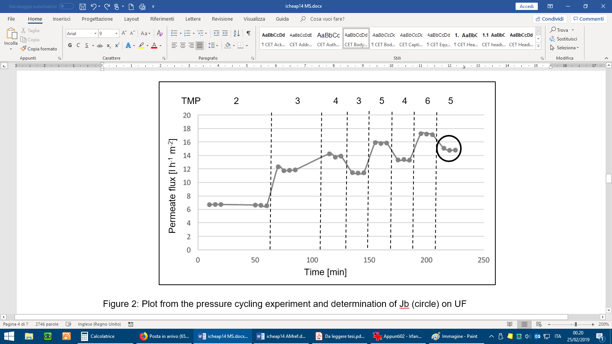

Figure 2: Plot from the pressure cycling experiment and determination of Jb (circle) on UF

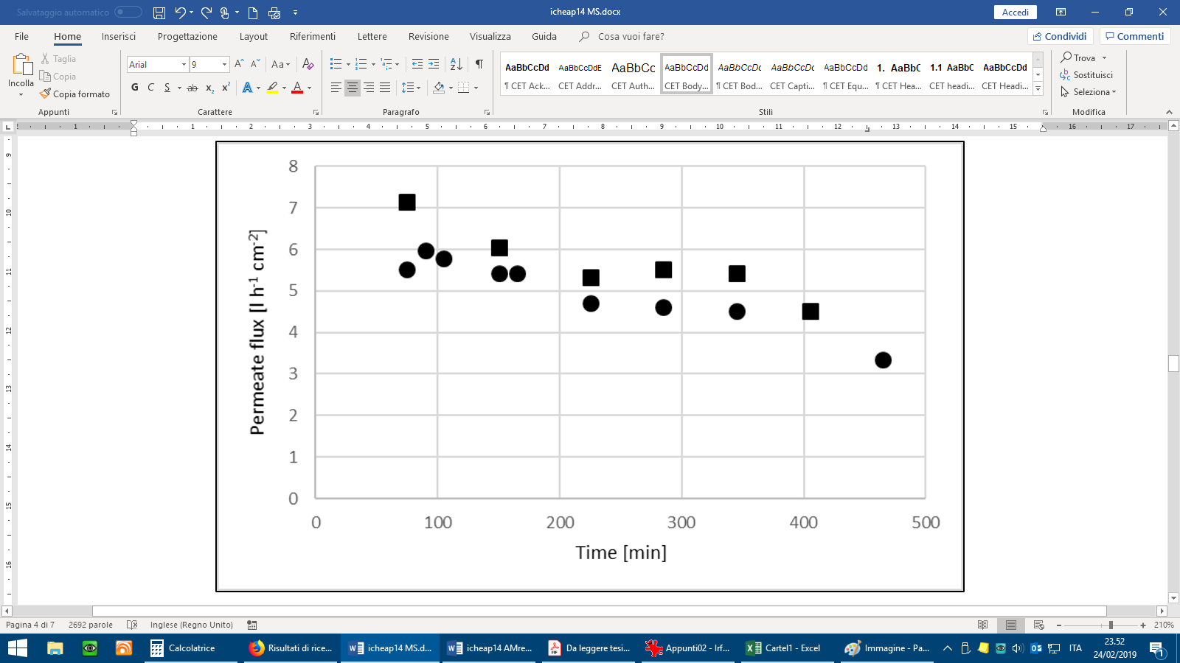

Figure 3: Plot of the PV permeate flow stream at TMP values equal to 4.0 bar (circle) and at 5.5 bar (square), respectively

In Figure 4, the estimation by correlation of the available data points were performed. A value of Jb of 2.9 l h-1 cm-2 and 2.1 l h-1 cm-2 was found. It is interesting to notice that the two values are different for the two experimental runs, due to irreversible fouling formed during the first one, that was the experiment performed at 5.5 bar.

Given a Jb(0) value and knowing the initial permeability value of the membrane, it is possible to estimate which TMP should have been applied to operate in boundary flux conditions, adopting the following equation:

TMPb = Jb(0) m(0)-1 (4)

where m(0) is the initial membrane permeability, precisely:

m(0) = Jp(0) TMP-1 (5)

The obtained results adopting eq. 4 are reported in Table 2.

Table 2: TMPb calculations

|  |  |  |  |  |
| --- | --- | --- | --- | --- |
| TMP | m(0)  [l h-2 m-2 bar-1] | Jb(0)  [l h-2 cm-2] | TMPb(0)  [bar] | α  [l h-2 m-2 bar-1] |
| 5.5 | 8.0 | 2.9 | 1.99 | 0.005 |
| 4.0 | 6.5 | 2.1 | 1.29 | 0.005 |

From the data in Table 2 it is possible to observe that the formation of irreversible fouling constraints the adoption of lower TMP values to permit further operation of the membrane in sub-boundary conditions, with a performance loss of about 35%.

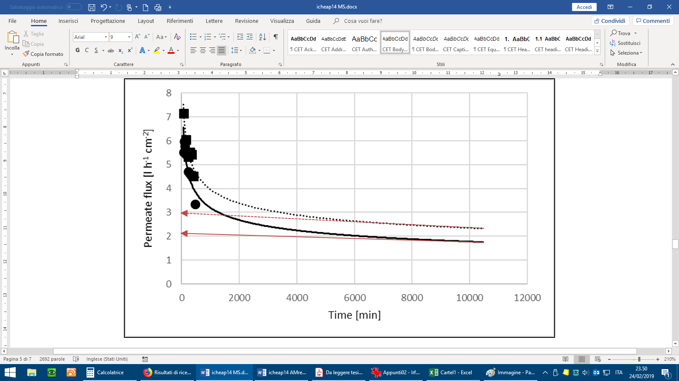

Figure 4: Plot of the estimation of the initial Jb(0) value by definition and interpolation (red lines).

From table 1, it might be observed that the hydrophilic pervaporation membrane used in this experiment is very permeable to water, but not to organics. Therefore, n-butanol is concentrated in the concentrate and indeed the PV concentrate was used as feedstock to NF.

Again, the boundary flux and α values were determined by using the pressure cycle method. The results were reported in Figure 4. A value of Jb, TMPb and α equal to 23.5 l h-1 m-2, 5 bar and 66.7 10-3 l h-2 m-2 bar-1 were found, respectively. Once determined, the separation of the permeate stream was performed by using a TMP value equal to 80% TMPb. The operation reached a recovery value Y equal to approx. 70%.

Table 1 reports the characteristics of all streams. The target stream is the NF concentrate.

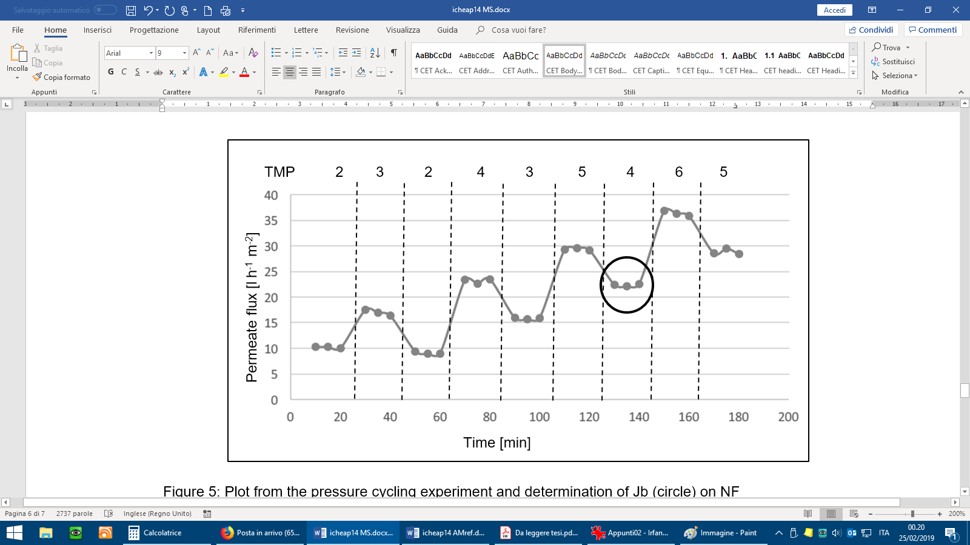

Figure 5: Plot from the pressure cycling experiment and determination of Jb (circle) on NF

Unfortunately, there appears to be no membrane capable to satisfactory separate the ABE components. On the other hand, the proposed membrane processes in series, in particular PV, permits to partially separate acetone from the rest. This appears to be an advantage for further processing: the NF still is above the azeotrope of water/n-butanol mixture (at 76.45%wt water), but in the immiscibility zone of the n-butanol/water/ethanol system (Zhou et al., 2014). Performing a raw calculation, by a decanter, it is possible to separate from the NF permeate 10.9% in volume of a 72% n-butanol / 25% water / 3% ethanol mixture.

As a last step, a preliminary design, in terms of membrane area requirements, of a possible treatment plant for n-butanol recovery by membranes was performed on 1m3 h-1. The target recovery values were set to 90% for each membrane step. For PV, the adopted Jb and TMPb values are those calculated by eq. 4 for the first run.

The obtained results are reported in Table 3.

Table 3: Results of the simulation performed for 1 m3 h-1 ABE, target recovery equal to 90% each step

|  |  |  |  |  |
| --- | --- | --- | --- | --- |
| STEP | Volume  [l] | Jb(0)  [l h-2 m-2] | α  [l h-2 m-2 bar-1] | Membrane area  [m2] |
| UF permeate | 900 | 13.9 | 33.3 10-3 | 76 |
| PV permeate | 81 | 2.9 | 5.0 10-3 | 312 |
| NF concentrate | 8 | 23.5 | 66.7 10-3 | 4 |

At the end, a total membrane area of 392 m2 m-3 ABE are required for the target process, corresponding to a total of 14 industrial membrane modules. The obtained values both in term of membrane area requirement and n-butanol concertation, reaching the immiscibility zone of the mixture to overcome the azeotrope, appear to be very promising.

Although technical feasibility holds, doubts may be expressed on the economic feasibility of the proposed process: a further distillation step leading to 95% n-butanol will result in a total yield of 56 g of biofuel each m3 of treated wastewater, or, in other words, 13.5 m3 must be treated to gain 1 l of biofuel. The gain appears to be too low to justify the operating costs of all involved units.

* 1. Conclusions

It is possible to see that the suggested process is technically feasible, but do not reach the desired final concentration of n-butanol in the NF permeate stream. Nevertheless, a final distillation step appears to be mandatory for post-processing the resulting NF concentrate to reach the desired specifications in n-butanol and to separate from ethanol. On the other hand, this last distillation step is performed on a smaller volume (0.8% of the initial one) and more concentrated (28 times initial n-butanol), leading to a less intensive and less costly operation.

As a future work, economic evaluation will be performed to compare the savings in using membrane technologies as a pre-processing step to distillation for ABE streams, in particular on the use of PV. Moreover, the use of reverse osmosis may be considered to achieve optimized starting concentrations to the final distillation column.

* 1. References

Esfahanian M., Ghorbanfarahi A.H., Ghoreyshi A.A., Najafpour G., Younesi H., Ahmad A.L.,2012, Enhanced Bioethanol Production in batch fermetantion by pervaporation using a pdms membrane bioreactor, IJE transactions B applications 25/4, 249-258.

Field R. W., Wu D., Howell J. A., Gupta B. B., 1995, Critical flux concept for microfiltration fouling, Journal of membrane science, 100(3), 259-272.

Lazarova M., Bosch P., Friedl A., 2012, POMS membrane for selective separation of ethanol from dilute alcohol- aqueous solutions by pervaporation, Sep Sci Technol 47, 1709-14.

Ochando-Pulido J. M., Stoller M., 2015, Kinetics and boundary flux optimization of integrated photocatalysis and ultrafiltration process for two-phase vegetation and olive washing wastewaters treatment, Chemical Engineering Journal, 279, 387-395.

Qureshi N., Friedl A., MaddoxI S., 2014, Butanol production from concentrated lactose/whey permeate: use of pervaporation membrane to recover and concentrate product, Appl Microbiol Biotechnol 98, 9859-67.

Stoller M., Ochando-Pulido J. M., 2014, The boundary flux handbook: A comprehensive database of critical and threshold flux values for membrane practitioners, Elsevier.

Zhou H., Su Y., Wan Y., 2014, Phase separation of an acetone–butanol–ethanol (ABE)–water mixture in the permeate during pervaporation of a dilute ABE solution, Separation and Purification Technology 132, 354-361.