|  |  |
| --- | --- |
| cetlogo ***CHEMICAL ENGINEERING TRANSACTIONS***  ***VOL. 76, 2019*** | A publication of  aidiclogo_grande |
| The Italian Association  of Chemical Engineering  Online at www.cetjournal.it |
| Guest Editors: Sauro Pierucci, Jiří Jaromír Klemeš, Laura Piazza  Copyright © 2019, AIDIC Servizi S.r.l. **ISBN** 978-88-95608-73-0; **ISSN** 2283-9216 | |

An empirical approach to Workload assessment for process optimization.

Lorenzo Combertia,\*, Gabriele Baldissonea, Micaela Demichelaa

aSAfeR, Dipartimento di Scienza Applicata e Tecnologia, Politecnico di Torino, Corso Duca degli Abruzzi, 24 – 10129 Torino, Italia

lorenzo.comberti@polito.it [Style: CET Email]

The Human Factors contribution in the scope of the industrial process optimization presented in this case study had to deal with considerations regarding the physical and mental workload requirements of different workstations and the capabilities of the operators assigned to them. The scope was to provide the industrial management with a better way to allocate human resources to tasks having different workload requirements.

This work presents an empirical model designed to quantify the impact of workload on workers with the aim of reducing operational errors and safety human errors.

The effects of this workload assessment can contribute to consider necessary areas of improvement in terms of technical measures, procedure optimizations and improved work organization, to reduce defects and waste generation.

The paper presents a brief description of the empirical approach used to assess the workload of complex tasks in assembly lines; furthermore, it also discusses some of the preliminary results of its application.

* 1. Introduction

Process optimization in manufacturing is generally applied to improve production efficiency and to obtain economic benefits. To reach this purpose process optimization works primary in several branches as: technical measures upgrading, work organization procedures designing, waste and energy saving. In addition, in more recent years, process optimization extended his action versus the Human Factors (Hong et al., 2007). Human Factors (HF) in fact, still has a strong influence of production efficiency despite the ever-increasing level of automation and the standardization of working-procedures (Baines et al., 2005).

The relevance of HF has been recognize in several sector and it has been modelled differently depending on the characteristics of field of analysis, as an example: quality experts investigated the connections between errors and human behaviour (Miller et al., 1987), Safety experts included HF into accidents precursor analysis (Comberti et al., 2015a,,Baldissone et al, 2018) and into ex-post events analysis (Comberti et al., 2015b and 2018a). With the aim of reducing their repetition HF optimization is used in the area of work organization to reduce operational risks and improve task-time optimization (Lin et al., 2007).

Dealing with HF into process optimization implies to face off with the concept of Human Performance (HP) as a result of interaction between two macro factors (Leva et al., 2018):

• Task Complexity (TC): summarising all factors contributing to physical and mental workload requirements for execution of a given operative task.

• Human Capability (HC): summarising the skills, training and experience of the people facing the tasks, representing a synthesis of their physical and cognitive abilities.

Human Performance is a complex system, where behaviour, cognition, physiology and working condition deeply interact and to include it into process optimization requires a multi-disciplinary approach (Leva et al., 2017). Automotive is a manufacturing-sector where production systems are based on a group of assembly lines composed by a sequence of working stations. Workstations are designed to allow under a time-constraint, named “Tack-time”, a task execution. Workstations demand different level of resources to workers to complete correctly each task depending to the task attributes.

A model to assess and predict the HP, such as the reliability of individuals to perform specific tasks can be a very useful support in the process of allocating human resources to various workstations in an assembly line.

Identifying the best couple worker-work station on the basis of the workstation attributes and the worker’s capabilities will have a positive impact in term of HP optimization and errors reduction (Groth et al., 2012).

The design of such a system was proposed with an empirical approach and recently presented in 2019 (Comberti et al., 2019). It consisted in a conceptual model resumed in Figure 1 that was focused on the variable’s identification for the Human Performance assessment and an operative-one designed to be applied into real working condition.

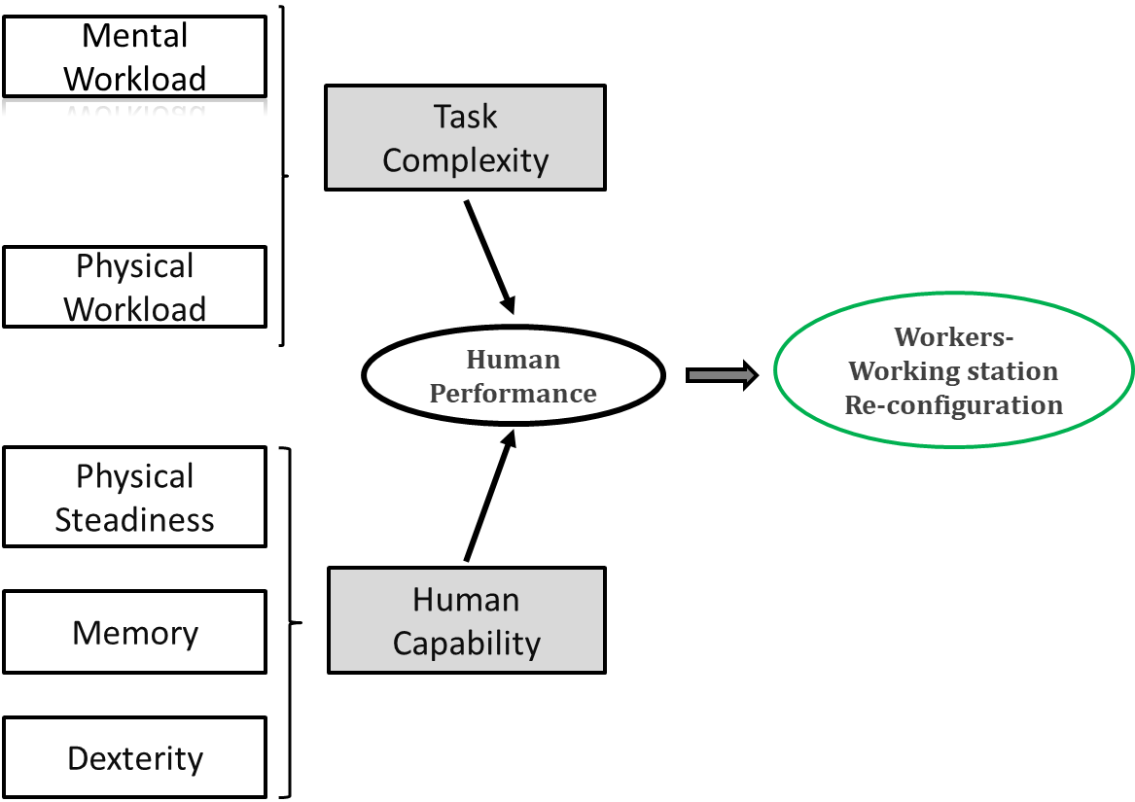

*Figure 1: Conceptual model for HP assessment*.

This model was applied in an automotive assembly plant and tested on a pilot-case of 15 working-stations involving 30 workers. Results of HP assessment have been used by plant Managers to make a re-configuration of the workers distribution into the assembly-line (Comberti at al., 2018b) and quality data monitored as measurable impact on the rate of human errors. Results of this experiment were encouraging and allowed an expansion of the application. This paper presents an additional development of the project in which the model was applied to a bigger group of working-stations to refine the operational model for workload (WL) assessment.

Section 2 of the paper describes the operative model for WL refined with the analysis of the variables selected and section 3 shows the results of the model application to the case study. Conclusions ended the paper and gives a view of up-comings developments.

* 1. Methods

To set an operational model to WL assessment it was necessary to identify a set of actual observable and measurable quantities to estimate/assess the model variables. In addition to this, a common scale of evaluation for all quantities was adopted so as to allow a quantitative comparison between Workload (WL) requirements. The WL operational model was defined using a task analysis approach (Jung et al., 2001) of each workstation activity plus an observation protocol to score the whole assembly line.

Operative model contains for each factor considered into the Conceptual model a set of observable and measurable variables.

The variables were selected after a field analysis with a participatory approach that involved both academic and industry professionals operating in the various management areas involved: Safety, Work Analysis, Quality, Work Organization.

The observable variables selected will measured both in numerical and qualitative scales. In order to allow the confrontation between variables with a different nature and scale, all the variables will be harmonized in a common numerical scale from 1 to 10.

Figure 2 shows the operational model for WL assessment with the relations between variables-quantities and indicators.



*Figure 2: Operational model for WL assessment.*

With reference to Figure 2, the choices made to build the operational model was done considering the assembly line organization. The assembly line is a sequence of working-places where a shell is moved automatically from a workstation to the next following a certain rate called takt-time. In all working-place a task is performed on the shell according to a specific well-defined procedure. Each task is composed by several operations that can change or remaining constant depending on the characteristic of the shell being assembled.

- Process Variability was measured with two quantities: number of process (NP) and the process variance (PV). NP represents the number of task-types required by different shell-types in a workstation; NP was assessed between 1 (when the task does not vary following a shell-type variation) and 6 (when there are more than 5 possible task differences following different shell-types).

PV represents the percentage of variations observed in each workstation. PV varied between 0 (when there are no variations depending on the shells being assembled) and 4, when the percentage of the most frequent activities for shell type is only about 60% of the total amount of assembly activities performed during the working day. The combination of this two quantities leads to definition of a numerical index called “Variability index” and it is expressed by the following equation:

IV=NM+MV (1)

- Cycle complexity refers to the number of sub-operations composing the task. This quantity was assessed analyzing the operational procedures of each working-station. A corresponding Working Cycle Complexity index, “WCI”, was set with a range of variation from 1 (when sub-operations are less than 5) to 10 (when the basic operations are more than 40).

- Dexterity Required. This variable was related to the level of difficulty of making correctly the assembly operation of each task. To assess properly this variable tree quantities were measured: Parts number (PN), Parts similarity (PS) and presence or not of higher manual sub-task (MI). PN was related to the quantity of small parts managed. As a consequence, Part number index was set between 1, (when the small parts managed are less than 5), and 5 (when the parts managed during the task are more than 50). PS assessed the workload related to the choice between similar parts required for assembly, as an example 2 kind of screws may differ by 2mm in length. The Parts Similarity index (PS) was set between a value of “0” (there are no parts similar) and 3, (the percentage of similar parts is more than 30% of the total parts managed during the task). Finally, MI index considered the presence of very complex sub-task requiring a higher level of manual skill. This index has a range of variation between “0” and 2 and was assessed with the support of work-analyst expert.

The combination of these 3 quantities leads to definition of a numerical index called “Dexterity index” and it is expressed by the following equation:

DI=PN+PS+MI (2)

* Physical effort and time pressure. These variables were related to physical workload of the workstation.

A set of two quantities was defined to assess them: a standard ergonomic measurement leads the Physical index (PI) and the level of saturation of takt-time gives the Saturation index (SI).

Both of them are values varying between 1 and 5. As a consequence of this the Physical Effort index (PEI) was defined as expressed by equation 3:

PEI = PI + SI (4)

In summary as a consequence of the operational model each workstation would be evaluated in term of Workload using 4 indicators: IV, CI, DI and PEI.

* 1. Results

An area of 3 assembly lines of a medium-vehicle manufacturing plant was used to test the WL operational model. That entailed the analysis of more than 70 working-stations and for all the set of 4 indicators above mentioned was calculated. Figures from 3 to 5 shows as example the distribution of values of 3 indicator. Lines were named by a letter from A to C and working-stations were identified by a letter (corresponding to the line belonging) and a progressive number.

*Figure 3: Variability index score.*

*Figure 4: Dexterity index score.*

Figure 5: Physical effort index score.

Figures from 3 to 5 highlights how each index was varying along the assembly lines, even if all working stations were characterized by the same tack-time. In addition, some work-stations can have higher scores in some index and lower in other index. This implies that each working station can implies a different level of workload even as total amount of workload even as workload composition. WCI index had a similar variation.

The 4th index system allowed a quantification of the workload requirements.

* 1. Conclusion

This work is part of two years industrial-academic project focused on Human Performance optimization.

The main scope of this work was to develop a model to estimate Workload for an assembly process and to use this information to optimize human resources allocation and workstation assessment. This work was carried out using an empirical approach to be customised for the real working condition under analysis. A case study of 3 lines and 75 working station was selected. On the basis of the WL operational model a set of 4 indicators were calculated for all workstations. Information collected highlighted how the amount and the composition of workload can differ along the assembly-lines. The different level of WL can be used to support the process of workers allocation along the lines. In order to minimize the risk of human error a better matching worker-working station can be achieved considering the quantitative information calculated with the using of WL operational model. The human capability assessment (Figure 1) is ongoing and will involves more than 150 workers. These results can be extended to all other field where the human factor as a relevant role as discontinuous process or maintenance operation. A detailed WL assessment coupled to a human capability assessment could contributes to human errors mitigation.

References

Baine T.S., Benedettini, O., 2007 Modelling human performance within manufacturing systems design: from a theoretical towards a practical framework, Journal of Simulation, Volume 1, pp 121-1306. National Center for Biotechnology Information.

Baines, T.S., Asch, R., Hadfield, L., Mason, J.P., Fletcher, S., Kay, J.M., 2005, Towards a theoretical framework for human performance modelling within manufacturing systems design. Simulation Modelling Practice and Theory, Vol. 13(6), pp. 451-524.

Baldissone, G., Comberti, L., Bosca, S., Murè, S., 2018, The analysis and management of unsafe acts and unsafe conditions. Data collection and analysis. Safety Science, In press, https://doi.org/10.1016/j.ssci.2018.10.006.

Comberti, L., Baldissone, G., Demichela, M., 2015,b, Workplace accidents analysis with a coupled clustering methods: S.O.M. and K-means algorithms, Chemical Engineering Transactions, 43, pp. 1261-1266.

Comberti, L., Baldissone, G., Bosca, S., Demichela, M., Murè, S., Petruni, A., Djapan, M., Cencetti, S., 2015b,

Comparison of two methodologies for occupational accidents pre-cursors data collection. Safety and Reliability of Complex Engineered Systems - Proceedings of the 25th European Safety and Reliability Conference, ESREL 2015, pp. 3237-3244

Comberti, L., Demichela, M., Baldissone, G., 2018,a, A combined approach for the analysis of large occupational accident databases to support accident-prevention decision making. Safety Science, Vol.106, pp. 191-202.

Comberti L., Demichela M., 2018,b, Human factor assessment in assembly line: an operative model, Chemical

Engineering Transactions, 67, 109-114 DOI: 10.3303/CET1867019

Comberti, L., Leva, M.C., Demichela, M., Desideri, S., Baldissone, G., Modaffari, F., 2019, An Empirical Approach to Workload and Human Capability Assessment in a Manufacturing Plant: Second International Symposium, H-WORKLOAD 2018, Amsterdam, The Netherlands, September 20-21, 2018, Revised Selected Papers.

Groth, K.M., Mosleh, A., 2012, A data-informed PIF hierarchy for model – based Human Reliability

Analysis. Reliability Engineering and System Safety 108, pp.154-174.DOI: 10.1016/j.ress.2012.08.006.

Hong K., Nagaraja R., Iovenitti, P., Dunn, M., 2007, A socio-technical Approach to Achieve Zero Defect Manufacturing of Complex Manual Assembly, Human Factor and Ergonomics in Manufacturing, Vol. 17 (2), pp. 137-148.

Jung, H. S.,Jung HS. 2001.”Establishment of over-all workload assessment technique for various tasks and workplaces”. International Journal of Industrial Ergonomics 28: 341-353.

Leva, M.C., Caimo, A., Duane, R., Comberti, L., Demichela, M., 2018, Task complexity, and operators’ capabilities as predictor of human error: Modeling framework and an example of application. European Safety and Reliability Conference, ESREL 2018, At Trondheim, Norway.

Leva, M. C., Comberti, L., Demichela, M., Duane, R.: Human performance modelling in manufacturing: mental workload and task complexity. H-Workload 2017: The first international symposium on human mental workload, Dublin Institute of Technology, Dublin,Ireland, June 28-30.

Lin, L., C. g. Drury, and S.-W. Kim. 2001. Ergonomics and Quality in Paced Assembly Lines. Human Factors and Ergonomics in Manufacturing 11: 377–382.

Miller, D.P., Swain, A.D., 1987, Human error and human reliability. Handbook Human Factor, Wiley-Interscience, New York.