 CHEMICAL ENGINEERING TRANSACTIONS  VOL. 76, 2019 | A publication of  
The Italian Association
of Chemical Engineering
Online at www.cetjournal.it
Guest Editors: Sauro Pierucci, Jiří Jaromír Klemeš, Laura Piazza
Copyright © 2019, AIDIC Servizi S.r.l.
ISBN 978-88-95608-73-0; ISSN 2283-9216

Effects of Heating Surface Areas on the Performance of Bagasse Boiler
Somchart Chantasiriwan
Department of Mechanical Engineering, Thammasat University, Rangsit Campus, Pathum Thani 12121, Thailand
somchart@engr.tu.ac.th
Main components of a bagasse boiler are furnace, evaporator, superheater, boiler bank, economizer, and air heater. Combustion of fuel and air in the furnace produces thermal energy that is used to evaporate feed water in the evaporator. Hot flue gases from the furnace also contribute to increasing steam temperature in the superheater. Hot flue gases then pass through the boiler bank, resulting in additional water evaporation. After that, they pass successively through the economizer, in which feed water temperature is increased, and the air heater, in which air temperature is increased, before being exhausted to the atmosphere. It is known qualitatively that the boiler efficiency is increased with the heating surface area of each component. Quantitative effects of increasing heating surface areas, however, require a bagasse boiler model that takes into account their effects. The unavailability of a suitable model in the open literature is the main reason why this paper is written. The proposed model assumes the superheater is a radiative-convective heat exchanger, whereas boiler bank, economizer, and air heater are convective heat exchangers. The model is then used to determine how the boiler efficiency is affected by the heating surface areas of superheater, economizer, and air heater. It is found the boiler efficiency is most sensitive to change in economizer surface area.
  - Introduction
Sugar manufacturing process requires saturated steam of pressure ranging from 200 to 240 kPa. Although this requirement can be met using a small boiler that generates saturated steam of the required pressure. Cogeneration system in sugar factories uses a larger boiler that generates superheated steam of a higher pressure. The high-pressure steam is expanded in either a back-pressure turbine or a condensing-extraction turbine to produce electrical power that is either used in the factory or exported to the grid. Exhausted or extracted steam is then used for the process. The main fuel for the boiler is bagasse, which is the remainder of sugar cane after juice is extracted. Bagasse is characterized by low sulphur and ash contents. Furthermore, since juice extraction process requires water addition, bagasse has a high moisture content.
An important performance parameter of a boiler is boiler efficiency, defined as the ratio of the enthalpy increase of feed water as it becomes superheated steam to the heating value of input fuel. Analysis of a boiler requires a boiler model. Simple models are black-box models that disregard components of the boiler. They only analyze the inputs to the boiler, which are feed water, fuel, and are, and the outputs, which are superheated steam, flue gases, and ash. Such models have been used to show the effects of flue gas temperature, excess air ratio, feed water temperature, fuel moisture content, and fuel heating value on the boiler efficiency. However, a boiler consists furnace and several heat exchangers. The boiler efficiency is undoubtedly affected by the heating surface areas of these heat exchangers. Although the effects of heating surface areas on boiler efficiency can be more or less qualitatively predicted, their quantitative effects have to be determined from a boiler model that is more sophisticated than black-box models. Examples of such models are available in the literature. Kakac (1991) provided the detail of the model of each component of a boiler, along with sample calculations. Diez et al. (2005) developed a model of utility boiler for on-line simula-tion. Cantrell and Idem (2010) modeled a boiler as a set of heat exchangers, and used the effectiveness-NTU method to analyze its performance under fouling conditions. Recently, Hajebzadeh et al. (2018) proposed a detailed model of a coal-fired boiler, validated it with measured data, and showed that the model can predict the boiler behavior operating at partial loads.
Previous models have been developed for coal-fired boilers. In this paper, these models are modified in order to develop a model of bagasse boiler. The difference between bagasse boilers and coal-fired boilers is that bagasse boilers do not have reheater. Furthermore, boiler bank, which is not found in coal-fired boilers, is installed after superheater in bagasse boilers to produce additional saturated steam. The following sections provide the description of bagasse boiler, and present mathematical models of the main components of the boiler. The proposed boiler model is then used to investigate the effects of heating surface on the boiler efficiency.
  - Components of industrial boiler
The diagram of bagasse boiler system is shown in Figure 1. The main components are furnace (F), evaporator (EV), steam drum (D), superheater (SH), boiler bank (BB), economizer (EC), and air heater (AH). Solid lines denote fuel, air, and flue gas flows, whereas and dashed lines denote water and steam flows. Fuel and heated air are fed to F where combustion occurs. Flue gases leaving F at temperature T_{g1} are used to increase steam temperature in SH from the saturated steam temperature (T_{v}) to T_{s}. It should be noted that SH also receives thermal energy by direct radiation from hot gases in F. Flue gases from SH at T_{g2} flow to BB, EC, and AH, and their temperatures are reduced, respectively, to T_{g3}, T_{g4}, and T_{g5}. Heat transfer from flue gases causes the increase of feed water temperature from T_{wi} to T_{we} in EC and the increase of air temperature from T_{ai} to T_{ae} in AH. Subcooled feed water at a mass flow rate m_{w} from EC flows into D, along with saturated steam at mass flow rates m_{s1} and m_{s2} from EV and BB. Saturated liquid water at the same mass flow rates are returned to EV and BB, and saturated steam at a mass flow rate m_{s} is sent to SH. Water evaporation in EV is due to radiative heat transfer from flue gases in F, whereas water evaporation in BB is due to convective heat transfer from flue gases. In order to maintain the concentration of dissolved solids in feed water at a safe level, it is assumed that 2% of steam is blowdown water (m_{bd} = 0.02m_{s}). It should be noted that, in an actual operation, the inputs to D from EV and BB are mixtures of saturated steam and saturated liquid water, which are separated in D. In other words, some saturated liquid water is recirculated through D. In this simplified model, the recirculated saturated liquid water is ignored, and inputs to D from EV and BB are assumed to be saturated steam.

Superheated steam (p_{s}, T_{s})
Bagasse
(m_{f}, x_{M})
T_{g5}
AH
F
EV

SH
Flue gases (m_{g}, T_{g1})
Saturated steam
T_{g2}
m_{s}

BB
m_{s2}
m_{s1}
D

Blowdown
(m_{bd}, T_{v})
T_{we}
T_{ae}
T_{g3}

EC
T_{g4}

Feed water
(p_{s}, m_{w}, T_{wi})
Air
(m_{a}, T_{ai})

Figure 1: Bagasse boiler system.
  - Mathematical model
Assume that the composition of bagasse is known. The higher heating value (HHV) in kJ/kg can be determin-ed the formula proposed by Qian et al. (2015).
$$\text{HHV}=8\text{.}\text{7352}×{\text{10}}^{4}\left(\frac{1}{3}x_{C}+x_{H}+\frac{1}{8}x_{S}\right)$$ | (1)
where x_{C}, x_{H}, and x_{S} are), respectively, mass fractions of carbon (C), hydrogen (H), and sulphur (S) in bagasse. In order to determine the lower heating value of bagasse, the amount of water resulting from the combustion of 1 kg of bagasse must be known. If the moisture content of bagasse is x_{M}, the complete combustion of 1 kg of bagasse produces 9x_{H} + x_{M} kg of water. Therefore,
$$\text{LHV}=\text{HHV}−\left(9x_{H}+x_{M}\right){Δi}_{r}$$ | (2)
where Δi_{r} is the latent heat of water evaporation at the standard state (2.44 × 10³ kJ/kg).
The combustion is assumed to be complete. The amount of excess air required for the combustion is φ, which is assumed to be 0.3. Once the excess air is known, the mass flow rates of air (m_{a}) and flue gases (m_{g}) can be determined from
$$m_{a}=\left(1+φ\right){\text{AFRm}}_{f}$$ | (3)
$$m_{g}=\left(1−x_{A}\right)m_{f}+m_{a}$$ | (4)
where m_{f} is the mass flow rate of bagasse, x_{A} is the mass fraction of ash in bagasse, and AFR is the stoichiometric air-fuel ratio, given by
$$\text{AFR}=\text{11}\text{.}\text{44}x_{C}+\text{34}\text{.}\text{32}x_{H}+4\text{.}\text{29}\left(x_{S}−x_{O}\right)$$ | (5)
Complex heat transfer mechanism occurs in the furnace. It is necessary to employ CFD simulation in order to assess the effects of burner arrangement (Liu et al., 2017) or fuel feeding pattern (Evans, 2018) on the characteristics of the furnace. Since neither of these effects is of concern in this simplified model, it is assum-ed that the temperature of flue gases is uniform. The temperature of flue gases (T_{g1}) at the exit of the furnace may be determined from energy balance, which is expressed as
$$\left(1−ε\right)m_{f}\text{LHV}+\left(1−x_{A}\right)m_{f}c_{\text{pb}}\left(T_{\text{ai}}−T_{r}\right)+m_{a}c_{\text{pa}}\left(T_{\text{ae}}−T_{r}\right)=m_{g}c_{\text{pg}}\left(T_{g1}−T_{r}\right)+x_{A}m_{f}c_{\text{pash}}\left(T_{g1}−T_{a}\right)+Q_{\text{EV}}+Q_{\text{SH}}$$ | (6)
where ε is heat loss parameter accounting for the heat loss from heat transfer from the boiler shell to the ambient air (ε_{r}) and unburned carbon loss (ε_{c}). According to Rein (2017), ε_{r} = 0.015, and the amount of unburned carbon depends on fuel moisture content. The reference temperature (T_{r}) is 25°C. The values of specific heat capacities of ash-less fuel (c_{pb}), water (c_{pw}), steam (c_{pv}), and ash (c_{pash}) are, respectively, 0.46, 4.20, 2.20, and 1.00 kJ/kg.K. The flue gases consist of CO₂, H₂O, O₂, N₂, and SO₂. The average specific heat capacities (c_{pg} and c_{pa}) of flue gases and air are determined by taking into account the variation of the heat capacity of each gas with temperature. In equation (6), Q_{EV} is the net radiation heat transfer from flue gases in the furnace to the evaporator, and Q_{SH} is the net radiation heat transfer from flue gases in the furnace to the superheater.
The furnace is modeled as a rectangular enclosure. Heat transfer in the furnace is predominantly radiative. Radiation exchange occurs between hot gases, which is the product of combustion, and the vertical surfaces, where evaporator tubes are located. Radiation exchange also occurs between hot gases and the top surface at the exit plane. All of the radiation heat transfer through the top surface reaches the superheater. This model suggests that the net radiation heat transfer from the hot gases to the evaporator is
$$Q_{\text{EV}}={σA}_{v}\left(ε_{g}T_{g1}^{4}−α_{g}T_{\text{EV}}^{4}\right)$$ | (7)
where ε_{g} is the emissivity, and α_{g} is the absorptivity of the gases, which are determined from correlations given by Leckner (1972). A_{v} is the effective vertical surface area of the enclosure, and T_{EV} is the temperature of the vertical surfaces, which is assumed to be equal to T_{v} + 50. Similarly, the net radiation heat transfer from the hot gases to the superheater is
$$Q_{\text{SH}}={σA}_{t}\left(ε_{g}T_{g1}^{4}−α_{g}T_{\text{SH}}^{4}\right)$$ | (8)
where A_{t} is the effective top surface area of the enclosure, and T_{SH} is the temperature of the superheater tubes.
The supply of subcooled feed water at temperature T_{we} to the steam drum, as shown in Fig. 1, results in condensation of some of saturated steam sent to the steam drum from the evaporator and the boiler bank. At steady-state, the amount of condensed steam (Δm_{s}) is determined from energy balance.
${Δm}_{s}=\frac{m_{w}c_{\text{pw}}\left(T_{v}−T_{\text{we}}\right)}{{Δi}_{v}}$ (9)
where Δi_{v} is the latent heat of water evaporation at p_{s}. This means that the amount saturated water that must be evaporated in the evaporator and the boiler bank is
$m_{s1}+m_{s2}=m_{w}\left[1+\frac{c_{\text{pw}}\left(T_{v}−T_{\text{we}}\right)}{{Δi}_{v}}\right]$ (10)
The radiative heat transfer to the evaporator results in the production of saturated steam. Consequently,
$$Q_{\text{EV}}=m_{s1}{Δi}_{v}$$ | (11)
The rate of steam generation in the evaporator can be expressed in terms of the total rate of steam generation as follows.
$m_{s1}=1\text{.}\text{02}m_{s}\left[1+\frac{c_{\text{pw}}\left(T_{v}−T_{\text{we}}\right)}{{Δi}_{v}}\right]−m_{s2}$ (12)
The superheater consists of tube bundles. Steam flows inside the tubes, and flue gases flow outside. It may be assumed that the tube thickness is negligible. Let the internal heat transfer coefficient between steam and tube walls of the superheater be h_{SH,i}, and the external heat transfer coefficient between tube walls of the superheater and flue gases be h_{SH,o}. The overall heat transfer coefficient is determined from
$$\frac{1}{U_{\text{SH}}}=\frac{1}{h_{\text{SH},i}}+\frac{1}{h_{\text{SH},o}}$$ | (13)
As shown previously, there is direct radiative heat transfer from furnace gases to the superheater. Diez et al. (2005) proposed a model of counter-flow heat exchanger that accounts for direct radiative heat transfer. This model is adopted as the model of superheater in this paper. It yields the following equations.
$$\text{ln}\left(\frac{T_{g2}−T_{v}+k}{T_{g1}−T_{s}+k}\right)=U_{\text{SH}}A_{\text{SH}}\left(\frac{1}{m_{s}c_{\text{pv}}}−\frac{1}{m_{g}c_{\text{pg}}}\right)$$ | (14)
$$k=\frac{Q_{\text{SH}}}{U_{\text{SH}}A_{\text{SH}}}\left(\frac{1}{m_{g}c_{\text{pg}}/m_{s}c_{\text{pv}}−1}+\frac{1}{h_{\text{SH},o}/h_{\text{SH},i}+1}\right)$$ | (15)
$$m_{s}c_{\text{pv}}\left(T_{s}−T_{v}\right)=m_{g}c_{\text{pg}}\left(T_{g1}−T_{g2}\right)+Q_{\text{SH}}$$ | (16)
The boiler bank also consists of tube bundles. Saturated water evaporates inside the tubes, and flue gases flow outside. Unlike the superheater, heat transfer in the boiler bank is predominantly convective. Therefore, the energy balance is
$$m_{s2}{Δi}_{v}=m_{g}c_{\text{pg}}\left(T_{g2}−T_{g3}\right)$$ | (17)
If the temperature of the tubes is assumed to be uniform, the heat transfer equation for the boiler bank may be written as
$$m_{s2}{Δi}_{v}=\frac{U_{\text{BB}}A_{\text{BB}}\left(T_{g2}−T_{g3}\right)}{\text{ln}\left[\left(T_{g2}−T_{v}\right)/\left(T_{g3}−T_{v}\right)\right]}$$ | (18)
where A_{BB} is the boiler bank surface area. Since the internal heat transfer coefficient (h_{BB,i}) between feed water and tube walls of the boiler bank is much larger than the external heat transfer coefficient (h_{BB,o}) between tube walls and flue gases, U_{BB} is approximately equal to h_{BB,o}.
The economizer and air heater are modeled as counter-flow heat exchangers. The analysis of this type of heat exchanger can be found in a heat transfer textbook. It can be shown that the result of the analysis yields the following equations.
$$\text{ln}\left(\frac{T_{g4}−T_{\text{wi}}}{T_{g3}−T_{\text{we}}}\right)=U_{\text{EC}}A_{\text{EC}}\left(\frac{1}{m_{w}c_{\text{pw}}}−\frac{1}{m_{g}c_{\text{pg}}}\right)$$ | (19)
$$m_{w}c_{\text{pw}}\left(T_{\text{we}}−T_{\text{wi}}\right)=m_{g}c_{\text{pg}}\left(T_{g3}−T_{g4}\right)$$ | (20)
$$\text{ln}\left(\frac{T_{g5}−T_{\text{ai}}}{T_{g4}−T_{\text{ae}}}\right)=U_{\text{AH}}A_{\text{AH}}\left(\frac{1}{m_{a}c_{\text{pa}}}−\frac{1}{m_{g}c_{\text{pg}}}\right)$$ | (21)
$$m_{a}c_{\text{pa}}\left(T_{\text{ae}}−T_{\text{ai}}\right)=m_{g}c_{\text{pg}}\left(T_{g4}−T_{g5}\right)$$ | (22)
where A_{EC} and A_{AH} are, respectively, the economizer and air heater surface areas. Since the internal heat transfer coefficient (h_{EC,i}) between feed water and tube walls of the economizer is much larger than the external heat transfer coefficient (h_{EC,o}) between tube walls and flue gases, U_{EC} is approximately equal to h_{EC,o}. For the air heater, the overall heat transfer coefficient is determined from
$$\frac{1}{U_{\text{AH}}}=\frac{1}{h_{\text{AH},i}}+\frac{1}{h_{\text{AH},o}}$$ | (23)
where h_{AH,i} is the internal heat transfer coefficient between air and tube walls of the air heater, and h_{AH,o} is the external heat transfer coefficient between tube walls of the air heater and flue gases. It is assumed that tube thickness in the air heater is negligible.
External heat transfer coefficient of the superheater (h_{SH,o}) is the sum of convective (h_{c}) and radiative (h_{r}) heat transfer coefficients. The expression of the radiative heat transfer coefficient is given by Kakac (1991).
$$h_{r}=5\text{.}\text{11}×{\text{10}}^{−\text{11}}α_{g}{\bar{T}}_{g}^{3}\left[\frac{1−{\left(T_{\text{SH}}/{\bar{T}}_{g}\right)}^{4}}{1−\left(T_{\text{SH}}/{\bar{T}}_{g}\right)}\right]$$ | (24)
where ${\bar{T}}_{g}$= (T_{g1} + T_{g2})/2. The temperature of the superheater tubes (TSH) is determined from the assumption that the superheater tubes have a uniform temperature.
$T_{\text{SH}}=\frac{T_{s}e^{h_{\text{SH},i}A_{\text{SH}}/m_{s}c_{\text{pv}}}−T_{v}}{e^{h_{\text{SH},i}A_{\text{SH}}/m_{s}c_{\text{pv}}}−1}$ (25)
The values of heat transfer coefficients are given by Rein (2017) as h_{SH,i} = 1.25 W/m².K, h_{c} = 0.065 W/m².K, h_{BB,o} = 0.07 W/m².K, h_{EC,o} = 0.065 W/m².K, h_{AH,i} = h_{AH,o} = 0.045 W/m².K.
  - Results and discussion
There is a wide range of steam pressures of boilers used in sugar factories. For simulation purpose, it is assumed that p_{s} = 4.5 MPa. Furthermore, the composition of bagasse according to Rein (2017) is 22.04% C, 21.07% O, 2.72% H, 0.15% N, 0.02% S, 52.00% M, and 2.00% A. In addition, ambient temperature and feed water temperature are T_{ai} = 30°C, and T_{wi} = 105°C.
The proposed model of bagasse boiler is represented by a system of nonlinear equations. The solution can be found if the mass flow rate of bagasse and the heating surface areas are given. The solution is used to deter-mine the boiler efficiency as follows.
$$η=\frac{m_{s}\left(i_{s}−i_{\text{wi}}\right)}{m_{f}\text{LHV}}$$ | (26)
where i_{s} is the enthalpy of superheated steam at the exit of the superheater, and i_{wi} is the enthalpy of the feed water at the inlet of the economizer. For m_{f} = 5.0 kg/s, A_{v} = 4.0 m², A_{t} = 1.2 m², A_{SH} = 200 m², A_{BB} = 500 m², A_{EC} = 500 m², and A_{AH} = 1000 m², the boiler efficiency is found to be 87.8%.
The bagasse boiler model is used to investigate the effects of heating surface areas of the superheater, economizer, and air heater on the boiler efficiency. Each heating surface area is varied while the other two heating surface areas are kept at the fixed values. Figure 2 shows that increasing each heating surface area results in increasing boiler efficiency. The rate of increase, however, decreases as the heating surface area increases. It is interesting to note that the boiler efficiency increases by 0.6%, 1.9%, and 0.8% as the surface areas of the superheater, economizer, and air heater increase, respectively, from 50 m² to 350 m², 350 m² to 650 m², and 850 m² to 1150 m². Therefore, the boiler efficiency is most sensitive to change in economizer surface area, and least sensitive to change in superheater surface area.

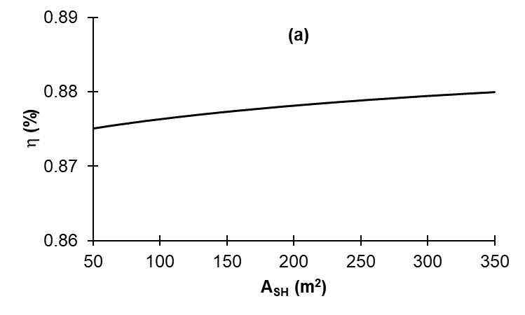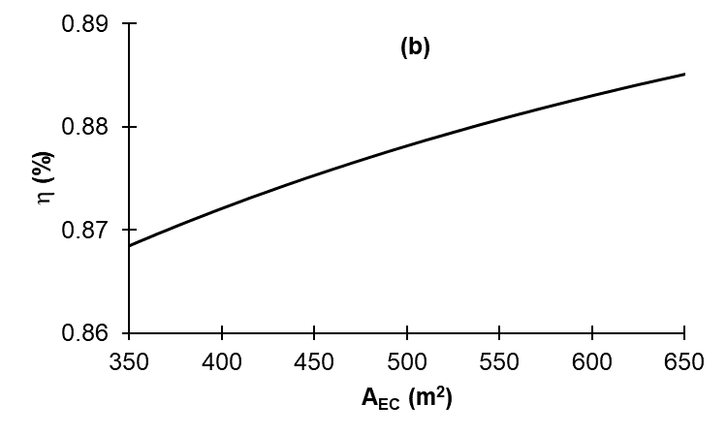
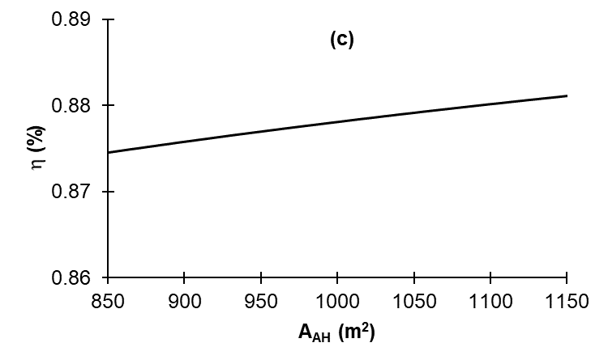
Figure 2: Variation of boiler efficiency with the surface area of (a) superheater, (b) economizer, and (c) air heater.
  - Conclusion
The detail of a model of bagasse boiler is presented in this paper. The boiler is modelled as furnace and a set of heat exchangers, consisting of superheater, boiler bank, economizer, and air heater. Heat transfer in the furnace is predominantly radiative. The superheater is a convective-radiative heat exchanger, whereas the other heat exchangers are convective heat exchangers. Mass and energy balances of all components of the boiler yield a set of nonlinear equations that can be solved if the fuel properties are known, and the inlet temperatures of air and feed water, the fuel mass flow rate, and the heating surface areas are specified. The model shows that the boiler efficiency increases with the surface areas of superheater, economizer, and air heater. The boiler efficiency is most sensitive to change in economizer surface area, and least sensitive to change in superheater surface area.
References
Cantrell C., Idem S., 2010. On-line performance model of the convection passes of a pulverized coal boiler, Heat Transfer Engineering, 31, 1173-1183.
Diez L.I., Cortes C., Campo A., 2005. Modelling of pulverized coal boilers: review and validation of on-line simulation techniques, Applied Thermal Engineering, 25, 1516-1533.
Evans W.K., 2018. The study of the effect of coal feeding pattern on combustion efficiency in pulverized coal combustion using CFD technique, Chemical Engineering Transactions, 70, 301-306.
Hajebzadeh H., Ansari A.N.M., Niazi S., 2018. Mathematical modeling and validation of a 320 MW tangentially fired boiler, Applied Thermal Engineering, 146, 232-242.
Kakac S., 1991. Boilers, Evaporators, and Condensers, Wiley & Sons, New York.
Leckner B., 1972. Spectral and total emissivity of water vapour and carbon dioxide, Combustion and Flame, 19, 33-48.
Lui Y., Wang J., Wang W., Yang R., Min C., Sunden B., 2017. Effect of the burner arrangement on slab reheating characteristics in a reheating furnace, Chemical Engineering Transactions, 61, 97-102.
Qian H., Guo X., Fan S., Hagos K., Lu X., Liu C., Huang D., 2015. A simple prediction model for higher heat value of biomass, Journal of Chemical Engineering Data, 61, 4039-4045.
Rein P., 2017. Cane Sugar Engineering, 2nd Ed., Verlag, Berlin.

