|  |  |
| --- | --- |
| cetlogo ***CHEMICAL ENGINEERING TRANSACTIONS***  ***VOL. 76, 2019*** | A publication of  aidiclogo_grande |
| The Italian Association  of Chemical Engineering  Online at www.cetjournal.it |
| Guest Editors: Sauro Pierucci, Jiří Jaromír Klemeš, Laura Piazza  Copyright © 2019, AIDIC Servizi S.r.l. **ISBN** 978-88-95608-73-0; **ISSN** 2283-9216 | |

Epoxy composites based on low-cost carbon filler derived from hydrothermal carbonization of waste

Monica Puccini\*, Eleonora Stefanelli, Andrea Luca Tasca, Sandra Vitolo

Dipartimento di Ingegneria Civile e Industriale, University of Pisa, Largo Lucio Lazzarino 1, 56122 Pisa, Italy

monica.puccini@unipi.it

Different kinds of composites based on polymer matrix are present on the market. In particular, composites based on epoxy resin are used as high-performance polymers due to their excellent mechanical properties, chemical resistance, thermal stability and low cost production. Recently, in composites production the attention has been focused on the study of materials derived from biomass and organic waste to be used as filler.

Hydrochar is a carbonaceous material obtained from hydrothermal carbonization (HTC) of biomasses and organic waste. During HTC biomass is carbonized in an aqueous environment at temperatures of 180-250 °C under saturated pressure (autogenous or provided by a gas) for several hours. For its characteristics, hydrochar can be potentially used as filler in composite materials in view of the growing concern about environmental sustainability.

In this work, hydrochar obtained from hydrothermal carbonization of green waste was used as filler for the preparation of diglycidyl ether of bisphenol A-type epoxy composite materials. Two different epoxy matrices were used; the content of hydrochar was varied between 5 and 15 wt%. The resulting samples were characterized by morphologic and mechanical analyses, and electrical properties were evaluated. The addition of hydrochar to epoxy resins resulted in a slight increase of the elastic modulus, although there was a decrease in tensile strength and toughness. Moreover, electrical properties of epoxy resins were not significantly modified by the addition of hydrochar. Therefore, the study provided encouraging results for the production of innovative hydrochar-based epoxy composites, allowing the recycling and re-use of industrial waste.

* 1. Introduction

Composites based on epoxy resins have received a great deal of attention as high performance materials due to their excellent mechanical properties, chemical resistance, thermal stability, and low production cost (Xu et al., 2018). As fillers, carbon materials are receiving a great attention due to their ability to enhance mechanical, electrical and thermal properties of final composites (Khan et al., 2017). Among them, carbon black (Byrne and Gun’ko, 2010) and more recently carbon nanotubes (Liu and An, 2018) are the most quoted. Alternative materials with high carbon content and low cost are evaluated as possible substitutes. Research is looking into the possibility of using waste biomasses as possible feedstock to produce these carbon fillers (Giorcelli et al., 2019).

Hydrochar is a carbonaceous material obtained from hydrothermal carbonization (HTC) of biomasses and organic waste (Gascó et al., 2018). The HTC of a biomass is achieved using water as the reaction medium and applying mild temperatures (180-250 °C) under saturated pressure (autogenous or provided by a gas) for several hours. The thermochemical process applied to biomass includes simultaneous reactions of hydrolysis, dehydration, decarboxylation, condensation, polymerization and aromatization of the original precursor (Puccini et al., 2016). The main product obtained, the so-called hydrochar, is a carbon-rich solid with physical structure and chemical characteristics comparable to lignite (Jess and Wasserscheid, 2013), showing potentiality as an energy source (Román et al., 2012) and soil amendment (Puccini et al., 2018). Considering its characteristics, hydrochar can be also used as filler in composite materials in view of the growing concern about environmental sustainability.

In this work, hydrochar obtained by hydrothermal carbonization of green waste was used as filler for the preparation of diglycidyl ether of bisphenol A-type epoxy composite materials. Two different epoxy matrices were used, and the content of hydrochar was varied between 5 and 15 wt%. Morphologic, mechanical and electrical properties of the resulting samples were evaluated. The mechanical characterization has shown a slight increase of the elastic modulus with the addition of hydrochar, while there was a decrease in tensile strength and elongation at break, as well as for the impact resistance. Mechanical properties were not significantly influenced by the hydrochar content. Electrical properties of epoxy resins were not significantly modified by the addition of hydrochar, suggesting a possible use as electrical insulator.

* 1. Experimental
     1. Materials

Composite materials were prepared using two different types of low viscosity epoxy matrices derived from diglycidyl ether of bisphenol A commercially available, HT (Model Center S.a.s.) and EC (Elantas Europe s.r.l.). Cycloaliphatic polyamines-based curing agents were supplied together with their epoxy resin. Hydrochar from HTC treatment of green waste (HC), supplied by Ingelia Srl (Valencia), was used as filler.

* + 1. Composites preparation

HC was first dried at 105 °C for 24 h and ground in an agate mortar for 3 h. The obtained powders were sieved to particle size less than 75 µm. HC was then dispersed in epoxy matrices using a mechanical mixer for 20 min, in order to obtain a homogeneous dispersion. The content of hydrochar in the composites was varied between 5 and 15 wt%. Composites were denoted as HT-x or EC-x, where x indicated the HC content (Table 1). After that, the hydrochar/resin mixtures were degassed in a vacuum drying oven for 60 min, and the curing agent was added manually mixing. Finally, the composites were transferred into different molds, cured and post-cured to obtain specimens for mechanical tests. Curing and post-curing conditions of composites were reported in Table 1.

Table 1: Composition, curing and post-curing conditions of HT and EC composites.

|  |  |  |  |  |  |
| --- | --- | --- | --- | --- | --- |
| Sample | Resin content (%) | Hardener content (%) | HC content (%) | Curing conditions | Post-curing conditions |
| HT | 76.9 | 23.1 | 0 | 60 °C  4 h | 180 °C  1 h |
| HT5 | 73.1 | 21.9 | 5 |
| HT10 | 69.2 | 20.8 | 10 |
| HT15 | 65.4 | 19.6 | 15 |
| EC | 76.9 | 23.1 | 0 | 70 °C  7 h | 110 °C  3 h |
| EC5 | 73.1 | 21.9 | 5 |
| EC10 | 69.2 | 20.8 | 10 |
| EC15 | 65.4 | 19.6 | 15 |

* + 1. Composites characterization

The tensile properties of the composites were measured using an INSTRON 5500R equipped with a load cell of 10 kN. Tensile tests were performed at a crosshead speed of 5 mm/min on dog bone shape type-1A specimens (total length 200 mm, total width 10 mm, thickness 4 mm), according to UNI EN ISO 527. For each sample a minimum of ten specimens were tested to obtain an average value.

Charpy impact tests on notched specimens were carried out by using a CEAST 9050, following the UNI EN ISO 179 standard.

The dielectric properties of the HC/epoxy composites were measured using an Impedance Material Analyzer E4991A. The experiments were carried out on composites at a temperature of 25 °C in a frequency range of 107 - 109 Hz. Real and imaginary parts of relative permittivity (ε’ and ε’’) and dielectric loss (tan δ) were evaluated, and an average value of five samples was taken.

The fractured surfaces of HT and EC composites were observed by using a JEOL 5600LV Scanning Electron Microscope (SEM). The samples were coated with Au on a SEM coating device (Edwards Sputter Coater S150B) to induce electro conductivity. A homogeneous layer of metal of 5-6 nm thickness coated the entire sample surface.

* 1. Results and discussion
     1. Morphologic properties

The morphology of HT and EC composites obtained by addition of hydrochar as filler was analyzed by SEM. Figure 1 displays, as an example, the SEM images of HT resin and HT composites with 5, 10 and 15 wt% of HC. Micrographs showed that hydrochar particles were homogeneously distributed throughout the matrix. Although the HC inclusion led to an increase in the roughness of the fracture surface with increasing of HC percentage, few particle agglomerates were observed indicating a good interfacial adhesion between epoxy matrix and HC. As evidenced by SEM images at higher magnification (Figure 1), hydrochar particles were well connected to the epoxy matrix and this could be attributed to a chemical interaction between HC and the resin. The chemical interaction probably resulted from reaction of amino groups in HC with epoxy groups of the matrix during the curing process.

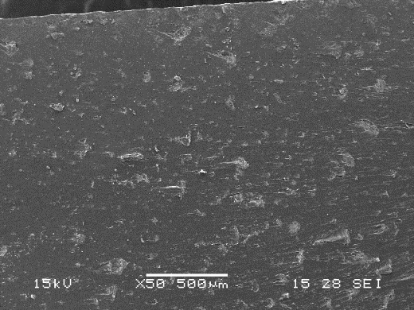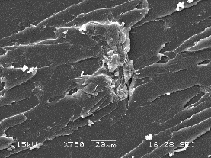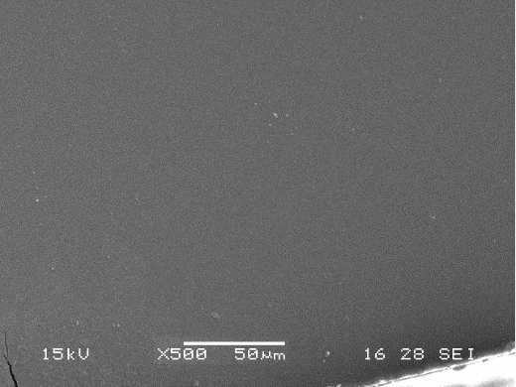

a

b

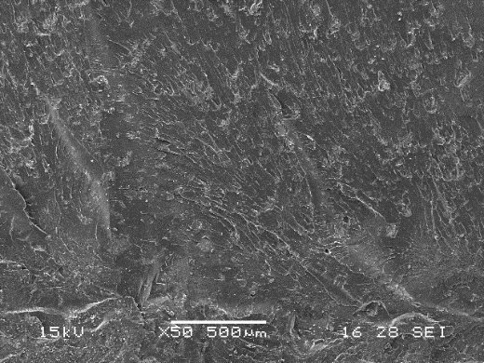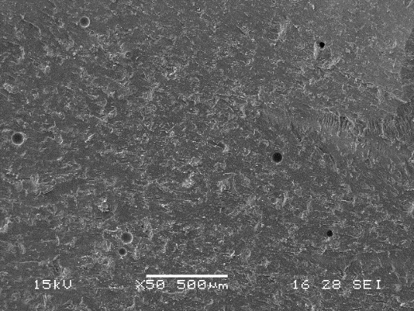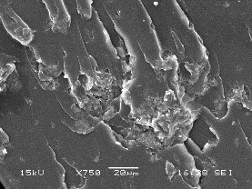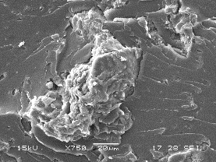

c

d

Figure 1: SEM images of HT composites with different HC content: (a) HT; (b) HT5; (c) HT10; (d) HT15.

* + 1. Mechanical analysis

The distribution of a filler in the matrix phase and the interfacial adhesion between the filler and the matrix are key factors determining the mechanical properties of composites. The tensile properties of HT and EC composites with 5, 10 and 15 wt% of HC are reported in Figures 2-4. Tensile tests on pure HT and EC epoxy resins were also performed for comparison. The results showed that the elastic modulus (Figure 2) was not significantly influenced by the addition of HC to the matrix HT, while it was slightly increased when HC was added to EC resin, reaching a value of 3.5 GPa for the sample EC5 (resulting in an increase of 20 % compared to pure EC resin). Higher filler contents led to lower enhancement of the composite stiffness.

The enhanced stiffness of EC matrix could be attributed to stress transfer from the matrix to the HC filler, which was favored by good adhesion between HC and the resin, as evidenced by morphologic analysis.

However, for both HT and EC composites there was a decrease in ultimate tensile strength and elongation at break, as shown in Figures 3 and 4. The results of the Charpy tests are reported in Figure 5 showing a decrease of the impact strength with increasing the HC content in both HT and EC composites. This weakening of mechanical properties was probably due to the high content of HC particles in the matrices. Giorcelli and co-workers (Giorcelli et al., 2019) reported that a high filler loading (biochar content in epoxy matrix greater than 2 wt%) led to an increase of the cross-link ratio of the epoxy resin and thus reduces the movement of polymer molecules. Consequently, the matrix shows a brittle behavior.

 

Figure 2: Young modulus of HT (left) and EC (right) composites as a function of HC content.

 

Figure 3: Ultimate tensile strength of HT (left) and EC (right) composites as a function of HC content.

 

Figure 4: Elongation at break of HT (left) and EC (right) composites as a function of HC content.

 

Figure 5: Charpy impact strength of HT (left) and EC (right) composites as a function of HC content.

* + 1. Electrical properties

Values of the real and imaginary parts of relative permittivity (ε’ and ε’’) and dielectric loss (tan δ) measured at a frequency of 1 GHz of the pure HT resin and HT composites with 5, 10 and 15 wt% of HC are reported in Table 2. As shown, all HC composites had similar values of dielectric constants than pure epoxy resin. Moreover, these values slightly increased with increasing HC content. This was probably due to the introduction of highly polarizable functional groups (e.g., OH, C=O, COOH, etc.). Nevertheless, electrical properties of epoxy resins were not significantly modified by the addition of hydrochar, suggesting a possible use as electrical insulator.

Table 2: Dielectric properties of HT composites.

|  |  |  |  |
| --- | --- | --- | --- |
| Sample | ε’ | ε’’ | tan δ |
| HT | 3.09 | 0.064 | 0.021 |
| HT5 | 3.10 | 0.065 | 0.021 |
| HT10 | 3.31 | 0.077 | 0.023 |
| HT15 | 3.39 | 0.077 | 0.023 |

* 1. Conclusions

Hydrochar (HC) derived from hydrothermal carbonization of green waste was used as filler to produce polymer composites based on two different types of epoxy resins. Three different percentages of hydrochar were used for composites preparation, and their morphologic, mechanical and electrical properties were studied. Results by SEM analysis showed few particle agglomerates indicating a good interfacial adhesion between epoxy matrix and HC. Hydrochar particles resulted well connected to the epoxy matrix and this was attributable to a chemical interaction between HC and the resin. The mechanical properties of HC-based composites were not significantly influenced by the addition of hydrochar, which was added up to 15 wt%. The incorporation of hydrochar particles resulted in a slightly increase of the elastic modulus, reaching a value of 3.5 GPa for the sample EC containing 5 wt% of HC (corresponding to an increase of 20 % compared to pure EC resin). Electrical properties of epoxy resins were not significantly modified by the addition of HC showing similar values of permittivity and dielectric loss than pure epoxy resin. Therefore, the addition of hydrochar to epoxy resins is a promising strategy for the production of cost-effective composites using a low-cost, ecofriendly and renewable filler, and to further promote the recycle and re-use of this industrial waste.

References

Byrne M.T., Gun’ko Y.K., 2010, Recent Advances in Research on Carbon Nanotube-Polymer Composites, Advanced Materials, 22, 1672–1688.

Gascó G., Paz-Ferreiro J., Álvarez M.L., Saa A., Méndez A., 2018, Biochars and hydrochars prepared by pyrolysis and hydrothermal carbonisation of pig manure, Waste Management, 79, 395–403.

Giorcelli M., Khan A., Pugno N.M., Rosso C., Tagliaferro A., 2019, Biochar as cheap and environmental friendly filler able to improve polymer mechanical properties, Biomass and Bioenergy, 120, 219–223.

Jess A., Wasserscheid P., 2013, Chemical technology: an integral textbook, Wiley-VCH, Weinheim, Germany.

Khan A., Savi P., Quaranta S., Rovere M., Giorcelli M., Tagliaferro A., Rosso C., Jia C.Q., 2017, Low-Cost Carbon Fillers to Improve Mechanical Properties and Conductivity of Epoxy Composites, Polymers, 9, 642.

Liu J., An L., 2018, Synthesis and Properties of Graphene/Carbon Nanotube/Epoxy Resin Composites, Chemical Engineering Transactions, 71, 949–954.

Puccini M., Ceccarini L., Antichi D., Seggiani M., Tavarini S., Hernandez Latorre M., Vitolo S., 2018, Hydrothermal carbonization of municipal woody and herbaceous prunings: Hydrochar valorisation as soil amendment and growth medium for horticulture, Sustainability, 10, 846.

Puccini M., Licursi D., Stefanelli E., Vitolo S., Raspolli Galletti A.M., Heeres H.J., 2016, Levulinic acid from orange peel waste by hydrothermal carbonization (HTC), Chemical Engineering Transactions, 50, 223–228.

Román S., Nabais J.M.V., Laginhas C., Ledesma B., González J.F., 2012, Hydrothermal carbonization as an effective way of densifying the energy content of biomass, Fuel Processing Technology, 103, 78–83.

Xu Y., He Q., Yang W., Sun T., Tang Q., 2018, Study on Relationships between Curing Pressures and Mechanical Properties for Epoxy Adhesive Films, Chemical Engineering Transactions, 66, 43–48.