CHEMICAL ENGINEERING TRANSACTIONS  VOL. 76, 2019 | A publication of
The Italian Association
of Chemical Engineering
Online at www.aidic.it/cet
Guest Editors: Sauro Pierucci, Jiří Jaromír Klemeš, Laura Piazza
Copyright © 2019, AIDIC Servizi S.r.l.
ISBN 978-88-95608-73-0; ISSN 2283-9216

Microbial Pb(II) Precipitation: Minimum Inhibitory Concentration and Precipitate Identity
Hendrik G. Brink*, Carla Hörstmann, Cherie B. Feucht
Department of Chemical Engineering, Faculty of Engineering, Built Environment and Information Technology, University of Pretoria, Pretoria, South Africa
*Corresponding Author. E-mail: deon.brink@up.ac.za, Tel: +27124203569
The biohydrometallurgical processing of metals have generated significant interest due to the potential for bioleaching and biological electrowinning processes to replace current energy intensive, costly, and environmentally contaminating smelting and hydrometallurgical processes. An ongoing research project aims to identify, study, and refine a Pb(II) bioremediation and biorecovery process for industrial application. Previous work has successfully demonstrated Pb(II) bioprecipitation of 86.5% of a 1,000 ppm Pb(II) initial concentration batch experiment within 22 days.
The objectives of the current study were: (1) to determine the minimum inhibitory concentration (MIC) at which a specific industrial consortium would cease to grow and/or precipitate Pb(II) from solution, (2) to determine the identity of the precipitate formed. The consortium was obtained from a borehole at an automotive battery recycling plant in Gauteng province South Africa. The MIC was studied using inoculated nutrient and simulated (reduced NaCl) agar plates. Pb(II) concentrations from 500 ppm to 200,000 ppm were tested in the nutrient agar, and Pb(II) concentrations of 50,000 ppm to the solubility limit of Pb(NO₃)₂ of 310,000 ppm Pb were tested in the simulated agar.
The results from the MIC study showed that the industrially obtained consortium was able to grow and precipitate Pb(II) at concentrations up to approximately 30,000 ppm. MIC values for the reduced NaCl and no NaCl runs of 34,914±5,995 ppm and 27,164±5,728 ppm, respectively. The results from the nutrient agar showed no evidence of inhibition, likely a result of decreased effective Pb(II) as a result of PbCl₂ precipitation.
The XPS analysis of the metallic ring on the surface of the nutrient agar indicated the presence of PbS and elemental Pb, in the ratio 0.818:0.182. These results confirm a Pb-reduction (Pb(II) to Pb⁰) capability is present in the consortium.
From the results, it can be concluded that the industrial consortium has the ability to grow and precipitate Pb(II) in significantly high concentrations. In addition, a biological Pb(II) reduction to elemental lead capability was confirmed, potentially providing a replacement for the electrowinning step in traditional hydrometallurgical processing of Pb(II).
  - Introduction
Lead (Pb) is a metal with a significant industrial value that is ubiquitously utilised globally (Illinois Department of Public Health, 2018). The use of Pb has increased over the last century with the main application of industrially produced Pb for Pb-acid batteries, while historically Pb was used as an additive in paints and petroleum (University of York, 2016). For many years, the removal of toxic heavy metals was achieved by sand filtration, precipitation sedimentation, flotation, ion-exchange as well as many other physicochemical process systems. However, these systems have many disadvantages and are not always successful or environmentally sound (Brink et al., 2017).
Bioremediation is advantageous compared to other methods of Pb removal since it is more efficient and cost-effective (Chatterjee et al., 2012). The use of this method to precipitate elemental Pb using a microorganism has not been widely investigated (Naik & Dubey, 2013). Pb precipitation as a removal strategy is preferred since solid Pb is easier to separate from the aqueous solution (Lenntech, 2018).
The effects of elevated lead concentrations on the precipitation of lead by a locally sourced industrial consortium has previously been investigated by authors in the research group (Peens, Wu & Brink, 2018). In that study experiments were performed under anaerobic conditions using both Luria Bertani broth and a simulated Luria Bertani broth (with reduced NaCl concentration for higher Pb(II) concentrations) as growth media. The media was spiked with various lead concentrations, ranging from 80 ppm to a 1000 ppm. It was found that 99% of Pb(II) was removed in the presence of 500 ppm within 11 days and 87% removal of Pb(II) in the presence of a 1000 ppm after 22 days.
The minimum inhibitory concentration (MIC) is defined as the minimum metal concentration that would visibly inhibit growth (Tomova et al, 2015). In literature lead MIC values of between 2000 ppm and 9000 ppm have been reported (Tomova et al., 2015, De Niederhäusern et al. 2013). However, the concentrations of industrial hydrometallurgical processing of lead is in the vicinity of 100 g/L Pb while automotive battery wastewater regularly contain 2000 mg/L Pb (Lee et al., 1986; Singh et al., 2007). Therefore, to compete with industrial hydrometallurgy the current consortium need resist Pb concentrations as high as 2 g/L to 100 g/L Pb.
The objectives of the current study were to 1) determine the MIC of the bacterial consortium originally studied by Peens, Wu & Brink (2018) and 2) to determine the identity of the precipitate formed. The study was performed using nutrient agar, a simulated Luria Bertani (LB)-agar with reduced NaCl and a simulated LB-agar with no NaCl present. The concentrations of Pb(II) tested were limited to a maximum concentration of 310 g/L Pb(II) due to the solubility limit of Pb(NO₃)₂. The study was performed at 35 °C and ambient pressures.
  - Materials and methods
    - Materials
Precultures were grown in sterile commercial Luria Bertani (LB)-broth (25 g.L⁻¹) spiked with 80 ppm Pb(II). The agar plates consisted of a base agar of either commercial nutrient agar (31 g.L⁻¹) or a simulated LB-agar consisting of plain agar – 15 g.L⁻¹, tryptone – 5 g.L⁻¹, yeast extract – 2 g.L⁻¹, and NaCl – 0.1 g.L⁻¹ for the simulated agar with NaCl present. In the case of the NaCl-free simulated agar, the composition was identical to the simulated agar, however, the NaCl was omitted. The Pb(II) solution was made by mixing the required amounts of Pb(NO₃)₂ and distilled water to make three stock solution (10,000 ppm, 200,000 ppm, and 310,000 ppm). All chemicals were of analytical grade and were purchased from Sigma-Aldrich (St. Louis, MO). AnearoGenTM sachets (Oxoid, Thermo Scientific, Basingstoke, Hampshire) were used to ensure an anaerobic environment for plate growth.
    - Microbial culture
A Pb resistant consortium was obtained from a borehole at an automotive-battery recycling plant in Gauteng, South Africa. The initial culture was prepared by adding 1 g of Pb the contaminated soil to sterile LB broth and spiked with 80 ppm Pb in a 100 ml serum bottle, incubating it for 24 hours at 35 °C under anaerobic conditions and on a shaker at 120 rpm. Glycerol was added to obtain a final ratio of 20% v/v and the samples were stored cryogenically at -77 °C as inoculum (Peens, Wu & Brink, 2018).
A preculture was prepared with the abovementioned cryogenically stored inoculum. The preculture was prepared by adding one loop of the inoculum to a mixture of LB broth and 80 ppm Pb in a serum bottle. The serum bottle was purged with nitrogen gas for 3 minutes and sealed, then incubated at 35°C and placed on a shaker at 120 rpm before inoculation took place to allow sufficient growth of the bacteria.
No attempt was made to purify or identify the consortium cultures; this will form part of a future project.
    - Methods
The MIC test method was derived from the agar dilution method (Barberis et al., 2018) and the agar well diffusion method (Hassen et al., 1997). A pour plate was made once the agar has cooled after autoclaving, but remained molten, by adding 1 ml of the inoculum to a petri dish, pouring the agar in the petri dish over the inoculum, and swirling the petri dish to ensure thorough mixing. Four wells were made in the solidified agar by heating a 10 mm hollow glass tube over a Bunsen flame and piercing the glass tube into the agar mixture. The dislodged agar was removed using a sterile scalpel, leaving a circular well in the solidified agar. One of the four wells were filled with 0.3 mL sterile water to act as an abiotic control, and the remaining 3 each with different concentrations of 0.3 mL Pb(NO₃)₂ solutions. The plates were sealed with parafilm and placed in an airtight glass jar with an AneroGenTM bag. The glass jar was placed in the incubator for two weeks at 35 °C to allow for growth. All agar plates were repeated at least 5 times. This method was repeated without bacteria, as an abiotic control.
The MIC was defined as the minimum metal concentration that would visibly inhibit growth (Tomova et al, 2015) and was determined by plotting the base 10 logarithm of the initial concentration (abscissa) against the zone of inhibition width (ordinate). The width of the zone of inhibition was measured as the distance from the well to the end of the zone of inhibition. The intercept with the abscissa indicated the log₁₀ of the MIC; this indicates the concentration when the zone of inhibition has a width of zero.
The identity of the precipitate formed was determined using X-ray photoelectron spectroscopy (XPS) (Thermo ESCAlab 250 Xi). The precipitate formed on the agar was extracted using a surgical scalpel from the surface of the agar. The extracted sample was dried for 48 hours using silica gel under anaerobic conditions, in an airtight glass jar and an AneroGenTM bag, to prevent Pb oxidation. The samples were sent to National Metrology Institute of South Africa for XPS analysis.
  - Results and discussion
Nutrient agar plates were used to test Pb(II) concentrations from 500 ppm to 200 000 ppm. The plates initially prepared are shown in Figure 1, where the abiotic run (control) and consortium runs were prepared in the same manner. The three plates shown in Figure 1 show the ascending order of Pb(II) concentration from 500 ppm to 200 000 ppm at initial conditions.
The figure exhibits a white precipitate forming around the well at high Pb(II) concentrations; the precipitate is presumed to be PbCl₂ as a result of the high concentration of NaCl (8 g.L⁻¹) in the nutrient broth. The presence of the precipitate resulted in a reduced concentration of Pb(II) and consequently an inaccurate indication of the metal resistance of the organism, necessitating follow-up experiments with simulated agar with reduced NaCl.

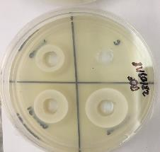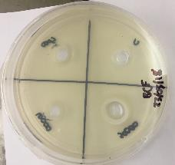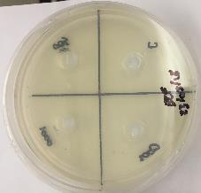
E
B
D
F
C
H
I
G
A
Figure 1: The agar plates as observed at the start of the experimental runs. The white precipitate is assumed to be PbCl₂ as a result of the NaCl present in the nutrient broth. A = 500 ppm, B = 1000 ppm, C = 2000 g/L, D = 5000 g/L, E = 10,000 g/L, F = 20,000 g/L, G = 50,000 ppm, H = 100,000 ppm, I = 200,000 ppm

Figure 2 shows the nutrient agar plates at the termination of the experimental runs. The abiotic control experiments did not show any change from that observed at the start of the experiments (Figure 1) and it can, therefore, be concluded that any changes are a result of biological activity. The results of the nutrient agar experiment show an absence of a zone of inhibition for Pb(II) concentrations up to 200,000 ppm, likely as a result of reduced Pb(II) concentration due to the PbCl₂ precipitation. There was also a dark precipitate observed inside the volume of the agar and a thin metallic film on the surface of the agar.

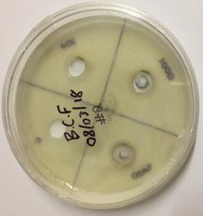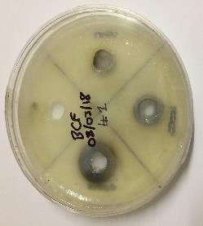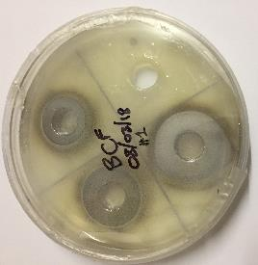
D
I
G
A
B
E
H
F
C
Figure 2: End of experimental run for nutrient agar consortium plates. A = 500 ppm, B = 1000 ppm, C = 2000 g/L, D = 5000 g/L, E = 10,000 g/L, F = 20,000 g/L, G = 50,000 ppm, H = 100,000 ppm, I = 200,000 ppm

For Pb(II) concentrations of 50 000 ppm to 310 000 ppm, a simulated agar (with and without sodium chloride) was used to reduce the amount of white precipitate in the agar. Figures 3 (reduced NaCl) and 4 (No NaCl) shows the results of the runs at the end of the simulated agar runs the experiment. The plates for both types of simulated agar runs exhibited significant zones of inhibition containing no observed microbial growth. The plates further showed a metallic film on the surface of the agar and dark precipitate inside the agar, however, these metallic films and precipitates were limited to the agar outside the zones of inhibition.

E
B
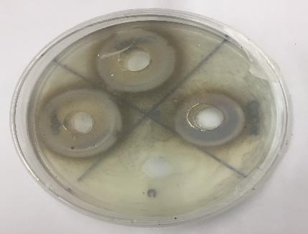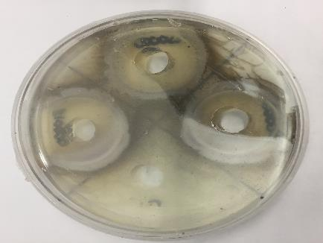
A
F
D
C

Figure 3: End of experimental run for simulated agar with NaCl consortium plates. A = 50,000 ppm, B = 100,000 ppm, C = 150,000 ppm, D = 200,000 ppm, E = 250,000 ppm, F = 310,000 ppm. Red circles represent the extreme boundary of the zone of inhibition.
.

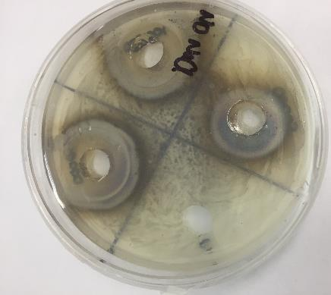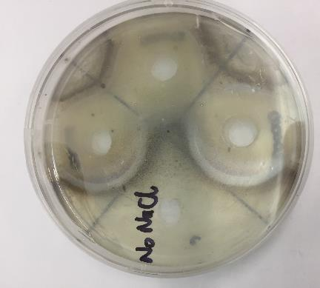
B
D
A
E
C
F
Figure 4: End of experimental run for simulated agar without NaCl consortium plates. A = 50,000 ppm, B = 100,000 ppm, C = 150,000 ppm, D = 200,000 ppm, E = 250,000 ppm, F = 310,000 ppm. Red circles represent the extreme boundary of the zone of inhibition.
The measured width of the zones of inhibition (x) as well as the linear regression lines, the 95% confidence intervals, and the regression equations are shown in figure 5. Figure 5a) shows the results from the reduced NaCl run and Figure 5b) the results from the run with no NaCl added.
x = 11.71logC_{o} - 53.20
r² = 0.909
x = 10.75logC_{o} – 47.65
r² = 0.905
Figure 5: The linear regression results of the a) reduced NaCl and b) no NaCl simulated agar runs.
The intercepts of the abscissa used to determine the MIC for the reduced NaCl and no NaCl runs were 4.543±0.075 and 4.434±0.095, respectively; with the 95% confidence interval is indicated. These results translate to MIC values for the reduced NaCl and no NaCl runs of 34,914±5,995 ppm and 27,164±5,728 ppm, respectively. The MIC results indicate a significantly high resistance to Pb(II) by the microbial consortium and compare well with results reported in literature. Tomova et al (2015) reported lead MIC values of between 2000 ppm and 9000 ppm, and De Niederhäusern et al. (2013) reported resistance of microbes derived from a lake in Italy to a concentration of Pb(II) of 10 mM (2000 ppm). The difference in the results in the presence and absence of NaCl might indicate an osmotic shielding mechanism that protects the microbe during growth, this corresponds with previous results by this research group that found an improved removal of lead in the presence of NaCl (Brink and Mahlangu, 2018).
The metallic film on the surface of the nutrient agar for an initial Pb(II) concentration of 100,000 ppm, as shown previously in Figure 2, was analysed using X-ray photoelectron spectroscopy (XPS). The XPS results are presented in Figure 6 and indicate the presence of both PbS an elemental Pb metallic film, in a ratio of 0.818:0.182. This result is highly significant as it provides strong evidence for the presence of a biological reduction mechanism that is capable of reducing the oxidised Pb(II) to elemental Pb and should be further explored.

Figure 6: XPS Pb narrow-scans for the film formed for a Pb(II) concentration of 100,000 ppm.
  - Conclusions
In conclusion, it is evident from the agar plate runs that the consortium can grow and produce a metallic film and dark precipitate. In the nutrient agar runs no significant inhibition was observed, likely as a result of PbCl₂ precipitation which decreased the effective Pb(II) inside the agar. In the simulated agar with attenuated and removed NaCl, MIC values of 34,914±5,995 ppm and 27,164±5,728 ppm were determined respectively.
The metallic ring on the surface of the nutrient agar around the 100,000 ppm well was analysed using XPS and indicated the presence of PbS and elemental Pb, in the ratio 0.818:0.182. These results confirm a Pb-reduction (Pb(II) to Pb⁰) capability is present in the consortium.
The study indicates that the consortium has significant Pb(II) resistance as well as biological Pb(II) reducing capabilities which potentially provides an alternative for the electrowinning step in traditional hydrometallurgical processing of Pb(II).
Acknowledgments
This work is based on the research supported in part by the National Research Foundation of South Africa for the grant, Unique Grant No. 106938
  - References
Andrews J.M., 2001, Determination of minimum inhibitory concentrations, The Journal of Antimicrobial Chemotherapy, 49, S1 5 – 16.
Barberis C. M., Sandoval E., Rodriguez C. H., Ramírez M. S., Famiglietti A., Almuzara M., Vay C., 2018, Comparison between disk diffusion and agar dilution methods to determine in vitro susceptibility of Corynebacterium spp. clinical isolates and update of their susceptibility, Journal of Global Antimicrobial Resistance, 14, 246–252.
Brink H.G., Lategan M., Naude K., Chirwa E.M.N., 2017, Lead removal using industrially sourced consortia: Influence of lead and glucose concentrations, Chemical Engineering Transactions, 57, 409 – 414.
Brink H.G., Mahlangu Z., 2018, Microbial Lead(II) precipitation: the influence of growth substrate, Chemical Engineering Transactions, 64, 439 – 444.
Chatterjee S., Mukherjee A., Sarkar A., Roy P., 2012, Bioremediation of lead by lead-resistant microorganisms, isolated from industrial sample, Advances in Bioscience and Biotechnology, 3, 290 – 295.
De Niederhäusern S., Bondi M., Anacarso I., Iseppi R., Sabia C., Bitonte F., Messi P., 2013, Antibiotics and heavy metals resistance and other biological characters in enterococci isolated from surface water of Monte Cotugno Lake (Italy), Journal of Environmental Science and Health, Part A, 48, 939 – 946.
Hassen A., Saidi N, Cherif M, Boudabous A., 1998, Resistance of environmental bacteria to heavy metal, Bioresource Technology, 64, 7–15.
Illinois Department of Public Health, 2018, Lead in Industry, <www.dph.illinois.gov> accessed 20.02.2018.
Lee, A. Y., Wethington, A. M., Cole, E. R.,1986, Hydrometallurgical Process for Producing Lead and Elemental Sulfur From Galena Concentrates. United States Department of the Interior, Washington, DC.
Lenntech, 2018, Lead and water: reaction mechanisms, environmental impact and health effects, <www.lenntech.com> accessed 12.04.2018.
Naik, M.M, Dubey, S.K., 2015, Lead resistant bacteria: Lead resistance mechanisms, their applications in lead bioremediation and biomonitoring. Ecotoxicology and Environmental Safety, 98, 1 – 7.
Peens J., Wu Y. W., Brink, H. G., 2018, Microbial Pb ( II ) Precipitation: The Influence of Elevated Pb ( II ) Concentrations, Chemical Engineering Transactions, 64, 583-588.
Singh, V., Tiwari, S., Sharma, A. K., Sanghi, R., 2007, Removal of lead from aqueous solutions using Cassia grandis seed gum-graft-poly(methylmethacrylate), Journal of Colloid and Interface Science, 316(2), 224–232.
Tomova I., Stoilova-Disheva M., Lazarkevich I., Vasileva-Tonkova E. 2015, Antimicrobial activity and resistance to heavy metals and antibiotics of heterotrophic bacteria isolated from sediment and soil samples collected from two Antarctic islands, Frontiers in Life Science, 8, 348 – 357.
Tong S., von Schirnding Y.E., Prapamonton T., 2000, Environmental lead exposure: a public health problem of global dimensions, Bulletin of the World Health Organization, 78, 1068 – 1077.
University of the Free State, 2018, Bioremediation; small solutions to big problems, <www.ufs.ac.za> accessed 20.02.2018.
University of York, 2016, Lead, <www.essentialchemicalindustry.org> accessed 12.04.2018.

