CHEMICAL ENGINEERING TRANSACTIONS  VOL. 76, 2019 | A publication of
The Italian Association
of Chemical Engineering
Online at www.aidic.it/cet
Guest Editors: Sauro Pierucci, Jiří Jaromír Klemeš, Laura Piazza
Copyright © 2019, AIDIC Servizi S.r.l.
ISBN 978-88-95608-73-0; ISSN 2283-9216

Improving Fucoidan Yield from Fucus Brown Algae by Microwave Extraction
Signe H. Ptakª, Knud V. Christensen^{a,}, Rafael Meichßner^{b}, Xavier Frettéª
ª University of Southern Denmark (SDU),
Department of Chemical Engineering, Biotechnology and Environmental Technology, Campusvej 55, 5230, Odense, Denmark
^{b} Christian-Albrechts-Universität zu Kiel, Botanisches Institut und Botanischer Garten, Am Botanischen Garten 5
D-24118 Kiel
sihp@kbm.sdu.dk
The bioactive sulfated polysaccharide from brown algae, fucoidan, can be used for a wide array of applications. As with other natural products, there are seasonal variabilities as well as variability within the investigated species, across regions, and from using different extraction procedures. In this study, the use of hot demineralized water and two variations of hot acidified water (10 mM sulfuric acid and 100 mM hydrochloric acid) as extraction solvents for microwave extraction of fucoidan from three different brown algae of the Fucus genus (F. vesiculosus, F. serratus, and F. evanescens) were investigated. The effect on yield of fucoidan from the different solvents at temperatures 80 °C, 100 °C, 120 °C was tested. The Fucus used in this study were harvested in the Baltic Sea in the Kiel Fjord, Germany, during Summer and Autumn of 2017. Air dried F. vesiculosus from Brittany in France was also analyzed and used for optimization of the extraction method and as a reference sample. The extraction procedure was adapted and modified from the method provided by Fletcher et al. (2017). The extracts were purified by performing dialysis. The results showed that fucoidan yield is maximized by extracting with 10 mM sulfuric acid for all species investigated. A large seasonal variance between species was observed, and large differences in yield were also dependent on species. These results suggest that to maximize fucoidan yield, one should tailor the extraction method to the specific algae species used, however, microwave assisted extraction (MAE) with 10 mM sulfuric acid proves a good general extraction method.

  - Introduction
The Baltic Sea and the North Sea are abundant in brown algae (Phaeophyta), which contain a group of sulfated, fucose-rich, polysaccharides called fucoidan, in their cell walls (Senthilkumar et al., 2013). The structure of fucoidans depends on the species, season, harvest location and plant maturity. The basic structure consists of a sulfated fucose backbone as well as small quantities of other sugars, such as xylose, uronic acids, rhamnose, and glucosamine (Nishino et al., 1991). Branched side chains are also often found in some brown algae species, with the molecular weight varying widely between species (Gupta and Abu-Ghannam 2011).
Fucoidan was first extracted and identified by Kylin in 1913 (Kylin, 1913), where it was named “fucoidin” from the many fucose units. Since then, insights into the structure and the properties linked to these structures have been the focus of fucoidan research. In recent years, fucoidan has gathered much interest in the search for drugs from natural products. Currently, the focus of fucoidan research is the application of fucoidan in the pharmaceutical industry. Some of the most studied properties of fucoidan are its anticoagulant activity (Church et al., 1989), its potential as an inhibitor of native (Baba et al., 1988) and recombinant HIV reverse transcriptase in vitro, and its ability to block cell invasion by different retroviruses, such as HIV (McClure et al., 1992).
Sulfated polysaccharides have also been found to exhibit antiproliferative and antitumor properties for carcinoma cell lines (Riou et al., 1996). Studies into other fucoidan applications include their use in nutraceuticals, as functional foods, and as an additive in cosmetics (Bedoux et al., 2014). The biological activity of the polysaccharides is species dependent, but factors such as the extraction method, seasonal variation, harvest location, and plant maturity have also been reported to influence the bioactivity of fucoidan (Fletcher et al., 2017). Essentially, fucoidan might be tailored to give certain health benefits based on the algae, location and the extraction procedure.
The extraction procedure of fucoidan generally involves five steps: 1) drying until the algae dry weight remains constant, 2) a defatting treatment to remove lipids and pigments, 3) extraction, which may be repeated several times for a higher extraction yield, 4) purification and separation of fucoidan from other co-extractants by addition of solvents, and 5) dialysis. Microwave-assisted extraction (MAE) could provide a green alternative to the traditional extraction methods. Removal of co-extracted compounds may also include membrane technology, which can help purify natural products (Roda-Serrat et al., 2015). Some of the advantages of MAE include shorter extraction time, less solvent, higher extraction rate (Rodriguez-Jasso et al., 2011) and lower cost, over traditional methods of extraction of compounds from various matrices, especially natural products (Delazar et al., 2012). The heavy metals present in seaweed also promote the formation of heat during microwave-assisted extraction, making algae and seaweeds suitable candidates for this extraction method. In this paper, a range of extraction solvents (pH range 2-7) for MAE of a variety of Fucus species harvested from Germany and France was investigated to determine which combination of Fucus species, extraction solvent, harvest time, and extraction temperature resulted in the highest fucoidan yield.

  - Materials and methods
Figure 1: Process chain for extraction and isolation of crude fucoidan

    - Algae pretreatment
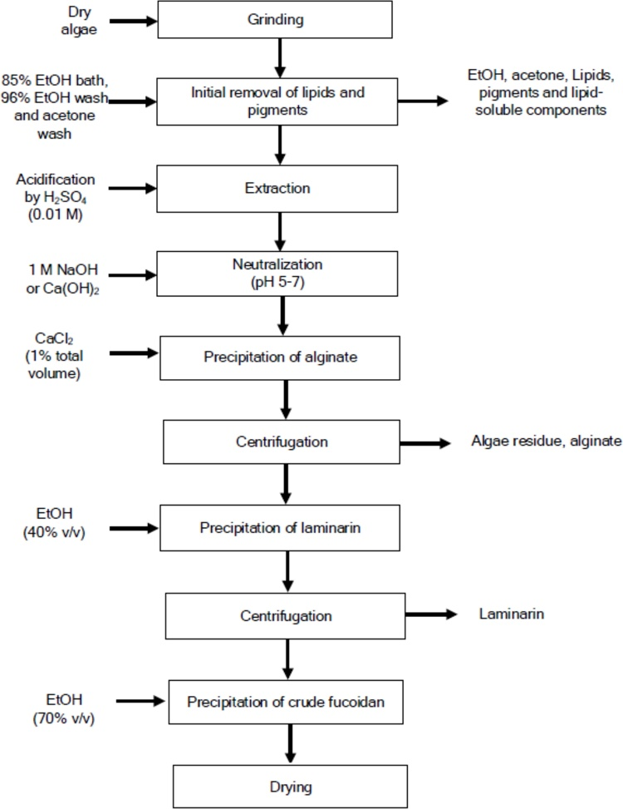
1000 g of three Baltic Fucus species, F. vesiculosus (FV), F. serratus (FS), and F. evanescens (FE) were harvested during Summer (3rd of July) and Autumn (10th of October) of 2017 in Kiel Fjord, Germany and subsequently kept frozen. 5000 g of air-dried FV reference material was obtained from the province of Brittany in France, 2018. The French algae was used to optimize the extraction method. The frozen algae from Kiel were freeze-dried at -80 °C for 72 h and subsequently ground using a Fritsch pulverisette 19 rotor mill through a 1 mm sieve. The FV from France was also ground under the same conditions. Dried samples were stored in sealed containers until analysis.

The extraction procedure was adapted and modified for MAE from Fletcher et al. (2017). The process chain for the extraction is shown in Fig. 1. 20 g of ground, dried seaweed was submerged in 150 mL 85 % ethanol and mechanically stirred overnight at room temperature. The supernatant was decanted, and the algae was transferred to a 50 ml centrifuge tube for centrifugation, followed by removal of the remaining supernatant. The pellet was washed once with 150 ml ethanol, then with 150 mL acetone, and subsequently left to dry at room temperature until constant weight.

    - Extraction
1.5 g of the washed seaweed and 25 ml of extraction solvent (demineralized water, 100 mM HCl, or 10 mM H₂SO₄) were added to the microwave vessels and placed into a microwave digesting system (Multiwave Go, Anton Paar, Austria). The samples were microwaved for 30 min. at either 80 °C, 100 °C, or 120 °C. Each analysis contained four replicates. After cooling, the vessel contents were transferred to a clean 50 ml centrifuge tube. The pH of the supernatant was determined and neutralized to pH 5-7 by addition of 1 M NaOH. A solution of 35 % CaCl₂ was added to the tubes, corresponding to 1 % CaCl₂ in the extract. The tubes were centrifugated at 4 °C for 45 min (5000 rpm) to precipitate the alginate. The supernatant was decanted into a clean tube and ethanol was added to give a concentration of 40 % v/v ethanol. The tubes were centrifuged at 4 °C for 45 min to precipitate laminarin, and the supernatant was transferred to a clean 50 mL centrifuge tube where ethanol was added to give a final concentration of 70 % v/v ethanol. The tube was centrifuged at 4 °C for 45 min to precipitate the extracted fucoidan. The extracted crude fucoidan was washed with ethanol, followed by acetone, and left to dry to a constant weight in the tube.

  - Results and discussion
The results from alternating the pH and solvents for the Fucus vesiculosus harvested in Brittany, France, is shown in Fig. 2 and Fig. 3. Increasing the temperature and lowering the pH increased the yield of storage glucans (laminarin, Fig. 2) and the yield of sulfated polysaccharides (fucoidan, Fig. 3). Increasing the temperature seems to have the highest effect overall. The yield of laminarin was continually higher than the fucoidan yields, which is as expected with laminarin being the main storage polysaccharide in brown algae. As the hydrochloric acid yields are only marginally better than sulfuric acid as extraction solvent, both acids were used as extraction solvents for extraction of fucoidan from the algae harvested in Kiel Fjord, Germany. The results from the algae harvested in Germany are shown in Fig. 4 and Fig. 5.
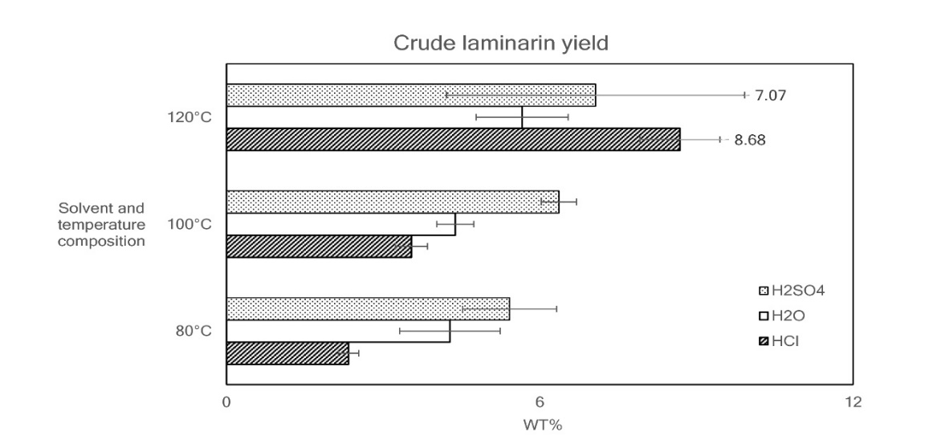
Figure 2: Yield (weight percent) of crude fucoidan from microwave extraction. Each solvent and temperature composition are expressed as means of 4 replicates with error lines showing the ± standard deviation.

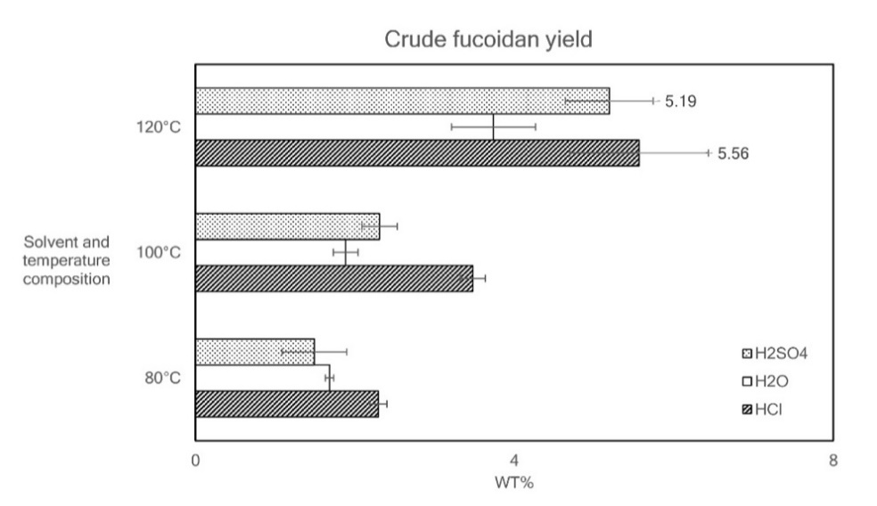
Fucus serratus (FS) appears to be more pH sensitive than the other algae used in this study, as the sulfuric acid (pH 4) is much more effective for fucoidan extraction than hydrochloric acid (pH 2). Additionally, the fucoidan content for FS and Fucus evanescens (FE) are very seasonally dependent. In contrast, the fucoidan content from FV is not as affected by seasonal changes. These findings suggest that fucoidan production from FS should be performed by extraction with sulfuric acid and from algae harvested in autumn. The seasonal difference in fucoidan content is generally attributed to increased carbohydrate storage over the summer, as the algae prepares for winter. This may not be the case for all algae species, however; one study found no significant correlation between the level of fucoidan in Saccharina japonica, Sargassum pallidum, and Stephanocystis crassipes algal tissues and the annual dynamics in seawater temperature, salinity, and concentration of biogenic elements. It appears more likely that the maximum amount of fucoidan is accumulated in the algae during reproduction season, which varies across species (Skriptsova, 2015). Fletcher et al. (2017) found that the fucoidan content is lowest in the Spring and reaches a maximum in late Autumn, before decreasing over the Winter. In accordance with the present study, Fletcher et al. (2017) found that FV has the highest content of fucoidan of the studied seaweed throughout the year, reaching a maximum of 12.2 wt% in December. Fletcher et al. (2017) reported that FS reaches its maximum of 7.5 wt% in November, which contrasts with this study. FS is more sensitive to the extraction method, and it seems like the algae might require individual optimization to maximize yield. This current study found that using sulfuric acid and MAE at 120°C for extraction of the German FV resulted in a yield of 11.10 wt% during Summer, which was the highest yield in this study.
Figure 3: Yield (weight percent) of crude fucoidan from microwave extraction. Each solvent and temperature composition are expressed as means of 4 replicates with error lines showing the ± standard deviation.

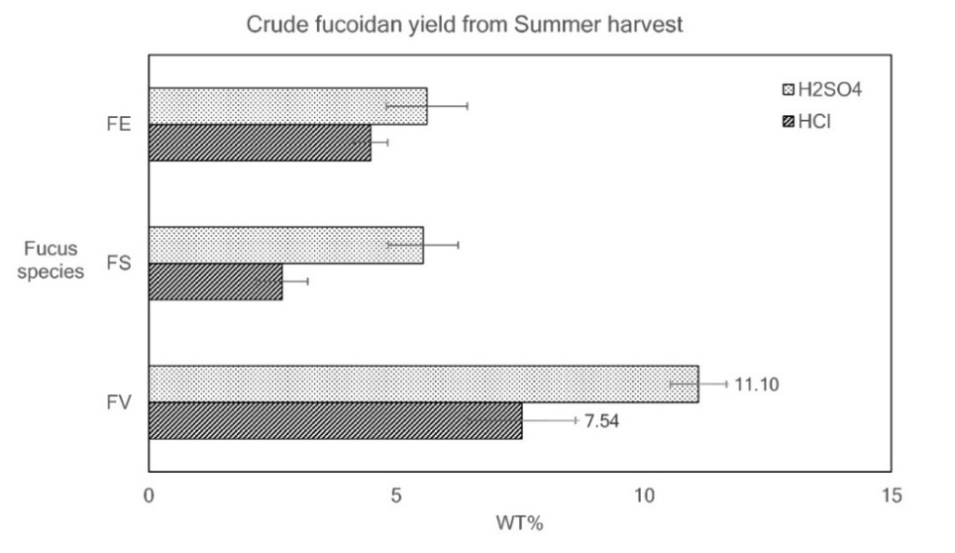
The algae used by Fletcher et al. (2017) were harvested off the coast of Aberystwyth in the UK. Rodriguez-Jasso et al. (2011) used MAE on FV harvested in Praia Norte, Viana do Castelo (Portugal) in September 2009. They varied the pressure and extraction time and found that MAE at 120 psi, 1 min, using 1 g algae and 25 ml solvent gave the highest fucoidan yield (18.22 wt%), and that the main constituent of the extracted fucoidan was L-Fucose. Yuan & Macquarrie (2015) used MAE at three different temperatures for fucoidan extraction from Ascophyllum nodosum. They reported that the highest fucoidan yield (16.08 wt%) was obtained at 120$°$C for 15 min extraction. At higher temperatures and at longer extraction times, the fucoidan may be subjected to thermal degradation, as fucose is not very heat stable (Yuan and Macquarrie 2015). The difference in yield
Figure 4: Yield (weight percent) of crude fucoidan from microwave extraction of Fucus vesiculosus (FV), Fucus serratus (FS) and, Fucus evanescens (FE). The algae were harvested July 3rd, 2017 in Kiel Fjord, Germany. Each bar is expressed as means of 4 replicates with error lines showing the ± standard deviation.

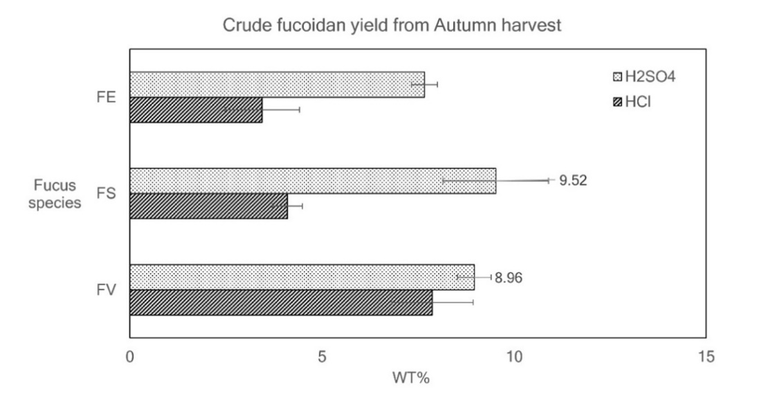
Figure 5: Yield (weight percent) of crude fucoidan from microwave extraction of Fucus vesiculosus (FV), Fucus serratus (FS) and, Fucus evanescens (FE). The algae were harvested October 10th, 2017 in Kiel Fjord. Each bar is expressed as means of 4 replicates with error lines showing the ± standard deviation.

between these and the current study might be due to thermal degradation of fucoidan. The climate of both Kiel, and Aberystwyth are oceanic (Köppen classification Cfb), and they have cool summers and cool winters with a relatively narrow annual temperature range and few extremes of temperature. The difference in yield is likely not due to varying temperatures or elevated pCO₂ during growth, but possibly due to differences in plant maturity and potentially the amount of daylight the algae receive. Age determination is quite complex, however. The age of a FV is usually based on the number of air vesicles (bladders), assuming one vesicle is formed annually. The correlation between age and the number of air vesicles is not very exact, however; some species of FV may only contain few or no vesicles if the currents are not very strong. Essentially, the difference in fucoidan yield may be skewed due to maturity. Some studies suggest that UV radiation and free radicals formed and stimulated by fluctuations in the surrounding environment promote higher contents of fucoidan, due to the antioxidant function of fucoidan in the cell wall (Holtkamp 2009). Fucoidan content may also be affected by the life cycle of organisms that feed off the algae. These organisms digest fucoidan using fucoidanase (Silchenko et al., 2013). The regional difference in fucoidan yield, between the German and the French FV, is quite significant, indicating that environmental conditions do affect the fucoidan content. Fucoidans are believed to stabilize the cell wall by crosslinking between matrix cellulose microfibrils, which strengthens the cell wall (Deniaud-Bouët, et al. 2014). This crosslinking supposedly protects the cell wall from mechanical, chemical and osmotic stress, and key environmental factors seemingly affects the fucoidan content of algae directly (Zvyagintseva et al., 2003). Due to the sulfate groups, fucoidan can bind cations (mainly K⁺, Na⁺, Ca²⁺, Mg²⁺) and participate in anion exchange with the environment. This exchange enables the algae to adapt to water salinity fluctuations and to the toxic effects of heavy metals (Skriptsova, 2016).
  - Conclusions
The Fucus species with the highest fucoidan yield, across seasons and solvent-temperature compositions, was FV. The extraction yield for all the algae was improved when microwaved with 10 mM H₂SO₄ at 120°C. These results imply that it is important to consider which algae to select for extraction, based on species, genera, time of harvest and harvest location when maximizing fucoidan yield. Future work on these extracts would include determining the sulfate content of the algae, the weight of the fucoidan fractions, as well as assessing the bioactivity.
Acknowledgments
This project is funded by the European Regional Development Fund and was performed as part of the FucoSan Study Group. The authors would like to thank the Coastal Research & Management (CRM) in Germany for collecting and supplying the brown algae used in this study.
References
Masanori B., Snoeck R., Pauwels R., De Clercq E., 1988, Sulfated Polysaccharides Are Potent and Selective Inhibitors of Various Enveloped Viruses, Including Herpes Simplex Virus, Cytomegalovirus, Vesicular Stomatitis Virus, and Human Immunodeficiency Virus, Antimicrobial Agents and Chemotherapy, 32, 1742-1745.
Bedoux G., Hardouin K., A. S. Burlot A.S., Bourgougnon N., 2014, Bioactive Components from Seaweeds: Cosmetic Applications and Future Development, Chapter 12 in N Bourgougnon (Ed.), Advances in Botanical Research, Elsevier. Vannes: Elsevier, 2014.
Church F.C., Meade J.B., Treanor R.E., Whinna H.C., 1989, Antithrombin Activity of Fucoidan - The Interaction of Fucoidan With Heparin Cofactor II, Antithrombin III, and Thrombin, Biological Chemistry, 264, 3618-3623.
Delazar A., Nahar L., Hamedeyazdan S., and Sarker S. D.,2012, Microwave-Assisted Extraction in Natural Products Isolation. In Natural Products Isolation, Methods in Molecular Biology, Sarker S, & Nahar L, 557. Springer, 2012.
Deniaud-Bouët E., Kervarec N., Michel G., Tonon T., Kloareg B., and Hervé C, 2014, Chemical and enzymatic fractionation of cell walls from Fucales: insights into the structure of the extracellular matrix of brown algae, Annals of Botany,114, 1203-1216.
Fletcher, H. R., Biller P., Ross A. B., and Adams J. M. M.,2017, The Seasonal Variation of Fucoidan Within Three Species of Brown Macroalgae, Algal Research, 22, 79-86.
Gupta, S., and Abu-Ghannam N., 2011, Bioactive potential and possible health effects of edible brown seaweeds, Trends in Food Science and Technology, 22, 315-326.
Holtkamp, A. D., 2009, Isolation, Characterisation, modification and application of fucoidan from Fucus vesiculosus. PhD thesis,
Kylin H., 1913, Biochemistry of sea algae, German Journal of physical chemistry (Zeitschrift für Physikalische Chemie), 83, 171-197.
McClure M. O., Moore J. P., Blanc D. F., Scotting P., Cook G. M. W., Keynes R. J., Weber J. N., Davies D., and Weiss R. A., 1992, Investigations into the Mechanism by Which Sulfated Polysaccharides Inhibit HIV Infection In Vitro, Aids Research and Human Retroviruses, 8 (1), 19-26.
Nishino, T., Aizu Y., and Nagumo T., 1991, The Influence of Sulfate Content and Molecular Weight of a Fucan Sulfate From the Brown Seaweed Ecklonia kurome on its Antithrombin Activity, Thrombosis Research, 64, 723-731.
Riou D., Colliec-Jouault S., Pinczon du Sel D., Bosch S., Siavoshian S., Le Bert V., Tomasoni C., Sinquin C., Durand P., Roussakis C., 1996, Antitumor and Antiproliferative Effects of a Fucan Extracted From Ascophyllum nosdum Against a Non-Small-Vell Bronchopulmonary Carcinoma Line, Anticancer Research, May-Jun, 16 (13A), 1213-1218.
Roda-Serrat, M. C., Christensen L. P., Christensen K. V., and Fretté X, 2015, Optimization of removal of D-trehalose from commercial food colorant by diafiltration with ultrafiltration membranes, Chem. Eng. Trans. 43, 1027-1032.
Rodriguez-Jasso, R. M., Mussatto S. I., Pastrana L., Aguilar C. N., and Teixeria J. A., 2011, Microwave-assisted extraction of sulfated polysaccharides (fucoidan) from brown seaweed, Carbohydrate Polymers, 86, 1137– 1144.
Senthilkumar, K., Manivasagan P., Venkatesan J., and Kim S., 2013, Brown Seaweed Fucoidan: Biological Activity and Apoptosis, Growth Signaling Mechanism in Cancer, International Journal of Macromolecules, 60, 366-374.
Silchenko, A. S., Kusaykin M. I., Kurilenko V. V., Zakharenko A. M., Isakov V. V., Zaporozhets T. S., Gazha A. K., and Zvyagintseva T. N., 2013, Hydrolysis of Fucoidan by Fucoidanase Isolated from the Marine Bacterium, Formosa algae, Marine Drugs, 11, 2413-2430.
Skriptsova, A. V., 2015, Fucoidans of Brown Algae: Biosynthesis, Localization, and Physiological Role in Thallus, Russian Journal of Marine Biology,41 (3),145-156.
Skriptsova, A. V., 2016, Seasonal Variations in the Fucoidan Content of Brown Algae from Peter the Great Bay, Sea of Japan, Russian Journal of Marine Biology,42 (4) 351-256.
Yuan, Y., and Macquarrie D., 2015, Microwave assisted extraction of sulfated polysaccharides (fucoidan) from Ascophyllum nodosum and its antioxidant activity, Carbohydrate Polymers, 129, 101-107.
Zvyagintseva, T. N., Schevchenko N. M., Chizhov A. O., Krupnova T. N., Sundukova E. V., and Isakov V. V, 2003, Water-Soluble Polysaccharides of Some Far-eastern Brown Seaweeds. Distribution, Structure, And Their Dependence On the Developmental Conditions, Journal of Experimental Marine Biology and Ecology, 294, 1-13.

