 CHEMICAL ENGINEERING TRANSACTIONS  VOL. xxx, 2026 | A publication of  
The Italian Association
of Chemical Engineering
Online at www.cetjournal.it

Guest Editors: Marco Bravi, Antonio Marzocchella, Giuseppe Caputo
Copyright © 2026, AIDIC Servizi S.r.l.
ISBN 979-12-81206-xx-x; ISSN 2283-9216

Sustainability of The Alcoholic Fermentation in Catarratto and Inzolia Grapes (V. vinifera L.)
Clara Vitaggioª, Matteo Pollon^{a*}, Manuel Schnitter^{a,} Valeria Guarrasi^{b}, Luigi Picariello^{c}, Diego Planetaª, Angelita Gambuti^{c}, Luciano Cinquantaª, Onofrio Coronaª
ª Department of Agricultural, Food and Forest Sciences, University of Palermo, (Palermo), Viale delle Scienze 13, 90128 Palermo, Italy
^{b} Institute of Biophysics at Palermo, Italian National Research Council, Via U. La Malfa 153, 90146 Palermo, Italy
^{c} Department of Agricultural Sciences, University of Naples Federico II, Portici,Italy
matteo.pollon@unipa.it

Improving environmental sustainability in winemaking involves reducing the energy required for thermal control during alcoholic fermentation, while preserving the fruity character of wines. This study evaluated two white grape cultivars (Catarratto and Inzolia), fermented at two temperatures (15 °C and 20 °C) using two Saccharomyces cerevisiae strains (SafOeno™ SC22 and SafOeno™ BC S103). Fermentation at 20 °C led to significantly faster sugar consumption, concluding 2.2 days earlier than fermentations at 15 °C. No major differences in fermentation kinetics were observed between the yeast strains. Volatile ester concentrations were generally higher at 15 °C, particularly with BC S103, although varietal effects were evident. Acetaldehyde levels were slightly higher at 20 °C (below 10%), particularly with BC S103, while acetoin was more abundant at 15 °C. However, all carbonyl compounds with potential odour impact remained below sensory thresholds. Sensory analysis indicated that the choice of yeast strain had a greater influence on aroma than fermentation temperature, suggesting that fermenting at 20 °C does not compromise wine quality. A cost analysis highlighted that fermentation at 20 °C significantly lowers production costs compared to 15 °C, mainly due to reduced energy and labor inputs. The lowest estimated cost was observed for BC S103 at 20 °C (5.30 € hL⁻¹), indicating that moderate fermentation temperatures combined with low-nutrient yeast strains offer a cost-effective and sustainable strategy for white wine production.
  - Introduction
Modern enology must aim not only at the aspects of healthiness and sensorial quality but also to reduce the environmental impact of the processes as much as possible (Christ e Burritt 2013). Must fermentation is an exergonic process: it is estimated that S. cerevisiae releases 101.2 kJ per mole of consumed hexose (Boulton et al. 1999). If this energy is not fully exchanged with the external environment it causes an increase in the must's temperature with significant consequences on both the kinetics of fermentation and the chemical composition of the white wines. Particularly, higher fermentation temperatures yield wines with lower ratio between fermentative esters and fusel alcohols compared to minor temperatures, with a possible fruity note alteration (Pollon et al. 2025). However, the accumulation of fermentative esters and fusel alcohols in wines also depends on other variables such as yeast strain, nitrogen profile and amount in the grape juice, turbidity of the musts, and the concentration of fatty acids in the must itself (strongly dependent on the quantity of suspended solids in the musts) (Guittin et al. 2021; Nicolini et al., 2011). The study conducted tested the possibility of limiting the amount of refrigeration for temperature control in the process of wine fermentation in white wines produced in Sicily (Italy), while preserving their fruity aroma. Two grape varieties were used: Catarratto and Inzolia, fermented with two different strains of S. cerevisiae (SafOeno™ BC S103 and SafOeno™ SC 22) at two different temperatures (15 and 20 °C). For this reason, the fermentation kinetics, the wine physico-chemical parameters, the volatile organic composition, the carbonyl compounds, and the sensory profiles of the wines were evaluated. Moreover, a comparative analysis of fermentation costs was conducted to evaluate energy consumption, labor requirements, and overall process efficiency.
  - Materials and Methods
2.1 Winemaking process
Catarratto and Inzolia grapes (250 kg) harvested in Marsala at 20 °Brix were vinified in triplicate (50 L tanks) at the University of Palermo experimental winery. After SO₂ addition, enzymatic treatment, and cold settling, fermentations were conducted at 15 and 20 °C using two commercial S. cerevisiae strains, with nitrogen supplementation applied at 60 g/hL for SC22 and 50 g/hL for BC S103. Fermentation was considered complete at < 2 g L⁻¹ reducing sugars, and wines were racked and adjusted to 30 mg L⁻¹ free SO₂.
2.2 Physico-chemical analyses
Alcohol content (%v/v), reducing sugars (g L⁻¹), titratable acidity (g L⁻¹ as tartaric acid), volatile acidity (g L⁻¹ as acetic acid), and pH were determined by means of Fourier-transform infrared (FTIR) technology through a WinescanTM FT 120 Fa. Instrument (FOSS, Hillerød, Denmark) according to the OIV Compendium of International Methods of Analsyis of Wine and Musts (2007).
2.3 Volatile organic compounds (VOCs)
Volatiles organic compounds (VOCs) were determined on 25 mL of wine, through an elution on 1 g C18 cartridge (Isolute, SPE Columns), with gas chromatography (Perkin Elmer Autosystem XL) and gas chromatography-mass spectrometry (Agilent 6890 Series GC system, Agilent 5973 Net Work Mass Selective Detector), both equipped with a DB-WAX column (Agilent Technologies, 30 m, 0.250 mm i.d., film thickness 0.25 μm), as described by Corona, 2010.
2.4 Determination of Carbonyls by High-Performance Liquid Chromatography
Total acetaldehyde, acetoin, pyruvic acid, and α-ketobutyric acid were determined according to Han et al. (2015) with minor modifications. Wine samples were derivatized with DNPH, incubated at 65 °C for 15 min, and analyzed by HPLC (Shimadzu LC-10 ADVP) on a Waters Spherisorb column using a water/formic acid–acetonitrile gradient. Compounds were identified with DNPH-acetaldehyde standards and quantified by external calibration curves.

2.5 Sensory analysis
Wines were evaluated by qualitative sensory analysis using a panel of 11 trained judges previously calibrated to develop a common vocabulary and evaluation procedure. A descriptive method was applied. Fifteen descriptors (citation frequency >60%) were selected, including visual, olfactory and gustatory attributes, as well as gustatory persistence and overall satisfaction. Samples were evaluated in random order using a 9-point intensity scale (1 = absence; 9 = extremely intense).

2.6 Fermentation cost analysis
Fermentation costs were estimated considering key process expenses: energy, yeast inoculum, additives, labor, and tank depreciation. Energy costs reflected cooling needs during fermentation, while labor and tank depreciation depended on fermentation duration. Yeast and additive costs were based on supplier prices and normalized to processed volume.

2.7 Data analysis
Fermentation kinetics were described by modelling reducing sugar concentration using a five-parameter logistic regression (5PLR) implemented in R (v.4.0.3) with the drc package as described by Pollon et al. (2025):

$S=c+ \frac{d-c}{{\left(1+e^{b\left(t-ε\right)}\right)}^{f}}$ (1)

Where S = the reducing sugar concentration (g L⁻¹) and t is time (days)

Six standard time points were calculated to compare fermentation kinetics: 1 g L⁻¹ fermented and 25%, 50%, 75% and 100% of initial sugars consumed. The fermentation inflection point was determined by setting the second derivative of S with respect to t equal to zero:
$${\left.ε-\frac{\ln\left(f\right)}{b}\right|t}_{\frac{d^{2}S}{dt^{2}}=0} (2)$$
After fitting the 5PLR model, the inverse form of Eq. (1) was used to estimate the time corresponding to the selected sugar concentrations:
$t= \frac{bε+\ln\left({\left(\frac{c-d}{c-S}\right)}^{\frac{1}{f}}-1\right)}{b}$ (3)
The calculated time points, inflection point, and maximum sugar consumption rate (minimum dS/dt) were used as kinetic variables. All data were analysed by factorial ANOVA including the interaction between variety and nutrition using R 4.0.3. When significant differences were detected (p < 0.05), means were separated using Tukey’s HSD test (α = 0.05) with the agricolae package. All measurements were performed in duplicate experimental replicates, each analyzed with two analytical replicates.
  - Results and discussion
The results showed significant differences related to temperature and sugar consumption kinetics. As expected, fermentative kinetics at 20 °C exhibit a higher sugar consumption rate in all phases, achieving fermentative dryness 2.2 days earlier compared to fermentations conducted at 15 °C with a respective maximum fermentative vigor of -94 ± 3 g L⁻¹ day⁻¹ versus -50 ± 2 g L⁻¹ day⁻¹, resulting in different kinetics of energy release (Figure 1). However, no significant differences were observed between the two yeast strains in sugar consumption kinetics.
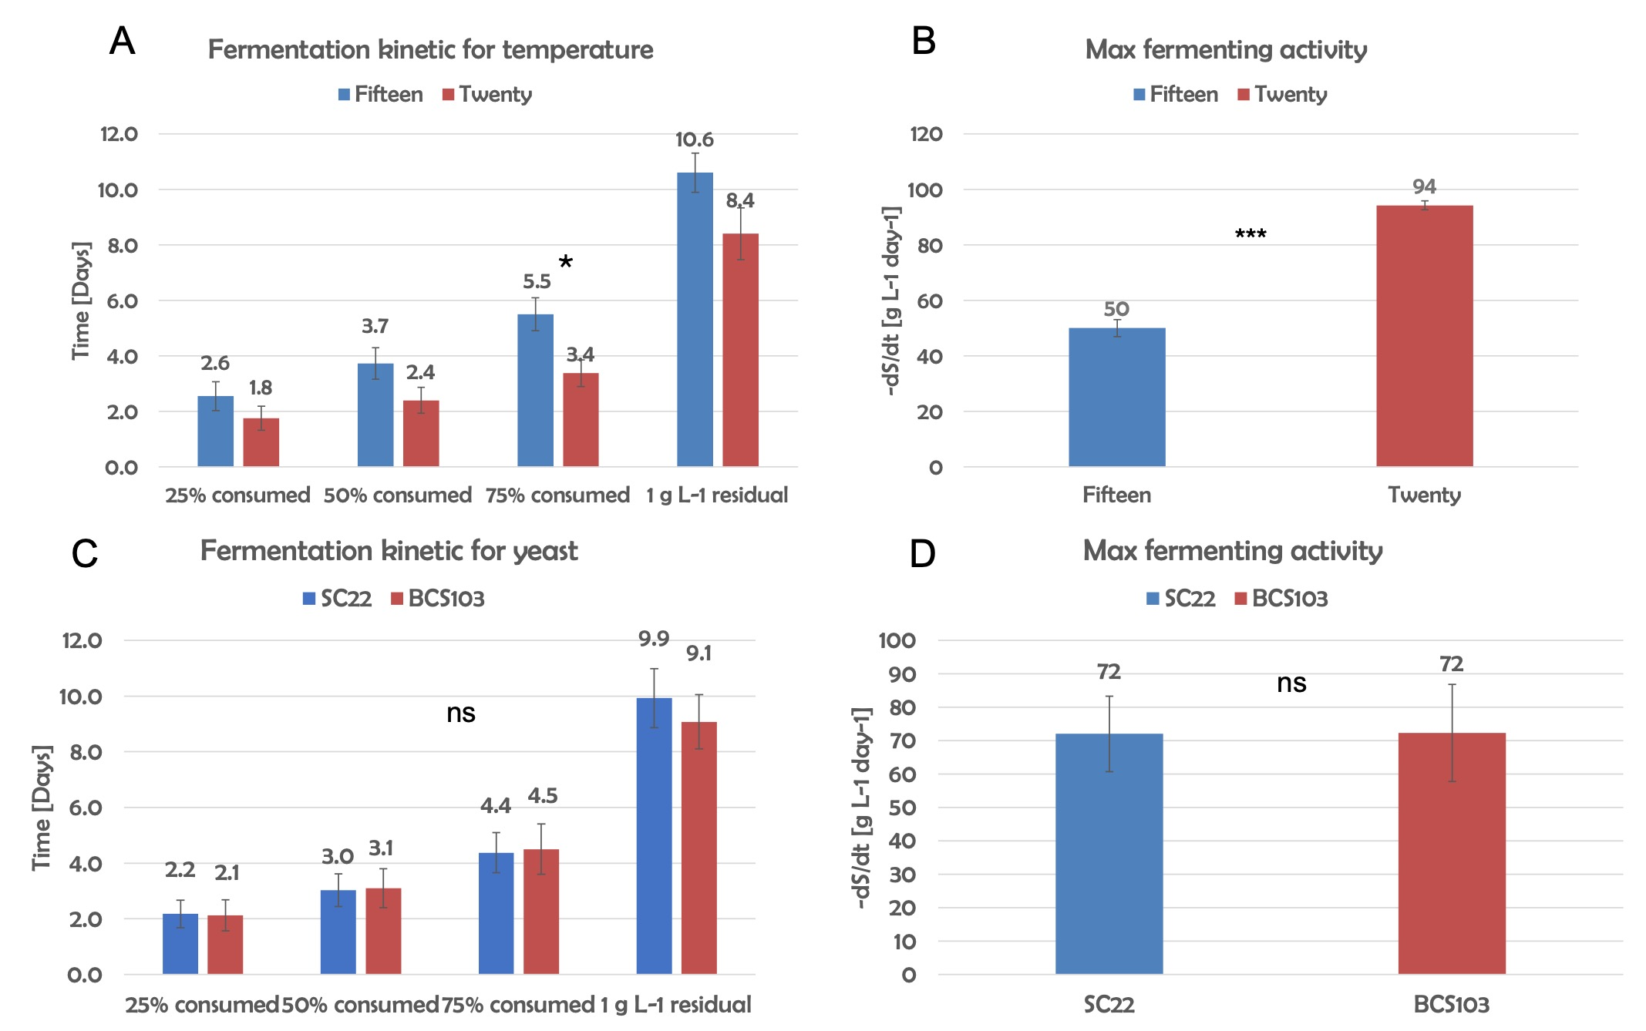
Figure 1: Fermentation kinetics. Left: Time required to reach 25%, 50%, 75% and 100% sugar consumption and to attain 1 g L⁻¹ residual sugar during fermentations conducted. Right: Maximum fermentation rate observed at the two temperatures. Fermentation kinetics at different temperatures (A) and different yeast strain (C) and Maximum fermentation at different temperatures (B) and different yeast strain (D). Sign. =ANOVA, ns = not significant, * = 90 % of significance, ** = 99 % of significance, *** = 99 % of significance.

As has already been observed, the increase in fermentation temperature causes an increase in the production of glycerol and fermentative acids (Gao et al. 2019), while the different yeasts did not affect the technological parameters of the wines processed.

Table 1: Wine physical-chemical composition
Factor | Alcohol  (% vol) | Reducing sugar (g L⁻¹) | pH | Titratable acidity (g L⁻¹) |  | Volatile acidity (g L⁻¹) | Dry extract  (g L⁻¹) | Glycerol  (g L⁻¹)
Temperature
(n = 8)
Fifteen | 12.2 ± 0.6 | 0.21 ± 0.08 | 3.3 ± 0.1 |  | 6.5 ± 0.8 | 0.11 ± 0.04 | 20.8 ± 0.3 | 5.82 ± .01
Twenty | 11.9 ± 0.6 | 0.13 ± 0.07 | 3.3 ± 0.1 |  | 6.6 ± 0.8 | 0.14 ± 0.05 | 22.1 ± 0.2 | 6.0 ± 0.2
Sign. | ns | ns | ns |  | ns | ns | * | ns
Yeast
(n = 8)
SC22 | 11.9 ± 0.6 | 0.20 ± 0.08 | 3.3 ± 0.1 |  | 6.5 ± 0.8 | 0.14 ± 0.06 | 21.4 ± 0.2 | 5.89 ± 0.1
BC S103 | 12.1 ± 0.6 | 0.14 ± 0.08 | 3.31 ± 0.1 |  | 6.5 ± 0.9 | 0.11 ± 0.03 | 21.5 ± 0.6 | 5.9 ± 0.2
Sign. | ns | ns | ns |  | ns | ns | ns | ns
Note: Data are reported as mean plus and minus standard error of the mean. n =number of measurements. Sign. =ANOVA, ns = not significant, * = 90 % of significance, ** = 99 % of significance, *** = 99 % of significance.

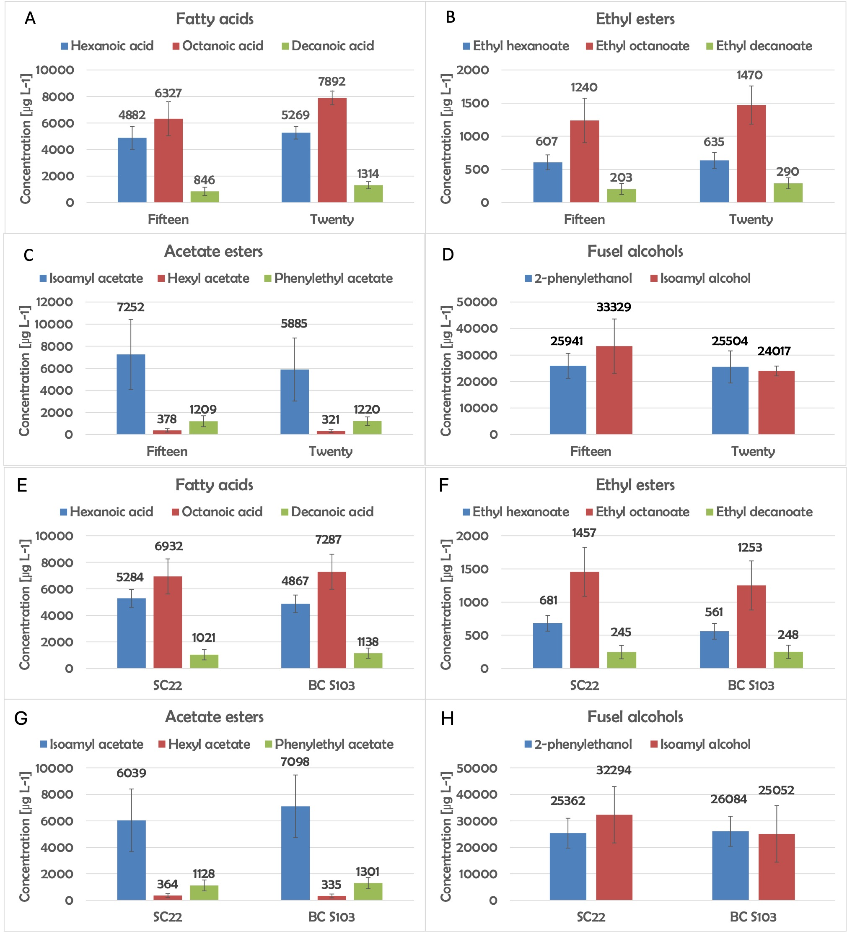
Figure 2: Volatile organic compounds (VOCs) (fatty acids, ethyl esters, acetate esters, fusel alcohols) in Catarratto and Inzolia wines fermented at different temperatures (A, B, C, D) and with different yeast strain (E, F, G, H.

Aroma plays a key role in defining the overall quality of foods, and in wine it is considered one of the main factors influencing consumer appeal and appreciation. The characteristic bouquet and flavor profile of a wine are shaped by multiple elements, including grape cultivar, vintage conditions, degree of fruit ripeness, fermentation process, maturation stage, and the specific winemaking practices applied (Cejudo-Bastante et al. 2013). No significant differences were found related to acetate esters, ethyl esters, their related medium-chain fatty acids and fusel alcohols neither for the temperature factor nor for the different yeasts used (Figure 2). Similarly, Samoticha et al. (2019) reported that fermentation temperature did not significantly affect ester formation, whereas yeast strain played a major role in influencing this class of compounds. As expected, acetaldehyde was the predominant carbonyl compound detected in the wines (Table 2), acting as a key intermediate in ethanol formation during alcoholic fermentation. In all samples, both free and SO₂-bound acetaldehyde remained well below the sensory threshold associated with off-flavours (100 mg L⁻¹) ( Russo et al., 2019; Coetzee et al. 2018). Higher free acetaldehyde concentrations were observed in wines fermented with the BC S103 strain, confirming the strong strain dependency of its production (Romano et al. 1994). In contrast, fermentation temperature in the tested range (15–20 °C) had only a minor influence on both free and bound acetaldehyde levels. Acetoin, a secondary product of alcoholic fermentation and a precursor of diacetyl and 2,3-butanediol, showed lower concentrations at 20 °C than at 15 °C, while no significant effect of yeast strain was observed. These results suggest that at higher temperatures acetoin may be more rapidly metabolized in downstream reactions leading to 2,3-butanediol formation. Pyruvic acid concentrations were higher at 20 °C, particularly in wines fermented with the BC S103 strain. This compound is typically produced during the early stages of fermentation and subsequently consumed by yeasts as a metabolic intermediate involved in the formation of several carbonyl compounds (Herzan et al. 2020). Finally, α-ketobutyric acid, an intermediate in amino acid metabolism formed during the conversion of threonine into higher alcohols, did not increase with fermentation temperature. This contrasts with conditions that generally favour higher alcohol production, suggesting that the temperature range tested (15–20 °C) was not sufficient to significantly affect its formation.

Table 2 shows the content of α-ketoglutaric acid, acetoin, pyruvic acid, and free and total acetaldehyde in the experimental wines.
Factor | α-Ketoglutaric acid  (mg L⁻¹) | Acetoin  (mg L⁻¹) | Piruvate  (mg L⁻¹) | Total acetaldehyde  (mg L⁻¹) | Free acetaldehyde (mg L⁻¹)
Yeast (n = 8)
SC22 | 30.65 ± 8.05 | 0.13 ± 0.02 | 11.57 ± 1.76 | 43.49 ± 2.08 | 4.02 ± 2.50
BC S103 | 33.47 ± 7.90 | 0.14 ± 0.01 | 22.51 ± 5.38 | 54.95 ± 2.29 | 21.61 ± 2.41
Sign. | ns | ns | . | ** | ***
Temperature
(n = 8)
15° C | 30.92 ± 7.42 | 0.16 ± 0.01 | 16.93 ± 0.75 | 49.61 ± 2.57 | 14.03 ± 3.69
20° C | 33.20 ± 8.50 | 0.11 ± 0.01 | 17.15 ± 6.33 | 48.84 ± 3.50 | 9.82 ± 4.89
Sign. | ns | * | ns | ns | ns
Note: Data are reported as mean plus and minus standard error of the mean. n = number of measurements. Sign. =ANOVA, ns = not significant, * = 90 % of significance, ** = 99 % of significance, *** = 99 % of significance.

From the sensory analysis profile of Catarratto wines, no significant differences were observed among samples for most descriptors, except for fruity intensity. In particular, the SC 22 strain fermented at 15 °C exhibited the highest fruity intensity, while the same strain at 20 °C showed intermediate values (Figure 3). Conversely, wines produced with the BC S103 strain displayed lower fruity intensity at reminding similar levels at both 15 and 20 °C. The same condition was also observed for the Inzolia variety, followed the same pattern among yeast strains and fermentation temperatures (Figure 6). These results indicate that differences in fruity perception are primarily attributable to the yeast strain rather than fermentation temperature.

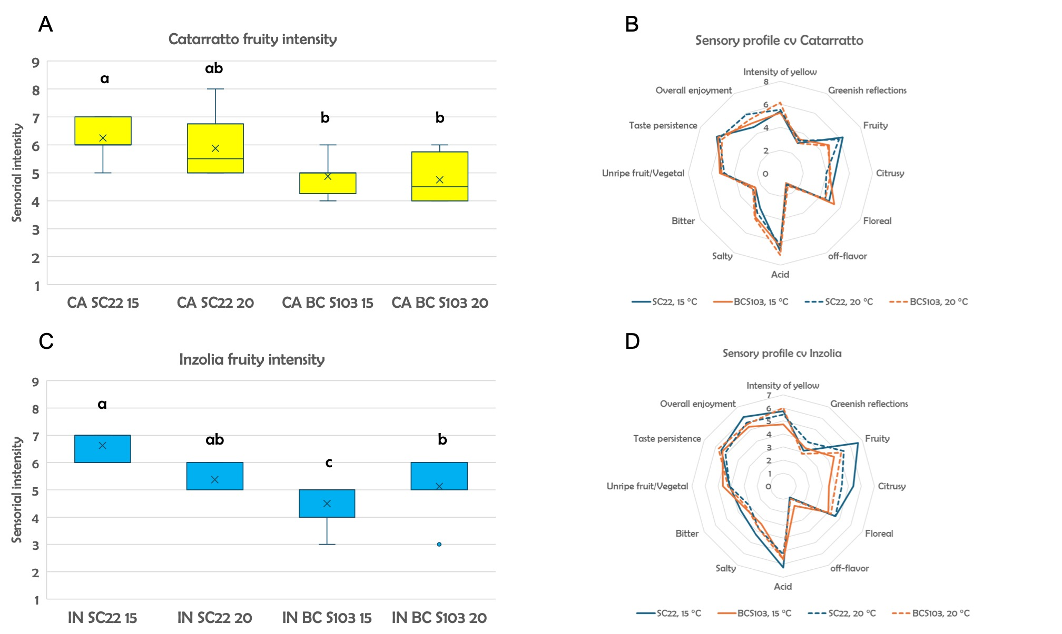
Figure 3: Sensory evaluation of Catarratto (A e B) and Inzolia (C e D) wines produced with different yeast strains and fermentation temperatures. Left: Boxplot of fruity intensity scores for wines fermented with SC22 and BC S103 yeast at 15 °C and 20 °C. Different letters indicate statistically significant differences (p < 0.05). Right: Radar plot showing the overall sensory profile. CA = Catarratto IN = Inzolia

Cost analysis of both winemaking processes was also performed, aimed at conducting energy audits and identifying opportunities for process optimization and energy efficiency improvements. Fermentation at 20 °C significantly reduced overall production costs compared to 15 °C, mainly due to lower energy and labor inputs. The lowest cost was observed for the BC S103 strain at 20 °C (5.30 € hL⁻¹) compared to 15 °C (6.20 € hL⁻¹), that moderate fermentation temperatures, when coupled with a yeast characterized by low nutrient requirements, represent an economically and environmentally sustainable strategy in white wine production.

Table 3: Comparison of production costs per hectoliter (€/hL) for SC 22 and BC S103 strains fermented at 15 °C and 20 °C.
Costs | SC 22 (15°C) | SC 22 (20°C) | BC S103 (15°C) | BC S103 (20°C)
Energy Cost (€) | 10.5 | 7 | 11.25 | 7.5
Yeast Cost (€) | 210.4 | 210.4 | 184 | 184
Additive Cost (€/ hL) | 2.4 | 2.4 | 1.6 | 1.6
Labour Cost (€) | 183.6 | 144 | 192.6 | 153
Tank Depreciation (€) | 30.6 | 24 | 32.1 | 25.5
Cost (€/hL) | 6.751 | 6.254 | 5.7995 | 5.3
  - Conclusion
This study demonstrated that increasing fermentation temperature from 15 °C to 20 °C accelerates fermentation kinetics without negatively affecting the chemical and sensory quality of Catarratto and Inzolia wines. The yeast strain had a greater influence on aroma perception than temperature, while volatile and carbonyl compounds remained within acceptable sensory ranges. Importantly, fermentations conducted at 20 °C significantly reduced production costs due to lower energy and labor requirements. These findings suggest that moderate fermentation temperatures, combined with suitable yeast strains, represent a practical strategy to improve both the economic and environmental sustainability of white wine production.
  - References
Boulton R. B., Vernon L. S., Linda F. B., e Ralph E.K., 1999, Yeast and biochemistry of ethanol fermentation, Principles and Practices of Winemaking, Springer US.
Cejudo-Bastante M. J., Isidro H.G., María Soledad P., 2013, Accelerated aging against conventional storage: effects on the volatile composition of Chardonnay white wines, Journal of Food Science, 78, 4, C507–13.
Christ K. L., and Roger L. B., 2013, Critical environmental concerns in wine production: an integrative review, Journal of Cleaner Production, 53, 232–42.
Coetzee C., Buica A, Du Toit W. J., 2018, The use of SO₂ to bind acetaldehyde in wine: sensory implications». South African Journal of Enology & Viticulture 32, 2.
Corona O., 2010, Wine-making with protection of must against oxidation in a warm, semi-arid terroir, South African Journal of Enology and Viticulture, 31, 1.
Gao Y., Zhang Y., Xiang W., et al., 2019, The glycerol and ethanol production kinetics in low-temperature wine fermentation using Saccharomyces cerevisiae yeast strains, International Journal of Food Science and Technology, 54,1,102–10.
Guittin C., Maçna F., Sanchez I., et al. 2021, Impact of high lipid contents on the production of fermentative aromas during white wine fermentation, Applied Microbiology and Biotechnology, 105 ,16, 6435–49.
Han S. H., Choi M., Jeong T., et al., 2015, Rhodium-catalyzed C–H alkylation of indolines with allylic alcohols: direct access to β-aryl carbonyl compounds, The Journal of Organic Chemistry, 80, 21, 11092–99.
Herzan J., Prokes K., Baron M., Kumsta M., Pavlousek P., Sochor J., 2020, Study of carbonyl compounds in white wine production, Food Science & Nutrition, 8, 11, 5850–59.
Mouret J. R., Camarasa C., Angenieux M., et al., 2014, Kinetic analysis and gas–liquid balances of the production of fermentative aromas during winemaking fermentations: Effect of assimilable nitrogen and temperature, Food Research International 62, 1–10.
Nicolini G., Moser S., Román T., Mazzi E., Larcher R., 2011, Effect of juice turbidity on fermentative volatile compounds in white wines, Vitis, 50, 3, 131-135.
Pollon M., Vitaggio C, Ghinolfi F., Amato F., Cinquanta L., Corona O., 2025, An automatic fermentation nutrition system compared to a traditional one: fermentation performances and composition of white wines, OENO One, 59, 1.
Romano P., Suzzi G., Turbanti L., and Polsinelli M., 1994, Acetaldehyde production in Saccharomyces cerevisiae wine yeasts, FEMS Microbiology Letters, 118, 3, 213–18.
Russo P., Liguori L., Corona O., Albanese D., Matteo M.D., and Cinquanta L., 2019, Combined membrane process for dealcoholization of wines. Osmotic distillation and reverse osmosis, Chemical Engineering Transaction, 75, 7-12.
Samoticha J., Wojdyło A., Chmielewska J., Nofer J., 2019, Effect of different yeast strains and temperature of fermentation on basic enological parameters, polyphenols and volatile compounds of aurore white wine, Foods 8, 12, 599.

