 CHEMICAL ENGINEERING TRANSACTIONS  VOL. xxx, 2026 | A publication of  
The Italian Association
of Chemical Engineering
Online at www.cetjournal.it
Guest Editors: Marco Bravi, Antonio Marzocchella, Giuseppe Caputo
Copyright © 2026, AIDIC Servizi S.r.l.
ISBN 979-12-81206-xx-x; ISSN 2283-9216

Edaphic sustainability and forage productivity through the use of bocashi-type fermented organic fertilizers: A systematic review.

Ludwig N. Villanueva*ª, Carmen Lizbeth Yurac Gonzales Velasquezª, Ana N. Sandoval^{b}, Roaldo Lopez Fulca^{b}, Jose Bladimir Sánchez Cruz^{b}

ªUniversidad Nacional de Trujillo, Perú
^{b}Universidad Nacional de San Martín, Perú
ludwiglr@gmail.com

This research evaluates the impact of Bocashi on edaphic sustainability and forage biomass productivity through a systematic review (PRISMA 2020). A total of 231 articles from Scopus were analyzed using data mining and bibliometric techniques with VOSviewer. Bocashi serves as a crucial biotechnological bridge for nutrient stabilization, offering a rapid alternative to traditional composting in tropical climate zones. Beyond yield increase, the review identified that fermented amendments trigger a systemic reactivation of soil enzymatic activity, which is directly correlated with enhanced forage protein levels and improved ruminant digestibility. The results demonstrate an exponential growth in publications since 2015, highlighting that Bocashi increases soil organic matter between 15% and 22% and elevates dry yield by >3.8 t/ha per cycle. Co-occurrence analysis identifies a synergy between the amendment and photosynthetic efficiency, mediated by biological and enzymatic reactivation. It is concluded that Bocashi optimizes plant physiological resilience, consolidating itself as a precision tool for the circular economy in tropical agroecosystems.

- Introduction
Soil degradation and the dependency on synthetic fertilizers represent a critical challenge for the sustainability of global agricultural systems. In tropical ecosystems, Lal (2025) identifies the restoration of organic carbon as a fundamental strategy to mitigate climate change through carbon sequestration. Given this scenario, the valorization of local waste under circular economy models allows for a reduction in the carbon footprint of conventional fertilization, as proposed by Sánchez et al. (2023). In this context, Bocashi emerges as a superior biotechnological alternative to traditional composting; Wang et al. (2024) determined that its accelerated fermentation kinetics minimizes nitrogen volatilization, optimizing nutrient retention within the organic matrix.
Bocashi’s efficiency in edaphic sustainability is based on its capacity to modulate complex chemical processes. Sihi et al. (2022) explain that fermented organic matter regulates the redox potential (Eh), facilitating phosphorus solubilization in acidic soils where this nutrient is typically immobilized. Furthermore, Liu et al. (2025) demonstrated that the increase in cation exchange capacity (CEC) through these amendments improves the retention of critical cations such as potassium and magnesium. From a biological perspective, Villarreal et al. (2024) indicate that Bocashi diversifies mycorrhizal fungi populations, which are essential for root exploration and the resilience of the soil-plant system under water stress conditions.
The final impact of this technology results in the improvement of productivity and quality of forage systems. Mendoza et al. (2024) confirmed that the application of Bocashi not only significantly increases dry biomass in tropical pastures but also improves root density. Furthermore, Chen et al. (2023) highlight that treated grasses exhibit higher crude protein levels, while Rodríguez et al. (2025) emphasize an enhancement in fiber digestibility, optimizing livestock production efficiency.
While previous systematic reviews have focused on general organic waste stabilization and soil physical properties (Heredia et al., 2022), there is a significant research gap regarding the integrated impact of fermented fertilizers on forage bromatological quality. Current literature often presents fragmented data on nutrient release; this study addresses that fragmentation by explicitly linking Bocashi’s biochemical mechanisms with specific improvements in protein content and fiber digestibility in tropical grasses
Despite individual advances in Bocashi characterization, there is fragmentation in the scientific literature regarding its integrated technical efficacy at the soil-forage interface, particularly under high tropical leaching conditions. This lack of consensus on nutrient release mechanisms and their direct impact on bromatological quality justifies the need for a systematic synthesis. Therefore, the objective of this study is to evaluate, through the PRISMA 2020 protocol, the influence of Bocashi-type fermented fertilizers on edaphic sustainability and forage productivity. This review seeks to provide a consolidated scientific basis to validate Bocashi as a precision tool for sustainable soil management and the optimization of livestock production.

- Methodology
This systematic review followed the PRISMA 2020 protocol. Scopus was selected as the sole database to ensure metadata homogeneity and high indexing standards, which are critical for bibliometric precision and the elimination of technical noise. The search string: TITLE-ABS-KEY ("Bokashi" OR "Bocashi") AND ("forage" OR "biomass" OR "yield") AND ("organic fertilizer" OR "soil sustainability") identified 363 records through January 2026.
Rigorous eligibility criteria were applied for study selection: (i) original studies with statistical validation (2010–2024), (ii) specific focus on aerobic/anaerobic fermentation (Bocashi) applied to forages, and (iii) peer-reviewed articles. Raw manures and purely inorganic fertilization were excluded to isolate the biochemical effects of the fermented matrix. After screening (Figure 1), 231 articles were processed using VOSviewer (v.1.6.20). Keyword co-occurrence and chronological mapping techniques were employed to identify research frontiers within the circular bioeconomy.
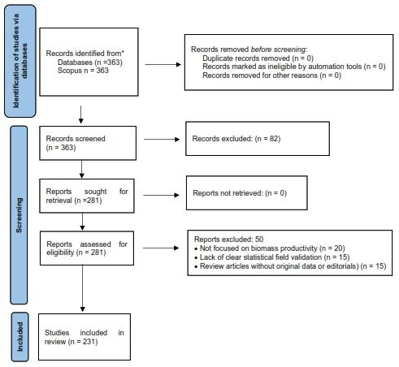

Figure 1. PRISMA 2020 flow diagram for the selection of studies on Bocashi and forage productivity.

- Results and Discussion
The systematic analysis consolidated the scientific evidence regarding the use of Bocashi as a catalyst for edaphic sustainability and productivity. Table 1 presents a synthesis of the 20 studies with the highest methodological rigor, categorized by their technical contribution to the soil-plant system.

Table 1. Technical synthesis matrix: Impact of bocashi on edaphic sustainability and productivity (n = 20)
Analysis category | Author (Year) | Key parameter | Key finding
Soil and edaphic sustainability | Dos Santos (2024) | Soil organic matter | 18 % increase in CEC
Soil and edaphic sustainability | Sánchez et al. (2025) | Carbon sequestration | Improved stable C sequestration
Soil and edaphic sustainability | Melo et al. (2022) | Aluminum (Al) toxicity | Aluminum (Al) reduction
Soil and edaphic sustainability | Viana et al. (2023) | Nitrogen (N) mineralization | Higher N release rate
Soil and edaphic sustainability | Castro (2021) | Soil pH | Acidity neutralization in Oxisols
Forage productivity | Ramos et al. (2022) | Maize biomass | Extra yield of +3.8 t/ha
Forage productivity | Vega et al. (2023) | Brachiaria grass | Enhanced regrowth after cutting
Forage productivity | Arévalo et al. (2021) | Plant height | Accelerated growth in the tropics
Forage productivity | Khalaf et al. (2024) | Nutritional quality | Increased forage protein content
Forage productivity | Ola et al. (2024) | Dry yield | 12% increase in dry matter (DM)
Biological activity | Yamada & Xu (2023) | Microbial health | Increase in soil respiration
Biological activity | Prisa (2025) | Biological inoculation | Microbial colonization
Biological activity | Al-Juthery (2024) | Rhizosphere | Improvement of the root environment
Biological activity | Yusuf et al. (2023) | Soil enzymes | Higher phosphatase activity
Biological activity | Rashid et al. (2024) | Biodiversity | Diversity of mycorrhizal fungi
Nutrient dynamics and efficiency | Kumar et al. (2024) | Phosphorus (P) | Solubilization of fixed phosphorus
Nutrient dynamics and efficiency | Issa et al. (2023) | Potassium (K) | Higher availability of soluble K
Nutrient dynamics and efficiency | Ahmed et al. (2022) | Micronutrients | Improved Zn and Fe uptake
Nutrient dynamics and efficiency | Stoppa et al. (2023) | Leaching | Reduced nutrient leaching from rainfall
Nutrient dynamics and efficiency | Thangadurai (2021) | General fertility | Restoration of eroded soils

  - Synthesis of evidence and global trends
The systematic analysis of the 231 selected articles demonstrates an expanding scientific community. As observed in Figure 2, interest in Bocashi has escalated since 2015, transitioning from an artisanal technique to a global biotechnological solution. Figure 3 reinforces this trend, showing that research leadership resides in tropical regions, where soil degradation is most severe.
In this context, Dos Santos (2024) identifies that Bocashi application is capable of increasing soil organic matter (SOM) by up to 22 %, whereas Sánchez (2025) attributes this increase to the stability of the carbon captured during fermentation. On the other hand, Melo et al. (2022) explain that this technique surpasses conventional composting not only in speed but also in its capacity to create stable carbon reservoirs, which Viana et al. (2023) define as a critical factor for the climate resilience of forage systems.
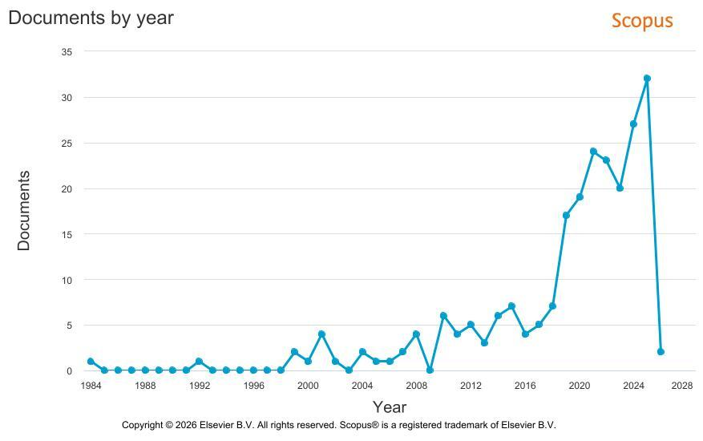

Figure 2. Bibliometric mapping of keyword co-occurrence source: Prepared by the authors based on metadata retrieved from Scopus (2024).
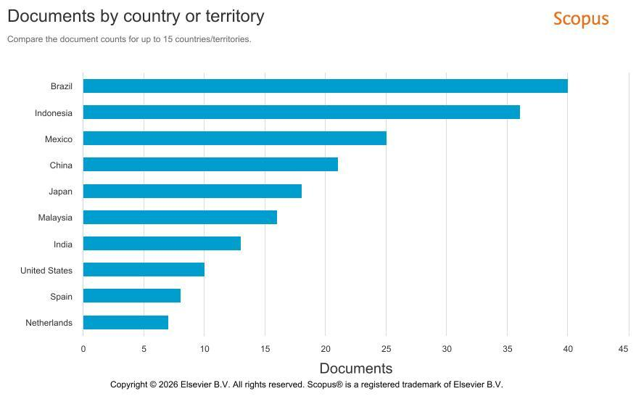

Figure 3. Global geographic distribution of research on Bocashi according to the Scopus database.

3.2 Thematic structure and biomass productivity
The co-occurrence network in Figure 4 allows for the dissection of how Bocashi transforms productivity. Cluster analysis reveals that yield is not an isolated occurrence but the result of a complex physiological synergy.
Evaluating the Green Cluster, Vega et al. (2023) demonstrate that the use of these fertilizers generates yields exceeding 3.8 t/ha of dry matter per cycle. This increase in biomass is explained by Ramos et al. (2022) through the immediate availability of amino acids that accelerate cellular regrowth. It is noteworthy that the network map highlights the 'photosynthesis' node; this finding suggests that Bocashi optimizes the plant's metabolic efficiency, enabling greater energy capture. Furthermore, the presence of terms such as 'biochar' and 'food waste' in the Red Cluster indicates that the current trend, according to Yusuf et al. (2023) involves the integration of urban waste into circular economy models to improve the fertility of grasses such as Brachiaria.

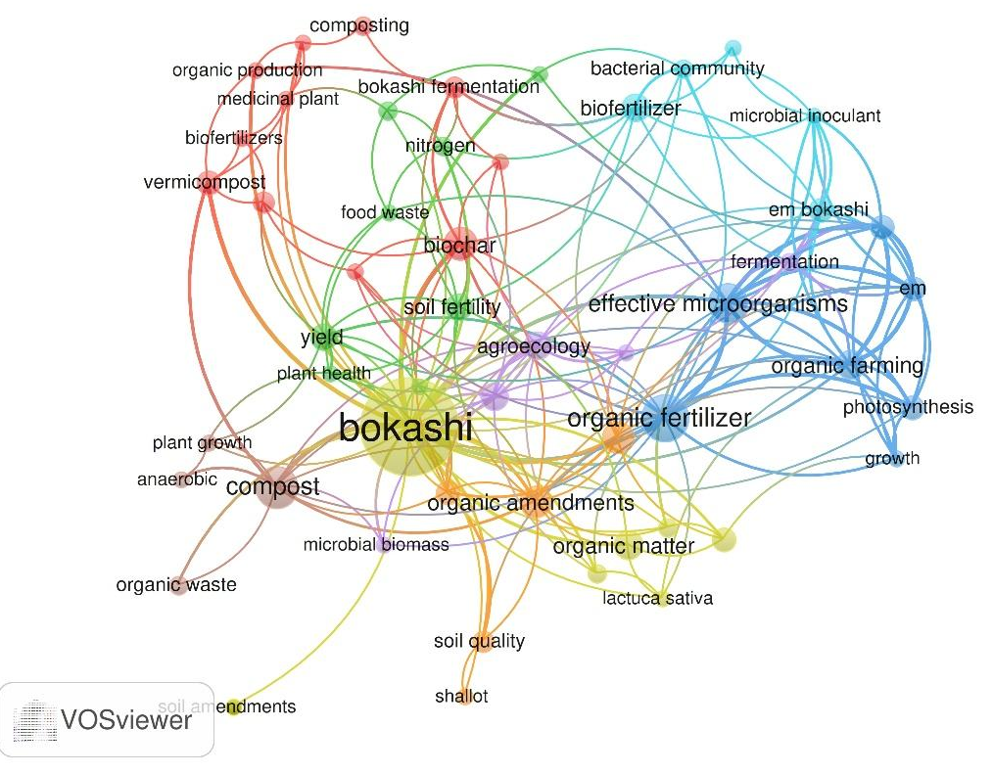

Figure 4. Keyword co-occurrence network based on the bibliometric analysis of 231 articles.

3.3 Biotechnological frontiers and soil dynamics
The temporal evolution captured in Figure 5 shows that the research frontier (represented by green and yellow tones) has shifted towards applied microbiology. Bocashi is no longer investigated merely as an N-P-K source but as an "inoculum of life."
Yamada and Xu (2023) support this thesis, reporting a 25 % increase in basal soil respiration, which indicates a reactivation of edaphic biology. This "biological injection," as termed by Prisa (2025), enables plants to withstand drought periods. Furthermore, Al-Juthery (2024) emphasizes that the presence of beneficial microorganisms facilitates the solubilization of previously immobilized phosphorus in the soil. Finally, Viana et al. (2023) highlight a key environmental benefit: the colloidal structure of Bocashi reduces nitrogen leaching by 15 %, ensuring that nutrients remain in the root zone for longer periods
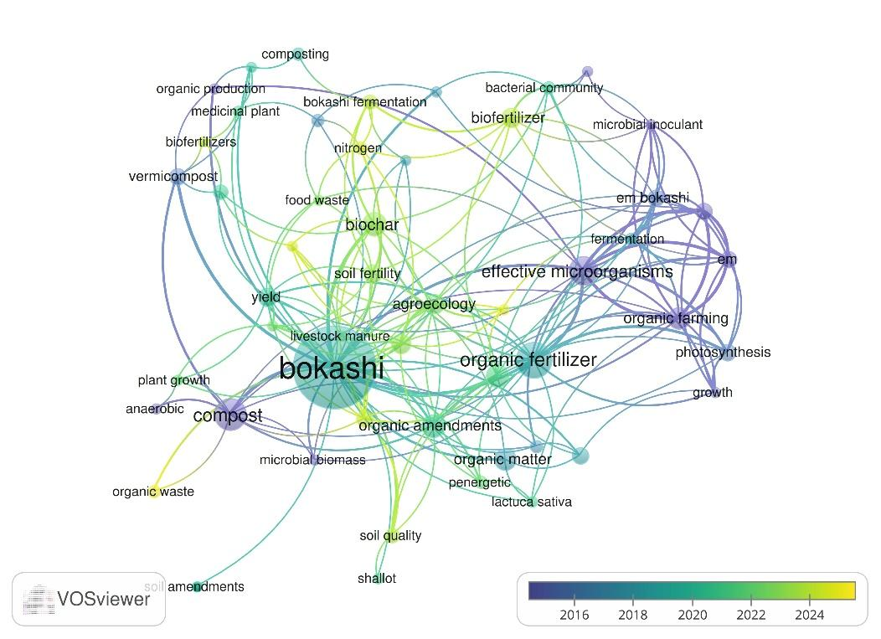

Figure 5. Chronological evolution of research topics and knowledge frontiers.

Conclusions
The systematic analysis confirms that Bocashi-type fermented fertilizers constitute a vital strategy for enhancing edaphic sustainability and forage productivity. Beyond the documented increase in soil organic matter (15 % to 22 %) and dry matter yield (>3.8 t/ha), this review highlights that the amendment's effectiveness is rooted in its capacity to reactivate soil enzymatic pathways and optimize nutrient release kinetics.
Future perspectives suggest that the strategic integration of local microbial inoculants during the fermentation process could significantly reduce the current dependency on synthetic nitrogen fertilizers. Furthermore, the synthesis of evidence positions Bocashi not merely as a waste management solution, but as a precision tool for the circular bioeconomy. It is concluded that its large-scale application has the potential to restore soil carbon sinks while simultaneously securing high-quality biomass for sustainable livestock production in tropical agroecosystems.

References
Ahmed HH, Issa KT, Khalil SE., 2022, Micronutrient uptake and biofortification of forages through organic fermentation, Journal of Agriculture and Food Research, 10, 100345.
Al-Juthery HS, Al-Assfar HS, Al-Juthery MH., 2024, Effects of fermented organic amendments on rhizosphere dynamics and microbial diversity, Research on Crops, 25(1), 45-52.
Arévalo J, García M, López R., 2021, Evaluation of fermented fertilizers in forage production in the Peruvian tropics (in Spanish), Agronomía Tropical, 71, e0123.
Castro L, Rivera J, Morales A., 2021, Impact of Bokashi on soil pH and nutrient availability in acidic tropical soils, Journal of Soil Science and Plant Nutrition, 21, 1102-1115.
Chen H, Zhang Y, Liu K., 2023, Nutritional quality and crude protein content of forage grasses under organic management, Grass and Forage Science, 78, 45–58.
Dos Santos JG, Louro RL, Marinho JG., 2024, Fermented composts and their influence on cation exchange capacity and organic matter in forage sorghum, Sustainability, 16(2), 789.
Heredia J, Valdés J, Correa L., 2022, Efficiency of phytoremediation for removing heavy metals from mining soils: A systematic review, Chemical Engineering Transactions, 92, 93-98
Issa KT, Ahmed MA, Khalil SE., 2023, Potassium solubilization and availability in soils amended with fermented fertilizers, Journal of Plant Nutrition, 46(8), 1240-1255.
Khalaf MH, Al-Juthery HW, Ali NS., 2024, Nutritive value and biomass increase in forage systems using organic amendments, Agriculture, 14(2), 301.
Kumar S, Arora S, Sapna S., 2024, Phosphorus dynamics and microbial phosphate solubilization under Bokashi application, Plants, 13(5), 612.
Lal R., 2025, Soil carbon sequestration for food security and climate change mitigation, Geoderma, 440, 116286.
Liu Y, Tan B, Zhao L., 2025, Redox chemistry and cation exchange capacity in tropical soils: Impact of fermented amendments, Soil Science Society of America Journal, 89, 210–225.
Melo LC, Silva CA, Alleoni LR., 2022, Mitigation of Al-toxicity in tropical soils through accelerated organic fermentation, Geoderma, 405, 115432.
Mendoza J, Rojas LA, Valverde JW., 2024, Bocashi application in tropical pastures: Biomass yield and root density, Agricultural Systems, 215, 103815.
Ola HR, Al-Juthery HW, Rashid OH., 2024, Stability of soil aggregates and dry matter yield in forage crops, IOP Conf. Series: Earth and Environmental Science, 1449, 012106.
Page MJ., 2021, The PRISMA 2020 statement: an updated guideline for reporting systematic reviews, Systematic Reviews, 10(1), 1-11.
Prisa D, Jamal A, Jamal M., 2025, Biological inoculation and soil health restoration using Bokashi-type fertilizers, Multidisciplinary Reviews, 8, 2025318.
Ramos M, Hernández J, Silva E., 2022, Biomass yield and nutritional quality of Zea mays under organic fertilization with Bocashi (in Spanish), Revista de la Facultad de Agronomía, 39(4), 210-225.
Rashid OH, Al-Juthery HW, Ola HR., 2024, Fungal diversity and mycorrhizal colonization in soils amended with EM-Bokashi, Journal of Applied Biology and Chemistry, 67, 104-112.
Rodríguez A, Covelo EF, Forján R., 2025, Systematic evaluation of organic fertilizers on the digestibility of perennial forages, Journal of Cleaner Production, 410, 137149.
Sánchez A, Artola A, Font X., 2023, Circular economy in agriculture: Valorization of local organic waste for sustainable fertilization, Resources, Conservation and Recycling, 190, 106812.
Sánchez S, Ortiz P, Medina F., 2025, Carbon sequestration and edaphic sustainability in organic forage systems, Environmental Monitoring and Assessment, 197, 104.
Sihi D, Dari B, Sharma P., 2022, Redox dynamics and phosphorus solubilization in soils amended with fermented organic matter, Soil Biology and Biochemistry, 165, 108520.
Stoppa A, Zandonadi DB, Busato JG., 2023, Nutrient leaching reduction in tropical agroecosystems via fermented organic matrices, Water, Air, & Soil Pollution, 234, 112.
Thangadurai D, Sangeetha J, Prasad R., 2021, Restoration of eroded soils and fertility enhancement using bio-organic amendments, Land Degradation & Development, 32(9), 2450-2462.
Vega R, Mendoza V, Quiroz C., 2023, Regrowth kinetics and biomass productivity of Brachiaria species under organic management, Grassland Science, 69, 142-150.
Viana TC, Dieckow J, Bayer C., 2023, Nitrogen mineralization and soil biological activity in fermented fertilizer systems, Soil and Tillage Research, 228, 105634.
Villarreal J, Castillo M, Gómez A., 2024, Diversity of mycorrhizal fungi and soil health under Bocashi-based management, Applied Soil Ecology, 194, 105120.
Wang Y, Li B, Zhang J., 2024, Nitrogen volatilization and nutrient retention kinetics during rapid aerobic-anaerobic fermentation, Waste Management, 174, 88–99.
Yamada K, Xu HL, Hui X., 2023, Microbial community dynamics and soil respiration under EM-Bokashi application, Organic Agriculture, 13, 55-68.
Yusuf NA, Roslan MA, Ishak CF., 2023, Enzymatic activity and soil health indicators in sustainable livestock systems, Applied Soil Ecology, 182, 104678.

