 CHEMICAL ENGINEERING TRANSACTIONS  VOL. xxx, 2026 | A publication of  
The Italian Association
of Chemical Engineering
Online at www.cetjournal.it
Guest Editors: Marco Bravi, Antonio Marzocchella, Giuseppe Caputo
Copyright © 2026, AIDIC Servizi S.r.l.
ISBN 979-12-81206-xx-x; ISSN 2283-9216
Redox dynamics and cadmium stabilization mechanisms via nanobubbles in tropical soils: A systematic review
Ana N. Sandoval*ª, Freddy Peláez Peláez^{b}, Jhonny Wilfredo Valverde Flores^{c}, Ludwig N. Villanueva^{d}
ªUniversidad Nacional de San Martin, Perú.
^{b}Universidad Nacional de Trujillo, Perú.
^{c}Universidad Nacional Agraria La Molina, Perú.
^{d}Universidad César Vallejo, Perú.
ansandoval@unsm.edu.pe

This systematic review analyzes the cadmium (Cd) stabilization mechanisms mediated by nanobubbles (NB) to mitigate its accumulation in Peruvian cacao crops, ensuring compliance with EU Regulation 488/2014. Following PRISMA 2020 guidelines, 63 high-impact studies were synthesized. The findings reveal that the high internal pressure and longevity exceeding 21 days of NBs facilitate sustained oxygen mass transfer, which dynamically increases the soil redox potential (Eh). A mean immobilization efficiency of 50.7 % was identified, which can exceed 70 % through the optimization of gas precursors and internal pressure, effectively shifting Cd toward stable residual fractions. Furthermore, the negative zeta potential of NBs promotes the electrostatic capture of Cd²⁺ cations, while oxygen saturation in the rhizosphere alters the gene expression of root metal transporters, significantly reducing translocation to the bean. It is concluded that the regulation of these transporters represents a high-precision biotechnological strategy to ensure food safety and the economic sustainability of cacao exporters in the San Martín region.

1. Introduction
Cadmium (Cd) accumulation in agricultural soils represents a critical health and economic concern, as it poses significant challenges under EU Regulation 488/2014. This regulation establishes strict thresholds for Cd content in cacao-derived products; metal bioaccumulation in the bean compromises access to European markets, necessitating the immediate implementation of mitigation technologies. According to Ushikubo et al. (2010) geological factors and fertilizer use have increased Cd levels, exceeding environmental quality standards and threatening international trade. Soils in the Peruvian Amazon contain naturally occurring cadmium derived from Andean weathering processes; the high metal bioavailability in these basins facilitates its translocation into the bean, frequently exceeding the maximum levels (ML) of 0.80 mg/kg established for products with high cacao solids content (Bian et al., 2025). Cd bioavailability in Amazonian soils is governed by the oxidation-reduction potential (Eh). As stated by Oñate et al. (2024) minimal Eh variations alter metal speciation; under hypoxic conditions, Cd remains in soluble fractions. Consequently, Eh manipulation emerges as a necessary strategy to force the transition of the metal toward stable mineral fractions, overcoming the limitations of traditional, slow-acting amendments (Aluthgun y Meegoda, 2019).
Given the requirement for fast-kinetic soil remediation solutions, Nanobubble (NB) technology has emerged. NBs are defined as gas cavities with diameters below 200 nm that possess exceptional physicochemical properties. One of their most distinctive features is their high internal pressure; according to the Young-Laplace equation (Eq. 1), internal pressure increases inversely proportional to the radius, facilitating superior gas mass transfer into the liquid phase compared to macroscopic bubbles (Priya et al., 2025). A crucial aspect is their negative zeta potential; as stated by Wang et al. (2023) this generates electrostatic repulsion forces that ensure prolonged temporal stability within the soil solution. This stability prevents coalescence and rapid buoyancy-driven ascent, optimizing oxygen saturation even within the micropores of the soil matrix. This is decisive for maintaining the oxidizing conditions required for heavy metal immobilization (Chen et al., 2023).
$∆P=Pin-Pout= \frac{2γ}{r}$ (1)

The nanobubble-mediated remediation mechanism transcends simple physical oxygenation; the collapse of these nanocavities under specific conditions generates hydroxyl radicals (·OH), inducing advanced oxidation processes (AOPs) that dynamically elevate the redox potential (Eh) of the soil matrix (Neda y Seyed, 2025). This physicochemical synergy promotes the precipitation of iron (Fe) and manganese (Mn) hydroxides, which serve as high-affinity sorption sites for cadmium (Cd²⁺), facilitating its transition toward less bioavailable geochemical fractions (Bui et al., 2019). Despite documented advances in water treatment systems and temperate soil remediation, a significant gap persists in the scientific literature regarding NB efficacy within the complex matrix of Oxisols and Ultisols in the Amazon basin (Meegoda et al., 2018). These soils, characterized by chemistry dominated by low-activity clays and high concentrations of native iron, present a unique geochemical scenario (Ushikubo et al., 2010). In this environment, redox dynamics and hydroxyl radical (·OH) generation could exhibit substantially different kinetic behaviors compared to those reported in calcareous soils (Foudas et al., 2023). To date, research has predominantly focused on continuous flow applications or hydroponic systems (Du et al., 2025). The potential of pulsating applications of NB-saturated water as a precision field remediation strategy has yet to be systematically synthesized for tropical agroecosystems (Dajiang et al., 2023).
It is important to recognize that nanobubble technology is part of a broader ecosystem of engineering solutions designed for heavy metal stabilization. For instance, equipment has been developed to rapidly produce energy-efficient nanomaterials for use in environmental emergencies, optimizing response in critical remediation scenarios (Chen et al., 2025). Likewise, the implementation of continuous flow strategies using fixed-bed columns packed with chitosan-nanomagnetite particles has proven effective in removing metals such as Cr(VI) (Evert et al., 2023). This review distinguishes itself by integrating interface physics with tropical rhizosphere dynamics, providing a mapping of biochemical translocation pathways that constitutes a novel contribution to ensuring food safety under EU Regulation 488/2014. Given the growing need for sustainable, high-precision remediation strategies, this systematic review aims to analyze the physicochemical mechanisms by which nanobubbles stabilize Cd in tropical soils within the Peruvian cacao sector.

- Methodology
The study was conducted as a systematic review, strictly adhering to the PRISMA 2020 guidelines to ensure transparency and reproducibility. A comprehensive search was performed across the Scopus and Web of Science databases, spanning the period from 2016 to 2024 to maintain consistency with the temporal distribution of the analyzed evidence. The search strategy utilized optimized Boolean strings: 'nanobubbles' AND ('cadmium' OR 'soil remediation' OR 'heavy metals' OR 'redox potential' OR 'immobilization'), initially identifying 137 records. To ensure technical rigor, specific inclusion and exclusion criteria were applied during the screening phase. Inclusion criteria comprised: (i) original peer-reviewed articles with a recognized impact factor (SJR > 0.5) focusing on nanobubble (NB) dynamics in porous matrices (soils or sediments); (ii) studies providing quantitative data on redox potential (Eh) and cadmium (Cd) stabilization efficiency; and (iii) investigations involving soil-plant system interactions. Conversely, exclusion criteria were: (i) grey literature and conference abstracts without available full text; (ii) studies focused exclusively on wastewater treatment without soil matrix application; and (iii) articles lacking statistical validation. This process resulted in a final selection of 63 scientific articles. Data extraction and bibliometric analysis were performed by systematizing these studies into a technical matrix. Scientific mapping, co-occurrence networks, and cluster identification were generated using VOSviewer software (v.1.6.20) to identify emerging trends and research frontiers in the field of Cd immobilization via NB (see Figure 1)
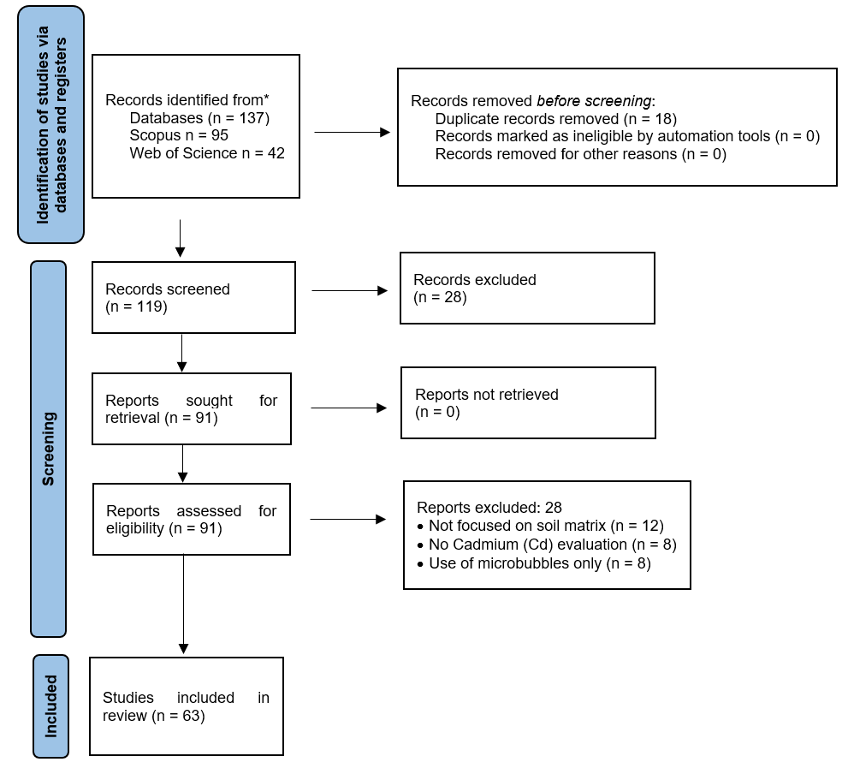

Figure 1: PRISMA 2020 flow diagram of the study selection process.

3. Results and discussion
The systematic analysis reveals a significant technical evolution in the use of NBs for heavy metal management. The intellectual structure of the field is organized into four thematic axes clearly defined by co-occurrence analysis.
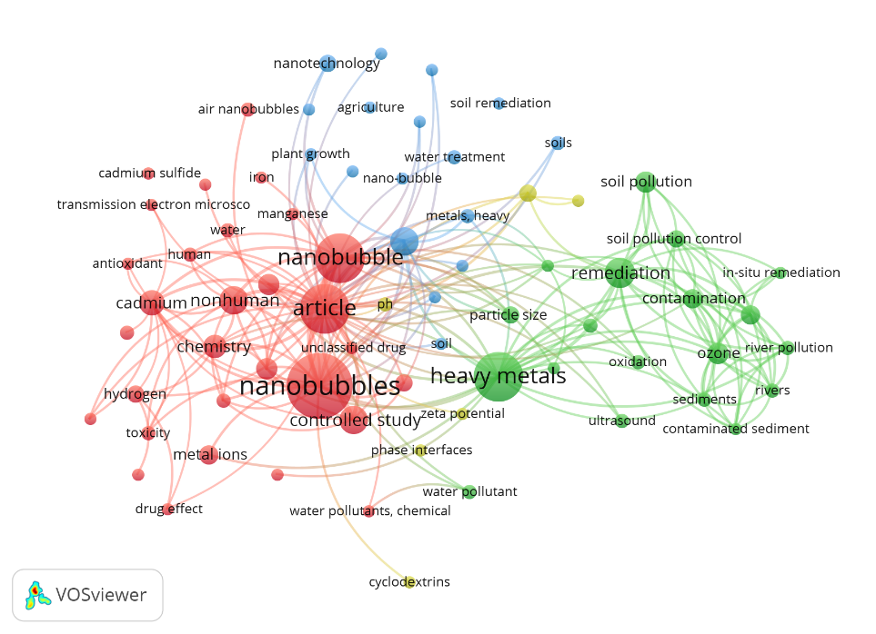

Figure 2: Keyword co-occurrence and thematic clusters in cadmium remediation via nanobubbles

As illustrated in Figure 2, the Green Cluster positions the 'oxidation' node as the primary link between NB technology and cadmium (Cd) stabilization, which validates the chemical remediation mechanism over simple physical aeration. This network of connections has been transformed over the last decade; as observed in figure 3, the scientific focus has shifted from fluvial sediment treatment toward precision solutions in phytoremediation and the management of oxidative stress in plants.

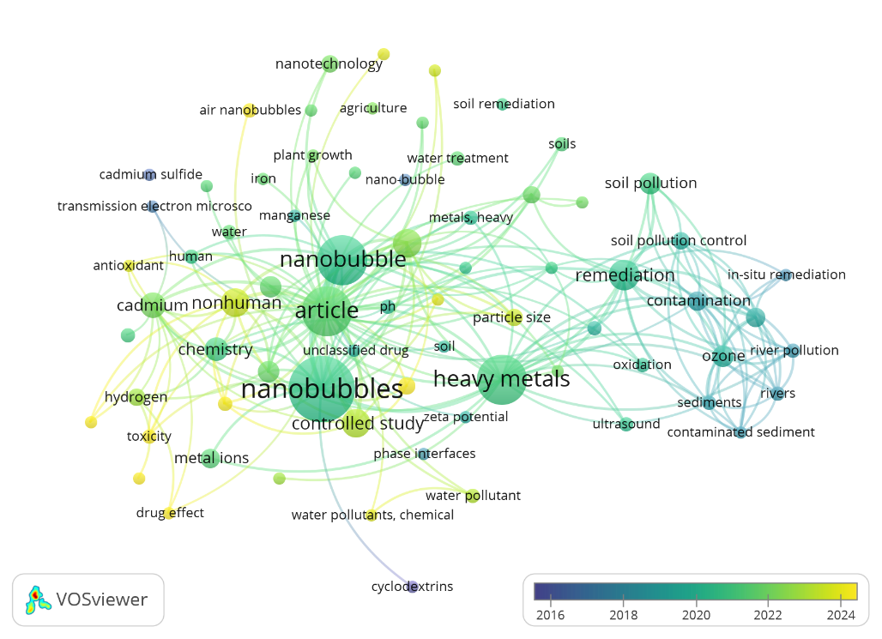

Figure 3: Chronological evolution and research trends between 2016 and 2024

According to the temporal scale of Figure 3 (2016-2024), the terms in yellow hues highlight the current relevance of 'air nanobubbles' and their impact on crop tolerance. Quantitatively, the synthesis of the 63 documents yields a mean Cd immobilization efficiency of 50.7 %, notably the work of Huang et al. (2023) although recent studies such as Montazeri et al. (2023) suggest that optimizing gas type and pressure can raise this efficiency above 70% by shifting the metal toward residual mineral fractions (Zhang et al., 2023). Cadmium (Cd) immobilization efficiency via nanobubbles (NB) shows significant variability depending on experimental conditions and system configuration, with reported ranges fluctuating from minimum values of approximately 25-30 % in low-porosity soils (Dajiang et al., 2023). Among the most critical influential factors are the NB zeta potential (usually maintained between -20 and -40 mV), which facilitates the electrostatic adsorption of Cd²⁺ cations, and the bubble diameter (less than 200 nm), allowing for stability within the soil microporosity (Priya et al., 2025). Moreover, the longevity of oxygen NBs, documented for periods exceeding 21 days under saturation conditions, enables sustained chemical stabilization that shifts Cd toward non-bioavailable residual fractions, outperforming the action kinetics of conventional physical aeration methods (Qian et al., 2019).

The foundation of this technology's success lies in the physics of the gas-liquid interface. The longevity of NBs, which according to Chen et al. (2025) exceeds 21 days, enables a sustained increase in redox potential (Eh). In the soils of the San Martín region, this elevation in Eh triggers the precipitation of iron and manganese oxyhydroxides, which serve as definitive sorption sites for Cd (Kristanti et al., 2021).
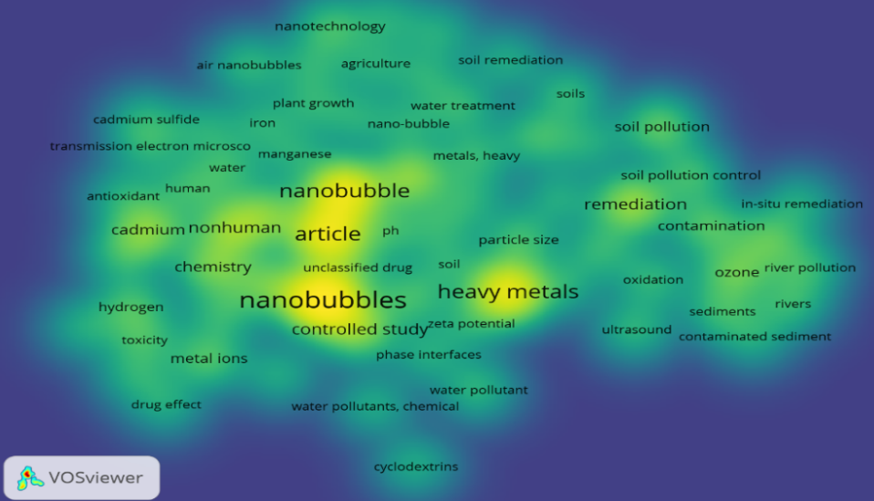

Figure 4: Term density map highlighting the advanced oxidation core as a technological hotspot.
Upon interpreting the term density map in this section, a strong scientific consolidation is identified within the clusters led by authors such as Dajiang et al. (2023) and Yan et al. (2023) who dominate the discourse on immobilization efficiency and electrostatic interaction mechanisms. However, the periphery of the map reveals low density in fundamental nodes such as 'economic viability,' 'scalability,' and 'energy requirements,' evidencing current limitations for the transition of this technology from laboratory settings to commercial field applications. This bibliometric gap aligns with the challenges highlighted by Aluthgun and Meegoda (2019) regarding the high energy demand required for nanobubble generation through cavitation systems a critical factor for rural infrastructure in the tropics. Likewise, although the map emphasizes NB longevity, long-term soil redox stability under high Amazonian leaching conditions remains an area with low data saturation (Wan et al., 2024). Consequently, the density map not only validates the mechanisms of technical success but also serves as a visual diagnostic of the economic and operational barriers that must be overcome for NBs to become a sustainable solution for cocoa exporters in compliance with EU Regulation 488/2014.

Findings indicate that, although NB technology promotes enhanced vigor and root development, these gas cavities simultaneously act to limit the effective uptake of cadmium (Cd²⁺) by the crop. Scientific evidence suggests that oxygen saturation in the rhizosphere alters the gene expression of heavy metal transporters in the roots, reducing metal entry into the plant's vascular system (Tang et al., 2021). This 'precision remediation' mechanism ensures that even in agroecosystems with naturally occurring cadmium, such as those in San Martín, translocation to the cacao bean is significantly decreased. The application of NBs is thus established as a viable strategy to ensure that the final product complies with international food safety requirements and current export limits (Arablousabet et al., 2024)

- Conclusions
This systematic review confirms that nanobubble (NB) technology constitutes a high-precision strategy for cadmium (Cd) immobilization in tropical agroecosystems. The stabilization mechanism is primarily driven by a dual physicochemical interaction: the significant elevation of the soil redox potential (Eh) through sustained oxygen mass transfer and the electrostatic sequestration of Cd²⁺ cations via the negative zeta potential of NBs. With a basal immobilization efficiency of 50.7 %, which can be optimized to over 70 % by modulating gas precursors and internal pressure, NBs effectively shift Cd toward stable residual fractions. Furthermore, rhizosphere oxygen saturation triggers a physiological blockade by altering the expression of root metal transporters, thereby mitigating translocation to the cocoa bean. These findings position NBs as a vital biotechnological tool to ensure compliance with EU Regulation 488/2014 and secure the economic sustainability of the Peruvian cacao sector. Future research should prioritize long-term field validation of NB longevity in complex soil matrices and the potential synergistic effects of combining NBs with microbial inoculants.
References
Arablousabet Y, Povilaitis A., 2024, Assessing the Role of Air Nanobubble-Saturated Water in Enhancing Soil Moisture, Nutrient Retention, and Plant Growth. Sustainability, 16, 13. DOI: 10.3390/su16135727
Aluthgun S, Meegoda JN., 2019, Remediation of contaminated sediments using nanobubble technology, Environmental Engineering Science, 36, 102–114. DOI: 10.1680/jenes.18.00012.
Bian Q, Yang Y, Ma L, Ma Y, Wang Z, Fu Y, Feng Y, Zhu J, Wei L, Lin L., 2025, Effects of combined technology of micro-/nanobubble oxygenation irrigation and microbial agents on saline soil remediation and cotton yield, Front. Plant Sci. DOI: 10.3389/fpls.2025.1605834.
Bui TT, Nguyen DC, Han M., 2019, Average size and zeta potential of nanobubbles in different reagent solutions. J Nanopart Res 21, 173. DOI: 10.1007/s11051-019-4618-y
Chen W, Bastida F, Liu Y, Zhou Y, He J, Song P, Kuang N, Li Y., 2023, Nanobubble oxygenated increases crop production via soil structure improvement: The perspective of microbially mediated effects, Agricultural Water Management, 282. DOI: 10.1016/j.agwat.2023.108263
Chen Q, Zhu X, Guo Y, Zhou Q., 2025, Research progress of micro-nano-bubbles in environmental remediation field. Front. Environ. Sci. 13:1623566. doi: 10.3389/fenvs.2025.1623566
Dajiang Y, Shan X, Zhibin Z, Guodong X, Yanhao Z, Jianan G, Wen Z., 2023, Air nanobubble water improves plant uptake and tolerance toward cadmium in phytoremediation, Environmental Pollution, 337, 122577. DOI: 10.1016/j.envpol.2023.122577
Du B, Fei J, You L, Zhou J, Zhou J., 2025, Nanomaterials Reduce Cadmium Bioavailability in Paddy Soils Through Redox-Driven Immobilization and Microbial Dynamics, Agronomy, 15 (6), 1423. DOI: 10.3390/agronomy15061423
Evert TE, Atkinson R, Zavaleta D, Rodriguez C, Lastra S, Yovera F, Arango K, Pezo A, Aguilar J, Tames M, Ramos A, Cruz W, Cosme R, Espinoza E, Chavez C, Ladd B., 2023, The distribution of cadmium in soil and cacao beans in Peru, Science of The Total Environment, 881. DOI: 10.1016/j.scitotenv.2023.163372.
Foudas AW, Kosheleva RI, Favvas EP, Kostoglou M, Mitropoulos AC, Kyzas GZ., 2023, Fundamentals and applications of nanobubbles: A review, Chemical Engineering Research and Design, 189, 64–86. DOI: 10.1016/j.cherd.2022.11.013
Haddaway NR, Page MJ, Pritchard CC, McGuinness LA., 2022, PRISMA2020: An R package and Shiny app for producing PRISMA 2020-compliant flow diagrams, with interactivity for optimised digital transparency and Open Synthesis Campbell Systematic Reviews, 18, e1230.
Huang M, Nhung N, Wu Y, He C, Wang K, Yang S, Kurokawa H, Matsui H, Dodbiba G, Fujita T., 2023, Different nanobubbles mitigate cadmium toxicity and accumulation of rice (Oryza sativa L.) seedlings in hydroponic cultures, Chemosphere, 312, 137250. DOI: 10.1016/j.chemosphere.2022.137250
Kristanti RA, Liong RM, Hadibarata T., 2021, Soil Remediation Applications of Nanotechnology. Tropical Aquatic and Soil Pollution, 1(1), 35–45. DOI: 10.53623/tasp.v1i1.12
Meegoda JN, Hewage SA, Batagoda JH., 2018, Principles and applications of nanobubble technology in environmental engineering, Environmental Engineering Science, 35, 1021–1035. DOI: 10.1089/ees.2018.0203
Montazeri SM, Kalogerakis N, Kolliopoulos G., 2023, Effect of chemical species and temperature on the stability of air nanobubbles. Sci Rep 13, 16716. DOI: 10.1038/s41598-023-43803-6
Neda B, Seyed JT., 2025, Enhancing Anthurium (Anthurium andraeanum) growth: the impact of oxygen nanobubbles in hydroponic systems, Journal of Plant Nutrition, 48, 1779-1788. DOI: 10.1080/10643389.2022.2136931
Oñate A, Bolaños D, Pozo C, Vera D, Torres E., 2024, Nanoparticles for treatment of cadmium-contaminated cacao-growing soils and beans: Performance on metal immobilization and removal, Journal Heliyon, 11, 4. DOI: 10.1016/j.heliyon.2024.e40519
Priya K, Neelkanth N, Grzegorz B., 2025, High performance ozone nanobubbles based advanced oxidation processes (AOPs) for degradation of organic pollutants under high pollutant loading, Journal of Environmental Management, 374, 124107. DOI: 10.1016/j.jenvman.2025.124107
Qian J, Craig VS, Jehannin M., 2019, Long-Term Stability of Surface Nanobubbles in Undersaturated Aqueous Solution. Langmuir, 22; 35(3):718-728. DOI: 10.1021/acs.langmuir.8b03487.
Tang Y, Zhang M, Zhang J, Lyu T, Cooper M, Pan G., 2021, Reducing arsenic toxicity using the interfacial oxygen nanobubble technology for sediment remediation, Water Research, 205. DOI: 10.1016/j.watres.2021.117657
Unión Europea, 2014, Reglamento (UE) No 488/2014 de la Comisión, de 12 de mayo de 2014, contenido máximo de cadmio en los productos alimenticios. Diario Oficial de la Unión Europea, L 138/75.
Ushikubo ST, Enari M, Furukawa T, Nakagawa R, Makino S, Ueda Y, Oshita S., 2010, Evidence of the existence of nanobubbles and their surface charge, Nanoscale Research Letters, 5, 1000–1005. DOI: 10.1016/j.colsurfa.2010.03.005
Wang Y, Wang T., 2023, Preparation Method and Application of Nanobubbles: A Review. Coatings, 13(9), 1510. https://doi.org/10.3390/coatings13091510
Yan D, Xue S, Zhang Z, Xu G, Zhang Y, Gao J, Zhang W., 2023, Air nanobubble water improves plant uptake and tolerance toward cadmium in phytoremediation, Environmental Pollution, 337, 122577. DOI: 10.1016/j.envpol.2023.122577
Zhang Y, Xu S, Li D, Chuan L, Zhu Y, Wang F, Cao L, Sha Z., 2023, Progress in research on preparation and application of oxygen nanobubbles in agriculture, Chinese Journal of Eco-Agriculture, 31, 1780–1791. DOI: 10.12357/cjea.20230066

